Exercise 4 - Git Merge Conflict Resolution

Objective
To perform branch creation, create a merge conflict, resolve it manually, and verify the repository state.

Step 1
Figure 1: Screenshot of step 1.
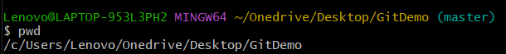

Step 2
Figure 2: Screenshot of step 2.
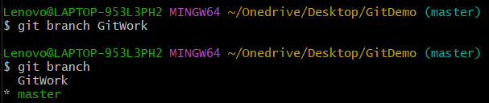

Step 3
Figure 3: Screenshot of step 3.
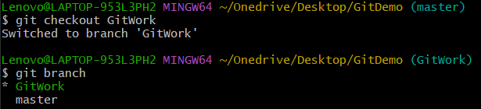

Step 4
Figure 4: Screenshot of step 4.
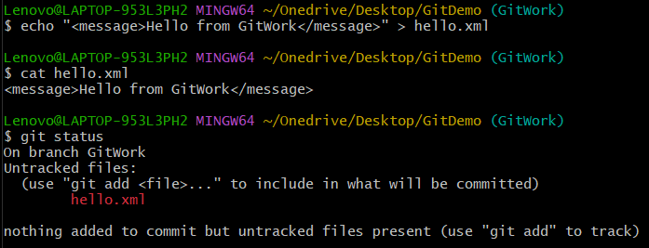

Step 5
Figure 5: Screenshot of step 5.
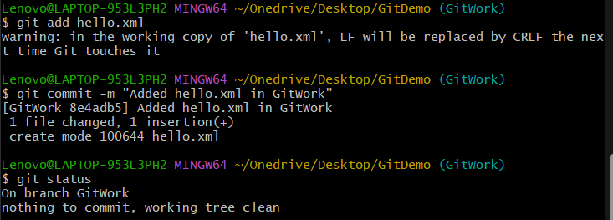

Step 6
Figure 6: Screenshot of step 6.
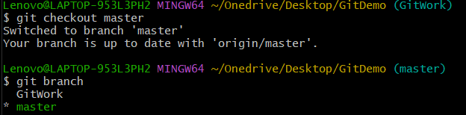

Step 7
Figure 7: Screenshot of step 7.
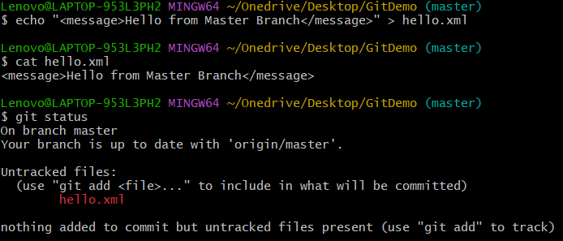

Step 8
Figure 8: Screenshot of step 8.
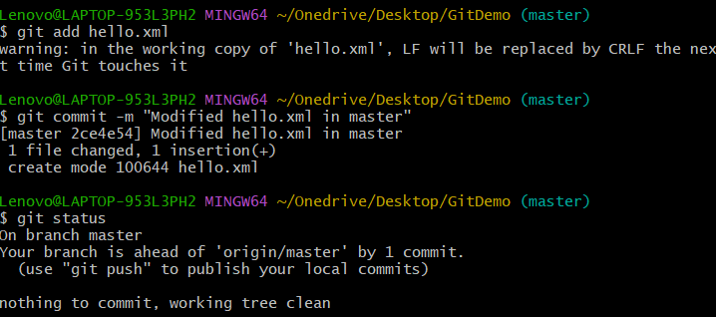

Step 9
Figure 9: Screenshot of step 9.
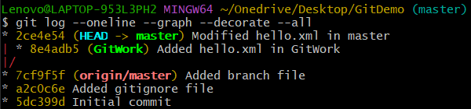

Step 10
Figure 10: Screenshot of step 10.
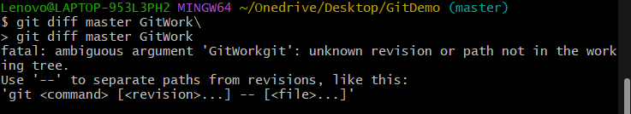

Step 11
Figure 11: Screenshot of step 11.
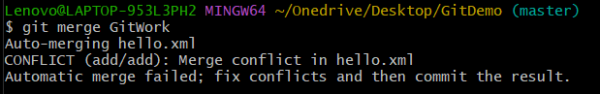

Step 12
Figure 12: Screenshot of step 12.
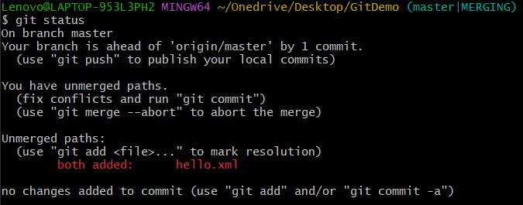

Step 13
Figure 13: Screenshot of step 13.
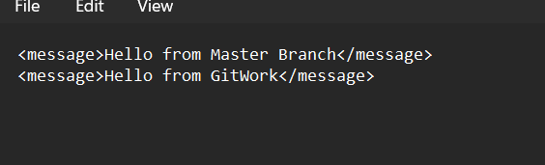

Step 14
Figure 14: Screenshot of step 14.
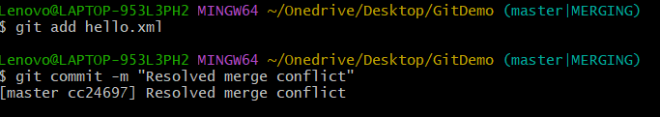

Step 15
Figure 15: Screenshot of step 15.
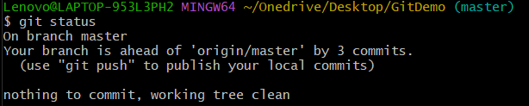

Step 16
Figure 16: Screenshot of step 16.
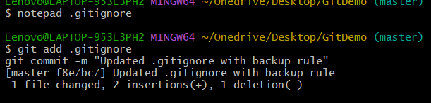

Step 17
Figure 17: Screenshot of step 17.
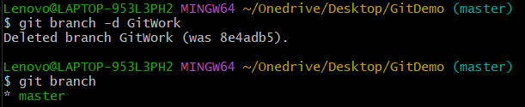

Step 18
Figure 18: Screenshot of step 18.
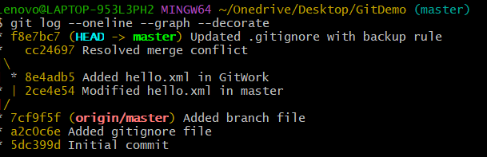

Result
The merge conflict was successfully resolved and the repository was restored to a clean state.

