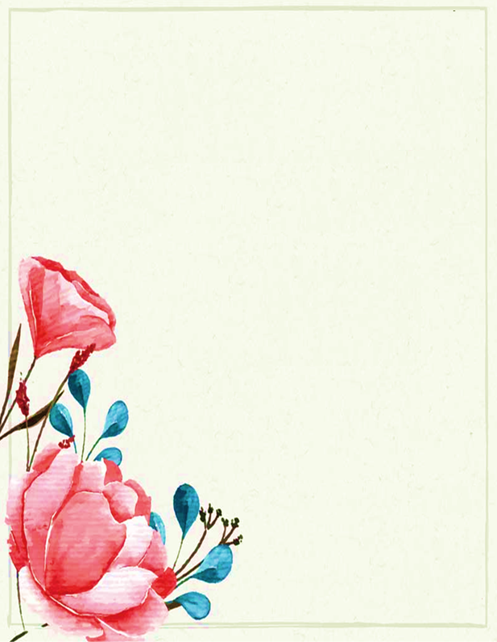

*Dear* ***ARTI KHATRI,***

A birthday is a wonderful day to begin something new, especially something that can bring you ***happy returns***, like starting an investment.

A monthly ***SIP of ₹5000*** invested on your special day ***03-July 1972***, would have grown to ***₹8.03 Crores*** today!

Instead of regretting, you can start investing for your ***Children / Spouse / Family Members*** today itself and gift them this wealth to make your birthday even more worth to celebrate.

***Once again, AUM Family wishes you a very Happy Birthday...***

**Happy Birthday !**

*Our warmest wishes*

*for happiness and prosperity*