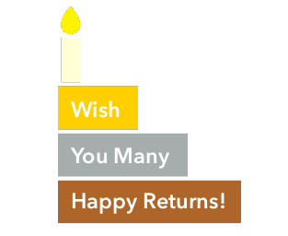

Dear **@name,**

A birthday is a wonderful day to begin something new, especially something that can bring you **happy returns**; like starting an investment.

A SIP* of ₹ **@sip** invested on your special day **@date** in

**@year**, would have grown to ₹ **@amount** today!

Once again, AUM Family wishes you many happy returns.

From,

**AUM INSURE AND SECURE (P) LTD**

SIP* in Sensex is used for illustration purpose only and represents periodic investment done in Sensex. It is not possible to directly invest into index.

Mutual fund investments are subject to market risks, read all scheme related documents carefully.