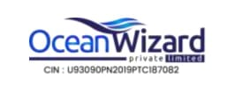

OceanWizard Pvt. Ltd.
Office No. 111/A, 1st Floor, Mayur Trade Center II, Chinchwad Station, Pune - 411 019

Customer Churn Prediction Using ML
Submitted to

Department of Computer Engineering

A.G.Patil Polytechnic Institute,Solapur
Submitted by
Student Name | EnrollmentNO
Kore Samarth Siddharam | 24212340148
Patil Shubham Sukhadev | 24212340181
Choragi Babushagauda Siddharam | 24212340174
Jamadar Saipan Salim | 24212340119




Department of Computer Engineering
A.G.Patil Polytechnic Institute,Solapur

Academic year: - 2026-2027

CERTIFICATE

This is certifying that Mr. Kore Samarth Siddharam of Class: Third Year Roll No.330
has successfully completed the project “Customer Churn Prediction Using ML” during the academic year 2026-27 in partial fulfilment of the requirements for Computer Engineering.
.

Enrollment No: 24212340148

Mr.GAIKWAD P.V
Mr.PATIL T.L

Name of Faculty Head of the Department

ACKNOWLEDGEMENT

The successful completion of this project, “Customer Churn Prediction Using ML” would not have been possible without the guidance, support, and encouragement of several individuals, and I take this opportunity to express my sincere gratitude to all of them.
I extend my heartfelt thanks to Mr.Tejas Giram sir for their invaluable guidance, constructive feedback, and continuous encouragement throughout the course of this project. Their insights into data analytics and structured problem-solving greatly shaped the direction of this work.
I am also grateful to Department of Computer Engineering, A.G.Patil Polytechnic Institute,Solapur for providing the resources, learning environment, and opportunity to undertake this project as part of my academic curriculum. The exposure to Python-based data analysis tools and libraries during this project has significantly strengthened my practical understanding of exploratory data analysis.
I would like to thank my peers and classmates for their collaboration, discussions, and shared learning during the development and testing of this project. Their feedback helped refine both the analysis and the presentation of results.

Finally, I would like to thank my family for their constant support and motivation throughout this endeavour.
- Guide: Mr.Tejas Giram

- Department: Department of Computer Engineering, A.G. Patil Polytechnic Institute, Solapur

ABSTRACT

Customer churn is a major challenge faced by businesses, as losing existing customers can directly affect revenue, growth, and long-term customer relationships. Identifying customers who are likely to leave allows organizations to take preventive actions, improve customer satisfaction, and develop effective retention strategies. This project, “Customer Churn Prediction Using Machine Learning,” was undertaken to demonstrate how machine learning techniques can be used to analyze customer data and predict the likelihood of customer churn.
The project begins with the collection and preprocessing of a customer dataset containing information such as customer demographics, tenure, contract type, payment method, monthly charges, total charges, and service-related details. The dataset is cleaned by handling missing values, removing unnecessary attributes, and converting categorical data into a suitable numerical format. Exploratory Data Analysis (EDA) is then performed to understand customer behavior and identify patterns associated with churn.
The analytical core of the project involves applying machine learning classification algorithms to predict whether a customer is likely to churn. Different models are trained and evaluated using appropriate performance measures such as accuracy, precision, recall, F1-score, and confusion matrix. The best-performing model is selected based on its ability to accurately identify customers at risk of leaving.
The analysis helps identify important factors that influence customer churn, such as contract type, tenure, monthly charges, payment method, and the services used by customers. The prediction results can help businesses identify high-risk customers and take suitable retention measures, such as personalized offers, improved services, and targeted communication.
Overall, the project demonstrates the practical application of Python, data preprocessing, exploratory data analysis, and machine learning for solving a real-world business problem. Customer churn prediction can support data-driven decision-making and help organizations reduce customer loss, improve customer retention, and increase overall business performance.

TABLE OF CONTENTS:

Chapter 1 Introduction to the Project
1.1 Background and Motivation
1.2 Problem Statement
1.3 Objectives of the Project
1.4 Scope of the Project
1.5 Need for Customer Churn Prediction

Chapter 2 Customer Churn and Exploratory Data Analysis
2.1 Introduction to Customer Churn
2.2 Types of Customer Churn
2.3 Importance of Customer Retention
2.4 Exploratory Data Analysis (EDA)
2.5 Business Impact of Customer Churn

Chapter 3 Tools and Technologies Used
3.1 Python Programming Language
3.2 Jupyter Notebook / VS Code
3.3 Pandas and NumPy
3.4 Matplotlib and Seaborn
3.5 Scikit-learn
3.6 MySQL / Database
3.7 Streamlit for Web Application

Chapter 4 Dataset Description and Data Preparation

4.1 Dataset Overview
4.2 Attribute Description
4.3 Data Collection
4.4 Data Cleaning and Preprocessing
4.5 Handling Missing Values
4.6 Encoding Categorical Data
4.7 Feature Selection and Engineering
4.8 Train-Test Data Splitting

Chapter 5 Project Methodology
  - Overall Workflow
  - Step-by-Step Process
  - Process Flow Diagram
  - Algorithm / Logic Summary

Chapter 6 Data Visualization and Results

6.1 Customer Churn Distribution

6.2 Churn Analysis by Subscription Plan

6.3 Churn Analysis by Customer Complaints

6.4 Monthly Charges and Churn Analysis

6.5 Customer Usage and Churn Analysis

Chapter 7 Business Insights and Recommendations
7.1 Key Findings from Customer Churn Analysis
7.2 Identification of High-Risk Customers
7.3 Major Factors Affecting Customer Churn
7.4 Impact of Subscription Plans on Chur

Chapter 8 Conclusion and Future Scope
8.1 Conclusion
8.2 Future Scope

Chapter 9 References

CHAPTER 1: INTRODUCTION TO THE PROJECT

1.1 Background and Motivation

In today's highly competitive business environment, customer retention has become one of the most important factors for the success and growth of an organization. Companies continuously collect large amounts of customer data, including information related to subscription plans, monthly charges, service usage, customer complaints, payment behavior, and overall customer satisfaction. When analyzed systematically, this data can reveal important patterns and help organizations understand why customers decide to leave their services.
This project, titled “Customer Churn Prediction Using Machine Learning,” was undertaken to develop a data-driven system capable of identifying customers who are likely to discontinue a company's services. The project uses customer-related data and applies data analysis, exploratory data analysis (EDA), and machine learning techniques to discover the major factors influencing customer churn.
Customer churn refers to the situation in which a customer stops using a company's product or service. High churn rates can significantly affect a company's revenue and growth. Therefore, identifying customers who are at risk of leaving at an early stage allows businesses to take preventive actions, improve customer satisfaction, and implement effective retention strategies.

1.2 Problem Statement

Many organizations face the challenge of losing customers without clearly understanding the reasons behind their decision to leave. Customer data may contain valuable information about service usage, subscription plans, monthly charges, complaints, and customer behavior, but analyzing thousands of records manually is time-consuming, difficult, and prone to errors.
The main problem addressed in this project is the absence of an automated and data-driven system for identifying customers who are likely to churn. Without an effective prediction system, businesses may recognize customer loss only after the customer has already stopped using the service.
Therefore, this project aims to develop a structured and repeatable machine learning-based solution that analyzes historical customer data, identifies important churn-related factors, and predicts whether a customer is likely to leave or continue using the service. The insights generated from the analysis can help businesses take proactive measures and develop effective customer retention strategies.

1.3 Objectives of the Project

The main objective of the project “Customer Churn Prediction Using Machine Learning” is to analyze customer data and predict whether a customer is likely to leave the service.

The specific objectives are:

To collect and understand customer data related to subscription plans, monthly charges, service usage, complaints, and other customer attributes.

To clean and preprocess the dataset by handling missing values, duplicates, and categorical data.

To perform Exploratory Data Analysis (EDA) to identify patterns and factors affecting customer churn.

To visualize customer behavior and churn patterns using graphs and charts.

To identify the major factors responsible for customer churn, such as complaints, subscription plans, charges, and service usage.

To build a Machine Learning model using the Random Forest algorithm for predicting customer churn.

To evaluate the performance of the trained model using appropriate evaluation metrics.

To identify high-risk customers who are more likely to leave the service.

To provide business insights and recommendations that can help improve customer retention and reduce churn.

To develop a simple prediction system that allows users to enter customer information and obtain a churn prediction.

Scope of the Project

The scope of this project is limited to exploratory (descriptive) data analysis — it does not extend into predictive modelling, machine learning forecasting, or real-time dashboarding, although the report discusses these as natural next steps in the future scope section. The dataset used is a synthetically generated but realistic retail transactions dataset comprising 500 orders across seven product categories and four geographic regions, spanning approximately sixteen months. The techniques demonstrated — cleaning, aggregation, and visualization — are, however, directly transferable to any real-world point-of-sale or e-commerce transaction export.

1.5 Need for Customer Churn Prediction

Customer churn prediction is important for businesses that provide subscription-based services, such as OTT platforms. Customer churn occurs when a customer stops using a service or cancels their subscription. Losing existing customers can reduce revenue and increase the cost of acquiring new customers.

By using Machine Learning and data analysis, businesses can identify customers who are likely to leave the platform. Factors such as watching hours, login frequency, subscription plan, payment failures, customer complaints, rating, and recent activity can help predict customer churn.

Tool / Library | Purpose
Python 3 | Core programming language for the entire pipeline
pandas | Data loading, cleaning, aggregation, and transformation
NumPy | Numerical operations and synthetic data generation
matplotlib | Base plotting engine for charts and figures
Jupyter / VS Code | Interactive development and script execution

Chapter 2 Customer Churn and Exploratory Data Analysis

2.1 Introduction to Customer Churn
Customer churn refers to the situation in which a customer stops using a company's product or service. In subscription-based businesses such as OTT platforms, telecom services, banking, and e-commerce platforms, churn may occur when a customer cancels a subscription or becomes inactive for a long period.
Customer churn is an important business problem because losing existing customers can reduce revenue and increase the cost of acquiring new customers. By analysing customer behaviour, businesses can identify patterns that indicate whether a customer is likely to leave. Factors such as service usage, login frequency, customer satisfaction, payment issues, and complaints can be useful for predicting churn.

2.2 Types of Customer Churn
Customer churn can occur for different reasons and can generally be classified into the following types:
Voluntary Churn: This occurs when a customer intentionally decides to stop using a product or service. Reasons may include dissatisfaction, high prices, poor service, or finding a better alternative.
Involuntary Churn: This occurs due to reasons that are not directly related to the customer's decision, such as payment failures, expired cards, technical issues, or account-related problems.
Active and Passive Churn: Active churn occurs when a customer officially cancels a subscription, whereas passive churn occurs when a customer gradually stops using the service without formally cancelling it.
Understanding different types of churn helps businesses develop appropriate strategies to reduce customer loss.

2.3 Importance of Customer Retention
Customer retention refers to the ability of a business to keep its existing customers for a long period. Retaining existing customers is important because acquiring new customers usually requires additional marketing and promotional costs.
A satisfied and loyal customer is more likely to continue using the service and may also recommend it to others. By identifying customers who are at risk of leaving, companies can provide personalised offers, discounts, better recommendations, or customer support.
Therefore, customer retention helps businesses improve customer satisfaction, maintain stable revenue, and build long-term relationships with customers.

2.4 Exploratory Data Analysis (EDA)
Exploratory Data Analysis (EDA) is the process of analysing and understanding a dataset before building a machine learning model. It helps identify patterns, trends, relationships, missing values, and unusual data.
In a customer churn prediction project, EDA can be performed on features such as customer age, subscription plan, watch time, login frequency, complaints, payment failures, satisfaction rating, and churn status.
Various techniques such as summary statistics, bar charts, histograms, pie charts, correlation analysis, and distribution plots can be used during EDA. This analysis helps in understanding the main factors associated with customer churn and supports better data preprocessing and model development.

2.5 Business Impact of Customer Churn
Customer churn can have a significant impact on a company's revenue and growth. When customers leave a service, the company loses future revenue from subscriptions and may need to spend additional money on marketing to acquire new customers.
High churn rates can also indicate problems related to customer satisfaction, service quality, pricing, technical issues, or competition. By predicting churn in advance, businesses can take preventive actions and focus their retention efforts on customers who are most likely to leave.
A customer churn prediction system can help organisations make data-driven decisions, improve customer experience, increase retention rates, and reduce revenue loss. Therefore, analysing and managing customer churn is important for the long-term success of any customer-focused business.

Chapter 3 : Tools and Technologies Used

This chapter describes the various tools, technologies, libraries, and platforms used for developing the Customer Churn Prediction System. These technologies were used for data collection, data cleaning, analysis, visualization, machine learning model development, database management, and web application development.

3.1 Python Programming Language

Python is the main programming language used in this project. It is simple, easy to understand, and widely used in the fields of Data Science, Machine Learning, and Artificial Intelligence.

Python was used for data preprocessing, exploratory data analysis, visualization, and building the customer churn prediction model. Its large collection of libraries makes it suitable for handling datasets and developing machine learning applications efficiently.

3.2 Jupyter Notebook / VS Code

Jupyter Notebook and Visual Studio Code (VS Code) were used as development environments for this project.

Jupyter Notebook was useful for performing data analysis and testing the machine learning model step by step. It allows code, output, graphs, and explanations to be displayed in one place.

VS Code was used for writing and managing Python code and developing the web application. It provides features such as code completion, debugging, and extension support, making the development process easier and more efficient.

3.3 Pandas and NumPy

Pandas and NumPy are important Python libraries used for data processing and analysis.

Pandas was used to load the dataset, handle missing values, remove duplicate records, select columns, filter data, and perform various data manipulation operations using DataFrames.

NumPy was used for numerical and mathematical operations. These libraries helped in preparing and processing the customer data before applying machine learning algorithms.

3.4 Matplotlib and Seaborn

Matplotlib and Seaborn were used for data visualization and Exploratory Data Analysis (EDA).

These libraries helped create different types of graphs and charts, such as bar charts, histograms, pie charts, and correlation heatmaps. Visualizations helped in understanding customer behaviour, identifying patterns, and analysing the relationship between different features and customer churn.

3.5 Scikit-learn

Scikit-learn is a popular Python library used for Machine Learning. It was used in this project to preprocess the data, divide the dataset into training and testing data, and build the customer churn prediction model.

The library provides various machine learning algorithms and evaluation tools. In this project, machine learning techniques were used to predict whether a customer is likely to churn based on different customer-related features.

3.6 MySQL / Database

MySQL was used as the database management system for storing and managing customer-related data. It provides an organised way to store large amounts of structured data.

SQL queries can be used to retrieve, filter, update, and analyse customer information. The database helps manage data efficiently and can also support future integration of the prediction system with real-time customer data.

3.7 Streamlit for Web Application

Streamlit was used to develop an interactive web application for the Customer Churn Prediction System. It allows Python-based machine learning models to be integrated into a simple and user-friendly web interface.

The application accepts customer-related input data and sends it to the trained machine learning model for prediction. The system can then display whether the customer is likely to churn or not. Streamlit makes it easier to convert a machine learning project into a functional and interactive application without requiring extensive web development knowledge.

Chapter 4: Dataset Description and Data Preparation
Data preparation is one of the most important stages in a Machine Learning project. The quality of the dataset directly affects the performance and accuracy of the prediction model. In this project, customer-related data was collected, cleaned, analysed, and transformed before training the Customer Churn Prediction model.
4.1 Dataset Overview
The dataset used in this project contains information related to customers and their behaviour on the OTT platform. It includes approximately 9,000 customer records with different attributes related to customer activity, subscription details, service usage, and churn status.
The main objective of the dataset is to analyse customer behaviour and predict whether a customer is likely to leave the service. The Churn attribute is considered the target variable, while the remaining attributes are used as input features for prediction.
The dataset contains both numerical and categorical data, which requires preprocessing before applying Machine Learning algorithms.
4.2 Attribute Description
The dataset contains various attributes that help in understanding customer behaviour and predicting churn. Some important attributes include:
- Customer ID: A unique identification number assigned to each customer.
- Age: Represents the age of the customer.
- Gender: Represents the gender category of the customer.
- Subscription Plan: Indicates the type of subscription selected by the customer.
- Monthly Charges: Represents the monthly subscription cost.
- Watch Time: Indicates the amount of time spent watching content.
- Login Frequency: Shows how frequently the customer accesses the platform.
- Primary Device: Represents the main device used by the customer.
- Complaints: Indicates whether the customer has raised any complaints.
- Payment Status/Failures: Represents payment-related issues faced by the customer.
- Auto Renewal: Indicates whether automatic subscription renewal is enabled.
- Churn: The target variable that shows whether the customer has left or continues to use the service.
These attributes were used to identify patterns and factors related to customer churn.
4.3 Data Collection
The dataset used for this project was obtained for educational and analytical purposes. The data represents customer-related information and their interaction with an OTT subscription platform.
The collected data was stored in CSV format and analysed using Python libraries. The dataset was also managed and explored using database tools such as MySQL. Before using the data for Machine Learning, it was examined to understand its structure, data types, and overall quality.
4.4 Data Cleaning and Preprocessing
Data cleaning and preprocessing were performed to prepare the raw dataset for analysis and Machine Learning.
The main preprocessing activities included:
- Removing unnecessary or duplicate records.
- Checking data types of different attributes.
- Handling missing or incomplete values.
- Removing irrelevant columns where necessary.
- Converting categorical data into numerical form.
- Preparing input features and the target variable.
These steps helped improve the quality and consistency of the dataset and made it suitable for model training.
4.5 Handling Missing Values
Missing values can negatively affect data analysis and Machine Learning model performance. Therefore, the dataset was checked for null or missing values using Python and the Pandas library.
Depending on the type of data, missing values can be removed or replaced with suitable values. Numerical missing values may be replaced using statistical measures such as the mean or median, while categorical missing values may be replaced using the mode or most frequent value.
Proper handling of missing values ensures that the dataset remains consistent and suitable for further analysis.
4.6 Encoding Categorical Data
Machine Learning algorithms generally require numerical input. Therefore, categorical attributes such as Gender, Subscription Plan, Primary Device, and Auto Renewal were converted into numerical form.
Encoding techniques such as Label Encoding and One-Hot Encoding can be used depending on the type of categorical variable. In this project, categorical features were transformed into a format that could be processed by the Machine Learning model.
This step allows the prediction model to use categorical customer information effectively.
4.7 Feature Selection and Engineering
Feature selection involves selecting the most relevant attributes from the dataset for building the Machine Learning model. Irrelevant or unnecessary features can increase complexity and may negatively affect model performance.
In this project, customer-related features such as Age, Subscription Plan, Monthly Charges, Watch Time, Login Frequency, Device Type, Complaints, Payment Information, and Auto Renewal were considered for predicting churn.
Feature engineering and preprocessing techniques were used to prepare these attributes in a suitable format. The Customer ID was generally not used as a prediction feature because it is only an identification value and does not directly represent customer behaviour.
Selecting relevant features helps improve model efficiency and prediction performance.
4.8 Train-Test Data Splitting
After completing data preprocessing, the dataset was divided into training data and testing data.
The training dataset was used to train the Machine Learning model and identify patterns associated with customer churn. The testing dataset was used to evaluate how well the trained model performs on previously unseen data.
A commonly used train-test split was applied, where approximately 80% of the data was used for training and 20% was used for testing.
This process helps evaluate the model's ability to make accurate predictions and ensures that the model is not only memorising the training data but can also perform effectively on new customer data.

Chapter 5: Project Methodology
This chapter explains the methodology followed for developing the Customer Churn Prediction System, from data collection and preparation to model training and churn prediction.
5.1 Overall Workflow
The project follows a systematic workflow:
Data Collection → Data Cleaning → Data Preprocessing → EDA → Feature Selection → Model Training → Model Evaluation → Churn Prediction
The customer data is collected and cleaned before performing analysis and preprocessing. Relevant features are then selected, and the data is used to train and evaluate the Machine Learning model.
5.2 Step-by-Step Process
- Data Collection: Customer-related data is collected in CSV format.
- Data Cleaning: Missing values, duplicate records, and unnecessary data are handled.
- EDA: Data is analysed using graphs and visualisations to identify churn patterns.
- Data Preprocessing: Categorical data is converted into numerical format.
- Feature Selection: Important features related to customer churn are selected.
- Train-Test Split: The dataset is divided into training and testing data.
- Model Training: The Random Forest algorithm is trained using customer data.
- Model Evaluation: The model is tested to evaluate its prediction performance.
- Deployment: The trained model is integrated with a Streamlit web application.
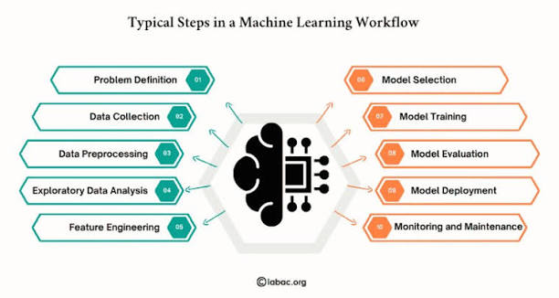
5.3 Process Flow
The project follows a simple process where customer data is collected, cleaned, and analysed. After preprocessing and feature selection, the data is used to train the Random Forest model. The trained model is then evaluated and integrated into the Streamlit application for customer churn prediction.
5.4 Algorithm / Logic Summary
The main algorithm used in this project is Random Forest. The model learns from historical customer data and predicts whether a customer is likely to Churn or Not Churn.
The basic logic is:
Input Customer Data → Data Preprocessing → Random Forest Model → Churn Prediction → Result Display
This methodology provides a simple and systematic approach for predicting customer churn and supporting customer retention strategies.

Chapter 6: Data Visualization and Results

Data visualization was performed to understand customer behaviour and identify patterns related to customer churn. Different graphs and charts were created using Matplotlib and Seaborn.

6.1 Customer Churn Distribution
Customer churn distribution shows the number of customers who churned and those who continued using the service. This analysis helps in understanding the overall churn rate in the dataset.

6.2 Churn Analysis by Subscription Plan
This analysis compares customer churn across different subscription plans. It helps identify whether customers using a particular plan are more likely to leave the service.

6.3 Churn Analysis by Customer Complaints
Customer complaints were analysed to understand their relationship with churn. Customers who raise complaints may have a higher possibility of leaving the service due to dissatisfaction or service-related issues.

6.4 Monthly Charges and Churn Analysis
Monthly charges were compared with customer churn status. This analysis helps determine whether higher subscription charges have an impact on customers deciding to leave the platform.

6.5 Customer Usage and Churn Analysis
Customer usage, such as watch time and login frequency, was analysed to identify its relationship with churn. Customers with lower engagement or reduced usage may have a higher chance of leaving the service.
Overall, these visualizations help identify important factors affecting customer churn and provide useful insights for improving customer retention.

Chapter 7: Business Insights and Recommendations

This chapter presents the important insights obtained from customer churn analysis. These insights help identify customers who are likely to leave the service and support businesses in developing effective customer retention strategies.

7.1 Key Findings from Customer Churn Analysis
The analysis shows that customer churn is influenced by several factors related to customer behaviour, satisfaction, service usage, complaints, and subscription details. Customers with low platform usage, frequent complaints, payment-related issues, or low satisfaction may have a higher possibility of churn.
These findings can help businesses understand customer behaviour and take appropriate actions to improve retention.

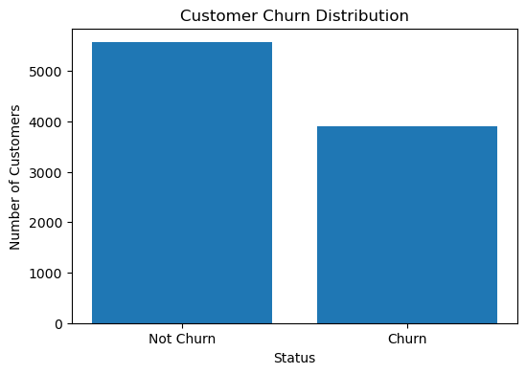

7.2 Identification of High-Risk Customers
High-risk customers are those who have a greater possibility of leaving the service. Such customers can be identified using the trained Machine Learning model based on their behaviour and other relevant features.
Customers with low watch time, reduced login frequency, complaints, payment failures, or inactive subscriptions may be considered high-risk customers. Identifying these customers early allows the company to take preventive action.

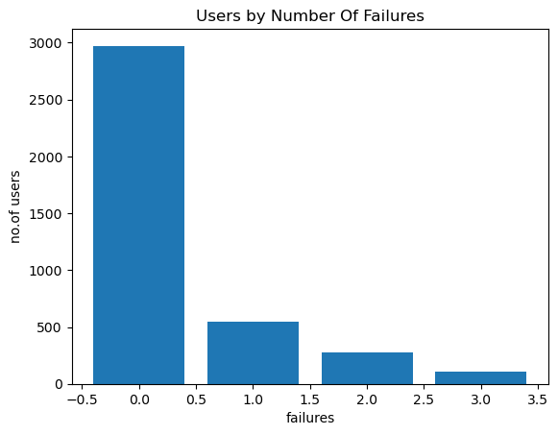

7.3 Major Factors Affecting Customer Churn
Several factors can affect customer churn. Important factors include:
- Customer complaints and dissatisfaction.
- Low watch time and login frequency.
- Payment failures or subscription issues.
- High monthly charges.
- Subscription plan and service value.
- Poor customer experience.
By analysing these factors, businesses can understand the main reasons behind customer churn and improve their services accordingly
.

7.4 Impact of Subscription Plans on Churn
Subscription plans can influence customer retention and churn behaviour. Customers may leave the platform if they feel that the subscription price is high or if the plan does not provide sufficient value.
Churn analysis based on different subscription plans helps identify plans with higher customer loss. Based on these insights, businesses can introduce better pricing, discounts, personalised offers, or improved plan benefits to increase customer satisfaction and reduce churn.

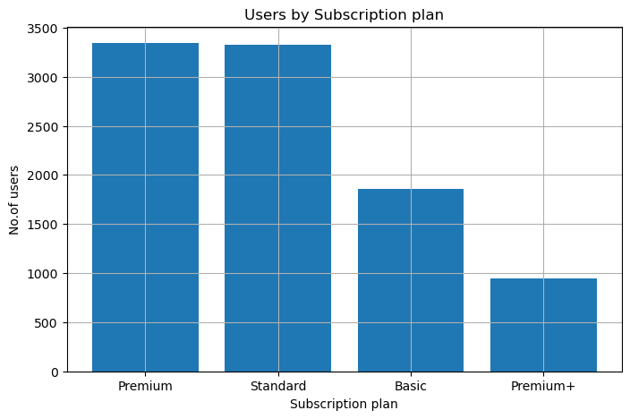

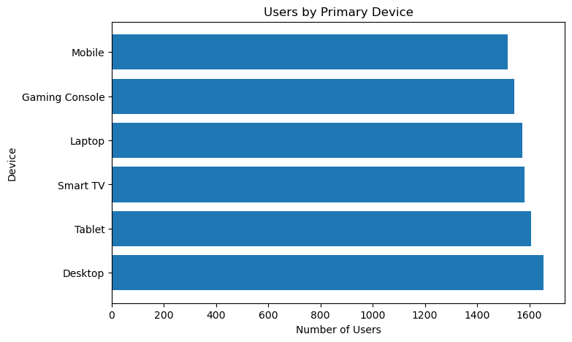

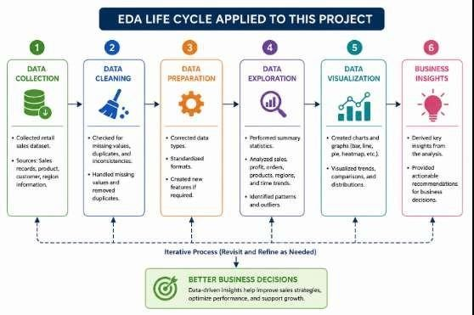

Chapter 8: Conclusion and Future Scope
8.1 Conclusion
The Customer Churn Prediction System was developed to analyse customer behaviour and predict whether a customer is likely to leave the service. The project involved data cleaning, preprocessing, exploratory data analysis, feature selection, and Machine Learning model development.
The Random Forest algorithm was used to predict customer churn based on factors such as subscription plans, monthly charges, customer usage, complaints, payment-related information, and other customer behaviour.
The project demonstrates how Machine Learning and data analysis can help businesses identify high-risk customers and take preventive actions. The Streamlit web application makes the prediction system simple and interactive for users.
Overall, the system can support better customer retention strategies, improve customer satisfaction, and reduce potential revenue loss.

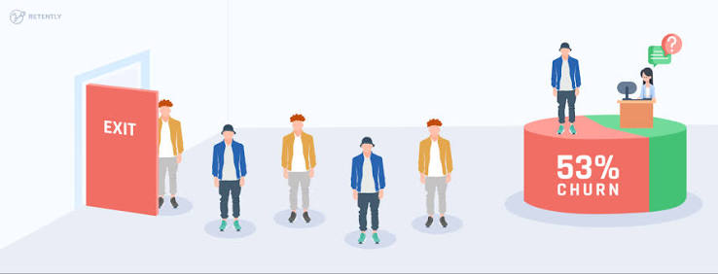
8.2 Future Scope
The project can be further improved in the following ways:
- Use a larger and real-time customer dataset.
- Compare multiple Machine Learning algorithms to improve prediction performance.
- Integrate the system with a live database.
- Add real-time churn monitoring and customer alerts.
- Provide personalised recommendations and retention offers for high-risk customers.
- Develop an AI chatbot to explain possible reasons for churn and suggest solutions.
- Deploy the application on a cloud platform for wider accessibility.
Thus, the future development of this system can make it more accurate, intelligent, and useful for real-world customer retention and business decision-making.



CHAPTER 9 : REFERENCES

9.1 Documentation and Official Sources

    - pandas Development Team — pandas Documentation, https://pandas.pydata.org/docs/
    - NumPy Developers — NumPy Documentation, https://numpy.org/doc/
    - Matplotlib Development Team — Matplotlib Documentation, https://matplotlib.org/stable/
    - Michael Waskom — seaborn: Statistical Data Visualization Documentation, https://seaborn.pydata.org/

9.2 Learning Platforms

    - GeeksforGeeks — Python and pandas tutorials for data cleaning and aggregation techniques.
    - W3Schools — Python syntax and pandas basics reference.
    - Kaggle Learn — Introductory courses on pandas and data visualization.
    - Stack Overflow — Community discussion used for debugging pandas grouping and plotting issues.

9.3 Conceptual References

    - Tukey, J. W. — Exploratory Data Analysis, Addison-Wesley (foundational text on the EDA approach).
    - Wickham, H. & Grolemund, G. — R for Data Science (referenced for general data-science workflow concepts, though implemented here in Python).

9.4 Tools and Platforms Used

    - Python 3 (Python Software Foundation)
    - Visual Studio Code (Microsoft)
    - Jupyter Notebook (Project Jupyter)
    - Git (version control)

DATA IMPORT AND DATA CLEANING

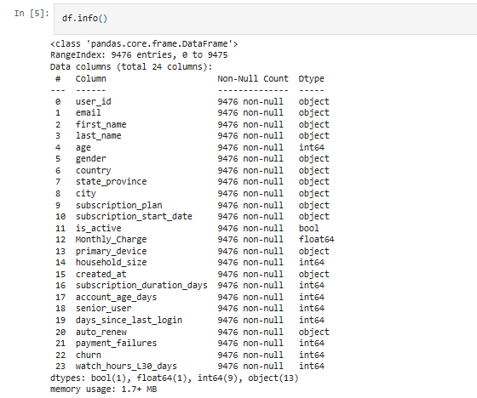
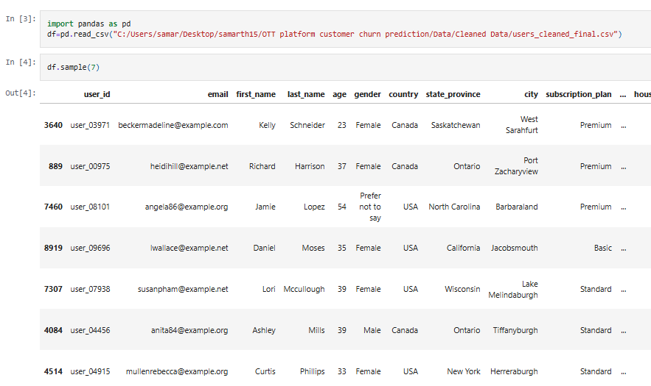

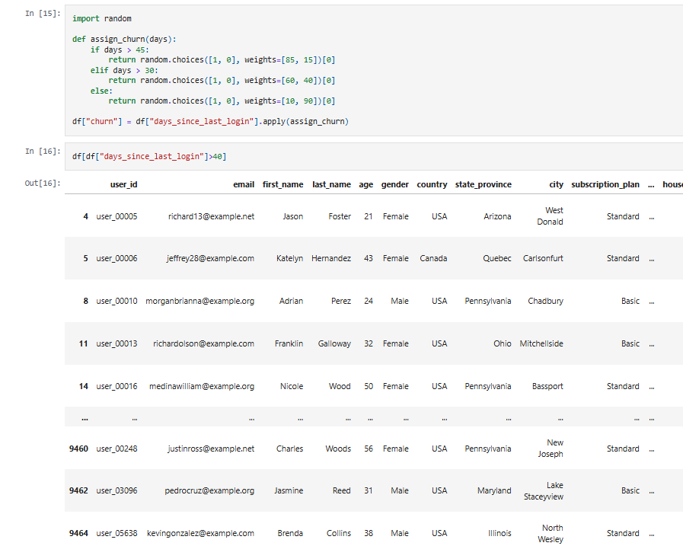

EXPLORATORY DATA ANALYSIS
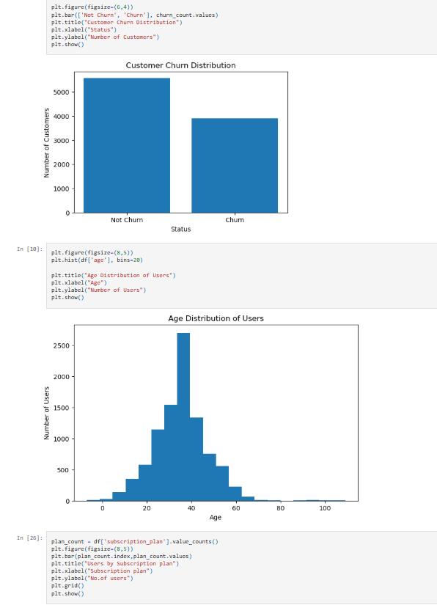

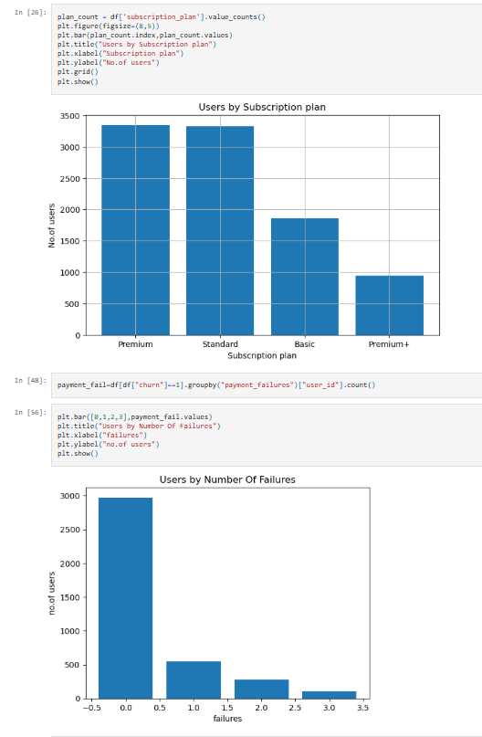

STREAMLIT APP UI

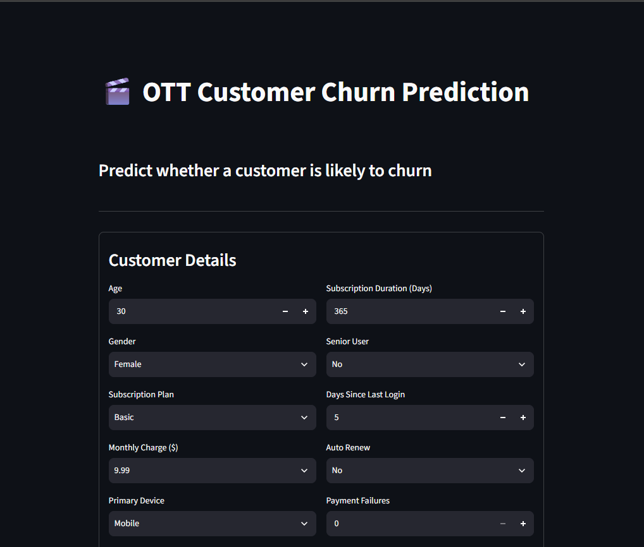

APP CODE

import streamlit as st
import pandas as pd
import joblib
import os
from dotenv import load_dotenv
from google import genai

# Load environment variables
load_dotenv()

# ----------------------------
# Page Config
# ----------------------------
st.set_page_config(
page_title="OTT Customer Churn Prediction",
page_icon="🎬",
layout="centered"
)

# ----------------------------
# Load Model & Files
# ----------------------------
@st.cache_resource
def load_assets():
base = os.path.dirname(os.path.abspath(__file__))
model = joblib.load(os.path.join(base, "models", "cust_churn_model.pkl"))
label_encoders = joblib.load(os.path.join(base, "models", "encoder.pkl"))
features = joblib.load(os.path.join(base, "models", "features.pkl"))
return model, label_encoders, features

model, label_encoders, features = load_assets()

# ----------------------------
# Mappings
# ----------------------------
GENDER_MAP = {"Female": 0, "Male": 1, "Other": 2, "Prefer not to say": 3}
PLAN_MAP = {"Basic": 0, "Premium": 1, "Premium+": 2, "Standard": 3}
DEVICE_MAP = {"Mobile": 3, "Smart TV": 4, "Laptop": 2, "Tablet": 5, "Desktop": 0, "Gaming Console": 1}
AUTO_RENEW_MAP = {"No": 0, "Yes": 1}

# ----------------------------
# UI
# ----------------------------
st.title("🎬 OTT Customer Churn Prediction")
st.markdown("### Predict whether a customer is likely to churn")
st.divider()

with st.form("churn_form"):
st.subheader("Customer Details")
col1, col2 = st.columns(2)

with col1:
age = st.number_input("Age", min_value=18, max_value=100, value=30)
gender_sel = st.selectbox("Gender", list(GENDER_MAP.keys()))
plan_sel = st.selectbox("Subscription Plan", list(PLAN_MAP.keys()))
monthly_charge = st.selectbox("Monthly Charge ($)", [9.99, 15.99, 21.99, 29.99])
device_sel = st.selectbox("Primary Device", list(DEVICE_MAP.keys()))
household_size = st.number_input("Household Size", min_value=1, max_value=10, value=3)

with col2:
subscription_duration_days = st.number_input("Subscription Duration (Days)", min_value=1, value=365)
senior_user_sel = st.selectbox("Senior User", ["No", "Yes"])
days_since_last_login = st.number_input("Days Since Last Login", min_value=0, value=5)
auto_renew_sel = st.selectbox("Auto Renew", list(AUTO_RENEW_MAP.keys()))
payment_failures = st.number_input("Payment Failures", min_value=0, value=0)
watch_hours = st.number_input("Watch Hours (Last 30 Days)", min_value=0.0, value=50.0)

submitted = st.form_submit_button("🔍 Predict Churn", use_container_width=True)

# ----------------------------
# Prediction
# ----------------------------
if submitted:
input_df = pd.DataFrame([{
"age": age,
"gender": GENDER_MAP[gender_sel],
"subscription_plan": PLAN_MAP[plan_sel],
"Monthly_Charge": monthly_charge,
"primary_device": DEVICE_MAP[device_sel],
"household_size": household_size,
"subscription_duration_days": subscription_duration_days,
"senior_user": 1 if senior_user_sel == "Yes" else 0,
"days_since_last_login": days_since_last_login,
"auto_renew": AUTO_RENEW_MAP[auto_renew_sel],
"payment_failures": payment_failures,
"watch_hours_L30_days": watch_hours,
}])

input_df = input_df[features]
prediction = model.predict(input_df)[0]
probability = model.predict_proba(input_df)[0]

st.divider()

if prediction == 1:
st.error("⚠️ Customer is likely to **Churn**")
else:
st.success("✅ Customer is likely to **Stay**")

st.subheader("Prediction Probability")
st.progress(float(probability[1]))

c1, c2 = st.columns(2)
c1.metric("Stay Probability", f"{probability[0]*100:.2f}%")
c2.metric("Churn Probability", f"{probability[1]*100:.2f}%")

# ----------------------------
# Gemini AI Insights
# ----------------------------
st.divider()
st.subheader("💡 AI Retention Insights (Gemini 3.6 Flash)")

with st.spinner("Analysing customer profile..."):
try:
api_key = os.getenv("GEMINI_API_KEY")
if not api_key:
st.warning("⚠️ GEMINI_API_KEY not found in .env — AI insights skipped.")
else:
client = genai.Client(api_key=api_key)
prompt = f"""
You are an expert customer retention analyst for an OTT platform.
Analyse the following customer data and predicted churn status:

- Churn Probability : {probability[1]*100:.1f}%
- Prediction : {"Likely to Churn" if prediction == 1 else "Likely to Stay"}
- Subscription Plan : {plan_sel} (${monthly_charge}/mo)
- Days Since Last Login : {days_since_last_login} days
- Watch Hours (30 days) : {watch_hours} hrs
- Payment Failures : {payment_failures}
- Auto Renew : {auto_renew_sel}
- Subscription Duration : {subscription_duration_days} days
- Primary Device : {device_sel}

Respond with clear bullet points:
1. **Primary Reasons** – Why is this customer at risk (or stable)?
2. **Actionable Recommendations** – 2-3 concrete strategies to retain this customer.
"""
response = client.models.generate_content(
model="gemini-3.6-flash",
contents=prompt,
)
st.info(response.text)

except Exception as e:
st.error(f"❌ Could not generate AI insights: {e}")

MACHINE LEARNING CODE

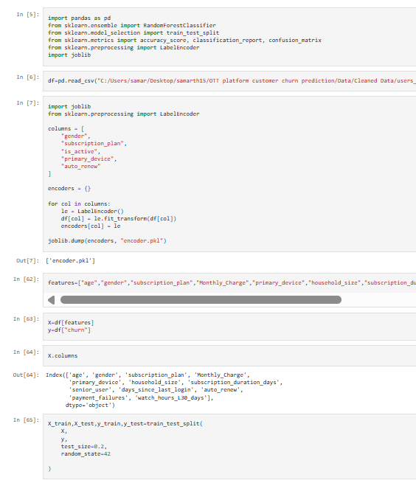

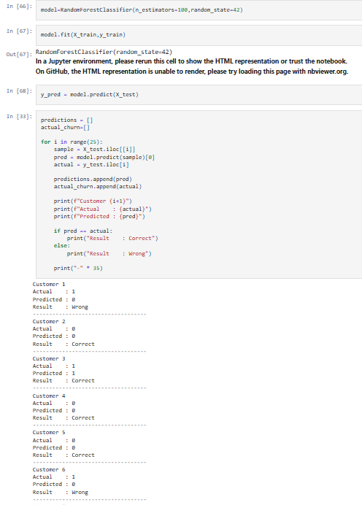

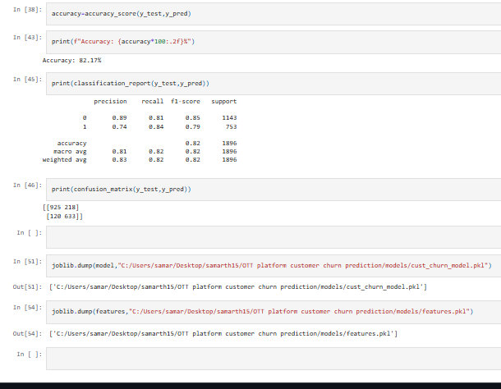

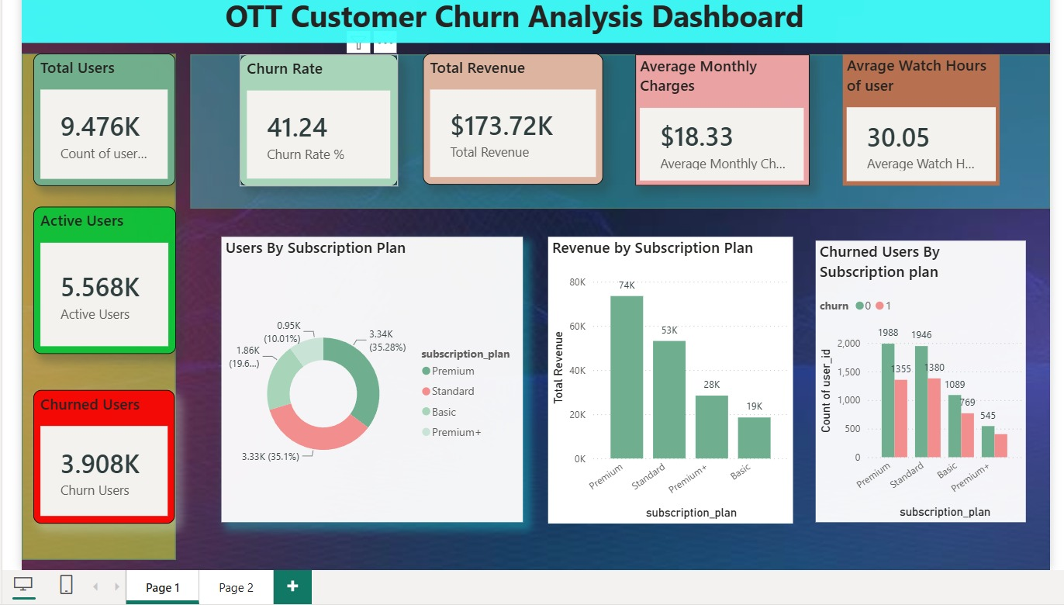
POWERBI DASHBOARD

