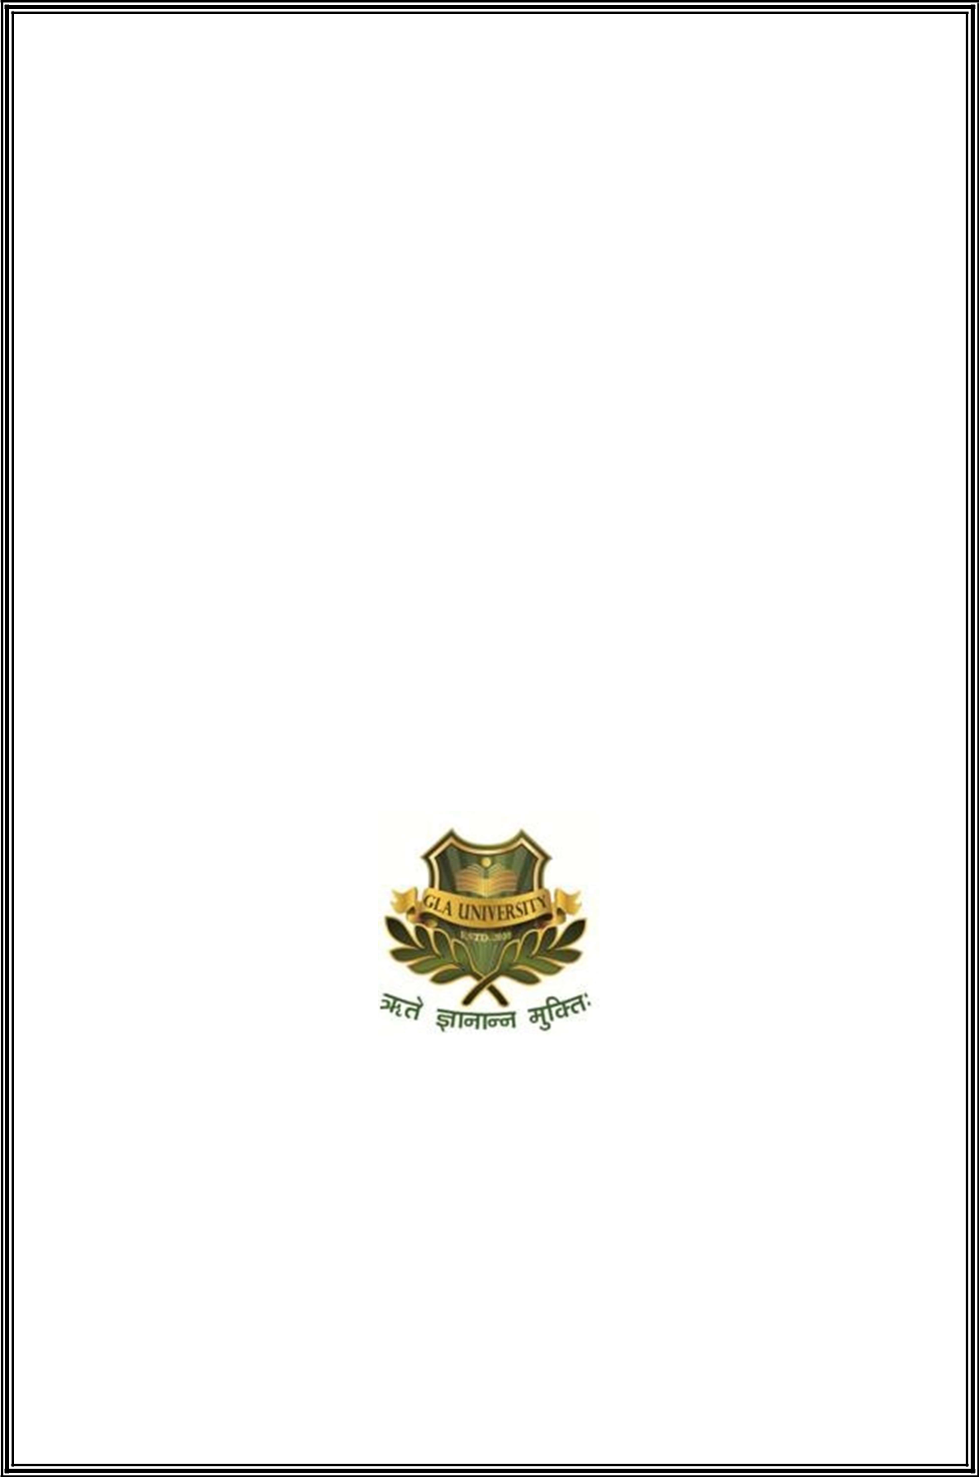
IMAGE TEXT

EXTRACTOR

PROJECT SYNOPSIS OF PROJECT-II

BACHELOR OF TECHNOLOGY Computer
Science & Engineering

SUBMITTED BY

Samarth Kulshrestha (181500610)
Aman Jadon (181500071)
Aman Gulwani (181500069)
Abhishek Sharma (181500026)
Abhishek Bhardwaj (181500014)

SUPERVISOR

Mrs. Harvinder kaur

DEPARTMENT OF COMPUTER ENGINEERING AND

APPLICATIONS, GLA UNIVERSITY, MATHURA

Abstract

Image text recognition has been one of the active and challenging research areas in the field of image processing and pattern recognition. It has numerous applications which include, reading aid for blind, bank cheques and conversion of any written document into structural text form. In this paper an attempt is made to recognize text for English alphabets without feature extraction using multilayer Feed Forward neural network. Each character data set contains 26 alphabets. Fifty different character data sets are used for training the neural network. The trained network is used for classification and recognition. In the proposed system, each character is resized into 30×20 pixels, which is directly subjected to training. That is, each resized character has 600 pixels and these pixels are taken as features for training the neural network. The results show that the proposed system yields good recognition rates which are comparable to that of feature extraction based schemes for Text character recognition.

Motivation

Before computers existed all the information was stored in written form, this is very inefficient form of storage as the paper information cannot be stored for very long time and can get lost or be destroyed

On the contrary information on computer is stored safely for long time and multiple copies of same information can be made easily.

Thus after inventing the computers lot of money was wasted in manual labor for converting this paper information into digital information.

Instead machine learning can be used to identify and convert this paper information into digital information without human intervention or manual labor.

My project is just an introduction to this approach.

Objective

On the basis of character recognition algorithms, one question to be answered is: which algorithm is the best choice for a given application? This question leads the thesis to characterize the available algorithms so that the most efficient methods can be sorted out for different applications. An experimental approach needs to be developed to compare and evaluate the performance of different invariants of shape-based script. An image with 1280×800 pixels will certainly take much longer time to compute than a 32×32 image. The investigations of the reconstruction of the region-based multi-script image are a major motivation for the work. Using neural networks, recognition of handwritten multi script is a good idea. However, in the practical image acquisition systems and conditions, shape distortion is common processes in HMSR system because of different people handwriting have different shape of characters. The observed character image is being representing only a degraded version of the original character image. Recognition of Multi script that are of various shapes is a goal of recent research. Gurumukhi characters using neural networks having Back
propagation algorithms are recognized.

Methodology

We have divided this project in three modules are as follows:

Planning : On this modules we will be taking all the points and ideas for making and designing the project in a better way. What Implementations and functionality are to be done.

Plotting : In this module we will be plotting all the ideas and implementations and also training the back-end of this project for accurate and efficient output.

User Interface : In this, we will be focusing on the user interface for presentation of the input and output data to the user.

Facilities required for proposed work

 |  | Software requirements
• | Processor | : intel i5
• | Operating System | : Windows 10
• | RAM | :8GB
• | Hardware Devices | : Computer System
• | Hard disk | : 256 GB

Hardware requirements

• | Technology Implemented | : Python and Machine Learning
• | Language Used | : | Python
• | IDE Used | : | VSCode, Anaconda

Bibliography

- https://www.javatpoint.com/python-tutorial

- https://www.w3schools.com/python/

- https://pypi.org/

- https://www.python.org/

