
Mutual Fund Analytics

Capstone Project Report

Submitted By
Samarth Magadum

Internship
Bluestock Fintech

Submitted To
Bluestock Fintech

Year
2026
CERTIFICATE

This is to certify that the project titled "Mutual Fund Analytics" has been successfully completed by Samarth Magadum as part of the Bluestock Fintech Data Analytics Internship Program.
This project was carried out under the guidance of Bluestock Fintech during the internship period. The project focuses on analysing mutual fund datasets using modern data analytics techniques and business intelligence tools. It includes data cleaning, database design, exploratory data analysis (EDA), financial performance analysis, advanced risk analytics, and the development of interactive dashboards using Power BI.
The work presented in this report is the original work carried out by the student and has not been submitted previously for any other academic or professional certification. Throughout the internship, the student demonstrated dedication, analytical thinking, and practical implementation skills while working on real-world mutual fund data.
The project successfully integrates Python, SQL, SQLite, Power BI, Git, and GitHub to build a complete end-to-end data analytics solution capable of providing meaningful business insights for investors and financial analysts.
We appreciate the sincere efforts and commitment shown during the successful completion of this capstone project and wish the student continued success in future academic and professional endeavours.

ACKNOWLEDGEMENT

I would like to express my sincere gratitude to Bluestock Fintech for providing me with the opportunity to work on the Mutual Fund Analytics Capstone Project as part of the Data Analytics Internship Program. This internship has been an excellent learning experience that allowed me to apply theoretical knowledge to practical business problems using real-world datasets.
I am thankful to the mentors, trainers, and the entire Bluestock team for their continuous guidance, encouragement, and valuable suggestions throughout the internship. Their support helped me understand the complete workflow of a data analytics project, from data collection and preprocessing to visualization and business intelligence reporting.
During this project, I gained practical exposure to Python programming, SQL database design, data cleaning techniques, exploratory data analysis, financial performance analytics, risk measurement, Power BI dashboard development, Git version control, and GitHub project management. Each stage of the project enhanced my technical knowledge and strengthened my problem-solving skills.
I would also like to thank my family, friends, and well-wishers for their constant motivation and encouragement throughout the internship period. Their support helped me remain focused and complete the project successfully.
Finally, I am grateful to everyone who contributed directly or indirectly toward the successful completion of this capstone project. The knowledge and experience gained during this internship will be valuable for my future career in Data Analytics and Business Intelligence.
Samarth Magadum
Date: __________________
EXECUTIVE SUMMARY

The Mutual Fund Analytics project was developed to analyse mutual fund data and generate meaningful insights that help investors make better investment decisions. The project uses Python, SQL, SQLite, and Power BI to process, analyse, and visualize financial data.
The project began with collecting multiple mutual fund datasets containing information about fund details, daily NAV, Assets Under Management (AUM), SIP inflows, investor transactions, benchmark indices, and portfolio holdings. These datasets were cleaned and validated using Python before being stored in a SQLite database.
Exploratory Data Analysis (EDA) was performed to identify investment trends, investor behaviour, and fund performance. Advanced financial metrics such as CAGR, Sharpe Ratio, Sortino Ratio, Alpha, Beta, Maximum Drawdown, Value at Risk (VaR), and Conditional Value at Risk (CVaR) were calculated to evaluate the return and risk of different mutual fund schemes.
Finally, an interactive Power BI dashboard was developed to present business insights through KPI cards, charts, filters, and drill-through pages. The project demonstrates how data analytics and business intelligence techniques can simplify financial analysis and support informed investment decisions.

TABLE OF CONTENTS

Chapter |  |  |  |  | Page No.
Certificate |  |  |  |  | 2
Acknowledgement |  |  |  |  | 3
Executive Summary |  |  |  |  | 4
Table of Contents |  |  |  |  | 5
Data |  |  |  |  | 6
ETL Process |  |  |  |  | 7,8
Exploratory Data Analysis (EDA) |  |  |  |  | 9,10
Performance Analysis |  |  |  |  | 11
Advanced Analytics |  |  |  |  | 12
Power BI Dashboard – Industry Overview |  |  |  |  | 13
Power BI Dashboard – Fund Performance |  |  |  |  | 14
Power BI Dashboard – Investor Analytics |  |  |  |  | 15
Power BI Dashboard – SIP & Market Trends |  |  |  |  | 16
Results & Business Insights |  |  |  |  | 17
Recommendations |  |  |  |  | 18
Limitations |  |  |  |  | 18
Conclusion |  |  |  |  | 19
Future Scope |  |  |  |  | 19
References |  |  |  |  | 20

DATA

The project uses multiple datasets related to the Indian mutual fund industry. These datasets were collected in CSV format and contain information about mutual fund schemes, NAV history, Assets Under Management (AUM), monthly SIP inflows, investor transactions, benchmark indices, and portfolio holdings.
The datasets were first examined to understand their structure and quality. Missing values, duplicate records, incorrect data types, and inconsistent formats were identified before performing any analysis. Each dataset serves a specific purpose in the project and contributes to different stages of financial analysis.
Datasets Used
Dataset |  |  |  |  |  |  | Description
Fund Master |  |  |  |  |  |  | Fund details and category
NAV History |  |  |  |  |  |  | Daily NAV values
AUM |  |  |  |  |  |  | Assets Under Management
SIP |  |  |  |  |  |  | Monthly SIP inflows
Category |  |  |  |  |  |  | Category-wise inflows
Folio |  |  |  |  |  |  | Industry folio count
Transactions |  |  |  |  |  |  | Investor investment details
Performance |  |  |  |  |  |  | Performance metrics
Portfolio |  |  |  |  |  |  | Portfolio holdings
Benchmark |  |  |  |  |  |  | Nifty 50 and Nifty 100 data
ETL PROCESS

ETL (Extract, Transform, Load)
The ETL process was used to prepare the data for analysis.
Extract
The mutual fund datasets were collected in CSV format from project resources and imported into Python using the Pandas library.
Transform
The datasets were cleaned by removing duplicate records, handling missing values, correcting incorrect data types, and converting date columns into datetime format. Numerical columns such as NAV, AUM, and transaction amounts were validated to ensure accuracy.
Load
After preprocessing, the cleaned datasets were stored in a SQLite database using SQLAlchemy. The database was then connected to Power BI for dashboard development.
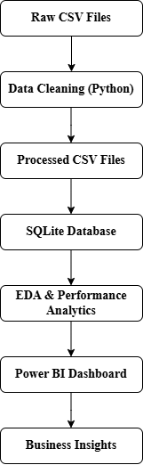
Figure – Project Architecture Diagram
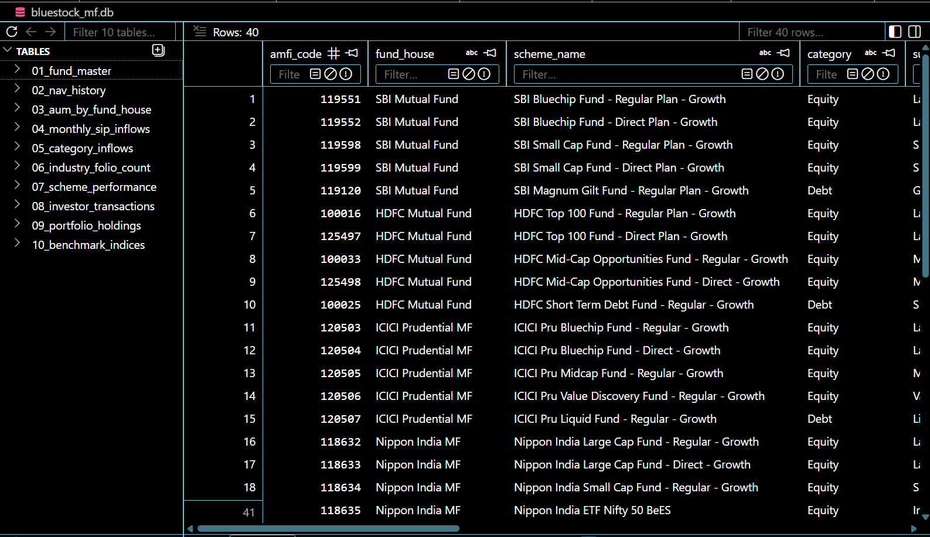
Figure: SQLite Database Showing the Mutual Fund Tables and Sample Records

EXPLORATORY DATA ANALYSIS (EDA)

Exploratory Data Analysis (EDA)
EDA was performed to understand the characteristics of the datasets and identify meaningful trends. Various charts were created using Matplotlib, Seaborn, and Plotly.
The analysis included daily NAV trends, AUM growth, SIP inflows, category-wise investments, investor demographics, and sector allocation.

Key Findings
- Mutual fund NAV showed steady growth over the analysis period.
- AUM increased consistently across major fund houses.
- SIP inflows increased every year.
- Equity funds attracted higher investments than debt funds.
- Category-wise inflows varied across different months.

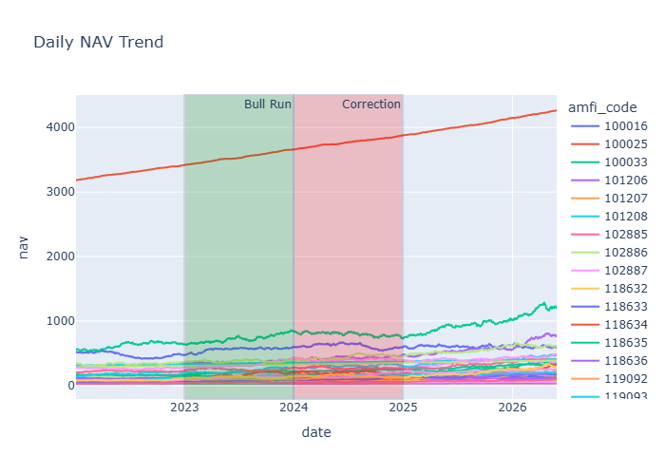
Figure – NAV Trend

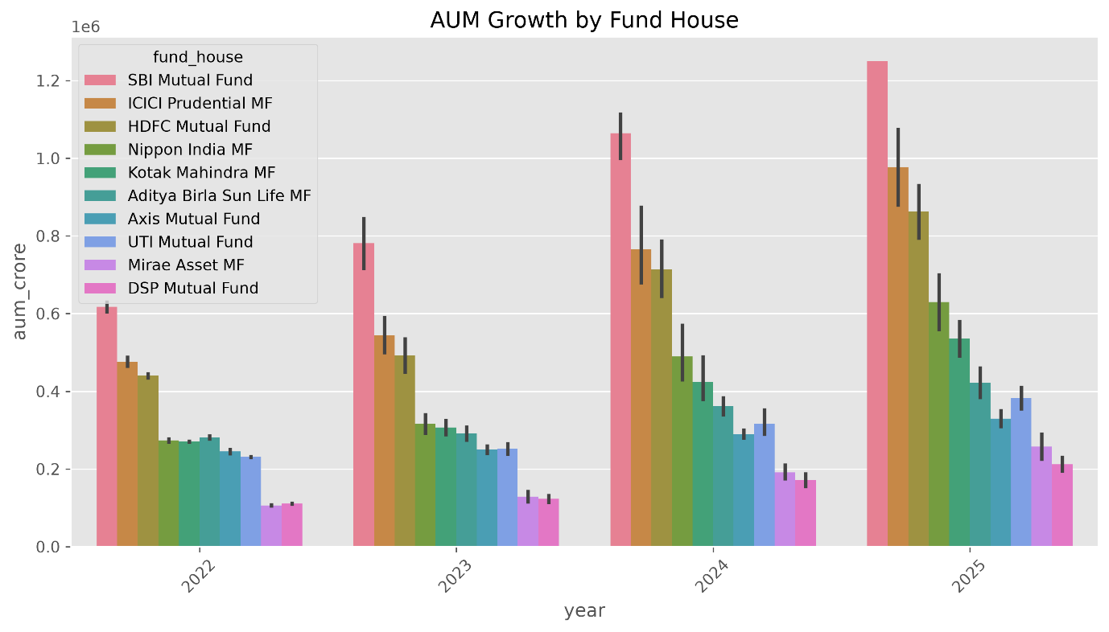
Figure – AUM Growth

Figure: Monthly SIP Inflow Trend
PERFORMANCE ANALYSIS

Performance Analysis
Financial performance metrics were calculated to evaluate mutual fund returns and investment risk.
The project calculated:
- Daily Returns
- CAGR (1 Year, 3 Year, 5 Year)
- Sharpe Ratio
- Sortino Ratio
- Alpha
- Beta
- Maximum Drawdown
- Fund Scorecard
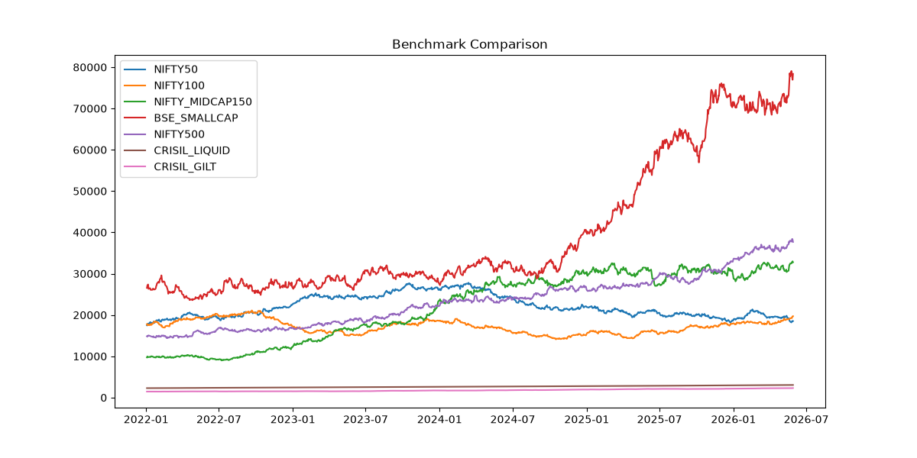
These metrics helped compare mutual fund schemes based on return, consistency, and market risk.

Figure – Benchmark Comparison Chart
ADVANCED ANALYTICS

Advanced Analytics
Advanced analytics were performed to understand investment risk and investor behavior.
The project calculated:
- Historical Value at Risk (VaR)
- Conditional Value at Risk (CVaR)
- Rolling 90-Day Sharpe Ratio
- Investor Cohort Analysis
- SIP Continuity Analysis
- Sector HHI
- Fund Recommendation System
These analyses provide additional insights beyond traditional performance measures.

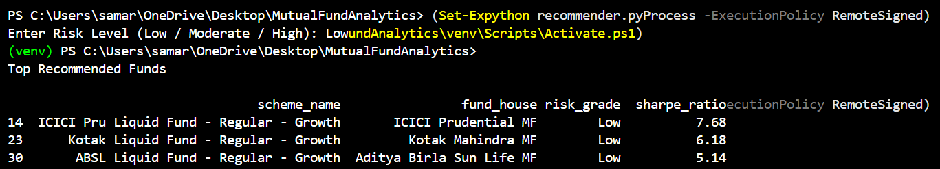
Figure: Mutual Fund Recommendation System Output

POWER BI DASHBOARD (Industry Overview)

Dashboard – Industry Overview
The first dashboard page provides a summary of the mutual fund industry using KPI cards and charts.
It includes:
- Total AUM
- Total SIP Inflows
- Total Folios
- Total Schemes
- Industry AUM Trend
- AUM by Fund House
The dashboard allows users to quickly understand the overall growth of the mutual fund industry.
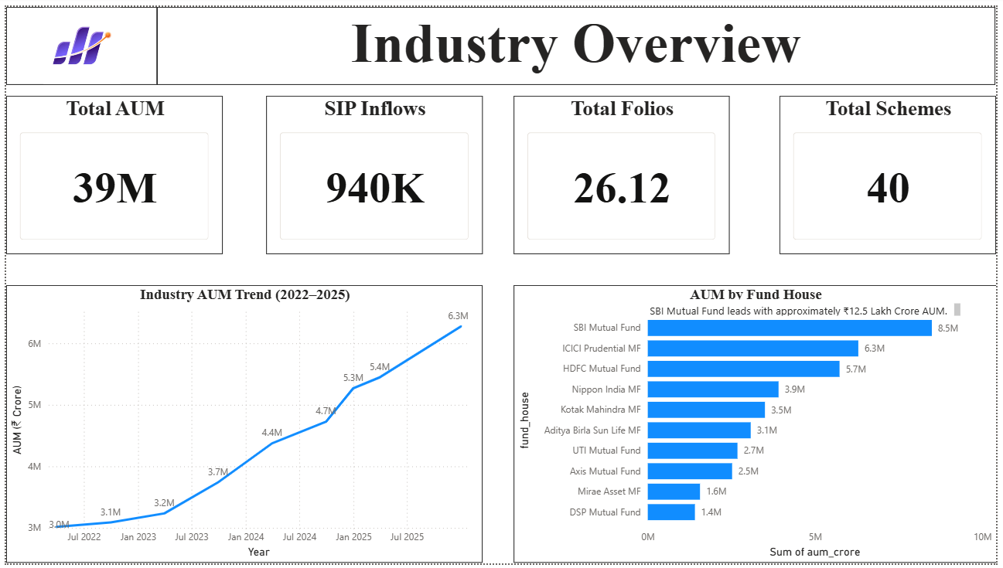
POWER BI DASHBOARD (Fund Performance)

Dashboard – Fund Performance
This dashboard focuses on comparing mutual fund schemes.
It contains:
- Risk vs Return Scatter Plot
- Benchmark Comparison
- Fund Scorecard
- NAV Trend
- Fund Filters
- Category Filters
Users can compare multiple funds using interactive filters.
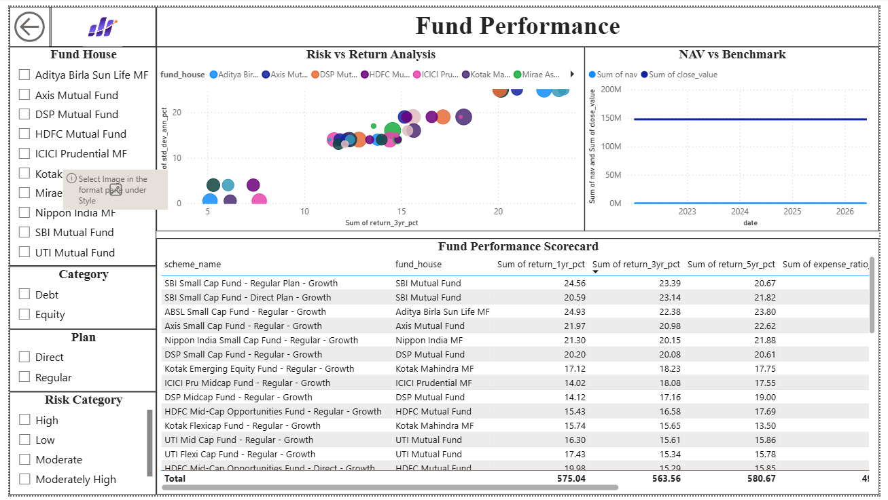
POWER BI DASHBOARD (Investor Analytics)

Dashboard – Investor Analytics
This page analyzes investor behavior.
The dashboard includes:
- State-wise Investments
- Transaction Type Distribution
- Age Group Analysis
- Monthly Transaction Volume
Interactive slicers allow users to filter data by state, city tier, and age group.
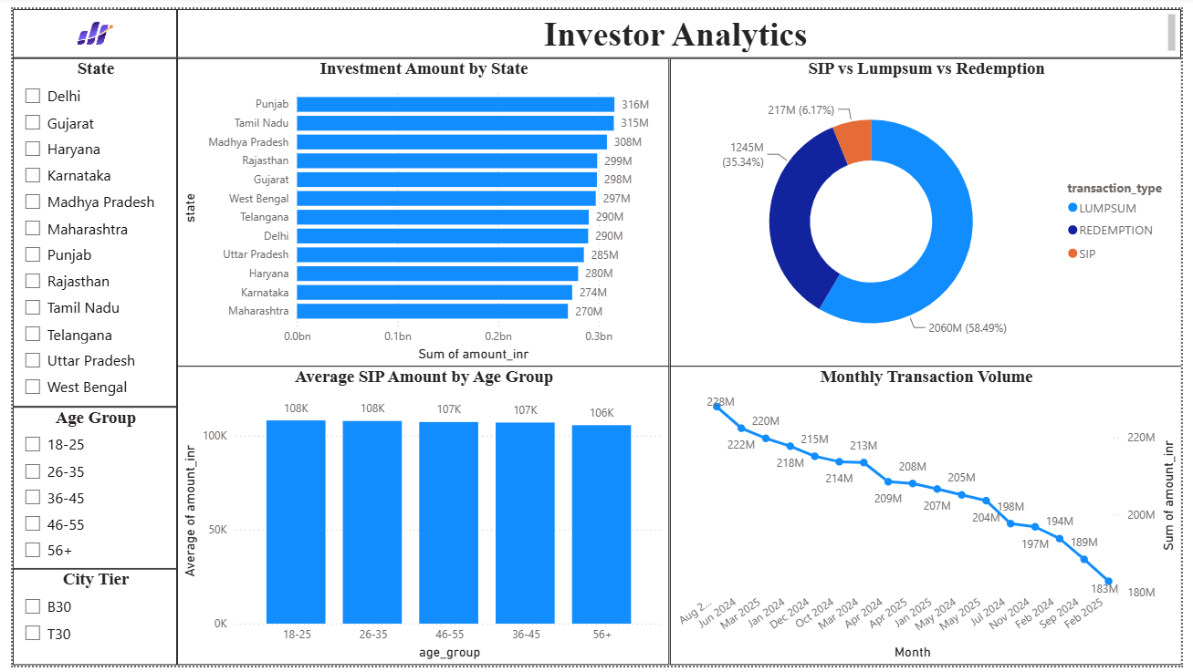

POWER BI DASHBOARD (SIP & Market Trends)

Dashboard – SIP & Market Trends
The fourth dashboard page analyzes SIP growth and market performance.
The dashboard contains:
- SIP Inflow Trend
- Nifty 50 Trend
- Category Inflow Heatmap
- Top Categories by Net Inflow
This page helps users understand investment patterns and market movements.

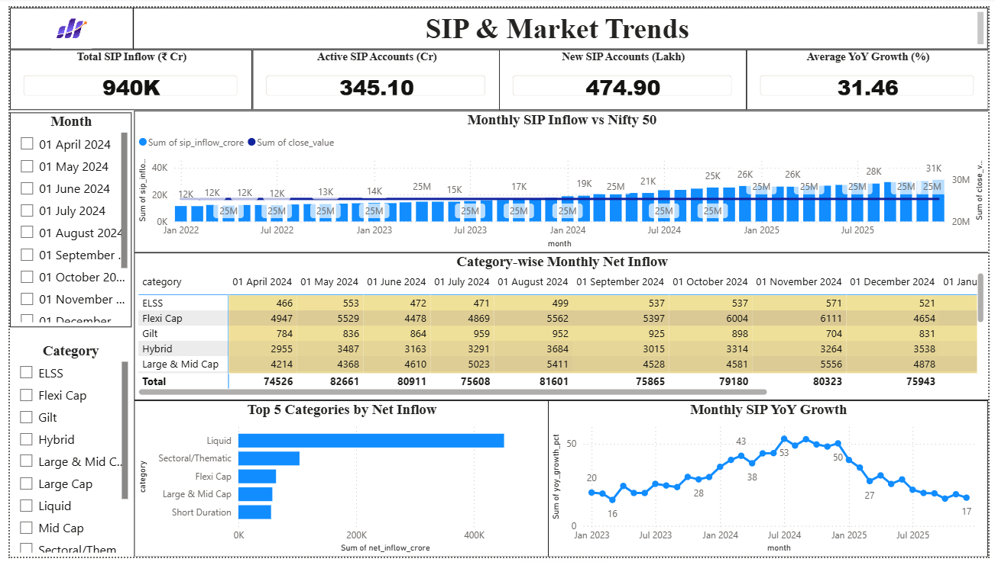

RESULTS & BUSINESS INSIGHTS

Business Insights
The analysis generated several useful business insights:
- Mutual fund AUM has grown consistently over the years.
- Monthly SIP inflows show increasing investor participation.
- Equity funds generated better long-term returns than debt funds.
- Some funds achieved high returns with lower risk.
- Large-cap funds showed more stable performance.
- Benchmark comparison identified funds outperforming the market.
- The recommendation system successfully ranked funds based on risk profile.
- Power BI dashboards simplified financial analysis through interactive visualization.

RECOMMENDATIONS

Based on the project findings, the following recommendations are suggested:
- Investors should compare funds using both returns and risk metrics.
- SIP investments should be continued for long-term wealth creation.
- Portfolio diversification should be considered to reduce investment risk.
- Fund performance should be reviewed periodically.
- Financial dashboards can support faster and better decision-making.

LIMITATIONS

The project has a few limitations:
- Analysis is based on historical data.
- Real-time market data is not included.
- Future market performance cannot be predicted.
- Recommendation system uses rule-based logic.
- Dataset contains selected mutual fund schemes only.
Despite these limitations, the project successfully demonstrates financial analytics using Python and Power BI.

Conclusion

The Mutual Fund Analytics project successfully analysed mutual fund data using Python, SQL, SQLite, and Power BI. Data cleaning, exploratory analysis, financial performance evaluation, and dashboard development were completed successfully.
The project generated valuable business insights through advanced financial metrics and interactive dashboards. It also demonstrated the practical use of data analytics techniques in solving real-world financial problems.
Overall, the project achieved all its objectives and provides a useful platform for investors to understand mutual fund performance and make informed investment decisions.
Future Scope
The project can be improved by adding:
- Real-time NAV data using APIs
- Machine Learning-based fund prediction
- AI-powered recommendation system
- Cloud database integration
- Mobile dashboard application
- Portfolio optimization techniques
- Live dashboard refresh
These improvements will make the system more intelligent and useful for investors.
References
- Python Documentation – https://docs.python.org/
- Pandas Documentation – https://pandas.pydata.org/
- NumPy Documentation – https://numpy.org/
- Matplotlib Documentation – https://matplotlib.org/
- Seaborn Documentation – https://seaborn.pydata.org/
- Plotly Documentation – https://plotly.com/python/
- SQLite Documentation – https://www.sqlite.org/
- Microsoft Power BI Documentation – https://learn.microsoft.com/power-bi/
- SQLAlchemy Documentation – https://docs.sqlalchemy.org/
- Bluestock Fintech Internship Project Resources.

