LatticeSense IQ-40 Environmental Sensor
Continuous indoor air-quality monitoring for commercial buildings, laboratories, and light industry.

Overview
The IQ-40 is Kestrel's fourth-generation ambient sensor node. It samples particulate matter, CO2, VOC, temperature, and relative humidity on a single board and streams calibrated readings over LoRaWAN every 30 seconds. A ten-year field-replaceable battery and tool-free mounting bring installed cost below half that of wired alternatives.
Each unit ships factory-calibrated against NIST-traceable references and re-calibrates optically in the field using Kestrel's drift-model firmware, holding PM2.5 accuracy within ±8% for the service life without bench recalibration.

Signal Path
Sensing, aggregation, and uplink are handled on-device; no local gateway software is required beyond a standard LoRaWAN network server.
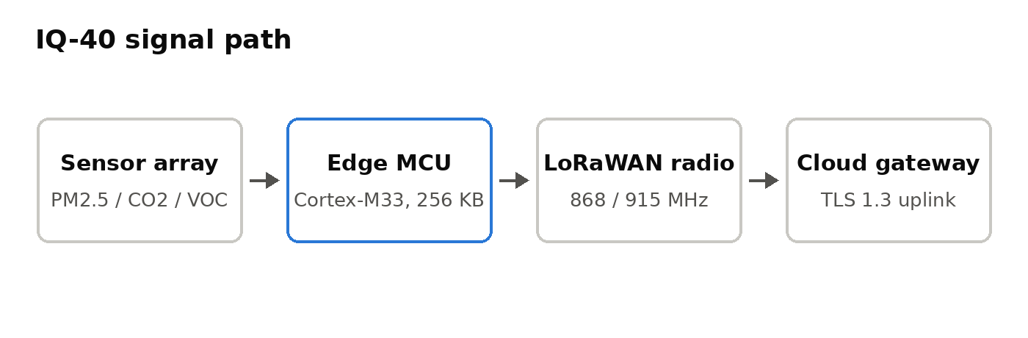
Figure 1 — IQ-40 acquisition and uplink chain.

Key Capabilities
- Five-parameter sensing (PM2.5, CO2, VOC index, temperature, RH) on one node, one radio licence.
- 30-second reporting interval at a 10-year battery life (2 AA lithium primary cells, field-replaceable).
- Optical drift compensation — no scheduled bench recalibration over the service life.
- Native LoRaWAN 1.0.4 with OTAA join; EU868 and US915 SKUs.
- REST and MQTT delivery from Kestrel Cloud with per-site data residency options.
Telemetry is retrievable per device, for example GET /v1/telemetry?device=iq40-000342&window=24h against the site tenant endpoint.

Model Comparison
The table compares the IQ-40 with the prior-generation IQ-25 and the closest competitive node in its price band, the Boreal ES-3.
Specification | IQ-40 | IQ-25 (prior gen) | Boreal ES-3
Sensed parameters | PM2.5, CO2, VOC, T, RH | CO2, T, RH | PM2.5, CO2, T, RH
Reporting interval | 30 s | 120 s | 60 s
Battery life | 10 years | 5 years | 3 years
Radio | LoRaWAN 1.0.4 | LoRaWAN 1.0.2 | Wi-Fi 4
Field recalibration | Not required (optical drift model) | Every 24 months | Every 12 months
Ingress rating | IP54 | IP42 | IP40
List price (100+ units) | USD 148 | USD 129 | USD 165

Availability
EU868 units ship from stock; US915 units ship from week 36. Evaluation kits (three nodes, one indoor gateway, 90-day cloud tenancy) are available through certified integration partners. Volume pricing and the integration guide are provided under NDA by regional sales.
Kestrel Instruments is a fictional company; this brief is synthetic test content and does not describe a real product.

