Quarterly Operations Report
Meridian Cold Chain Logistics Ltd — Q2 FY2026 (April – June 2026)
Prepared by the Office of the COO · Circulated 14 July 2026 · Classification: Internal

Executive Summary
Meridian closed the second quarter of FY2026 with consolidated revenue of INR 1,720.8 lakh, up 9.3% on Q1 and 14.1% year on year. Growth was led by the West region, where the Nashik and Pune spokes completed their first full quarter of operation, and by the export lane into Colombo, which moved 214 reefer container equivalents against 168 in the prior quarter. Operating margin held at 11.4% despite diesel escalation, reflecting the route-consolidation programme initiated in February.
Service quality remained within contract: 96.8% of temperature-controlled shipments arrived inside the agreed excursion band (target 96.0%), and claims incidence fell to 0.31% of consignments from 0.42% in Q1. Two customer escalations were recorded, both traced to a single pre-cooling fault at the Bhiwandi hub that has since been rectified and re-certified.
The quarter also saw the signing of a three-year dedicated-fleet contract with Anandi Dairy Cooperative covering 46 routes across Maharashtra and northern Karnataka. Mobilisation begins in August; capital commitments for the associated 18 vehicles are reflected in the outlook section.

Financial Performance

Revenue
Revenue by region is shown below. West contributed INR 468.2 lakh (27.2% of consolidated revenue), overtaking North for the first time. Export revenue of INR 189.7 lakh grew 21.6% quarter on quarter, driven by pharmaceutical cold chain volumes routed through Tuticorin. South revenue softened 2.4% on the loss of one retail distribution account, partially offset by spot-market reefer hires in the Bengaluru cluster.
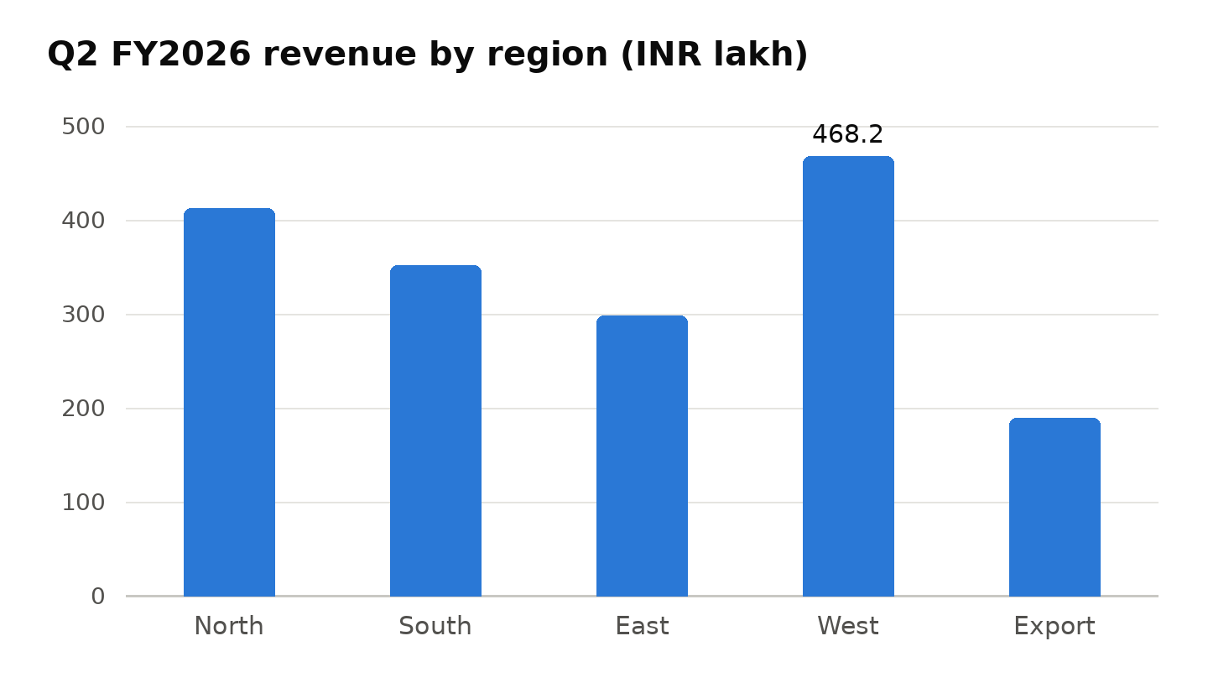
Figure 1 — Quarterly revenue by operating region, INR lakh.

Operating Costs
Fuel remained the largest cost line at 38.7% of direct operating cost, up 1.9 points on Q1 owing to the April diesel price revision. The telematics-led idling programme recovered an estimated INR 11.3 lakh in the quarter; idling hours per vehicle-day fell from 1.42 to 0.97. Maintenance cost per kilometre improved to INR 3.84 from INR 4.02 as the first tranche of the refrigeration-unit overhaul cycle completed.
Employee cost rose 6.1% with the annual increment cycle and the addition of 22 drivers for the new western spokes. Attrition among trained reefer drivers stayed elevated at 17% annualised; the retention allowance approved in May takes effect from the first August payroll and is expected to bring this below 12% by Q4.

Operational Highlights
Key operational developments during the quarter:
- Commissioned the Nashik spoke (14 routes, 9 vehicles) on 6 April; utilisation reached 81% by June against a 70% ramp plan.
- Completed FSSAI re-certification audits at all seven hubs with zero critical non-conformities.
- Rolled out door-sensor telemetry to 214 of 260 reefer vehicles; full coverage expected by end of August.
- Reduced average dock dwell at Bhiwandi from 74 to 51 minutes through slot-booking enforcement.
- Signed the Anandi Dairy dedicated-fleet contract (46 routes, three years, estimated INR 610 lakh annualised revenue).

Key Metrics
The table below summarises the quarter's headline indicators against the prior quarter and the full-year plan.
Metric | Q1 FY2026 | Q2 FY2026 | Change
Consolidated revenue (INR lakh) | 1,574.3 | 1,720.8 | +9.3%
Operating margin | 11.6% | 11.4% | –0.2 pt
On-time, in-temperature delivery | 96.1% | 96.8% | +0.7 pt
Claims incidence (of consignments) | 0.42% | 0.31% | –0.11 pt

Risks and Mitigations
The register below lists the four risks rated High at the June review, in priority order:
- Diesel price escalation beyond the 8% contracted pass-through band — hedged 40% of H2 volume via fixed-price supply agreements in June.
- Reefer driver attrition disrupting the Anandi mobilisation — retention allowance live from August; 28 trainees in the July induction batch.
- Single-point dependency on the Bhiwandi pre-cooling plant — capital approval sought for a second 40-pallet chamber, decision due in Q3.
- Monsoon flood exposure on the Konkan corridor — alternate routing via NH-48 agreed with the three affected customers, adds 6.5% lane cost.

Outlook
The board's guidance of INR 6,900–7,100 lakh full-year revenue is maintained. Q3 will absorb the Anandi mobilisation cost (estimated INR 38 lakh one-time) ahead of revenue commencing in September; margin is therefore expected to dip to approximately 10.5% before recovering in Q4. Capital expenditure of INR 412 lakh is committed for the quarter, of which INR 344 lakh relates to the 18 dedicated-fleet vehicles.
Management attention in Q3 centres on three items: completing door-sensor telemetry coverage, closing the Bhiwandi redundancy decision, and converting the two pharmaceutical pilots in the export lane to annual contracts.
Supporting schedules, lane-level P&Ls, and the full risk register are published on the investor information portal at https://example.com (credentials issued by the Company Secretary's office).

