

Lab 5: Create blob storage

At the end of each lab, any resources you created in your account will be preserved. Some Azure resources, such as VM instances, may be automatically shut down, while other resources, such as storage services will be left running. Keep in mind that some Azure features cannot be stopped and can still incur charges (i.e. Azure Bastion). To minimize your costs, delete all resources and recreate them as needed to test your work during a session.

Reference: [AZ-900T0X-MICROSOFTAZUREFUNDAMENTALS](https://microsoftlearning.github.io/AZ-900T0x-MicrosoftAzureFundamentals)

# 05 - Create blob storage

In this walkthrough, we will create a storage account, then work with blob storage files.

# Task 1: Create a storage account (5 min)

In this task, we will create a new storage account.

1. Sign in to the Azure portal at [https://portal.azure.com](https://portal.azure.com/)
2. From the **All services** blade, search for and select **Storage accounts**, and then click **+ Add**.
3. On the **Basics** tab of the **Create storage account** blade, fill in the following information (replace **xxxx** in the name of the storage account with letters and digits such that the name is globally unique). Leave the defaults for everything else.

| Setting | Value |
| --- | --- |
| Subscription | **Choose your subscription** |
| Resource group | **myRGStorage** (create new) |
| Storage account name | **<studentID>storageaccountxxxx (example: dtrinh1storageaccount)** |
| Location | **(US) East US** |
| Performance | **Standard** |
| Account kind | **StorageV2 (general purpose v2)** |
| Replication | **Locally redundant storage (LRS)** |
|  |  |

1. **Note** - Remember to change the **xxxx** so that it makes a unique **Storage account name**
2. Click **Review + Create** to review your storage account settings and allow Azure to validate the configuration.
3. Once validated, click **Create**. Wait for the notification that the account was successfully created.
4. From the Home page, search for and select **Storage accounts** and ensure your new storage account is listed.

[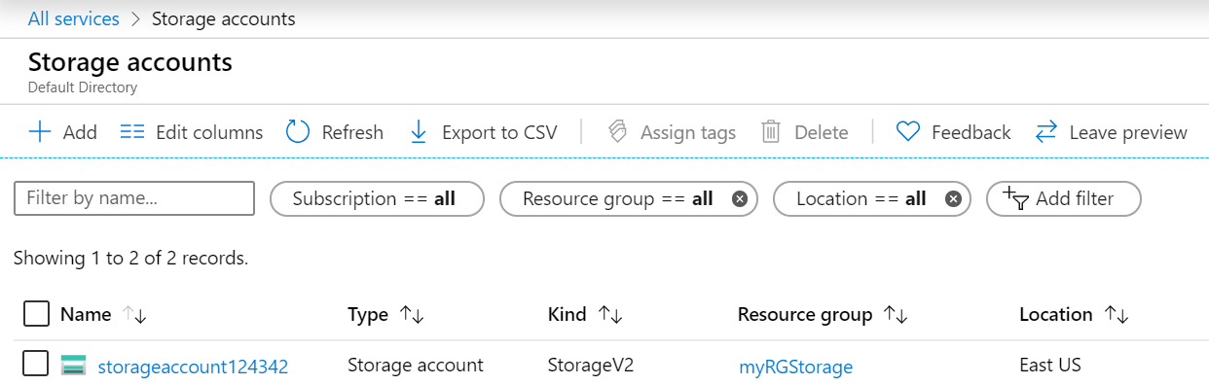](https://microsoftlearning.github.io/AZ-900T0x-MicrosoftAzureFundamentals/Instructions/images/0401.png)

# Task 2: Work with blob storage

In this task, we will create a Blob container and upload a blob file.

1. Click the name of the new storage account, scroll to the **Blob service** section, and then click **Containers**.
2. Click **+ Container** and complete the information. Use the Information icons to learn more. When done click **OK**.

| Setting | Value |
| --- | --- |
| Name | **container1** |
| Public access level | **Private (no anonymous access)** |
|  |  |

1. [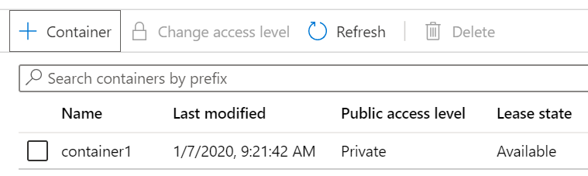](https://microsoftlearning.github.io/AZ-900T0x-MicrosoftAzureFundamentals/Instructions/images/0402.png)
2. Click the **container1** container, and then click **Upload**.
3. Browse to a file on your local computer.

**Note**: You can create an empty .txt file or use any existing file. Consider chooosing a file of a small size to minimize the upload time.

1. Click the **Advanced** arrow, leave the default values but review the available options, and then click **Upload**.

**Note**: You can upload as many blobs as you like in this way. New blobs will be listed within the container.

1. Once the file is uploaded, right-click on the file and notice the options including View/edit, Download, Properties, and Delete.
2. As you have time, from the storage account blade, review the options for Files, Tables, and Queues.

# Task 3: Monitor the storage account

1. If needed, return to the storage account blade and click **Diagnose and solve problems**.
2. Explore some of the most common storage problems. Notice there are multiple troubleshooter.
3. On the storage account blade, scroll down to the **Monitoring** section and click **Insights**. Notice there is information on Failures, Performance, Availability, and Capacity. Your information will be different.

[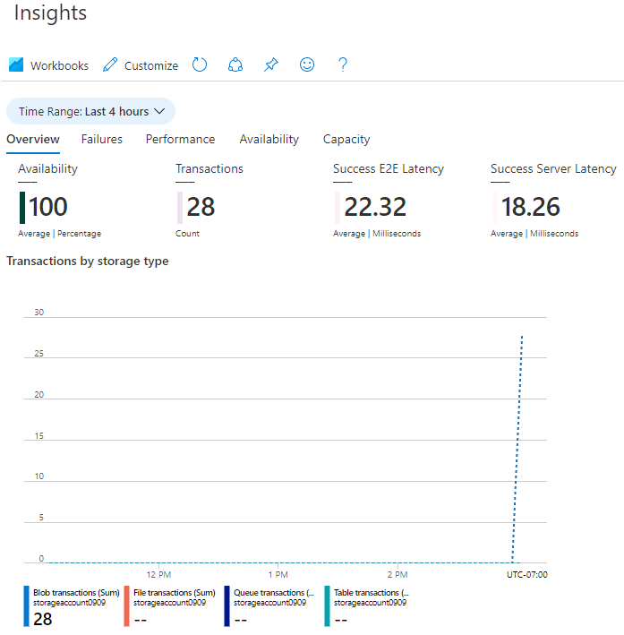](https://microsoftlearning.github.io/AZ-900T0x-MicrosoftAzureFundamentals/Instructions/images/0403.PNG)

Congratulations! You have created a storage account, then worked with storage blobs.

**Note**: To avoid additional costs, you can remove all resources in the resource group. Search for resource groups, click your resource group, and then delete the resources within the resource group. **DO NOT DELETE YOUR RESOURCE GROUP.**

# Submission Requirements

Submit a screenshot with the following information:

Screenshot #1:

* An uploaded file to your Blob storage container
* The Azure Portal with your login ID

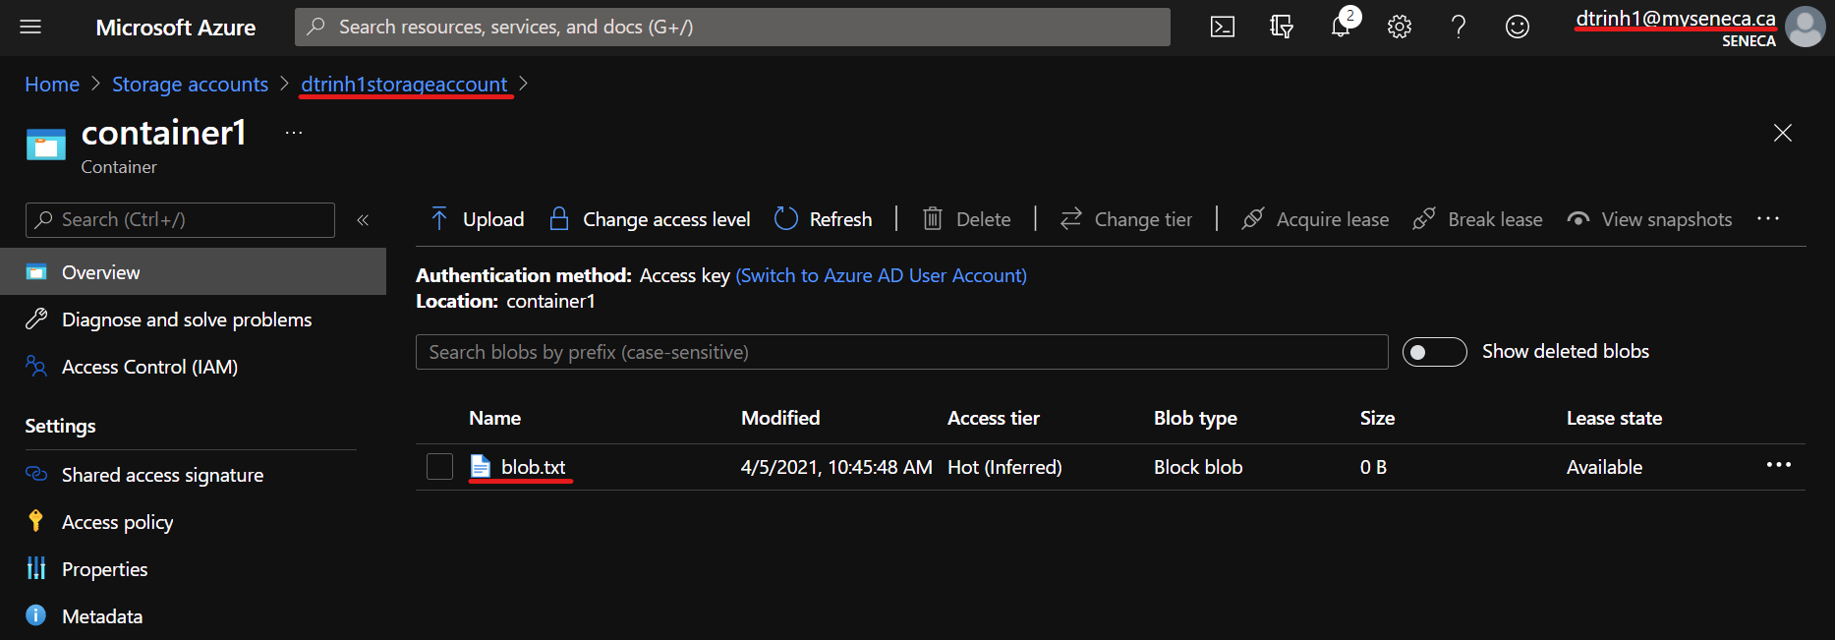

Screenshot #2:

* Successful deletion of resources within resource group. **DO NOT DELETE YOUR RESOURCE GROUP!**

