

Lab 15: Manage resource locks

At the end of each lab, any resources you created in your account will be preserved. Some Azure resources, such as VM instances, may be automatically shut down, while other resources, such as storage services will be left running. Keep in mind that some Azure features cannot be stopped and can still incur charges (i.e. Azure Bastion). To minimize your costs, delete all resources and recreate them as needed to test your work during a session.

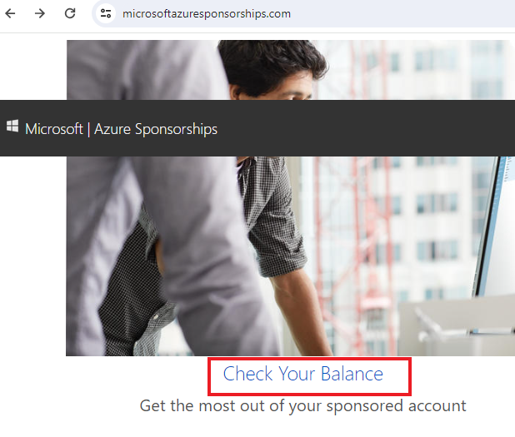

Reference: AZ-900T0X-MICROSOFTAZUREFUNDAMENTALS

# 15 - Manage resource locks

In this walkthrough, we will create a resource group, add a lock to resource group and test deletion, test deleting a resource in the resource group, and remove the resource lock.

# Task 1: Create a resource group (5 min)

In this task, we will create a resource group for this exercise.

1. Sign in to the [Azure portal](https://portal.azure.com/) with your **odl_user_xxx** azure account
2. From the **All services** blade, search for and select **Resource groups**, then select **+ Create**.
3. Create a new resource group. When you are done click **Review + create** and then **Create**.

| Setting | Value |
| --- | --- |
| Subscription | **Use your subscription (you should see “Seneca College : <course name>”)** |
| Name | **myRGLocks** |
| Region | **(US) East US** |

# Task 2: Add a Lock to the resource group and test deletion

In this task, we will add a resource lock to the resource group and test deleting the resource group.

1. In the Azure portal, navigate to the newly created resource group **myRGLocks**.
2. You can apply a lock to a subscription, resource group, or individual resource to prevent accidental deletion or modification of critical resources.
3. In the **Settings** section, click **Locks**, and then click **+ Add**.

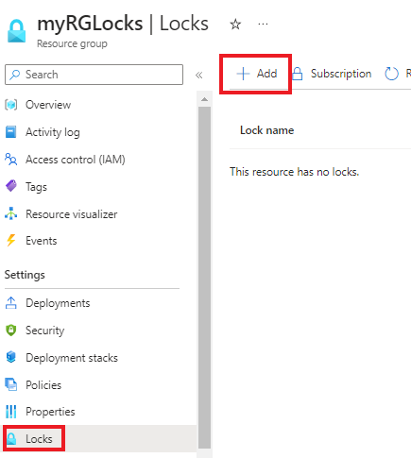

1. Configure the new lock. When you are done click **OK**.

| Setting | Value |
| --- | --- |
| Lock name | **RGLock** |
| Lock Type | **Delete** |

1. Click **Overview** and click **Delete resource group**. Type the name of the resource group and click **Delete**. You receive an error message stating the resource group is locked and can’t be deleted.

[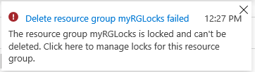](https://microsoftlearning.github.io/AZ-900T0x-MicrosoftAzureFundamentals/Instructions/images/1602.png)

# Task 3: Test deleting a member of the resource group

In this task, we will test if the resource lock protects a storage account in the resource group.

1. From the **All services** blade, search for and select **Storage accounts**, and then click **+ Create**.
2. On the **Basics** tab of the **Create storage account** blade, fill in the following information (replace **xxxx** in the name of the storage account with letters and digits such that the name is globally unique). Leave the defaults for everything else.

| Setting | Value |
| --- | --- |
| Subscription | **Select your subscription (you should see “Seneca College : <course name>”)** |
| Resource group | **myRGLocks** |
| Storage account name | **Storageaccountxxxx (The name of the storage account needs to be unique)** |
| Location | **(US) East US** |
| Performance | **Standard** |
| Redundancy | **Locally redundant storage (LRS)** |

1. Click **Review** to review your storage account settings and allow Azure to validate the configuration.
2. Once validated, click **Create**. Wait for the notification that the account was successfully created.
3. Wait for the notification that the storage account was successfully created.
4. Access your new storage account and from the **Overview** pane, click **Delete**. You receive an error message stating the resource or its parent has a delete lock.

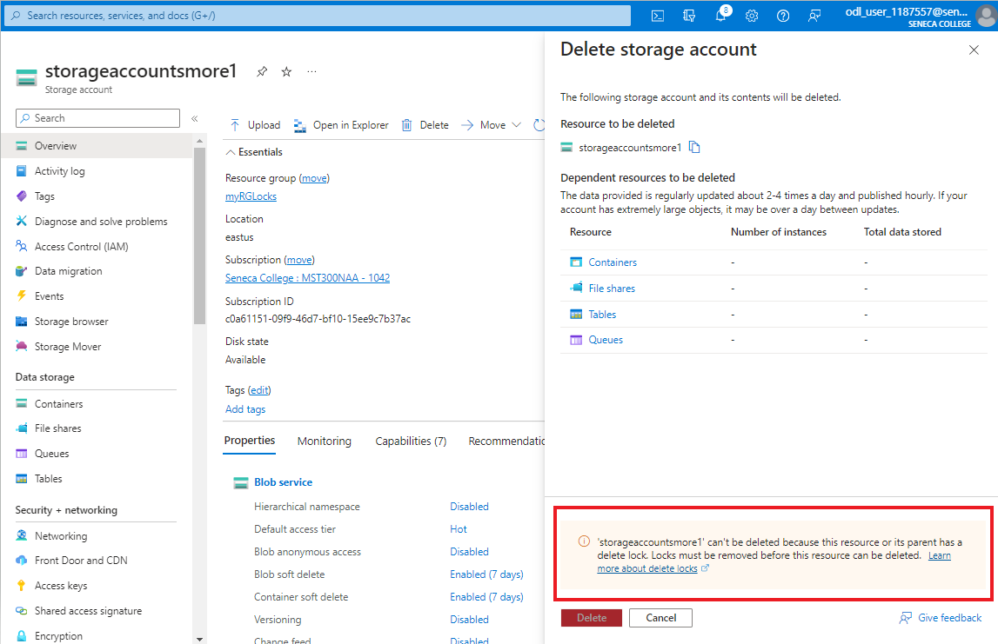

**Note**: Although we did not create a lock specifically for the storage account, we did create a lock at the resource group level, which contains the storage account. As such, this parent level lock prevents us from deleting the resource and the storage account inherits the lock from the parent.

# Task 4: Remove the resource lock

In this task, we will remove the resource lock and test.

1. Return to the **myRGLocks** resource group blade and, in the **Settings** section, click **Locks**.
2. Click **Delete** link to the right of the **RGLock** entry.

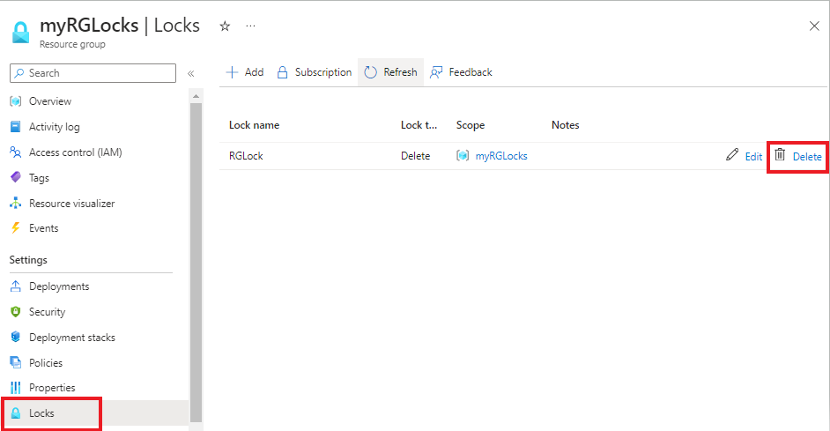

1. Return to the storage account blade and confirm you can now delete the resource.

Congratulations! You created a resource group, added a lock to resource group and tested deletion, tested deleting a resource in the resource group, and removed the resource lock.

**Note**: To avoid additional costs, you can remove all resources in the resource group. Search for resource groups, click your resource group, and then delete the resources within the resource group. **DO NOT DELETE YOUR RESOURCE GROUP.**

# Submission Requirements

Submit a screenshot with the following information:

**Screenshot #1:**

* Error message when attempt to delete storage account
* The Azure Portal with your **CloudLab Account** [requires another browser window]
  + **Note**: underline the above items as described in the below picture

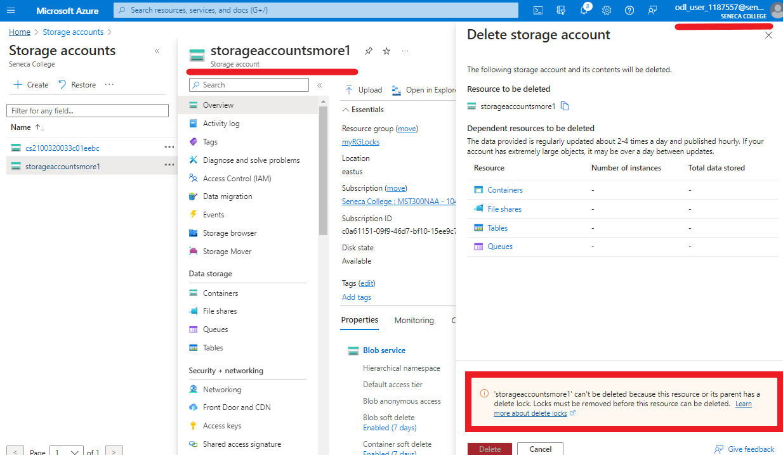

**Screenshot #2:**

* Successful deletion of all resources within resource group. **DO NOT DELETE YOUR RESOURCE GROUP!**
  + To delete all resources with a resource group, go to “**Resource Group**”, select “**MyRGLocks**”, select all resources within the resource group, and select “**Delete**”

