

Lab 18: Explore the Trust Center

At the end of each lab, any resources you created in your account will be preserved. Some Azure resources, such as VM instances, may be automatically shut down, while other resources, such as storage services will be left running. Keep in mind that some Azure features cannot be stopped and can still incur charges (i.e. Azure Bastion). To minimize your costs, delete all resources and recreate them as needed to test your work during a session.

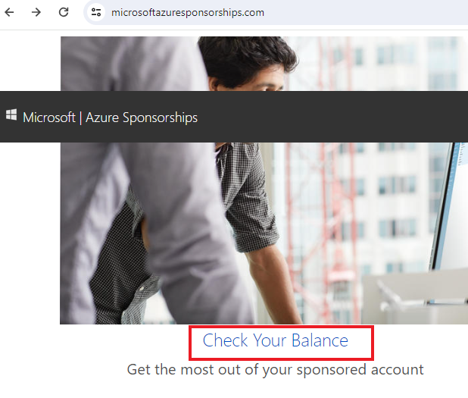

Reference: [AZ-900T0X-MICROSOFTAZUREFUNDAMENTALS](https://microsoftlearning.github.io/AZ-900T0x-MicrosoftAzureFundamentals)

# 18 - Explore the Trust Center

In this walkthrough, we will access the Trust Center, Service Trust Portal (STP), and Compliance Manager.

# Task 1: Access the Trust Center (5 min)

1. In a browser, access the [Microsoft Trust Center compliance offerings](https://docs.microsoft.com/en-us/microsoft-365/compliance/offering-home) page.
2. Notice the offerings are grouped into **Global**, **US Government**, **Industry**, and **Regional**.
3. In the **Global** group, click **ISO 27017**.

**Note:** The ISO 27017 Code of Practice for Information Security Controls page is typical of the type of complaince information we provide.

1. Notice there is an overview of the standard; in-scope cloud services; audits, reports and certificates; assessments and reports; FAQs; resources; and white papers.
2. Browse through any content of interest to you.

**Note:** Is there a compliance offering your organization is most interested in?

# Task 2: Access the Service Trust Portal (STP)

1. In a browser, access the [Service Trust Portal (STP)](https://servicetrust.microsoft.com/)
2. Notice the **Certifications, Regulations and Standards** section. In this section are independent reports for different Microsoft’s Cloud services.
3. It may take a couple of minutes for all reports to load. You will need to login to your Microsoft account to view specific reports.
4. If you have time, review any other information that is of interest to you.

# Task 3: Access the Compliance Manager

1. The Compliance Manager makes it easy to perform risk assessments of Microsoft’s cloud services. Use Compliance Manager to manage your organization’s compliance activities from implementation to reporting. If you want to try the Compliance Manager you will need to login.
2. Instead, visit the [Compliance Guides](https://compliance.microsoft.com/homepage) page.
3. If you have time, review any other information that is of interest to you.

Congratulations! In this walkthrough, you accessed the Trust Center, Service Trust Portal (STP), and Compliance Manager.

# Submission Requirements

Submit a screenshot with the following information:

* An example of a certificate of registration downloaded from the Service Trust portal
* The Service Trust Portal with your login ID [requires another browser window]

