

Lab 19: Use the Pricing Calculator

At the end of each lab, any resources you created in your account will be preserved. Some Azure resources, such as VM instances, may be automatically shut down, while other resources, such as storage services will be left running. Keep in mind that some Azure features cannot be stopped and can still incur charges (i.e. Azure Bastion). To minimize your costs, delete all resources and recreate them as needed to test your work during a session.



Reference: [AZ-900T0X-MICROSOFTAZUREFUNDAMENTALS](https://microsoftlearning.github.io/AZ-900T0x-MicrosoftAzureFundamentals)

# 19 - Use the Pricing Calculator

In this walkthrough, we will use the Azure Pricing Calculator to generate a cost estimate for an Azure virtual machine and related network resources.

# Task 1: Configure the pricing calculator (10 min)

In this task, we will estimate cost of a sample infrastructure by using the Azure Pricing Calculator.

**Note**: To create an Azure Pricing Calculator estimate, this walkthrough provides example configurations for the VM and related resources. Use this example configurations or provide the Azure Pricing Calculator with details of your actual resource requirements instead.

1. In a browser, navigate to the [Azure Pricing Calculator](https://azure.microsoft.com/en-us/pricing/calculator/) webpage.
2. To add details of your VM configuration, click **Virtual Machines** on the **Products** tab. Scroll down to view the virtual machine details.
3. Replace **Your Estimate** and **Virtual Machines** text with more descriptive names for your Azure Pricing Calculator estimate and your VM configuration. This walkthrough example uses **My Pricing Calculator Estimate** for the estimate, and **Windows VM** for the VM configuration.

[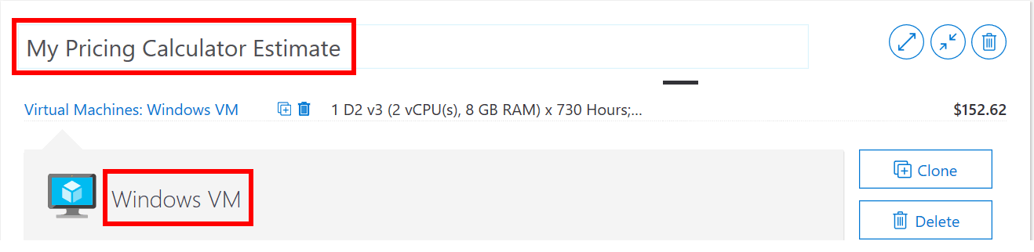](https://microsoftlearning.github.io/AZ-900T0x-MicrosoftAzureFundamentals/Instructions/images/1901.png)

1. Modify the default VM configuration.

| Region | Operating system | Type |
| --- | --- | --- |
| North Europe | Windows | (OS only) |
|  |  |  |

| Tier | Instance |
| --- | --- |
| Standard | A2: 2 Core(s), 3.5 GB RAM, 135 GB Temporary storage |
|  |  |

1. [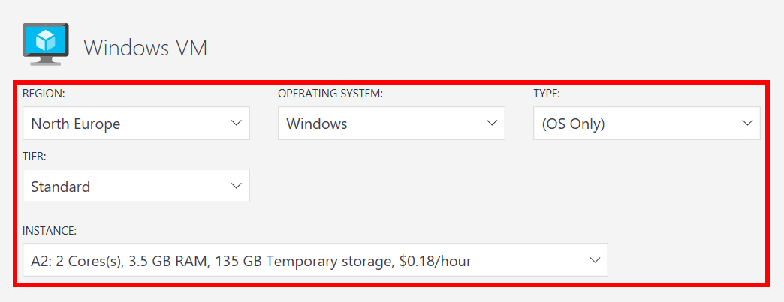](https://microsoftlearning.github.io/AZ-900T0x-MicrosoftAzureFundamentals/Instructions/images/1902.png)
2. **Note**: The VM instance specifications and pricing may differ from those in this example. Follow this walkthrough by choosing an instance that matches the example as closely as possible. To view details about the different VM product options, choose **Product details** from the **More info** menu on the right.
3. Set the **Billing Option** to **Pay as you go**.

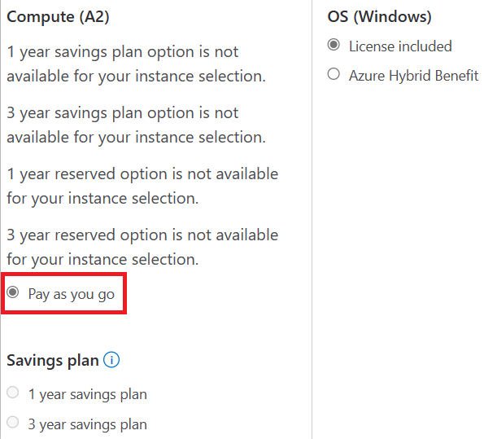

1. In Azure, a month is defined as 730 hours. If your VM needs to be available 100 percent of the time each month, you set the hours-per-month value to 730. This walkthrough example requires one VM to be available 50 percent of the time each month.

Leave the number of VMs set at 1, and change the hours-per-month value to 365.

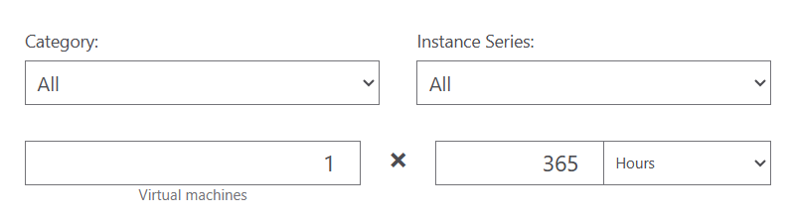

1. In the **Managed OS Disks** pane, modify the default VM storage configuration.

| Tier | Disk size | Number of disks | Snapshot | Storage transactions |
| --- | --- | --- | --- | --- |
| Standard HDD | S4: 32GiB | 1 | Off | 10,000 |

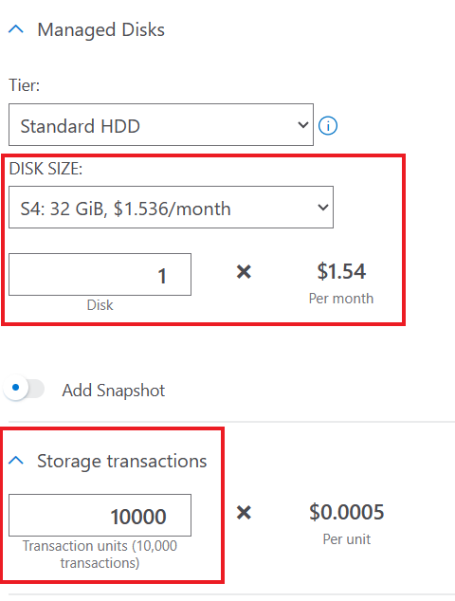

1. To add networking bandwidth to your estimate, go to the top of the Azure Pricing Calculator webpage. Click **Networking** in the product menu on the left, then click the **Bandwidth** tile. In the **Bandwidth added** message dialog, click **View**.

[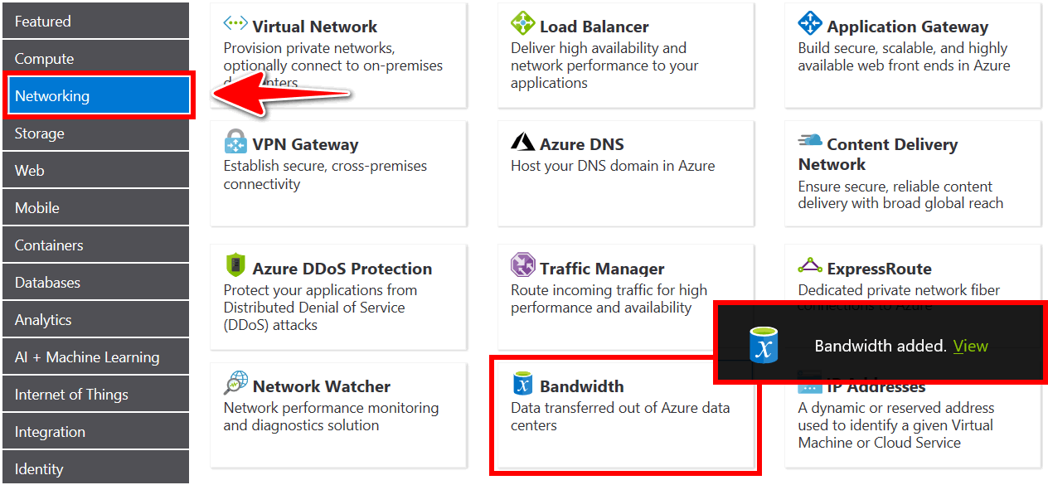](https://microsoftlearning.github.io/AZ-900T0x-MicrosoftAzureFundamentals/Instructions/images/1906.png)

1. Add a name for your VM bandwidth configuration. This walkthrough example uses the name **Bandwidth: Windows VM**. Modify the default bandwidth configuration by adding the following details.

| Region | Zone 1 Outbound Data Transfer Amount |
| --- | --- |
| North Europe | 50 GB |

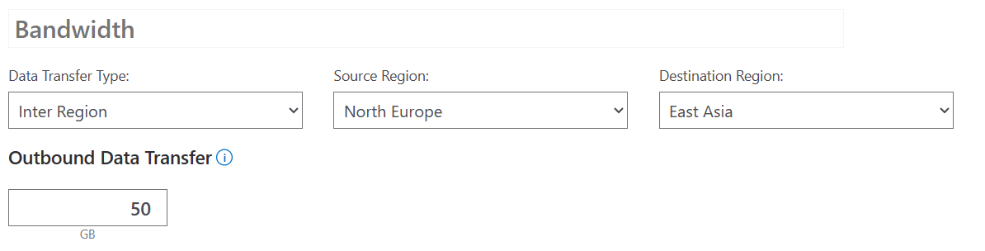

1. To add an Application Gateway, return to the top of the Azure Pricing Calculator webpage. In the **Networking** product menu, click the **Application Gateway** tile. In the **Application Gateway** message dialog, click **View**.

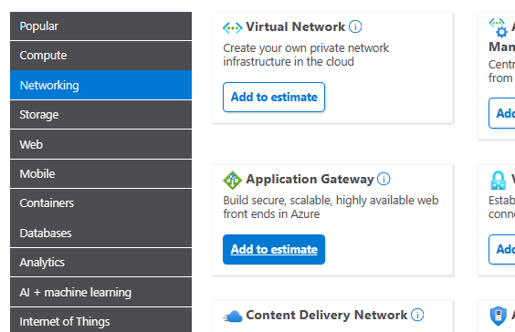

1. Add a name for your Application Gateway configuration. This walkthrough uses the name **App Gateway: Windows VM**. Modify the default Application Gateway configuration by adding the following details.

| Region | Tier | Size |
| --- | --- | --- |
| North Europe | Basic | Small |
|  |  |  |

| Instances | Hours |
| --- | --- |
| 1 | 365 |
|  |  |

| Data processed |  |
| --- | --- |
| 50 GB |  |
|  |  |

| Outbound Data Transfer |  |
| --- | --- |
| 50 GB |  |
|  |  |

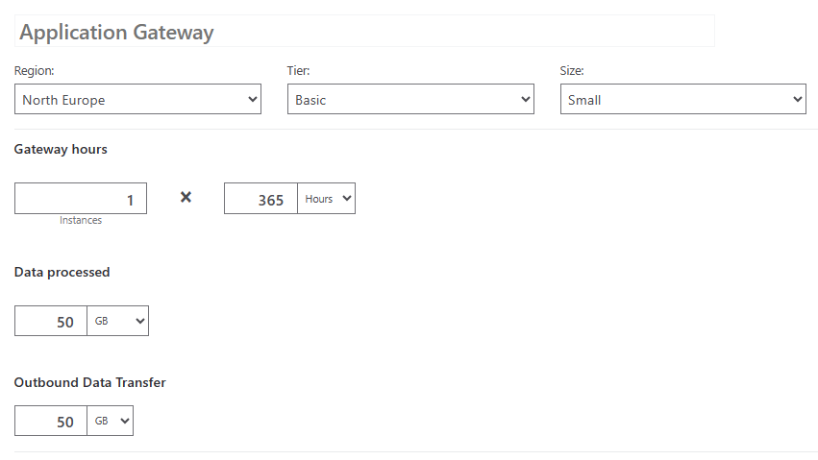

# Task 2: Review the pricing estimate

In this task, we will review the results of the Azure Pricing Calculator.

1. Scroll to the bottom of the Azure Pricing Calculator webpage to view total **Estimated monthly cost**.

**Note**: Explore the various options available within the Azure Pricing Calculator. For example, this walkthrough requires you to update the currency to Euro.

1. Change the currency to Euro, then select **Export** to download a copy of the estimate for offline viewing in Microsoft Excel (.xlsx) format.

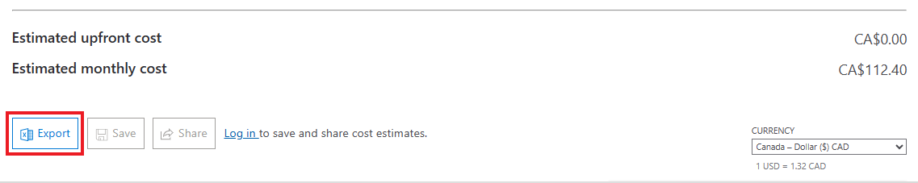

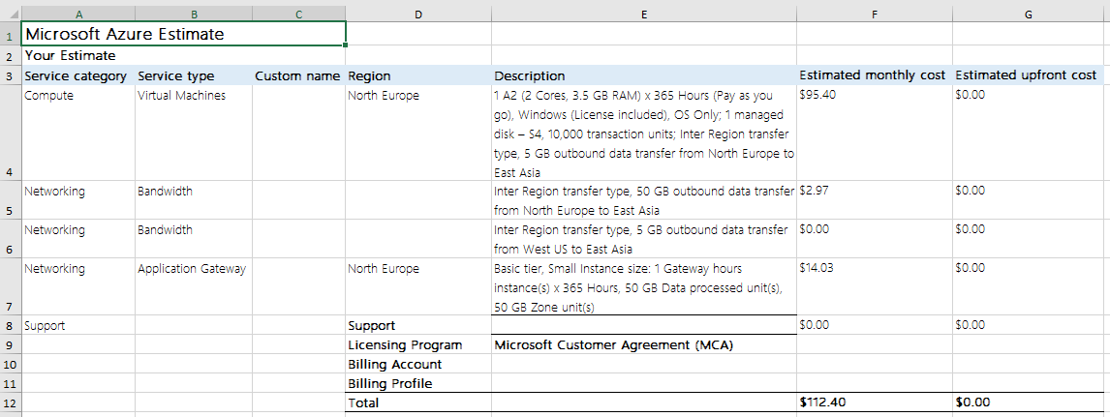

Congratulations! You downloaded an estimate from the Azure Pricing Calculator.

# Submission Requirements

Submit a screenshot with the following information and the reflection:

1. Estimate the cost of running **Project 2** for one month
2. **Reflection**: Think about what are the greatest costs and how you can save on those costs

