

Lab 20: Use the Azure TCO Calculator

At the end of each lab, any resources you created in your account will be preserved. Some Azure resources, such as VM instances, may be automatically shut down, while other resources, such as storage services will be left running. Keep in mind that some Azure features cannot be stopped and can still incur charges (i.e. Azure Bastion). To minimize your costs, delete all resources and recreate them as needed to test your work during a session.

Reference: [AZ-900T0X-MICROSOFTAZUREFUNDAMENTALS](https://microsoftlearning.github.io/AZ-900T0x-MicrosoftAzureFundamentals)

# 20 - Use the Azure TCO Calculator

In this walkthrough, you will use the Total Cost of Ownership (TCO) Calculator to generate cost comparison report for an on-premises environment.

**Note**: This walkthrough provides example definitions of on-premises infrastructure and workloads for a typical datacenter. To create a TCO Calculator report, use the example definitions or provide details of your actual on-premises infrastructure and workloads.

# Task 1: Configure the TCO calculator (10 min)

In this task, we will add infrastructure information to the calculator.

1. In a browser, navigate to the [Total Cost of Ownership (TCO) Calculator](https://azure.microsoft.com/en-us/pricing/tco/calculator/) page.
2. To add details of your on-premises server infrastructure, click **+ Add server workload** in the **Define your workloads** pane.

| Settings | Value |
| --- | --- |
| Name | **Servers: Windows VMs** |
| Workload | **Windows/Linux server** |
| Environment | **Virtual Machines** |
| Operating system | **Windows** |
| VMs | **50** |
| Virtualization | **Hyper-V** |
| Core(s) | **8** |
| RAM (GB) | **16** |
| Optimize by | **CPU** |
| Windows Server 2008/2008 R2 | **Off** |
|  |  |

1. Select **+ Add server workload** to make a row for a new server workloads definition.

| Settings | Value |
| --- | --- |
| Name | **Servers: Linux VMs** |
| Workload | **Windows/Linux server** |
| Environment | **Virtual Machines** |
| Operating system | **Linux** |
| VMs | **50** |
| Virtualization | **VMware** |
| Core(s) | **8** |
| RAM (GB) | **16** |
| Optimize by | **CPU** |
| Windows Server 2008/2008 R2 | **Off** |
|  |  |

1. In the **Storage** pane, click **Add storage**.

| Settings | Value |
| --- | --- |
| Name | **Server Storage** |
| Storage type | **Local Disk/SAN** |
| Disk type | **HDD** |
| Capacity | **60 TB** |
| Backup | **120 TB** |
| Archive | **0 TB** |
|  |  |

1. In the **Networking** pane, add bandwidth.

| Settings | Value |
| --- | --- |
| Outbound bandwidth | 15 TB |
|  |  |

1. Click **Next**.
2. Explore the options and make any adjustments that you require.

| Settings | Value |
| --- | --- |
| Currency | **Canadian Dollar** |
|  |  |

1. Click **Next**.

# Task 2: Review the results and save a copy

In this task, we will review cost saving recommendations and download a report.

1. Review the Azure cost saving recommendations and visualizations.

| Settings | Value |
| --- | --- |
| Timeframe | **3 years** |
| Region | **Canada East** |
|  |  |

1. To modify the information you provided, go to the bottom of the page, and click **Back**.
2. To save or print a PDF copy of the report, click **Download**.

[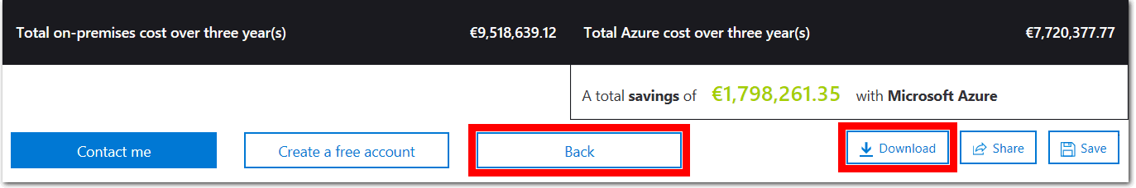](https://microsoftlearning.github.io/AZ-900T0x-MicrosoftAzureFundamentals/Instructions/images/2001.png)

Congratulations! You have used the TCO Calculator to generate a cost comparison report for an on-premises environment.

# Submission Requirements

Submit a screenshot with the following information and the reflection:

* Pricing comparison of On-premises and Azure costs
* Reflection: Think about reasons why a category would cost more in Azure vs On-Premises

