

Project 2: Load Balancing Websites

At the end of each session, any resources you created in your account will be preserved. Some Azure resources, such as VM instances, may be automatically shut down, while other resources, such as storage services will be left running. Keep in mind that some Azure features cannot be stopped and can still incur charges (i.e. Azure Bastion). To minimize your costs, delete all resources and recreate them as needed to test your work during a session.

# Lab Objectives

In this project, we will investigate and construct an architecture using the following Azure services:

* [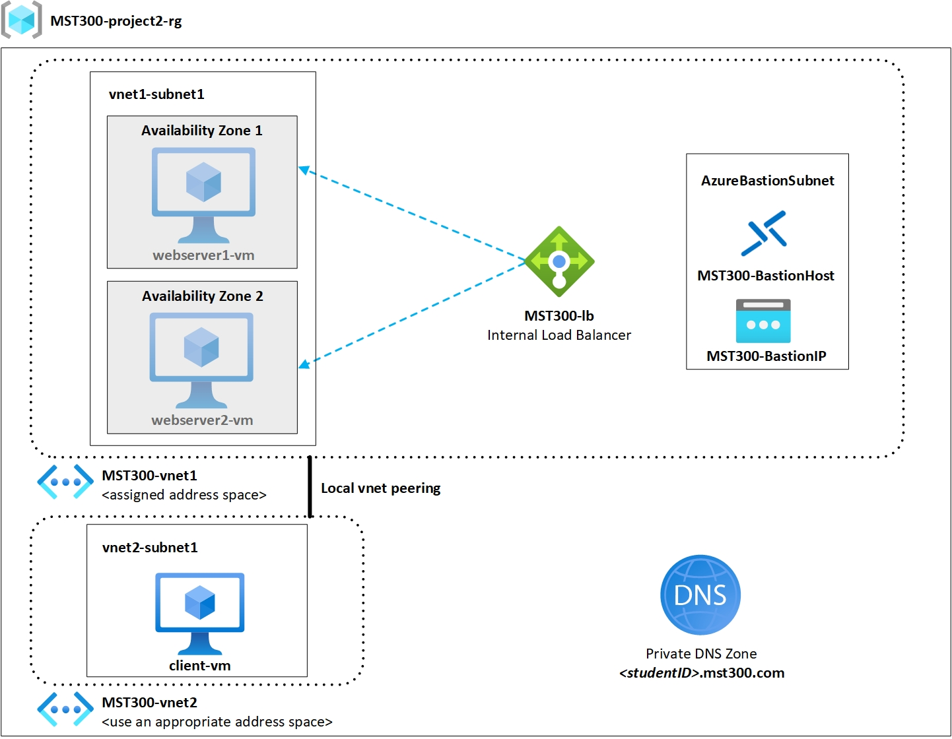](https://seneca.sharepoint.com/:i:/s/CTYCurriculum/EYGCCzA0lZ1Os3uAtx4xGt8BexgPSmoxV0T_AISRSNPfeA?e=sgDEYy)Azure Bastion
* Azure Virtual Machines
* Azure Virtual Networks
* Azure Virtual Network peering
* Azure Load Balancer
* Azure Private DNS

# Lab Materials

* Azure Bastion
  + [What is Azure Bastion?](https://docs.microsoft.com/en-us/azure/bastion/bastion-overview)
  + [Azure Bastion Tutorial](https://docs.microsoft.com/en-us/azure/bastion/tutorial-create-host-portal)
* Azure Virtual Networks
  + [What is Azure Virtual Network?](https://docs.microsoft.com/en-us/azure/virtual-network/virtual-networks-overview)
  + [Azure Virtual Network Tutorial](https://docs.microsoft.com/en-us/azure/virtual-network/quick-create-portal)
* Azure Virtual Network Peering
  + [What is Azure Virtual Network Peering?](https://docs.microsoft.com/en-us/azure/virtual-network/virtual-network-peering-overview)
  + [Azure Virtual Network Peering Tutorial](https://docs.microsoft.com/en-us/azure/virtual-network/tutorial-connect-virtual-networks-portal)
* Azure Load Balancer
  + [What is Azure Load Balancer?](https://docs.microsoft.com/en-us/azure/load-balancer/load-balancer-overview)
  + [Create Internal Load Balancer Tutorial](https://docs.microsoft.com/en-us/azure/load-balancer/quickstart-load-balancer-standard-internal-portal?tabs=option-1-create-internal-load-balancer-standard)
* Azure Private DNS
  + [What is Azure Private DNS?](https://docs.microsoft.com/en-us/azure/dns/private-dns-overview)
  + [Create a Private Zone Tutorial](https://docs.microsoft.com/en-us/azure/dns/private-dns-getstarted-portal)
* Project Topology
  + [Download Topology](https://seneca.sharepoint.com/:i:/s/CTYCurriculum/EUw1U8vzZ6NBkpMjz-wbc88ByJape5VBIY5sDaGebP6-Ag?e=HNr65J)
* Network address space from Seneca Blackboard
  + Use the assigned network address space as indicated in the project

# Project Instructions

We will be creating an internal load balancer which randomly selects which webserver will be serving our private website. A client VM will be accessing this website from another virtual network outside of our webservers’ virtual network. We will demonstrate on the client VM that both webservers can service our private website. The project topology outlines the different components and requirements for our project.

[](https://seneca.sharepoint.com/:i:/s/CTYCurriculum/EYGCCzA0lZ1Os3uAtx4xGt8BexgPSmoxV0T_AISRSNPfeA?e=sgDEYy)

Project components:

1 – Resource Group

2 – Webservers

1 – Client VM

1 – Azure Load Balancer

2 – Virtual Networks

3 – Subnets in total

1 – Azure Bastion Host

1 – Private DNS Zone

# Resource Group Requirements

Create a resource group that will be the logical container that holds all our resources for this project.

Resource group name: **MST300-project2-rg**

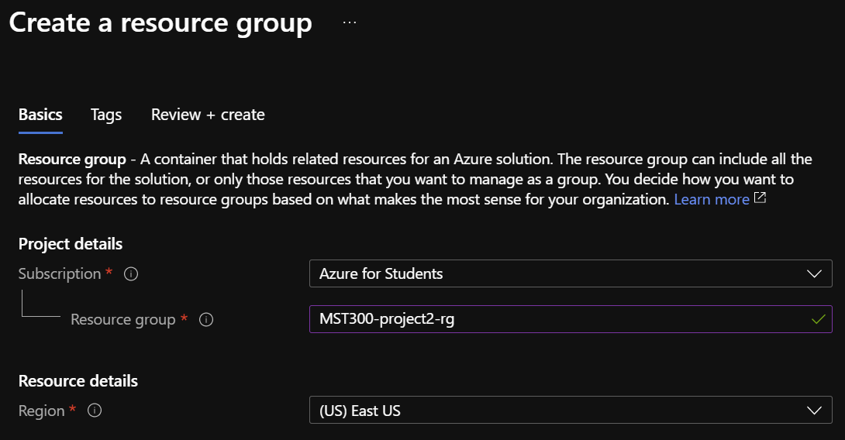

# Virtual Network Requirements

Create 2 virtual networks which will be used to connect our resources. A total of 3 subnets will be created [2 subnets in vnet1 and 1 subnet in vnet2].

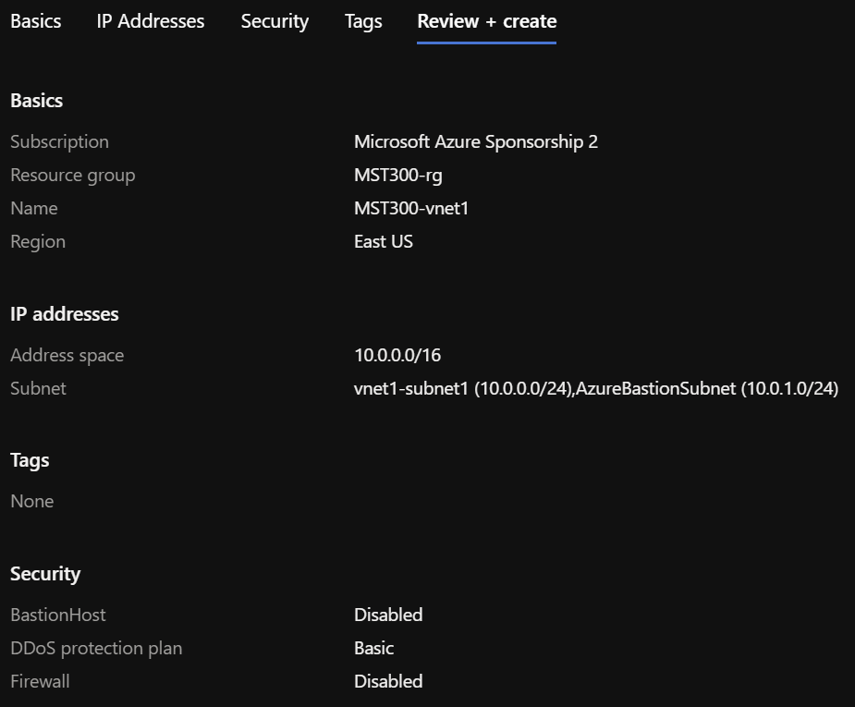Virtual Network 1

* Use your network address space assigned in Blackboard
* Name: **MST300-vnet1**
* Create 2 subnets within this Virtual Network
  + Subnet Name: **vnet1-subnet1**
  + Subnet Name: **AzureBastionSubnet**
* Assign an appropriate address using your network address

Virtual Network 2

* Name: **MST300-vnet2**
* Create 1 subnet within this Virtual Network
  + Subnet Name: **vnet2-subnet1**
* Assign an appropriate address for this virtual network
* *\*Note: Do not use overlapping network address spaces*

Configure Virtual Network Peering between virtual networks.

# Load Balancer Requirements

Create a load balancer within virtual network 1 in vnet1-subnet1.

* 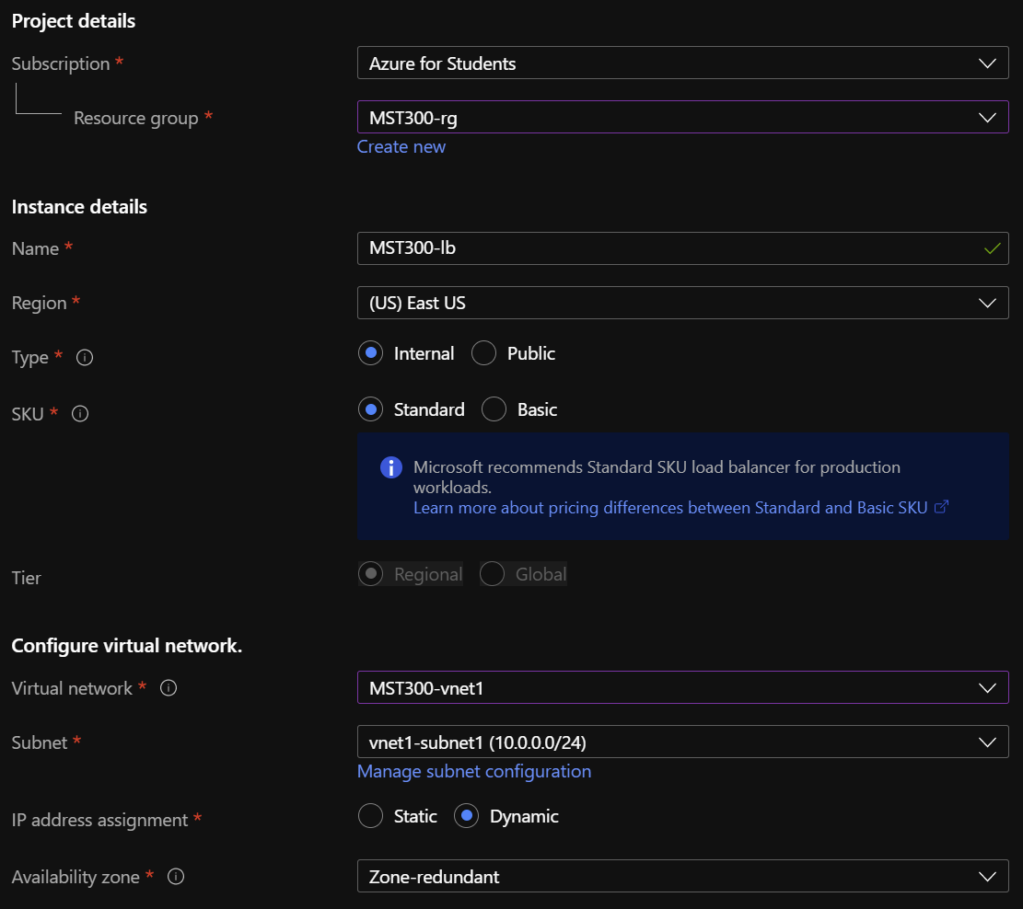Name: **MST300-lb**
* Type: **Internal**
* Virtual network: **MST300-vnet1**
* Subnet: **vnet1-subnet1**

**Load Balancer –** **Backend Pool**

* Name: **MST300-BackendPool**

**Load Balancer – Health Probe**

* Name: **MST300-HealthProbe**
* Protocol: **HTTP**
* Port: **80**
* Interval: **15**
* Unhealthy threshold: **3**

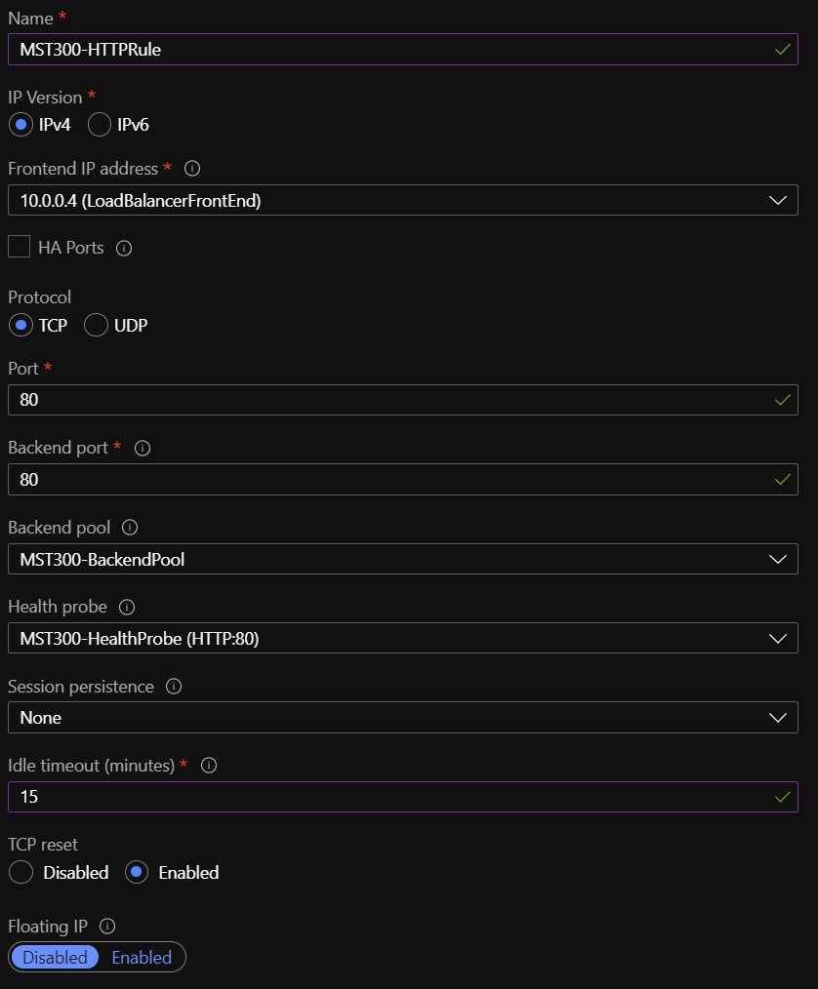**Load Balancer – Load Balancer Rule**

* Name: **MST300-HTTPRule**
* Protocol: **TCP**
* Port: **80**
* Idle timeout (minutes): **15**
* TCP reset: **Enabled**

# Azure Bastion Requirements

**To access our virtual machines, we will use the Azure Bastion PaaS service. This service allows us to connect to our virtual machines through SSL. By using this service, we do not need a public IP address for our virtual machines.**

* 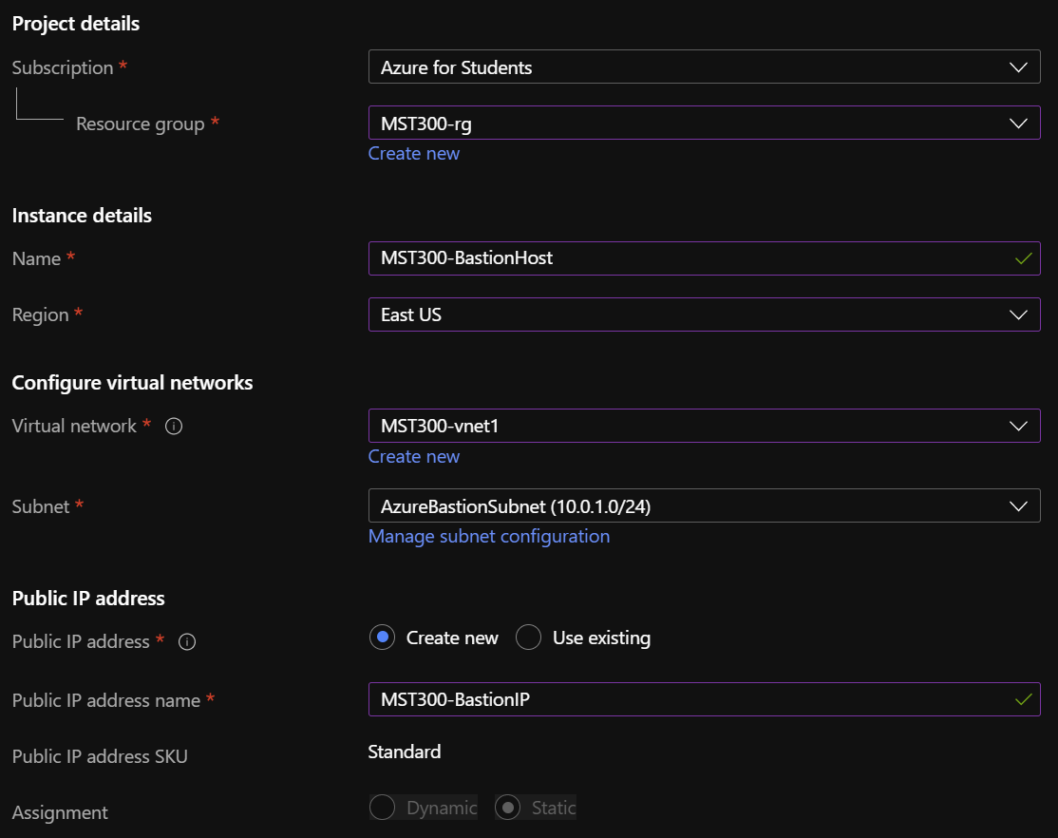Name: **MST300-BastionHost**
* Region: **Use the same region as your vnets**
* Virtual network: **MST300-vnet1**
* Subnet: **AzureBastionSubnet**
* Public IP address name: **MST300-BastionIP**

# Webserver Requirements

Create 2 virtual machines which will be running IIS roles on both servers. Each server will be hosted on different availability zones. The default pages will be modified to include the name of the servers.

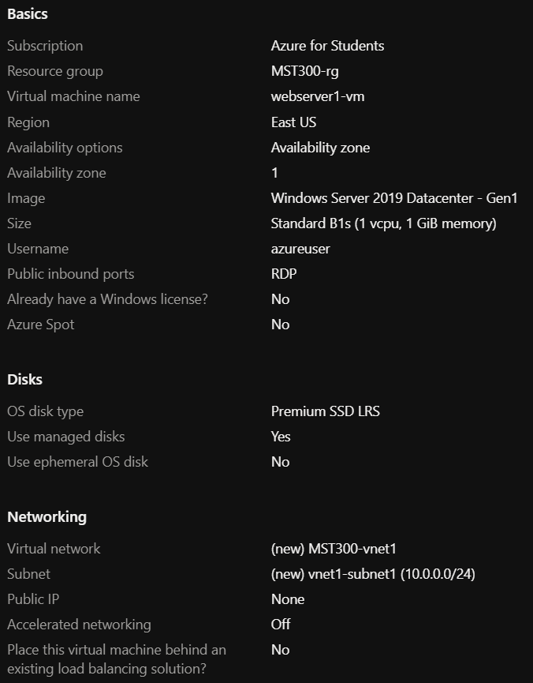Webserver 1

* Name: **webserver1-vm**
* Availability zone: **1**
* Image: **Windows Server 2019 Datacenter – Gen1**
* Size: **Standard_B1s**
* Virtual network: **MST300-vnet1**
* Subnet: **vnet1-subnet1**
* Public IP: **None**
* Place this webserver in the load balancer created earlier

Webserver 2

* Name: **webserver2-vm**
* Availability zone: **2**
* Image: **Windows Server 2019 Datacenter – Gen1**
* Size: **Standard_B1s**
* Virtual network: **MST300-vnet1**
* Subnet: **vnet1-subnet1**
* Public IP: **None**
* Place this webserver in the load balancer created earlier

IIS on Webserver 1

* Webpage Title: **studentID’s Windows Server**
* Body Text: **This webspage is hosted on webserver1-vm**

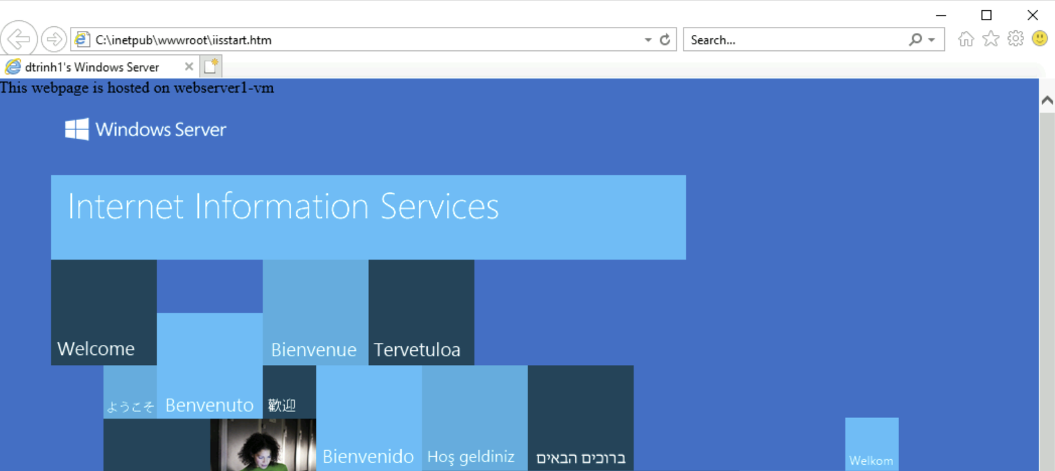

IIS on Webserver 2

* Webpage Title: **studentID’s WebPage**
* Body Text: **This webspage is hosted on webserver2-vm**

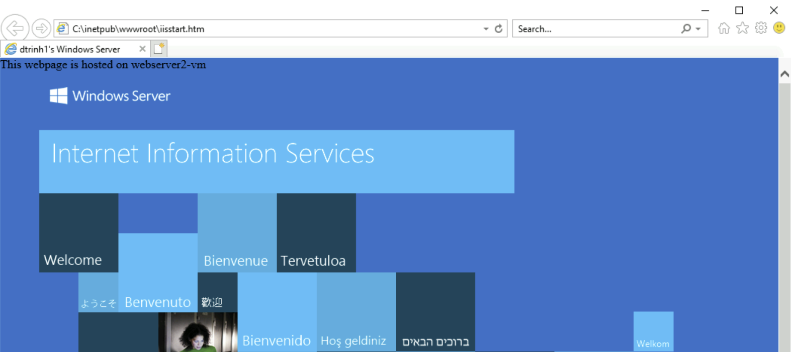

# Client VM Requirements

Create 1 virtual machine which will be running Windows 10 operating system. This virtual machine will reside in a different virtual network than the webservers. We will need to configure virtual network peering in order for us to log into the virtual machine using our Bastion Host.

* 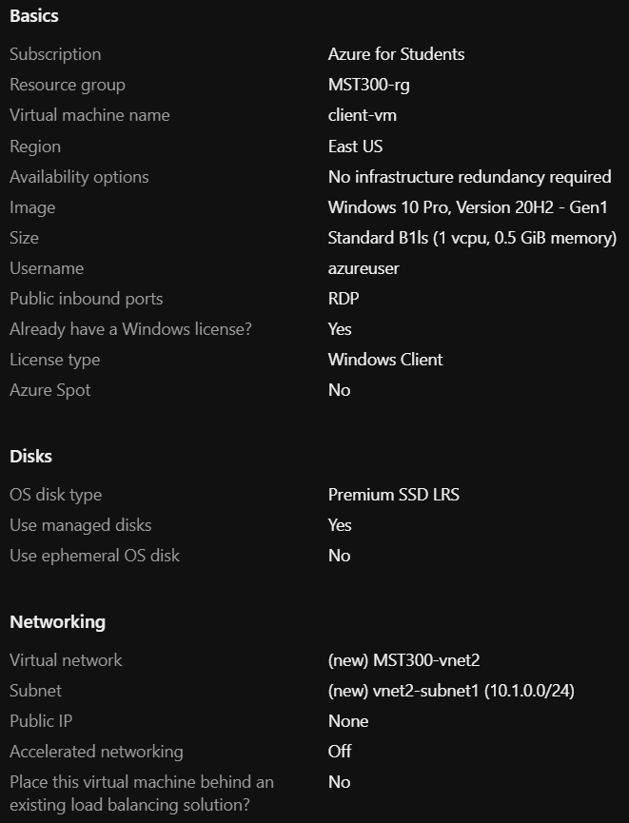Name: **client-vm**
* Image: **Windows 10 Pro, Version 20H2 – Gen1**
* Size: **Select an appropriate size based on the OS**
* Virtual network: **MST300-vnet2**
* Subnet: **vnet2-subnet1**
* Public IP: **None**

Remember to configure Virtual Network Peering between vnet1 and vnet2. This step is required for us to connect to the client VM using our Bastion Host.

# Private DNS Zones Requirements

Create a private DNS zone which will be used when we access our website from our client VM. Configure the private DNS zone so that the client VM can connect to the webserver using its FQDN. Remember you may need to create an A record for the load balancer.

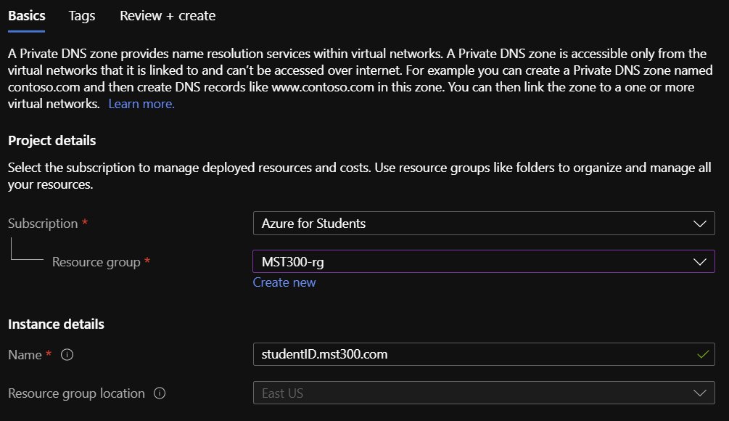

# Project Rubric

The project will be graded on successful functionality of each of the following components:

1. **Azure Bastion [Yes / No]**
   * Demonstrate connectivity to client-vm using Azure Bastion Host
2. **Azure Load Balancer [Yes / No]**
   * Demonstrate load balancer configurations
   * Demonstrate the client-vm’s browser launching the load balancer
   * Forced refresh of browser shows switching between webservers
3. **Webservers with modified default pages [Yes / No]**
   * Default webpages modified
   * Title modified to show studentID
   * Body of default webpage displays name of webserver
4. **Virtual Network Peering [Yes / No]**
   * Demonstrate the client-vm resides in a different vnet than the webservers
   * Successful access of website from client-vm
5. **Azure Private DNS Zone [Yes / No]**
   * Accessing website using FQDN on client-vm browser

# Project Submission

1. The project submission will be in a video format uploaded to Microsoft Stream.
2. Use a screen capturing software to demonstrate the different project components as outlined in the project rubric.
3. Submit a link to your video demonstration in Blackboard.

Resources:

* Microsoft Stream: <https://www.microsoft.com/en-us/microsoft-365/microsoft-stream>
* Microsoft Stream screen capture: [Create a screen recording from your desktop](https://docs.microsoft.com/en-us/stream/portal-create-screen-recording#:~:text=To%20record%20your%20screen%2C%20you,use%20your%20camera%20and%20microphone.)
* Video link: [Obtain direct link to video](https://docs.microsoft.com/en-us/stream/portal-share-video)
* Submission Example: [Project Demonstration Sample](https://web.microsoftstream.com/video/0886c3fa-36b2-4943-8b5e-a902a1cc4498)