DEPARTMENT OF COMPUTER SCIENCE AND ENGINEERING
RV COLLEGE OF ENGINEERING
(Autonomous Institution affiliated to VTU, Belagavi)
PROJECT REPORT
On
IoT-Based Soldier Safety and Battlefield Environment Monitoring System Using ESP32
Submitted in partial fulfilment of First year IDEA Lab
Submitted by
1. Saamarth S [1RV25CS151]
2. Satvik Tripathi [1RV25CS162]
3. Samarth S Prabhu [1RZ25CS153]
4. Sanchit Mahajan [1RZ25CS154]
Under the guidance of
Dr. Vivekanand S Gogi
RV College of Engineering, Bengaluru
2025 - 2026

CERTIFICATE
Certified that the project work titled 'IoT-Based Soldier Safety and Battlefield Environment Monitoring System Using ESP32' is carried out by Saamarth S (1RV25CS151), Satvik Tripathi (1RV25CS162), Samarth S Prabhu (1RZ25CS153), and Sanchit Mahajan (1RZ25CS154), who are bonafide students of RV College of Engineering, Bengaluru, in partial fulfilment for the award of degree of Bachelor of Engineering in Computer Science and Engineering of the Visvesvaraya Technological University, Belagavi during the academic year 2025-2026.
It is certified that all corrections and suggestions indicated for the Internal Assessment have been incorporated in the report deposited in the departmental library. The report has been approved as it satisfies the academic requirements in respect of experiential learning work prescribed by the institution for the said degree.
Signature of Guide Signature of Head of the Department
Dr. Vivekanand S Gogi Dr. Shanta Rangaswamy
External Viva
Name of Examiners Signature with Date
1.
2.

DECLARATION
We, Saamarth S, Satvik Tripathi, Samarth S Prabhu, and Sanchit Mahajan, students of second semester B.E., Department of Computer Science and Engineering, RV College of Engineering, Bengaluru, hereby declare that the Experiential Learning project titled 'IoT-Based Soldier Safety and Battlefield Environment Monitoring System Using ESP32' has been carried out by us and submitted in partial fulfilment for the award of degree of Bachelor of Engineering in Computer Science and Engineering during the academic year 2025-26.
We also declare that any Intellectual Property Rights generated out of this project carried out at RVCE will be the property of RV College of Engineering, Bengaluru, and we will be among the authors of the same.
Place: Bengaluru
Date: 10-07-2026
Name Signature
1. Saamarth S (1RV25CS151)
2. Satvik Tripathi (1RV25CS162)
3. Samarth S Prabhu (1RZ25CS153)
4. Sanchit Mahajan (1RZ25CS154)

ABSTRACT
Soldiers operating in field environments may face sudden hazards such as smoke or toxic gas exposure, high temperature, nearby obstacles or intrusions, and emergency conditions that require quick communication to a monitoring point. This project presents a low-cost ESP32-based soldier safety and battlefield environment monitoring system that continuously observes the surrounding conditions of a soldier and sends live telemetry to a laptop-based base station dashboard.
The wearable prototype integrates a DHT22 temperature and humidity sensor, MQ-2 gas sensor, HC-SR04 ultrasonic distance sensor, HC-SR501 PIR motion sensor, OLED display, buzzer, and manual SOS button. A single ESP32 reads the sensor values, applies threshold-based decision rules, displays local status on the OLED, activates buzzer alerts when required, and sends JSON data over WiFi to a Node.js server running on a laptop. The browser dashboard displays real-time temperature, humidity, gas value, motion state, distance, radar view, emergency state, and event logs.
The final implementation differs from the initial research-paper concept in two important ways: the ESP32 does not use deep sleep during demonstration, and no second base-station ESP32 is used. Instead, the soldier unit transmits directly to the laptop or base-station computer through WiFi. Bench testing shows that the prototype can update the dashboard in near real time, classify proximity zones as SAFE, CAUTION, or DANGER, and provide immediate SOS and gas/motion alert visibility. The system demonstrates an affordable and reproducible IoT approach for field-safety monitoring.
Keywords: ESP32, soldier safety, IoT, battlefield monitoring, gas detection, proximity sensing, WiFi dashboard, SOS alert.

TABLE OF CONTENTS
Section | Page
Certificate | 2
Declaration | 3
Abstract | 4
Chapter 1 - Introduction | 6
Chapter 2 - Literature Review | 8
Chapter 3 - System Design and Architecture | 10
Chapter 4 - Hardware and Software Implementation | 13
Chapter 5 - Experimental Setup | 16
Chapter 6 - Results and Discussion | 18
Chapter 7 - Conclusion and Future Work | 20
References | 22
Appendices | 23

CHAPTER 1 - INTRODUCTION
1.1 Background
Battlefield and disaster-response environments are dynamic, uncertain, and often hazardous. A soldier may encounter toxic gases, smoke, extreme heat, nearby obstacles, motion in restricted areas, or a situation where manual emergency signalling is needed. Conventional military-grade monitoring systems can be expensive, bulky, or dependent on specialised infrastructure. Low-cost embedded IoT platforms create an opportunity to build compact field prototypes that combine sensing, decision making, local alerts, and remote visibility.
1.2 Problem Definition
The problem addressed in this project is the delay between the occurrence of an environmental hazard near a soldier and the awareness of that hazard at a monitoring point. Manual observation alone is unreliable in high-stress conditions. A practical demonstrator should continuously acquire environmental data, classify risk states, alert the soldier locally, and transmit live values to a base station without requiring a dedicated mobile application or a second microcontroller at the monitoring side.
1.3 Motivation
The project is motivated by the need for an affordable and reproducible safety-monitoring kit for field scenarios. ESP32 is suitable because it combines GPIO, ADC, I2C, processing capability, and WiFi in a single board. By pairing the ESP32 with simple sensors and a browser dashboard, the system can be demonstrated using commonly available hardware while still showing the core ideas behind tactical IoT monitoring.
1.4 Objectives
- Measure temperature, humidity, gas level, proximity distance, motion, and manual SOS state using one ESP32-based unit.
- Display local readings and threat status on an OLED display and activate a buzzer during emergency states.
- Transmit sensor data over WiFi as JSON packets to a laptop or base-station server.
- Provide a real-time browser dashboard with live values, radar-style distance visualization, status badges, and event logs.
- Keep the prototype low-cost, portable, and suitable for IDEA Lab demonstration.

1.5 Scope
The scope includes hardware assembly on a breadboard, ESP32 firmware, local OLED and buzzer feedback, WiFi telemetry, a Node.js server, browser dashboard, and bench-level validation using simulated hazards. The scope excludes certified military deployment, encrypted tactical radio communication, medical monitoring, GPS tracking, cloud storage, and battery-life certification. The final prototype remains active during demonstration and does not implement ESP32 deep sleep.

CHAPTER 2 - LITERATURE REVIEW
2.1 Existing Soldier Monitoring Approaches
Existing IoT-based soldier monitoring work commonly focuses on health monitoring, GPS tracking, or communication between wearable nodes and a command station. Such systems prove that wireless telemetry is useful, but many low-cost prototypes give limited attention to environmental hazards such as smoke, toxic gases, heat, or nearby movement.
2.2 Wireless Body Area and Field Sensor Networks
Wireless Body Area Networks and field sensor networks support communication between wearable devices and monitoring systems. These studies show that multi-sensor integration is valuable in operational environments, but they also highlight the need for compact, energy-aware, and reliable embedded design.
2.3 Environmental Monitoring Systems
Environmental monitoring systems are widely used in industrial safety for gas detection, temperature monitoring, and automated alarms. However, industrial systems are often not designed as lightweight soldier-wearable units. This project adapts the idea of environmental hazard detection to a low-cost wearable ESP32 platform.
2.4 Research Gap
The gap identified from the reviewed work is the lack of a simple, low-cost, single-controller wearable that combines gas sensing, temperature and humidity monitoring, proximity detection, motion detection, manual SOS, local alerting, and live dashboard visibility. The proposed system addresses this gap using one ESP32 and a WiFi-connected laptop dashboard.
Approach | Strength | Limitation addressed
Military-grade monitoring | High reliability and coverage | Costly and complex for student prototype scale
Health/GPS soldier trackers | Useful for location and physiological status | Limited environmental hazard sensing
Industrial gas monitoring | Effective gas and smoke alarms | Not wearable or battlefield-oriented
Proposed system | Combines multiple environmental sensors, local alert, and dashboard | Prototype requires rugged enclosure and field validation

CHAPTER 3 - SYSTEM DESIGN AND ARCHITECTURE
3.1 System Overview
The final system is organised as a soldier wearable unit and a laptop/base-station dashboard. The wearable side contains one ESP32 DevKit board connected to sensors, OLED display, SOS button, and buzzer. The ESP32 joins the local WiFi network and posts live sensor data to a Node.js server running on the laptop. The laptop then serves a browser dashboard for monitoring.
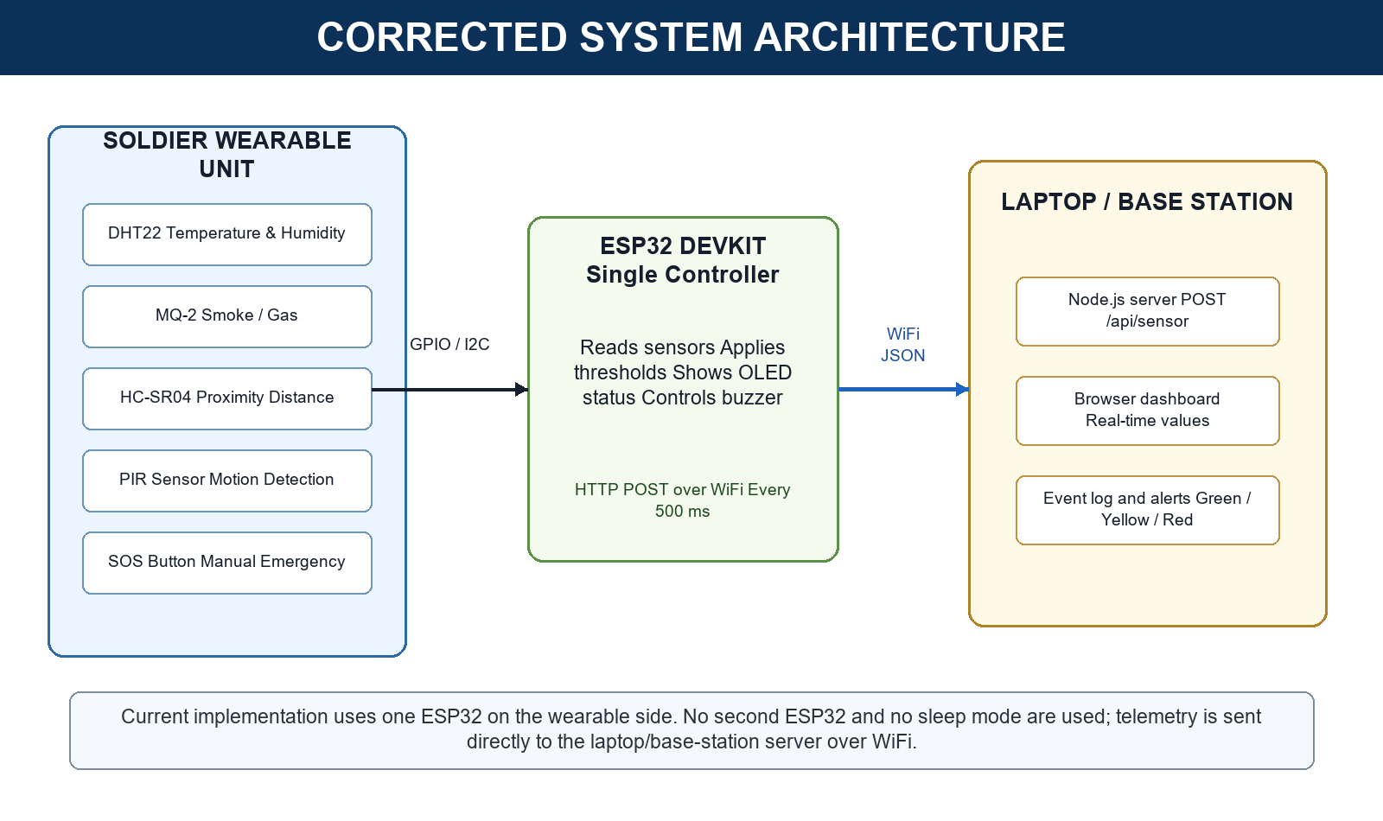
Fig. 3.1 Corrected architecture of the implemented single-ESP32 system.
3.2 Component Selection
Component | Connection / role | Purpose
ESP32 DevKit | Main controller with WiFi | Sensor acquisition, threshold logic, telemetry
DHT22 | GPIO 4 | Temperature and humidity sensing
MQ-2 | GPIO 34 analog, GPIO 35 digital | Smoke/gas detection
HC-SR04 | TRIG GPIO 5, ECHO GPIO 18 | Distance and proximity sensing
PIR sensor | GPIO 19 | Motion detection
SOS button | GPIO 27 with pull-up | Manual emergency trigger
OLED SH1106 | I2C SDA/SCL | Local readings and alert status
Buzzer | GPIO 23 | Audible local alert
Laptop server | Node.js, port 3000 | Receives JSON and serves dashboard

3.3 Threat Classification
The dashboard classifies distance into zones. Distances below 50 cm are treated as DANGER, distances from 50 cm to below 150 cm are CAUTION, values from 150 cm to below 400 cm are SAFE, and values beyond the practical ultrasonic range are OUT_OF_RANGE. Gas alert, PIR motion, and SOS state are also displayed as independent alert indicators.
3.4 Communication Protocol
Communication uses IEEE 802.11 WiFi and HTTP. The ESP32 sends a JSON payload to POST /api/sensor on the laptop server. The current firmware sends telemetry approximately every 500 ms, while DHT readings are updated every 2 seconds and faster sensors are refreshed more frequently. The dashboard polls the server and updates the visible interface in near real time.

CHAPTER 4 - HARDWARE AND SOFTWARE IMPLEMENTATION
4.1 Hardware Implementation
The hardware prototype was assembled on a breadboard. The ESP32 is placed centrally and connected to the DHT22, MQ-2, ultrasonic sensor, PIR sensor, OLED display, buzzer, and SOS button. The selected modules are low-cost and easily available, making the prototype reproducible for laboratory evaluation.
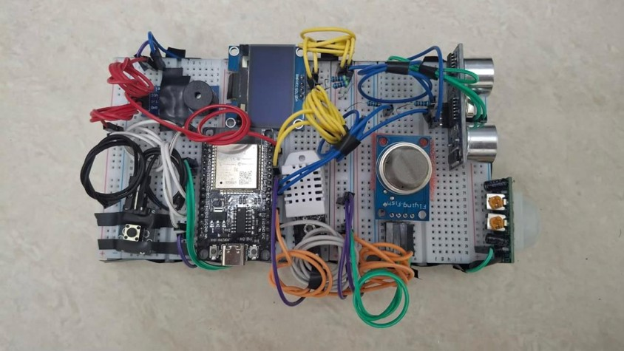
Fig. 4.1 Final assembled prototype.
4.2 Circuit and Power Design
The prototype uses a 18650 Li-ion cell with TP4056 charging/protection and MT3608 boost conversion in the planned power path. During demonstration, the system remains active and continuously connected to WiFi. The corrected report architecture avoids the earlier two-ESP32 base-station assumption.
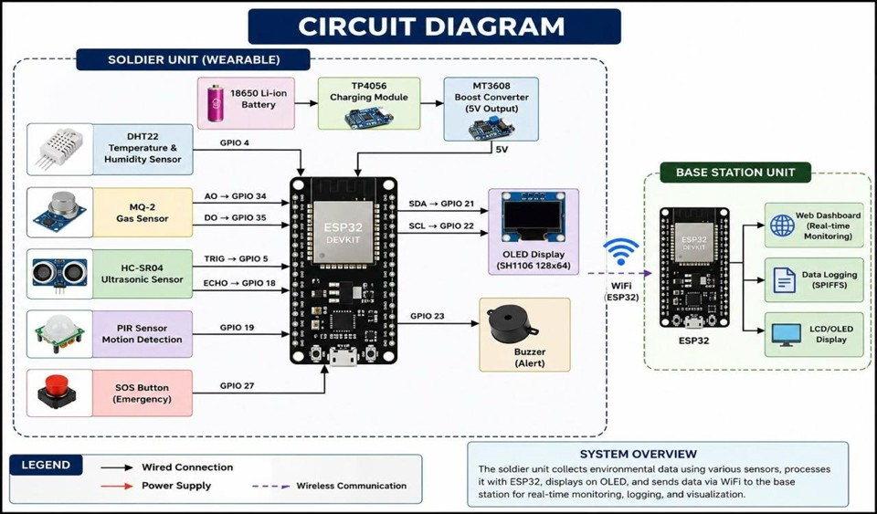
Fig. 4.2 Original circuit reference image used during development.
Note: The final implementation uses the sensor-side ESP32 only and sends directly to the laptop server. Any base-station ESP32 shown in the original development drawing is not part of the final report implementation.
4.3 Firmware Implementation
The Arduino firmware initializes WiFi, the DHT sensor, GPIO pins, and OLED display. It uses millis()-based timing instead of blocking delays for periodic sensor reading and WiFi transmission. DHT22 is read every two seconds, ultrasonic, MQ-2, and PIR readings are refreshed around every 200 ms, and the JSON payload is sent every 500 ms. The SOS button activates the buzzer and immediately sends an emergency state.
4.4 Dashboard Implementation
The laptop dashboard uses a Node.js Express server. The POST /api/sensor endpoint stores the latest telemetry, computes the distance zone, and exposes the current state through GET /data. The browser interface displays temperature, humidity, ultrasonic distance, MQ-2 gas value, PIR motion state, emergency status, radar visualization, connection state, and event logs.
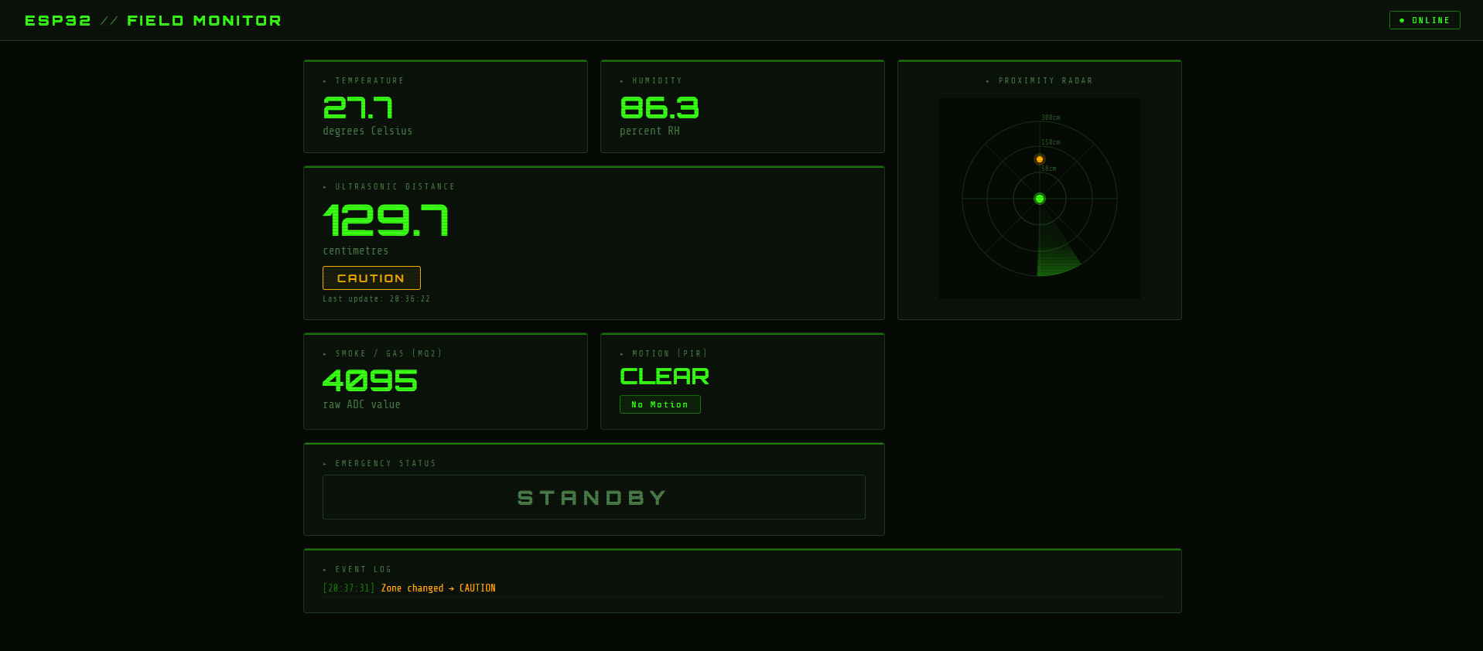
Fig. 4.3 Real-time dashboard screenshot.

CHAPTER 5 - EXPERIMENTAL SETUP
5.1 Test Setup
Testing was performed by powering the ESP32 prototype, connecting the ESP32 and laptop to the same WiFi network, starting the Node.js dashboard server, and observing the browser dashboard at http://localhost:3000. The server endpoint configured in the ESP32 firmware points to the laptop IP address and port 3000.
5.2 Test Procedure
- Verify WiFi connection and OLED startup message.
- Observe temperature and humidity readings from the DHT22.
- Move an object near the HC-SR04 sensor and confirm zone changes on OLED and dashboard.
- Expose the MQ-2 sensor to a safe simulated smoke/gas source and observe gas value changes.
- Trigger PIR motion and check the dashboard motion state.
- Press the SOS button and verify buzzer activation and emergency dashboard status.

5.3 Visual Evidence
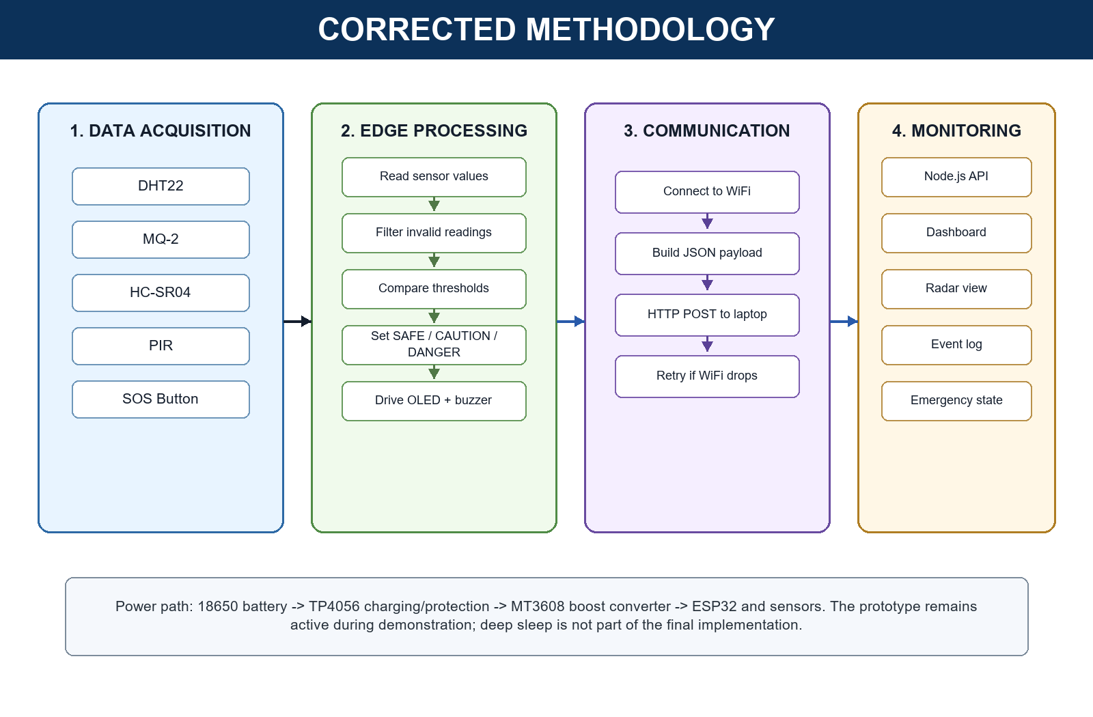
Fig. 5.1 Corrected methodology followed by the final implementation.
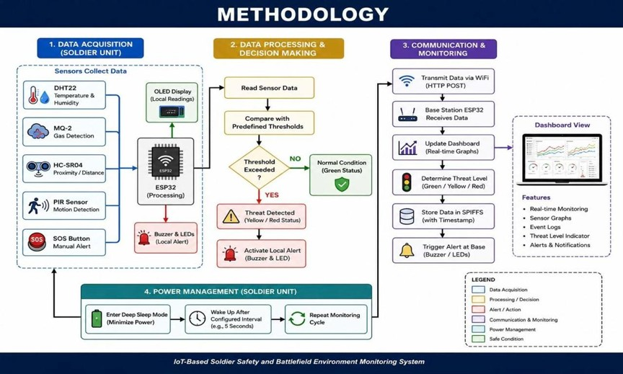
Fig. 5.2 Earlier methodology reference image from the research phase.
Note: The final methodology excludes deep sleep and the second ESP32. The corrected methodology diagram in Fig. 5.1 represents the implemented project.
5.4 Data Collected
Parameter | Observed source | Dashboard representation
Temperature | DHT22 | Degrees Celsius panel
Humidity | DHT22 | Percent RH panel
Distance | HC-SR04 | Centimetres, radar, zone badge
Gas | MQ-2 ADC | Raw ADC value and emergency state when alert is high
Motion | PIR | CLEAR or MOTION state
SOS | Button | STANDBY or emergency state

CHAPTER 6 - RESULTS AND DISCUSSION
6.1 Functional Results
The prototype successfully reads all connected sensors, shows local information on the OLED display, sends telemetry over WiFi, and updates the dashboard in near real time. The radar view provides an intuitive distance visualization, while the event log records important state transitions such as zone changes, motion detection, and emergency activation.
6.2 Alert Behaviour
The system distinguishes normal and risky conditions using threshold logic. For distance, SAFE, CAUTION, DANGER, and OUT_OF_RANGE states are shown. The SOS button overrides normal operation by activating an emergency state. Gas alert and danger-zone proximity are highlighted as urgent conditions.
6.3 Key Findings
Metric / feature | Result
Telemetry mode | ESP32 to laptop using WiFi HTTP POST
Dashboard refresh | Near real-time polling and radar animation
Distance classification | SAFE, CAUTION, DANGER, OUT_OF_RANGE
Emergency input | Manual SOS button with buzzer and dashboard emergency status
Final controller count | One ESP32 in the wearable unit
Sleep mode | Not implemented in final demonstration firmware
Approximate BOM target | Around INR 2,000 using low-cost modules

6.4 Limitations
- The breadboard prototype requires a rugged enclosure before field use.
- MQ-2 readings can drift during warm-up and require calibration for accurate gas concentration.
- WiFi range depends on local network conditions and is not suitable for long-distance battlefield deployment without LoRa or mesh networking.
- The current system does not implement encryption, authentication, GPS tracking, or cloud logging.
- Battery life was not validated for the final always-active implementation.

CHAPTER 7 - CONCLUSION AND FUTURE WORK
7.1 Conclusion
The project demonstrates a working low-cost IoT-based soldier safety and battlefield environment monitoring system using ESP32. By integrating DHT22, MQ-2, HC-SR04, PIR, OLED, buzzer, and SOS button with a WiFi dashboard, the prototype provides both local and remote awareness of environmental hazards. The final implementation uses one ESP32 and transmits directly to a laptop/base-station server, making the system simpler and easier to demonstrate than the earlier two-node concept.
The system satisfies the main IDEA Lab report requirements by including a clear problem definition, literature gap, architecture, implementation details, experimental setup, real visual evidence, results, limitations, and future scope. Its novelty lies in combining multiple environmental hazard sensors, local alerting, and real-time dashboard visibility in a compact and affordable wearable-style prototype.
7.2 Future Work
- Design and 3D-print a rugged wearable enclosure with protected sensor openings.
- Add GPS for live soldier location tracking.
- Replace local WiFi with LoRa or mesh networking for longer range.
- Add encrypted communication and authenticated dashboard access.
- Improve gas calibration and add sensor warm-up compensation.
- Evaluate controlled battery runtime for the always-active final implementation.
- Add cloud logging or offline CSV export for post-mission analysis.

REFERENCES
[1] N. Patil and B. Iyer, "Health monitoring and tracking system for soldiers using Internet of Things (IoT)," 2017 International Conference on Computing, Communication and Automation.
[2] T. D. Nguyen et al., "IoT-based military safety monitoring systems: concepts and challenges," International Journal of Engineering Research, 2022.
[3] M. Gone et al., "Real-time soldier health monitoring system using IoT and ESP32," SSRN Electronic Journal, 2024.
[4] S. Ullah et al., "A review of wireless body area networks for medical applications," International Journal of Communications, Network and System Sciences.
[5] D. Antolin, N. Medrano, B. Calvo, and F. Perez, "A wearable wireless sensor network for indoor smart environment monitoring in safety applications," Sensors Journal.
[6] M. Sokol et al., "Design and implementation of a wireless sensor network based on ESP32 for IoT applications," Proc. IEEE ELMAR, 2024.
[7] Project team, "IoT-Based Soldier Safety and Battlefield Environment Monitoring System Using ESP32: firmware, dashboard source, circuit notes, and bench observations," IDEA Lab project records, RV College of Engineering, 2025-26.
[8] Espressif Systems, "ESP32 Series Datasheet," Espressif Systems.
[9] Aosong Electronics, "DHT22/AM2302 Digital Temperature and Humidity Sensor Datasheet."
[10] Hanwei Electronics, "MQ-2 Semiconductor Sensor for Combustible Gas Datasheet."

APPENDICES
Appendix A - Core Algorithm Pseudocode
INITIALISE GPIO, sensors, OLED, buzzer, WiFi, and HTTP endpoint
REPEAT:
Read DHT22 temperature and humidity every 2 seconds
Read HC-SR04 distance, MQ-2 gas value, and PIR motion periodically
IF SOS button pressed THEN activate buzzer and set emergency state
Classify distance as SAFE, CAUTION, DANGER, or OUT_OF_RANGE
Update OLED with temperature, humidity, distance, gas, and status
Build JSON payload and POST it to laptop /api/sensor endpoint
Dashboard polls latest state and updates panels, radar, and event log
Appendix B - Pin and Interface Summary
Signal / module | ESP32 connection | Notes
DHT22 data | GPIO 4 | Temperature and humidity
MQ-2 analog | GPIO 34 | Raw ADC gas value
MQ-2 digital | GPIO 35 | Gas alert input
HC-SR04 trigger | GPIO 5 | Ultrasonic trigger
HC-SR04 echo | GPIO 18 | Ultrasonic echo
PIR sensor | GPIO 19 | Motion detection
SOS button | GPIO 27 | Input pull-up, active LOW
Buzzer | GPIO 23 | Local alert
OLED display | I2C SDA/SCL | SH1106 128x64 display

Appendix C - Demonstration Checklist
- Functional assembled kit with secure wiring.
- Laptop with working dashboard server and offline working-model video.
- Current prototype photograph and dashboard screenshot included in report.
- All student names, USNs, mentor name, and date verified.
- Formal dress, college ID card, hall ticket, charger, pen drive, and backup copy ready.
- Report printed with OHP transparent front and back covers.
- Each member prepared to explain individual contribution.

