Lab 6: Code and Branch Coverage Analysis
Name: Samarth Rajesh Rao
SRN: PES1UG24AM244
Assigned repo: L6_L7_06_event_ticket_tier (Event Ticket Tier)
Tools: Python 3.11.9, pytest 9.2.0, coverage.py

1. Objective
Measure the line and branch coverage of event_ticket_tier.py, then write test cases that reach at least 90% for each. Both were taken to 100%.

2. Application under test
process_ticket_manifest(manifests, service_tax_rate) prices ticket manifests by tier (vip 150, premium 90, general 45), applies an EARLYBIRD 20% discount or a 20 bulk discount for 5 or more seats, adds a 75 lounge fee, rejects bad or fraudulent orders, and returns COMPLETED, ZERO_SALES or AUDIT_REJECTED. monitor_gate_flow(turnstile_streams) returns NO_DATA, OVERFLOW (two consecutive rates above 50) or FLOW_NORMAL.

3. Results
Test file | Tests | Statements | Branches | Coverage
CodeCoverageTest_event_ticket_tier.py | 14 | 57 / 57 | not measured | 100% line
BranchCoverageTest_event_ticket_tier.py | 39 | 57 / 57 | 40 / 40 | 100% line and branch

4. Line coverage vs branch coverage
Line coverage asks whether each line ran at least once. Branch coverage asks whether each decision went both ways. A test can execute every line while never taking the else side of an if, so branch coverage is the stricter measure. Examples from this module: a fraud order on a non-VIP tier, a quantity of exactly 4 versus 5, and a streak that resets between turnstile streams.

5. Test design
- Input validation: a non-list manifest and a negative tax rate raise ValueError; a zero rate is valid.
- Tier selection: vip, premium, general, and an unknown tier that is rejected.
- Order loop: empty orders, quantity 0 and negative quantity rejected, missing keys defaulting.
- Promo handling: FRAUD_RISK on VIP (resets the total and breaks) and on non-VIP, EARLYBIRD, bulk discount at exactly 5 and not at 4, and an unrecognised promo.
- Lounge fee added or not added.
- Final status boundaries: exactly 4 rejections is COMPLETED, 5 is AUDIT_REJECTED, and AUDIT_REJECTED takes priority over ZERO_SALES.
- Gate flow: no data, overflow, a single high reading, streak reset, a rate of exactly 50, an empty stream, and streaks not carrying across streams.

6. Observations
- A FRAUD_RISK order on a non-VIP tier is counted as rejected, but its price is still added to the manifest total, so the customer is still billed. Tests record the current behaviour.
- On the VIP tier a fraud order wipes the manifest total and stops processing, but the exclusive lounge fee of 75 is still added afterwards.
- EARLYBIRD orders do not receive the bulk discount, because the discount is applied in an if/elif chain.

7. Screenshots
Code (line) coverage: 14 passed, 57 of 57 statements, 100%.
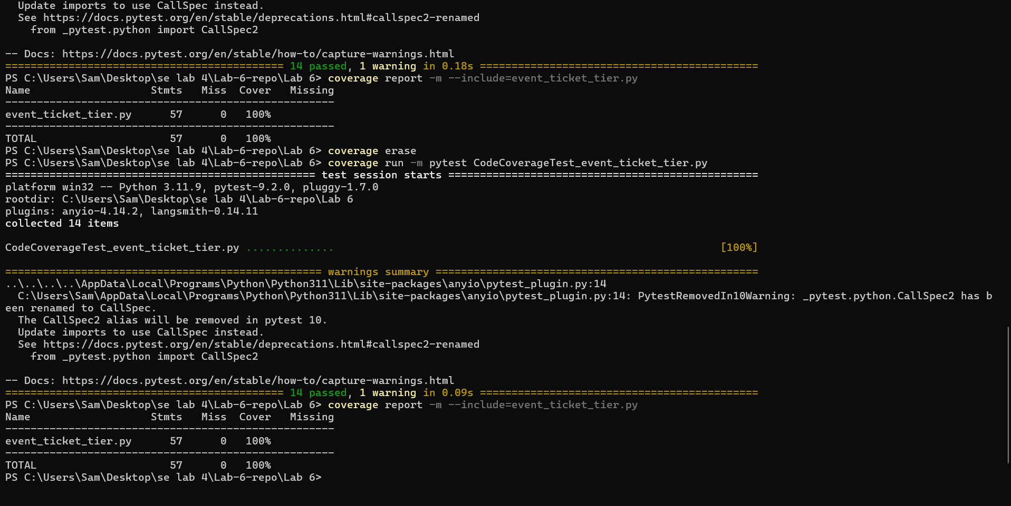
Branch coverage: 39 passed, 57 of 57 statements, 40 of 40 branches, 100%.
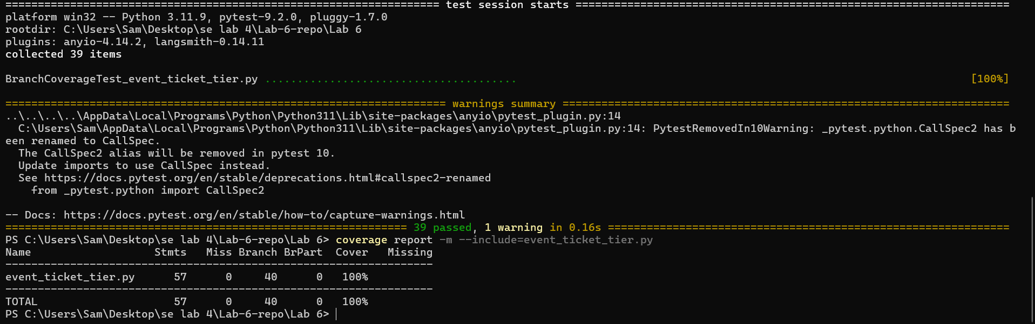

8. Commits
- Add event ticket application and starter test
- Add code coverage tests with screenshot
- Add branch coverage tests with screenshot
- Add report

