EXPERIMENT NO :- 7
Aim :-Aim: Use Seaborn to visualize data using boxplots, violin plots, and pairplots. Plot a heatmap to show correlations between variables. Customize plots with themes and color palettes.
Roll No.: 60
PROGRAM 1 – AGE LINE PLOT
Program:
import matplotlib.pyplot as plt
import seaborn as sns
import pandas as pd
data = {
'name': ['anash', 'maroof', 'saket', 'prashik'],
'age': [21, 23, 20, 24]
}
df = pd.DataFrame(data)
sns.lineplot(x=df.index, y='age', data=df)
plt.title('Age plot')
plt.xlabel('index')
plt.ylabel('age')
plt.show()
Output:
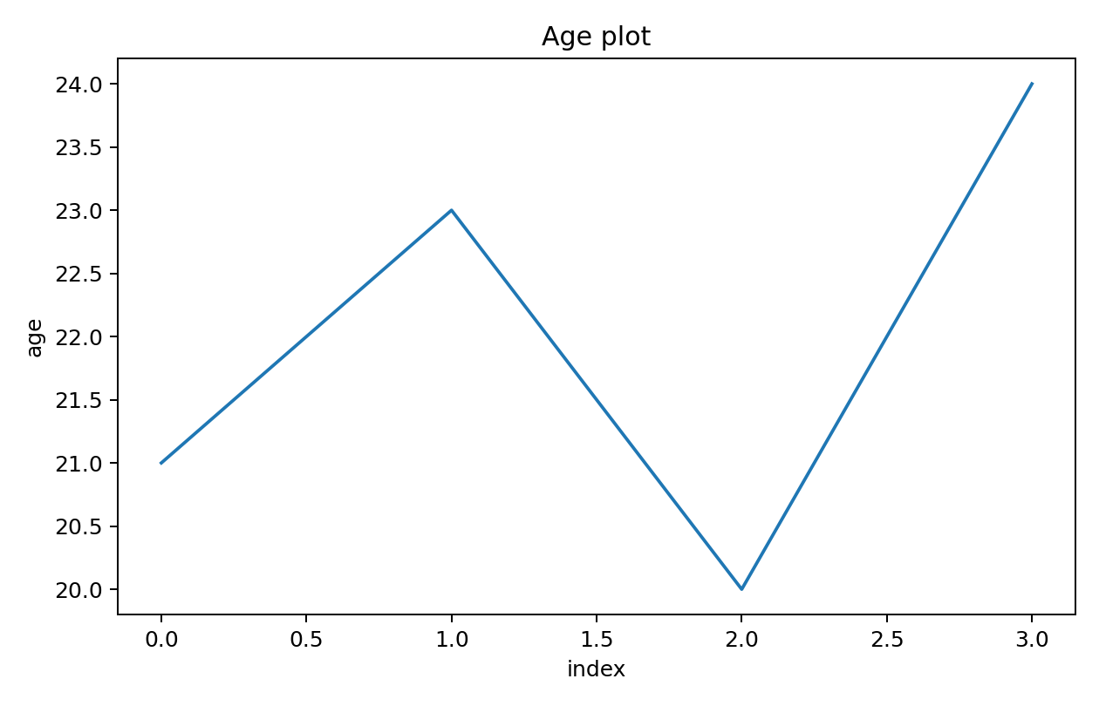
Graphical output obtained by executing the above program.

PROGRAM 2 – PRODUCT SALES BAR PLOT
Program:
import seaborn as sns
import matplotlib.pyplot as plt
import pandas as pd
data = {
'Product': ['Laptop', 'Phone', 'Tablet', 'TV', 'Watch', 'Headphones'],
'year': [2021, 2022, 2023, 2024, 2025, 2026],
'sales': [120, 180, 150, 220, 190, 250]
}
df = pd.DataFrame(data)
sns.barplot(x='Product', y='sales', hue='year', data=df)
plt.title('Product Sales')
plt.xlabel('Product')
plt.ylabel('Sales')
plt.show()
Output:
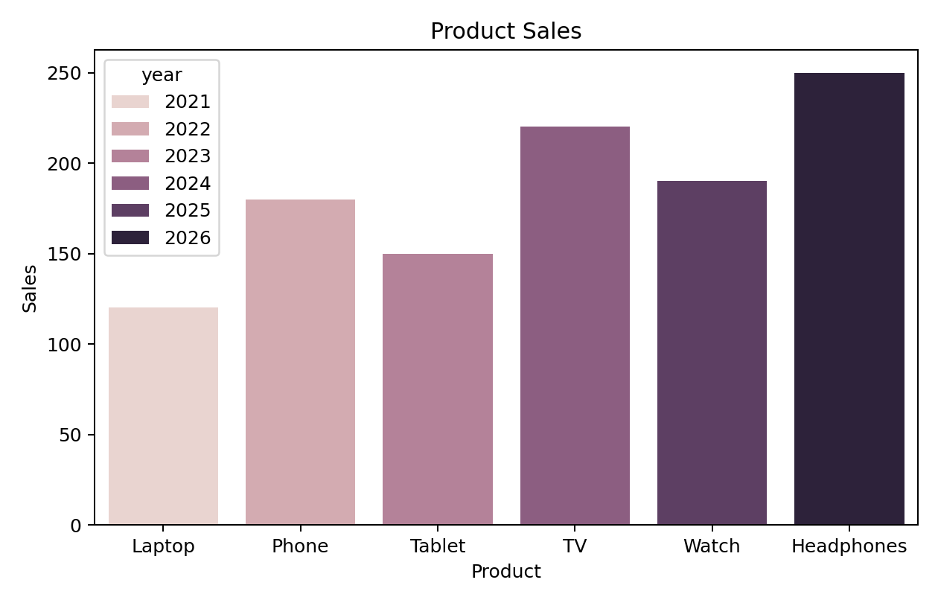
Graphical output obtained by executing the above program.

PROGRAM 3 – AGE SCATTER PLOT
Program:
import matplotlib.pyplot as plt
import seaborn as sns
import pandas as pd
data = {
'name': ['anash', 'maroof', 'saket', 'prashik'],
'age': [21, 23, 20, 24]
}
df = pd.DataFrame(data)
sns.scatterplot(x=df.index, y='age', data=df)
plt.title('Age plot')
plt.xlabel('index')
plt.ylabel('age')
plt.show()
Output:
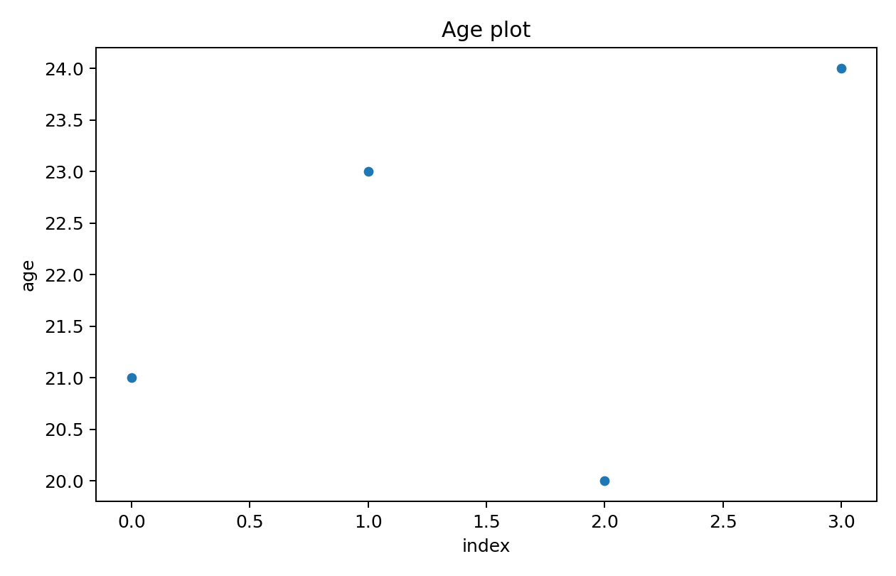
Graphical output obtained by executing the above program.

PROGRAM 4 – BOX PLOT.
Program:
import pandas as pd
import seaborn as sns
import matplotlib.pyplot as plt
data = {
'Department': ['Electrical', 'Electrical', 'Mechanical',
'Mechanical', 'Electrical', 'Mechanical'],
'Gender': ['Male', 'Female', 'Male', 'Female', 'Male', 'Female'],
'Marks': [78, 85, 72, 88, 65, 92]
}
df = pd.DataFrame(data)
sns.boxplot(data=df, x='Department', y='Marks', hue='Gender')
plt.title('Distribution of Marks by Department and Gender')
plt.xlabel('Department')
plt.ylabel('Marks')
plt.show()
Output:
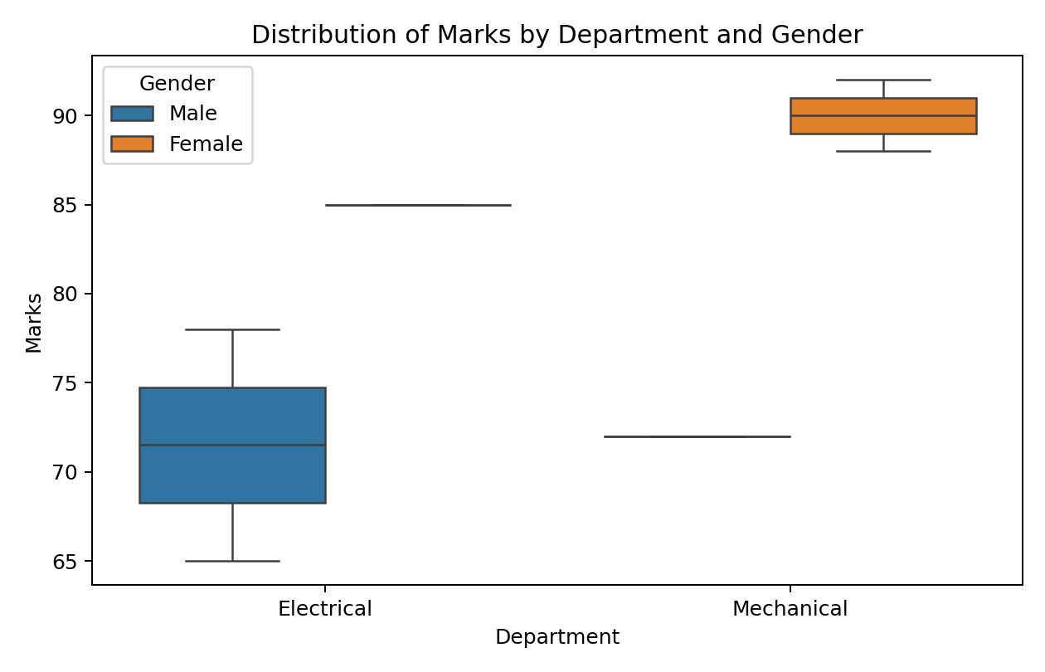
Graphical output obtained by executing the above program.

PROGRAM 5 – CORRELATION HEATMAP
Program:
import pandas as pd
import seaborn as sns
import matplotlib.pyplot as plt
x = [10, 12, 14, 16, 18, 20]
y = [5, 8, 11, 14, 16, 17]
z = [8, 10, 12, 15, 17, 19]
df = pd.DataFrame({'X': x, 'Y': y, 'Z': z})
corr = df.corr()
sns.heatmap(corr, annot=True, fmt='.4f', cmap='Reds')
plt.title('Correlation Heatmap')
plt.show()
Output:


