**PIJ Assignment 3: Student Management System**

// Name: Samarth Bhadane

// PRN: 24070126503

// Batch: A2

import java.util.Scanner;

public class Main {

    public static void main(String[] args) {

        // creating Scanner object

        Scanner sc = new Scanner(System.in);

        // creating StudentOperations object

        StudentOperations operations = new StudentOperations();

        int choice;

        // displaying the menu

        do {

            System.out.println("\n=== Student Management System ===");

            System.out.println("1. Add Student");

            System.out.println("2. Display Students");

            System.out.println("3. Search Student by PRN");

            System.out.println("4. Search Student by Name");

            System.out.println("5. Update Student");

            System.out.println("6. Delete Student");

            System.out.println("7. Exit");

            System.out.print("Enter your choice: ");

            choice = sc.nextInt();

            sc.nextLine();

            // switch case to handle operations according to input

            switch (choice) {

                case 1:

                    operations.addStudent(sc);

                    break;

                case 2:

                    operations.displayStudents();

                    break;

                case 3:

                    operations.searchStudentByPrn(sc);

                    break;

                case 4:

                    operations.searchStudentByName(sc);

                    break;

                case 5:

                    operations.updateStudent(sc);

                    break;

                case 6:

                    operations.deleteStudent(sc);

                    break;

                case 7:

                    System.out.println("Exiting...");

                    break;

                default:

                    System.out.println("Invalid choice! Try again.");

            }

        } while (choice != 7);

        sc.close();

    }

}

// Student.java

import java.text.SimpleDateFormat;

import java.util.Date;

public class Student {

    // declaring the instance members

    private long prn;

    private String name;

    private Date dob;

    private double marks;

    // declaring constructors

    public Student(long prn, String name, Date dob, double marks) {

        this.prn = prn;

        this.name = name;

        this.dob = dob;

        this.marks = marks;

    }

    // getters and setters

    public long getPrn() {

        return prn;

    }

    public void setPrn(long prn) {

        this.prn = prn;

    }

    public String getName() {

        return name;

    }

    public void setName(String name) {

        this.name = name;

    }

    public Date getDob() {

        return dob;

    }

    public void setDob(Date dob) {

        this.dob = dob;

    }

    public double getMarks() {

        return marks;

    }

    public void setMarks(double marks) {

        this.marks = marks;

    }

    // display method

    public void displayStudentDetails() {

        SimpleDateFormat sdf = new SimpleDateFormat("dd-MM-yyyy");

        System.out.println("PRN: " + prn);

        System.out.println("Name: " + name);

        System.out.println("DOB: " + sdf.format(dob));

        System.out.println("Marks: " + marks);

    }

}

// StudentOperations.java

import java.text.ParseException;

import java.text.SimpleDateFormat;

import java.util.ArrayList;

import java.util.Date;

import java.util.Scanner;

public class StudentOperations {

    private ArrayList<Student> students;

    // constructor

    public StudentOperations() {

        students = new ArrayList<>();

    }

    // method to add student

    public void addStudent(Scanner sc) {

        try {

            System.out.println("Enter PRN: ");

            long prn = sc.nextLong();

            sc.nextLine();

            System.out.println("Enter Name: ");

            String name = sc.nextLine();

            System.out.println("Enter DOB (yyyy-mm-dd): ");

            String dobStr = sc.nextLine();

            SimpleDateFormat sdf = new SimpleDateFormat("dd-MM-yyyy");

            Date dob = sdf.parse(dobStr); // parse the input string to a date object

            System.out.println("Enter Marks: ");

            double marks = sc.nextDouble();

            students.add(new Student(prn, name, dob, marks));

            System.out.println("Student added successfully!");

        } catch (ParseException e) {

            System.out.println("Invalid date format! Please use dd-MM-yyyy.");

        }

    }

    // method to display all students

    public void displayStudents() {

        if (students.isEmpty()) {

            System.out.println("No students to display!");

            return;

        }

        for (Student student : students) {

            student.displayStudentDetails();

        }

    }

    // method to search student by PRN

    public void searchStudentByPrn(Scanner sc) {

        System.out.print("Enter PRN to search: ");

        long prn = sc.nextLong();

        for (Student student : students) {

            if (student.getPrn() == prn) {

                System.out.println("Student found:");

                student.displayStudentDetails();

                return;

            }

        }

        System.out.println("Student with PRN " + prn + " not found.");

    }

    // method to search student by name

    public void searchStudentByName(Scanner sc) {

        System.out.print("Enter Name to search: ");

        String name = sc.nextLine();

        for (Student student : students) {

            if (student.getName().equalsIgnoreCase(name)) {

                System.out.println("Student found:");

                student.displayStudentDetails();

                return;

            }

        }

        System.out.println("Student with Name " + name + " not found.");

    }

    // method to update student details

    public void updateStudent(Scanner sc) {

        System.out.print("Enter PRN of student to update: ");

        long prn = sc.nextLong();

        sc.nextLine();

        for (Student student : students) {

            if (student.getPrn() == prn) {

                System.out.print("Enter new Name: ");

                String name = sc.nextLine();

                student.setName(name);

                System.out.print("Enter new Date of Birth (yyyy-mm-dd): ");

                String dobStr = sc.nextLine();

                if (!dobStr.isEmpty()) {

                    SimpleDateFormat sdf = new SimpleDateFormat("dd-MM-yyyy");

                    try {

                        Date dob = sdf.parse(dobStr);

                        student.setDob(dob);

                    } catch (ParseException e) {

                        System.out.println("Invalid date format! Please use dd-MM-yyyy.");

                        return;

                    }

                }

                System.out.print("Enter new Marks: ");

                double marks = sc.nextDouble();

                student.setMarks(marks);

                System.out.println("Student updated successfully.");

                return;

            }

        }

        System.out.println("Student with PRN " + prn + " not found.");

    }

    // method to delete student

    public void deleteStudent(Scanner sc) {

        System.out.print("Enter PRN of student to delete: ");

        long prn = sc.nextLong();

        for (int i = 0; i < students.size(); i++) {

            if (students.get(i).getPrn() == prn) {

                students.remove(i);

                System.out.println("Student deleted successfully.");

                return;

            }

        }

        System.out.println("Student with PRN " + prn + " not found.");

    }

}

Output-

1. Add Student

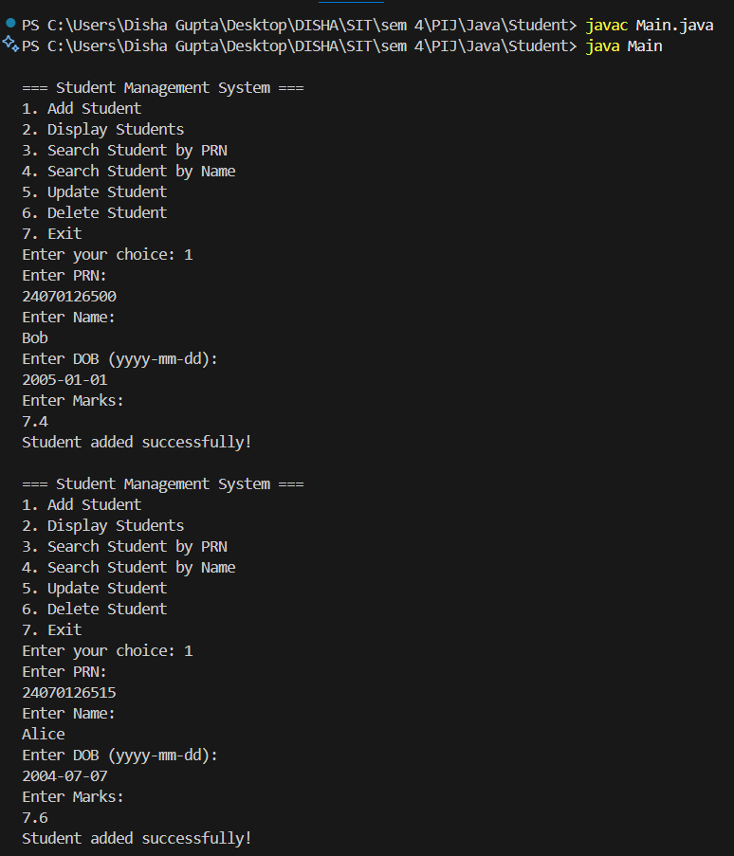

1. Display Students

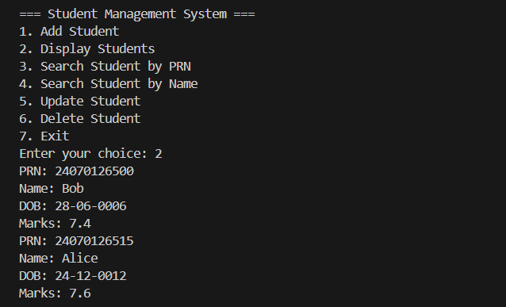

1. Search Student by PRN

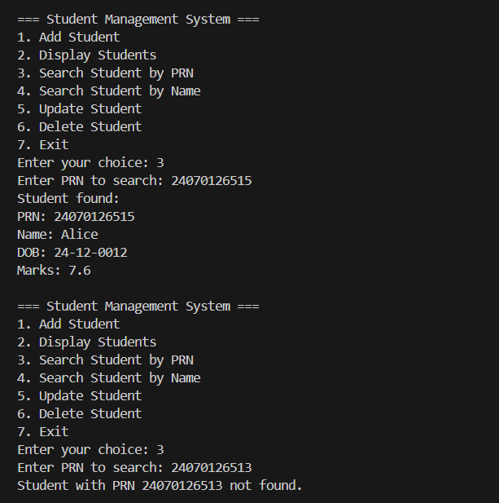

1. Search student by name

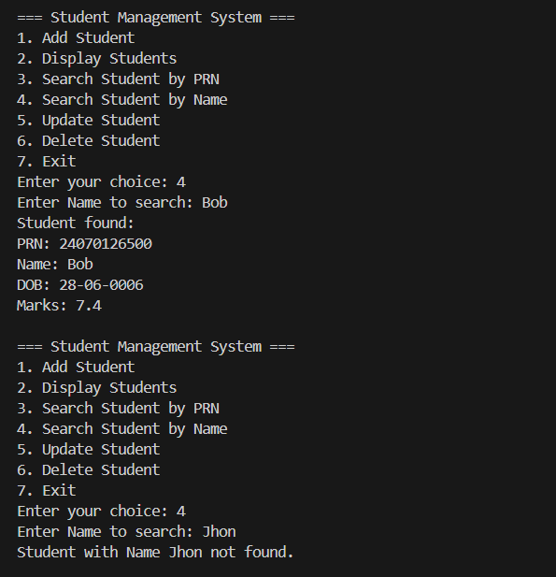

1. Update Student

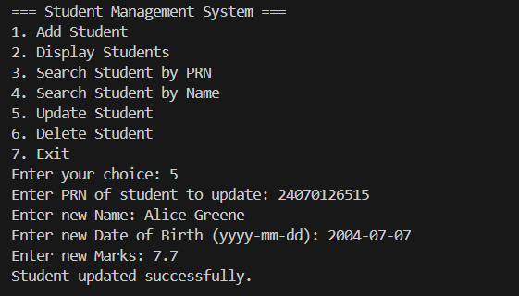

1. Delete Student

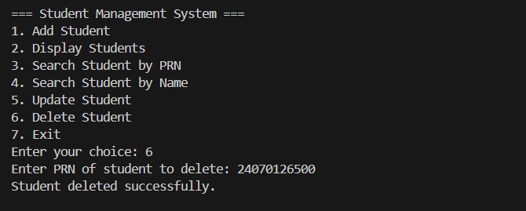

1. Exit

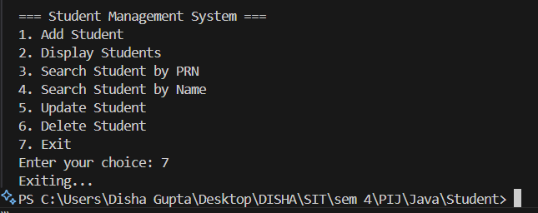

Link to the repository: <https://github.com/samarthsb4real/PIJ-Assignment-3.git>