DEEP DATA HACKATHON 2026 · PROBLEM STATEMENT 1 · HEALTHCARE
Sepsis Monitor
Early ICU sepsis prediction, from raw hourly records to a clinician-facing dashboard
0.821  AUROC, 5-fold cross-validation with whole patients held out | 0.114  AUPRC, 5.3 times the 0.022 chance level for this data | 108,704  test rows scored, validated against the organizers’ format | 6 pages  dashboard with live in-browser prediction for manual entry

One pipeline, two halves: a Python backend that cleans the data, builds causal time-series features, trains and calibrates a gradient-boosted model and writes the Kaggle submission, and a React frontend that shows the same model’s output to clinicians and lets anyone enter a patient’s values and get a prediction.
Data: PhysioNet/CinC Challenge 2019 ICU records. Research demonstration, not a medical device.
THE CHALLENGE

Predict sepsis hours before it is clinically obvious
- Sepsis is a life-threatening response to infection. Treatment works best when it starts early.  - The task: for every hour of an ICU stay, output the probability that the patient is developing sepsis, ideally about six hours before clinical onset.  - Scored on AUPRC and AUROC. AUPRC is the harder, more honest metric here because only about 2% of hours are sepsis hours.  - The hard parts are in the data itself: sparse labs, informative missingness, two hospital systems that record differently, and a heavy class imbalance. | The data at a glance
   | Value
  Training set | 11,245 patients, 437,418 hourly rows
  Test set (labels hidden) | 2,812 patients, 108,704 hourly rows
  Patients who develop sepsis | 991 (8.8%)
  Sepsis hours | 2.2% of all rows
  Variables per hour | 7 usable vital signs, 26 lab values, 6 demographic and stay fields
  Labs measured in a given hour | 0.1% to 13% of hours per lab; one vital sign (EtCO₂) is 100% empty
  Patient overlap, train vs test | none (checked)
APPROACH

One pipeline from raw CSV to a prediction on screen
1  Clean  Range checks, forward-fill only, measurement flags | 2  Features  219 causal features: windows, trends, scores | 3  Model  Gradient-boosted trees (scikit-learn) | 4  Validate  5-fold CV, whole patients held out | 5  Calibrate  Probabilities you can read, justified alert threshold | 6  Deliver  Kaggle submission and the dashboard

Backend (Python)  - pandas and NumPy for data, scikit-learn for the model and validation.  - A package (src/sepsis) with cleaning, features, calibration, evaluation, submission and pipeline modules.  - 13 automated tests, including a proof that features never use future hours.  - The same code builds the self-contained Kaggle notebook. | Frontend (React)  - React 18, TypeScript and Vite; charts are hand-drawn SVG, no chart library.  - Six pages: census, alert queue, patient investigation, assess patient, model performance, settings.  - The trained model is exported as JSON and runs in the browser.  - Every number on screen comes from data; missing results show “Not available”.
BACKEND 1

Cleaning that never looks at the future
Step | What we do | Why
Drop empty column | EtCO₂ is missing in 100% of rows and is removed. | It carries no information.
Physiological range checks | Impossible values become missing (for example heart rate outside 20 to 300, FiO₂ outside 0.1 to 1, pH outside 6.5 to 8). | Entry and sensor errors would otherwise distort the model.
Forward-fill only | The last known value is carried forward; nothing is ever back-filled. | Back-filling would copy a future measurement into the past.
Measurement flags | For every vital and lab: measured this hour, how many times so far, hours since last measured. | Missingness is informative: sicker patients are measured more.
Hospital signal | The unit fields are empty for one hospital system; this is kept as an explicit flag. | The two systems record different things and have different base rates.

Per patient and causal. No step looks at a later hour or at another patient. The test set is cleaned with exactly the same code, patient by patient.
BACKEND 2

219 causal features that describe how a patient is changing
Feature group | Examples | Count
Latest known values | Heart rate, MAP, lactate, creatinine, platelets, and the other vitals and labs | 33
Measurement history | Hours since each variable was last measured; how many times it has been measured | 66
Short rolling windows (6 h) | Mean, minimum, maximum and spread of each vital sign | 28
Long rolling windows (12 h) | Mean, minimum and maximum of each vital sign | 21
Trends | Change over 6 h for every variable; change over 12 h for vital signs | 40
Running extremes | Highest heart rate, lowest MAP, peak lactate and creatinine since ICU admission | 12
Clinical scores | qSOFA, SIRS, partial SOFA, shock index, MAP < 65, lactate > 2, and their running maximum and 6 h change | 12
Patient and stay | Age, sex, unit, hospital-to-ICU time, ICU length of stay, hospital-system flag | 7

Proof, not promise. A unit test changes or deletes every future hour of a patient and checks that each earlier feature is identical. A second test checks that patients do not leak into one another. Scores use only variables this dataset has (no GCS), and say so.
BACKEND 3

Validated on patients the model never saw
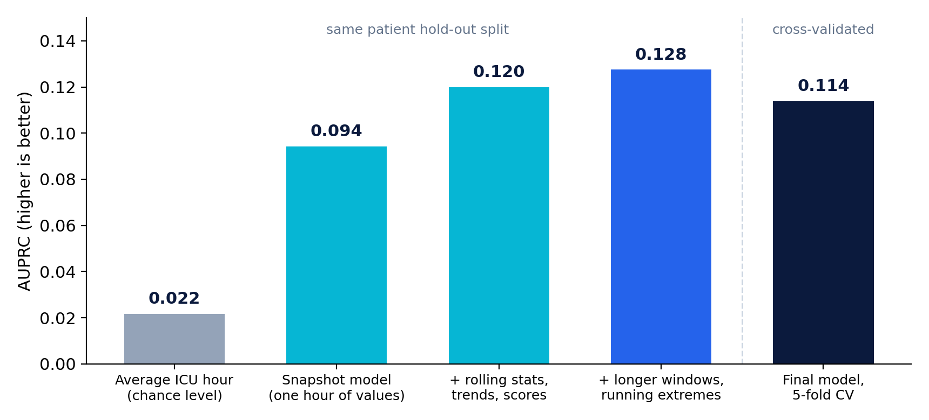  AUPRC at each stage. The first four bars use one patient hold-out split; the last is the final 5-fold result. | 5-fold cross-validation
  Fold | AUROC | AUPRC
  1 | 0.830 | 0.133
  2 | 0.825 | 0.111
  3 | 0.814 | 0.118
  4 | 0.832 | 0.113
  5 | 0.805 | 0.103
  All out-of-fold | 0.821 | 0.114

- GroupKFold on Patient_ID: all hours of a patient sit on one side only, and the pipeline asserts it. Row-level splits would leak and inflate the score.
- Model: HistGradientBoostingClassifier (400 trees, 15 leaves, strong regularisation). It handles missing values natively, so labs are never invented.
- Time-aware features lifted AUPRC from 0.094 to 0.128 and AUROC from 0.808 to 0.845 on the same hold-out split. Scores vary by fold (AUPRC 0.103 to 0.133), which is expected with about 990 septic patients.
BACKEND 4

Probabilities you can read, and an alert threshold we can defend
Calibration  - Platt scaling is fitted on out-of-fold predictions and judged on patients it was not fitted on.  - Held-out Brier score 0.0192 → 0.0188; expected calibration error 0.0055 → 0.0035. It is kept only because it helped.  - The transform is strictly monotone, so AUROC and AUPRC are unchanged.  Alert threshold: 0.079  - Chosen to maximise F1 on the calibrated out-of-fold probabilities.  - At that point: sensitivity 33.0%, specificity 95.7%, precision 14.6%.  - 502 of 991 septic patients trigger an alert; the median first alert comes 28.5 h before the labelled onset. This counts any early alert, including false alarms, so we treat it as a ceiling, not a promise. | 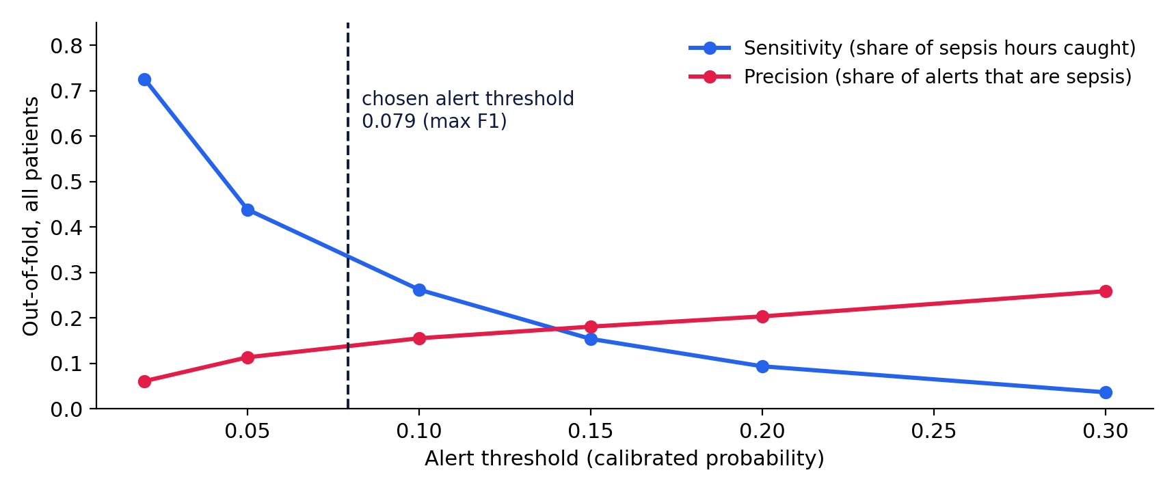  Lower thresholds catch more sepsis and raise more false alarms. A hospital would pick its own point.
SUBMISSION

Built to the organizers’ rules, and checked by code
Rule | How we meet it | How it is verified
Exact columns Patient_ID, Hour, SepsisLabel, same rows and order as sample_submission.csv | The file is built from the sample’s own keys, never from the test file’s order. | submission.validate and unit tests that break the file six different ways
Predict every test row; never drop missing rows | Left join from the sample; any row without a prediction raises an error. | Validated: 108,704 of 108,704 rows present
Continuous probabilities between 0 and 1, not 0/1 | Calibrated probabilities (test range 0.0009 to 0.62). | Validated range and non-binary check
Validate at patient level; no leakage | GroupKFold on Patient_ID with an assertion; causal features. | Pipeline assertion and test_features.py
Hand in a runnable Kaggle notebook | sepsis_submission.ipynb is generated from the same modules, finds the data under /kaggle/input, trains and writes submission.csv. | Executed end to end on the real data; the output file passed validation

Step-by-step Kaggle instructions (verify phone, upload the dataset publicly, import the notebook, attach the data, Run All, Save and share) are written up in SUBMIT_ON_KAGGLE.md.
FRONTEND 1

Unit Census: who needs attention, right now
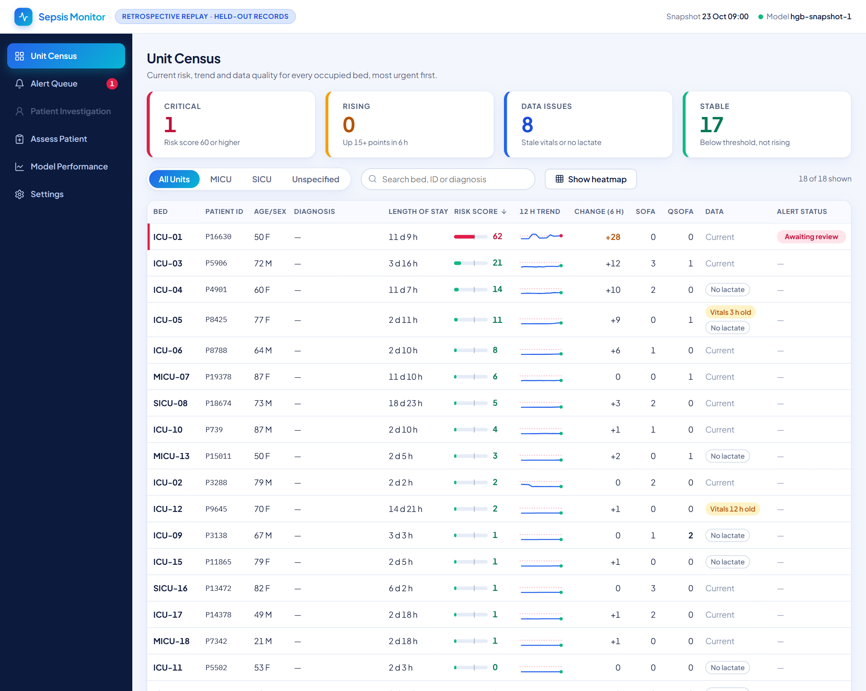  Unit Census (retrospective replay of held-out records) | - Critical, Rising, Data issues and Stable cards count the unit and double as filters.  - Sortable table with a risk bar, 12-hour trend and 6-hour change for every bed.  - Unit filter, search, and a 48-hour risk heatmap to see who deteriorated and when.  - Stale vitals and missing lactate are flagged beside the score so nobody trusts a number that rests on old data.
FRONTEND 2

Alert Queue: act on the most urgent first
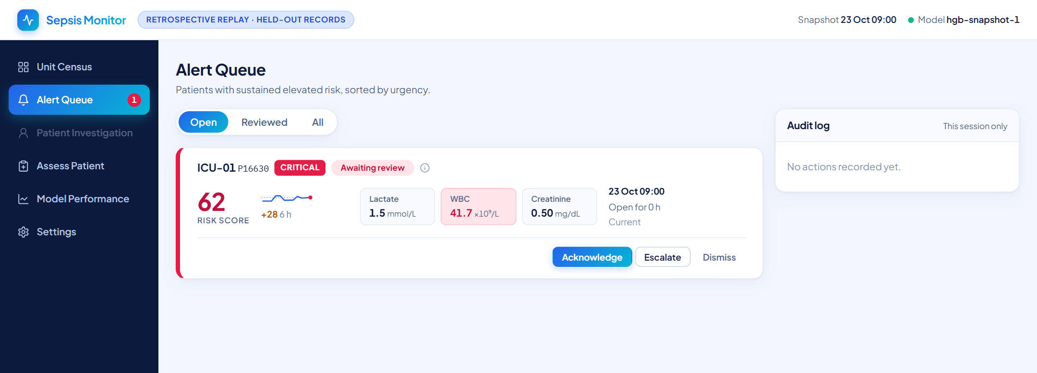  Alert Queue | - Alerts are ranked by a priority score; hover the (i) to see exactly how it is built.  - Each card shows the score, trend, 6-hour change and the lactate, WBC and creatinine behind it.  - Acknowledge, Escalate or Dismiss, with a required reason, and an audit log of every action in the session.
FRONTEND 3

Patient Investigation: why is this score high?
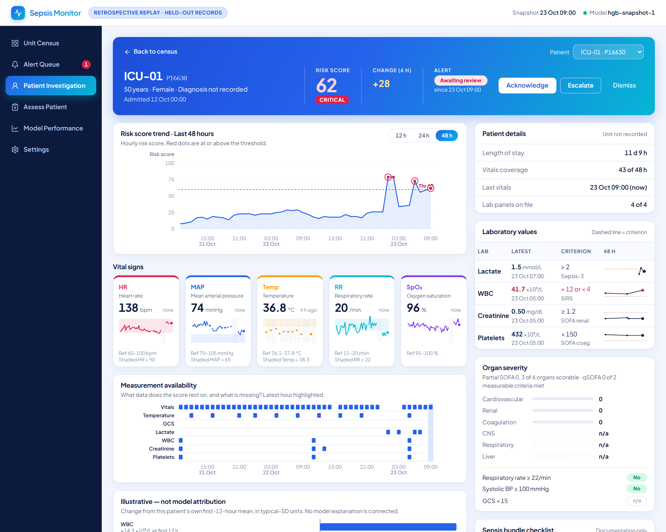  Patient Investigation | - Risk trend with the alert threshold and recorded events; 12, 24 and 48 hour views.  - Five vital-sign panels share one hover time with the risk chart.  - Labs with their decision criteria, partial SOFA and qSOFA, data-quality summary and a documentation-only sepsis-bundle checklist.
FRONTEND 4

Assess Patient: type a record in, get a prediction
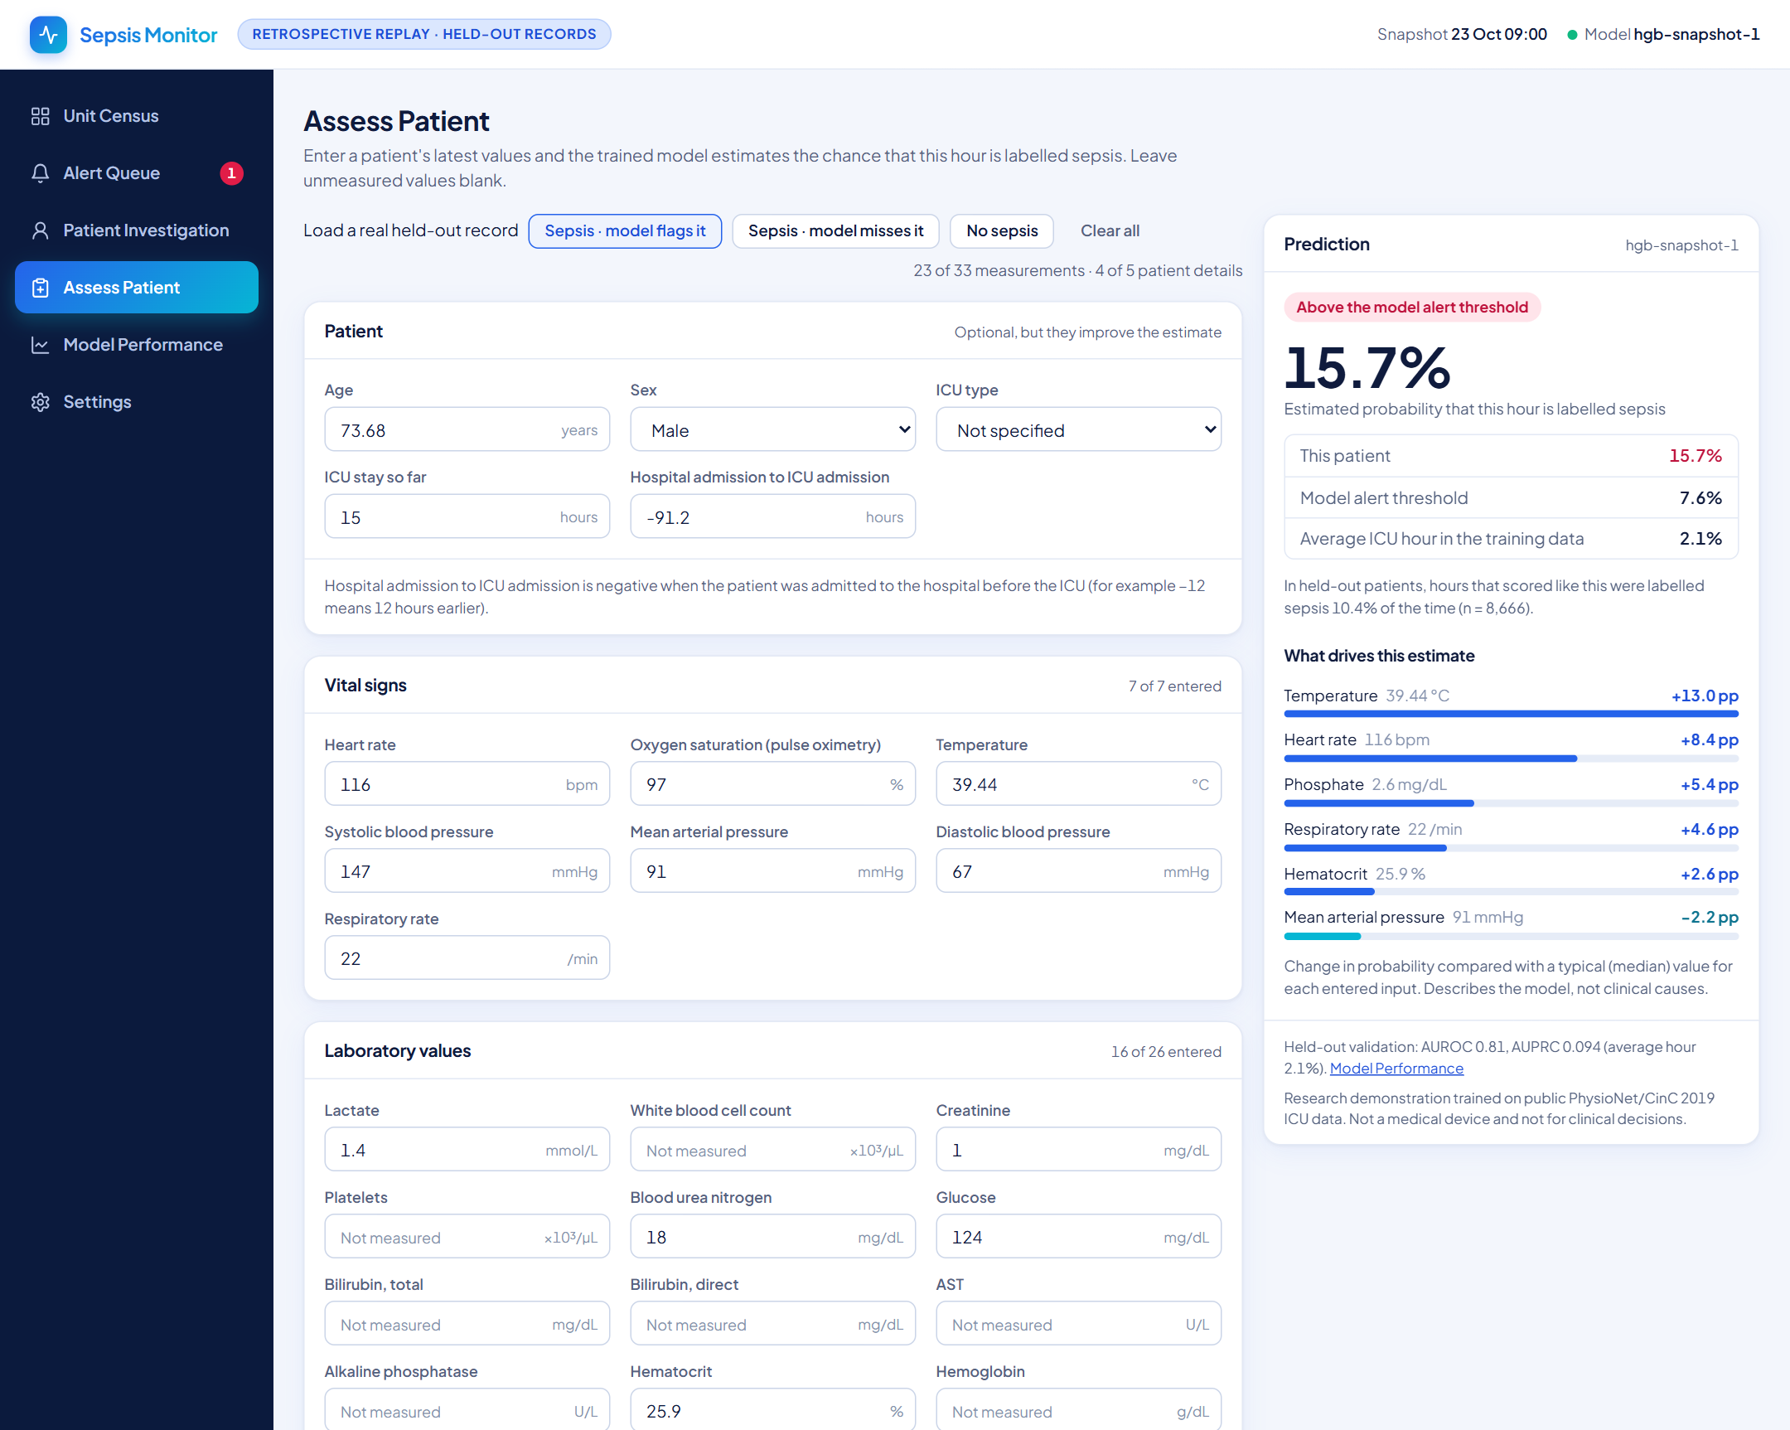  Assess Patient with a real held-out record loaded | - Enter any of the 33 vitals and labs plus patient details; leave the rest blank.  - The model answers instantly in the browser: the probability, the alert threshold, and how often similar scores were sepsis in held-out data.  - What drives the estimate: each entered value compared with a typical one.  - Three real held-out records load in one click: a sepsis case the model flags, one it misses, and a non-sepsis case. The miss is shown on purpose.
FRONTEND 5

Honest model reporting and engineering that holds up
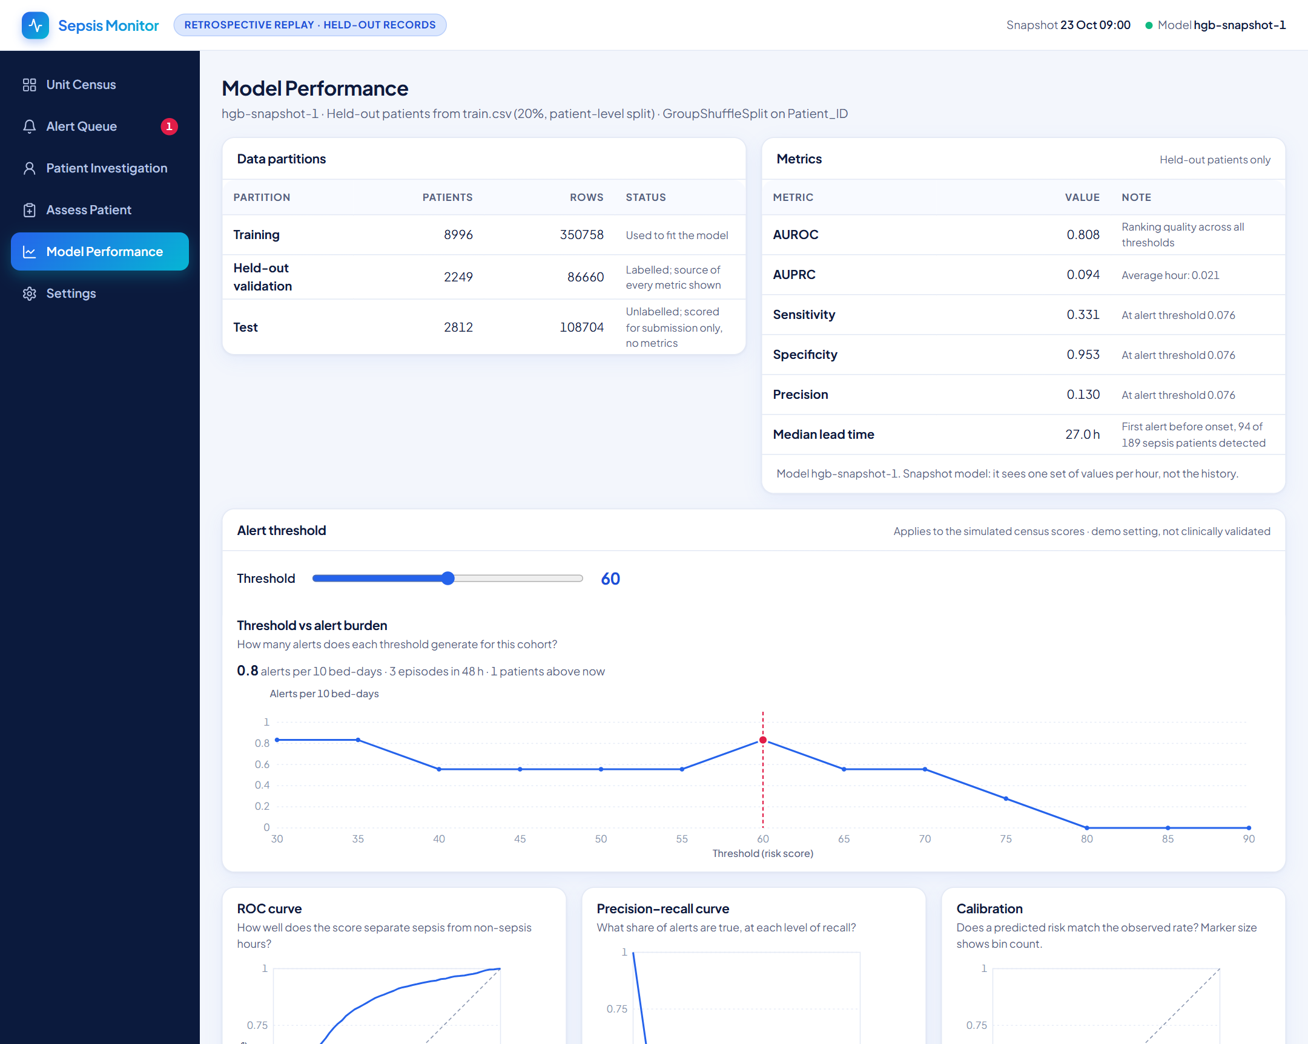  Model Performance, drawn from the real held-out evaluation | - Metrics and ROC, precision-recall, calibration and lead-time charts come from the evaluation file. If a result does not exist the page says “Not available”.  - The browser model reproduces scikit-learn to 1e-8 on 500 real rows, including blank inputs. That check found two export bugs before users could.  - 50+ scripted browser checks cover filters, dialogs, hover sync, the assess form and every page.  - Keyboard operable, focus-trapped dialogs, labelled charts, and a data-source badge so simulated and real data are never confused.
PUTTING IT TOGETHER

How the backend feeds the frontend
Backend produces | Frontend uses it for
model.json: 250 exported trees of the snapshot model, feature ranges, held-out evaluation and curves | Assess Patient predictions and every metric on Model Performance
examples.json: three real held-out records with the model’s probability | The “Load a real held-out record” buttons
dataset.json: patients, hourly observations and model scores | Unit Census, Alert Queue and Patient Investigation (labelled as retrospective replay of held-out records)
submission.csv: one probability per test hour | The Kaggle hand-in, and the scores replayed in the dashboard

Why two models?
- The submission model (219 features, AUROC 0.821, AUPRC 0.114) needs an hour-by-hour history, which a person typing one record cannot provide.
- The dashboard form uses a snapshot model trained on the same data from a single set of values (held-out AUROC 0.808, AUPRC 0.094), so manual entry is honest about what it can see.
- Both use the same cleaning, the same patient-level validation and the same calibration check.
LIMITS AND NEXT STEPS

What we claim, and what we do not
Limits, stated plainly  - AUPRC 0.114 is a real but modest signal: the model finds about a third of sepsis hours at a 15% hit rate. It is a screening aid, not a diagnosis.  - All metrics are out-of-fold on the training patients. The hidden test labels were never used.  - No GCS and no oxygenation ratio in this data, so SOFA is partial.  - The 28.5 h median lead time counts any early alert, including false alarms.  - Trained on one public dataset from two hospital systems; it has not been validated on another hospital.  - Research demonstration. Not a medical device and not for clinical decisions. | Next steps  - Add a sequence model (GRU or temporal convolution) and blend it with the trees.  - Calibrate per hospital system and check fairness across age and sex.  - Tune the alert threshold with clinicians to a workable alert rate per ward.  - Serve the model behind an API so the dashboard reads live scores.  - Prospective and external validation before any clinical use.
REPRODUCE AND SUMMARY

Run it yourself
Goal | Command
Clean the raw data | python scripts/01_clean.py
Train, cross-validate, calibrate, write submission.csv | python scripts/05_train_temporal.py
Train the snapshot model for the dashboard | python scripts/03_train.py
Rebuild the Kaggle notebook | python scripts/build_notebook.py
Run the tests | python -m pytest tests -q
Run the dashboard | cd frontend && npm install && npm run dev

5.3×  better than chance at ranking sepsis hours (AUPRC 0.114 vs 0.022) | 0  patients shared between training and validation folds | 100%  of 108,704 test rows predicted, in the sample’s order | 2 halves  one codebase: backend model and frontend that explains it

