PORTFOLIOPRO — WORKING APPLICATION SCREENSHOTS
Live Deployed / Localhost Running System Verification
Candidate: Samarth Singh | HCL Career Shaper COE Submission
GitHub: https://github.com/samarthsingh1507/Portfolio-Pro

Figure 1: Authentication & User Login Portal
Secure authentication screen with BCrypt password verification and reactive Angular form validation.

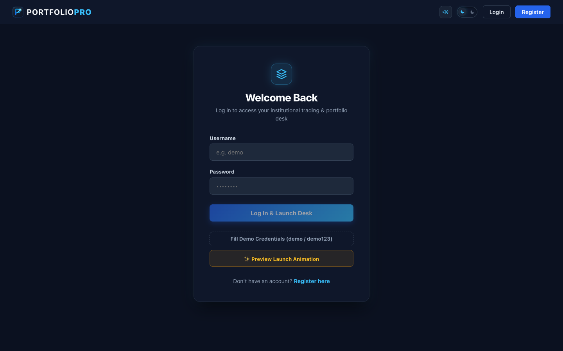

Figure 2: Executive Market Dashboard & Live Tickers
Main trading dashboard displaying market metrics, top gainers/losers, indices, and real-time quote feeds.

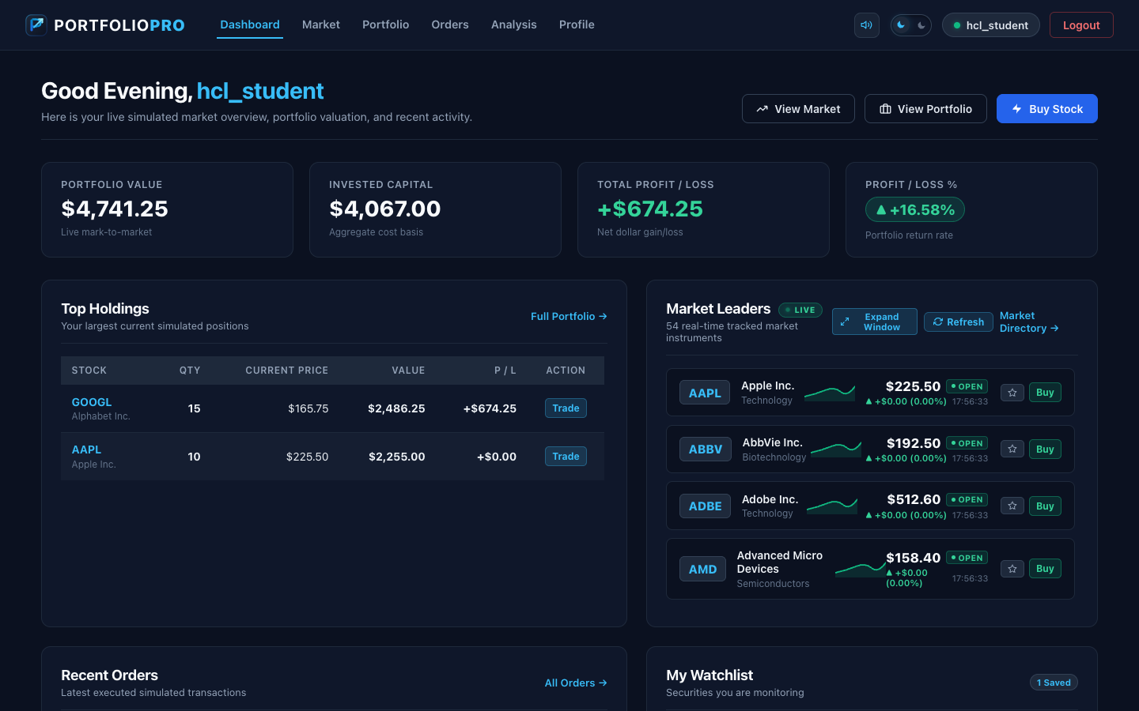

Figure 3: Stock Detail & Quantitative Technical Analysis (AAPL)
Interactive equity deep-dive featuring SVG price charting, Wilder's RSI-14, 20/50-day moving averages, and fundamentals.

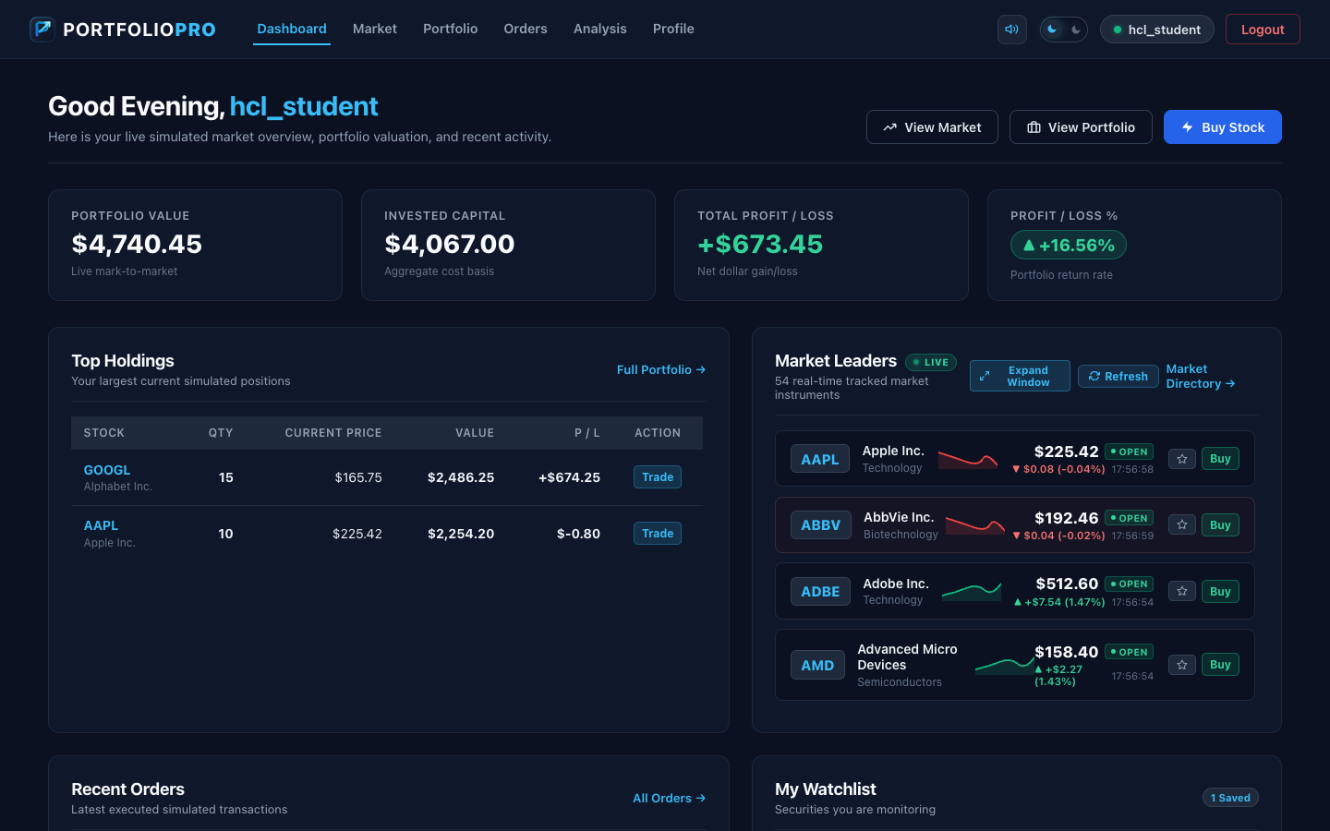

Figure 4: Mark-to-Market Portfolio Valuation & Asset Holdings
Real-time mark-to-market portfolio view showing total invested capital, current valuation, unrealized P&L (+16.58%), and open positions.

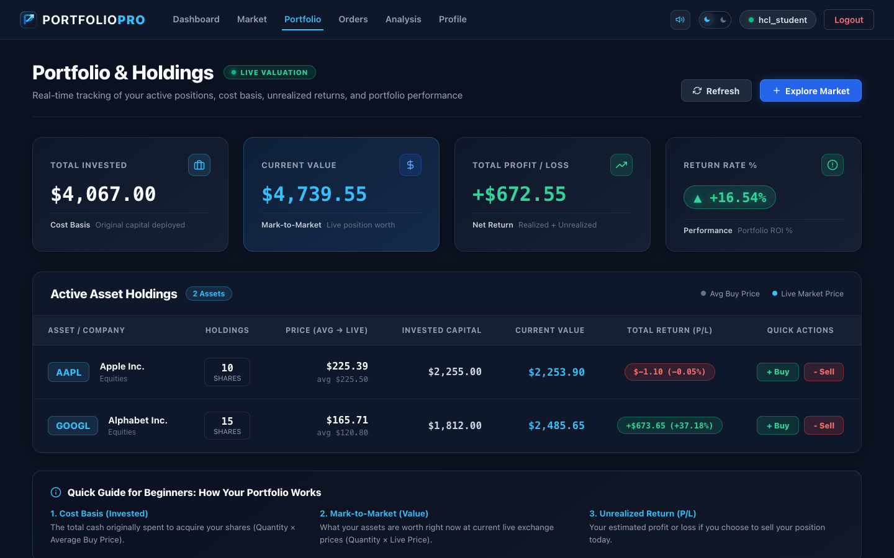

Figure 5: Order Execution & Trading Terminal
Simulated execution interface supporting BUY and SELL market orders with real-time price estimation and validation.

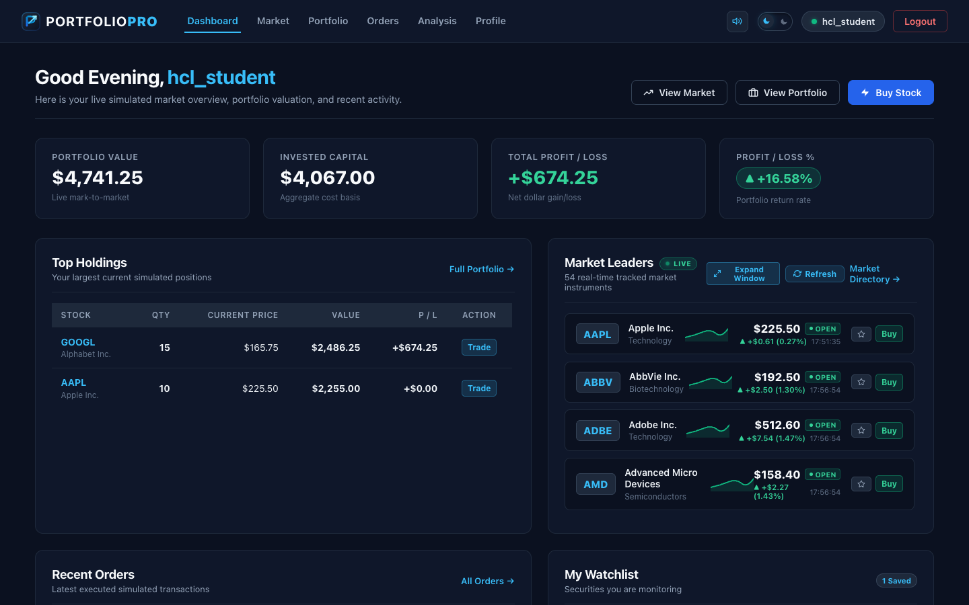

Figure 6: Custom Watchlist & Ticker Tracking
Personalized equity watchlist enabling fast tracking and quick-trade actions for prioritized stocks.



