

**Common SY Department**

**Vishwakarma Institute of Technology, Pune.**

**Student Report Card System**

Aayush Surawar [ME_D-26] , Samarth Takbhate [ME_D-27] , Gopal Tapadiya [ME_D-30] ,

Shivam Tapre [ME_D-31] , Umesh Wanare [ME_D-43] .

Guided by - Prof. Kanade Dnyanesh .

***Abstract*—** *Student Report Card System is being developed record student personal details*

*and generate report for college student . The report card generated using this software can be retained permanently on the computer which can be referred permanently on the computer which can be referred. This project is done using Code Blocks C++ compiler. This system will present a comprehensive picture of the student in overall development.*

*The project is aimed to be create a C++ program that can store, retrieve, display, insert, delete and modify a student's marks in their subjects. The program is completely menu driven without any graphical interface.*

***Keywords—*** *Student Report card management, C++, OOPs*

# Introduction

C++ is based on the C language, and it was developed in early 1980’s by Bjarne Stroustrup. It is an object

oriented programming language.It supports reusability.

Student report card system project in C++ is a simple console application built without the use of graphics. In this project, users can perform typical report card related functions like adding a new student record and

displaying, modifying, editing and deleting it. File handling has been effectively used to perform all these. This project will teach you how to use file handling in C++, add, read, display, search, modify and delete record from file.

Also we have added new feature called class statistics . In it we can see percentage wise student list with all their details.

In this project we can see these fatures :

* Create student report card record.
* Read all students report card record.
* Read specific student’s report card record.
* Display all student’s grade report.
* Modify student’s report card record.
* Delete student record.
* Check class statistics.

File handling has been used for the effective implementation of all the typical features of this project.

# LITERATURE SURVEY

System will relieve teachers for writing manually on report card and providing print facility by which,

it will enable them to display the marks of each student on paper by just one click. As the system has

been provided with all maximum possibility to make their task easier, so number of features has been

made available to continue the task without any intervention. It will not only prepare the report card,

but also able to store data of each students, so that it can be accessed any time and if required can make

modification as per requirement.

We used structures with functions as their members which was an easier way to access records and

store and calculate the percentages and grades. We need loops and filing to add the data.

Then we began with the design phase of the system. The system design is a solution, that “HOW TO”

approach to the creation of the new system. It translates system requirements into ways by which they can be made operational. It is a translational from a user oriented document to a document oriented

programmers. For that, it provides the understanding and procedural details necessary for the

implementation. The system should be reliable, durable and all should have least possible maintenance costs. It should overcome all drawbacks of the old existing system and the most important of all meet the user requirements.

# Methodology

## Domain , Tools & Technology –

Project Domain :- **Education**

Technology :-

1. **Object Oriented Programming C++**
2. **File handling in C++**

Tool - **Compiler: Codeblocks**





## Flowchart :-

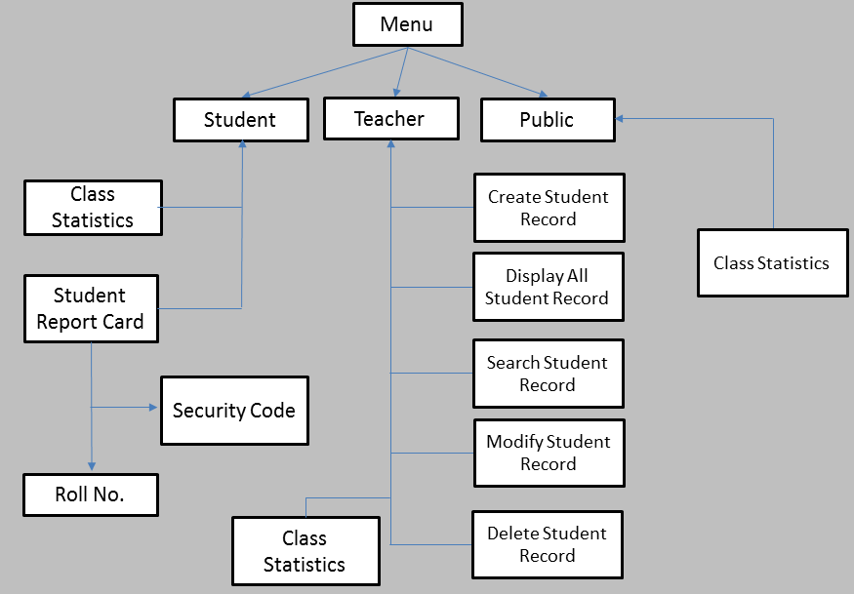

* 1. *Header Files Used :-*

Student report card system is a very simple project that runs with just five header files. Here, are the header files required for this project:

1. *#****include<iostream>***

It is used as a stream of Input and Output using cin and cout.

1. ***#include<fstream.h>***

It is used to control the data to read from a file as an input and data to write into the file as an output.

1. ***#include<string.h>***

The string.h header defines one variable type, one macro, and various functions for manipulating arrays of characters

1. *#****include<process.h>***

process.h is a C header files which contains function declarations and macros used in working with threads and processes.

Basically it is used for exit status.

1. *#****include<windows.h>***

windows. h is a Windows-specific header file for the C and C++ programming languages which contains declarations for all of the functions in the Windows API, all the common macros used by Windows programmers, and all the data types used by the various functions and subsystems.

Basically it is used to change background color and to pause the screen*..*

# Results and discussions

* The key features and the functions used for the Student Report Card Management are:
* The main screen will have 3 menu -

1. Admin / Teacher
2. Student
3. Public

* In Admin / Teacher menu , there are operations like add a new student record , search for a student record , modify a record , delete a record , display all records and class statistics.
* In class statistics , we can check the ascending order of percentage of student and check percentage wise list of students.
* In Student menu , the students can see their report cards by entering **roll no**. and **security code** and also can see class statistics.
* In public menu , the person other than student or teacher are able to check the class statistics .

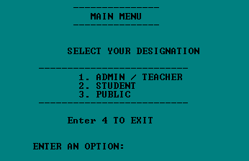

Fig.1 Main menu

In fig. 1 , it displays the main menu which consists of three different options like Admin / Teacher menu, Student menu, Public menu. When we select any one option from one which is mentioned in it then it perform its own operation and displays the output of that particular operation which we mentioned in options.



Fig. 2 Password

In fig.2 , It asks for the **password** when we select option 1 in main menu i.e Admin / Teacher.

It will give 3 chances to try the password & after 3 chances it will go to main menu.

And if password is correct then it will open Admin / Teacher menu.

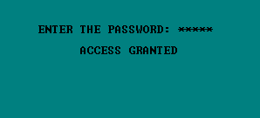

Fig. 3 Access Granted

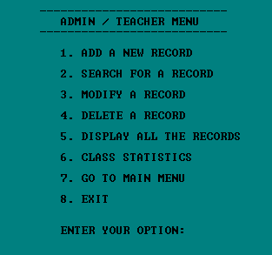

Fig. 4 Admin / Teacher menu

1. **Admin / Teacher menu :**

In fig. 4 , Shows the Admin / Teacher menu which is having options like add new student , search for a student , modify a student , delete a record , display all records , class statistics , go to main menu & exit.[8]

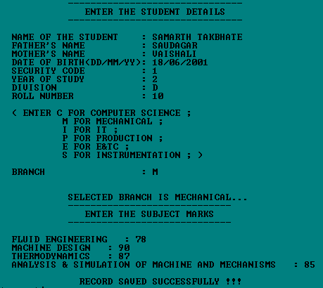

Fig. 5 Add new record

**Create student report card record:** This feature creates a new student record containing his marks. Void add(); function writes a record in a file. For this the information to be provided are the name and roll no. of the student, and the marks obtained by him/her in subjects .[1]

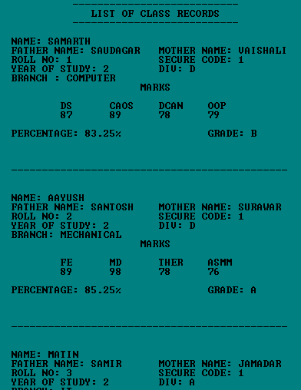

Fig. 6 Display all data

**Display all students report card record:** The void display_all(); function in this student report card management system project in C++ has been used for this feature. It shows the progress report of all the students added in file. This feature displays the roll no. and name of all the students, the marks obtained by them in subjects.All other details are also provided.

**Search specific student’s report card record**: (Fig.7 and 8)This feature is same as the one explained above, except it shows the progress report and relevant data related to a particular student. Void search() is used for this purpose.[2]



Fig. 7 Ask for roll no.

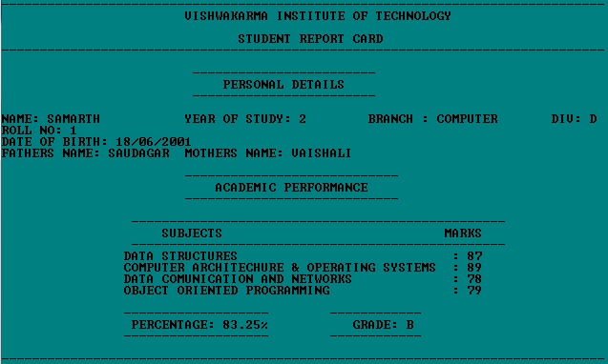

Fig. 8 Displays Report card

**Modify student’s report card record:** void modify (); function is used to edit the report card record of a particular student. For this the roll no. of the student is asked . Upon successful modification, the program displays the message “Record Updated”. If no record of student is found in file, it displays the message “Record not found”.[3]

**Delete student record:** void del (); function deletes the report card record of a particular student; it first of all asks for the Roll no. of the student whose record is to be deleted.

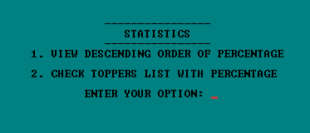

Fig. 9 Class Statistics

**Class Statistics :** Sorting the all data will give the descending order of the percentage and the marks .

Also displays the list of student with their percentage .

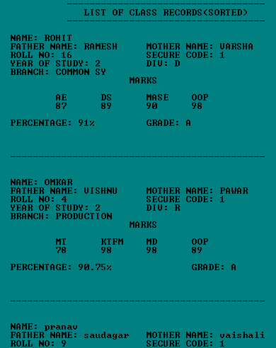

Fig. 10 Descending order of percentage with all details

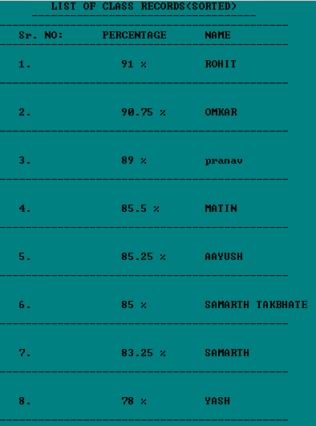

Fig. 11 Topper Student list with percentage

B. **Student Menu :**

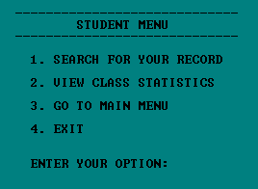

Fig.12 Student Menu

In fig.12 , displays the student menu which include options like search for a record and view class statistics .[5]

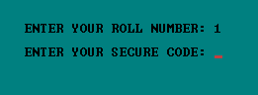

Fig.13 Student need security code to see report card

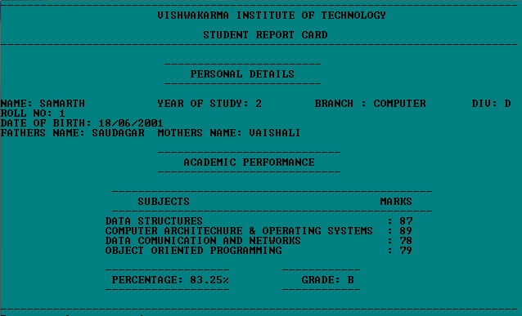

Fig.14 Student report card

Class statistics already seen in admin / teacher menu.

**C. Public Menu :**

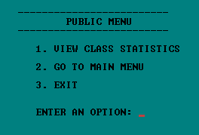

Fig. 15 Public Menu

Class statistics already seen in admin / teacher menu.

1. FUTURE SCOPE

* For the project, a graphical user interface can be developed.
* This system is designed for small engineering colleges or schools ; however, we will develop a robust system with more functionality and information to manage large data sets for large engineering firms or schools.
* Class statistics can be seen by year wise , Branch wise or Division wise.

1. CONCLUSION

* This project will be efficient in maintaining student’s details and can easily perform operations on student’s records.
* This project will also reduces the work load of the of teachers in colleges as all the details are store in computer system and whenever the detail marks of student needed it can be searched and displayed on the screen.
* This software has its advantages and disadvantages but it can surely help with the record storage system .We don’t have to worry about the misplacing of the record which is a great clash while storing the record on separate files.
* **The features like add student , modify , delete , search are already available on internet . We refered that to code our project . The features like password for Admin / Teacher , security code for the students and the class statistics are new features we added in our project.**

1. Acknowledgment

We would like to thank our college vishwakarma institute of technology for providing us with this opportunity to make something useful and beneficial to the college by ourself . This is a great experience and helps us improve as engineers.

1. References
2. [**https://www.geeksforgeeks.org/file-handling-c-classes/**](https://www.geeksforgeeks.org/file-handling-c-classes/)
3. [**https://www.tutorialspoint.com/cplusplus/cpp_files_streams.htm**](https://www.tutorialspoint.com/cplusplus/cpp_files_streams.htm)
4. [**https://www.researchgate.net/publication/348960289_Files_in_C**](https://www.researchgate.net/publication/348960289_Files_in_C)
5. [**https://youtu.be/Ma0P9T4nTDA**](https://youtu.be/Ma0P9T4nTDA)
6. [**https://www.programiz.com/cpp-programming/friend-function-class**](https://www.programiz.com/cpp-programming/friend-function-class)
7. [**https://www.javatpoint.com/cpp-files-and-streams**](https://www.javatpoint.com/cpp-files-and-streams)
8. [**https://youtu.be/TF2-F2duY6c**](https://youtu.be/TF2-F2duY6c)
9. [**http://www.cppforschool.com/project/student-report-card-project.html**](http://www.cppforschool.com/project/student-report-card-project.html)