

**VISHWAKARMA INSTITUTE OF TECHNOLOGY, PUNE – 411037**

666, Upper Indiranagar , Bibwewadi, Pune 411037

B.Tech Second Year 2020-21

Semester 2

**Subject :** Object Oriented Programming **Code** : **CS2218**

**Course Project**

**Topic – Student Report Card System**

**Div.: ME-D Batch 2 – Group 2**

Students Names :

1. D26 Aayush Surawar 11910859

2. D27 Samarth Takbhate 11910739

3. D30 Gopal Tapadiya 11911318

4. D31 Shivam tapre 11910774

5. D43 Umesh Wanare 11911112

**Guided by – Prof. Dnyanesh Kanade.**

Content :

* Introduction
* Project Objective
* Project Domain, Technology and Tools
* Flowchart
* Outputs
* Future scope
* Conclusion

***Abstract***- The present project is aimed to be create a C++ program that can store, retrieve, display, insert, delete and modify a student's marks in their subjects. The program is completely menu driven without any graphical interface. The data is stored in a binary file(txt) for future reference.

***Keywords****— Student Report card management, C++, OOPs*

**Introduction :**

* Student report card system project is a simple console application built without the use of graphics.
* In this project, users can perform typical report card related functions like adding a new student record and displaying, modifying, editing and deleting it.
* File handling has been effectively used to perform all these.

**Project Objective :**

* The project is aimed to be create a program that can store, retrieve, display, insert, delete and modify a student's marks in their subjects. The program is completely menu driven without any graphical interface.
* Also project is aimed to reduce the paper work required for the result of the students.

**Domain , Technology , Tools :**

* Project Domain

1. Education

* Technology

1. Object Oriented Programming C++
2. File handling in C++

* Tool

1. Compiler: Codeblocks
2. Online gdb compiler

 

**Flowchart:**

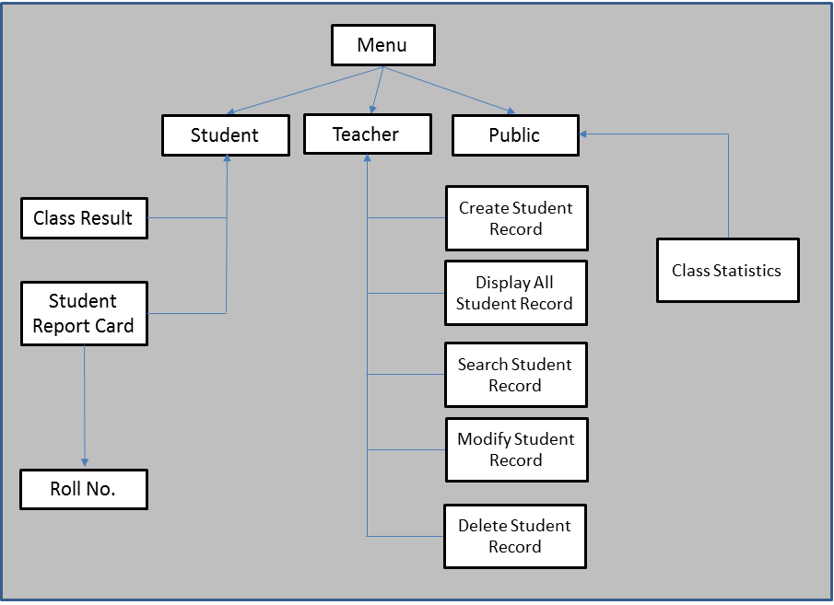

***Header Files Used:***

*Student report card system is a very simple project that runs with just five header files. Here, are the header files required for this project:*

*1. #include<iostream>*

*It is used as a stream of Input and Output using cin and cout.*

*2. #include<fstream.h>*

*It is used to control the data to read from a file as an input and data to write into the file as an output.*

* The key features and the functions used for the Student Report Card Management are:
* The main screen will have 3 menu -

1. Admin / Teacher
2. Student
3. Public

* In Admin / Teacher menu , there are operations like add a new student record , search for a student record , modify a record , delete a record , display all records and class statistics.
* In class statistics , we can check the ascending order of percentage of student and check percentage wise list of students.
* In Student menu , the students can see their report cards by entering roll no. and security code and also can see class statistics.
* In public menu , the person other than student or teacher are able to check the class statistics .

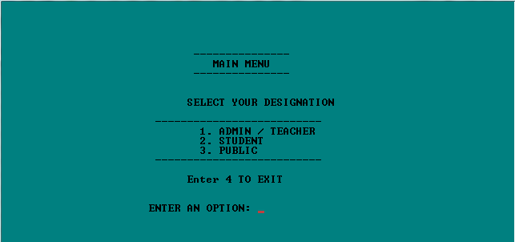

Fig.1 :Main menu

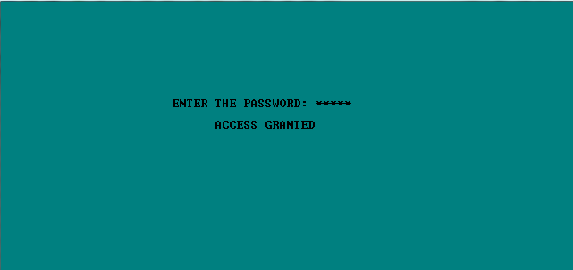

Fig.2 :Password Screen (Admin menu need password to access)

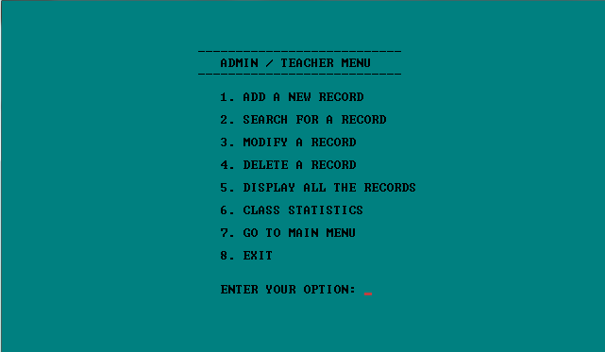

Fig.3 :Admin / Teacher menu

**Create student report card record:** This feature creates a new student record containing his marks. void write_student(); function writes a record in a binary file. For this the information to be provided are the name and roll no. of the student, and the marks obtained by him/her in 5 subjects – OOPs, Data Structures, Analog and Digital Electronics, Computer Organization and Architecture and Computer Oriented Statistical Methods.

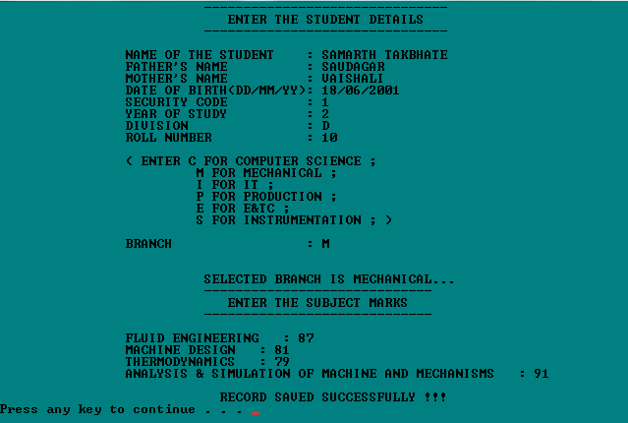

Fig.4 :Add new student

**Read all students report card record:** The void display_all(); function in this student report card management system project in C++ has been used for this feature. It shows the progress report of all the students added in file. This feature displays the roll no. and name of all the students, the marks obtained by them in 5 subjects – OOPs, Data Structures, Analog and Digital Electronics, Computer Organization and Architecture and Computer Oriented Statistical Methods along with the percentage and grade of each student.

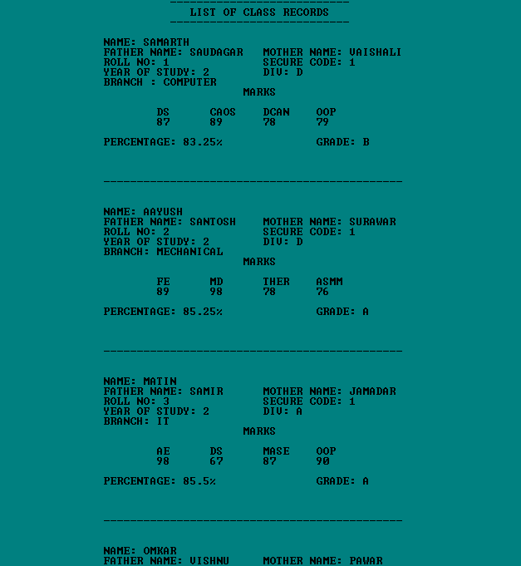

Fig.5 :Display all records

**Read specific student’s report card record**: This feature is same as the one explained above, except it shows the progress report and relevant data related to a particular student. void display_sp(int) is used for this purpose.

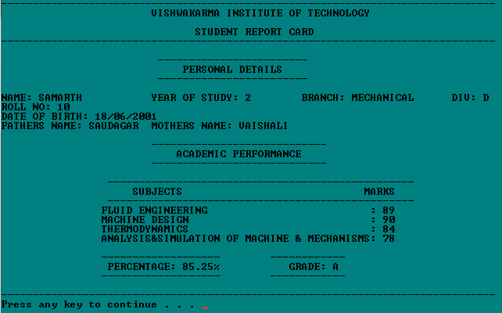

Fig.6 :Search for a student report card

**Modify student’s report card record:** void modify_student(int); function is used to edit the report card record of a particular student. For this, the name and roll no. of the student is sought. Upon successful modification, the program displays the message “Record Updated”. If no record of student is found in file, it displays the message “Record not found”.

**Delete student record:** void delete_student(int); function deletes the report card record of a particular student; it first of all asks for the name and roll no. of the student whose record is to be deleted.

**Class Statistics :** Sorting the all data will give the ascending order of the percentage and the marks .

Also displays the list of student with their percentage .



Fig.7 :Class Statistics

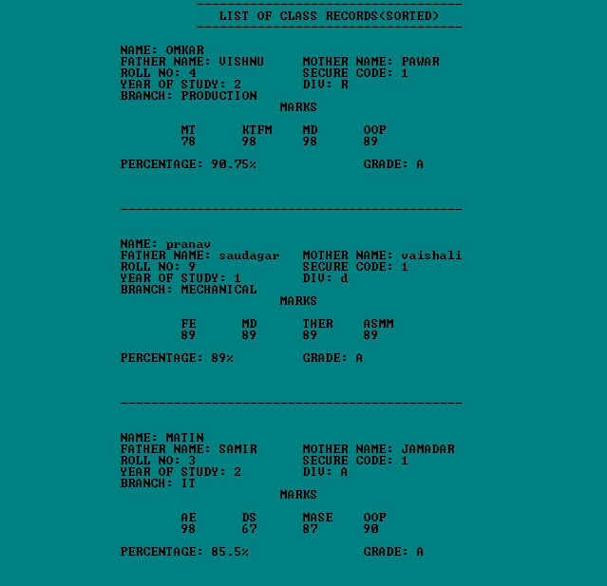

Fig.8 :Ascending order of percentage with all details

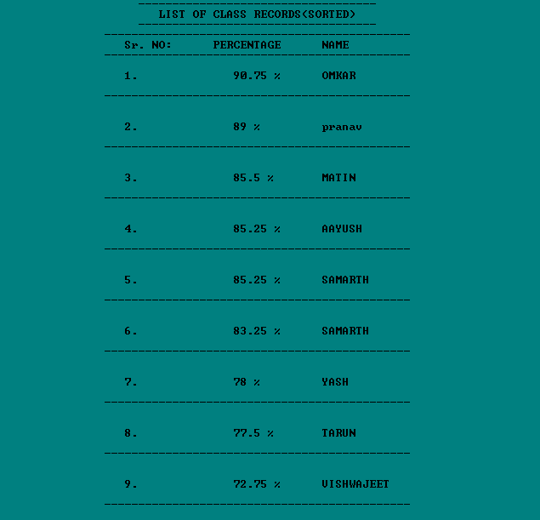

Fig.9 :Topper Student list with percentage

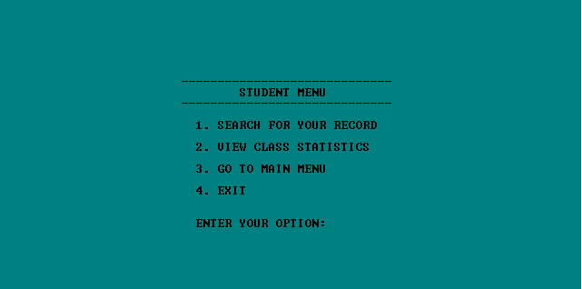

Fig.10 :Student Menu

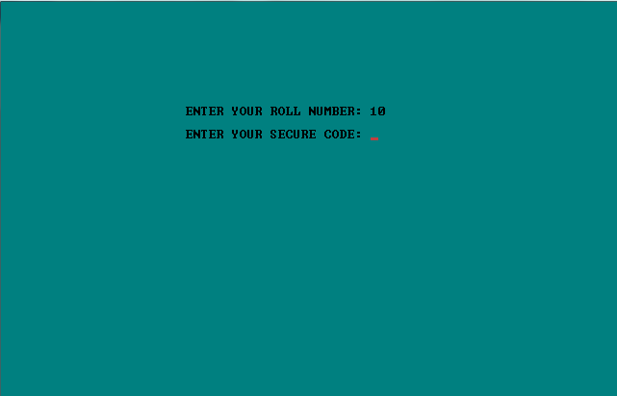

Fig.11 :Student need security code to see report card

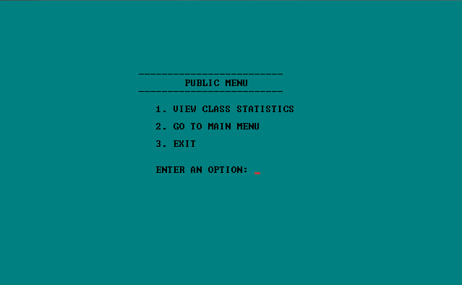

Fig.12 :Public menu

**Future scope :**

* For the project, a graphical user interface can be developed.
* This system is designed for small engineering colleges or schools ; however, we will develop a robust system with more functionality and information to manage large data sets for large engineering firms or schools.

**Conclusion :**

* This project will be efficient in maintaining student’s details and can easily perform operations on student’s records.
* This project will also reduces the work load of the of teachers in colleges as all the details are store in computer system and whenever the detail marks of student needed it can be searched and displayed on the screen.

**References :**

* [**https://www.geeksforgeeks.org/file-handling-c-classes/**](https://www.geeksforgeeks.org/file-handling-c-classes/)
* [**https://www.tutorialspoint.com/cplusplus/cpp_files_streams.htm**](https://www.tutorialspoint.com/cplusplus/cpp_files_streams.htm)
* [**https://www.javatpoint.com/cpp-files-and-streams**](https://www.javatpoint.com/cpp-files-and-streams)
* [**https://www.programiz.com/cpp-programming/friend-function-class**](https://www.programiz.com/cpp-programming/friend-function-class)
* [**https://www.researchgate.net/publication/348960289_Files_in_C**](https://www.researchgate.net/publication/348960289_Files_in_C)
* [**https://youtu.be/TF2-F2duY6c**](https://youtu.be/TF2-F2duY6c)
* [**https://youtu.be/Ma0P9T4nTDA**](https://youtu.be/Ma0P9T4nTDA)