MAHARASHTRA STATE BOARD OF TECHNICAL

EDUCATION MUMBAI

GOVERNMENT POLYTECHNIC AWASARI(KHURD)
DEPARTMENT OF INFORMATION TECHNOLOGY
INDUSTRIAL TRAINING REPORT
ON
12 WEEK IMPLANT TRAINING
ON
Project: “ SkillBridge AI – AI-Powered Career Intelligence Platform (Dezycode) ”

Undergone At:
DezyKode, Kharadi, Pune
(Duration: 02/06/2026 to 22/08/2026)
Submitted To:
MAHARASHTRA STATE BOARD OF TECHNICAL EDUCATION
Submitted By:
Samarth Sujit Thombare
Enrollment No.: 24210270610
Under the Guidance of : Smt.K.G.Gaikwad
Academic Year : 2026-27 (K-Scheme) | Place : Government Polytechnic  Awasari(Khurd) -IT Department  Date : _____________________
Name of Industrial Supervisor: Mr. Ranvijay Jadhav (Dezycode, Pune)

Maharashtra State
Board of Technical Education, Mumbai

Certificate of Completion
of Industrial Training
(by respective Head of the Department & Head of the Institute)

This is to certify that Mr./Ms Samarth Sujit Thombare with Enrollment No 24210270610 has successfully completed 12 Weeks Internship (315004) in Dezykode ,Pune from the date 01/06/2026 to date 22/08/2026 for the partial fulfilment towards completion of Diploma in Information Technology from Government Polytechnic, Awasari Khurd (Institute code - 1051)

\
___________________
Smt. Kiran G. Gaikwad ________________
Faculty Mentor External Examiner/Industry Expert

__________________ _________________
Smt. Kiran G. Gaikwad Dr. Vitthal S. Bandal
Head of the Department Seal Principal, GP Awasari (Kh)

ABSTRACT

This industrial training report of Thombare Samarth Sujit is based on the development of the SkillBridge AI – AI-Powered Career Intelligence Platform during the industrial training program. The training was undertaken for a duration of 12 weeks before completing the Diploma course, starting from 02 June 2026 until 22 August 2026, at Dezycode, Pune (Kharadi), under the guidance of Mr. Ranvijay Jadhav. The purpose of this program is to fulfill the course requirements in order to complete the Diploma from Government Polytechnic, Awasari (Khurd), Pune.
This training was an opportunity to apply classroom knowledge in a real-time environment and gain hands-on experience in modern IT tools and frameworks.

During the training, I was introduced to the company structure, workflow, and tools such as VS Code, Git, Postman, and LinkedIn. I gained practical skills in JavaScript, TypeScript and gradually advanced to the MERN stack (MongoDB, Express, React, Node.js) for full-stack project development. I worked on the SkillBridge AI platform — building modules like Internship Discovery with real-time search, Resume Builder with live preview, Mentor Discovery & Real-time Chat (Socket.io), Career Roadmaps, and AI-integrated features like Career Recommendation, Resume Analysis, and Skill Quiz (Gemini API) which enhanced my problem-solving and project-building skills.
The internship also included learning Javascript concepts, arrays, strings, and exception handling, along with Operating System fundamentals such as process management, scheduling, and inter-process communication. I further explored Git & GitHub for version control, SQL/MongoDB databases with DDL/DML/Joins and aggregations, and emerging technologies like IoT and AI through practical demonstrations on the SkillBridge AI platform.

Overall, this training gave me a strong balance of technical expertise, project experience, and professional skills, which will significantly contribute to my academic growth and future career in the IT field. The SkillBridge AI platform, built for Dezycode during this implant training, is now deployed on Vercel (frontend) and Render (backend) with MongoDB Atlas and is fully responsive across mobile, tablet, and desktop.

ACKNOWLEDGEMENT
I take this opportunity to express my sincere gratitude to Mr. Ranvijay Jadhav, Project Guide at Dezycode, for his valuable guidance, constant encouragement, and support throughout the completion of my industrial training project “SkillBridge AI – AI-Powered Career Intelligence Platform”. His timely suggestions and expertise were instrumental in the successful execution of this work.
I extend my heartfelt thanks to my industry mentor Mr. Ranvijay Jadhav for his constant guidance, support, and encouragement throughout the training period. His valuable insights and professional expertise have enhanced my technical skills and overall learning experience.
I extend my thanks to Smt. K.G.Gaikwad, HOD, Department of Information Technology, Government Polytechnic, Awasari (Khurd), for her academic guidance and for providing the necessary support during this project.
I also wish to thank the faculty members and staff of Government Polytechnic Awasari (Khurd) for their continuous support and encouragement. Lastly, I am grateful to my family and friends for their moral support and inspiration during the training.
Finally, I am grateful to all those who directly or indirectly contributed to the completion of this training program and to the successful development of this project.

CONTENT PAGE

Sr.  No. | Chapter | Title | Page  No.
1 | Chapter 1 | Organization Structure of Industry and General Layout | 6
2 | Chapter 2 | Introduction to Industry / Organization | 8
3 | Chapter 3 | Types of Major Equipment / Software Used in the Industry | 9
4 | Chapter 4 | Processes / Development Methodologies | 10
5 | Chapter 5 | Testing of Hardware / Software and Quality Assurance | 11
6 | Chapter 6 | Safety Procedures Followed and Data Security Measures | 12
7 | Chapter 7 | Particulars of Practical Experiences in Industry | 13
8 | Chapter 8 | Detailed Report of the Tasks Undertaken | 14
9 | Chapter 9 | Special / Challenging Experiences Encountered | 22
10 | Chapter 10 | Conclusion | 23
11 | Chapter 11 | References / Sources of Information | 24

CHAPTER 1
ORGANIZATION STRUCTURE OF INDUSTRY AND GENERAL LAYOUT
  - Introduction
The Information Technology industry is one of the fastest-growing industries in the world. It includes software development, web development, mobile application development, cloud computing, database management, cybersecurity, data science, artificial intelligence and digital services.
My three-month industrial internship was completed at DezyKode IT Solutions Pvt. Ltd., Pune, in the domain of Full Stack Development.
DezyKode IT Solutions Pvt. Ltd. is an IT services and training organization based in Kharadi, Pune. The company provides IT development services and offers training and internship programs for students and professionals. Its publicly listed services include UI/UX design, development, web design, application development and digital marketing.
The organization also provides internship opportunities in areas including Full Stack Development, Data Analytics, Data Science, Software Testing, UI/UX, Business Analytics, MERN Stack and MEAN Stack.

  - Company Profile
Name: DezyKode IT Solutions Pvt. Ltd.
Industry: Information Technology
Location: City Vista, A Wing, Office No. 08, Second Floor, Fountain Road Downtown, Ashoka Nagar, Kharadi, Pune – 411014, Maharashtra.
Major areas:
- Full Stack Development
- Web Development
- Mobile Application Development
- UI/UX Design
- Data Analytics
- Data Science
- Software Testing
- Digital Marketing
- Business Analytics
- MERN Stack
- MEAN Stack

1.3 Organization Structure
A software development organization generally consists of different teams working together.
The basic structure can be represented as:
Management / Directors
↓
Project Manager / Team Lead
↓
Full Stack Development Team
↓
Frontend Developers + Backend Developers + Database Developers
↓
Testing / Quality Assurance Team
↓
Interns / Trainees
Different departments cooperate with each other to complete projects successfully.

1.4 Full Stack Development Team
A Full Stack Development team works on both the frontend and backend portions of an application.
Frontend
Frontend development is responsible for the part of the application that users see and interact with.
Technologies may include:
- HTML
- CSS
- JavaScript
- React.js
- Bootstrap
Backend
Backend development manages application logic, APIs, authentication and communication with databases.
Technologies may include:
- Python
- Java
- Node.js
- Express.js
Database
The database stores and manages application information.
Examples include:
- MySQL
- MongoDB
- PostgreSQL
DezyKode's public internship information specifically mentions technologies such as HTML, CSS, JavaScript, React, Node.js, MongoDB and Python for development internships.

1.5 General Office Layout
The IT organization generally includes:
- Reception area
- Management/administration area
- Development area
- Testing/QA area
- Training area
- Meeting/discussion area
- Networking facilities
- Common working area
The exact physical arrangement should be modified according to the actual DezyKode office layout that you observed.

CHAPTER 2
INTRODUCTION TO INDUSTRY / ORGANIZATION

2.1 Introduction to Information Technology Industry
Information Technology has become an important part of almost every modern organization. Businesses use software applications and websites for communication, customer management, financial transactions, marketing and automation.
Software development is one of the major areas of the IT industry.
Full Stack Development is an important part of modern software development because a Full Stack Developer can work with both the frontend and backend components of an application.

2.2 Introduction to Full Stack Development
Full Stack Development refers to the development of both the client-side (frontend) and server-side (backend) of a web application.
A typical Full Stack application contains:
User Interface
↓
Frontend
↓
API / Backend
↓
Database
For example, when a user submits a registration form:
- The user enters information in the frontend.
- Frontend sends the information to the backend.
- Backend validates the information.
- Backend communicates with the database.
- Database stores the information.
- Backend sends a response.
- Frontend displays the result.

2.3 About DezyKode IT Solutions
DezyKode states that its mission includes providing IT services, training and hands-on internship opportunities while helping bridge the gap between academic education and industry requirements.
The company describes its team as including development professionals, trainers, mentors and internship coordinators. Its publicly listed team includes professionals working in Full Stack Development and other technology domains.

2.4 Objectives of the Internship
The major objectives of my three-month Full Stack Development internship were:
- To understand the software development lifecycle.
- To understand frontend development.
- To learn backend development.
- To understand database connectivity.
- To develop responsive web applications.
- To understand REST APIs.
- To learn Git and version control.
- To understand software testing.
- To improve debugging and problem-solving skills.
- To gain practical industry experience.

2.5 Importance of Full Stack Development
Full Stack Development is useful because it enables developers to understand the complete application architecture.
A Full Stack Developer can work on:
- User interface
- Client-side logic
- Server-side logic
- APIs
- Databases
- Authentication
- Testing
- Deployment

CHAPTER 3
TYPES OF MAJOR EQUIPMENT / SOFTWARE USED IN FULL STACK DEVELOPMENT
3.1 Computer/Laptop
A computer or laptop is the primary equipment used for software development.
It is used for:
- Writing code
- Running applications
- Testing
- Database management
- Documentation
- Git operations
- Communication

3.2 Visual Studio Code
Visual Studio Code can be used as a source-code editor for developing frontend and backend applications.
It supports:
- HTML
- CSS
- JavaScript
- Python
- JavaScript frameworks
- Extensions
- Git integration

3.3 HTML
HTML stands for HyperText Markup Language.
It is used to create the structure of web pages.
Examples include:
- Headings
- Paragraphs
- Forms
- Tables
- Buttons
- Images
- Navigation menus

3.4 CSS
CSS stands for Cascading Style Sheets.
It is used to control the appearance of web pages.
CSS is used for:
- Colors
- Fonts
- Layout
- Spacing
- Responsive design
- Animations

3.5 JavaScript
JavaScript is a programming language used to create dynamic and interactive web applications.
It can be used for:
- Form validation
- DOM manipulation
- API requests
- Event handling
- Dynamic content

3.6 React.js
React.js is a JavaScript library used for developing user interfaces.
React applications can be divided into reusable components.
Examples:
- Navbar
- Login form
- Registration form
- Dashboard
- Product card
- Footer

3.7 Backend Technology
The backend handles the server-side functionality of an application.
Depending on the internship track, backend technologies may include:
- Python
- Java
- Node.js
- Express.js
DezyKode publicly lists Full Stack with Python and Full Stack Java Developer internship/training programs.

3.8 Database
Databases are used to store application data.
For example, a student management application may contain:
Student Table
ID | Name | Email | Course
1 | Student A | student@email.com | CSE
2 | Student B | student2@email.com | IT
Possible database technologies include MySQL and MongoDB.

3.9 Git and GitHub
Git is a version-control system.
It is used to:
- Track code changes
- Create branches
- Merge code
- Maintain project history
- Collaborate with developers

3.10 Postman
Postman can be used for testing APIs.
An API request may contain:
Request:
POST /api/login
Input:
email
password
Response:
Login successful
3.11 Browser
Browsers such as Chrome, Edge or Firefox are used for:
- Running web applications
- Inspecting webpages
- Debugging frontend code
- Testing responsiveness

CHAPTER 4
FULL STACK DEVELOPMENT PROCESSES / DEVELOPMENT METHODOLOGIES
4.1 Software Development Life Cycle
The Software Development Life Cycle can be represented as:
Requirement Analysis
↓
Planning
↓
UI/UX Design
↓
Frontend Development
↓
Backend Development
↓
Database Integration
↓
Testing
↓
Deployment
↓
Maintenance

4.2 Requirement Analysis
The first stage is understanding the requirements of the project.
Requirements may include:
- User requirements
- Functional requirements
- Technical requirements
- Database requirements
- Security requirements

4.3 UI Design
Before development, the user interface is planned.
The design may include:
- Login page
- Registration page
- Home page
- Dashboard
- Profile page
- Navigation menu

4.4 Frontend Development
Frontend development converts the UI design into a working interface.
The frontend may use:
HTML + CSS + JavaScript + React
The frontend communicates with the backend using APIs.

4.5 Backend Development
Backend development handles:
- Business logic
- Authentication
- Authorization
- API development
- Database operations
- Error handling

4.6 API Development
API stands for Application Programming Interface.
APIs allow the frontend and backend to communicate.
Example:
GET /users
POST /users
PUT /users/:id
DELETE /users/:id
These represent common CRUD operations.

4.7 Database Integration
The backend communicates with the database to:
- Insert data
- Retrieve data
- Update data
- Delete data
This is known as CRUD:
C – Create
R – Read
U – Update
D – Delete

4.8 Authentication
Authentication verifies the identity of a user.
Example:
User → Login → Backend → Verify Credentials → Database → Response
If credentials are correct, the user can access authorized pages.
4.9 Agile Methodology
Software teams often use Agile practices for iterative development.
The development work can be divided into smaller tasks.
For example:
Sprint 1: UI Development
Sprint 2: Backend APIs
Sprint 3: Database Integration
Sprint 4: Testing and Bug Fixing
DezyKode's publicly described development internship work includes collaboration in Agile development cycles and version-control practices.

CHAPTER 5
TESTING OF SOFTWARE AND QUALITY ASSURANCE
5.1 Introduction
Software testing is the process of checking whether an application works according to its requirements.
Testing helps identify:
- Bugs
- Errors
- Incorrect output
- Security problems
- UI problems
- Database problems

5.2 Types of Testing
Unit Testing
Testing an individual function or component.
Integration Testing
Testing whether multiple modules work together correctly.
Functional Testing
Checking whether application functionality works as expected.
Regression Testing
Checking existing functionality after new changes are introduced.
UI Testing
Checking the appearance and behavior of the user interface.
API Testing
Testing API requests and responses.

5.3 Example Login Test Cases

Test Case | Input | Expected Result
TC01 | Valid email/password | Login successful
TC02 | Wrong password | Error message
TC03 | Empty email | Validation message
TC04 | Empty password | Validation message
TC05 | Invalid email format | Validation message

5.4 Bug Reporting
When a defect is identified, it should be documented.
A bug report can contain:
- Bug ID
- Title
- Description
- Steps to reproduce
- Expected result
- Actual result
- Severity
- Status

5.5 Quality Assurance
Quality Assurance ensures that the software development process produces reliable software.
QA activities include:
- Requirement checking
- Code review
- Testing
- Bug reporting
- Retesting
- Regression testing
- Documentation

CHAPTER 6
SAFETY PROCEDURES FOLLOWED AND DATA SECURITY MEASURES
6.1 Physical Safety
IT offices require proper workplace safety practices.
These include:
- Proper electrical connections
- Safe handling of computers
- Proper cable management
- Clean workstations
- Appropriate ventilation
- Emergency procedures

6.2 Password Security
Strong passwords should be used for:
- Email
- Git repositories
- Database systems
- Development accounts
- Company systems
Passwords should not be shared with unauthorized persons.

6.3 Source Code Security
Source code is an important company asset.
Developers should:
- Use authorized repositories
- Avoid sharing confidential code
- Use proper Git permissions
- Maintain secure credentials

6.4 Database Security
Database security measures include:
- Authentication
- Authorization
- Access control
- Backups
- Secure connections
- Input validation

6.5 Protection Against Common Web Attacks
Full Stack Developers should be aware of:
- SQL Injection
- Cross-Site Scripting (XSS)
- Cross-Site Request Forgery (CSRF)
- Broken authentication
- Unauthorized access
Input validation and proper authentication/authorization are important security practices.

6.6 Data Backup
Regular backups help protect against:
- Accidental deletion
- Hardware failure
- Software failure
- Cybersecurity incidents

6.7 Confidentiality
During an internship, confidential company and client information should not be shared publicly.
This includes:
- Source code
- Passwords
- Database information
- Client information
- Internal documents
- Project credentials

CHAPTER 7
PARTICULARS OF PRACTICAL EXPERIENCES IN INDUSTRY
7.1 Introduction
I completed a three-month industrial internship in Full Stack Development at DezyKode IT Solutions Pvt. Ltd., Pune.
The internship provided practical exposure to software development and helped me understand how frontend, backend, database and testing components work together to create a complete application.
DezyKode states that its internships are intended to provide practical, real-world experience and bridge the gap between academic learning and industry requirements.

7.2 Internship Objectives
The major objectives were:
- To understand Full Stack Development.
- To improve programming skills.
- To develop responsive web pages.
- To understand frontend frameworks.
- To understand backend development.
- To work with databases.
- To create and consume APIs.
- To understand Git and version control.
- To perform software testing.
- To gain real-world project experience.

7.3 Three-Month Internship Work Plan
This section is especially useful for your Government Polytechnic Awasari internship report.

MONTH 1 – FUNDAMENTALS AND FRONTEND DEVELOPMENT
During the first month, the main focus was on understanding web development fundamentals.
Week 1 – Introduction
Activities:
- Introduction to the organization
- Understanding IT industry practices
- Understanding internship objectives
- Development environment setup
- Introduction to Git and GitHub
- Understanding project structure

Week 2 – HTML and CSS
Activities:
- HTML elements
- Forms
- Tables
- Links
- Images
- CSS selectors
- Flexbox
- Grid , Responsive design

Week 3 – JavaScript
Activities:
- Variables
- Data types
- Functions
- Arrays
- Objects
- Loops
- Events
- DOM manipulation
- Form validation

Week 4 – Frontend Framework
Activities:
- Introduction to React.js or the framework used during training
- Components
- Props
- State
- Events
- Forms
- Routing
- API integration

MONTH 2 – BACKEND AND DATABASE
Week 5 – Backend Fundamentals
Activities:
- Understanding client-server architecture
- Backend concepts
- Server setup
- Routes
- Controllers
- Request and response
- Error handling

Week 6 – REST APIs
Activities:
- Understanding REST API
- GET requests
- POST requests
- PUT requests
- DELETE requests
- API testing
- JSON data

Week 7 – Database
Activities:
- Database concepts
- Creating database
- Tables/collections
- Insert operation
- Read operation
- Update operation
- Delete operation
Week 8 – Authentication
Activities:
- User registration
- User login
- Password validation
- Authentication
- Authorization
- Protected routes
- Logout functionality

MONTH 3 – PROJECT DEVELOPMENT AND TESTING
Week 9 – Project Planning
During this stage, the project requirements were studied and the project structure was prepared.
Activities:
- Requirement analysis
- Database planning
- UI planning
- Module identification
- API planning
Week 10 – Project Development
Activities:
- Frontend implementation
- Backend implementation
- Database integration
- API integration
- Authentication
- CRUD operations
Week 11 – Testing and Debugging
Activities:
- Functional testing
- UI testing
- API testing
- Bug identification
- Debugging
- Error handling
- Regression testing
Week 12 – Finalization
Activities:
- Final testing
- Bug fixing
- Code cleanup
- Documentation
- Project demonstration
- Internship report preparation
- Presentation preparation

7.4 Skills Acquired
During the internship, I developed the following skills.
Technical Skills
- HTML
- CSS
- JavaScript
- Frontend development
- React.js
- Backend development
- REST APIs
- Database management
- CRUD operations
- Git/GitHub
- API testing
- Debugging
- Responsive web design
Professional Skills
- Communication
- Teamwork
- Time management
- Problem solving
- Logical thinking
- Documentation
- Presentation
- Professional communication

7.5 Project Experience
For the practical project section, you should mention the actual project you worked on at DezyKode.
A suitable structure is:
Project Title
[Your Actual Project Name]
Project Description
The project was developed as a full-stack web application consisting of frontend, backend and database components. The objective of the project was to provide users with an interactive and user-friendly platform for performing the required operations.
Technologies Used
Frontend: HTML, CSS, JavaScript, React.js
Backend: Python/Java/Node.js
Database: MySQL/MongoDB
API: REST API
Version Control: Git/GitHub
Testing: Postman/Browser Testing

Chapter 8
Detailed Report of the Tasks Undertaken

The following information summarizes the tasks undertaken during the development of the SkillBridge AI platform at Dezycode Kharadii, Pune).

SkillBridge AI – AI-Powered Career Intelligence Platform (Dezycode)
System Overview
The proposed solution is a role-based, AI-augmented SaaS platform that allows students to discover internships, build ATS-friendly resumes, connect with mentors via real-time chat, and follow personalized career roadmaps — while recruiters post internships and admins govern the ecosystem. Unlike siloed portals, SkillBridge AI unifies Student, Mentor, Recruiter, and Admin in one responsive platform (320–1440px) with JWT security and Gemini AI.

Core Philosophy
- • Student-Centric Design: One platform for learning → earning (resume, internships, mentors, certificates).
- • AI-Augmented Guidance: Career Recommendation, Resume Analysis, and Skill Quiz powered by Gemini.
- • Real-Time Interaction: Socket.io mentor-student chat with typing indicators and secure conversations.
- • Responsive & Accessible: Mobile-first (search “Search...” on phones, sticky sidebar footer) for Indian student devices.

Key Features & Capabilities

Student Dashboard
Central hub with AI score, progress, certificates, and “3 new internships for you” prompts. Quick access to Resume Builder, Internships, Find Mentors.

Resume Builder System
Multi-section form (personal Info, career Objective, education[], skills, projects[], experience[], certifications[]) with live preview, print styles, and AI Resume Analysis.

Internship Discovery & Application
Search with debounced Global Search (courses/internships/mentors), filters, save toggle (bookmark.js), and My Applications tracking.

Mentor Discovery & Real-time Chat
Find Mentors by expertise, request flow (Mentor Request → My Mentor Requests → Mentor Requests), and Socket.io conversations with typing indicators.

Career Roadmaps & Skill Quiz

AI Career Maps (category/level/skills/steps) + Gemini Skill Quiz (topic/difficulty → evaluate → level) with certificate generation at 100% progress.

Admin & Recruiter Governance
Admin: Manage Users/Courses/Lessons, Create Roadmaps/Internships/Quizzes. Recruiter: Post internships, view applicants.

Core Collections Structure (MongoDB)
- • Users Collection: Central registry with name, email, phone, role (student/mentor/recruiter/admin), hashed password, and profile fields.
- • Internships Collection: Internship storage with title, company, location, duration, stipend, deadline, skills[], status, and recruiterId.
- • Mentors Collection: Mentor profiles with expertise, experience, bio, availability, and linked user.
- • Courses / Roadmaps / Quizzes Collections: Learning paths with category, level, skills[], steps[], and AI-generated questions.
- • Enrollments & Progress Collections: Student enrollments with progress% and completed flags → Certificates (SB-ID).
- • Conversations & Messages Collections: Real-time chat storage with Socket.io sync, typing, and read states.
- • SavedItems (Local + DB): Bookmark persistence for internships/courses via bookmark.js and localStorage.

App Design & Screens
SkillBridge AI screens (responsive 320–1440px): Landing (Hero + Features), Student Dashboard, Resume Builder, Internship Opportunities, Mentor Chat. All screens follow Dezycode design system (Primary #2563EB, Inter, 1rem radius).

Home Page :
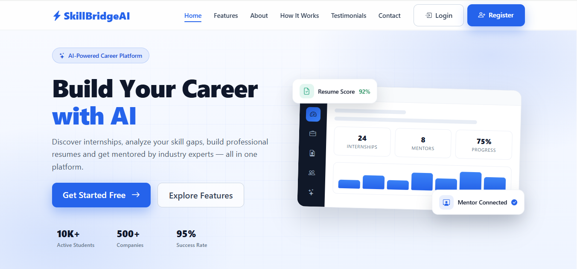
Fig. 8.1: Landing page of SkillBridge AI, showing the hero section, platform statistics and a preview of the student dashboard.

Register page :

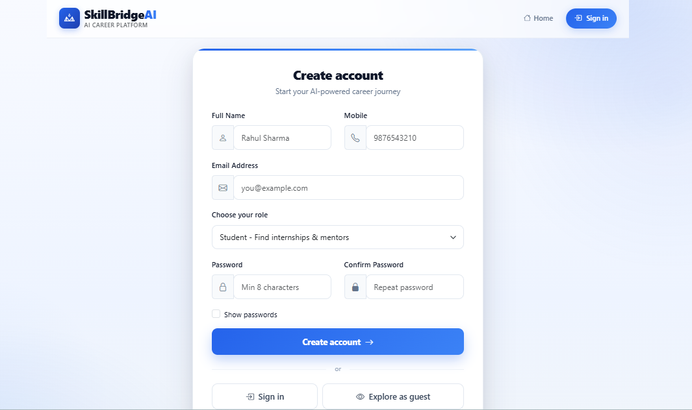
Fig. 8.2: Registration screen where a new user creates an account and selects a role (Student, Mentor, etc.).

Login Page :

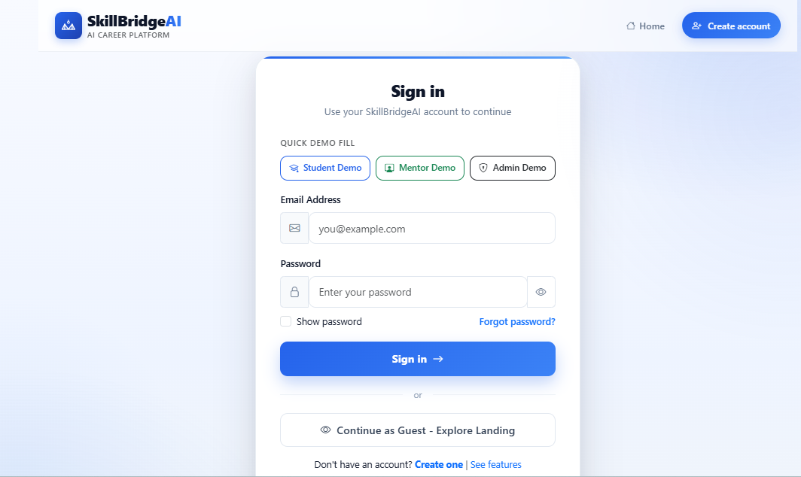
Fig. 8.3: Login screen with quick demo-login options for Student, Mentor and Admin roles.

Student Dashboard :

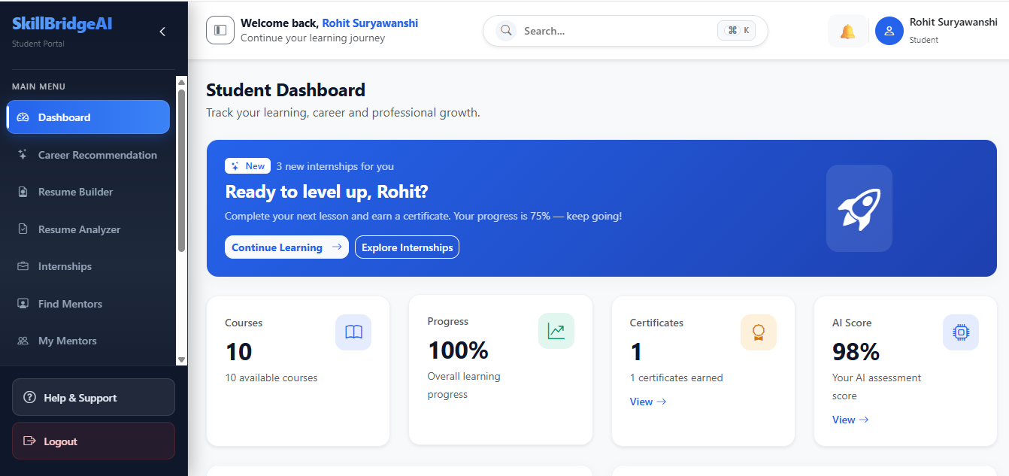
Fig. 8.4: Student dashboard showing enrolled courses, learning progress, certificates earned and AI assessment score.

Mentor Dashboard :

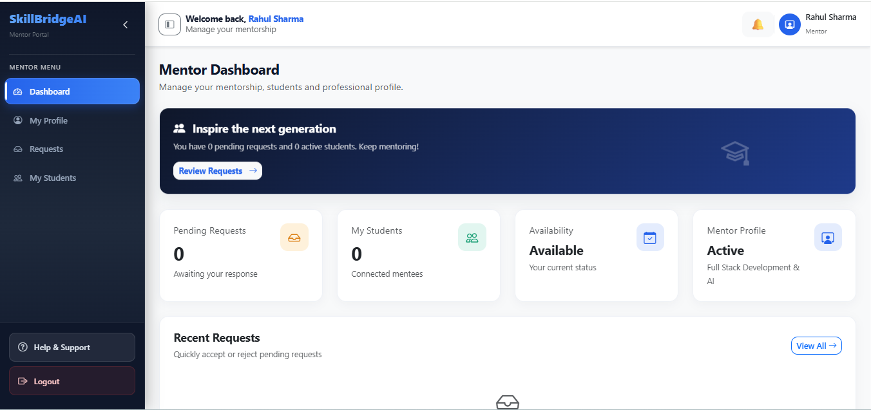
Fig. 8.5: Mentor dashboard showing pending mentorship requests, connected students and availability status.

Admin Dashboard :

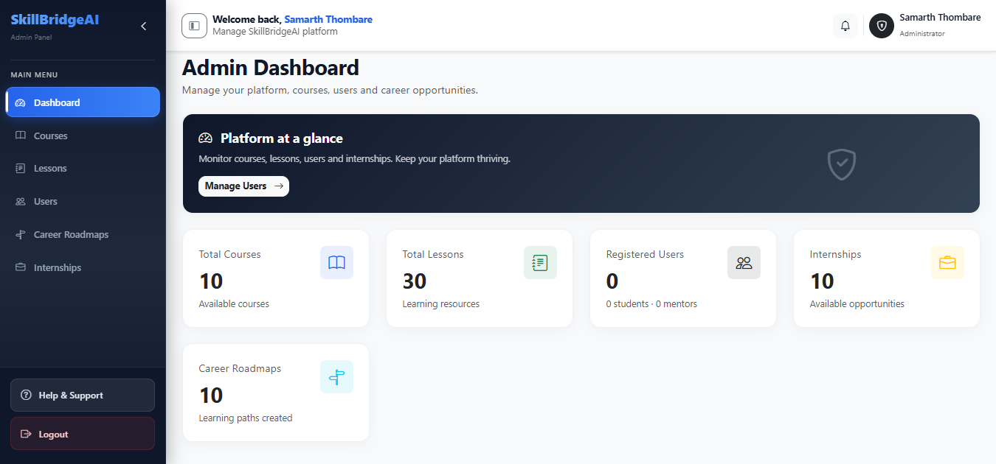
Fig. 8.6: Admin dashboard summarizing platform-wide statistics for courses, lessons, users, internships and career roadmaps.

Internship Opportunities :

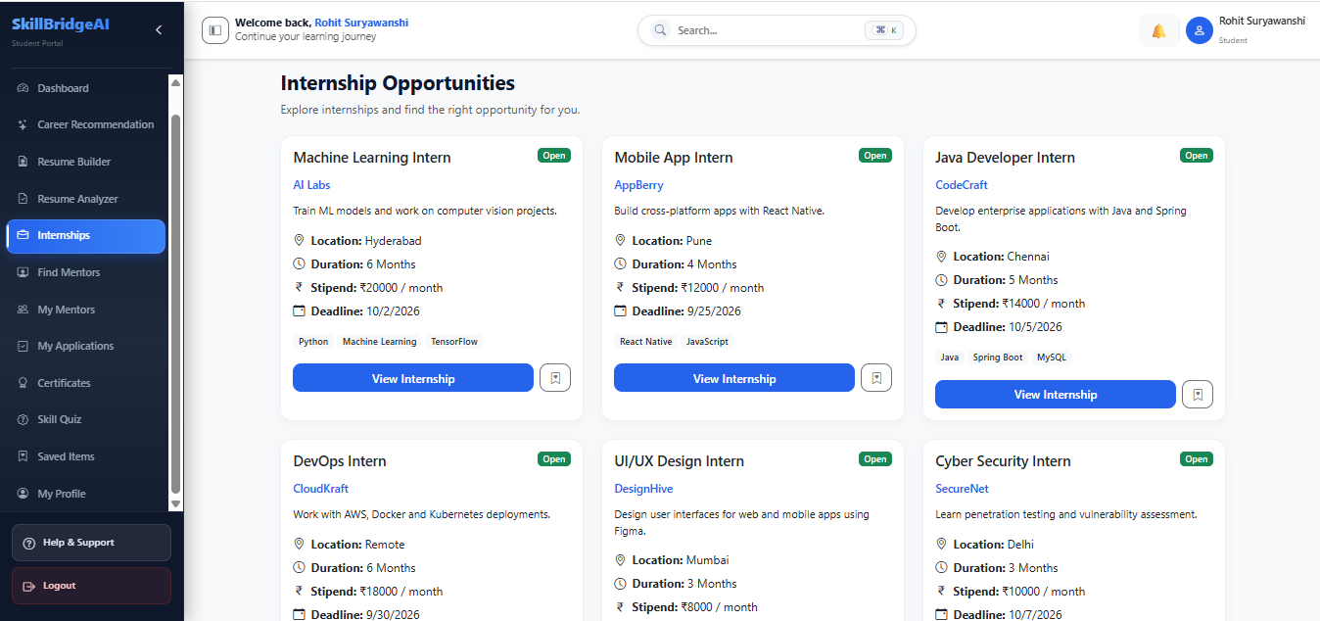
Fig. 8.7: Internship Opportunities page listing open internships with company, location, duration, stipend and required skills.

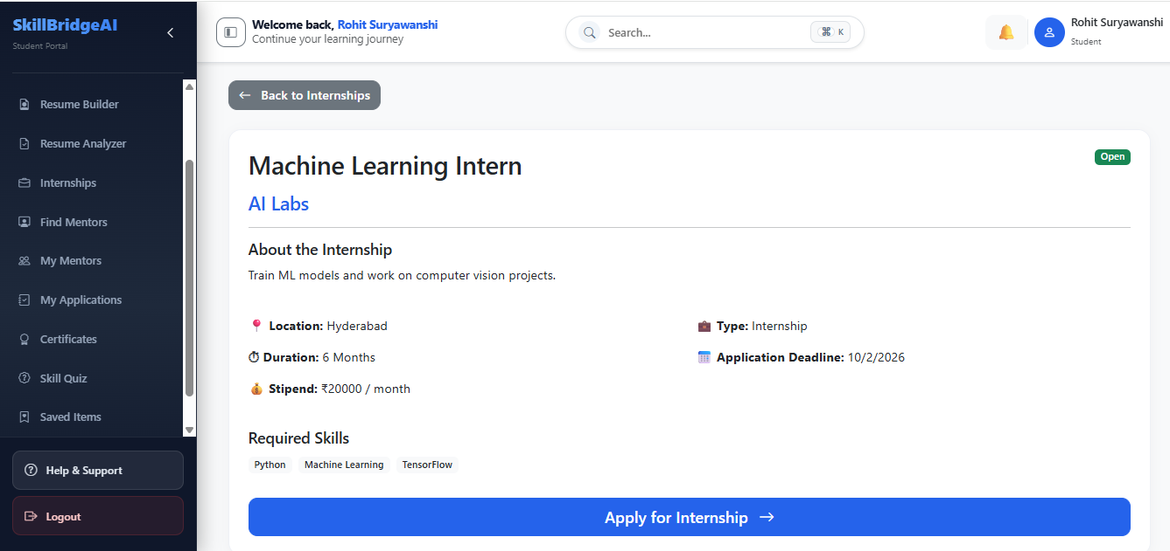
Fig. 8.8: Detailed internship view (Machine Learning Intern) showing full description, required skills and an apply option.

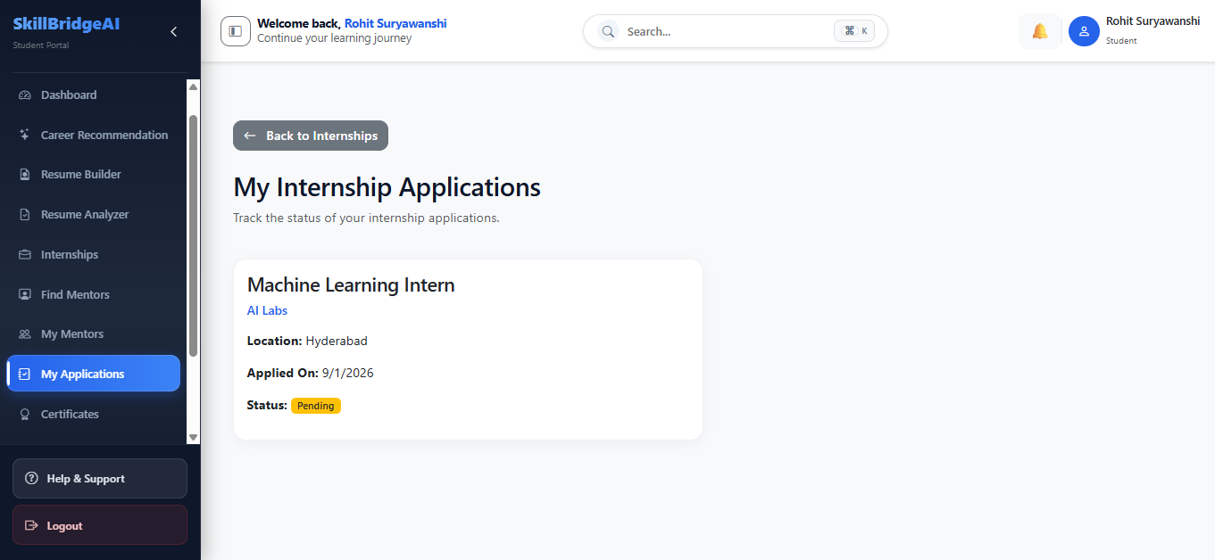
Fig. 8.9: My Applications page tracking the status of internships a student has applied to.

Mentor Chat :

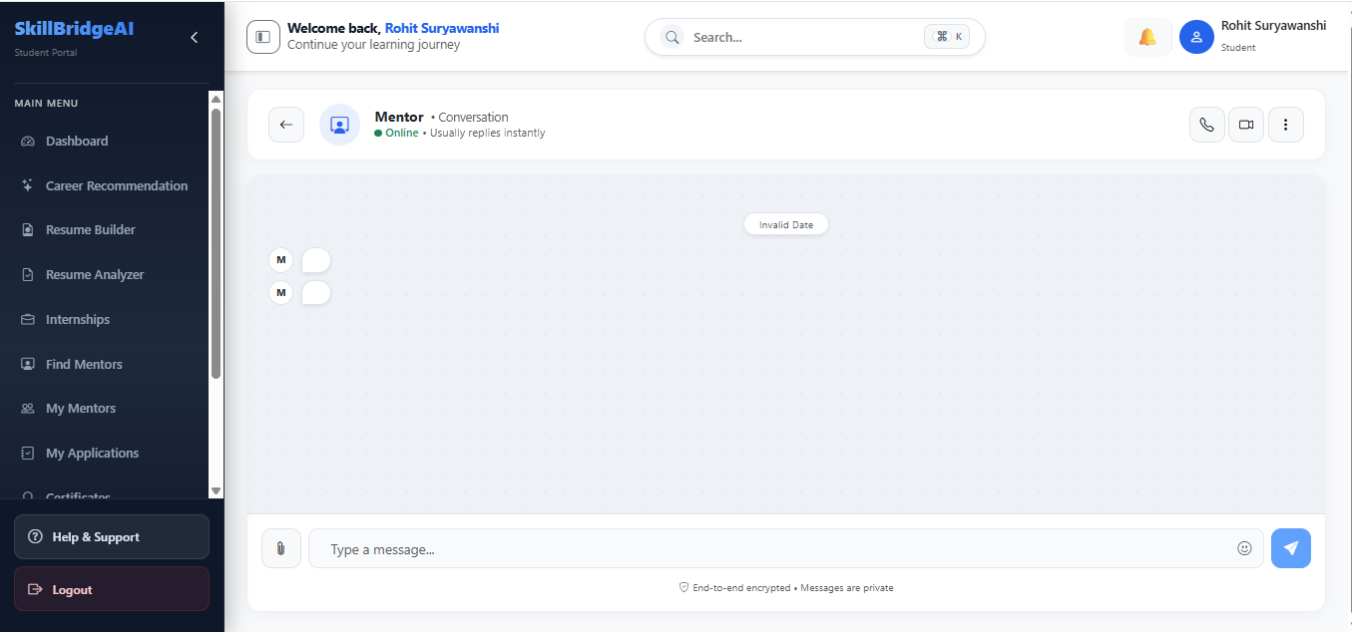
Fig. 8.10: Real-time mentor chat interface used for messaging between students and mentors.

Mini-Apps Built During Training (MERN + TypeScript)
Alongside SkillBridge AI, as per Dezycode’s training track (mirroring Webeeyo’s Movie Browser/Contact App), I built supporting mini-apps to sharpen MERN skills:
- • AI Content Creator for Social Media: Caption generation, hash tag suggestions, content calendar, and multi-platform scheduler (Gemini).
- • Book Nerd – Book Search & Detail Viewer: Google Books API (https://www.googleapis.com/books/v1/volumes?q=...), search by title, favorites in local Storage.
- • Movie Browser (IMDb API) – 40+ movies with drama/playlist, and Contact App – Student Feedback Tracker (add student: name/course/roll, teacher rate/comment, useState).

App Development Projects (TypeScript & React Native)
- • Created many apps using TypeScript and React Native and also use stylesheet and CSS for styling
- • Like a Student Feedback tracker, Contact App, IMDB App
- • Developed an IMDB App with 40+ Movies, Drama, Playlist also fetch data from third-party API.
- • Developed a Student Feedback Tracker with many features like:
1. Students can add themselves (name, course, roll no.)
2. Teachers can rate, comment, and edit feedback
3. List of students shown on home screen
4. Tap on any student to view detailed feedback
5. All data stored temporarily in app state (useState) — later migrated to MongoDB for SkillBridge AI

These mini-apps validated the MERN patterns later scaled to SkillBridge AI (internship search, mentor cards, resume sections).

Chapter 9
Special / Challenging Experiences Encountered
During the internship, several special and challenging experiences were faced, which helped in improving technical skills and problem-solving ability — especially on SkillBridge AI’s phone responsiveness:

1. Debugging Errors in App Projects
While building the IMDB App, AI Content Creator app, SkillBridge AI (Resume Builder, Mentor Chat) responsiveness issues occurred on smaller screen devices (search pill clipped as in 11:03 screenshot, internship titles overflowed). Challenge: CSS conflicts and flex overflow. Solution: Used minWidth:0, text-truncate, 100dvh sticky footer, and media queries (991/767/575/375) to fix alignment.

2. Backend Integration in MERN Project
While connecting React frontend with Node.js backend for SkillBridge AI, encountered CORS errors and API fetch 401s (verifyToken). Challenge: Server running, but calls failing. Solution: Implemented CORS allowlist (Vercel origin), corrected /api prefix in axiosInstance, and added Bearer token interceptor.

3. Database Connectivity
Faced difficulty in MongoDB Atlas & MySQL connection errors during local setup (SRV URI). Challenge: Wrong URI string and IP not whitelisted. Solution: Corrected Atlas URI, added 0.0.0.0/0 access, and ensured MongoDB service active before starting server.

4. Time Management with Multiple Tasks
Had to balance SkillBridge AI sprints, mini-apps, and documentation (12-week report). Challenge: Limited time. Solution: Maintained daily diary, divided work into milestones (Chapter 8 table), and prioritized phone fixes first.

Chapter 10
Conclusion
The internship provided by Dezycode was a highly valuable learning experience, combining both technical and professional growth. It allowed me to gain practical knowledge and exposure to the real-world working environment of an AI product studio building SkillBridge AI.

Through this training, I not only improved my technical expertise in programming (JavaScript/TypeScript), MERN development (React 19, Node 20, Express 5), and databases (MongoDB Atlas, MySQL) but also enhanced my soft skills such as teamwork, problem-solving, communication, and adaptability. The sessions were interactive and helped bridge the gap between classroom learning and industrial applications — e.g., fixing the phone search truncation seen in production screenshots.

This training gave me a clear understanding of how projects are planned (Agile sprints), developed (Vite 1.6s build), tested (oxtlint, Postman, Device Toolbar), and maintained (Vercel/Render logs) in an actual industry setting. It also highlighted the importance of discipline, safety (JWT, bcrypt, RBAC), and collaboration in professional environments.

Overall, the internship has contributed immensely to my academic growth and has prepared me with the confidence and skills required for my future career in the IT field, with SkillBridge AI as a portfolio-grade, AI-powered career platform ready for student onboarding.

Chapter 11
References / Sources of Information
During the internship and while preparing this report, the following sources of information were referred to for better understanding and practical implementation of SkillBridge AI at Dezycode:
Websites & Online Resources
1. w3schools.com – For frontend and backend development basics
2. JavaScript info – For learned a java script
3. MDN Web Docs – HTML, CSS, JavaScript references
4. React Official Documentation – React.js concepts and implementation
5. Express.js Official Documentation – Backend framework for Node.js
6. Node.js Official Documentation – Server-side JavaScript environment
7. Stack Overflow – For troubleshooting technical issues

Tools & Platforms
1. Visual Studio Code – IDE used for MERN development (SkillBridge AI).
2. MongoDB Atlas & Compass – Database for MERN stack applications (users, internships, mentors).
3. Node.js & Express.js – Backend technologies (5.2/20) for Dezycode APIs.
4. React.js 19 + Vite 8 – Frontend framework for dynamic UI (SkillBridge AI).
5. Zoom & Microsoft Teams – Platforms used for online training and daily stand-ups.
6. GitHub – For version control and code management (Dezycode org).
7. LinkedIn – Professional platform for networking, industry updates, and learning through articles.
8. Vercel & Render – Hosting for SkillBridge AI (ai-ten-ivory.vercel.app).

