Ticket Booking System

Data Structures Project Report

1. Introduction
The Ticket Booking System is a simple program developed using C++ to manage ticket reservations for events or movies. The system allows users to book tickets, cancel tickets, search booking details, display bookings, and manage a waiting list.
This project demonstrates the use of basic data structures and algorithms such as arrays, stacks, queues, searching, and sorting techniques.
The system helps manage seat reservations efficiently and handles situations such as ticket cancellations and waiting list management.

2. Objectives
The objectives of this project are:
• To manage ticket bookings efficiently.
• To perform operations such as booking, cancellation, searching, and displaying tickets.
• To manage a waiting list for customers when seats are unavailable.
• To implement sorting algorithms for booking records.
• To understand the practical use of data structures in real-world applications.

3. Data Structures Used

3.1 Array
An array is used to store ticket booking records. Each record contains:
• Seat Number
• Customer Name
Arrays allow quick access to booking records using indexing.

3.2 Stack
A stack is used to implement the Undo Cancellation operation.
When a ticket is cancelled:
• The ticket record is pushed onto the stack.
• If the user chooses undo, the record is popped from the stack and restored.
This follows the LIFO (Last In First Out) principle.

3.3 Queue
A queue is used to manage the waiting list of customers.
When all seats are booked:
• Customers are added to the waiting list queue.
• If a ticket is cancelled, the first customer in the queue gets the available seat.
This follows the FIFO (First In First Out) principle.

4. Algorithms Used

4.1 Linear Search
Linear Search is used to find a booking using the seat number.
Steps:
- Traverse the booking array.
- Compare each seat number with the target seat number.
- If found, display the booking details.
Time Complexity: O(n)

4.2 Bubble Sort
Bubble Sort is used to sort bookings based on seat numbers.
Steps:
- Compare adjacent booking records.
- Swap them if they are in the wrong order.
- Repeat the process until the array becomes sorted.
Time Complexity: O(n²)

5. System Features
The system provides the following features:

1. Book Ticket
Allows the user to book a ticket by entering the seat number and customer name.

2. Cancel Ticket
Cancels a booked ticket using the seat number.

3. Search Booking
Searches and displays booking details using the seat number.

4. Display All Bookings
Displays all booked tickets stored in the system.

5. Sort Bookings
Sorts the bookings based on seat number using Bubble Sort.

6. Undo Cancellation
Restores the last cancelled ticket using a stack.

7. Waiting List Management
Customers are added to a waiting queue when seats are unavailable.

6. System Flow
- Start the program
- Display the main menu
- User selects an operation
- Perform the requested operation
- Return to the menu
- Exit when the user chooses the exit option

7. Advantages
• Simple and easy to understand
• Demonstrates the use of multiple data structures
• Efficient for small booking systems
• Supports waiting list management
• Provides undo cancellation feature

8. Limitations
• Uses fixed array size
• No file storage (data lost after program ends)
• Suitable only for small-scale ticket systems

9. Future Improvements
• Use Linked Lists instead of arrays
• Add file handling for permanent data storage
• Implement Binary Search for faster searching
• Add Graphical User Interface (GUI)
• Connect the system to a database

10. Conclusion
The Ticket Booking System demonstrates how basic data structures such as arrays, stacks, and queues can be used to manage ticket reservations effectively.
The project also illustrates the use of searching and sorting algorithms in practical applications. This system provides a simple solution for managing ticket bookings, cancellations, and waiting lists.

3.1 Main Menu Screen
Description:
This screen shows the main menu of the Ticket Booking System. The user can choose different options to perform operations like booking tickets, cancelling tickets, searching bookings, displaying bookings, and sorting records.
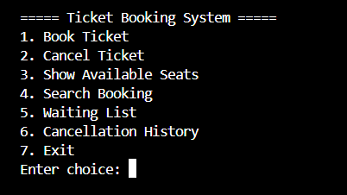

3.2 Book Ticket
Description:
This screen shows the process of booking a ticket by entering the seat number and customer name.
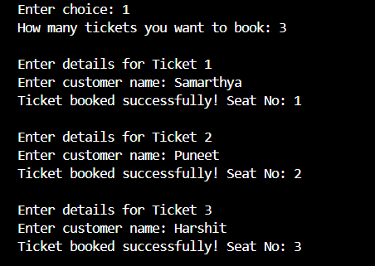

3.3 Cancel Ticket
Description:
This screen shows how a ticket booking is cancelled using the seat number.
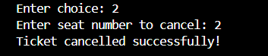

3.4 Seat Status Display in Ticket Booking System
Description:
This screen shows the current seat availability in the Ticket Booking System. It displays which seats are booked along with the customer names and which seats are still available for booking. This helps users easily view the booking status of all seats.
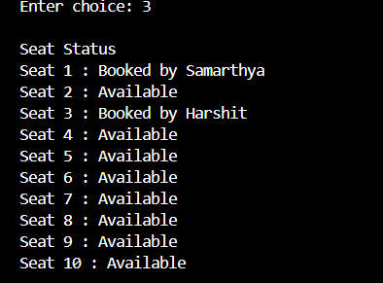

3.5 Display Bookings
Description:
This screen displays ticket bookings stored in the system.
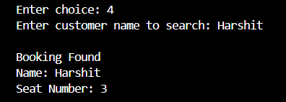

3.6 Waiting List Status in Ticket Booking System
Description:
This screen displays the status of the waiting list in the Ticket Booking System. It shows that currently there are no customers in the waiting list because seats are still available.

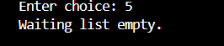

3.7 Undo Cancellation
Description:
This screen shows how the system restores the last cancelled ticket using the stack-based undo operation.
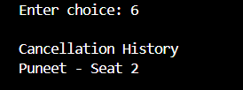

3.8 Exit Program
Description:
This screen shows the exit operation of the Ticket Booking System. When the user selects the Exit option, the program terminates and stops execution.
