SLE-3: Architectural Design (Full C4 Model)
Course: 02AML204 – Introduction to Artificial Intelligence
PRN: 25UAM122
Name: Samarth Sanjay Yamgar
Division: B
Date: 04 October 2026
GitHub Link: https://github.com/samarthyamgar/AI_Augmented_Workflow.git

1. System Title & Short Description
System: Maze Solver System (BFS / DFS) – the same 6×6 grid maze solver profiled in SLE-2.
The system takes a maze grid (0 = open path, 1 = wall) with a start cell (0,0) and a goal cell (5,5), and finds a route using Breadth-First Search (BFS) and Depth-First Search (DFS). It prints the route on the maze, and measures average run time, nodes expanded and path length for both algorithms. It solves the problem of finding and comparing paths in a maze: BFS gives the shortest path (10 steps), DFS gives a longer one (16 steps).

2. Context Diagram (Level 1)
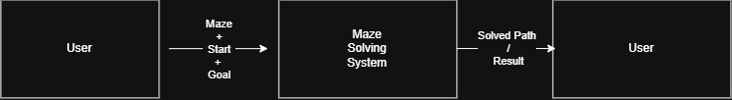

The Maze Solving System allows the user to provide a maze along with the start and goal positions. The system processes the maze using a search algorithm and finds a suitable path from the start position to the goal. The resulting path or search result is then provided to the user.

3. Container Diagram (Level 2)
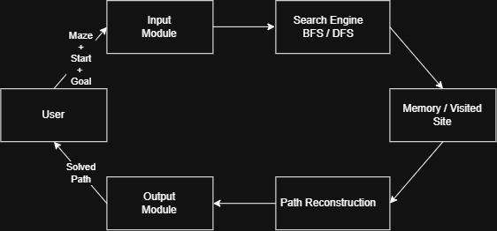

Input Module | Takes the maze, starting position and goal position from the user.
Search Engine | Applies the selected search algorithm such as BFS, DFS or A* to find a path.
Memory / Visited Set | Stores already explored positions to avoid unnecessary repeated searches.
Path Reconstruction | Builds the final path from the start position to the goal.
Output Module | Displays the solved path and search result to the user.
The Maze Solving System is divided into five main containers. The Input Module receives the maze and required positions, while the Search Engine performs the selected search algorithm. The Memory/Visited Set keeps track of explored positions. Path Reconstruction generates the final path, and the Output Module presents the result to the user. This separation makes the system easier to understand and modify.

4. Component Diagram (Level 3) – Search Engine
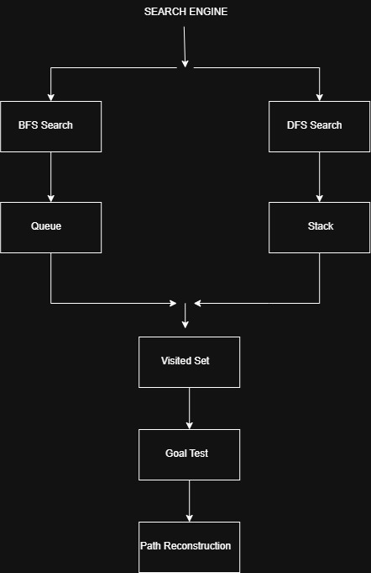
BFS Search | Finds a path using Breadth-First Search and uses a queue to explore positions.
DFS Search | Finds a path using Depth-First Search and uses a stack to explore positions.
Visited Set | Keeps track of already explored positions to avoid repeated exploration.
Goal Test | Checks whether the current position has reached the goal.
Path Reconstruction | Builds and returns the path from the start position to the goal.

The Search Engine is divided into five main components. BFS Search uses a queue to explore the maze, while DFS Search uses a stack to explore possible paths. The Visited Set prevents repeated exploration of the same positions. The Goal Test checks whether the destination has been reached, and Path Reconstruction generates the final path from the start position to the goal.

5. Code Level Overview (Level 4)
print_maze_with_path() – Displays the maze and the path found by the search algorithm.
get_neighbors() – Finds valid neighboring positions from the current maze position.
solve_bfs() – Finds a path from start to goal using Breadth-First Search.
solve_dfs() – Finds a path from start to goal using Depth-First Search.
run_profiling() – Runs BFS and DFS multiple times and calculates their average execution time.
MAZE – Stores the maze structure where 0 represents an open path and 1 represents a wall.

START / GOAL – Define the starting and destination positions.

6. Design Decisions

The system is divided into separate modules to make the architecture simple and easy to understand. BFS and DFS are kept as separate search components so their performance can be compared. A Visited Set is used to avoid exploring the same position repeatedly. The design also separates input, search, path generation, and output for easier modification and testing.

7. AI Contribution Note
AI tools used: ChatGPT , CLAUDE.
What AI helped with: Understanding the C4 Model, organizing the system into four architecture levels, and improving the explanations.

What I did myself: Developed and tested the BFS and DFS maze-solving code, performed the performance analysis, verified the architecture, and created the C4 diagrams.

8. Conclusion
The C4 Model helped me understand the architecture of my Maze Solving System at different levels. I learned how to represent the system from the user level to its containers, components, and actual code functions. This architecture makes the system easier to understand, modify, test, and compare.

