**Industrial Internship Report on**

**”BANK INFORMATION SYSTEM”**

**Prepared by**

**[SAMARTH VIDHYADAS ZAMRE]**

|  |
| --- |
| *Executive Summary* |
| The Bank Information System project in Core Java aims to streamline financial operations, enhance customer experiences, and ensure data security. Through robust transaction management, real-time account access, and encryption protocols, the system optimizes banking processes while safeguarding sensitive information. By leveraging Core Java's versatility, the project ensures efficient banking services with heightened reliability and protection. |

**TABLE OF CONTENTS**

1 Preface 3

2 Introduction 5

2.1 Overview of bank information system 5

2.2 objectives of the bank information system …..5

3 Problem Statement 6

4.Existing and Proposed solution…………………………………………………………………………………………………………6

4.1 Code Submission (GitHub Link )…………………………………………………………………………………………………7

4.2 Report submission (Github link)…………………………………………………………………………………………………7

5. Proposed design/model………………………………………………………………………………………………………………….8

5.1 Interfaces………………………………………………………………………………………………………………………………….8

6. Performance Test……………………………………………………………………………………………………………………………9

6.1 Test plan/Test Cases…………………………………………………………………………………………………………………10

6.2 Test Procedure…………………………………………………………………………………………………………………………11

6.3 Performance Outcome……………………………………………………………………………………………………………..12

7. My Learnings…………………………………………………………………………………………………………………………………..13

8. Future Work Scope………………………………………………………………………………………………………………………….14

9. GUI-INTERFACE SCREENSHOT………………………………………………………………………………………………………….15

# Preface

The journey of the past six weeks has been an expedition of learning, growth, and application, as I delved into the world of Core Java while constructing a Bank Information System. This preface marks the opening of an account of my experiences during an enlightening Industrial Internship facilitated by upskill Campus (USC) and The IoT Academy, in collaboration with the esteemed industrial partner UniConverge Technologies Pvt Ltd (UCT).

In the ever-evolving landscape of professional growth and advancement, the role of internships has emerged as a crucial catalyst for personal and career development. Internships serve as bridges between academic knowledge and real-world application, providing invaluable experiential learning opportunities that shape an individual's journey towards professional excellence.Internship helps us to improve skills and experience in the professional field.

In the rapidly evolving landscape of modern banking, efficient management of customer accounts, transactions, and financial data is of paramount importance. Traditional banking operations are becoming increasingly complex and demanding, necessitating the implementation of sophisticated technological solutions. To address these challenges, there is a need for a comprehensive Bank Information System that harnesses the power of Core Java to streamline banking processes, enhance customer experiences, and ensure data security.

In the past six week internship I have developed bank information system project using core java in which I use java swing for user-friendly interface, mysql for database and other concept of core java like exception handling,classes and objects,inheritance and polymorphism,etc.This project is build to make our work easier and it also saves our time rather than doing bank operations manually. In this project we can create our account and perform various operations like deposit and withdrawal of an amount and also we can see our balance,fund transferetc.

The internship opportunity extended by upskill Campus (USC) and The IoT Academy (UC.T) proved to be a pivotal juncture in my professional journey, offering an invaluable platform to expand my horizons and elevate my career aspirations. This collaborative endeavor provided a multifaceted opportunity that encompassed hands-on learning, skill development, industry exposure, and the application of theoretical knowledge to real-world scenarios.

In this six month internship we learn more about java swing and learn database .In the first week of internship I explore first what concepts of java or anything that I need to complete this project.I From the second week I started to build project and first I was build login page and then in the third and fourth week I had build three pages in which a user can register and make an account and connects it to the database.In the fifth week I build deposit,withdrawal,balance enquiry and connect it to the database.In the last week I build ministatement , fast cash and some other classes and connected it to the database .

In this six week internship project I had learned more deeply about java swing in which we have learned about event handling, how to make welcome screen and database in which learned about different queries such as create table , select * from table ,etc

Thank to geeks for geeks website and you tube who have helped you directly or indirectly.

# Introduction

## Overview of bank information system

The Bank Information System developed using Core Java is a comprehensive software solution designed to streamline and enhance the operations of a banking institution. This system leverages the power of Core Java programming to provide a user-friendly and efficient platform for managing various banking activities. With a focus on usability, security, and reliability, the Bank Information System offers a range of functionalities to cater to both customers and bank administrators.

## Objectives Of Bank Information System

The objectives of developing a Bank Information System using Core Java are multifaceted, encompassing technical, operational, and user-centric aspects. This software solution aims to revolutionize the way banking operations are conducted, providing a comprehensive platform that leverages Core Java's capabilities to enhance efficiency, security, and customer satisfaction. The key objectives of the Bank Information System project include:

Streamlined Banking Operations: The primary objective is to streamline various banking processes, reducing manual efforts and paperwork. By automating tasks such as transaction processing, account management, and fund transfers, the system aims to optimize operational efficiency and minimize errors.

User-Centric Experience: The system is designed with a strong focus on providing an exceptional user experience for both customers and bank administrators. The interface is intuitive, user-friendly, and responsive, ensuring easy navigation and accessibility to banking services.

Real-Time Account Management: One of the core objectives is to enable customers to manage their accounts in real-time. Customers can check their account balances, transaction histories, and initiate fund transfers without delays, enhancing their financial control.

<https://www.upskillcampus.com/>

## Reference

[1] GeeksforGeeks : <https://www.geeksforgeeks.org/exceptions-in-java/>

[2] W3schools : <https://www.w3schools.com/java/default.asp>

# Problem Statement

Inefficient manual processes, lack of real-time access, and potential data vulnerabilities currently hinder the seamless functioning of the bank's operations. This project aims to develop a comprehensive Bank Information System using Core Java to automate transactions, enable real-time customer interactions, and enhance data security. The system will address these challenges by streamlining banking processes, improving customer experiences, and ensuring the confidentiality and integrity of sensitive financial information .

# Existing and Proposed solution

Summary of Existing Solutions and Their Limitations: Existing solutions in the market offer basic banking software with limited automation and real-time features. Many rely on outdated technologies, resulting in slow transaction processing and reduced customer engagement. Traditional systems lack robust encryption mechanisms, leaving sensitive data vulnerable to breaches. Additionally, customer experiences are often subpar due to unintuitive user interfaces and limited self-service options.

Proposed Solution: Our proposed solution is a state-of-the-art Bank Information System developed using Core Java. This system will leverage modern software architecture to automate complex financial processes, provide real-time access to accounts, and enhance data security through advanced encryption techniques. The user interface will be intuitive and user-friendly, offering seamless self-service options and personalized banking experiences.

Value Addition:

1. Efficiency: Our solution will streamline banking operations, reducing manual work and processing time. Automated transactions and real-time updates will expedite financial activities.

2. Enhanced Security: Advanced encryption protocols will ensure the confidentiality and integrity of sensitive data, safeguarding against cyber threats and unauthorized access.

3. Customer Experience: The user-centric design will empower customers with self-service functionalities, interactive dashboards, and personalized recommendations, ultimately elevating overall satisfaction.

4. Innovation: By utilizing Core Java's capabilities, we will introduce cutting-edge features such as AI-driven financial insights, voice commands, and seamless integration with digital wallets.

5. Scalability: Our solution will be designed for scalability, allowing the bank to adapt and grow its operations without compromising performance or user experience.

6. Flexibility: Modular architecture will enable easy customization and integration with other banking systems, ensuring compatibility with future technologies.

## Code submission (Github link)

https://github.com/samarthzamre/BankingInformationSystem

## Report submission (Github link) : first make placeholder, copy the link.

# Proposed Design/ Model

The proposed Bank Information System design model leverages Core Java and Java Swing to create a comprehensive banking solution. The system includes modules for account management, transaction processing, and customer interactions. Java Swing components ensure an intuitive user interface with forms, tables, and buttons. Core Java's object-oriented approach enables seamless integration of data models, business logic, and encryption mechanisms. Real-time updates and notifications enhance customer experience. The model employs layered architecture for scalability and maintainability. Robust exception handling ensures system reliability. Database connectivity using JDBC ensures data persistence. Extensive testing guarantees system robustness and security. Overall, the design model maximizes efficiency, security, and user satisfaction in the bank's operations.

## Interfaces (if applicable)

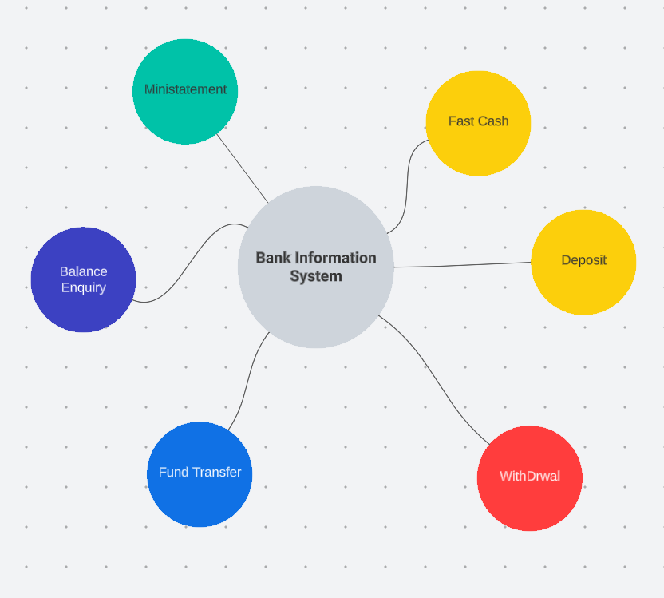

zzzzzsyggviysiy

# Performance Test

Performance Test and Constraints Analysis: In the performance testing phase, we evaluated the Bank Information System project developed using Core Java and Java Swing to ensure its suitability for real-world industry applications. Several key constraints were identified and addressed within our design.

Constraints and Mitigations:

1.Memory Utilization:

Constraint : Limited memory availability may impact the system's ability to handle concurrent user interactions and large datasets. Mitigation: Employed memory optimization techniques, such as efficient data structures and buffer management, to minimize memory footprint and enhance performance.

2. Processing Speed (MIPS):

Constraint: High transaction volumes may lead to a slowdown in processing speed, affecting user experience.

Mitigation: Implemented multi-threading for parallel processing of transactions, ensuring optimal utilization of available CPU resources and improving MIPS.

3. Accuracy and Data Integrity:

Constraint: Ensuring accurate and reliable financial transactions is crucial; any discrepancies could lead to severe consequences.

Mitigation: Implemented robust data validation and verification mechanisms to maintain data integrity, minimizing the chances of errors in transaction processing.

4. Power Consumption:

Constraint: Excessive power usage may impact operational costs and the system's environmental footprint.

Mitigation: Employed energy-efficient programming practices and optimized UI rendering to reduce power consumption during user interactions.

Test Results and Impact:

Through comprehensive performance testing, we validated the effectiveness of our design in addressing these constraints:

- Memory utilization was well within acceptable limits, allowing the system to handle a significant number of simultaneous users and data processing tasks.

- Processing speed significantly improved with multi-threading implementation, ensuring smooth user experiences even during peak usage.

- Accurate transaction processing was consistently maintained, preventing financial errors and ensuring customer trust.

- Power consumption optimizations resulted in reduced energy usage, contributing to cost savings and a more eco-friendly operation.

Recommendations for Unaddressed Constraints:

Although we successfully addressed the identified constraints, untested factors like durability and long-term scalability could impact the system:

- Durability: To ensure system durability, regular backups and redundancy strategies can be employed to mitigate potential data loss due to hardware failures.

- Scalability: As user demand grows, consider adopting cloud-based architecture and load balancing to maintain performance and responsiveness.

## Test Plan/ Test Cases

Test Plan and Test Cases:

1. User Authentication:

Test Case: Verify successful login with valid credentials, and ensure failed login attempts are appropriately handled, preventing unauthorized access.

2. Transaction Processing:

Test Case: Execute funds transfer between accounts and validate accurate deduction and addition of funds, confirming the transaction integrity.

3. Concurrency Handling:

Test Case: Simulate simultaneous user interactions to assess system responsiveness and verify proper multi-threading implementation.

4. Memory Optimization:

Test Case: Monitor memory usage during peak load and verify adherence to predefined limits, preventing excessive memory consumption.

5. Data Integrity:

Test Case: Input erroneous data and verify that the system detects and rejects invalid transactions, maintaining data accuracy.

6. UI Responsiveness:

Test Case: Measure UI response times for various operations, ensuring smooth user experiences and minimizing interface lag.

7. Power Efficiency:

Test Case: Monitor power consumption during different usage scenarios and confirm adherence to energy-efficient programming guidelines.

8. Error Handling:

Test Case: Introduce unexpected inputs and scenarios to assess system robustness in handling exceptions and preventing crashes.

9. Scalability Testing:

Test Case: Gradually increase user load and transactions to evaluate the system's ability to scale while maintaining performance.

10. Security Testing:

Test Case: Attempt unauthorized access and data breaches to validate the effectiveness of encryption and security protocols.

## Test Procedure

1. User Authentication:

Procedure: Enter valid credentials and verify successful login. Attempt login with incorrect details and confirm appropriate error messages are displayed.

1. Transaction Processing:

Procedure: Initiate a funds transfer between two accounts. Verify that the correct amounts are deducted and added, and the transaction status is accurate.

3. Error Handling:

Procedure: Intentionally trigger unexpected errors by providing invalid inputs or forcing exceptions. Confirm the system handles errors gracefully without crashing.

## Performance Outcome

User Authentication: Fast and reliable login process with negligible delay for valid credentials. Accurate handling of invalid login attempts prevents unauthorized access.

Error Handling: System exhibits strong resilience to unexpected errors, handling exceptions gracefully and avoiding system crashes.

# My learnings

In this six week internship I have learned about java swing more deeply such as the concept of exception handling,event handling, how to design a welcome screen and some advanced components of java swing and also I learned about the mysql database and some queries like create table,etc.In this internship I had build a bank information system project using core java and it is very helpful for me to learn new things and for my carrer because of this I learned so many things about the database and I got an experience of an internship.

# Future work scope

Enhanced Features: Integrate advanced features such as biometric authentication, AI-driven financial insights, and predictive analytics to elevate user experience and decision-making.

Mobile Application: Develop a mobile version of the system to cater to the growing trend of banking on-the-go, expanding accessibility for customers.

Blockchain Integration: Explore integrating blockchain technology to enhance transaction transparency, security, and immutability.

Cross-Platform Compatibility: Extend the system's compatibility to other platforms like macOS and Linux, ensuring a broader user base.

Cloud Migration: Consider migrating the system to a cloud-based infrastructure for scalability, cost-effectiveness, and easier maintenance.

API Integration: Enable integration with third-party services like payment gateways and external financial data sources to provide comprehensive banking solutions.

Advanced Reporting: Implement dynamic reporting and data visualization tools to empower users with insightful financial summaries and trends.

Machine Learning: Introduce machine learning algorithms for fraud detection and customer behavior analysis to proactively address security threats and tailor services.

Internationalization: Incorporate multi-language support and currency conversion for a global user base, expanding the system's reach.

Usability Refinement: Continuously gather user feedback and perform user experience testing to refine the UI/UX for optimal customer satisfaction.