LLM-Guided Federated Continual Learning for Recycling Image Classification

1. Background (our works so far)
- Prototype paper (2025): Showed how AI can support waste-sorting workers; introduced the DWRL dataset.
- FCL paper (2025): Applied Federated Continual Learning (FCL) to recycling image classification.
  - Highlight: combined CIFAR-100 (benchmark) with DWRL (real dataset).
  - Results: 83.7% accuracy on DWRL, ~62% on CIFAR-100.
  - Limitation: forgetting and instability when data was split across clients.

2. New Idea
- Extend FCL with a policy controller, eventually powered by LLMs (most likely GPT).
- Each round (server–client training cycle):
  - the controller looks at training logs (accuracy, forgetting, imbalance),
  - then adjusts hyperparameters (learning rate, replay ratio).
- Makes the system adaptive, unlike the fixed settings in our earlier work.

3. Demo Results (CIFAR-100, subset run on CPU)
- Setup: 4 clients, 3k images each (12k total ≈ 24% of CIFAR-100), 3 rounds, 1 epoch per client.
- Test set: full 10k CIFAR images.
- Hardware: CPU only.
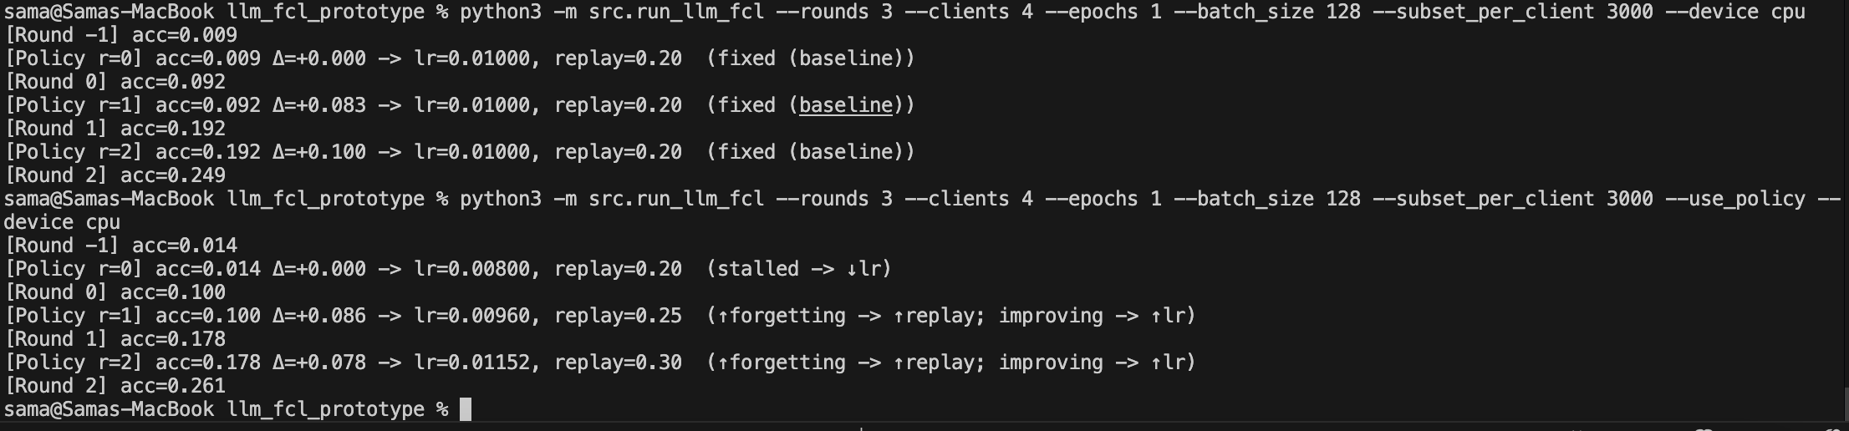
Setup | Round -1 | Round 0 | Round 1 | Round 2
Baseline (fixed) | 0.9% | 9.2% | 19.2% | 24.9%
Policy (adaptive) | 1.4% | 10.0% | 17.8% | 26.1%

Interpretation:
- Baseline: accuracy steadily rises, but LR/replay stay fixed.
- Policy: controller adapts LR & replay each round (“stalled → ↓lr”, “forgetting ↑ → ↑replay”), and accuracy still improves — slightly surpassing baseline by Round 2.
- This proves the adaptive loop works. In the real setup, the rule controller will be swapped for an LLM (GPT) to make those same decisions.

4. Why this matters
- Extends directly from our last paper: same FCL backbone, but now adaptive.
- Demo already shows the system works on CIFAR-100.
- With full dataset on GPU, we expect clear improvements over the ~62% baseline from our paper.
- If replicated on DWRL, we’ll have:
  - Continuation of our joint work,
  - CIFAR vs. DWRL comparison,

5. Next Steps
- Run full CIFAR-100 with GPU (full 50k train images).
- Apply method to DWRL (If I could access).
- Write paper: “LLM-Guided Federated Continual Learning for Recycling Image Classification.”

