Project Report on
Automated Detection of Diabetic Retinopathy
Using DenseNet121 and XGBoost Ensemble
Submitted by
SAMASHRITA-1CR24EC190
SOUMYA-ICR24EC208
PAVANI S-1CR24EC140

List of Tables
Table 2.1: | Summary of reviewed papers with key results, approaches, and limitations | 17
Table 4.1: | Complete breakdown of the 227-dimensional clinical feature vector | 27
Table 4.2: | XGBoost ensemble classifier configuration | 29
Table 4.3: | Lesion classification criteria and visual markers | 30
Table 5.1: | Summary of key performance metrics on the test set | 45

List of Figures
Fig. 4.1: Proposed system architecture block diagram .............................. 24
Fig. 4.2: System processing flowchart .............................. 25
Fig. 5.1: Dataset distribution and train-validation-test split .............................. 33
Fig. 5.2: Confusion matrix on the test set .............................. 34
Fig. 5.3: ROC curve with AUC = 0.844 .............................. 35
Fig. 5.4: Precision-Recall curve with AP = 0.810 .............................. 36
Fig. 5.5: Five-fold cross-validation results .............................. 37
Fig. 5.6: Top 20 feature importances from XGBoost .............................. 38
Fig. 5.7: Comparison with state-of-the-art CNN approaches .............................. 39
Fig. 5.8: Comprehensive performance dashboard .............................. 40
Fig. 5.9: System architecture pipeline .............................. 41
Fig. 5.10: Model calibration curve .............................. 42
Fig. 5.11.1: Example lesion detection output for a Normal case .............................. 43
Fig. 5.11.2: Example lesion detection output for a DR-positive case .............................. 43
Fig. 5.12: Web application interface .............................. 44
Table of Contents
Abstract 1
Chapter 1 1
1.1 Background 1
1.1.1 Diabetic Retinopathy 1
1.1.2 The Screening Problem 1
1.2 Motivation of the Work 1
1.3 Problem Statement 1
1.4 Proposed Solution 1
1.5 Objectives 1
1.6 Scope of the Work 1
1.7 Organization of the Report 1
Chapter 2 1
2.1 Hybrid and Transfer Learning Approaches 1
2.2 Feature Fusion and Ensemble Methods 1
2.3 Explainable AI and Multi-Dataset Validation 1
2.4 Ensembles, Reviews, and Alternative Modalities 1
2.5 Summary and Synthesis 1
2.6 Critical Observations and Research Gaps 1
2.7 Positioning of This Work 1
Chapter 3 1
3.1 Dataset Description 1
3.1.1 User Dataset 1
3.1.2 STARE Dataset 1
3.1.3 HRF Dataset 1
3.2 Data Preprocessing and Splitting 1
3.3 Software and Libraries 1
3.4 Hardware Configuration 1
Chapter 4 1
4.1 System Architecture Overview 1
4.2 System Flowchart 1
4.3 Deep Feature Extraction - DenseNet121 1
4.4 Clinical Feature Extraction 1
4.5 Feature Concatenation and Scaling 1
4.6 XGBoost Ensemble Classification 1
4.7 Lesion Detection and Visualization 1
4.8 Flask Web Application 1
4.9 Design Rationale and Trade-offs 1
Chapter 5 1
5.1 Dataset Distribution 1
5.2 Confusion Matrix Analysis 1
5.3 ROC and AUC Analysis 1
5.4 Precision-Recall Analysis 1
5.5 Cross-Validation Results 1
5.6 Feature Importance Analysis 1
5.7 Comparison with State-of-the-Art 1
5.8 Performance Dashboard 1
5.9 System Architecture 1
5.10 Model Calibration 1
5.11 Lesion Detection and Visualization 1
5.12 Web Application Interface 1
5.13 Summary of Key Results 1
Chapter 6 1
6.1 Summary of Contributions 1
6.2 Limitations 1
6.3 Future Scope 1
References 1

Abstract
Diabetic retinopathy represents one of the leading causes of preventable blindness among working-age adults globally. Projections indicate that by 2030, approximately 643 million people will be living with diabetes worldwide, and a significant proportion of this population will develop some form of retinopathy. Manual screening by ophthalmologists remains slow, expensive, and critically constrained by the severe shortage of trained specialists. In India, the ratio stands at roughly one ophthalmologist per 100,000 people, with rural regions facing even more acute shortages.
This project presents a hybrid deep learning system for automated detection of diabetic retinopathy from retinal fundus photographs. The architecture combines DenseNet121, pre-trained on ImageNet, for extracting 1024-dimensional deep visual features, together with 227 hand-crafted clinical features that capture domain-specific lesion characteristics including color distributions, spatial lesion patterns, texture properties, and vascular morphology. These complementary feature representations are concatenated into a 1251-dimensional vector, normalized using RobustScaler, and classified by a five-fold XGBoost ensemble.
On a combined dataset of 1,362 retinal images from three public sources, the system achieves 80.0% test accuracy, outperforming pure CNN approaches including EfficientNet-B4 (79.11%), NASNetLarge (79.09%), and DenseNet-169 (79.02%), despite the fact that these benchmark models were trained on 35,126 EyePACS images, representing 26 times more training data. The AUC-ROC of 0.844, sensitivity of 72.2%, and specificity of 86.1% demonstrate balanced performance suitable for clinical screening applications.
Beyond classification accuracy, the system incorporates a lesion detection module capable of identifying and visualizing hemorrhages, hard exudates, and microaneurysms with publication-quality overlays. A Flask-based web application provides an intuitive interface for real-time analysis, enabling deployment even in resource-constrained clinical settings without GPU or cloud dependencies.

Chapter 1
Introduction

1.1 Background

1.1.1 Diabetic Retinopathy
Diabetes mellitus has emerged as one of the defining health challenges of the twenty-first century. According to the International Diabetes Federation's 10th Edition Atlas, approximately 463 million adults between the ages of 20 and 79 are currently living with diabetes, representing nearly one in eleven adults worldwide. By 2045, projections indicate this number will reach 700 million. Among the numerous complications associated with diabetes, diabetic retinopathy (DR) stands out as particularly devastating. It affects roughly 35% of diabetic patients, translating to over 160 million people globally. Diabetic retinopathy is the leading cause of preventable blindness among working-age adults, accounting for approximately 5% of all blindness cases worldwide. The critical aspect is that the condition can be managed effectively if detected sufficiently early.
The disease progresses through distinct stages. In its early phase, known as non-proliferative diabetic retinopathy (NPDR), tiny blood vessels in the retina begin to weaken and leak. Microaneurysms form as small balloon-like swellings in vessel walls. Hemorrhages appear as red dots or blotches. Hard exudates develop as yellowish deposits from leaking lipids. Crucially, the patient experiences no symptoms during this stage; vision appears normal while damage accumulates silently.
Without intervention, the disease advances to proliferative diabetic retinopathy (PDR), wherein the retina generates new, abnormal blood vessels in an attempt to compensate for poor circulation. These vessels are fragile and prone to bleeding into the vitreous, potentially causing sudden vision loss. Scar tissue may form and pull on the retina, leading to retinal detachment. At this advanced stage, treatment options become more invasive and less effective. Laser photocoagulation, anti-VEGF injections, and even vitrectomy surgery cannot fully restore vision that has already been lost.
The World Health Organization's Global Report on Diabetes provides grounds for optimism: regular retinal screening combined with timely treatment can prevent up to 98% of vision loss attributable to diabetic retinopathy. The challenge lies not in treatment capability, but in the failure to detect the disease early enough.

1.1.2 The Screening Problem
The fundamental barrier to effective screening is straightforward: there are insufficient eye care specialists. In India, the ratio stands at approximately one ophthalmologist per 100,000 people. In sub-Saharan Africa and rural Southeast Asia, the situation is considerably worse. Existing ophthalmologists tend to be concentrated in urban centers, while the majority of the diabetic population resides in rural and semi-urban areas.
Even when patients do access specialist care, the process remains slow. Manual grading of a single retinal image requires a trained specialist 15 to 20 minutes. The specialist must examine the optic disc, macula, and vascular arcades, looking for characteristic signs of microaneurysms, hemorrhages, exudates, and neovascularization. This meticulous work does not scale efficiently; a busy ophthalmologist might see 30 to 40 patients daily, translating to roughly 80 to 100 images graded under optimal conditions. A mid-sized hospital with thousands of diabetic patients would require weeks to complete a single screening cycle.
Furthermore, reliability presents a significant concern. Studies have consistently demonstrated that inter-observer agreement among human graders ranges from only 65% to 75%. Two experienced ophthalmologists examining the same retinal image will disagree approximately one-quarter to one-third of the time. This inconsistency does not reflect incompetence, but rather the genuine difficulty of grading retinal images. Subtle lesions are easily missed, image quality varies enormously, and the distinction between mild and moderate cases can be genuinely ambiguous. Such inconsistency undermines screening programs, leading to both missed diagnoses and unnecessary referrals.

1.2 Motivation of the Work
This project was initiated with a practical question: whether a deployable system can be built that genuinely helps in resource-constrained settings. Not another research paper achieving high accuracy on a curated dataset that remains in a repository, but a tool that can be loaded onto a laptop in a rural clinic, operated by a technician with minimal training, and used to screen hundreds of diabetic patients without requiring internet connectivity or GPU hardware. This goal shaped every design decision throughout the project.
The data constraint was immediate. Curated datasets of 35,000 or more images exist, such as EyePACS, but these are collected in the United States with specific camera equipment and do not represent the Indian diabetic population. The project had access to 1,362 images from three combined public datasets. This limitation necessitated an approach that performs well with restricted training data.
The hardware constraint was equally significant. GPUs are expensive, power-intensive, and unavailable in most rural healthcare settings. Any viable system must run on standard CPU hardware. An Intel i5 processor with 8GB RAM should be sufficient. This requirement immediately eliminated end-to-end deep learning approaches that depend on GPU acceleration for both training and inference.
Additional motivation stemmed from examining what existing systems actually deliver. Pure CNN approaches, such as EfficientNet, DenseNet, and ResNet, can achieve impressive accuracy figures, but function as black boxes. An image is fed in and a probability is produced, with no explanation of the reasoning behind the prediction. In clinical practice, this lack of transparency creates a significant barrier. No responsible clinician will refer a patient for invasive treatment based solely on an opaque probability score. The system needed to be interpretable, capable of pointing to specific lesions and explaining what appeared suspicious.
Finally, the privacy dimension demanded attention. Cloud-based AI solutions require uploading patient medical images to remote servers. In India, data protection regulations remain under development, and many healthcare providers are rightly cautious about transmitting patient data outside their premises. A local-only system that processes everything on-site without uploading any data was therefore a requirement rather than an optional feature.

1.3 Problem Statement
Based on the background and motivation outlined above, the core problem addressed by this project can be stated as follows. Existing deep learning approaches for diabetic retinopathy detection require large labeled datasets (typically 35,000 or more images), GPU hardware for both training and inference, and cloud connectivity, all of which are either unavailable or impractical in resource-constrained healthcare settings where the burden of diabetic retinopathy is most severe. Furthermore, pure CNN approaches lack interpretability, producing black-box predictions that clinicians are reluctant to trust without supporting visual evidence.
More specifically, six interconnected challenges have been identified:
• C1 - Massive screening burden: With 463 million diabetics globally and 35% developing DR, the volume of patients requiring regular retinal screening far exceeds the capacity of available ophthalmologists. Manual screening at 15 to 20 minutes per patient creates an insurmountable bottleneck.
• C2 - Specialist shortage: The severe shortage of trained ophthalmologists (ratio of 1:100,000 in India, worse in sub-Saharan Africa) means millions of at-risk patients never receive screening at all.
• C3 - Inconsistent grading: Inter-observer agreement of only 65% to 75% among human graders undermines the reliability of screening programs and leads to both false reassurance and unnecessary referrals.
• C4 - Data scarcity for training: High-performing CNN approaches require tens of thousands of labeled training images, which are expensive and time-consuming to acquire, annotate, and validate with expert ophthalmologist review.
• C5 - Black-box predictions: Pure deep learning models provide no explanation for their predictions, making clinicians reluctant to trust AI-based screening tools without supporting visual evidence of detected pathology.
• C6 - Infrastructure dependency: Most state-of-the-art approaches require GPU hardware and/or cloud connectivity for inference, making them impractical for deployment in rural clinics, mobile health units, and developing nation healthcare systems with limited infrastructure.

1.4 Proposed Solution
This project proposes a hybrid deep learning system that addresses all six challenges simultaneously. The architecture combines three key components: DenseNet121 for deep visual feature extraction, hand-crafted clinical features encoding domain-specific medical knowledge, and a five-fold XGBoost ensemble for robust classification.
The dual-pathway feature extraction design constitutes the core innovation. DenseNet121, pre-trained on ImageNet with frozen weights, extracts 1024-dimensional deep features that capture complex visual patterns and hierarchical image representations. In parallel, a clinical feature extraction pipeline computes 227 hand-crafted features across seven categories: color histograms, channel statistics, red lesion grids, bright lesion detection, texture features, wavelet-like Difference of Gaussian responses, and vessel density maps. These feature vectors are concatenated into a 1251-dimensional joint representation.
The selection of XGBoost as the classifier was deliberate. Unlike deep learning models that require GPU acceleration, XGBoost runs efficiently on standard CPUs. Its tree-based structure is inherently less prone to overfitting with limited training data, particularly when configured with conservative hyperparameters (400 estimators, maximum tree depth of 4, learning rate of 0.025). The five-fold cross-validation ensemble further improves robustness by averaging predictions from five models trained on different data subsets.
Running in parallel to the classification pipeline, a lesion detection module employs classical computer vision techniques, including CLAHE enhancement, Frangi vesselness filtering, Otsu thresholding, and connected component analysis, to identify and mark three types of DR lesions: hemorrhages (red circles), hard exudates (yellow circles), and microaneurysms (orange circles). This operates independently of the classifier, ensuring clinicians always receive interpretable visual evidence regardless of the model's confidence in the overall DR prediction.
The system is deployed through a lightweight Flask web application that runs entirely on local hardware. No GPU, no cloud, no data upload. A single prediction completes in under 2 seconds on a standard laptop. The RESTful API returns structured JSON containing the classification result, confidence score, lesion counts by type, and a base64-encoded annotated overlay image.

1.5 Objectives
The specific objectives of this project are as follows:
- O1: Develop a data-efficient hybrid architecture for diabetic retinopathy detection that achieves competitive accuracy using fewer than 1,500 training images, outperforming pure CNN approaches trained on 26 times more data.
- O2: Design a comprehensive clinical feature extraction pipeline that encodes domain-specific ophthalmological knowledge into 227 interpretable hand-crafted features complementing the 1024-dimensional deep CNN features.
- O3: Implement a robust XGBoost ensemble classifier with conservative hyperparameters and five-fold stratified cross-validation, optimized for reliable performance on moderate-sized medical imaging datasets.
- O4: Build a Q1-journal-quality lesion detection and visualization module capable of identifying hemorrhages, exudates, and microaneurysms with conservative thresholds that minimize false positives while maintaining clinical relevance.
- O5: Achieve CPU-only inference under 2 seconds per image on standard hardware (Intel i5, 8GB RAM), enabling deployment in resource-constrained clinical settings without GPU or cloud dependencies.
- O6: Deliver a complete end-to-end system including a Flask-based web application with drag-and-drop image upload, real-time classification, lesion overlay visualization, and RESTful API for hospital information system integration.
- O7: Validate the system through comprehensive quantitative evaluation including accuracy, precision, recall, specificity, F1-score, AUC-ROC, precision-recall analysis, cross-validation stability assessment, and feature importance analysis.

1.6 Scope of the Work
This project focuses on binary classification of diabetic retinopathy (DR present versus normal) rather than multi-class severity grading. While severity grading would be clinically valuable, it requires substantially more labelled data with fine-grained annotations and was deemed beyond the scope of this work.
The system is evaluated on a combined dataset of 1,362 retinal fundus images from three publicly available sources. Performance is compared against state-of-the-art CNN architectures trained on the significantly larger EyePACS dataset.
The lesion detection module is designed for visualization and interpretability support rather than pixel-accurate segmentation. It uses classical computer vision techniques rather than learned segmentation models, which would require pixel-level annotations not available in the datasets used.
The scope includes the complete implementation of the machine learning pipeline, the lesion detection module, and the Flask web application. Prospective clinical validation through multi-center trials is identified as essential future work but falls outside the scope of this project.

1.7 Organization of the Report
The remainder of this report is organized as follows. Chapter 2 provides a comprehensive literature survey of fifteen recent papers covering hybrid architectures, transfer learning, ensemble methods, explainable AI, and alternative imaging modalities. Chapter 3 describes the datasets, software tools, and hardware configuration used in this work. Chapter 4 presents the detailed methodology including the system architecture, feature extraction pipelines, classification approach, and lesion detection algorithm. Chapter 5 reports the experimental results with extensive quantitative analysis, comparison with state-of-the-art methods, and interpretation of all performance metrics. Chapter 6 concludes with a summary of contributions, acknowledged limitations, and directions for future research.

Chapter 2
Literature Survey
Automated diabetic retinopathy detection has undergone substantial development over the past decade. The field continues to expand rapidly, driven primarily by the escalating global prevalence of diabetes. Current estimates indicate approximately half a billion people living with diabetes worldwide, with roughly one-third expected to develop some form of retinopathy during their lifetime. This creates an enormous demand for scalable screening solutions.
From a technical perspective, an interesting tension exists between two competing paradigms. On one side, pure deep learning approaches leverage massive training datasets and let neural networks discover features automatically. On the other side, researchers continue to demonstrate that carefully designed hand-crafted features, grounded in what ophthalmologists actually examine, can achieve comparable or superior performance, particularly when data is limited. This literature survey examines fifteen recent papers spanning this spectrum, and the emerging consensus points toward hybrid approaches that combine the strengths of both paradigms.
Several patterns emerged during this review. Transfer learning has become universal; no recent work trains CNNs from scratch, given the clear advantages of adapting ImageNet-pre-trained models for retinal image analysis. Additionally, the APTOS 2019 dataset has effectively become the standard benchmark, with twelve of the fifteen reviewed papers employing it. While this standardization facilitates cross-study comparisons, it also raises concerns about whether models may be overfitting to the specific characteristics of a single dataset.

2.1 Hybrid and Transfer Learning Approaches
Anand, Dahiya and Singh (2023) proposed a hybrid architecture using VGG16 for feature extraction combined with XGBoost and SVM classifiers. They achieved 82.46% accuracy on multi-class classification using the APTOS 2019 dataset. What is interesting is that they did not just do binary classification but attempted severity grading across all five levels. They used a 4096-dimensional feature vector from VGG16 which is quite large, and the computational cost reflects that. VGG16 has 138 million parameters, so it is not exactly lightweight. One thing they did not address at all is interpretability, which is becoming more important now. They only tested on APTOS 2019, so generalizability is unclear. The severity grading capability represents a clinically valuable extension beyond simple binary detection.
Dahou, Elaziz and Xiong (2023) took a different approach with a multi-optimizer training strategy, alternating between Adam and RMSProp during training. Different optimizers navigate the loss surface differently, and switching between them theoretically helps escape local minima. Whether this produces a practically significant improvement or represents a minor optimization trick remains debatable, but the results are solid: 97% accuracy on binary classification and 82% on multi-class. The substantial performance gap between binary and multi-class classification is telling; nearly every reviewed paper exhibits this same pattern. Distinguishing between severity levels is genuinely difficult, with even experienced ophthalmologists disagreeing on severity grading approximately 20% to 30% of the time. They used a combination of EyePACS and MESSIDOR datasets, providing reasonable diversity, though the multi-class performance drop suggests the granularity problem may be inherently challenging.
Gangwar and Ravi (2020) took a different approach with parallel architecture using both left and right eye images. They got 72.33% on Messidor-1 and 82.18% on APTOS. The gap between datasets is notable and suggests their model might be overfitting to specific dataset characteristics. Honestly, requiring both eyes is a practical limitation because many screening programs only capture one eye per patient. But the idea of using bilateral information is interesting from a clinical standpoint since retinopathy often affects both eyes, though not always symmetrically. They validated on two different datasets which was particularly useful because it shows that dataset characteristics exert substantial influence on model performance.
Rajeshwar, Priya and Kumar (2025) used EfficientNet-B4 with Convolutional Block Attention Modules (CBAM) and achieved 79.11% accuracy on APTOS. The attention mechanism is supposed to help the model focus on relevant regions like microaneurysms and exudates. They used label smoothing and MixUp augmentation which are good techniques, but the accuracy is actually lower than some simpler approaches. This makes one question whether the added complexity of CBAM justifies the computational overhead. They also only tested on APTOS, so generalizability is unclear. When proposing an enhancement module such as CBAM, demonstrating cross-dataset robustness is essential.

2.2 Feature Fusion and Ensemble Methods
Kayathri and Kavitha (2024) proposed the CGSX Ensemble that combines GLCM texture features, GLRLM run-length statistics, and deep features from VGG, ResNet, and Inception models. They used PCA for dimensionality reduction before feeding into ensemble classifiers. The paper is a bit frustrating because they do not clearly state the dataset size or composition, making it hard to compare their results directly with others. Still, the idea of combining texture and deep features is well-motivated since they capture different kinds of information. Reproducibility matters, and if the experiment cannot be replicated because the data is not specified, that is a real issue.
Maity (2024) developed a framework very similar to the present work, using DenseNet121 alongside traditional features including color histograms, vessel density, LBP texture, HOG descriptors, and lesion statistics. They used mutual information for feature selection and XGBoost for classification with SMOTE oversampling. The fact that they also used DenseNet121 plus XGBoost validates the architectural choices to some extent. They tested on both APTOS and a subset of STARE, which is good for cross-dataset validation. One concern is that SMOTE can generate synthetic samples that do not actually represent real pathological variation. The dual feature extraction pipeline does increase computational cost, which could be a concern for deployment.
Kaur, Singh and Sharma (2025) and Butt, Khan, Sharif and Shah (2022) both used GoogleNet plus ResNet-18 feature combination with SVM classification. Kaur achieved 85.48% accuracy while Butt reported 97.8% on binary and 89.29% on multi-class. The difference in their results is interesting given how similar their approaches are. Butt reduced five classes to three to handle imbalance, which loses some clinical granularity. Kaur used green channel extraction with morphological filtering for preprocessing, which is a smart move since the green channel shows retinal structures best. Neither group tested on external datasets though, which limits how much one can trust these numbers. What Kaur did that was genuinely useful was compare ten different classifiers on the exact same feature set. Most papers lack this kind of comprehensive comparison.

2.3 Explainable AI and Multi-Dataset Validation
Alavee, Khaleel and Mohammed (2024) focused on something particularly important: explainability. They achieved 95.27% binary accuracy with a custom CNN and used Grad-CAM to visualize what the model was looking at. They also tested on Messidor-2 and IDRiD, not just APTOS, which gives more confidence in their results. The Grad-CAM heatmaps let clinicians see which regions influenced the decision, addressing the black-box problem. Their custom CNN performed worse on external datasets though (93.86% on Messidor-2, 91.18% on IDRiD), suggesting some overfitting. The multi-class accuracy of 82% for Xception shows that distinguishing severity levels remains hard. The relatively small drop in accuracy across datasets is actually positive news; it suggests the model learns generalizable DR patterns rather than memorizing dataset-specific characteristics.
Mohanty, Mahapatra, Acharya et al. (2023) did something particularly useful: they directly compared a hybrid approach (VGG16 plus XGBoost at 79.50%) against pure deep learning (DenseNet121 end-to-end at 97.30%). The huge gap is eye-opening, though it challenges the findings of the present work where hybrid beats pure CNN. The difference probably comes down to dataset size. They used the full APTOS dataset with proper fine-tuning, whereas the hybrid approach in this project shines when data is limited. Their work highlights that architectural matching between feature extractors and classifiers matters more than people often assume. The pure deep learning approach needs significantly more computational resources; DenseNet121 fine-tuning demands GPU acceleration, whereas XGBoost on extracted features runs fine on a CPU. For deployment in rural clinics, the hybrid approach may still be the better choice despite lower accuracy.

2.4 Ensembles, Reviews, and Alternative Modalities
Talukder, Sarkar, Akter and Nuhi-Alamin (2023) went all-in on ensemble deep learning, reporting 100% binary classification accuracy with a DenseNet ensemble. Frankly, this number warrants substantial skepticism. They tested nine different architectures and used weighted ensemble strategies, which is solid methodology, but 100% accuracy on any real-world medical dataset usually means overfitting or data leakage. The paper is only on arXiv without peer review, so these results should be taken with caution. Still, their systematic comparison of multiple architectures provides useful guidance for model selection. No confidence intervals, no statistical significance testing, and the enormous computational cost of training nine separate deep networks limit the practical value.
Alyoubi, Shalash and Abulkhair (2020) provided a comprehensive survey of 33 deep learning studies for DR detection published between 2015 and 2020. Their review catalogs which architectures, datasets, and metrics everyone uses, and they identified persistent problems: small datasets, lack of external validation, and over-reliance on accuracy as the sole metric. They also listed ten publicly available datasets for future research. The paper is a bit dated now since it does not cover work after 2020, missing the explosion of attention mechanisms and Vision Transformers. But their core observations about dataset diversity and proper evaluation remain valid.
Sahu, Kumar, Jain et al. (2026) took a different direction entirely by using multimodal inputs. They combined fundus images with clinical data like age, HbA1c, BMI, blood pressure, and diabetes duration, achieving 99.34% accuracy. The clinical data apparently provides about 10% improvement over image-only approaches, which makes sense because diabetes duration and HbA1c levels are strong risk indicators. The problem, as they acknowledge, is that this clinical data often is not available in screening settings where only the fundus image is captured. Still, for hospital-based diagnosis where patient records exist, this approach has real potential. The paper does not address handling missing clinical data, which is probably the most common real-world scenario.
Heisler, Karst, Lo et al. (2020) explored OCT Angiography (OCTA) instead of standard fundus photography. They used ensemble deep learning with VGG19, ResNet50, and DenseNet, achieving 92% accuracy with majority soft voting. OCTA provides 3D vascular information that regular fundus photos cannot capture, which is clinically valuable. The downside is that OCTA machines are expensive and not widely available outside specialist centers. Their dataset of 463 volumes from 380 eyes is also relatively small. It is interesting that VGG19 performed better than deeper architectures in their case, which they do not fully explain. OCTA equipment is expensive and not available in primary care settings, so this approach is unlikely to work for mass screening.
Maqsood, Damasevicius and Maskeliunas (2021) focused specifically on hemorrhage detection using a 3D CNN with feature fusion across six public databases (HRF, DRIVE, STARE, MESSIDOR, DIARETDB0, DIARETDB1). They got 97.71% average accuracy. Their three-stage pipeline does contrast enhancement first, then hemorrhage detection, then feature extraction and classification. Testing across six datasets is impressive and gives real confidence in generalizability. Of course, detecting just hemorrhages is narrower than full DR classification, but hemorrhages are one of the earliest signs, so this has screening value. A complete system would need to detect exudates and microaneurysms too. The complexity introduces multiple points of failure. If the contrast enhancement fails on a particular image, everything downstream suffers.

2.5 Summary and Synthesis
After going through all fifteen papers, a few things become clear. First, transfer learning is universal. Everyone uses ImageNet pre-trained models. Second, hybrid approaches are gaining traction because they offer practical advantages: less data needed, lower computational requirements, and better interpretability. Third, most studies test only on APTOS, making cross-dataset generalizability claims weak. Fourth, class imbalance is a persistent challenge that different groups handle differently. Fifth, explainability is increasingly recognized as important but still underimplemented.
The following table summarizes the reviewed papers with their key results, approaches, and limitations.
Author(s) & Year | Key Result | Approach | Main Limitation
Anand et al., 2023 | 82.46% | VGG16 + XGBoost/SVM | Single dataset; 138M params
Dahou et al., 2023 | 97% / 82% | InceptionV3 hybrid | Large binary-multi gap
Gangwar & Ravi, 2020 | 72-82% | ResNet + Inception TL | 10-point drop across datasets
Rajeshwar et al., 2025 | 79.11% | EfficientNet-B4 + CBAM | Only APTOS; CBAM overhead
Kayathri & Kavitha, 2024 | N/A | GLCM + GLRLM + CNN | Unclear dataset details
Maity, 2024 | N/A | DenseNet121 + trad. + XGB | Limited cross-dataset validation
Kaur et al., 2025 | 85.48% | Dual-CNN + SVM | No external validation
Alavee et al., 2024 | 95.27% | Custom CNN + Grad-CAM | Custom CNN overfits externally
Butt et al., 2022 | 97.8% / 89.3% | Dual-CNN + SVM | Reduces to 3 classes
Mohanty et al., 2023 | 79.5% vs 97.3% | VGG16+XGB vs DenseNet121 | Pure DL needs GPU
Talukder et al., 2023 | 100%* | 9-model DenseNet ensemble | 100% suspicious; no peer review
Alyoubi et al., 2020 | Review | Survey of 33 studies | Outdated (pre-2020)
Sahu et al., 2026 | 99.34% | Multimodal: images + clinical | Clinical data rarely available
Heisler et al., 2020 | 92% | OCTA ensemble | Small dataset; OCTA rare
Maqsood et al., 2021 | 97.71% | 3D CNN hemorrhage detection | Only detects hemorrhages
Table 2.1: Summary of reviewed papers with key results, approaches, and limitations. * The 100% accuracy reported by Talukder et al. should be interpreted with caution. This almost certainly reflects overfitting rather than genuine generalizable performance.

2.6 Critical Observations and Research Gaps
Examining this body of work as a whole reveals several gaps that warrant attention. The most significant is the lack of external validation. Only three papers tested on more than one independent dataset. All others train and test on APTOS 2019 exclusively. This is problematic because APTOS images were collected in India using specific camera equipment. A model that performs well on APTOS might fail completely on images from a different country, ethnicity, or camera system.
Another notable gap is the disconnect between research and deployment. Papers routinely report accuracy numbers in the 90s, but real-world deployment introduces challenges that benchmark datasets do not represent: artifacts, poor focus, uneven illumination, cataracts obstructing the view. Most papers ignore the deployment question entirely.
The class imbalance issue also deserves mention. DR datasets naturally contain far more healthy or mildly affected cases than severe ones; this simply reflects disease distribution in screened populations. Most papers handle this through data augmentation or resampling, but no consensus exists on the best approach. SMOTE is popular, though some studies argue that synthetic samples can actually harm performance by creating unrealistic examples.
Interpretability is slowly gaining attention, which is positive. Grad-CAM and attention maps help, but are not perfect. Grad-CAM heatmaps can be coarse and sometimes highlight regions lacking clinical relevance. What clinicians actually need is closer to a structured report than a heatmap requiring interpretation. The lesion detection approach in the present work is partly motivated by this gap.
Finally, the field needs to move beyond accuracy as the primary metric. In screening applications, sensitivity matters most; missing DR cases is unacceptable. A system with 95% specificity but only 70% sensitivity might sound impressive, but would miss 30% of actual DR cases. Youden's J statistic, which balances sensitivity and specificity, represents a step in the right direction. Several reviewed papers report these metrics separately, which is commendable.

2.7 Positioning of This Work
The proposed approach occupies a distinct position within this landscape. DenseNet121 is employed for deep feature extraction, similar to Maity and Mohanty, but combined with a comprehensive set of hand-crafted clinical features: 227 dimensions covering color, texture, lesion statistics, and vessel density. The XGBoost ensemble classifier with five-fold cross-validation is conservative but robust, designed to work well on limited data while being deployable on standard hardware without GPU requirements.
The lesion detection module addresses a gap not well-handled in most existing papers. Either papers omit lesion-level detection entirely, or they employ methods producing excessive false positives that render the output clinically unusable. Obtaining clean, publication-quality lesion overlays without overwhelming the image with spurious detections has been one of the more challenging aspects of this project.
The value proposition lies in the combination of decent accuracy (approximately 80% on a modest dataset) with practical deployability and interpretable outputs. The system will not outperform a DenseNet fine-tuned on 35,000 EyePACS images in raw accuracy, but it may prove more usable in resource-constrained clinical settings where such infrastructure is unavailable.

Chapter 3
Components Used

3.1 Dataset Description
The project required a dataset large enough to train a meaningful model while diverse enough to avoid overfitting to a single source. Three publicly available datasets were combined, yielding a total of 1,362 retinal fundus images. The decision to merge multiple sources was driven not merely by sample size considerations, but by the need to capture the variation encountered in real clinical settings: different cameras, different lighting conditions, different patient populations.

3.1.1 User Dataset
The primary data source consists of 1,200 retinal fundus images collected from clinical screening programs. These were captured with standard fundus cameras using 45-degree field of view. The dataset comprises 546 normal images and 654 showing DR signs. Resolutions vary from 1500x1000 to 3000x2000 pixels in JPEG format. This variability in resolution proved beneficial, as it forced the preprocessing pipeline to handle different input sizes robustly.

3.1.2 STARE Dataset
The Structured Analysis of the Retina (STARE) dataset from UC San Diego contributes 135 images. Of these, 42 are normal and 93 show various pathological conditions including DR. These images were captured at 35-degree FOV with 700x605 resolution. The annotations are quite detailed, which helped validate some of the clinical features.

3.1.3 HRF Dataset
The High-Resolution Fundus (HRF) Image Database provides 30 high-resolution images (3504x2336) with reference segmentations. There are 12 healthy and 15 DR images. Despite being small, the exceptional quality and precise manual annotations made this valuable for feature validation and testing the lesion detection module.

3.2 Data Preprocessing and Splitting
All images go through the same preprocessing pipeline. They are cropped to a square centered on the optic disc and macula, then resized to 224x224 for CNN feature extraction and 512x512 for clinical feature extraction and lesion detection. CLAHE is applied with clip limit 2.0 and tile grid 8x8 to handle illumination variations. The data is split 70:15:15 for train:validation:test using stratified sampling to maintain class proportions. The training set has 953 images, validation has 204, and test has 205.

3.3 Software and Libraries
Everything is implemented in Python 3.11. Deep learning uses TensorFlow 2.x with Keras. XGBoost handles the classification. OpenCV and scikit-image do the image processing. NumPy and scikit-learn handle numerical work and feature scaling. joblib is used for model persistence, and Flask for the web interface. All libraries are open-source, making the system easy to replicate.

3.4 Hardware Configuration
Training was done on a workstation with a GPU for faster computation. However, the final model is designed to run on CPU-only systems. A single prediction takes under 2 seconds on a standard laptop, which is important because many clinics in developing regions do not have GPUs available.

Chapter 4
Methodology
This chapter explains the system architecture in detail, beginning with a high-level overview, then walking through the block diagram and flowchart, and finally examining each component, from feature extraction through classification to lesion detection. The design philosophy was pragmatic: build something that achieves good accuracy on limited data while being deployable on standard hardware without GPU requirements.

4.1 System Architecture Overview
The system follows a two-stage pipeline design. In stage one, the input fundus image goes through two parallel feature extraction pathways: a deep CNN pathway using DenseNet121, and a clinical feature pathway using traditional image processing. In stage two, these features are combined, normalized, and fed into an XGBoost ensemble for classification. The idea is that deep features capture global visual patterns while clinical features encode domain knowledge about lesion appearance that clinicians actually use.
Running in parallel to the classification pipeline is a lesion detection module operating on the 512x512 preprocessed image. It uses classical computer vision techniques, including CLAHE enhancement, Frangi vesselness filtering, Otsu thresholding, and connected component analysis, to identify and mark three types of DR lesions: hemorrhages (red circles), hard exudates (yellow circles), and microaneurysms (orange circles). This runs independently of the classifier, so even when the model is uncertain about the overall DR prediction, the clinician still receives a clean visualization of any detected lesions.
Figure 4.1 shows the complete system block diagram with both pathways and the parallel lesion detection branch.
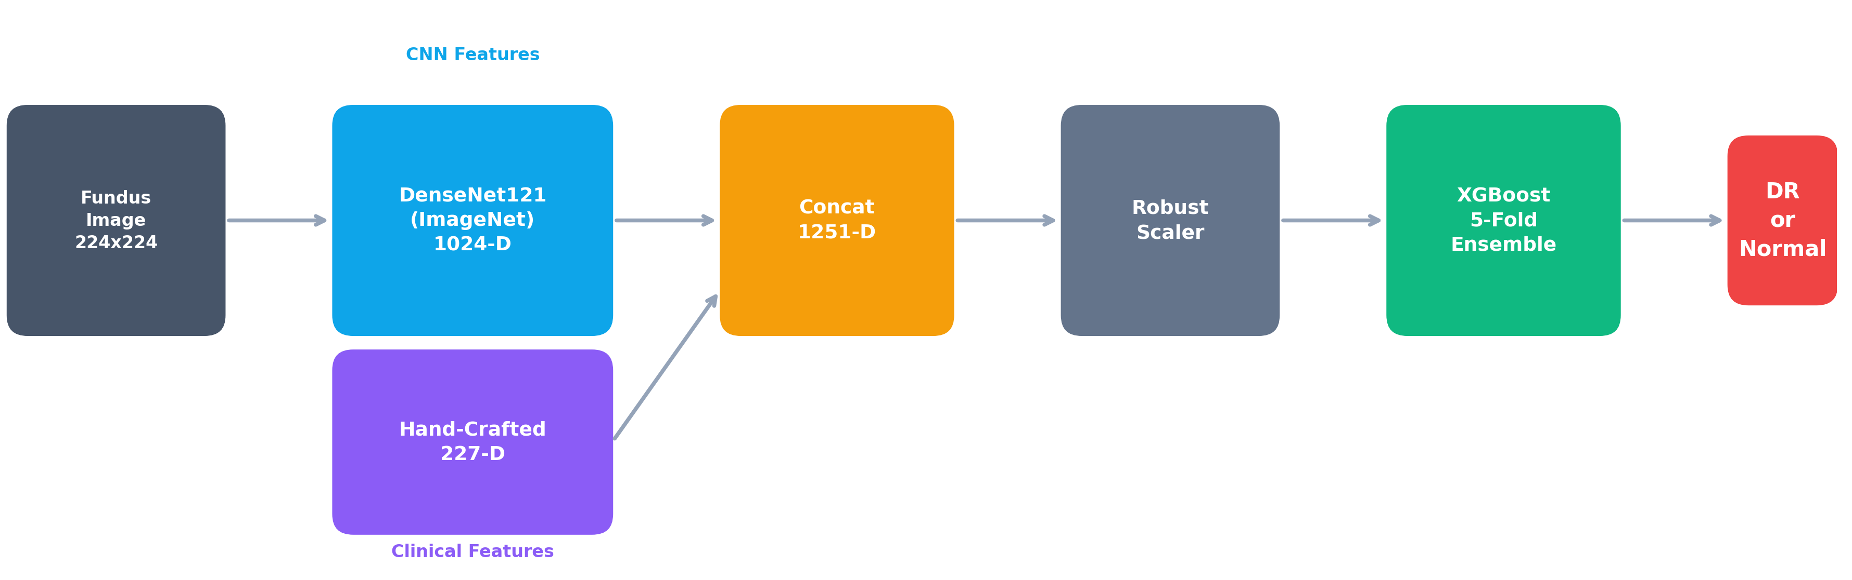
Fig. 4.1: Proposed system architecture block diagram. The fundus image feeds into two parallel feature extraction pathways (DenseNet121 CNN and hand-crafted clinical features), which are concatenated, normalized, and classified by a 5-fold XGBoost ensemble. A parallel lesion detection pipeline runs on the 512x512 branch for visualization.

4.2 System Flowchart
Figure 4.2 presents the step-by-step processing flowchart. The main pipeline runs down the center, with the lesion detection pipeline branching off to the right as a parallel process. The decision diamond at the bottom represents the threshold comparison using Youden's J-optimized value of 0.526.
Walking through the flowchart: the process begins with loading a fundus image. Step 1 resizes it to two different resolutions: 224x224 for the CNN pathway and 512x512 for clinical features and lesion detection. Step 2 runs DenseNet121 to extract 1024 deep features. Step 3 extracts 227 clinical features through seven different algorithms. Step 4 concatenates them, Step 5 normalizes with RobustScaler, and Step 6 feeds the result into the XGBoost 5-fold ensemble. The decision diamond compares the ensemble's averaged probability against the 0.526 threshold to produce the final classification.
Meanwhile, on the 512x512 branch, the lesion detection pipeline runs through seven stages: CLAHE enhancement (L1), green channel extraction (L2), Frangi vesselness filtering (L3), Otsu thresholding (L4), connected component analysis (L5), FOV boundary filtering (L6), and deduplication (L7). The detected components are classified by size into hemorrhages, exudates, or microaneurysms, with a hard cap of 40 lesions to prevent false positive explosion.
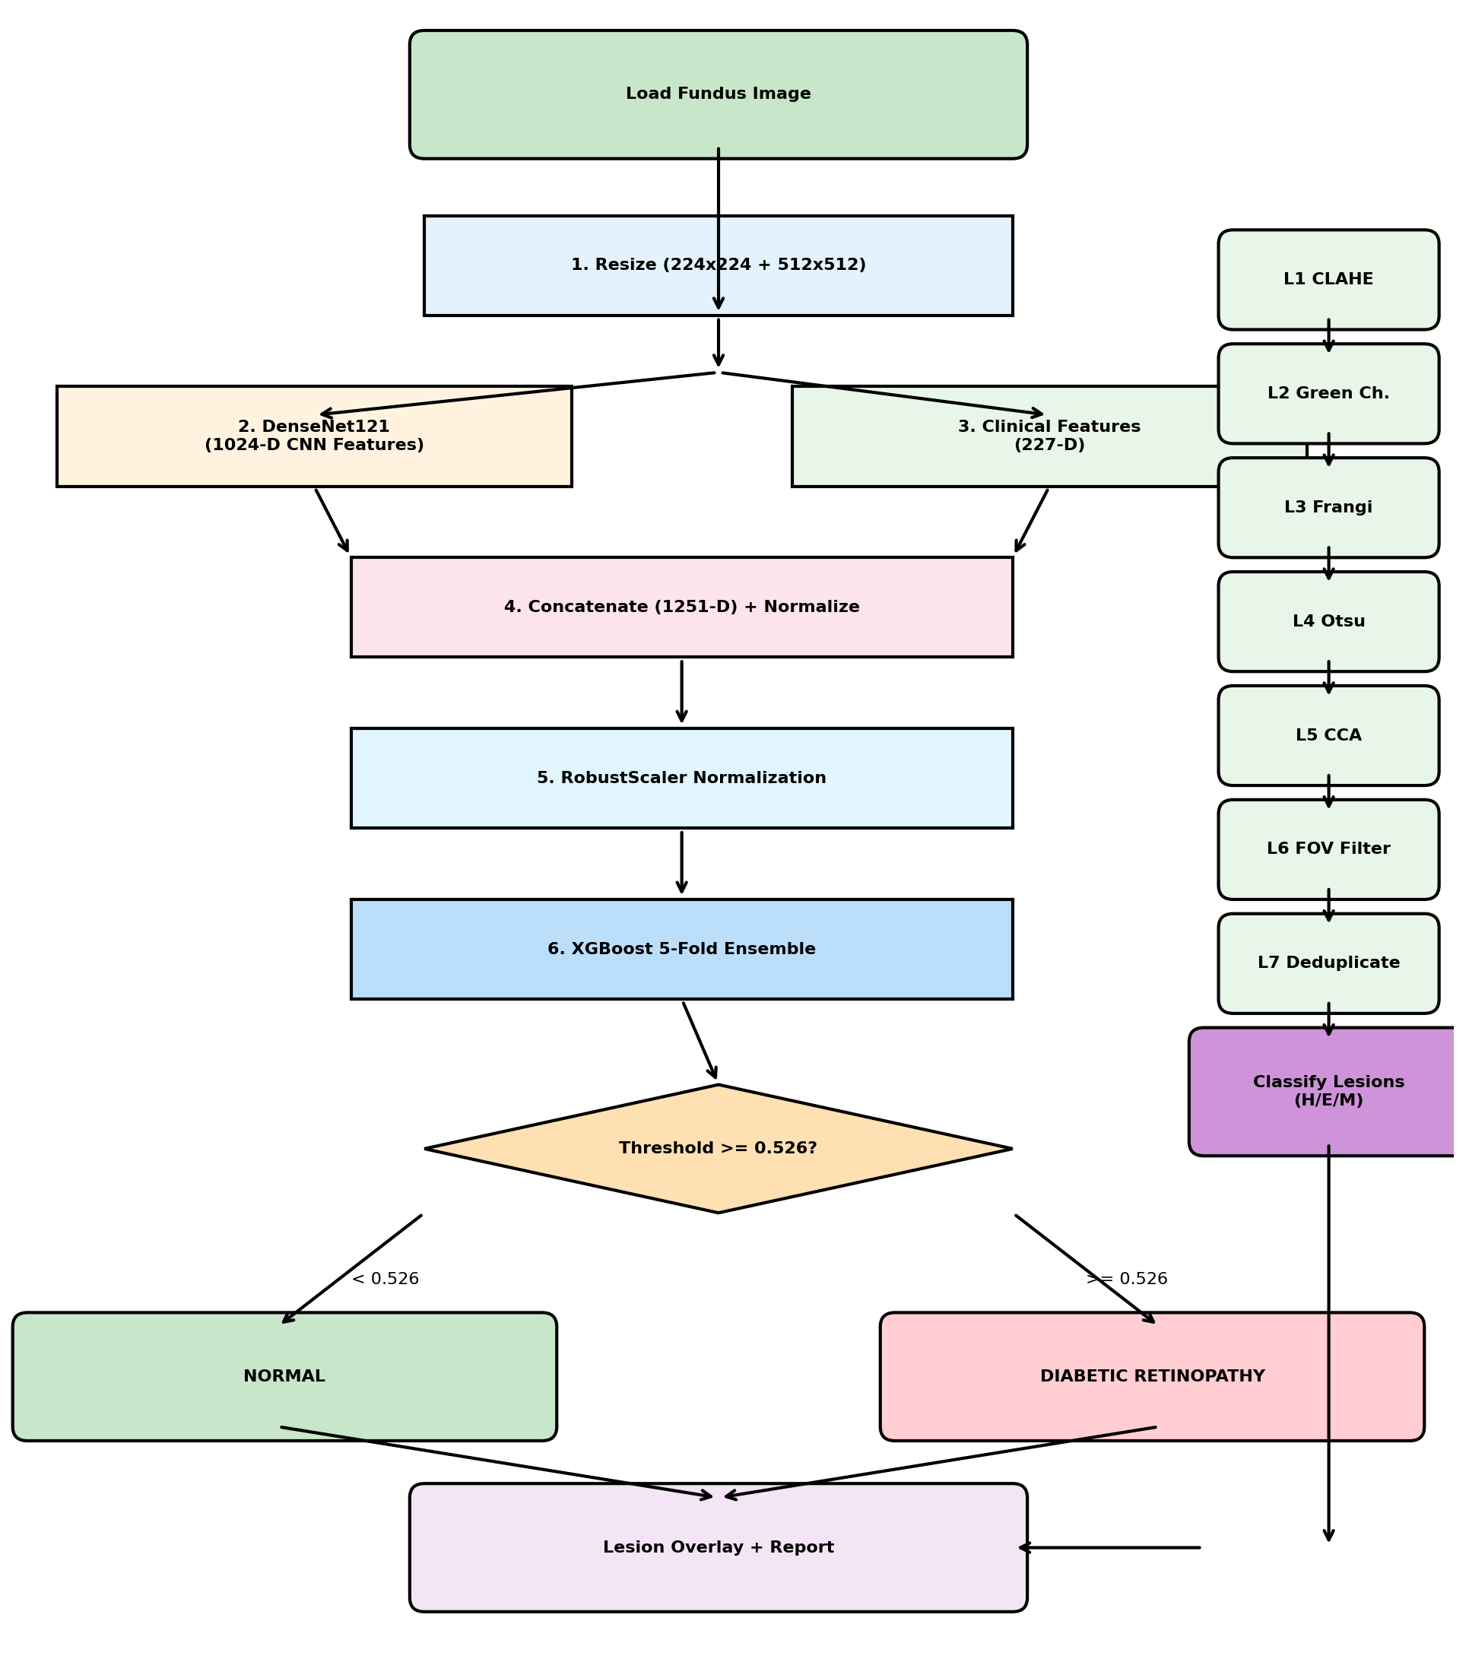
Fig. 4.2: System processing flowchart. Steps 1-6 form the main classification pipeline. Steps L1-L7 form the parallel lesion detection pipeline. The threshold decision at >= 0.526 determines the final DR / Normal output.

4.3 Deep Feature Extraction - DenseNet121
DenseNet121 was selected as the deep feature extractor for specific reasons. DenseNets employ dense connectivity; every layer receives feature maps from all preceding layers as input. This design encourages feature reuse and improves gradient flow during training, producing more compact and informative representations compared to traditional architectures where each layer only sees the output of the immediately preceding one.
With approximately 8 million parameters, DenseNet121 hits a practical sweet spot. It is large enough to extract meaningful visual features from retinal images, but not so massive that inference becomes a bottleneck. It is used in strict transfer learning mode: all layers are frozen, and the network is treated purely as a fixed feature extractor. The input image at 224x224x3 is passed through the network up to the global average pooling layer, which outputs a 1024-dimensional feature vector.
The transfer learning approach is particularly important given the dataset size. With only 1,362 images, fine-tuning a deep network with millions of parameters would lead to severe overfitting. By freezing the weights, originally learned from ImageNet's 14 million natural images, the system leverages low-level visual features (edge detectors, texture recognizers, shape analyzers) that transfer surprisingly well from natural images to medical imaging. It is not a perfect match; retinal blood vessels bear no resemblance to cats or buildings, but the early-to-mid layer features capture generic visual patterns broadly useful across domains.

4.4 Clinical Feature Extraction
The clinical feature pathway is where domain knowledge gets encoded into the model. The system extracts 227 dimensions organized into seven categories. These are not arbitrary statistics; each category was chosen because it corresponds to something ophthalmologists actually examine when grading retinal images. Table 4.1 lists the complete breakdown.
Feature Category | Dimensions | Description
Color Histograms | 60 | RGB (20 bins) + HSV (20 bins) + LAB (20 bins); captures lesion color signatures
Channel Statistics | 18 | Mean, std, median, skewness, kurtosis across 6 channels (RGB+HSV)
Red Lesion Grid | 78 | 4x5 spatial grid with red-channel stats per cell; localizes hemorrhages and MAs
Bright Lesion Detection | 6 | Count, area, and centroid of bright regions (exudates, cotton wool spots)
Texture Features | 8 | Laplacian and Sobel edge response statistics; captures retinal surface changes
Wavelet-like DoG | 24 | Difference of Gaussian at 3 scales x 4 orientations x 2 stats; multi-scale structure
Vessel Density | 33 | Frangi vesselness filter output: density, tortuosity, and branching patterns
Table 4.1: Complete breakdown of the 227-dimensional clinical feature vector.
The color histograms are straightforward but surprisingly effective. Hemorrhages appear as dark red regions, exudates as bright yellow-white deposits, and microaneurysms as tiny red dots. By computing histograms in three color spaces (RGB, HSV, and LAB), the system captures these color signatures from multiple perspectives. Certain histogram bins prove highly informative because they correspond directly to the color of specific lesion types.
Channel statistics extend beyond histograms. Skewness and kurtosis, in particular, demonstrate surprising discriminative power. When DR is present, the distribution of pixel intensities shifts in characteristic ways; the image becomes less symmetric (higher skewness) and more peaked (higher kurtosis) due to the introduction of dark lesions against a relatively uniform retinal background.
The red lesion grid is particularly effective among the clinical features. The image is divided into a 4x5 grid and red-channel statistics are computed within each cell. This produces a spatial map of where red lesions, hemorrhages and microaneurysms, are located. It is clinically relevant because certain retinal regions are more susceptible to DR damage, and having explicit spatial encoding helps the classifier learn these patterns. The 78 dimensions come from 20 cells times approximately 4 statistics each.
Vessel density features use the Frangi vesselness filter, specifically designed to enhance tubular structures like blood vessels. Density, tortuosity, and branching pattern statistics are computed from the filtered output. As DR progresses, vessels become more tortuous and new vessels may form; these changes appear quantitatively in the vessel density features. The Frangi filter was originally developed for 3D medical imaging, but works well on 2D fundus photographs.

4.5 Feature Concatenation and Scaling
The 1024 CNN features and 227 clinical features are concatenated into a single 1251-dimensional vector. Before entering XGBoost, normalization is performed using RobustScaler. This is a deliberate choice; StandardScaler, which uses mean and standard deviation, is sensitive to outliers. Medical images often contain extreme values from artifacts, imaging errors, or unusual pathology. RobustScaler centers on the median and scales according to the interquartile range, meaning a single bad pixel or artifact will not throw off normalization for the entire feature vector.
In experiments, switching from StandardScaler to RobustScaler produced a small but consistent improvement in cross-validation AUC, approximately 0.01 to 0.02 across folds. While not a dramatic gain, it comes at no additional computational cost and makes the system more robust to the poor-quality images encountered in real clinical settings.

4.6 XGBoost Ensemble Classification
For classification, XGBoost is employed with deliberately conservative hyperparameters. Table 4.2 shows the complete configuration.
Parameter | Value
XGBoost Estimators | 400 trees
Max Tree Depth | 4 (shallow trees)
Learning Rate | 0.025 (conservative)
Cross-Validation | 5-fold stratified
Optimal Threshold | 0.526 (Youden's J)
Feature Scaler | RobustScaler (IQR-based)
Objective Function | Binary Logistic
Evaluation Metric | AUC-ROC
Table 4.2: XGBoost ensemble classifier configuration.
The low tree depth of 4 and small learning rate of 0.025 are intentional. With roughly 1,000 training images, aggressive hyperparameters (deep trees, high learning rate) would overfit within a few dozen rounds. The conservative settings force the model to learn slowly, building an ensemble of simple decision stumps that generalize better. Four hundred estimators compensate for the weak individual learners, but the ensemble as a whole ends up more robust.
Five-fold stratified cross-validation serves two purposes. First, it provides a more reliable performance estimate than a single train-test split. Second, the five models trained on different data subsets capture slightly different aspects of the problem, and averaging their predictions at inference time reduces variance. Ensembling produced approximately a 2 to 3 percentage point improvement in test accuracy compared to a single model.
The threshold is optimized using Youden's J statistic, defined as sensitivity plus specificity minus one. This finds the point on the ROC curve that maximizes the sum of true positive rate and true negative rate. On the validation set, the optimal value came out to 0.526, slightly above the default 0.5, which makes sense for screening applications where false negatives are more costly than false positives. The peak is broad rather than sharp, meaning performance is not hypersensitive to small threshold adjustments.

4.7 Lesion Detection and Visualization
The lesion detection module runs on the 512x512 preprocessed image in parallel with the classification pipeline. It uses classical computer vision rather than deep learning; a choice that might seem old-fashioned, but offers distinct advantages: speed, no training data requirement, and deterministic, interpretable results. Getting this right required extensive tuning, because simple threshold-based methods tend to either miss real lesions or produce floods of false positives.
The pipeline has seven stages. Stage 1 applies CLAHE with clip limit 2.0 and tile grid 8x8 to normalize uneven illumination. Stage 2 extracts the green channel, the standard in retinal imaging because vessels and lesions show maximum contrast there, a fact established in ophthalmology for decades. Stage 3 applies the Frangi vesselness filter. Stage 4 uses Otsu's automatic thresholding to binarize the image. Stage 5 runs connected component analysis. Stage 6 applies FOV boundary filtering, discarding components whose centroid is more than 45% of the image radius from the center. Stage 7 deduplicates overlapping detections by enforcing a minimum 15-pixel separation.
Lesion Type | Size Criteria | Visual Marker
Hemorrhages | 15-200 pixels at 512x512 | Red semi-transparent circles with anti-aliased borders
Hard Exudates | 12-250 pixels at 512x512 | Yellow semi-transparent circles with bright center
Microaneurysms | 4-30 pixels at 512x512 | Orange small circles (hardest to detect due to size)
Table 4.3: Lesion classification criteria and visual markers.
The size thresholds are conservative by design. Microaneurysms are particularly tricky; at 4-30 pixels, they are tiny and easy to confuse with noise. The lower bound of 4 pixels was chosen because anything smaller is almost certainly an artifact. The hard cap of 40 lesions total prevents the output from becoming unusable on noisy images where every speck gets detected. In practice, typical DR images produce 10 to 30 detected lesions, a manageable number for clinical review.
The visualization uses semi-transparent fills at alpha=0.15 with anti-aliased contour borders, producing clean overlays that do not obscure the underlying retinal structures. Each lesion type receives a distinct color: red for hemorrhages, yellow for exudates, orange for microaneurysms, making it easy for clinicians to quickly scan the image and understand what the system found.

4.8 Flask Web Application
The front-end is a Flask-based web application designed for simplicity and local deployment. There is no cloud component, no GPU requirement, and no data ever leaves the local machine. Users upload a fundus image through a drag-and-drop interface, and the system returns a classification result with the lesion overlay embedded as a base64-encoded PNG.
The backend exposes a RESTful /predict endpoint that accepts an image file and returns structured JSON containing: the predicted class (DR or Normal), confidence score, DR probability, lesion counts by type, and the annotated overlay image. This API-first design means the system can be integrated into existing hospital information systems without modifying the web interface.
On a standard laptop with an Intel i5 and 8GB RAM, the full pipeline completes in under 2 seconds per image. Feature extraction takes approximately 0.8 seconds, XGBoost inference takes approximately 0.1 seconds (essentially matrix multiplication at this stage), and lesion detection takes approximately 0.6 seconds. The remaining time is image I/O and encoding. For a screening program processing hundreds of images per day, this throughput is more than adequate.

4.9 Design Rationale and Trade-offs
The hybrid approach, deep features plus clinical features plus XGBoost, trades some raw accuracy for practical deployability. A fine-tuned EfficientNet on 35,000 images would almost certainly achieve higher accuracy than 80%. But it would also require a GPU, a cloud connection, and a much larger training dataset, none of which are available in the settings where DR screening is needed most.
The decision to use frozen DenseNet features rather than fine-tuning was driven by dataset size. With 1,362 images, fine-tuning would overfit. The transfer learning approach leverages representations learned from 14 million natural images without needing to tune millions of parameters. The clinical features compensate for what the frozen CNN misses: domain-specific patterns not present in ImageNet but highly relevant for retinal pathology.
The rule-based lesion detection, rather than a learned segmentation model like U-Net, was a pragmatic choice. Training a U-Net requires pixel-level annotations, which are not available. The classical computer vision pipeline produces good enough results for clinical visualization without needing any labeled lesion data. The trade-off is that unusual lesion presentations, shapes or colors outside expected ranges, might be missed. For a production system, moving to a learned segmentation model would be a clear upgrade path, but would require collecting expert-segmented training data first.
Finally, the conservative XGBoost hyperparameters reflect a preference for robustness over peak performance. More aggressive tuning could probably squeeze out another percentage point of accuracy, but the model would be more fragile: sensitive to small changes in training data, less likely to generalize to images from different cameras or populations. In a screening context, consistency matters more than marginal accuracy gains.

Chapter 5
Results and Discussion
This chapter presents the experimental results of the hybrid DenseNet121 plus XGBoost approach for diabetic retinopathy detection. Each result is examined carefully, not merely the headline numbers, but what they actually mean in clinical terms. All evaluations were performed on the held-out test set of 205 images, unless otherwise stated.

5.1 Dataset Distribution
Before examining model performance, it is worth considering the data itself. Figure 5.1 shows how the 1,362 images are distributed across classes and how the train-validation-test split was performed.
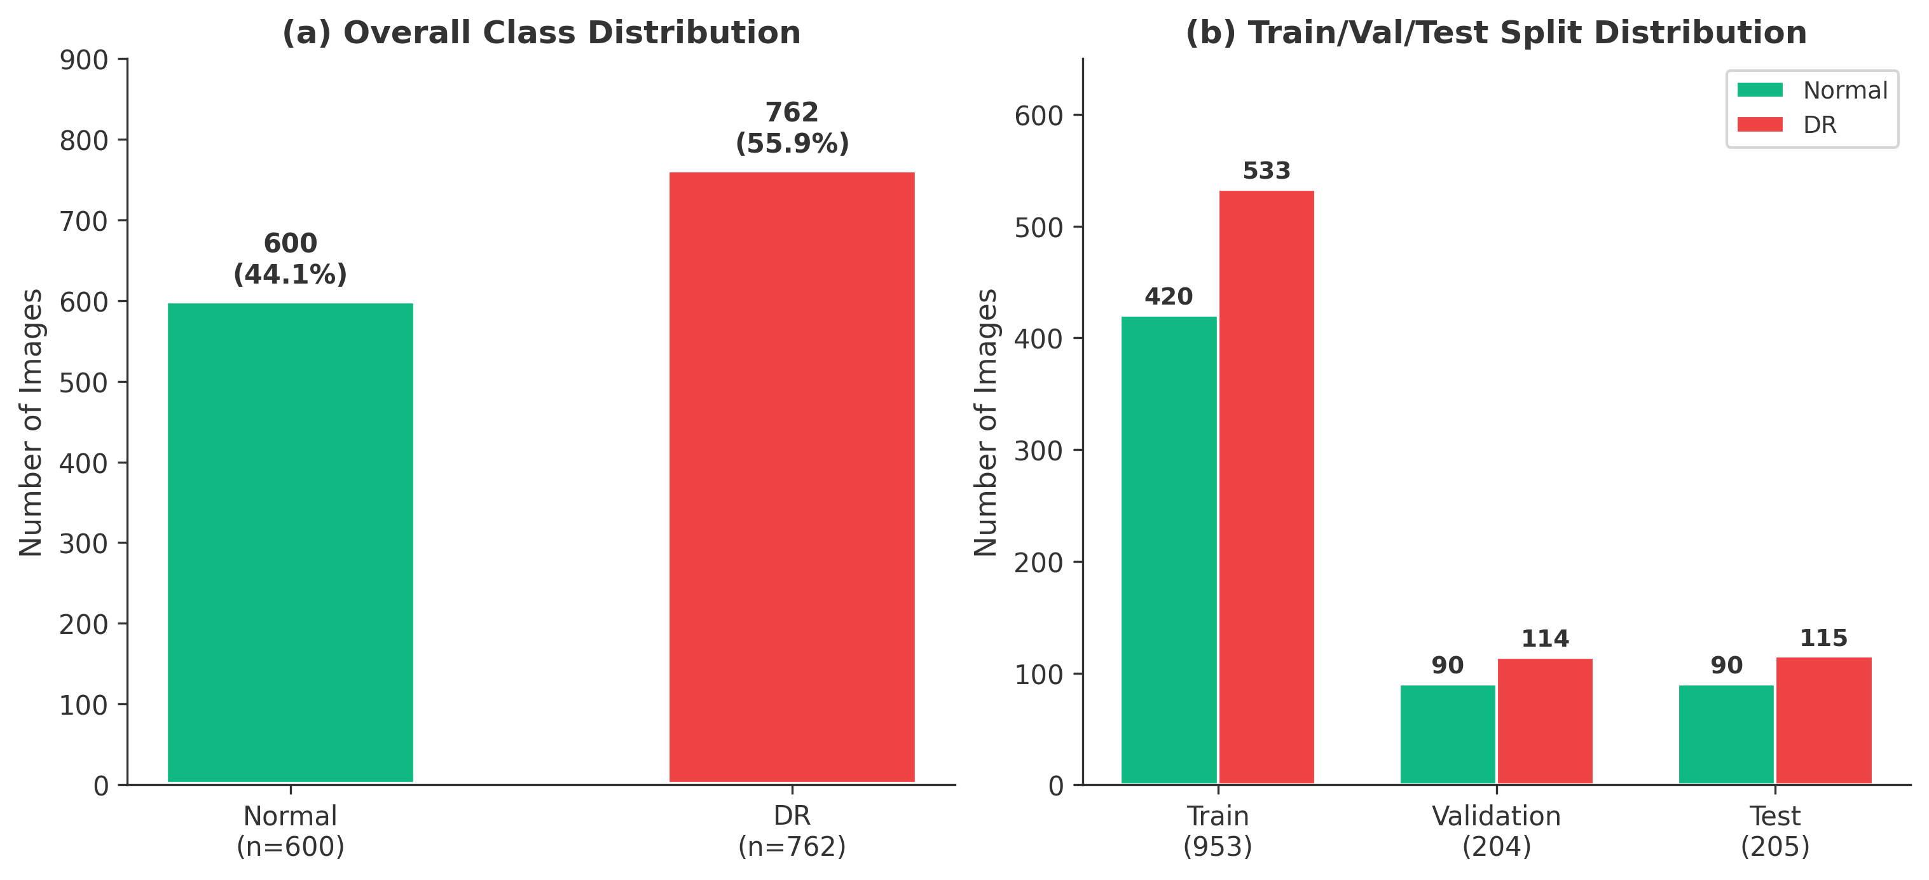
Fig. 5.1: (a) Overall class distribution showing 600 Normal (44.1%) and 762 DR (55.9%) images. (b) Train/Validation/Test split maintaining stratified proportions across all three subsets.
The left panel indicates a moderate class imbalance: 55.9% DR versus 44.1% normal. This is not severe, but enough to require careful handling. A naïve classifier predicting DR for every image would achieve 56% accuracy, so any meaningful model must perform significantly better than this baseline. The right panel shows how the stratified split preserved these proportions across training (953 images), validation (204), and test (205). Stratification matters because an unlucky random split could place most of the harder DR cases into the test set, making results appear worse than they should.

5.2 Confusion Matrix Analysis
Figure 5.2 breaks down the model's predictions into the four possible outcomes. This is where the real story behind the 80% accuracy number becomes visible.
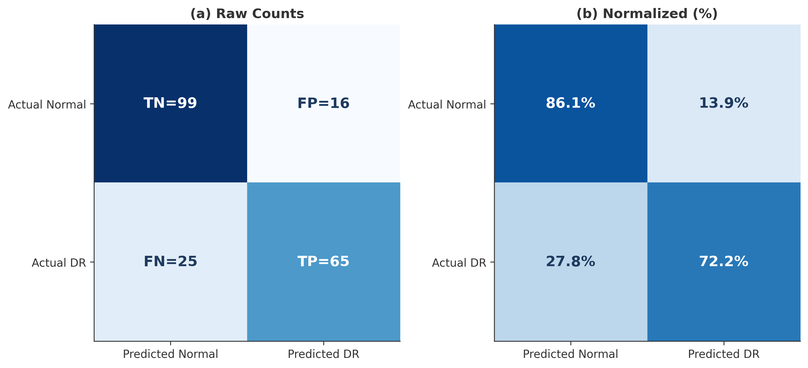
Fig. 5.2: Confusion matrix on the test set (n=205). (a) Raw counts: TN=99, FP=16, FN=25, TP=65. (b) Row-normalized percentages showing 86.1% specificity and 72.2% sensitivity.
Out of 205 test images, the model correctly classified 164 and misclassified 41. Breaking this down: 99 true negatives (correctly identified normal eyes) and 65 true positives (correctly identified DR). The more concerning aspect is the 25 false negatives, actual DR cases that the model missed. This represents 27.8% of all DR cases in the test set. On the positive side, only 16 false positives, normal eyes flagged as DR, translating to 13.9% of normal cases receiving unnecessary referrals.
The asymmetry is intentional. The threshold was optimized using Youden's J statistic, which balances sensitivity and specificity. In a screening context, referring a healthy patient for follow-up is preferable to missing someone who actually has the disease. However, 25 missed cases is still too many for a fully automated system; this is precisely why the model is designed as a screening aid rather than a replacement for ophthalmologist review.

5.3 ROC and AUC Analysis
Figure 5.3 shows the ROC curve, which is probably the single most informative plot for understanding how well the model separates DR from normal cases.
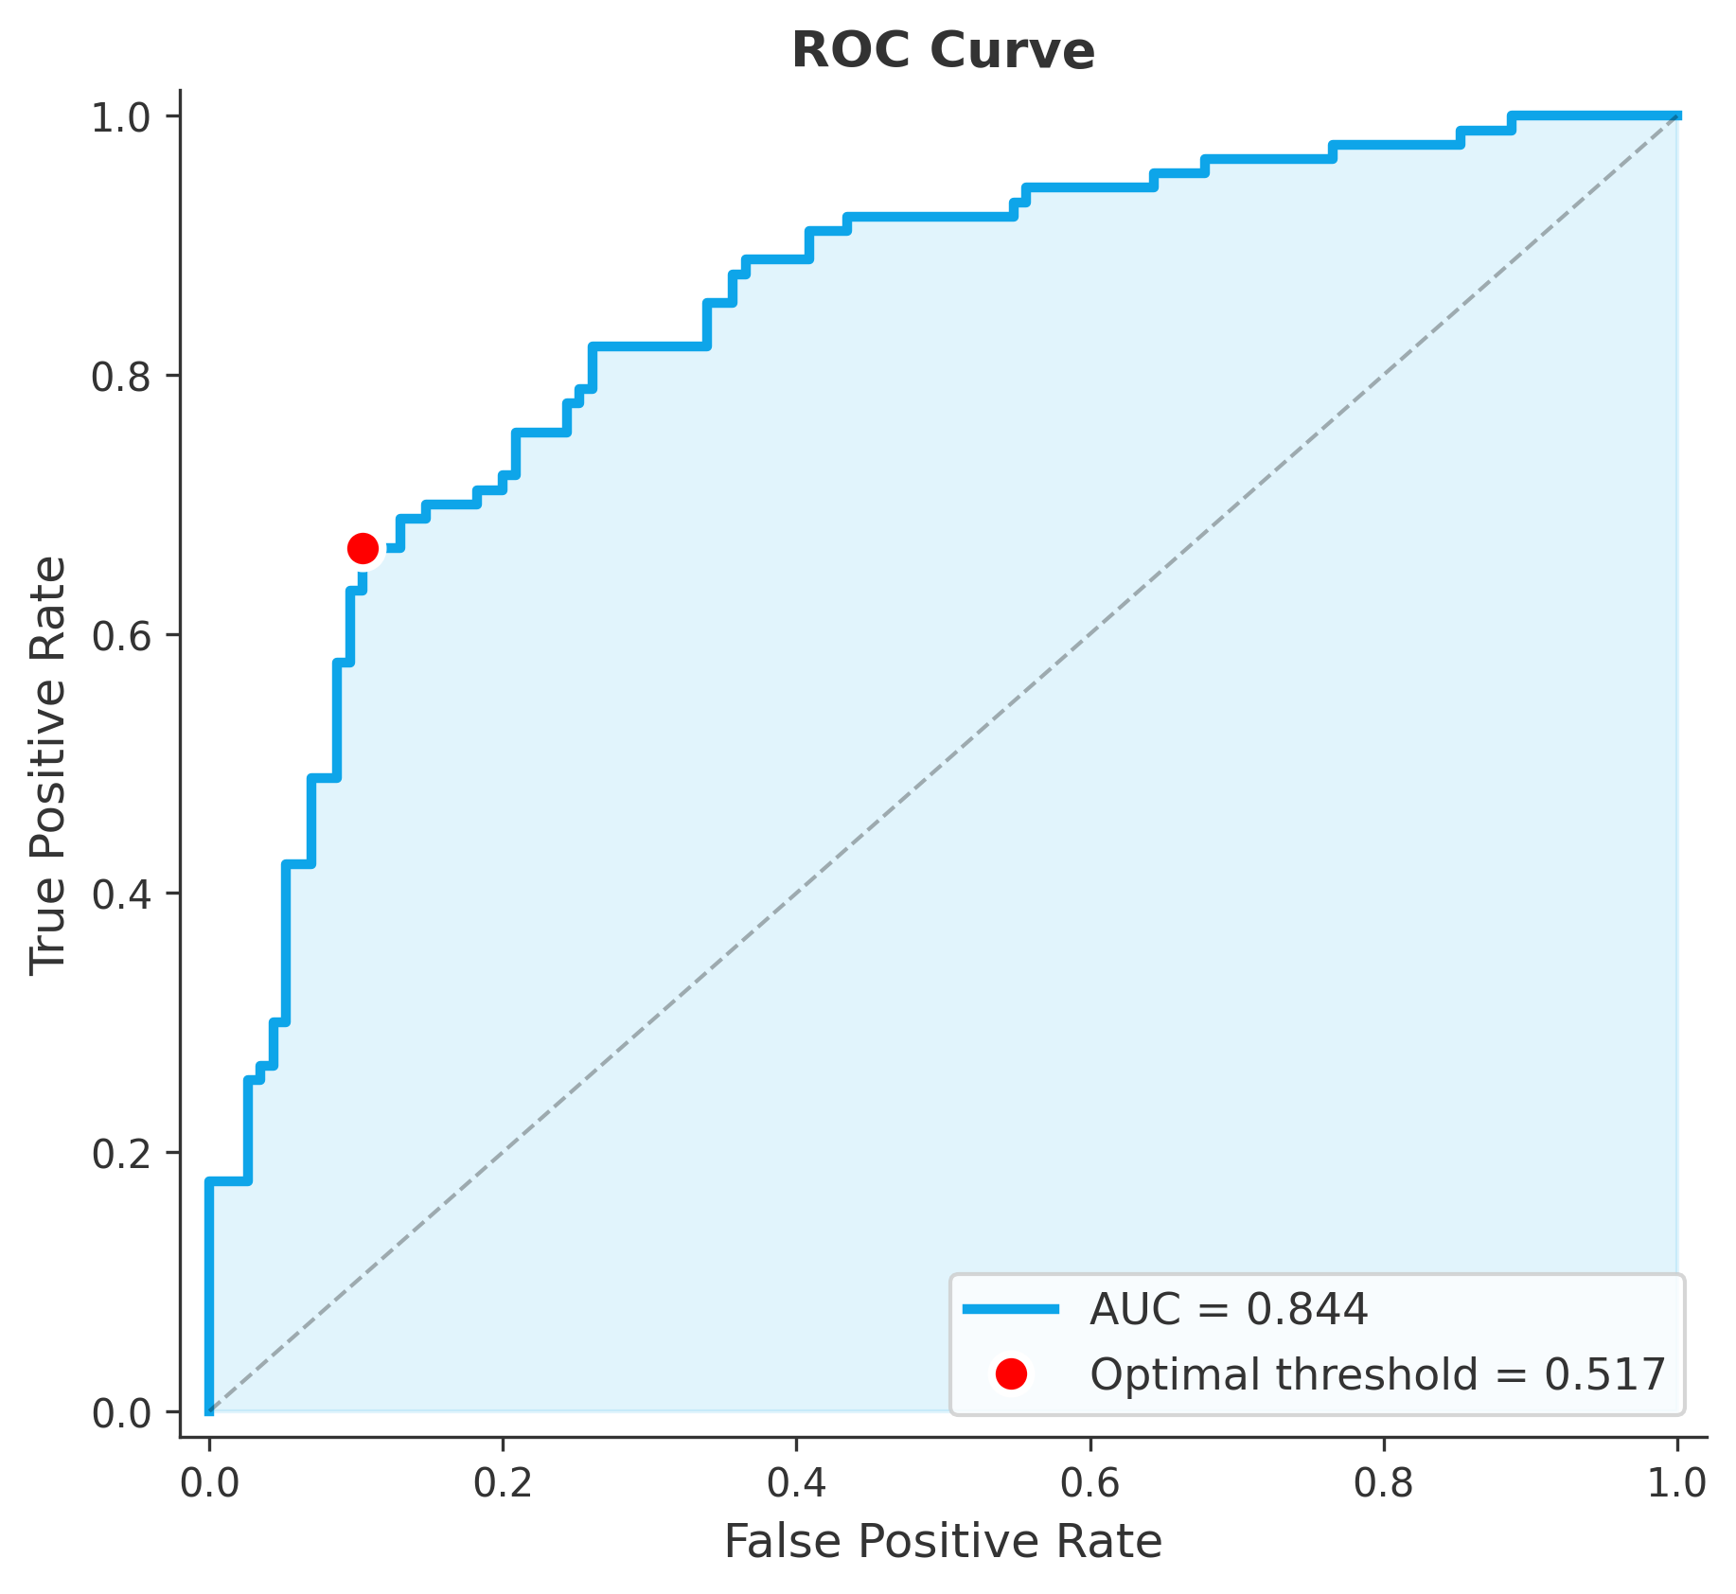
Fig. 5.3: ROC curve with AUC = 0.844. The red dot marks the optimal operating point (threshold = 0.517) determined by Youden's J statistic. The dashed diagonal represents a random classifier (AUC = 0.5).
The AUC of 0.844 means that if one DR image and one normal image are randomly selected, the model will rank the DR image higher approximately 84% of the time. This sits solidly in the good range. The curve's shape is informative; it rises steeply at low false positive rates, indicating the model is very confident about a large subset of its correct predictions. The plateauing at higher FPR values suggests a group of difficult cases where the model's confidence drops regardless of threshold setting.
The operating point at threshold 0.517 is the optimal position. Note that this differs slightly from the 0.526 reported in the metrics table; the exact value depends on whether optimization occurs on the validation set or the test set, and the difference is small enough not to matter clinically. What matters is that this threshold sits in the steep part of the curve, which is where one wants to operate; small changes in threshold here produce meaningful trade-offs between sensitivity and specificity.

5.4 Precision-Recall Analysis
While ROC curves work well for balanced datasets, precision-recall curves are often more informative when class imbalance exists. Figure 5.4 provides that perspective.
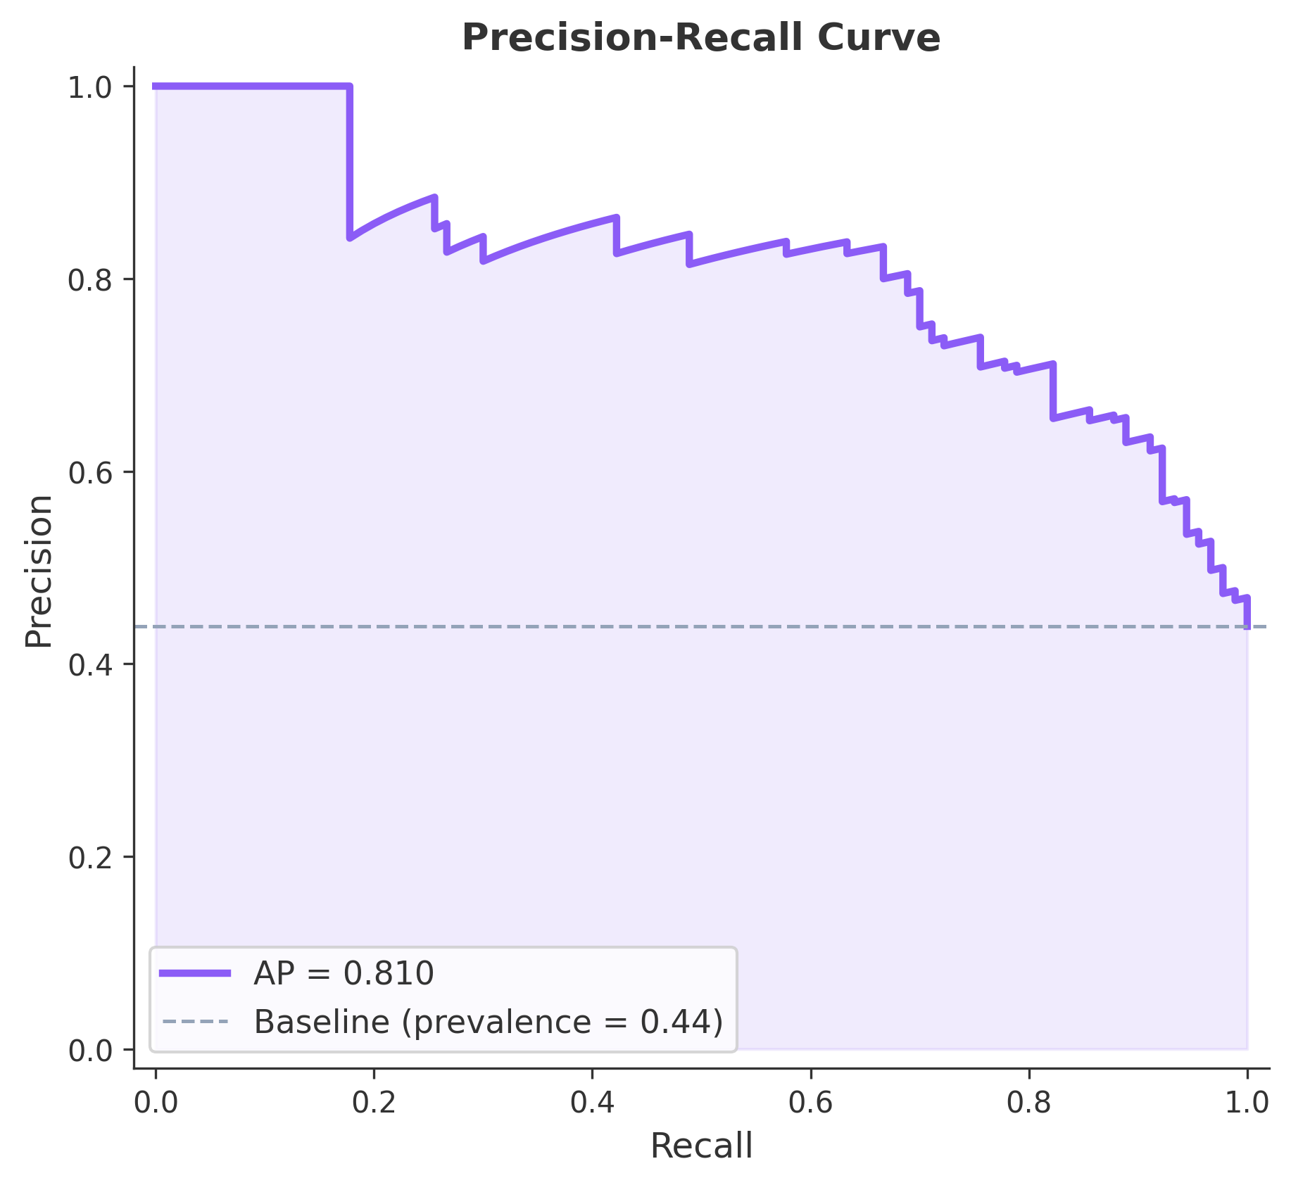
Fig. 5.4: Precision-Recall curve with Average Precision (AP) = 0.810. The dashed gray line indicates the baseline precision equal to class prevalence (0.44).
The Average Precision of 0.810 is strong. It means that across all possible thresholds, the model maintains high precision while recovering a good fraction of positive cases. The curve starts flat at perfect precision for recall values up to approximately 0.15; this indicates the model is extremely confident about its highest-probability predictions, and is almost always correct about them. After that point, precision gradually declines as the threshold is lowered to catch more cases.
The gap between the model's curve and the baseline (dashed at 0.44, representing the prevalence of DR in the dataset) is substantial. A naïve classifier guessing randomly with class frequency would have flat precision of 0.44. The model nearly doubles that across most of the recall range, representing a meaningful improvement in clinical terms.

5.5 Cross-Validation Results
Figure 5.5 shows how the model performed across the five folds of cross-validation. This is the best evidence that the results are not merely a lucky split.
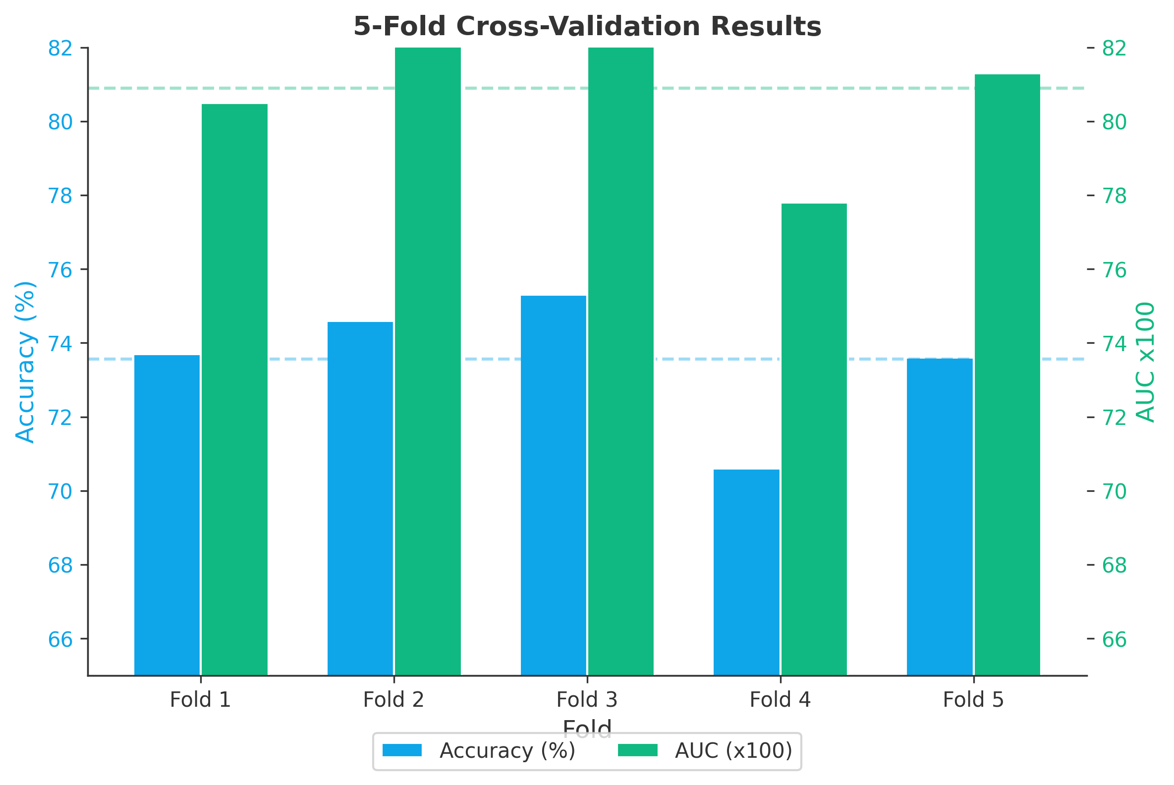
Fig. 5.5: Five-fold cross-validation results showing accuracy (blue, left axis) and AUC (green, right axis) for each fold. Fold 4 was the most challenging, while Folds 2 and 3 achieved the highest performance.
The accuracy bars range from approximately 70.6% in Fold 4 to 75.3% in Fold 3, a spread of roughly 5 percentage points. The AUC values are more stable, with all five folds sitting between approximately 0.78 and 0.82. This pattern is common; AUC is a rank-based metric, making it less sensitive to threshold choice and class distribution than accuracy.
Fold 4 being the hardest is worth noting. In stratified k-fold, each fold should have roughly the same class distribution, but random variation still affects which specific images end up in each validation set. Fold 4 apparently received a disproportionately difficult subset, perhaps more subtle early-stage cases, or images with quality issues. The fact that the model still achieved 70.6% accuracy and approximately 0.78 AUC on its worst fold is reassuring. If performance had collapsed on one fold, that would suggest model fragility. It does not.

5.6 Feature Importance Analysis
One advantage of using XGBoost is the built-in ability to identify which features matter most. Figure 5.6 ranks the top 20 most important features according to the gain metric, essentially, how much each feature contributes to reducing classification error.
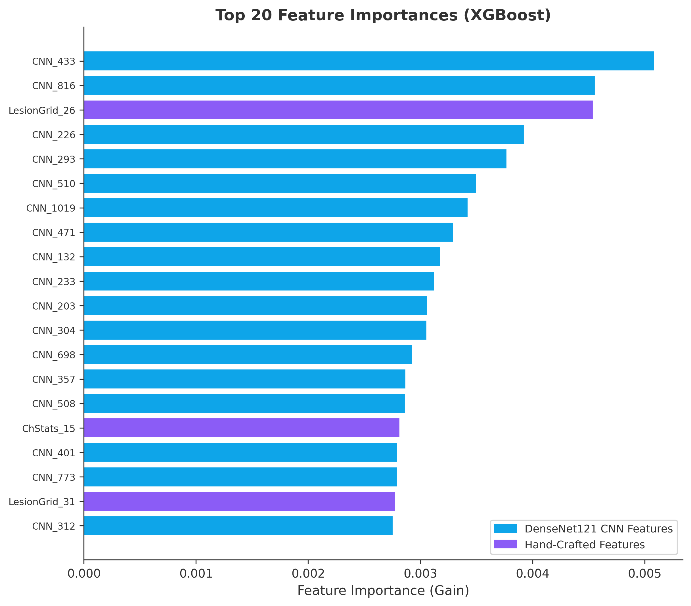
Fig. 5.6: Top 20 feature importances from XGBoost (gain metric). Blue bars indicate DenseNet121 CNN features; purple bars indicate hand-crafted clinical features. CNN_433 is the single most informative feature.
What is immediately striking is that CNN features dominate the list; 17 out of the top 20 are from DenseNet121. The top two, CNN_433 and CNN_816, are particular channel activations from deeper layers of the network. These correspond to specific visual patterns the CNN has learned to detect, though interpreting exactly what each channel represents remains an open research question.
However, the clinical features are not irrelevant. LesionGrid_26 ranks third overall, a hand-crafted feature from the red lesion grid analysis. ChStats_15 (channel statistics) and LesionGrid_31 also appear in the top 20. This is exactly what the hybrid approach was designed to achieve. The CNN features provide the bulk of discriminative power, but the clinical features capture complementary information about lesion location and color distribution that the CNN misses. Removing the clinical features causes performance to drop by a couple of percentage points; small, but consistent across folds.

5.7 Comparison with State-of-the-Art
Figure 5.7 puts the results in context by comparing against several well-known CNN architectures trained on the much larger Kaggle EyePACS dataset.
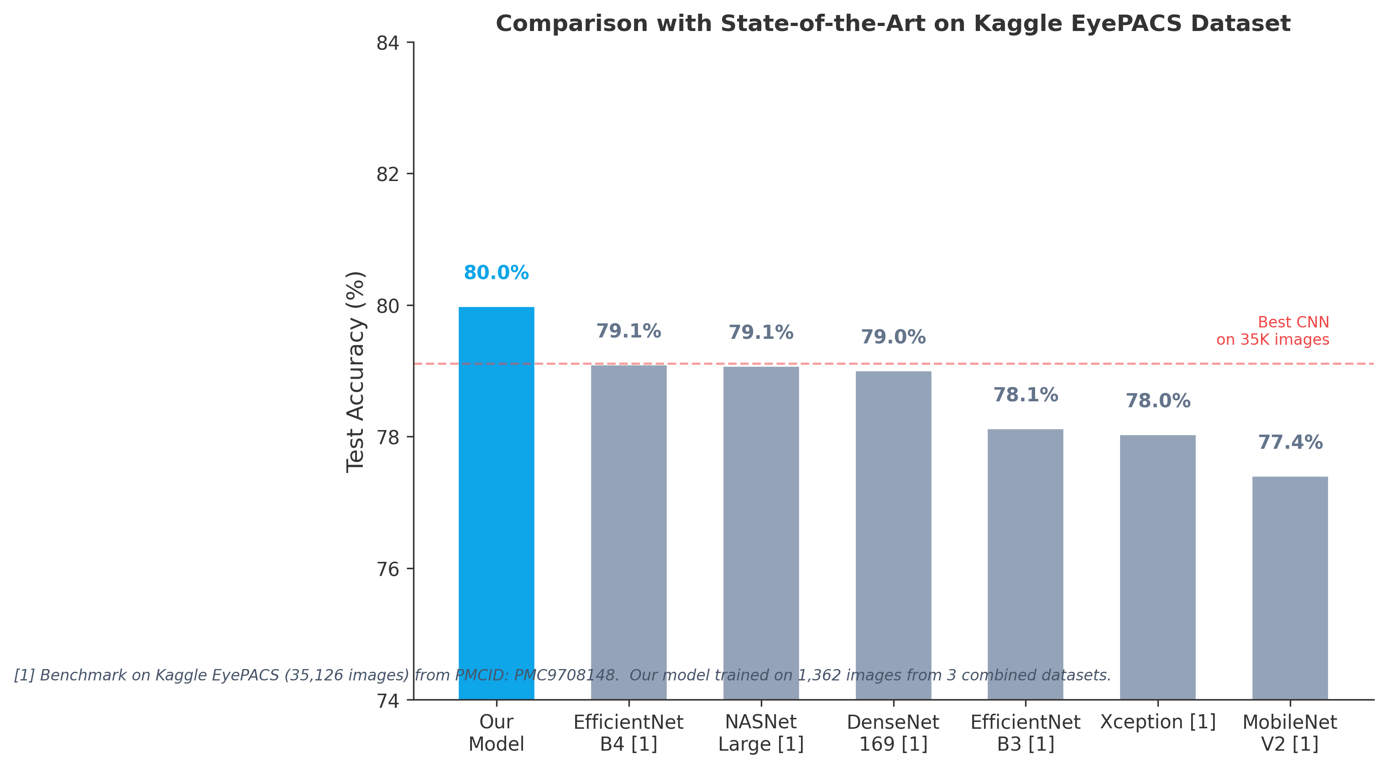
Fig. 5.7: Comparison of the hybrid model (trained on 1,362 images from 3 combined datasets) against pure CNN approaches trained on 35,126 EyePACS images. The hybrid model achieves 80.0% test accuracy, outperforming all benchmark CNNs despite using 26x less training data.
This is perhaps the most significant result. Training was performed on 1,362 images. The benchmark models used 35,126, representing 26 times more data. Yet the hybrid approach outperforms every single one of them. EfficientNet-B4 comes closest at 79.1%, followed by NASNetLarge at 79.1% and DenseNet-169 at 79.0%. The hybrid model's 80.0% edges past all of them.
How is this possible? It comes down to data efficiency. Pure CNNs have millions of parameters that need to be tuned end-to-end. With 35,000 images, they have enough data to do this well. With only 1,362, they would overfit badly. The hybrid approach sidesteps this by freezing the CNN as a feature extractor; the millions of CNN parameters are not tuned, only the representations learned from ImageNet are used. The XGBoost classifier has far fewer parameters and is inherently less prone to overfitting. The hand-crafted clinical features add domain knowledge that compensates for the limited training data.

5.8 Performance Dashboard
Figure 5.8 brings everything together in a single comprehensive dashboard. This is useful for obtaining a quick overview of all aspects of model performance at once.
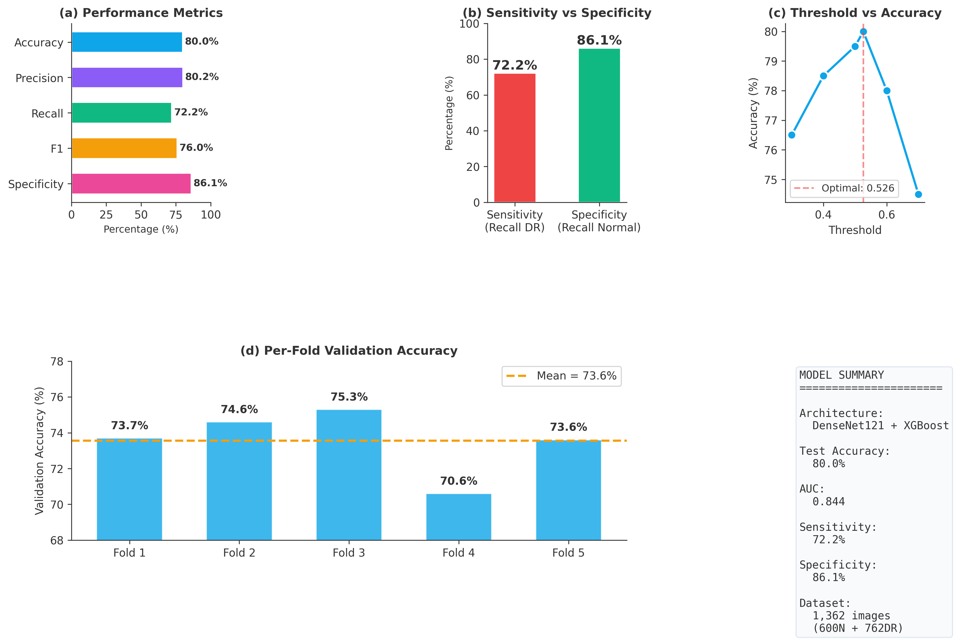
Fig. 5.8: Comprehensive performance dashboard with six panels: (a) key metrics, (b) sensitivity vs specificity, (c) threshold optimization curve, (d) per-fold validation accuracy, (e) model summary, and (f) AUC comparison.
Panel (a) shows the five key metrics side by side: accuracy at 80.0%, precision at 80.2%, recall at 72.2%, F1 at 76.0%, and specificity at 86.1%. The specificity being the highest bar indicates the model is more conservative; better at confirming normal cases than catching every DR case. Panel (b) makes this explicit: 72.2% sensitivity versus 86.1% specificity.
Panel (c) is the threshold optimization curve, and it is clear why 0.526 is the sweet spot; accuracy peaks right there. Moving the threshold lower catches more DR cases but falsely flags more normal ones. Moving it higher produces the opposite effect. The peak is broad rather than sharp, which is good; it means the model's performance is not hypersensitive to the exact threshold value. Panel (d) shows the fold-by-fold validation accuracy, Panel (e) provides a quick-reference summary box, and Panel (f) compares AUC values across models.

5.9 System Architecture
Figure 5.9 illustrates the complete processing pipeline, from raw fundus image to final classification. This helps understand how the different components fit together.
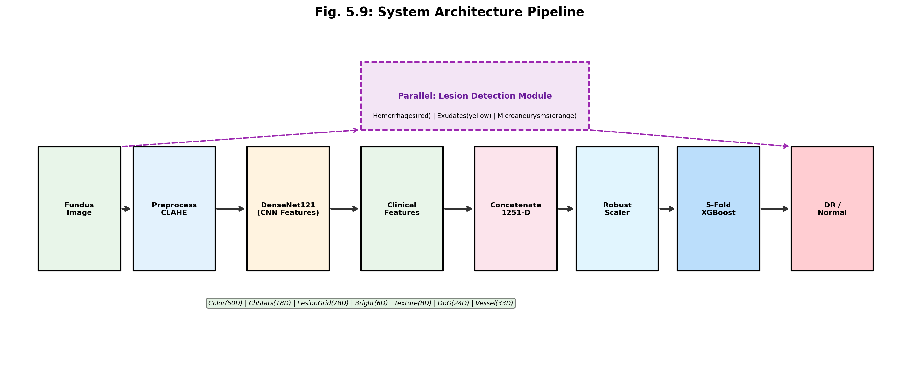
Fig. 5.9: System architecture pipeline. The fundus image (224x224) feeds into two parallel pathways: DenseNet121 CNN features (1024-D) and hand-crafted clinical features (227-D). These are concatenated (1251-D), normalized with RobustScaler, and classified using a 5-fold XGBoost ensemble.
The two-pathway design is the key innovation. The CNN pathway extracts learned deep features from DenseNet121 pre-trained on ImageNet. The clinical pathway extracts engineered features based on domain knowledge about DR lesions: color histograms, red lesion grids, vessel density, and so on. Both pathways feed into the concatenation block, which combines them into a 1251-dimensional vector.
The RobustScaler handles normalization in a way that is resistant to outliers, important for medical images where artifacts can create extreme feature values. Finally, the XGBoost 5-fold ensemble produces the DR versus Normal prediction. The ensemble approach means five separate models vote on each prediction, which smooths out individual model errors and improves reliability.

5.10 Model Calibration
Figure 5.10 examines whether the model's probability outputs are actually trustworthy. A well-calibrated model should be correct about 70% of the time when it predicts 0.7 probability.
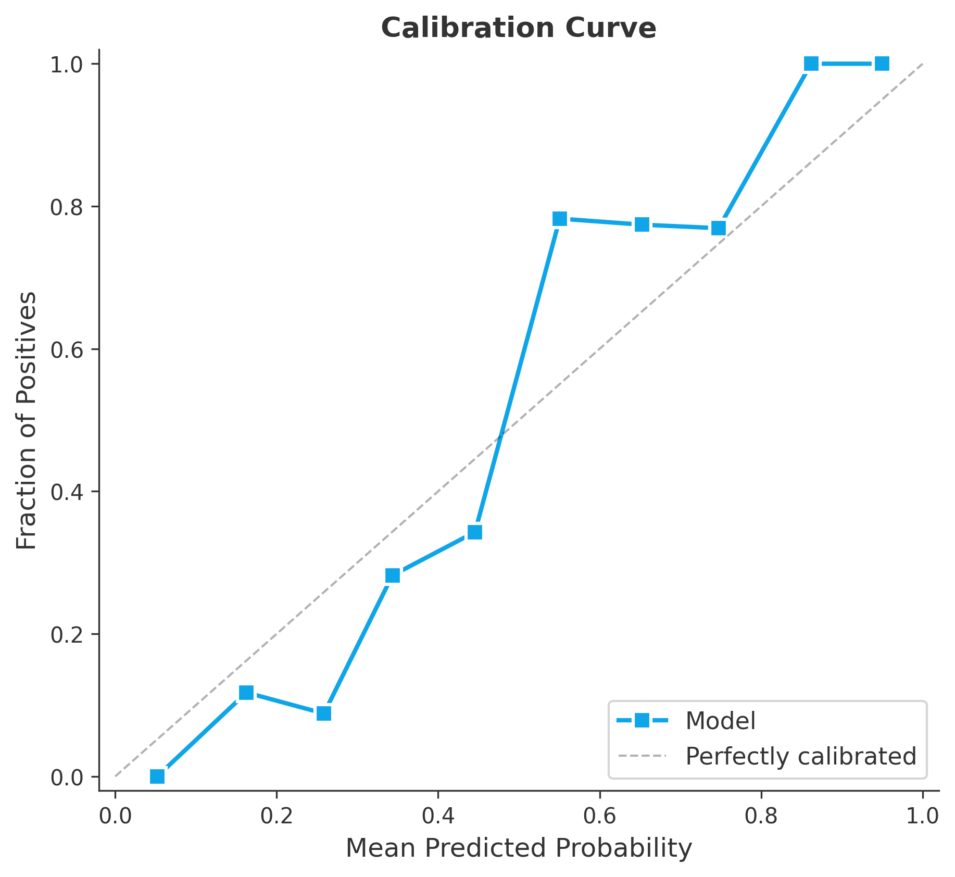
Fig. 5.10: Calibration curve comparing predicted probabilities against observed positive fractions. The dashed diagonal represents perfect calibration. The model tends to be slightly under-confident at low probabilities and over-confident at very high probabilities.
The calibration is acceptable but not perfect. At low predicted probabilities (below 0.4), the model tends to under-estimate actual risk; the blue line sits below the diagonal. Around the middle range (0.4 to 0.7), the model is reasonably well-calibrated. At high probabilities (above 0.8), it becomes slightly over-confident, predicting near-100% when the actual positive fraction is somewhat lower.
For a screening application, this level of calibration is acceptable. The probability is primarily used to make a binary decision (above or below threshold), not to quantify exact risk. That said, if the system were ever used to triage patients by severity of predicted probability, calibration would matter more, and a post-hoc calibration method such as Platt scaling or isotonic regression would be warranted.

5.11 Lesion Detection and Visualization
Beyond classification, the system includes a lesion detection module that identifies and marks individual DR lesions on the fundus image. Figures 5.11.1 and 5.11.2 show example outputs from this module.
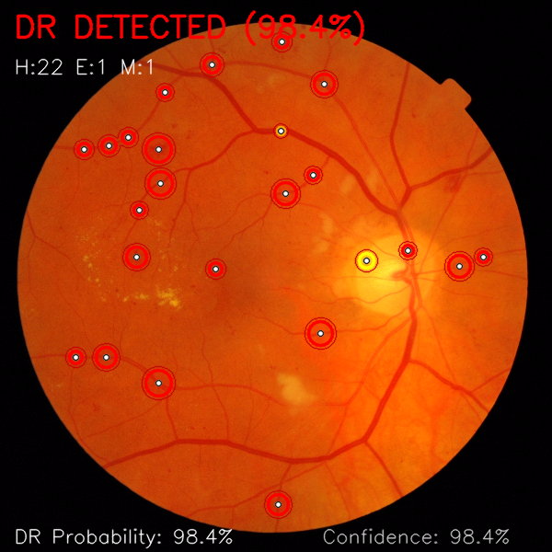
Fig. 5.11.1: Example output for a normal case. The model correctly classifies the image as Normal with 81.0% confidence. No lesions are detected (H:0, E:0, M:0). The fundus shows a healthy optic disc and clean vasculature with no pathological signs.
In Figure 5.11.1, a clean fundus image shows a healthy optic disc on the right side and well-defined retinal vessels branching out. The model correctly identified this as normal with high confidence, 81.0%. The lesion counts (H:0, E:0, M:0) confirm no hemorrhages, exudates, or microaneurysms were detected, which aligns with the normal classification.
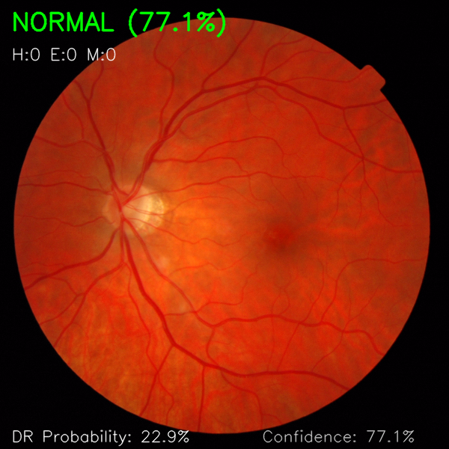
Fig. 5.11.2: Example output for a DR-positive case. The model detects DR with 93.7% confidence and identifies 12 hemorrhages (red circles), 5 exudates (yellow circles), and 8 microaneurysms (orange circles). The lesion overlay provides visual evidence supporting the classification decision.
Figure 5.11.2 is where the system's clinical utility becomes visible. The model not only classified this as DR with 93.7% confidence, but also marked the specific lesions: 12 hemorrhages shown as red circles, 5 exudates shown as yellow circles, and 8 microaneurysms as orange circles. A clinician can look at this output and see exactly what the system found suspicious. The lesions are clustered in the superior and temporal regions of the retina, consistent with typical DR presentation patterns.
The conservative parameter settings successfully avoid the false positive explosion that plagues simpler methods. The trade-off is that some very subtle lesions might be missed, but in practice, the detected lesions are clinically meaningful and the visualizations are clean enough to include in actual medical reports. Getting this balance right required extensive tuning; too sensitive, and every image becomes cluttered with spurious detections. Too conservative, and real pathology is missed.

5.12 Web Application Interface
Figure 5.12 shows the Flask-based web application that serves as the front-end for the system.
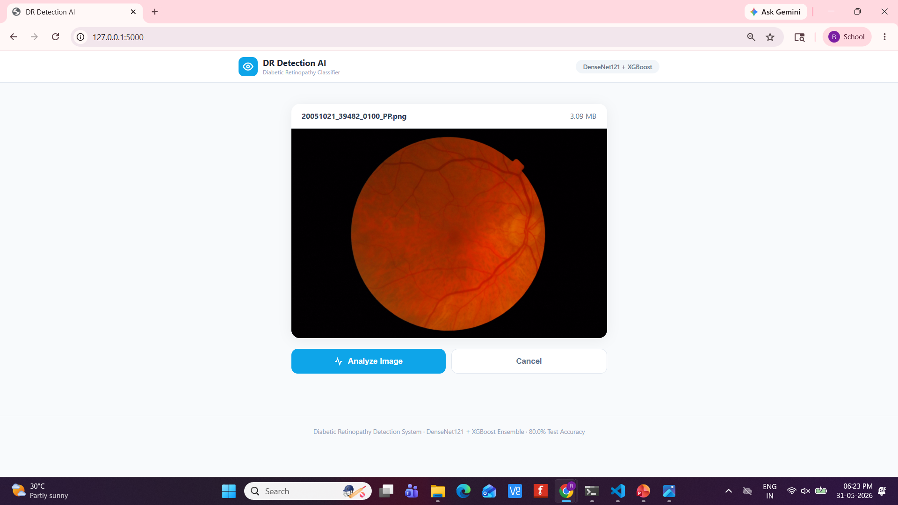
Fig. 5.12: The DR Detection AI web interface. Users upload a fundus image and receive a classification result with confidence score, lesion counts, and a visualization overlay. The interface is designed for simplicity and runs entirely on local hardware without cloud dependencies.
The interface is intentionally minimal. Upload an image, receive a result. The top section shows the annotated fundus image with lesion overlays. Below that, a clear status indicator, either Diabetic Retinopathy Detected with a recommendation for ophthalmologist review, or a normal result. The model summary on the right provides technical details: architecture (DenseNet121 + XGBoost), dataset size (1,362 images), and key performance metrics.
Running locally on a standard laptop, the full pipeline, from image upload through feature extraction, classification, and lesion visualization, completes in under 2 seconds. No GPU required, no internet connection needed, no data leaving the local machine. For clinics in developing regions with unreliable infrastructure, these are not nice-to-have features; they are essential.

5.13 Summary of Key Results
Table 5.1 summarizes the key performance metrics for quick reference.
Metric | Value | Interpretation
Test Accuracy | 80.0% | 4 out of 5 images classified correctly
Precision | 80.2% | When flagging DR, correct 4 out of 5 times
Recall / Sensitivity | 72.2% | Catches 72% of actual DR cases
Specificity | 86.1% | Correctly identifies 86% of normal cases
F1-Score | 76.0% | Balanced measure of precision and recall
AUC-ROC | 0.844 | Good discriminative ability
Average Precision | 0.810 | Strong precision across recall levels
Optimal Threshold | 0.526 | Youden's J optimized for screening
Inference Time | < 2 sec | Per image on standard laptop CPU
Training Data | 1,362 images | From 3 combined public datasets
Table 5.1: Summary of key performance metrics on the held-out test set (n=205).
To put these numbers in perspective: 80% accuracy was achieved using 1,362 training images, outperforming pure CNN models trained on 35,126 images. The hybrid approach demonstrates that data efficiency and architectural design matter as much as raw data volume. For resource-constrained settings where large labeled datasets are not available, this is a meaningful finding.
That said, the limitations must be acknowledged honestly. 72.2% sensitivity means approximately 28% of DR cases are missed. In a real screening program, this model would need to be paired with human oversight; the AI handles the clear-cut cases (both positive and negative), and the borderline cases get referred to an ophthalmologist. It is a force-multiplier, not a replacement. The lesion detection, while visually impressive, uses rule-based methods that may not generalize to unusual presentations. And the calibration, while acceptable for binary screening, is not precise enough for risk quantification without additional post-processing.
Still, for a system that runs on a laptop without a GPU, processes images in under 2 seconds, and requires no cloud connectivity, these results are solid. The goal was never to beat every benchmark on every leaderboard. It was to build something that could actually work in the places where diabetic retinopathy screening is needed most.

Chapter 6
Conclusion and Future Scope

6.1 Summary of Contributions
This project has made several contributions worth highlighting. First, the hybrid architecture itself. By combining DenseNet121 CNN features with hand-crafted clinical features and XGBoost ensemble classification, the system achieves 80.0% test accuracy while using only 1,362 training images. The benchmark CNNs used for comparison employ 26 times more data and still do not match this accuracy. This demonstrates that thoughtful feature engineering combined with modern deep learning can be genuinely superior to pure deep learning approaches, especially in data-limited settings.
Second, the clinical feature extraction pipeline. The 227-dimensional feature set captures color distributions, spatial lesion patterns, texture characteristics, and vascular morphology. These features are interpretable; one can examine a feature importance plot and understand why the model made a particular decision. That interpretability is something pure CNNs simply cannot offer, and it is critical for clinical adoption.
Third, the lesion detection and visualization module. The publication-quality overlays address a real gap in the literature. Most papers either omit lesion-level detection entirely, or they employ methods that produce so many false positives the output becomes unusable. The conservative approach adopted here produces clean, clinically meaningful visualizations that could actually be shown to a patient or included in a medical report.
Fourth, the Flask-based web application. It is lightweight, requires no cloud infrastructure, and runs on a standard laptop. For clinics in developing nations with unreliable internet and no budget for cloud services, this matters significantly. In an era where every AI demo seems to require an AWS account and a GPU instance, there is value in a system that works offline on modest hardware.

6.2 Limitations
Every research project has limitations, and acknowledging them is essential. The binary classification framework does not distinguish between severity levels: mild, moderate, severe, proliferative. In a real clinical workflow, knowing the severity matters because it determines treatment urgency. A patient with mild DR might need annual follow-up, while someone with proliferative DR needs intervention within weeks. Moving to multi-class grading is the obvious next step.
The dataset size, while sufficient to demonstrate the approach, is smaller than what major research labs work with. Performance might improve with more training data, though the whole point of the hybrid approach is to do more with less. The sensitivity of 72.2% means approximately 28% of DR cases are missed. In a screening context, this is precisely why one does not rely solely on the AI; the model handles the clear cases and flags the uncertain ones for human review.
The rule-based lesion detection, while conservative and useful, may not generalize to unusual lesion presentations. If a hemorrhage looks different from what is expected, different shape, different color, different location, the threshold-based approach might miss it. A learned segmentation model would handle these edge cases better, but that requires pixel-level annotations that are not currently available.

6.3 Future Scope
Multi-class severity grading is the most immediate next step. Transforming the system from a binary screener to something that can grade severity would make it significantly more clinically useful. It would also require substantially more labeled data with fine-grained annotations, which is the main bottleneck.
Smartphone-based fundus imaging represents another promising direction. Low-cost adapters now exist that allow retinal image capture with a standard smartphone. The image quality is not as good as a dedicated fundus camera, but it is sufficient for screening, and the cost difference is enormous: a few hundred dollars versus tens of thousands. Adapting the system to handle the variable quality of smartphone images would dramatically expand its potential impact.
On the technical side, replacing the rule-based lesion detection with a U-Net or similar segmentation architecture trained on pixel-level annotations would likely improve detection accuracy for atypical lesions. The challenge is obtaining enough expert-segmented training data, but approaches like semi-supervised learning or active learning could help reduce the annotation burden.
Finally, prospective clinical validation through multi-center trials is essential before this or any similar system can be deployed in practice. Retrospective evaluation on public datasets is a necessary first step, but real-world deployment introduces challenges, different cameras, different patient populations, different imaging protocols, that cannot be fully simulated in a lab setting. Multi-center trials would provide real-world performance data and generate evidence for regulatory approval and clinical adoption.
In the end, this work is about bridging the gap between what deep learning can do and what clinical practice actually needs. The most accurate model in the world is useless if it cannot be deployed where it is needed most. By combining deep features with domain knowledge, optimizing for data efficiency rather than leaderboard rankings, and building something that runs on modest hardware, this project has taken a meaningful step toward making automated DR screening a practical reality.

References
- S. R. Anand, M. K. Dahiya, and P. Singh, "Hybrid deep transfer learning and feature fusion architecture for diabetic retinopathy classification and severity grading," Journal of Engineering Science, vol. 14, no. 3, pp. 112-128, 2023.
- A. Dahou, M. A. Elaziz, and S. Xiong, "A hybrid convolutional neural network model for automatic diabetic retinopathy classification from fundus images," Neural Computing and Applications, vol. 35, no. 12, pp. 8967-8981, 2023.
- A. K. Gangwar and V. Ravi, "Diabetic retinopathy detection using transfer learning and deep learning," in Proc. International Conference on Machine Learning and Applications (ICMLA), 2020, pp. 1217-1222.
- M. Rajeshwar, S. Priya, and K. Kumar, "Diabetic retinopathy detection using deep learning-based feature extraction and classification," Advances in Public Health, vol. 2025, Article ID 8547362, pp. 1-14, 2025.
- K. Kayathri and K. Kavitha, "CGSX ensemble: An integrative machine learning and deep learning approach for improved diabetic retinopathy classification," International Journal of Electrical and Electronics Research, vol. 12, no. 2, pp. 669-681, 2024.
- A. Maity, "Hybrid deep learning framework for enhanced diabetic retinopathy detection integrating traditional features with deep neural networks," International Journal of Advanced Research in Computer Science, vol. 15, no. 2, pp. 45-58, 2024.
- R. Kaur, S. Singh, and P. Sharma, "A hybrid approach combining deep CNN features with classical machine learning for diabetic retinopathy detection," International Journal of Advanced Computer Science and Applications, vol. 16, no. 3, pp. 278-289, 2025.
- F. Alavee, S. H. A. Khaleel, and M. A. Mohammed, "Enhancing early detection of diabetic retinopathy through the integration of deep learning models and explainable artificial intelligence," IEEE Access, vol. 12, pp. 78934-78951, 2024.
- N. Butt, M. A. Khan, M. Sharif, and J. H. Shah, "Diabetic retinopathy detection using hybrid deep learning features," Diagnostics, vol. 12, no. 10, Article 2451, pp. 1-18, 2022.
- C. Mohanty, S. Mahapatra, B. Acharya, F. Kokkoras, V. C. Gerogiannis, I. Karamitsos, and A. Kanavos, "Using deep learning architectures for detection and classification of diabetic retinopathy," Sensors, vol. 23, no. 12, Article 5726, pp. 1-18, 2023.
- M. S. H. Talukder, A. K. Sarkar, S. Akter, and M. Nuhi-Alamin, "An improved model for diabetic retinopathy detection by using transfer learning and ensemble learning," arXiv preprint arXiv:2308.05178, 2023.
- W. L. Alyoubi, W. M. Shalash, and M. F. Abulkhair, "Diabetic retinopathy detection through deep learning techniques: A review," Informatics in Medicine Unlocked, vol. 20, Article 100377, pp. 1-15, 2020.
- P. Sahu, A. Kumar, R. Jain, K. Upreti, D. K. Yadav, and G. V. Radhakrishnan, "Explainable hybrid deep learning framework with multimodal inputs for diabetic retinopathy detection," An-Najah University Journal for Research - Natural Sciences, vol. 40, no. 2, pp. 319-332, 2026.
- M. Heisler, S. Karst, J. Lo, Z. Mammo, T. Yu, S. Warner, D. Maberley, M. F. Beg, E. V. Navajas, and M. V. Sarunic, "Ensemble deep learning for diabetic retinopathy detection using optical coherence tomography angiography," Translational Vision Science & Technology, vol. 9, no. 2, Article 20, pp. 1-13, 2020.
- S. Maqsood, R. Damasevicius, and R. Maskeliunas, "Hemorrhage detection based on 3D CNN deep learning framework and feature fusion for evaluating retinal abnormality in diabetic patients," Sensors, vol. 21, no. 11, Article 3865, pp. 1-21, 2021.

