**Super Simple Stock Market Document**

Details of project SimpleSuperStockMarket

Please find below detail explanation of coding of project SimpleSuperStockMarket:

1. Created model class for Stock.cs and Trade.cs which contains properties of stock and trade.

2. Business logic is written in controller class.

3. Created Stockcontroller.cs class which contains methods for adding stock and displaying stocks.

4. Created TradeController.cs class which contains method for adding trade and displaying trades.

5. Created CalculationController.cs which contains methods of calculating Divident Yeild,P/E ratio,Volume weighted stock price of last 15 minutes trades,All share index.

6. Created interfaces IStockController.cs ITradeContorller.cs,ICalculationController.cs and controller classes are inherit interfaces.

7. In main class created class PerformStockMarketOperation.cs.

8. In PerformStockMarketOperation.cs ControllerInterfaces are declared and initialize with controllerclasses and in method StockMarketOperation () using interfaces methods for adding stock,trade for calculation of stock.

9. Unit testing of project SimpleSuperStockMarket is written in Project SuperSimpleStockMarketTest.

10. For running Application please make project SimpleSuperStockMarket as a startup project as shown in below screen.

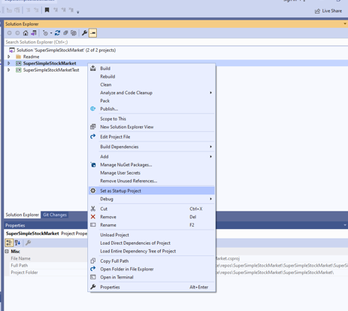

11 For running test please make SuperSimpleStockMarketTest project as a startup project as shown in below screen.

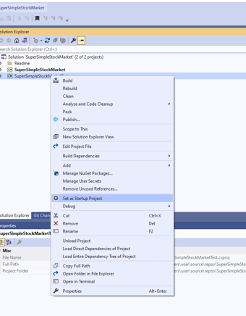

.

Output of project SimpleSuprStockMarket:

Please find below screens of output:

1. Add stock:

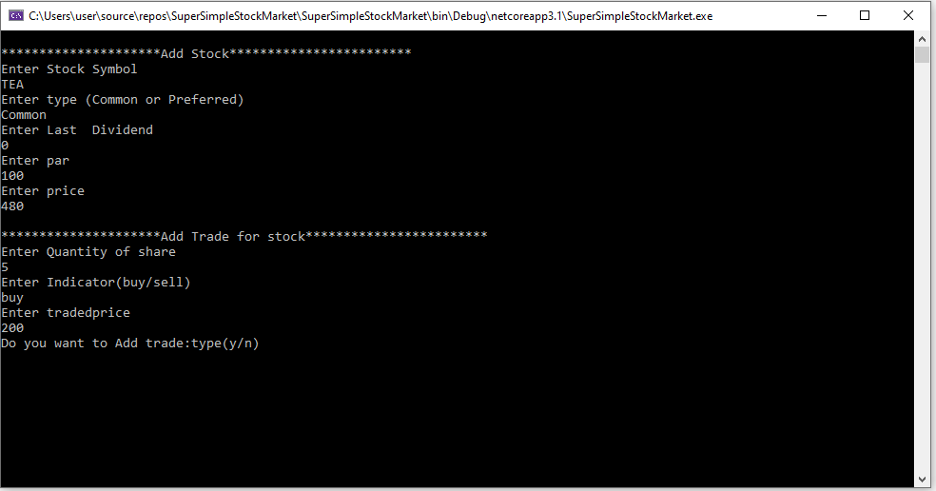

2. Calculation of Divident yield for type Common,P/E ratio,Volume weightd stock Price:

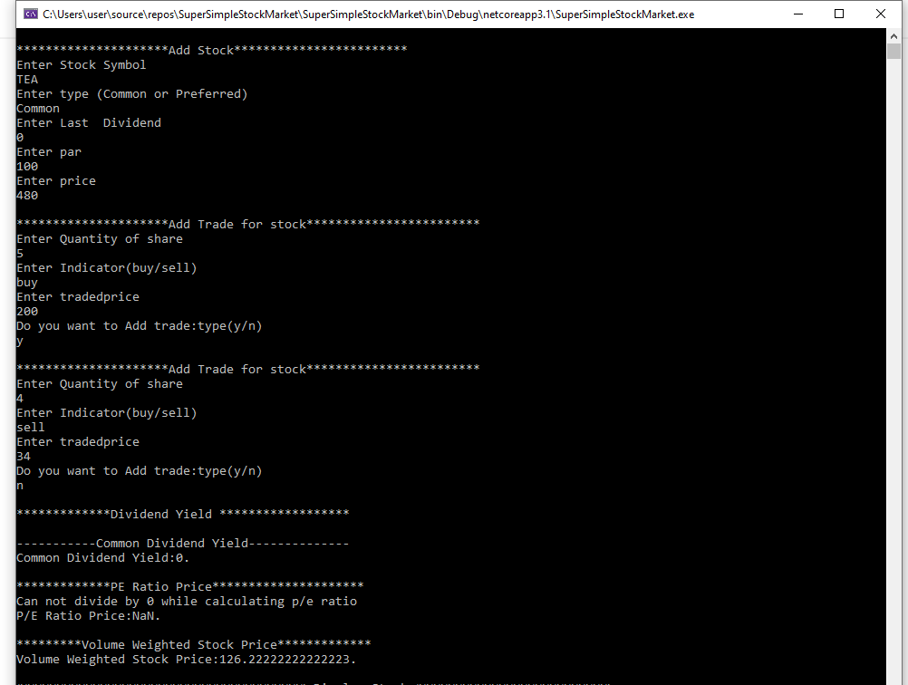

1. Calculation of Divident yield for type Preferred ,P/E ratio,Volume weightd stock Price:

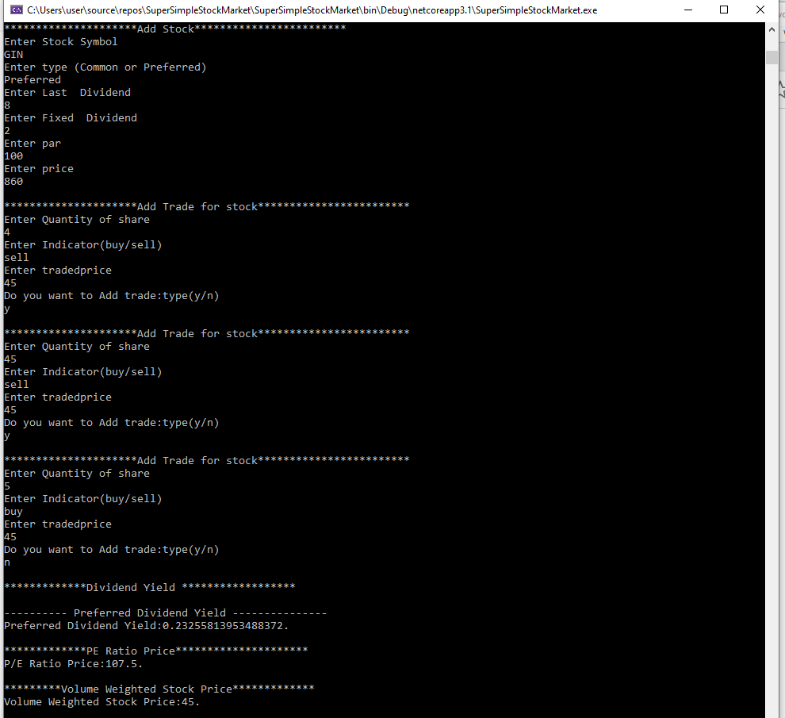

1. Display Stock:

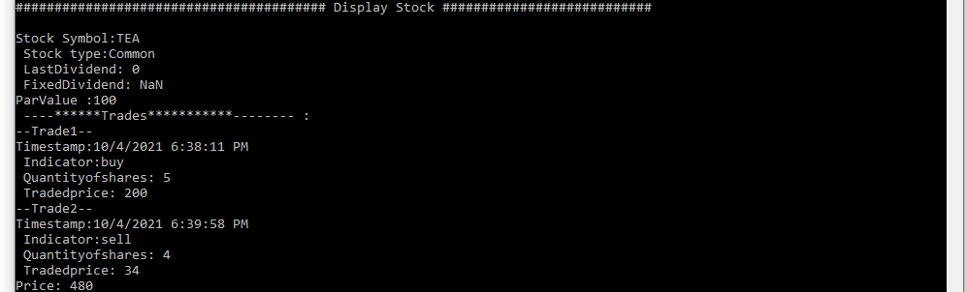

5. Calculation of All share index of all stock prices:

