LAB-1

(13-08-2025)

ARITHMATIC OPERATIONS:

a<-20
> b<-34
> print(paste("sum:",a+b))
[1] "sum: 54"
> print(paste("diff:",a-b))
[1] "diff: -14"
>
> print(paste("multiplication:",a*b))
[1] "multiplication: 680"
>
> print(paste("division:",a/b))
[1] "division: 0.588235294117647"

DATA SETS

> iris
Sepal.Length Sepal.Width Petal.Length Petal.Width Species
1 5.1 3.5 1.4 0.2 setosa
2 4.9 3.0 1.4 0.2 setosa
3 4.7 3.2 1.3 0.2 setosa
4 4.6 3.1 1.5 0.2 setosa
5 5.0 3.6 1.4 0.2 setosa
6 5.4 3.9 1.7 0.4 setosa
7 4.6 3.4 1.4 0.3 setosa
8 5.0 3.4 1.5 0.2 setosa
9 4.4 2.9 1.4 0.2 setosa
10 4.9 3.1 1.5 0.1 setosa
11 5.4 3.7 1.5 0.2 setosa
12 4.8 3.4 1.6 0.2 setosa
13 4.8 3.0 1.4 0.1 setosa
14 4.3 3.0 1.1 0.1 setosa
15 5.8 4.0 1.2 0.2 setosa
16 5.7 4.4 1.5 0.4 setosa
17 5.4 3.9 1.3 0.4 setosa
18 5.1 3.5 1.4 0.3 setosa
19 5.7 3.8 1.7 0.3 setosa
20 5.1 3.8 1.5 0.3 setosa
21 5.4 3.4 1.7 0.2 setosa
22 5.1 3.7 1.5 0.4 setosa
23 4.6 3.6 1.0 0.2 setosa
24 5.1 3.3 1.7 0.5 setosa
25 4.8 3.4 1.9 0.2 setosa
26 5.0 3.0 1.6 0.2 setosa
27 5.0 3.4 1.6 0.4 setosa
28 5.2 3.5 1.5 0.2 setosa
29 5.2 3.4 1.4 0.2 setosa
30 4.7 3.2 1.6 0.2 setosa
31 4.8 3.1 1.6 0.2 setosa
32 5.4 3.4 1.5 0.4 setosa
33 5.2 4.1 1.5 0.1 setosa
34 5.5 4.2 1.4 0.2 setosa
35 4.9 3.1 1.5 0.2 setosa
36 5.0 3.2 1.2 0.2 setosa
37 5.5 3.5 1.3 0.2 setosa
38 4.9 3.6 1.4 0.1 setosa
39 4.4 3.0 1.3 0.2 setosa
40 5.1 3.4 1.5 0.2 setosa
41 5.0 3.5 1.3 0.3 setosa
42 4.5 2.3 1.3 0.3 setosa
43 4.4 3.2 1.3 0.2 setosa
44 5.0 3.5 1.6 0.6 setosa
45 5.1 3.8 1.9 0.4 setosa
46 4.8 3.0 1.4 0.3 setosa
47 5.1 3.8 1.6 0.2 setosa
48 4.6 3.2 1.4 0.2 setosa
49 5.3 3.7 1.5 0.2 setosa
50 5.0 3.3 1.4 0.2 setosa
51 7.0 3.2 4.7 1.4 versicolor
52 6.4 3.2 4.5 1.5 versicolor
53 6.9 3.1 4.9 1.5 versicolor
54 5.5 2.3 4.0 1.3 versicolor
55 6.5 2.8 4.6 1.5 versicolor
56 5.7 2.8 4.5 1.3 versicolor
57 6.3 3.3 4.7 1.6 versicolor
58 4.9 2.4 3.3 1.0 versicolor
59 6.6 2.9 4.6 1.3 versicolor
60 5.2 2.7 3.9 1.4 versicolor
61 5.0 2.0 3.5 1.0 versicolor
62 5.9 3.0 4.2 1.5 versicolor
63 6.0 2.2 4.0 1.0 versicolor
64 6.1 2.9 4.7 1.4 versicolor
65 5.6 2.9 3.6 1.3 versicolor
66 6.7 3.1 4.4 1.4 versicolor
67 5.6 3.0 4.5 1.5 versicolor
68 5.8 2.7 4.1 1.0 versicolor
69 6.2 2.2 4.5 1.5 versicolor
70 5.6 2.5 3.9 1.1 versicolor
71 5.9 3.2 4.8 1.8 versicolor
72 6.1 2.8 4.0 1.3 versicolor
73 6.3 2.5 4.9 1.5 versicolor
74 6.1 2.8 4.7 1.2 versicolor
75 6.4 2.9 4.3 1.3 versicolor
76 6.6 3.0 4.4 1.4 versicolor
77 6.8 2.8 4.8 1.4 versicolor
78 6.7 3.0 5.0 1.7 versicolor
79 6.0 2.9 4.5 1.5 versicolor
80 5.7 2.6 3.5 1.0 versicolor
81 5.5 2.4 3.8 1.1 versicolor
82 5.5 2.4 3.7 1.0 versicolor
83 5.8 2.7 3.9 1.2 versicolor
84 6.0 2.7 5.1 1.6 versicolor
85 5.4 3.0 4.5 1.5 versicolor
86 6.0 3.4 4.5 1.6 versicolor
87 6.7 3.1 4.7 1.5 versicolor
88 6.3 2.3 4.4 1.3 versicolor
89 5.6 3.0 4.1 1.3 versicolor
90 5.5 2.5 4.0 1.3 versicolor
91 5.5 2.6 4.4 1.2 versicolor
92 6.1 3.0 4.6 1.4 versicolor
93 5.8 2.6 4.0 1.2 versicolor
94 5.0 2.3 3.3 1.0 versicolor
95 5.6 2.7 4.2 1.3 versicolor
96 5.7 3.0 4.2 1.2 versicolor
97 5.7 2.9 4.2 1.3 versicolor
98 6.2 2.9 4.3 1.3 versicolor
99 5.1 2.5 3.0 1.1 versicolor
100 5.7 2.8 4.1 1.3 versicolor
101 6.3 3.3 6.0 2.5 virginica
102 5.8 2.7 5.1 1.9 virginica
103 7.1 3.0 5.9 2.1 virginica
104 6.3 2.9 5.6 1.8 virginica
105 6.5 3.0 5.8 2.2 virginica
106 7.6 3.0 6.6 2.1 virginica
107 4.9 2.5 4.5 1.7 virginica
108 7.3 2.9 6.3 1.8 virginica
109 6.7 2.5 5.8 1.8 virginica
110 7.2 3.6 6.1 2.5 virginica
111 6.5 3.2 5.1 2.0 virginica
112 6.4 2.7 5.3 1.9 virginica
113 6.8 3.0 5.5 2.1 virginica
114 5.7 2.5 5.0 2.0 virginica
115 5.8 2.8 5.1 2.4 virginica
116 6.4 3.2 5.3 2.3 virginica
117 6.5 3.0 5.5 1.8 virginica
118 7.7 3.8 6.7 2.2 virginica
119 7.7 2.6 6.9 2.3 virginica
120 6.0 2.2 5.0 1.5 virginica
121 6.9 3.2 5.7 2.3 virginica
122 5.6 2.8 4.9 2.0 virginica
123 7.7 2.8 6.7 2.0 virginica
124 6.3 2.7 4.9 1.8 virginica
125 6.7 3.3 5.7 2.1 virginica
126 7.2 3.2 6.0 1.8 virginica
127 6.2 2.8 4.8 1.8 virginica
128 6.1 3.0 4.9 1.8 virginica
129 6.4 2.8 5.6 2.1 virginica
130 7.2 3.0 5.8 1.6 virginica
131 7.4 2.8 6.1 1.9 virginica
132 7.9 3.8 6.4 2.0 virginica
133 6.4 2.8 5.6 2.2 virginica
134 6.3 2.8 5.1 1.5 virginica
135 6.1 2.6 5.6 1.4 virginica
136 7.7 3.0 6.1 2.3 virginica
137 6.3 3.4 5.6 2.4 virginica
138 6.4 3.1 5.5 1.8 virginica
139 6.0 3.0 4.8 1.8 virginica
140 6.9 3.1 5.4 2.1 virginica
141 6.7 3.1 5.6 2.4 virginica
142 6.9 3.1 5.1 2.3 virginica
143 5.8 2.7 5.1 1.9 virginica
144 6.8 3.2 5.9 2.3 virginica
145 6.7 3.3 5.7 2.5 virginica
146 6.7 3.0 5.2 2.3 virginica
147 6.3 2.5 5.0 1.9 virginica
148 6.5 3.0 5.2 2.0 virginica
149 6.2 3.4 5.4 2.3 virginica
150 5.9 3.0 5.1 1.8 virginica

> Titanic

, , Age = Child, Survived = No

Sex
Class Male Female
1st 0 0
2nd 0 0
3rd 35 17
Crew 0 0

, , Age = Adult, Survived = No

Sex
Class Male Female
1st 118 4
2nd 154 13
3rd 387 89
Crew 670 3

, , Age = Child, Survived = Yes

Sex
Class Male Female
1st 5 1
2nd 11 13
3rd 13 14
Crew 0 0

, , Age = Adult, Survived = Yes

Sex
Class Male Female
1st 57 140
2nd 14 80
3rd 75 76
Crew 192 20

> mtcars
mpg cyl disp hp drat wt qsec vs am gear carb
Mazda RX4 21.0 6 160.0 110 3.90 2.620 16.46 0 1 4 4
Mazda RX4 Wag 21.0 6 160.0 110 3.90 2.875 17.02 0 1 4 4
Datsun 710 22.8 4 108.0 93 3.85 2.320 18.61 1 1 4 1
Hornet 4 Drive 21.4 6 258.0 110 3.08 3.215 19.44 1 0 3 1
Hornet Sportabout 18.7 8 360.0 175 3.15 3.440 17.02 0 0 3 2
Valiant 18.1 6 225.0 105 2.76 3.460 20.22 1 0 3 1
Duster 360 14.3 8 360.0 245 3.21 3.570 15.84 0 0 3 4
Merc 240D 24.4 4 146.7 62 3.69 3.190 20.00 1 0 4 2
Merc 230 22.8 4 140.8 95 3.92 3.150 22.90 1 0 4 2
Merc 280 19.2 6 167.6 123 3.92 3.440 18.30 1 0 4 4
Merc 280C 17.8 6 167.6 123 3.92 3.440 18.90 1 0 4 4
Merc 450SE 16.4 8 275.8 180 3.07 4.070 17.40 0 0 3 3
Merc 450SL 17.3 8 275.8 180 3.07 3.730 17.60 0 0 3 3
Merc 450SLC 15.2 8 275.8 180 3.07 3.780 18.00 0 0 3 3
Cadillac Fleetwood 10.4 8 472.0 205 2.93 5.250 17.98 0 0 3 4
Lincoln Continental 10.4 8 460.0 215 3.00 5.424 17.82 0 0 3 4
Chrysler Imperial 14.7 8 440.0 230 3.23 5.345 17.42 0 0 3 4
Fiat 128 32.4 4 78.7 66 4.08 2.200 19.47 1 1 4 1
Honda Civic 30.4 4 75.7 52 4.93 1.615 18.52 1 1 4 2
Toyota Corolla 33.9 4 71.1 65 4.22 1.835 19.90 1 1 4 1
Toyota Corona 21.5 4 120.1 97 3.70 2.465 20.01 1 0 3 1
Dodge Challenger 15.5 8 318.0 150 2.76 3.520 16.87 0 0 3 2
AMC Javelin 15.2 8 304.0 150 3.15 3.435 17.30 0 0 3 2
Camaro Z28 13.3 8 350.0 245 3.73 3.840 15.41 0 0 3 4
Pontiac Firebird 19.2 8 400.0 175 3.08 3.845 17.05 0 0 3 2
Fiat X1-9 27.3 4 79.0 66 4.08 1.935 18.90 1 1 4 1
Porsche 914-2 26.0 4 120.3 91 4.43 2.140 16.70 0 1 5 2
Lotus Europa 30.4 4 95.1 113 3.77 1.513 16.90 1 1 5 2
Ford Pantera L 15.8 8 351.0 264 4.22 3.170 14.50 0 1 5 4
Ferrari Dino 19.7 6 145.0 175 3.62 2.770 15.50 0 1 5 6
Maserati Bora 15.0 8 301.0 335 3.54 3.570 14.60 0 1 5 8
Volvo 142E 21.4 4 121.0 109 4.11 2.780 18.60 1 1 4 2

LOOP
x<-30
> for (i in 1:5) {
+ print(paste("For Loop:", i))
+ }
[1] "For Loop: 1"
[1] "For Loop: 2"
[1] "For Loop: 3"
[1] "For Loop: 4"
[1] "For Loop: 5"
> i<-1
> while(i<=5){
+ print(paste("while loop:",i))
+ i<-i+1
+ }
[1] "while loop: 1"
[1] "while loop: 2"
[1] "while loop: 3"
[1] "while loop: 4"
[1] "while loop: 5"
> x<-70
> if(x>0){
+ print("x is big")
+ }
[1] "x is big"
> x<-70
> if(x>0){
+ print("x is positive")
+ } else if(x==0){
+ print("x is zero")
+ } else {
+ print("x is negative")
+ }
[1] "x is positive"
> x<-7
> if(x>0){
+ print("hey")
+ } else{
+ print("hi")
+ }
[1] "hey"

FUNCTIONS
> sub_num<-function(x,y){
+ return(x-y)
+ }
> result<-sub_num(20,5)
> print(paste("result:",result))
[1] "result: 15"

VECTOR

> vec<-c(1,2,3,4,5,6,7,8)
> print("original vec")
[1] "original vec"
> print(vec)
[1] 1 2 3 4 5 6 7 8
> print(sum(vec))
[1] 36
> print(vec[4])
[1] 4

LAB-2
(20-08-2025)

LIST:

list=list(name="sam",age=19,rollno=81)
> print(list)
$name
[1] "sam"

$age
[1] 19

$rollno
[1] 81

> print(list$name)
[1] "sam"
> print(list$rollno)
[1] 81

Mathematical Functions:

> sqrt(65)
[1] 8.062258
> log10(1000)
[1] 3
> abs(-5)
[1] 5
> abs(-8)
[1] 8
> log(10)
[1] 2.302585
> exp(15)
[1] 3269017
> exp(4)
[1] 54.59815
> sin(30)
[1] -0.9880316
> cos(30)
[1] 0.1542514
> tan(30)
[1] -6.405331
> floor(4.76)
[1] 4
> ceiling(7.3)

Statistical functions:

> x<-c(5,10,15,20,25,30,35,40,45,50)
> mean(x)
[1] 27.5
> median(x)
[1] 27.5
> var(x)
[1] 229.1667
> sd(x)
[1] 15.13825
> min(x)
[1] 5
> max(x)
[1] 50
> range(x)
[1] 5 50
> summary(x)
Min. 1st Qu. Median Mean 3rd Qu. Max.
5.00 16.25 27.50 27.50 38.75 50.00

Data frame:

> std<-data.frame()
> std<-data.frame(
+ name=c("sam","tom","jam"),
+ rollno=c(10,20,30)
+ )
> print(std)
name rollno
1 sam 10
2 tom 20
3 jam 30
> print(std[2])
rollno
1 10
2 20
3 30
> print(std[1])
name
1 sam
2 tom
3 jam

> new<-matrix(1:9)
> print(new)
[,1]
[1,] 1
[2,] 2
[3,] 3
[4,] 4
[5,] 5
[6,] 6
[7,] 7
[8,] 8
[9,] 9
> new1<-matrix(1:9,nrow=3,ncol=3)
> print(new1)
[,1] [,2] [,3]
[1,] 1 4 7
[2,] 2 5 8
[3,] 3 6 9
> new1[2,3]
[1] 8
> new1[2,]
[1] 2 5 8
> new1[-1,]
[,1] [,2] [,3]
[1,] 2 5 8
[2,] 3 6 9
> new1[,3]
[1] 7 8 9
> new1[,-2]
[,1] [,2]
[1,] 1 7
[2,] 2 8
[3,] 3 9
> print("hello")

Data Preparation:

- Loading:

Txt file

> data_txt<-read.table("D:/new.txt",header=TRUE,sep="\t")
> print(data_txt)
[1] this.is.a.new.file
<0 rows> (or 0-length row.names)

CSV file

data_txt<-read.table("d:/new.csv",header=TRUE,sep="\t")
> print(data_txt)
sno.names.marks
1 1,ria,89
2 2,bia,78
3 3,tia,67
4 4,lia,89
5 5,mia,65
6 6,wia,45
7 7,xia,56
print(head(data_txt))
sno.names.marks
1 1,ria,89
2 2,bia,78
3 3,tia,67
4 4,lia,89
5 5,mia,65
6 6,wia,45

URL file

url<-"https://people.sc.fsu.edu/~jburkardt/data/csv/airtravel.csv"
> web_data<-read.csv(url,header=TRUE)
> print(web_data)
Month X1958 X1959 X1960
1 JAN 340 360 417
2 FEB 318 342 391
3 MAR 362 406 419
4 APR 348 396 461
5 MAY 363 420 472
6 JUN 435 472 535
7 JUL 491 548 622
8 AUG 505 559 606
9 SEP 404 463 508
10 OCT 359 407 461
11 NOV 310 362 390
12 DEC 337 405 432
> print(head(web_data))
Month X1958 X1959 X1960
1 JAN 340 360 417
2 FEB 318 342 391
3 MAR 362 406 419
4 APR 348 396 461
5 MAY 363 420 472
6 JUN 435 472 535
> print(tail(web_data))
Month X1958 X1959 X1960
7 JUL 491 548 622
8 AUG 505 559 606
9 SEP 404 463 508
10 OCT 359 407 461
11 NOV 310 362 390
12 DEC 337 405 432

Lab 3

(10-09-2025)

1. Perform simple Arithmetic Operations (add, sub, mul, div, mod) and mathematical operations (sqrt, abs, log, exp, sin, cos, tan) With and without using objects

> a<-20
> b<-5
> print(paste("sum:",a+b))
[1] "sum: 25"
> print(paste("diff:",a-b))
[1] "diff: 15"
> print(paste("product:",a*b))
[1] "product: 100"
> print(paste("quotient:",a/b))
[1] "quotient: 4"
> 10+5
[1] 15
> 10-5
[1] 5
> 10*3
[1] 30
> 10/5
[1] 2
> 10^3
[1] 1000
> 10%%2
[1] 0
> 10%%3
[1] 1
> sqrt(64)
[1] 8
> log10(100)
[1] 2
> abs(-4)
[1] 4
> log(20)
[1] 2.995732
> exp(2)
[1] 7.389056
> sin(60)
[1] -0.3048106
> cos(75)
[1] 0.9217513
> tan(30)
[1] -6.405331

2. Work with conditional statements (if-else), Loops (for & while)

> for(i in 1:5){
+ print(paste("numbers:",i))
+ }
[1] "numbers: 1"
[1] "numbers: 2"
[1] "numbers: 3"
[1] "numbers: 4"
[1] "numbers: 5"

> h<-1
> while(i<=10) {
+ print(paste("student:",i))
+ i<-i+1
+ }
[1] "student: 5"
[1] "student: 6"
[1] "student: 7"
[1] "student: 8"
[1] "student: 9"
[1] "student: 10"
> x<-50
> if(x>0)
+ print("old")
[1] "old"
> if(x>0) {
+ print("old")
+ } else {
+ print("young")
+ }
[1] "old"

3. Execute the sample program using functions

> sub_num<-function(x,y){
+ return(x-y)
+ }
> result<-sub_num(20,5)
> print(paste("Result:",result))
[1] "Result: 15"

4. Work with vectors and its operations

> vec<-c(1,3,5,7,9)
> print("original vec")
[1] "original vec"
> print(vec)
[1] 1 3 5 7 9
> print(vec[2])
[1] 3
> print(sum(vec))
[1] 25
> print(vec[0:-1])
[1] 3 5 7 9
> print(vec[-3])
[1] 1 3 7 9
> print(vec[0:-2])
[1] 5 7 9
> vec1<-c(2,3,4,5,6)
> print(mean(vec1))
[1] 4
> print(median(vec1))
[1] 4
> print(mode(vec1))
[1] "numeric"

5.Prepare the data sets - reading and uploading the CSV files from URL on the local drive upload and download (working with IRIS, MTCARS and TITANIC datasets

2 4.9 3.0 1.4 0.2 setosa
3 4.7 3.2 1.3 0.2 setosa
4 4.6 3.1 1.5 0.2 setosa
5 5.0 3.6 1.4 0.2 setosa
6 5.4 3.9 1.7 0.4 setosa

> mtcars_data <- read.csv("https://raw.githubusercontent.com/selva86/datasets/master/mtcars.csv")
> write.csv(mtcars_data, "mtcars.csv", row.names = FALSE)
> mtcars_local <- read.csv("mtcars.csv")
> head(mtcars_local)
mpg cyl disp hp drat wt qsec vs am gear carb fast cars carname
1 4.582576 6 160 110 3.90 2.620 16.46 0 1 4 4 1 Mazda RX4 Mazda RX4
2 4.582576 6 160 110 3.90 2.875 17.02 0 1 4 4 1 Mazda RX4 Wag Mazda RX4 Wag
3 4.774935 4 108 93 3.85 2.320 18.61 1 1 4 1 1 Datsun 710 Datsun 710
4 4.626013 6 258 110 3.08 3.215 19.44 1 0 3 1 1 Hornet 4 Drive Hornet 4 Drive
5 4.324350 8 360 175 3.15 3.440 17.02 0 0 3 2 1 Hornet Sportabout Hornet Sportabout
6 4.254409 6 225 105 2.76 3.460 20.22 1 0 3 1 1 Valiant Valiant

> titanic_data <- read.csv("https://raw.githubusercontent.com/datasciencedojo/datasets/master/titanic.csv")
> write.csv(titanic_data, "titanic.csv", row.names = FALSE)
> titanic_local <- read.csv("titanic.csv")
> head(titanic_local)
PassengerId Survived Pclass Name Sex Age SibSp Parch
1 1 0 3 Braund, Mr. Owen Harris male 22 1 0
2 2 1 1 Cumings, Mrs. John Bradley (Florence Briggs Thayer) female 38 1 0
3 3 1 3 Heikkinen, Miss. Laina female 26 0 0
4 4 1 1 Futrelle, Mrs. Jacques Heath (Lily May Peel) female 35 1 0
5 5 0 3 Allen, Mr. William Henry male 35 0 0
6 6 0 3 Moran, Mr. James male NA 0 0
Ticket Fare Cabin Embarked
1 A/5 21171 7.2500 S
2 PC 17599 71.2833 C85 C
3 STON/O2. 3101282 7.9250 S
4 113803 53.1000 C123 S
5 373450 8.0500 S
6 330877 8.4583 Q

Txt file

> data_txt<-read.table("D:/new.txt",header=TRUE,sep="\t")
> print(data_txt)
[1] this.is.a.new.file
<0 rows> (or 0-length row.names)

CSV file

data_txt<-read.table("d:/new.csv",header=TRUE,sep="\t")
> print(data_txt)
sno.names.marks
1 1,ria,89
2 2,bia,78
3 3,tia,67
4 4,lia,89
5 5,mia,65
6 6,wia,45
7 7,xia,56
print(head(data_txt))
sno.names.marks
1 1,ria,89
2 2,bia,78
3 3,tia,67
4 4,lia,89
5 5,mia,65
6 6,wia,45

URL file

url<-"https://people.sc.fsu.edu/~jburkardt/data/csv/airtravel.csv"
> web_data<-read.csv(url,header=TRUE)
> print(web_data)
Month X1958 X1959 X1960
1 JAN 340 360 417
2 FEB 318 342 391
3 MAR 362 406 419
4 APR 348 396 461
5 MAY 363 420 472
6 JUN 435 472 535
7 JUL 491 548 622
8 AUG 505 559 606
9 SEP 404 463 508
10 OCT 359 407 461
11 NOV 310 362 390
12 DEC 337 405 432

6. Implement Descriptive statistics functions (str, summary, Quantile, Standard Deviation and dim names) - any of the data sets and central tendency functions

>df<-data.frame(name<-c("q","g","r"),rollno<-c(1,2,3),marks<-c(30,29,50))
> df
name rollno marks
1 q 1 30
2 g 2 29
3 r 3 50
> str(df)
'data.frame': 3 obs. of 3 variables:
$ name : chr "q" "g" "r"
$ rollno : num 1 2 3
$ marks : num 30 29 50
> summary(df)
Name rollno marks
Length:3 Min. :1.0 Min. :29.00
Class :character 1st Qu.:1.5 1st Qu.:29.50
Mode :character Median :2.0 Median :30.00
Mean :2.0 Mean :36.33
3rd Qu.:2.5 3rd Qu.:40.00
Max. :3.0 Max. :50.00
> dim(df)
[1] 3 3
> names(df)
[1] "name" "rollno" "marks"
> sd(df$marks,na.rm=TRUE)
[1] 11.84624

LAB 4

(10-9-25)

7. Perform the data cleaning operations on any of the data sets for

a. Count missing
>df1<-data.frame(name<-c("q","g","r","h"),rollno<-c(1,2,3,4),marks<-c(30,NA,50,NA))
> df1
name rollno marks
1 q 1 30
2 g 2 NA
3 r 3 50
4 h 4 NA

> sum(is.na(df1))
[1] 2
> sum(is.na(df1$marks))
[1] 2
b. Replace NA with mean

>df2<-data.frame(name<-c("q","g","r","h",”h”),rollno<-c(1,2,3,4,4),marks<-c(30,NA,50,NA,NA))
> df2$marks[is.na(df2$marks)]<-mean(df2$marks,na.rm=TRUE)
> df2
name rollno marks marks
1 q 1 30 30
2 g 2 NA 40
3 r 3 50 50
4 h 4 NA 40
5 h 4 NA 40
c. Remove duplicates
> duplicated(df2)
[1] FALSE FALSE FALSE FALSE TRUE
d. Convert data types
> x<-c("1","23")
> class(x)
[1] "character"
> y<-as.numeric(x)
> class(y)
[1] "numeric"
> y
[1] 1 23
> x
[1] "1" "23"
> z<-as.character(y)
> z
[1] "1" "23"
> class(z)
[1] "character"
> class(y)
[1] "numeric"
> class(x)
[1] "character"
e. Handle outliers
> df2 <- data.frame(name = c("q", "g", "r", "h", "h"),rollno = c(1, 2, 3, 4, 4),marks = c(30, NA, 50, NA, NA))
> df2
name rollno marks
1 q 1 30
2 g 2 NA
3 r 3 50
4 h 4 NA
5 h 4 NA
> Q1 <- quantile(df2$marks, 0.25, na.rm = TRUE)
> Q3 <- quantile(df2$marks, 0.75, na.rm = TRUE)
> IQR <- Q3 - Q1
> print(IQR)
75%
10
> print(Q1)
25%
35
> print(Q3)
75%
45

f. Normalization
> df2$new<-(df2$marks-min(df2$marks))/(max(df2$marks)-min(df2$marks))
> df2
name rollno marks marks new
1 q 1 30 30 0.0
2 g 2 NA 40 0.5
3 r 3 50 50 1.0
4 h 4 NA 40 0.5
5 h 4 NA 40 0.5

G. Standardization

df <- data.frame(
+ Name = c("Alice", "Bob", "Charlie", "David", "Eve"),
+ Age = c(25, 30, 35, 40, 22),
+ Income = c(50000, 60000, 75000, 100000, 52000)
+ )
> print(df)
Name Age Income
1 Alice 25 50000
2 Bob 30 60000
3 Charlie 35 75000
4 David 40 100000
5 Eve 22 52000
> df$Age <- scale(df$Age)
> print(df)
Name Age Income
1 Alice -0.73965663 50000
2 Bob -0.05478938 60000
3 Charlie 0.63007787 75000
4 David 1.31494512 100000
5 Eve -1.15057698 52000
> df$Income <- scale(df$Income)
>
> print(df)
Name Age Income
1 Alice -0.73965663 -0.8402758
2 Bob -0.05478938 -0.3573587
3 Charlie 0.63007787 0.3670170
4 David 1.31494512 1.5743098
5 Eve -1.15057698 -0.7436924

H. Encode categorical

data("airquality")
> airquality$Month <- as.factor(airquality$Month)
> airquality$Day <- as.factor(airquality$Day)
> str(airquality)

'data.frame': 153 obs. of 6 variables:
$ Ozone : int 41 36 12 18 NA 28 23 19 8 NA ...
$ Solar.R: int 190 118 149 313 NA NA 299 99 19 194 ...
$ Wind : num 7.4 8 12.6 11.5 14.3 14.9 8.6 13.8 20.1 8.6 …
$ Temp : int 67 72 74 62 56 66 65 59 61 69 ...
$ Month : Factor w/ 5 levels "5","6","7","8",..: 1 1 1 1 1 1 1 1 1 1...
$ Day : Factor w/ 31 levels "1","2","3","4",..: 1 2 3 4 5 6 7 8 9 10.

- Training and split

set.seed(42)
> train_idx <- sample(1:nrow(airquality), size = 0.7 * nrow(airquality))
> train_data <- airquality[train_idx, ]
> test_data <- airquality[train_idx, ]
> print(train_idx)
[1] 49 65 74 146 122 153 128 47 24 71 100 89 110 20 114 111 131 41 142 27 109 5 92 104 3 58
[27] 97 42 145 30 43 15 22 147 8 36 68 86 18 133 137 69 4 98 50 99 88 87 148 26 6 103
[53] 2 129 21 101 120 10 40 132 33 105 73 29 76 84 9 35 16 112 141 82 125 115 107 55 95 108
[79] 57 126 80 13 53 54 32 60 90 123 127 48 119 67 78 38 1 72 14 94 106 85 130 66 151 51
[105] 93 62 25

LAB 5

(17-9-25)

8. perforn the following data transformation operations on any of the datasets(IRIS,MTCARS AND TITANIC datasets)

- Creating new columns

data(iris)
> iris$new_petal_area <- iris$Petal.Length * iris$Petal.Width
> iris$is_setosa <- iris$Species == "setosa"
> head(iris)
Sepal.Length Sepal.Width Petal.Length Petal.Width Species new_petal_area is_setosa
1 5.1 3.5 1.4 0.2 setosa 0.28 TRUE
2 4.9 3.0 1.4 0.2 setosa 0.28 TRUE
3 4.7 3.2 1.3 0.2 setosa 0.26 TRUE
4 4.6 3.1 1.5 0.2 setosa 0.30 TRUE
5 5.0 3.6 1.4 0.2 setosa 0.28 TRUE
6 5.4 3.9 1.7 0.4 setosa 0.68 TRUE

- sorting

data <- c(5, 3, 8, 1, 2)
> sorted_data <- sort(data)
> print(sorted_data)
[1] 1 2 3 5 8

- Merging and joining

df1 <- data.frame(ID = c(1, 2, 3), Name = c("John", "Alice", "Bob"))
> df2 <- data.frame(ID = c(1, 2, 4), Age = c(23, 30, 25))
> merged_df <- merge(df1, df2, by = "ID")
> print(merged_df)
ID Name Age
1 1 John 23
2 2 Alice 30

- Aggregation and grouping

df <- data.frame(
+ ID=c(1,2,2,3,3,4,4),
+ Score = c(85, 90, 80, 85, 70, 87, 88)
+ )
> aggregated_df <- aggregate(Score ~ ID, data = df, FUN = mean)
> print(aggregated_df)
ID Score
1 1 85.0
2 2 85.0
3 3 77.5
4 4 87.5

- Exporting data

install.packages("titanic")

Installing package into ‘/cloud/lib/x86_64-pc-linux-gnu-library/4.5’
(as ‘lib’ is unspecified)
trying URL 'http://rspm/default/__linux__/focal/latest/src/contrib/titanic_0.1.0.tar.gz'
Content type 'application/x-gzip' length 87147 bytes (85 KB)
==================================================
downloaded 85 KB

* installing *binary* package ‘titanic’ ...
* DONE (titanic)

The downloaded source packages are in
‘/tmp/RtmpK70I0d/downloaded_packages’

library(titanic)
> data <- titanic::titanic_train
> dir.create("C:/Users/Student/Downloads/7081",recursive = TRUE)
> write.csv(iris, "iris_data.csv", row.names=FALSE)
> file.exists("iris_data.csv")
[1] TRUE

LAB 6

(08-10-25)

9)implement EDA operations on any of the datasets(IRIS,MTCARS and TITANIC dataset)

Sum of missing values

> data(iris)
> missing_values <- colSums(is.na(iris))
> print(missing_values)
Sepal.Length Sepal.Width Petal.Length Petal.Width Species
0 0 0 0 0

Standard deviations
> std_devs <- sapply(iris[, 1:4], sd)
> print(std_devs)
Sepal.Length Sepal.Width Petal.Length Petal.Width
0.8280661 0.4358663 1.7652982 0.7622377

Covariance
> cov_sepal <- cov(iris$Sepal.Length, iris$Sepal.Width)
> print(cov_sepal)
[1] -0.042434
> cov_matrix <- cov(iris[, 1:4])
> print(cov_matrix)
Sepal.Length Sepal.Width Petal.Length Petal.Width
Sepal.Length 0.6856935 -0.0424340 1.2743154 0.5162707
Sepal.Width -0.0424340 0.1899794 -0.3296564 -0.1216394
Petal.Length 1.2743154 -0.3296564 3.1162779 1.2956094
Petal.Width 0.5162707 -0.1216394 1.2956094 0.5810063

Correlations
> cor_matrix <- cor(iris[, 1:4])
> print(cor_matrix)
Sepal.Length Sepal.Width Petal.Length Petal.Width
Sepal.Length 1.0000000 -0.1175698 0.8717538 0.8179411
Sepal.Width -0.1175698 1.0000000 -0.4284401 -0.3661259
Petal.Length 0.8717538 -0.4284401 1.0000000 0.9628654
Petal.Width 0.8179411 -0.3661259 0.9628654 1.0000000

Skewness
> data(iris)
> skewness <- sapply(iris[, 1:4], function(x) {
+ n <- length(x)
+ m3 <- mean((x - mean(x))^3)
+ m2 <- mean((x - mean(x))^2)
+ m3 / m2^(3/2)
+ })
> print(skewness)
Sepal.Length Sepal.Width Petal.Length Petal.Width
0.3117531 0.3157671 -0.2721277 -0.1019342

Kurtosis
> kurtosis <- sapply(iris[, 1:4], function(x) {
+ n <- length(x)
+ m4 <- mean((x - mean(x))^4)
+ m2 <- mean((x - mean(x))^2)
+ m4 / m2^2 - 3
+ })
> print(kurtosis)
Sepal.Length Sepal.Width Petal.Length Petal.Width
-0.5735679 0.1809763 -1.3955359 -1.3360674

Normal or gaussian distribution
> for (i in 1:4) {
+ x <- iris[, i]
+ test <- shapiro.test(x)
+ cat(names(iris)[i], ": W =", round(test$statistic, 4), ", p-value =", test$p.value, "\n")
+ }
Sepal.Length : W = 0.9761 , p-value = 0.01018116
Sepal.Width : W = 0.9849 , p-value = 0.1011543
Petal.Length : W = 0.8763 , p-value = 7.412263e-10
Petal.Width : W = 0.9018 , p-value = 1.680465e-08

10. Perform the following visualization operations on any of the vectors using ggplot2 library
Load libraries
> library(ggplot2)
> library(gridExtra) # for arranging plots
> # Data
> x <- 1:10
> y <- c(3, 5, 6, 8, 7, 10, 12, 11, 14, 18)
> df <- data.frame(x, y)

Scattered graph
> p1 <- ggplot(df, aes(x, y)) +
+ geom_point(color = "blue", size = 3) +
+ ggtitle("Scatter Plot")
> print(p1)
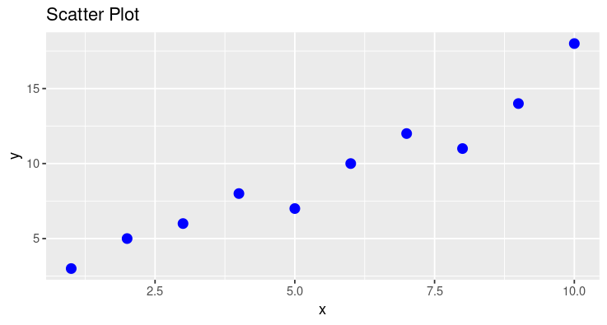

Line graph
p2 <- ggplot(df, aes(x, y)) +
+ geom_line(color = "red", size = 1.2) +
+ ggtitle("Line Graph")
> print(p2)
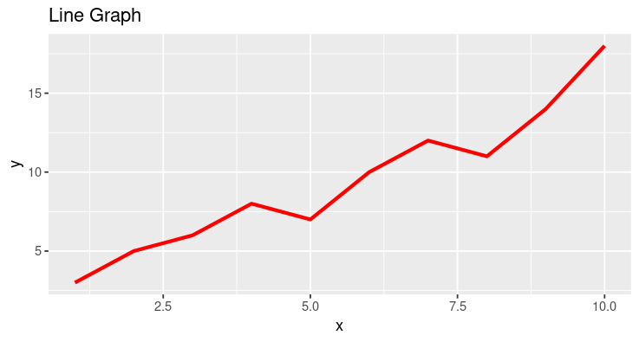

Bar plot
> p3 <- ggplot(df, aes(factor(x), y)) +
+ geom_bar(stat = "identity", fill = "purple") +
+ ggtitle("Bar Plot")
> print(p3)
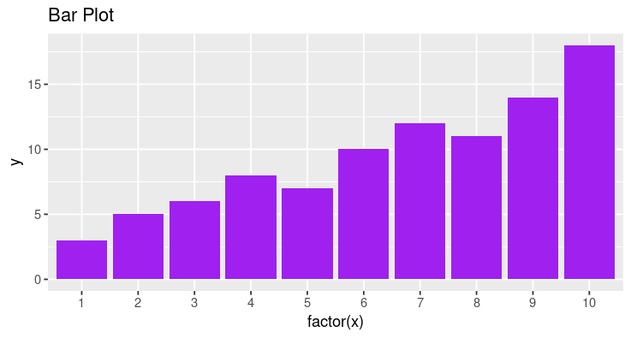

Line and scattered plot graph
> p4 <- ggplot(df, aes(x, y)) +
+ geom_point(color = "blue", size = 3) +
+ geom_line(color = "red", size = 1.2) +
+ ggtitle("Scatter + Line Graph")
> print(p4)
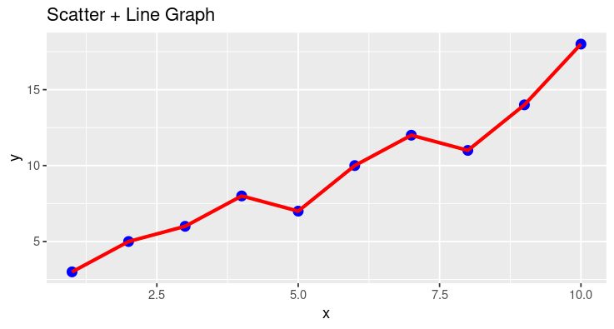

PlotBox
> p5 <- ggplot(df, aes(x = factor(1), y = y)) +
+ geom_boxplot(fill = "cyan") +
+ ggtitle("Box Plot")
> print(p5)
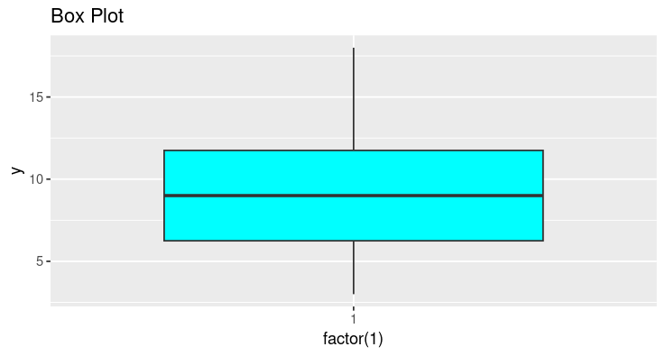

Histogram
> p6 <- ggplot(df, aes(y)) +
+ geom_histogram(binwidth = 2, fill = "orange", color = "black") +
+ ggtitle("Histogram of y")
> print(p6)
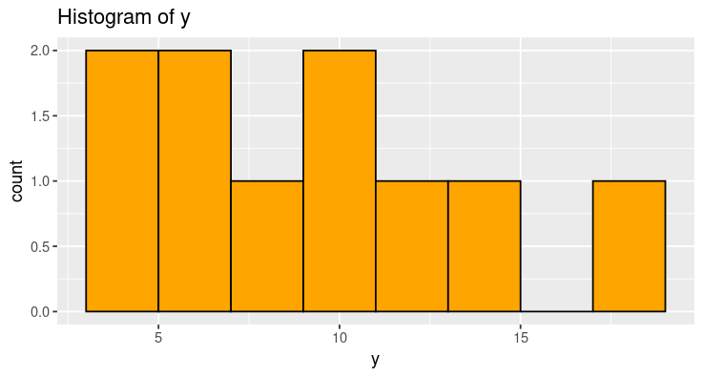

Pie chart
> pie(y, labels = x, main = "Pie Chart", col = rainbow(length(y)))

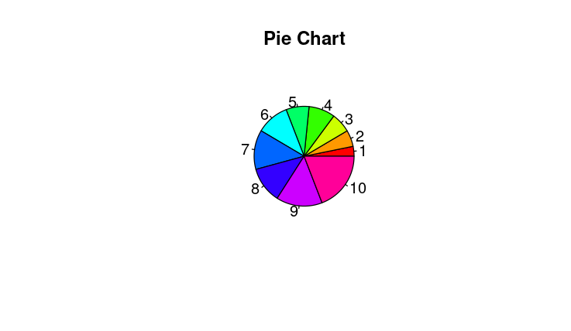

12. Find the covariance and correlation for the IRIS/
MTCARS/ TITANIC data sets.
> x<-c(10,20,30,40,50)
> y<-c(5,10,15,20,15)
> cov_value<-cov(x,y)
> print(cov_value)
[1] 75

LAB 7

(17-10-25)
13. Perform the simple linear regression(univariate analysis) on any data set.
> # Data
> x <- c(1, 2, 3, 4, 5)
> y <- c(1.5, 3.7, 4.2, 5.0, 7.1)
> # Model
> model <- lm(y ~ x)
> # Output
> summary(model)
Call:
lm(formula = y ~ x)
Residuals:
1 2 3 4 5
-0.30 0.65 -0.10 -0.55 0.30
Coefficients:
Estimate Std. Error t value Pr(>|t|)
(Intercept) 0.5500 0.5792 0.950 0.41239
x 1.2500 0.1746 7.157 0.00562 **---
Signif. codes: 0 ‘***’ 0.001 ‘**’ 0.01 ‘*’ 0.05 ‘.’ 0.1 ‘ ’ 1
Residual standard error: 0.5523 on 3 degrees of freedom
Multiple R-squared: 0.9447, Adjusted R-squared: 0.9262
F-statistic: 51.23 on 1 and 3 DF, p-value: 0.005617

> plot(mtcars$hp, mtcars$mpg, main = "MPG vs Horsepower",
+ xlab = "Horsepower (hp)", ylab = "Miles Per Gallon (mpg)",
+ pch = 16, col = "blue")
> abline(model, col = "red", lwd = 2

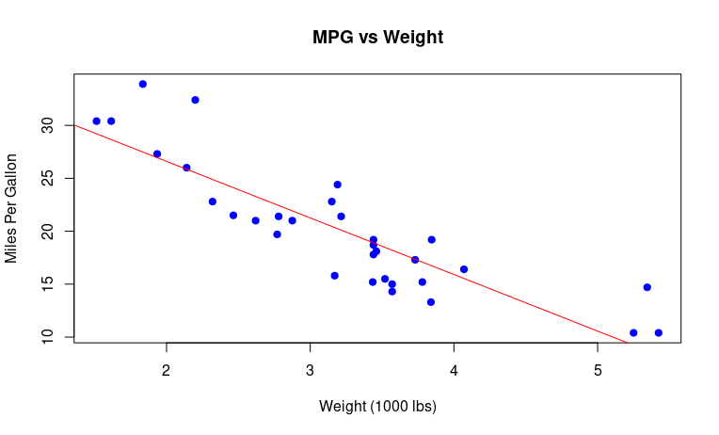
14. Perform the multiple linear regression(bivariate analysis) on any data set.
> # Load dataset
> data(mtcars)
>
> # Fit model
> model <- lm(mpg ~ wt + hp, data = mtcars)
>
> # Summary of the model
> summary(model)

Call:
lm(formula = mpg ~ wt + hp, data = mtcars)

Residuals:
Min 1Q Median 3Q Max
-3.941 -1.600 -0.182 1.050 5.854
Coefficients:
Estimate Std. Error t value Pr(>|t|)
(Intercept) 37.22727 1.59879 23.285 < 2e-16 ***
wt -3.87783 0.63273 -6.129 1.12e-06 ***
hp -0.03177 0.00903 -3.519 0.00145 **
---
Signif. codes: 0 ‘***’ 0.001 ‘**’ 0.01 ‘*’ 0.05 ‘.’ 0.1 ‘ ’ 1

Residual standard error: 2.593 on 29 degrees of freedom
Multiple R-squared: 0.8268, Adjusted R-squared: 0.8148
F-statistic: 69.21 on 2 and 29 DF, p-value: 9.109e-12
> plot(mtcars$wt, mtcars$mpg, main="MPG vs Weight",
+ xlab="Weight (1000 lbs)", ylab="Miles Per Gallon", pch=19, col="blue")
> abline(lm(mpg ~ wt, data=mtcars), col="red")
LAB 8

(29-10-25)

1. Healthcare and Medical Diagnosis
• Example: Predicting whether a patient has a disease (yes/no) based on symptoms, test results, and other factors.
• Use Case: Logistic regression models the probability of having diabetes, heart disease, or cancer.
• Dependent Variable: Disease (1 = Yes, 0 = No)
> library(ggplot2)
> # Example dataset
> health_data <- data.frame(
+ Age = c(45, 34, 67, 50, 29, 55, 60, 40, 70, 35),
+ BMI = c(25, 30, 28, 32, 22, 29, 33, 26, 31, 24),
+ BloodSugar = c(150, 180, 120, 200, 95, 160, 210, 130, 190, 100),
+ Disease = c(1, 1, 0, 1, 0, 1, 1, 0, 1, 0)
+ )
> # Logistic regression model
> health_model <- glm(Disease ~ Age + BMI + BloodSugar, data = health_data, family = "binomial")
> health_data$Predicted_Prob <- predict(health_model, type = "response")
> # View to confirm the column exists
> print(head(health_data))
Age BMI BloodSugar Disease Predicted_Prob
1 45 25 150 1 1.000000e+00
2 34 30 180 1 1.000000e+00
3 67 28 120 0 2.238440e-11
4 50 32 200 1 1.000000e+00
5 29 22 95 0 2.220446e-16
6 55 29 160 1 1.000000e+00
> # Plot predicted probabilities vs actual
> ggplot(health_data, aes(x = Predicted_Prob, y = Disease)) +
+ geom_jitter(width = 0.02, height = 0.05, color = "blue", size = 2) +
+ geom_smooth(method = "glm", method.args = list(family = "binomial"), color = "red") +
+ labs(
+ title = "Predicted Probability of Disease vs Actual Outcome",
+ x = "Predicted Probability",
+ y = "Actual (0 = No Disease, 1 = Disease)"
+ ) +
+ theme_minimal()
`geom_smooth()` using formula = 'y ~ x'

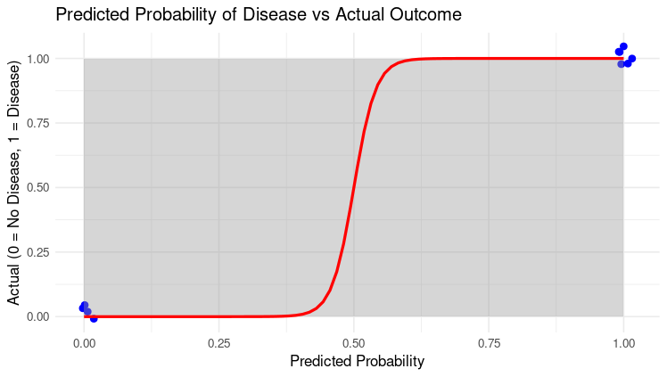

2. Banking and Finance
• Example: Credit scoring and loan default prediction.
• Use Case: Banks use logistic regression to decide whether a customer is likely to default on a loan.
• Dependent Variable: Default (1 = Default, 0 = No Default)
> library(ggplot2)
> cat("banking and finance\n")
banking and finance
> # Sample dataset
> bank_data <- data.frame(
+ Income = c(3000, 4000, 5400, 6000),
+ CreditScore = c(700, 600, 750, 800),
+ LoanAmount = c(1500, 2000, 1300, 4000),
+ Default = c(0, 1, 0, 1)
+ )
> # Logistic regression model
> bank_model <- glm(Default ~ Income + CreditScore + LoanAmount,
+ data = bank_data, family = "binomial")
> # Predicted probabilities
> bank_data$Predicted_Prob <- predict(bank_model, type = "response")
> # Print probabilities
> print(round(bank_data$Predicted_Prob, 2))
[1] 0 1 0 1
> #visualize the results
> ggplot(bank_data, aes(x = Predicted_Prob, y = Default)) +
+ geom_jitter(width = 0.02, height = 0.05, color = "blue", size = 3) +
+ geom_smooth(method = "glm", method.args = list(family = "binomial"),
+ color = "red", se = FALSE) +
+ labs(title = "Predicted Probability vs Actual Loan Default",
+ x = "Predicted Probability of Default",
+ y = "Actual Default (0 = No, 1 = Yes)") +
+ theme_minimal()
`geom_smooth()` using formula = 'y ~ x'
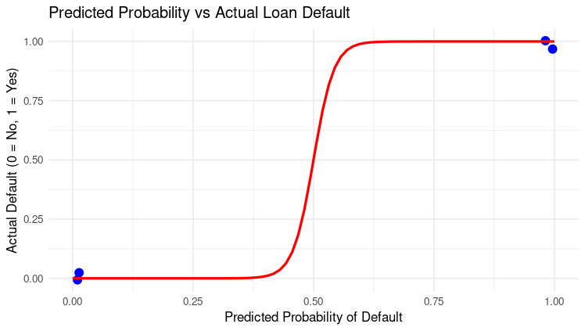
3. Marketing and Customer Analytics
• Example: Predicting whether a customer will buy a product based on age, income, and previous purchases.
• Use Case: Targeted marketing campaigns and conversion prediction.
• Dependent Variable: Purchase (1 = Yes, 0 = No)
> # Load required library
> library(ggplot2)
> cat("Marketing and Customer Analytics\n")
Marketing and Customer Analytics
> # Sample dataset
> marketing_data <- data.frame(
+ Age = c(22, 25, 30, 35, 40, 45, 50, 28, 33, 38),
+ Income = c(25000, 30000, 40000, 50000, 60000, 55000, 70000, 32000, 45000, 52000),
+ PreviousPurchases = c(0, 1, 2, 3, 4, 2, 5, 1, 3, 2),
+ Purchase = c(0, 0, 1, 1, 1, 0, 1, 0, 1, 1)
+ )
> # Logistic regression model
> marketing_model <- glm(Purchase ~ Age + Income + PreviousPurchases,
+ data = marketing_data, family = "binomial")

> # Add predicted probabilities to dataset
> marketing_data$Predicted_Prob <- predict(marketing_model, type = "response")
> # View predicted probabilities
> print(round(marketing_data$Predicted_Prob, 2))
[1] 0 0 1 1 1 0 1 0 1 1
> # Visualize the results
> ggplot(marketing_data, aes(x = Predicted_Prob, y = Purchase)) +
+ geom_jitter(width = 0.02, height = 0.05, color = "blue", size = 3) +
+ geom_smooth(method = "glm", method.args = list(family = "binomial"),
+ color = "red", se = FALSE) +
+ labs(
+ title = "Predicted Probability vs Actual Purchase",
+ x = "Predicted Probability of Purchase",
+ y = "Actual Purchase (0 = No, 1 = Yes)"
+ ) +
+ theme_minimal()
`geom_smooth()` using formula = 'y ~ x'
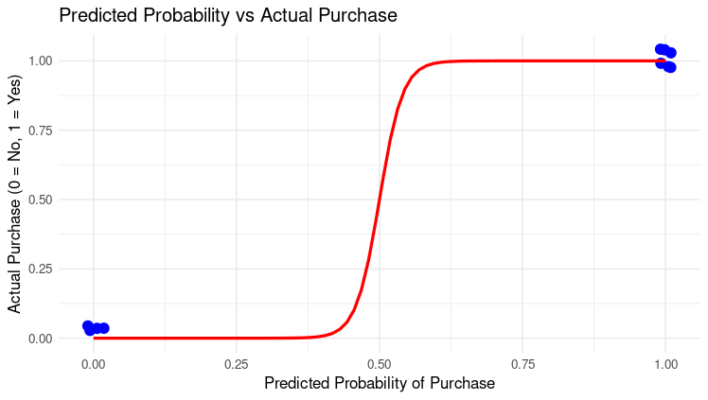

4. Spam Detection
• Example: Classifying emails as spam or not spam.
• Use Case: Logistic regression uses word frequency and metadata features to classify emails.
• Dependent Variable: Spam (1 = Spam, 0 = Not Spam)

> # Load required library
> library(ggplot2)
> cat("Spam Detection Example\n")
Spam Detection Example
> # Sample dataset
> spam_data <- data.frame(
+ WordFreq_Free = c(0.8, 0.1, 0.6, 0.05, 0.9, 0.02, 0.7, 0.03, 0.4, 0.05),
+ NumLinks = c(5, 0, 3, 0, 4, 1, 6, 0, 2, 0),
+ EmailLength = c(120, 500, 200, 600, 150, 700, 180, 650, 250, 550),
+ Spam = c(1, 0, 1, 0, 1, 0, 1, 0, 1, 0)
+ )
> # Logistic regression model
> spam_model <- glm(Spam ~ WordFreq_Free + NumLinks + EmailLength,
+ data = spam_data, family = "binomial")

> # Predicted probabilities
> spam_data$Predicted_Prob <- predict(spam_model, type = "response")
> # View predicted probabilities
> print(round(spam_data$Predicted_Prob, 2))
[1] 1 0 1 0 1 0 1 0 1 0
> # visualize the resullts
> ggplot(spam_data, aes(x = Predicted_Prob, y = Spam)) +
+ geom_jitter(width = 0.02, height = 0.05, color = "purple", size = 3) +
+ geom_smooth(method = "glm", method.args = list(family = "binomial"),
+ color = "red", se = FALSE) +
+ labs(
+ title = "Predicted Probability vs Actual Spam Classification",
+ x = "Predicted Probability of Spam",
+ y = "Actual Spam (0 = Not Spam, 1 = Spam)"
+ ) +
+ theme_minimal()
`geom_smooth()` using formula = 'y ~ x'
