**ROTARY CLUB OF KARIMNAGAR**

**CLUB MONTHY REPORT**

**1. JULY’2018:**

**In the month of July’2018 under WATER AND SANITATION programme, we have visited Zilla Parishad High School, Nagulamalyal and explained the uses of hygiene water and sanitation. Distributed Water Bottles, Soaps, Hand wash liquid to 200 students. Club president Rtn CA K.Ram Mohan has sponsored the funds to this programme. PDG DK.Anand, AG CA G.Anand Kumar, PAG Cheeti Rama Rao, Secreatary P.Thirupathi, IPP Rtn G.Venkata Kishan Club members P.Venu Gopal, E.Raji Reddy were participated in this programme.**

**Cost of project Beneficiaries Man Hours Rotarians**

**Rs.6,000/- 200 16 8**

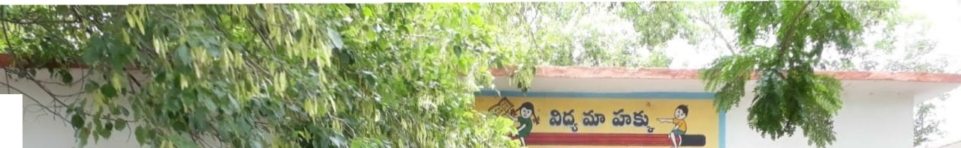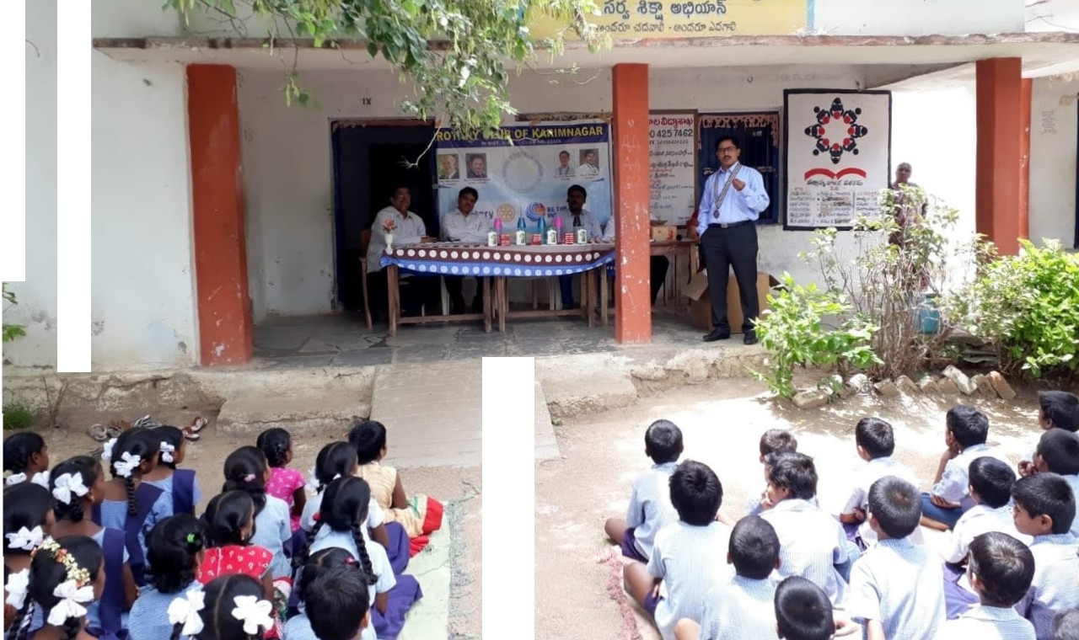

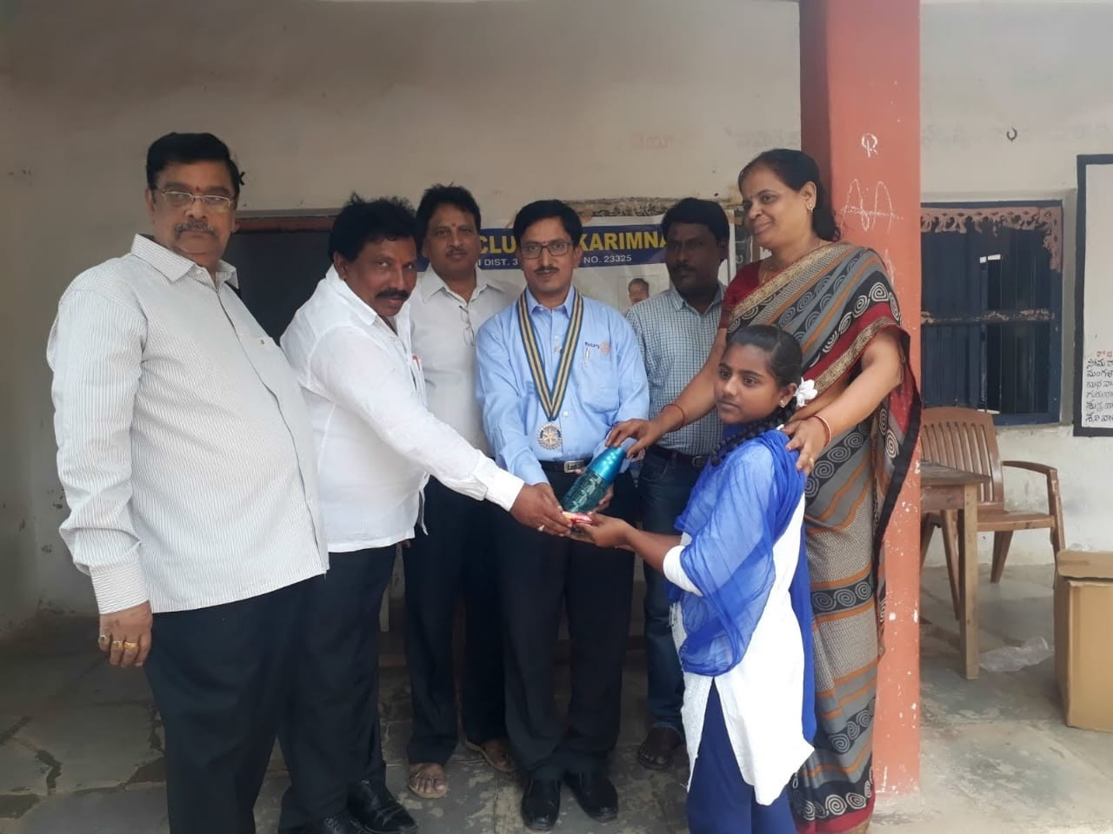

**2. AUGUST’2018:**

**i) In the month of August’2018 under ENVERONMENT PROJECT, we have planted 100 plants with the help of PAG Cheeti Rama Rao at Manovikas Kendram, Near LMD on Dt: 15.08.2018 and distributed Fruits and biscuits to the physically challenged students. Club president CA K.Ram Mohan, Secreatary P.Thirupathi, PDG DK.Anand, AG CA G.Anand Kumar, PAG Cheeti Rama Rao, Club members T.Venu Kumar, R.Sathish were participated in this event.**

**Cost of project Beneficiaries Man Hours Rotarians**

**Rs.4,000/- 75 14 7**

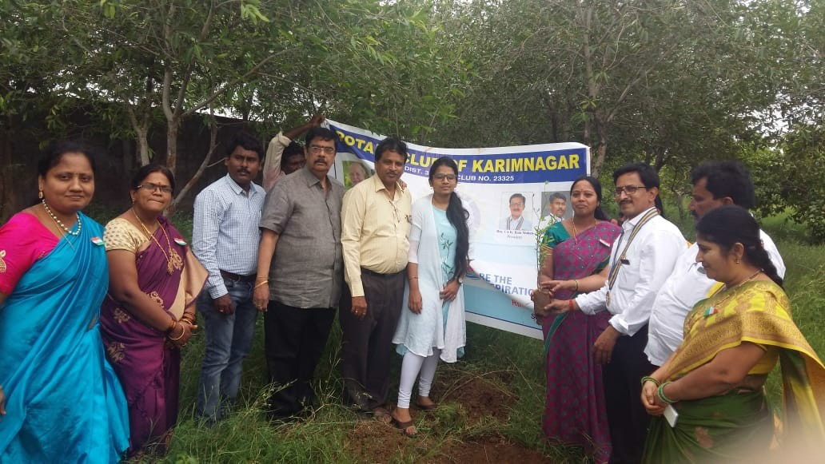

**ii) In the month of August’2018 we have participated in another programme under PEACE AND CONFLICT PREVENTION, we have been invited by the Commissioner of Police, Karimnagar to participate in Peace Rally on the occasion of Independence day on Dt: 10.08.2018. Club president CA K.Ram Mohan, Secreatary P.Thirupathi, PDG DK.Anand, AG CA G.Anand Kumar, Club members N.Ram Mohan Rao, N.Raja Reddy, Venu Madhav Reddy and other Rotarians were participated in this Rally and got special appreciation from CP, Karimnagar.**

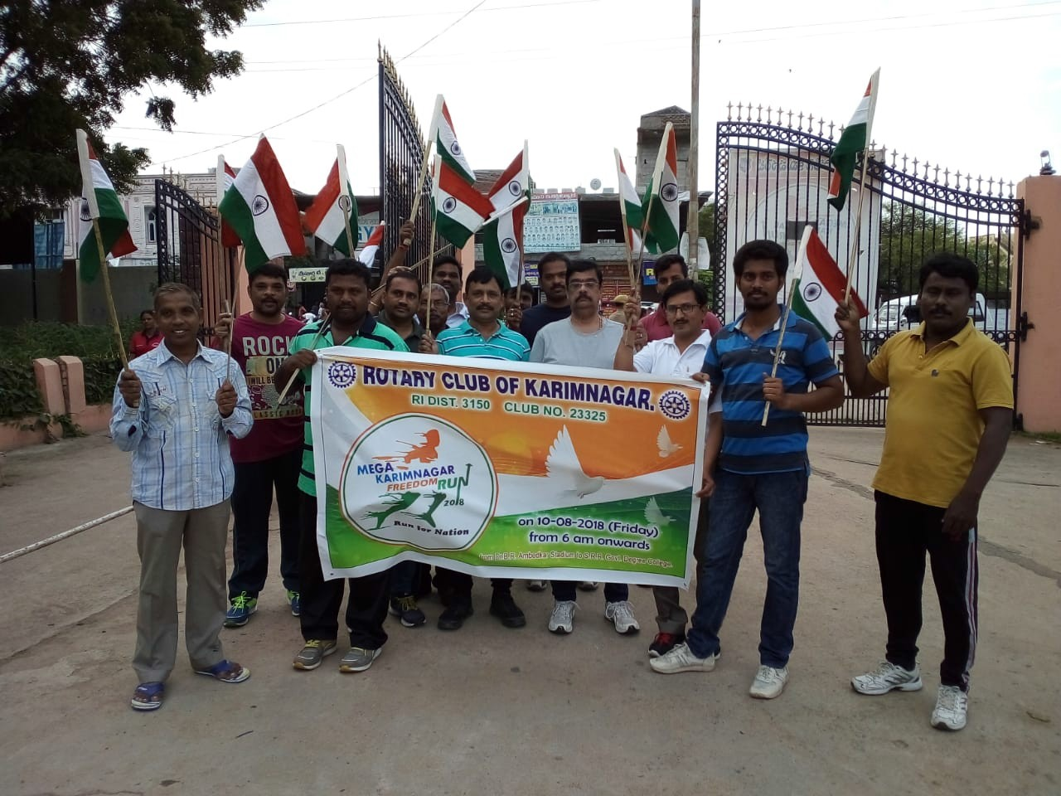

**3. SEPTEMBER’2018:**

**In the month of September we have conducted a HEALTH CAMP at Ekalavya Ashramam and distributed groceries and fruits worth of Rs.4,500/- to the children with the financial help of President CA K.Ram Mohan. Office bearers of Club and other Rotarians participated in this program.**

**4. OCTOBER’2018:**

**In the month of October under COMMUNITY SERVICE PROJECT we have distributed Food provisions worth of Rs,5,000/- at Veerabrahmendra Vrudasramam with the help of AG CA G.Anand Kumar, President K.Ram Mohan, Secretary P.Thirupathi, PDG DK Anand and other Rotarian were participated.**

**5. NOVEMBER’2018.**

**In the month of November under WOMEN EMPOWERMENT program we have conducted a Skill & Personality development program in Girls Junior College, Karimnagar. Club office bearers and other Rotarians participated.**

**6. DECEMBER’2018**

**In the month of December under NEW GENERATION program we have visited Primary School, Sapthagiri Colony and explained about the Rotary Club International and distributed note books worth of Rs.4,000/- to the children with the help of AG CA G.Anand Kumar.**

**7. JANUARY’2019**

**In the month of January’2019 under DISEASE PREVENTION AND TREATMENT program we have distributed Homeopathic Medicine for prevention of Chickengunya with the help of president CA K.Rammohan and also donated Rs.5,000/- to Baby Vaishnavi for treatment of her brain related disease the same was published in Eenadu News paper.**

**8. FEBRUARY’2019**

**In the month of February’2019 we have installed a RO plant capacity of 250Ltr at ZPHS, Koheda with the financial support of Rs.40,000/- from the Chairman of KIMS Institutions Sri P.Ravinder Rao Garu.**

**9. MARCH’2019**

**In the month of March’2019 under END POLIO NOW we have conducted a pulse polio immunization program on Dt:10.03.2019 at Jyothi Nagar, Karimnagar.**

**In this month Governors official visit also completed.**

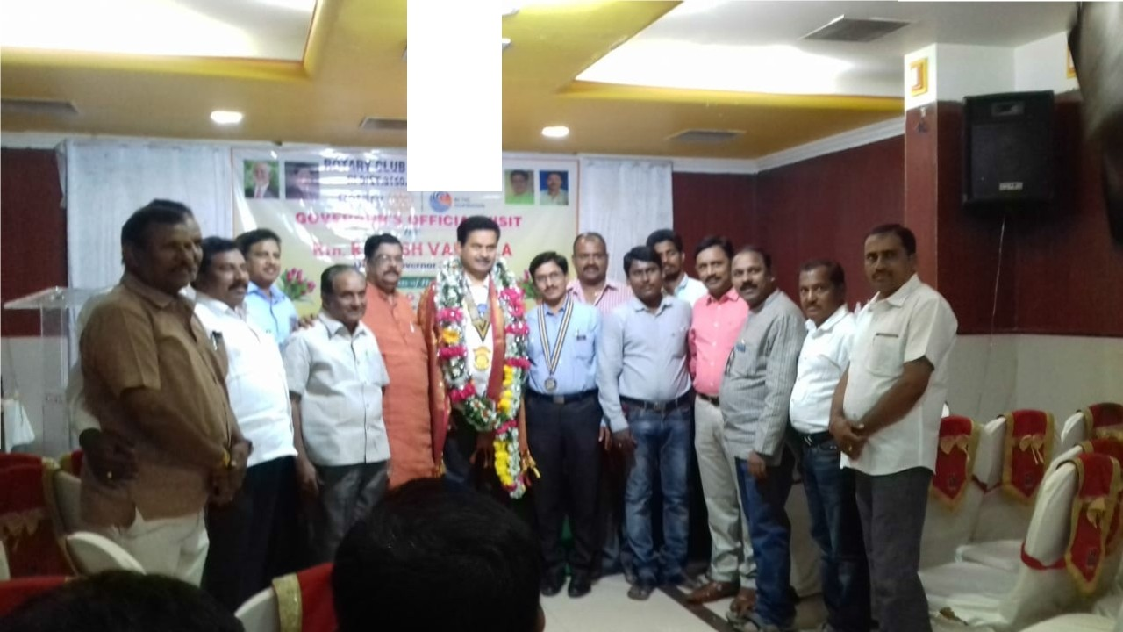

**10. APRIL’2019**

**In the month of April’2019 under MATERNAL AND CHILD HEALTH program we have distributed Fruits and bread at Government hospital, Karimnagar.**

**11. MAY’2019**

**In the month of May’2019 under COMMUNITY SERVICE program our Club president Rtn CA K. Rammohan has donated a Tricycle to a physically challenged person.**

**12. JUNE’2019.**

**In the month of June’2019 under FRIENDSHIP EXCHANGE program Rotary Club of Springfield, Secunderabad has visited our club and we have distributed note books at Venkat Foundation, Karimnagar after that we have visited Veerabrahmendra Vruddasramam and our club Rtn and AG CA G.Anand Kumar has donated Rs.5,000/- towards groceries.**

