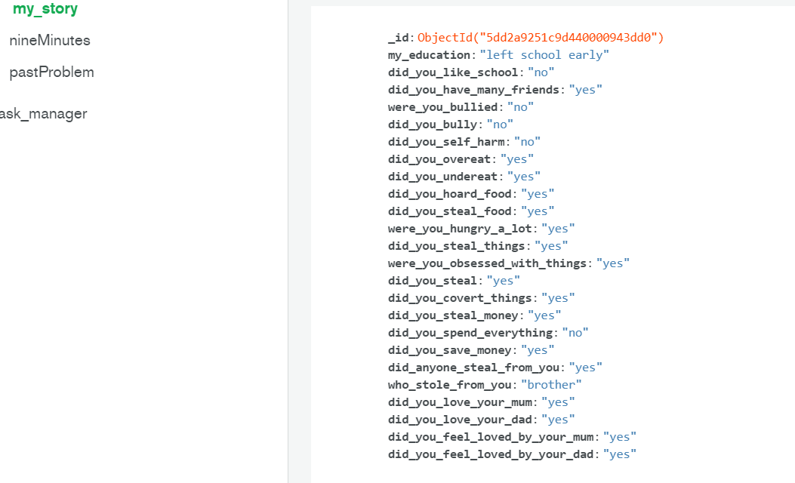

Bson key value pairs

{"_id":{"$oid":"5dd2a9251c9d440000943dd0"},"my_education":"left school early","did_you_like_school":"no","did_you_have_many_friends":"yes","were_you_bullied":"no","did_you_bully":"no","did_you_self_harm":"no","did_you_overeat":"yes","did_you_undereat":"yes","did_you_hoard_food":"yes","did_you_steal_food":"yes","were_you_hungry_a_lot":"yes","did_you_steal_things":"yes","were_you_obsessed_with_things":"yes","did_you_steal":"yes","did_you_covert_things":"yes","did_you_steal_money":"yes","did_you_spend_everything":"no","did_you_save_money":"yes","did_anyone_steal_from_you":"yes","who_stole_from_you":"brother","did_you_love_your_mum":"yes","did_you_love_your_dad":"yes","did_you_feel_loved_by_your_mum":"yes","did_you_feel_loved_by_your_dad":"yes","who_did_you_love_most":"mum","who_did_you_trust_most":"dad","who_did_you_fear_most":"dad","who_listened_to_you":"gran","who_influenced_you_most":"gran","did_you_enjoy_music":"yes","did_you_enjoy_art":"yes","did_you_enj0y_the_park":"yes","did_you_enjoy_the_beach":"yes","what_was_your_favourite_season":"summer","what_was_your_favourite_day_of_the_year":"school holidays","what_did_you_dream_of_becoming":"a doctor"}

