DEAD CODE ELIMINATION IN THREE ADDRESS CODE
C Programming Lab Record
Student Details
Name | Sama Vaishnavi
Register Number | 192372117
Course / Subject | C Programming – Code Optimization

Aim
To write a C program to identify and eliminate dead code from Three Address Code (TAC) statements and display the optimized code.
Program
#include <stdio.h>

int main() {
char *tac[] = {
"t1 = a + b",
"t2 = c * d",
"t3 = t1 + 10",
"x = t3",
"y = 20"
};

int n = 5, used[5] = {0};

used[0] = 1; // t1 is used by t3
used[2] = 1; // t3 is used by x
used[3] = 1; // x is an output
used[4] = 1; // y is an output

printf("Optimized Three Address Code:\n");

for (int i = 0; i < n; i++) {
if (used[i])
printf("%s\n", tac[i]);
}

return 0;
}
Sample Input
t1 = a + b
t2 = c * d
t3 = t1 + 10
x = t3
y = 20
Output Screenshot
The following screenshot shows the optimized output in OnlineGDB.
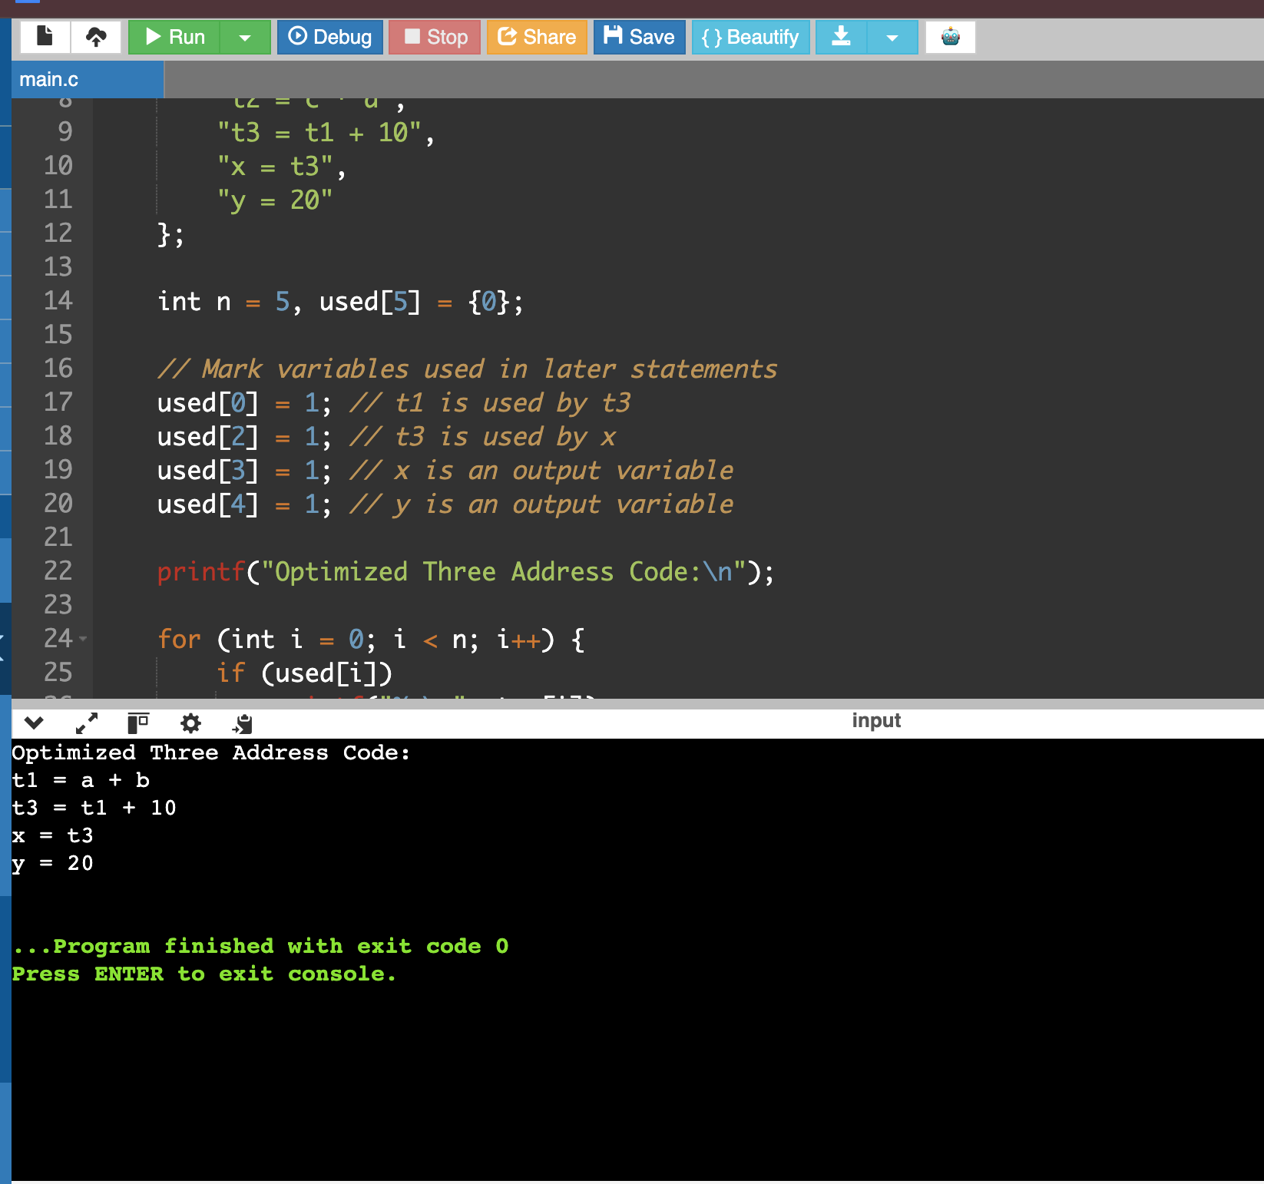
Expected Output
Optimized Three Address Code:
t1 = a + b
t3 = t1 + 10
x = t3
y = 20
Result
The C program displays the optimized Three Address Code after removing the dead statement t2 = c * d, whose result is never used.

