LEXICAL ANALYZER IN C
C Programming Lab Record
Student Details
Name | Sama Vaishnavi
Register Number | 192372117
Course / Subject | C Programming – Lexical Analyzer

Aim
To write a C program that reads a C statement and identifies basic tokens such as keywords, identifiers, operators, constants, and special symbols.
Program
#include <stdio.h>
#include <ctype.h>
#include <string.h>

int main() {
char s[200];
int i = 0;

printf("Enter a C statement: ");
fgets(s, sizeof(s), stdin);

while (s[i]) {
if (isspace(s[i])) {
i++;
}
else if (isalpha(s[i]) || s[i] == '_') {
printf("Identifier/Keyword: ");
while (isalnum(s[i]) || s[i] == '_')
putchar(s[i++]);
printf("\n");
}
else if (isdigit(s[i])) {
printf("Constant: ");
while (isdigit(s[i]))
putchar(s[i++]);
printf("\n");
}
else if (strchr("+-*/%=<>!", s[i])) {
printf("Operator: %c\n", s[i++]);
}
else {
printf("Special Symbol: %c\n", s[i++]);
}
}

return 0;
}
Sample Input
a = b + 10;
Output Screenshot
The following screenshot shows the program output in OnlineGDB.
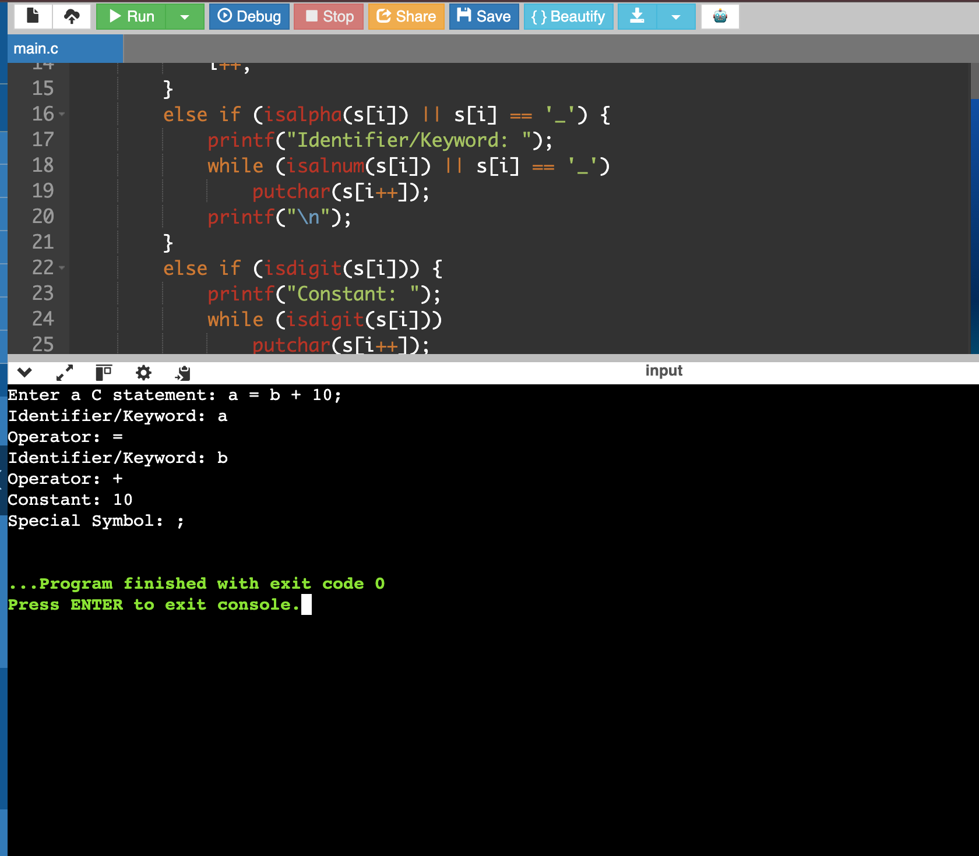
Expected Output
Enter a C statement: a = b + 10;
Identifier/Keyword: a
Operator: =
Identifier/Keyword: b
Operator: +
Constant: 10
Special Symbol: ;
Result
The C program successfully reads a C statement and displays its tokens as identifiers/keywords, operators, constants, and special symbols.

