

Assignment Cover Sheet

Student name: | Samantha Avila de Medeiros
Student number: | 3125216
Faculty: | Computing Science
Course: | HDC |  |  | Stage/year: | 1
Subject: | Relational Databases
Study Mode: | Full time | X |  | Part-time
Lecturer Name: | Nasim Sobhani
Assignment Title: | LabTwo
No. of pages:
Disk included? | Yes |  |  | No | X
Additional Information: | (ie. number of pieces submitted, size of assignment, A2, A3 etc)

Date due:

Date submitted:
Plagiarism disclaimer:
I understand that plagiarism is a serious offence and have read and understood the college policy on plagiarism. I also understand that I may receive a mark of zero if I have not identified and properly attributed sources which have been used, referred to, or have in any way influenced the preparation of this assignment, or if I have knowingly allowed others to plagiarise my work in this way.

I hereby certify that this assignment is my own work, based on my personal study and/or research, and that I have acknowledged all material and sources used in its preparation. I also certify that the assignment has not previously been submitted for assessment and that I have not copied in part or whole or otherwise plagiarised the work of anyone else, including other students.
Signed: _____________________ Date: ______________________

Please note: Students MUST retain a hard / soft copy of ALL assignments as well as a receipt issued and signed by a member of Faculty as proof of submission.

PART ONE.

Normalization is a process to achieve good database design. A database design requires some refinement, which is achieved through normalization. Complex relationships are decomposed into simpler relationships using normalizations. Normalization is also used to check the quality of database design. There are three levels of normalization. In a given relation R, A and B are attributes, B is functionally dependent on A, and each value of A determines exactly one value of B.

Let's analyse the given relation and determine if it is in 1NF, 2NF, or 3NF.

- 1NF (First Normal Form):
The relation is in 1NF if all attributes are atomic (indivisible) and there are no repeating groups.
The given relation is already in 1NF because it has a flat structure with atomic attributes.

- 2NF (Second Normal Form):
A relation is in 2NF if it is in 1NF and all non-prime attributes are fully functionally dependent on the entire primary key.
The primary key is (Car, Salesperson).
The attributes Commission and Discount_amt are dependent on the Salesperson, and Date_sold is dependent on Date_sold (the entire primary key).
Therefore, the relation is in 2NF.

- 3NF (Third Normal Form):
A relation is in 3NF if it is in 2NF and all transitive dependencies are removed.
In this case, there is a transitive dependency between Salesperson and Commission.
Salesperson determines Commission, but Salesperson is not a superkey; it is part of the primary key (Car, Salesperson).
To achieve 3NF, we need to remove the transitive dependency. We can create a new relation with Salesperson as the key and Commission as the attribute.

- Normalized Relations:
Original Relation: Car_Sale(Car, Salesperson, Date_sold, Commission, Discount_amt)
After 3NF Normalization:
  - Relation 1: Car_Sale_1(Car, Salesperson, Date_sold, Discount_amt)
  - Relation 2: Commission_Sale(Salesperson, Commission)

The normalized relations satisfy 3NF, as there are no transitive dependencies, and each relation has a proper primary key.

In summary, the original relation is in 1NF and 2NF but not in 3NF due to the transitive dependency between Salesperson and Commission. Normalizing it into two relations resolves this issue and achieves 3NF.

EXERCISE TWO.

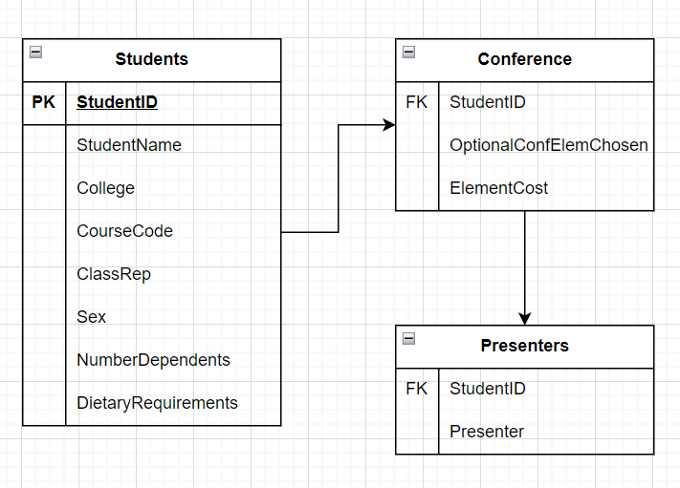

Table 1: Students
- student id (PK)
- student name
- college
- course code
- class rep (yes/no)
- sex
- number of dependents
- dietary requirements (if any)

Table 2: Conference Elements
- student id (FK)
- Optional conference elements chosen
- Element cost

Table 3: Presenters
- student id (FK)
- presenter (yes/no)

The explanation is as follows:
- Students: Contains information about students, including their ID, name, college, course code, whether they are class representatives, gender, number of dependents and dietary requirements.
- Conference Elements: Stores information about the optional elements chosen by students for the conference, along with the associated costs.
- Presenters: Registers whether a student is a presenter or not.

Each table is in BCNF, which means there are no transitive dependencies and all functional dependencies are covered by the primary keys. This helps prevent update anomalies and maintain data integrity.

