Probabilistic Assessment of Future Pharmaceutical Environmental Risk

Sam A Welch, Merete Grung, Knut Erik Tollefsen, Jannicke Moe

IEAM – 30 double-spaced pages, all inclusive

No more than 6 figures/no more than 6 tables…

# Abstract

# Introduction

In its 6th report cycle, the IPCC predicts a 1.5 degree C change in global temperatures is highly likely (cite, what does highly likely mean?), with attendant effects on weather, etc. Climate change represents a relatively well-characterised subset of future uncertainty, but understanding future risks to the environment requires as good an understanding of *all* uncertainty as is possible.

Pharmaceuticals are one of the primary tools for mitigating and controlling human and animal health risks, and have, over the past 150 years, become industrially manufactured and broadly dispensed due to their many advantages over other therapies.

However, by their very nature as effective therapies, pharmaceuticals can also pose unexpected effects to non-target species. Scientific and public interest in pharmaceuticals as pollutants has grown in the last few decades, and in [year], under the Human Medicines Directive (?), new pharmaceuticals registered for market authorisation in the EU were required to provide either an exemption, or an Environmental Risk Assessment.

Environmental Risk Assessment’s core paradigm in the EU is built around comparing a measured or predicted level in the environment to a threshold below which no effects are predicted to occur. Depending on the degree of detail and sophistication of the ERA, “the environment” can cover a wide variety of different physical matrices (air, freshwater, marine water, soil, etc.), and the corresponding threshold can be calculated from a broad panel of testing conditions and species – however this is not normally the case for pharmaceuticals.



This core paradigm is simple, intuitive and easy to employ, but has not gone without criticism. Uncertainty is collapsed to a simple threshold, which fails to capture the true nuance of variation and creates bias towards parameters closer to these thresholds. Other criticisms go here. Particularly the fact that as uncertainty grows (in the future?), their effectiveness falls.



Bayesian Networks, probabilistic graphical networks, present a number of potential advantages in ERA, as well as some limitations. Best used as a supplement to existing ERA? In particular, may be well-suited for meeting future goals such as “toxic-free environment”, if we (speculatively) assume that RQ < 1 is toxic-free.

Talk about scenarios and WWTPs here!

In this paper, we present a Bayesian Network for predicting present and future risk of a subset of pharmaceuticals sold across Mainland Norway.

* Introduction of state of the art – people have been discussing these issues for 20+ years
  + EU risk assessment guidelines were introduced in the 1990s in the TGDs
  + ERA should protect all human populations & ecosystems, but several explicit groups are defined that get a risk estimate (Jager et al., 2001)
    - This is done via a point estimate: a RQ or RCR based on threshold PECs and PNECs
  + However, in doing so we diverge from the conventional definition of risk “hazard * probability) because we neither fully define the impact nor quantify the probability



* + - There’s a bunch of valuable citations in Jager et al that I can’t access because the journal sucks
* ERA severely hampered by collapsing uncertainty to thresholds
* Big plans for toxic-free environment, but a big question mark over how ERA will change to account for this
* How will risks increase in the future, and how
* Bayesian Networks overcome (some?) of these issues
* We present a novel (as far as we know) application of BN ERA in a conceptual model for predicting mixture risks of a subset of APIs in Norway

Figure 1: Conceptual Model of BN

* Goals:
  + Predict sales weights up to 2050 under various population growth scenarios
  + Predict ECs in a variety of matrices
  + Predict RQ in surface water (& elsewhere?)
  + Predict SRQ, or STU?

# Methods

## Source Data

Norwegian pharmaceutical sales data for the years 1999 – 2018 were extracted from the Norwegian Institute for Public Health (NIPH’s) Norwegian Wholesale Drugs Database and adapted to an ecotoxicology-friendly format following the methods in Welch et al. (2022).

National and county historic populations on January 1st for 1999 – 2018, and nation population predictions from 2020 – 2050 were accessed via Statistics’ Norway’s website and database. A count of population connected to both large (>50 person-equivalent) and small (<50 p.e.), by county, in 2020, was acquired from the same source.

Pharmaceutical removal rates under various levels of wastewater treatment were taken from van Dijk et. al. (in print?), for a full list of original sources please see whatever Joanke asks for.

## Prediction of Future Sales

Future sales for a panel of 8 APIs were predicted using a linear model of the form (ax + b):

$$Sales weight \left(kg\right)=Year× kg∙{Year}^{-1} ∙{Population \left(mil\right)}^{-1} ×Population+Intercept$$

## Discretising Variation

Continuous variables, as well as percentages, were discretised into intervals or rounded to the nearest value to reduce Bayesian network complexity. Spatial discretisation is discussed briefly below; for a full oversight of node discretisation, please refer to the Bayesian network file.

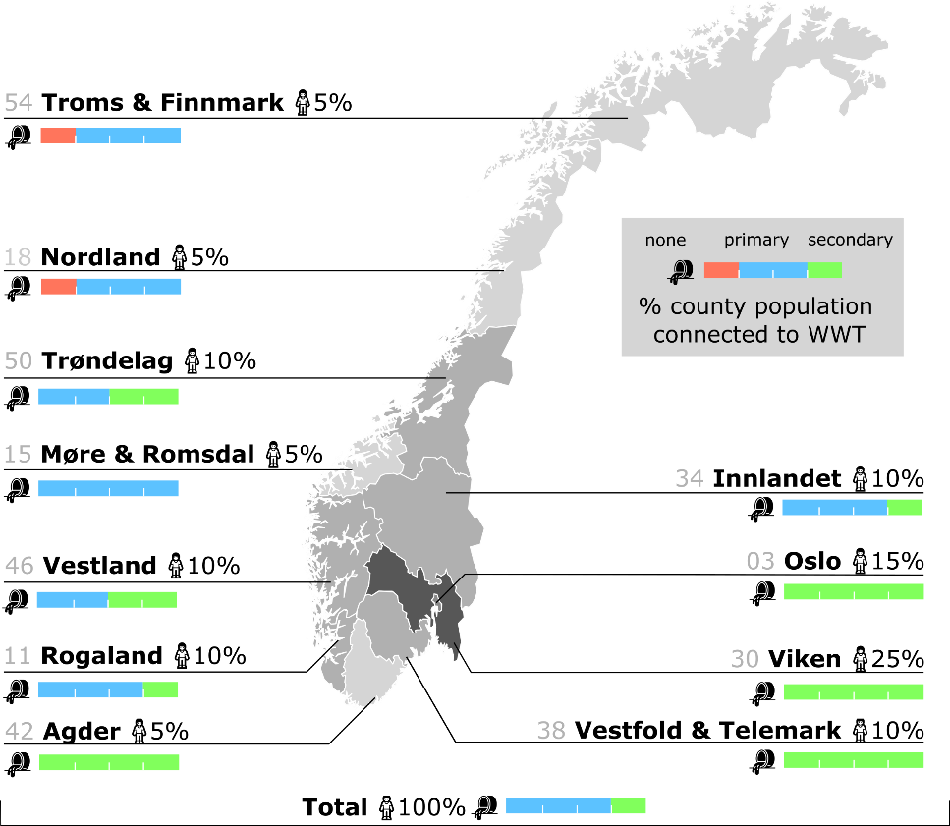

Figure 2: Discretised WWTP access and population, by Norwegian county ("fylker".)

As the applicability of the model used in 1.2 is in the millions of people, sales weights per county were predicted by multiplying national sales by a fixed, discretised percentage based on share of the population in 2020 (Figure 2). Due to rounding, the sum of population percentages is greater than 100%, but where national-scale risk is calculated the actual population is used instead.

Percentage access to WWTP level were discretised to the nearest 25%. In one county, Møre og Romsdal, 75% of the population had access to primary WWT, roughly 12.5% none and 12.5% secondary. In this case, access was manually adjusted to 100% primary.

A note on discretisation of WWTP to the nearest 25%. In one case I ended up with a <100% split, which is obviously a problem (e.g. Møre og Romsdal has 0 – 75 – 0).

I elected to simply bump the percentage primary up to 100%, as this distorted the actual ratio the least. I think.

## Selection of APIs

A panel of {8} APIs were selected from the ~800 ecotoxicologically-relevant APIs sold yearly in Norway, based on existing prediction of high risk. These APIs, and their properties are summarised below.

|  |  |  |
| --- | --- | --- |
| API Name | Criteria | Toxicity (µg/L) |
| Estradiol (estrogen) | Well-studied, high risk | PNEC: 4.00E-4  (JRC) |
| Ethinylestradiol (estrogen) | Well-studied, high risk | PNEC: 3.00E-5 (FASS)  Chronic toxicity to fish: 3.00E-4 * AF = 10 |
| Diclofenac (NSAID/Analgesic) | Well-studied, moderate risk | PNEC: 5.00E-2  (JRC) |
| Ibuprofen (NSAID/Analgesic) | Well-studied, moderate risk | PNEC: 1.00E+0  Chronic toxicity to algae: 1.00E+1 * AF = 10 |
| Paracetamol  (analgesic) | Well-studied, moderate risk | PNEC: 1.00E+1  Chronic toxicity to *Daphnia*: 1.00E+0 * AF = 10 |
| Ciprofloxacin  (quinolone antibiotic) | [Well-studied?](https://www.aces.su.se/aces/wp-content/uploads/2018/11/Ciprofloxacin-EQS-data-overview-2018.pdf), high risk | PNEC:  Chronic toxicity to fish: 8.90E-1 |

## Assumptions and Selection of Parameters

* No spatial or temporal variation below the county/year scale
* Even distribution of population and drug consumption across Norway
* Effects of climate, environmental change on societal, economic and environmental factors ignored
* Demographic consumption patterns and change ignored
* No consideration of new drugs on markets/old drugs being removed
* Drugs pass through the body without being broken down or modified
* Drugs removed in wastewater treatment plants cease to exist

## Bayesian Network Construction

An Object-Oriented Bayesian Network was created in Hugin Researcher 9.1 to perform analyses.

Table 1: Condensed list of BN nodes.

|  |  |  |  |  |
| --- | --- | --- | --- | --- |
| Node Name | Type | States | Class | Notes |
| WWT Scenario | Label | Current, Compliance | Master |  |
| County | Label | Total + 13 counties | Master |  |
| Year | Number | 2020, 2035, 2050 | Master |  |
| Population Scenario | Label | Low, Main, High | Master |  |
| Population of Norway (mil) | Number | 4.5, 5, 5.5, 6, 6.5, 7 | Master |  |
| WWT Scenario | Label | Current, Compliance | Spatial |  |
| Year | Number | 2020, 2035, 2050 | Spatial |  |
| County | Label | Total + 13 counties | Spatial |  |
| Population of Norway (mil) | Number | 4.5, 5, 5.5, 6, 6.5, 7 | Spatial |  |
| County Pop. Share (%) | Number | 0.05, 0.1, 0.15, 0.2, 0.25, 1 |  |  |
| No WWT (%) | Number | 0, 0.25, 5 | Spatial |  |
| Primary WWT (%) | Number | 0, 0.25, 5, 0.75, 1 | Spatial |  |
| Secondary WWT (%) | Number | 0, 0.25, 5, 0.75, 1 | Spatial |  |
| Wastewater  (L/person/day) | Interval | 150 – 170, 170 – 190, 190 – 210, 210 – 230 | Spatial |  |
| Total County Wastewater (ML) | Interval | 0 – 10, 10 – 30, 30 – 100, 100 – 300, 300 – 1000, 1000 – 3000 | Spatial |  |
| [API Name]  (weight) | Label | API 1, …, API n | Master |  |
| [API Name]  RQ | Interval | 0 -1, 1 – 10, 10 – 100, 100 – 1000, 1000 – 10000, 10000 - inf | Master |  |
|  |  |  |  |  |
|  |  |  |  |  |
|  |  |  |  |  |
|  |  |  |  |  |

Figure 4: Bayesian Network Diagram.

# Results

Anchor results & discussion more around specific counties/case studies?

Visualisation: <https://www.mdpi.com/2073-4441/11/9/1767>

## Spatial Distribution of Risks

|  |  |  |  |  |
| --- | --- | --- | --- | --- |
|  |  |  |  |  |
|  |  |  |  |  |
|  |  |  |  |  |
|  |  |  |  |  |
|  |  |  |  |  |

## Risk Under Population Scenarios

## Risk Under WWTP Scenarios

## Combined and Cumulative Risk

# Discussion

## Spatial Distribution of Risks

## Risk Under Population Scenarios

## Risk Under WWTP Scenarios

## Combined and Cumulative Risk

# Conclusions

* BN/PERA is good for predicting nuanced risk
* Fish are in trouble, possibly, under various scenarios
* We could do so much more cool stuff if I had the time
  + Spatially explicit BNs
  + Proper inclusion of population, climate, demographic, etc. scenarios
  + And so on