

Human Values & Community Outreach (HVCO) — SW102

WEEKLY PROGRESS REPORT (WPR) — WEEK 2

Student Name | Samay Kumar
Enrollment No. | A2305325001
Programme | B.Tech – Information Technology (IT)
Semester | 3rd Semester
Academic Session | 2026–2027
NGO Name | Kind Beings NGO
NGO Supervisor | Sanya Bajaj, Regional Manager
Internship Period | 2nd June 2026 – 6th July 2026

Week 2 — Tasks Undertaken (09/06/2026 – 15/06/2026)

The following tasks were undertaken during the second week of the internship with Kind Beings NGO as part of the HVCO (SW102) course framework.

Task | Description & Action Points
Stationery Collection Drive | Visited the Kind Beings NGO office, collected stationery items (notebooks, pens, pencils, erasers, rulers) donated by supporters, sorted and packaged the items, and distributed them directly to underprivileged beneficiaries at the NGO premises. Documented the process with photographs  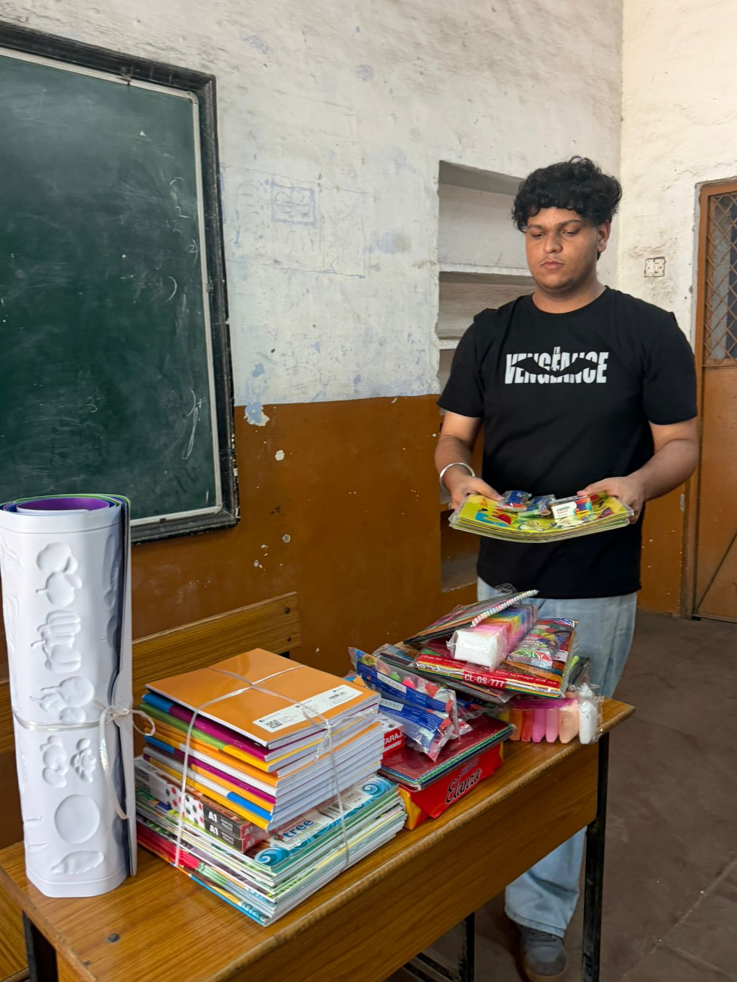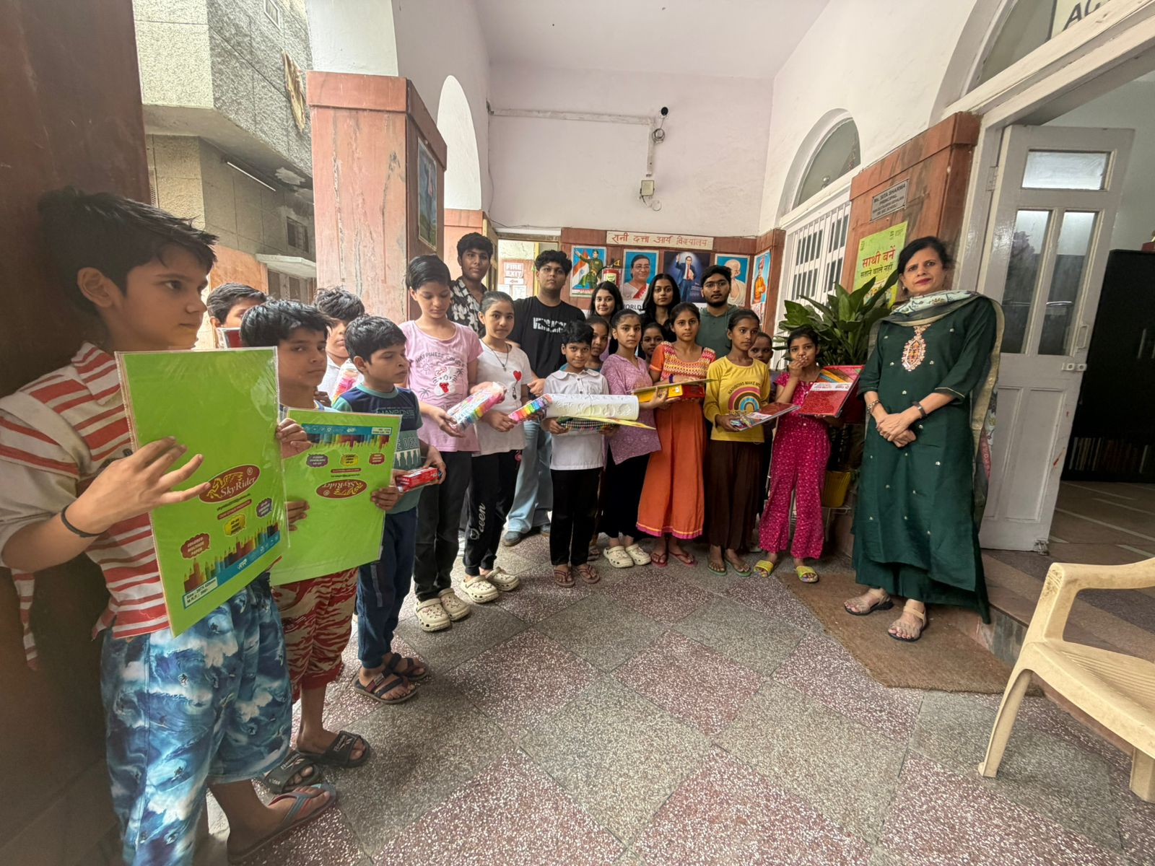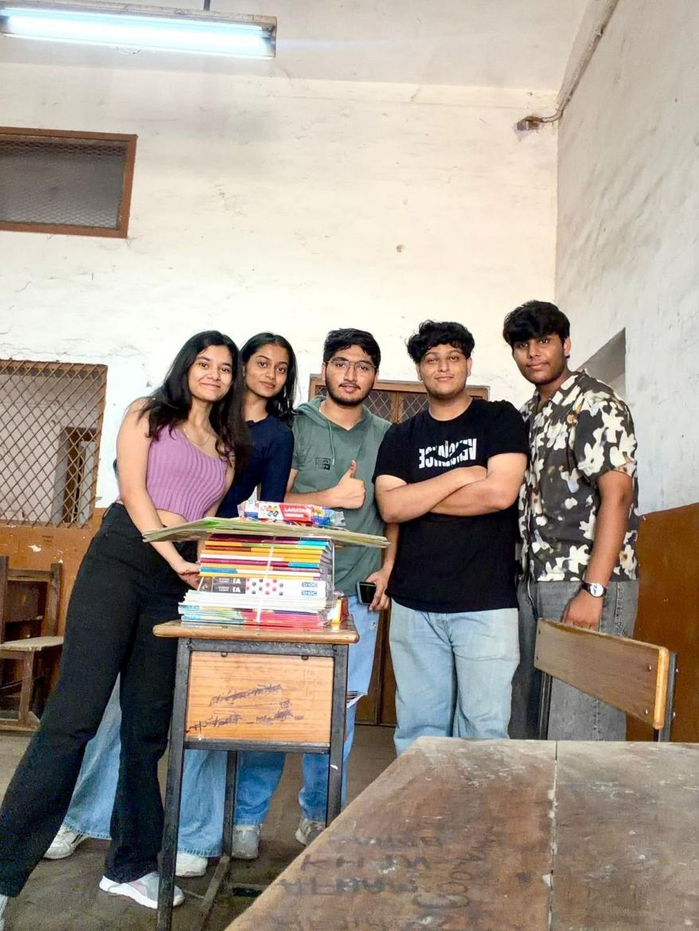
Teaching Session for Underprivileged Kids | Identified a community center in coordination with Kind Beings NGO, prepared engaging educational content covering basic math, English, and general life skills, conducted an interactive session using props and teaching aids, encouraged active participation from all children, and documented the experience with photographs and a brief report.  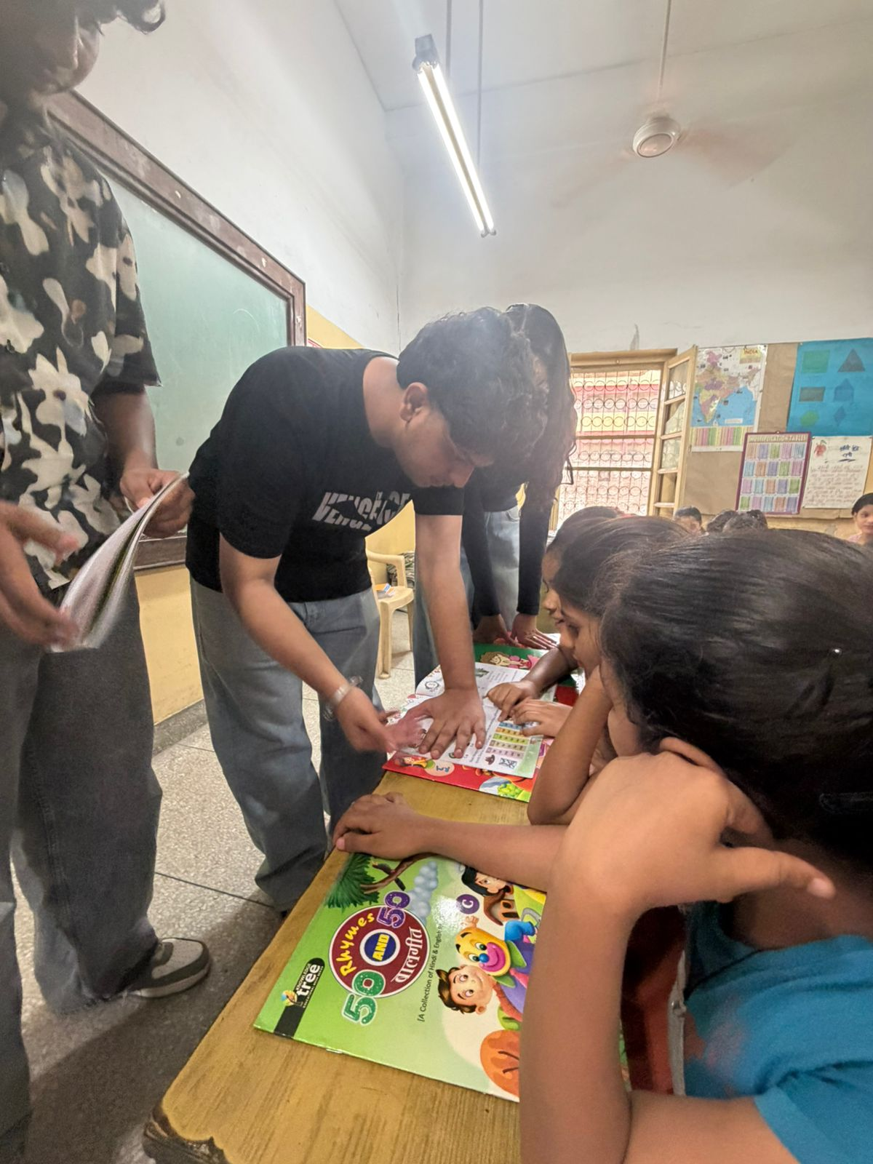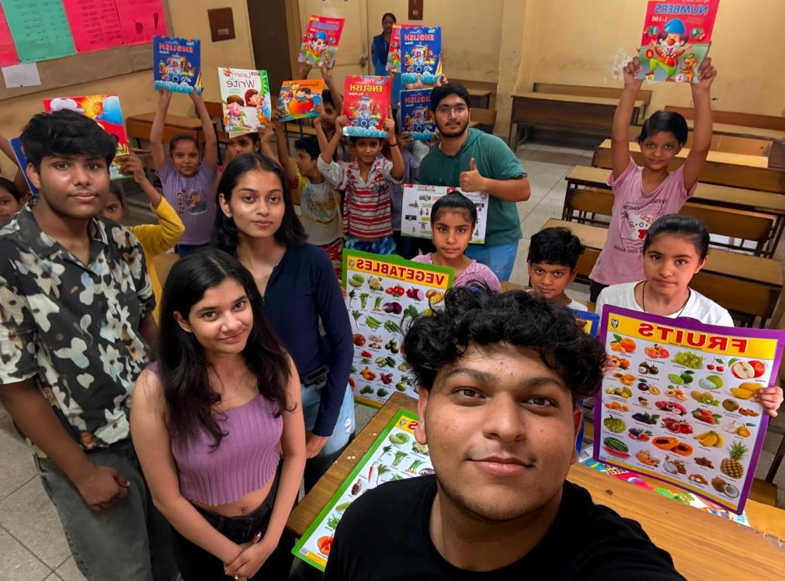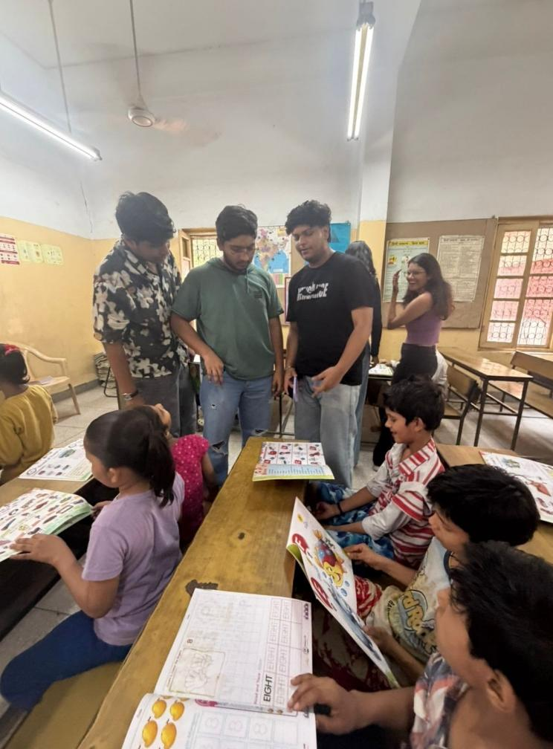
Tree Plantation Drive | Identified a suitable location in collaboration with the NGO, procured native tree saplings and necessary tools, promoted the event through social media and word of mouth, conducted the plantation drive in groups, educated participants about environmental sustainability and climate change with photographs.  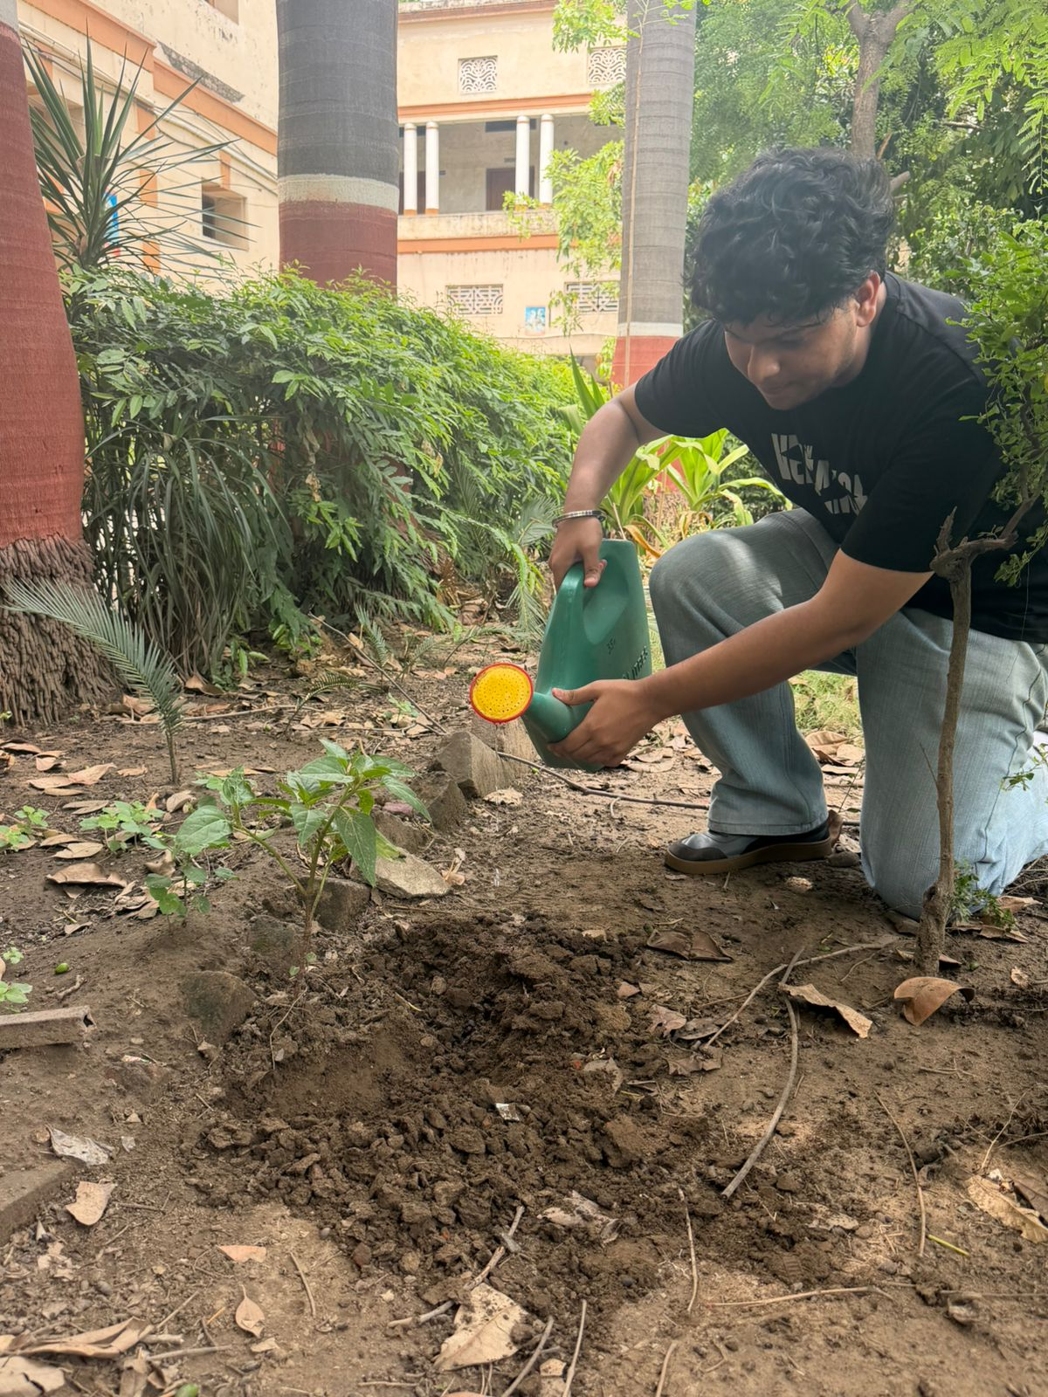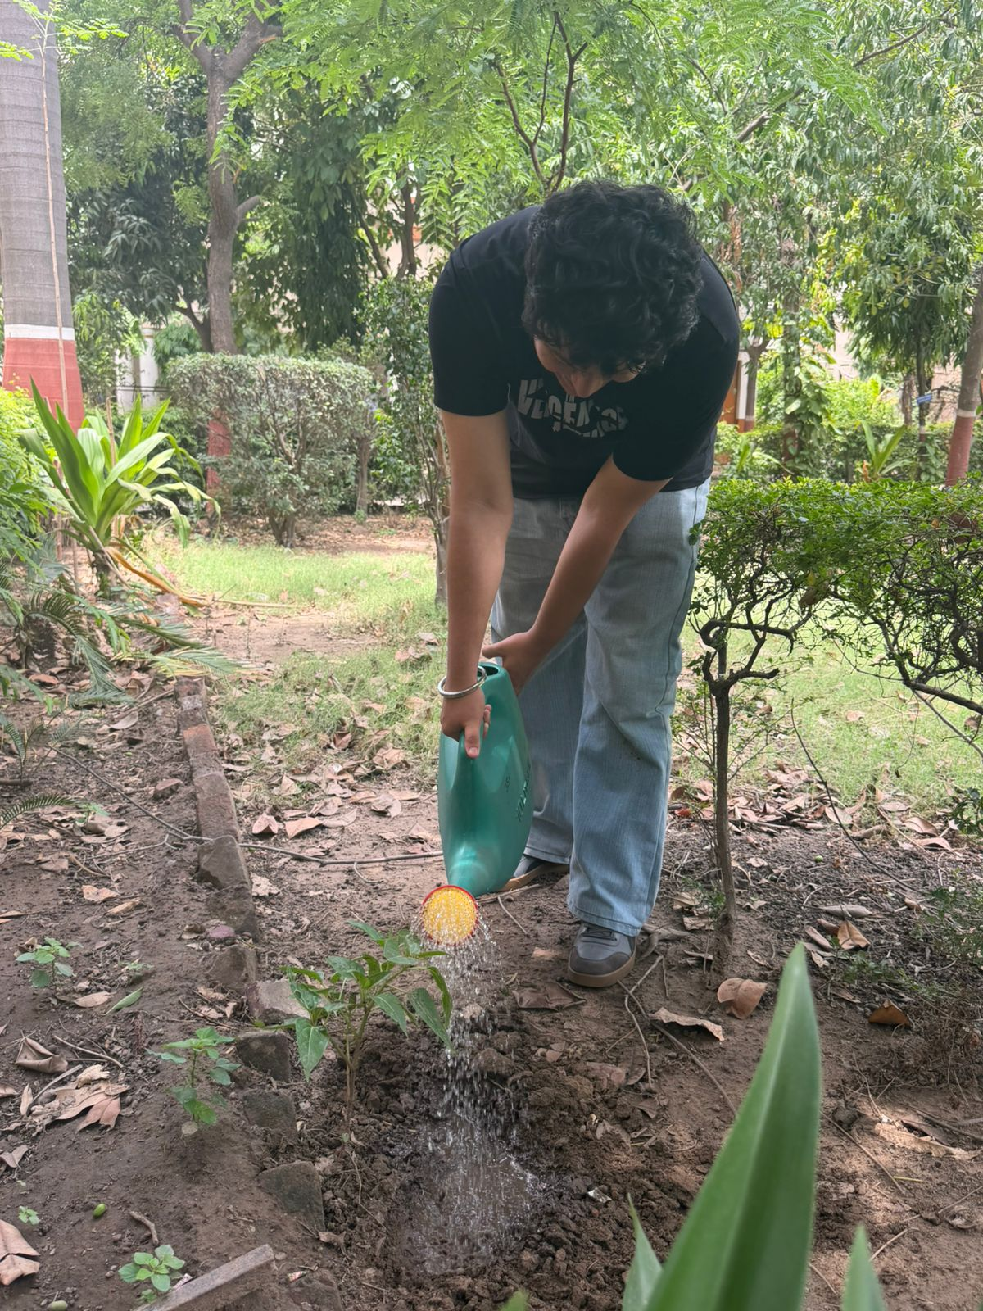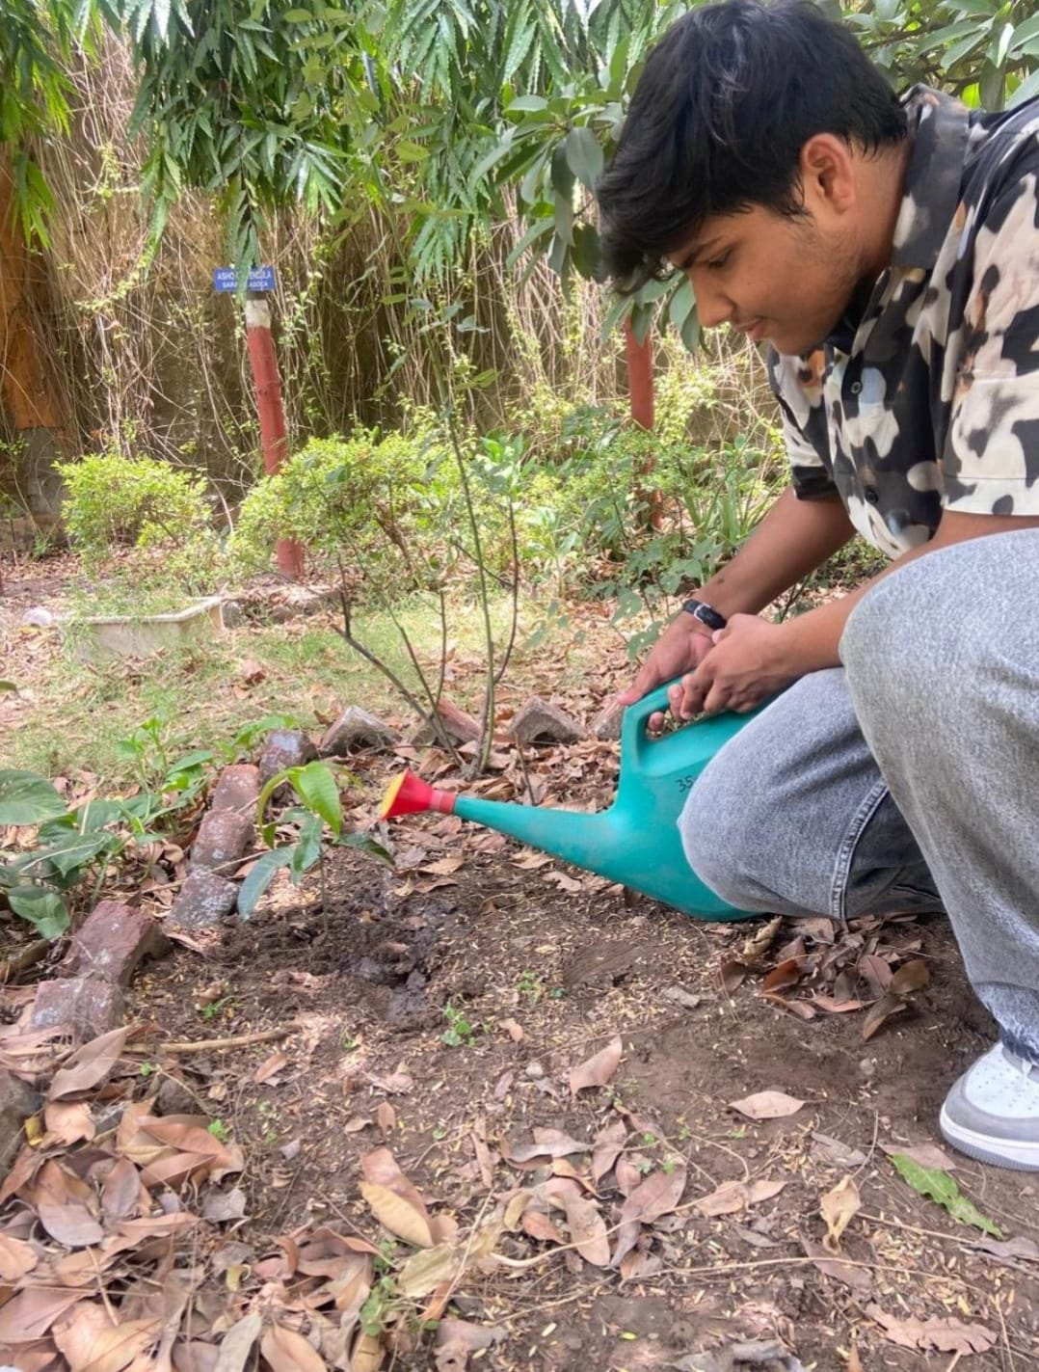
Public Space Clean-up & Beautification Drive | Identified a public space requiring attention, gathered cleaning supplies and eco-friendly materials, recruited student volunteers, cleaned the designated area by removing trash and debris, beautified the space with plants and decorative elements, educated participants on maintaining clean public spaces, and documented the transformation with before-and-after photographs.  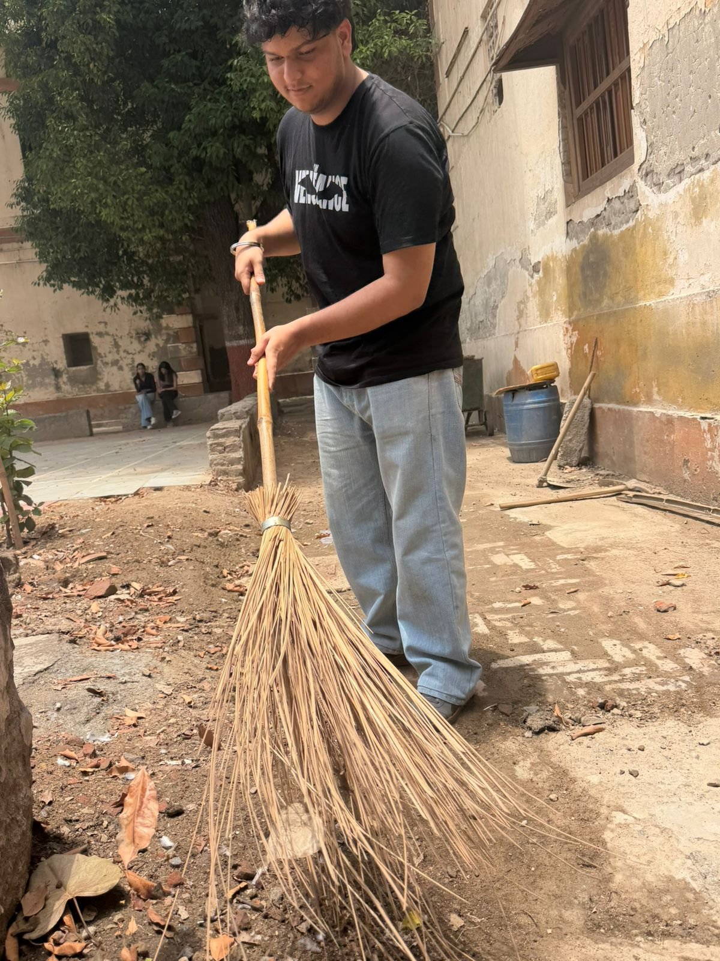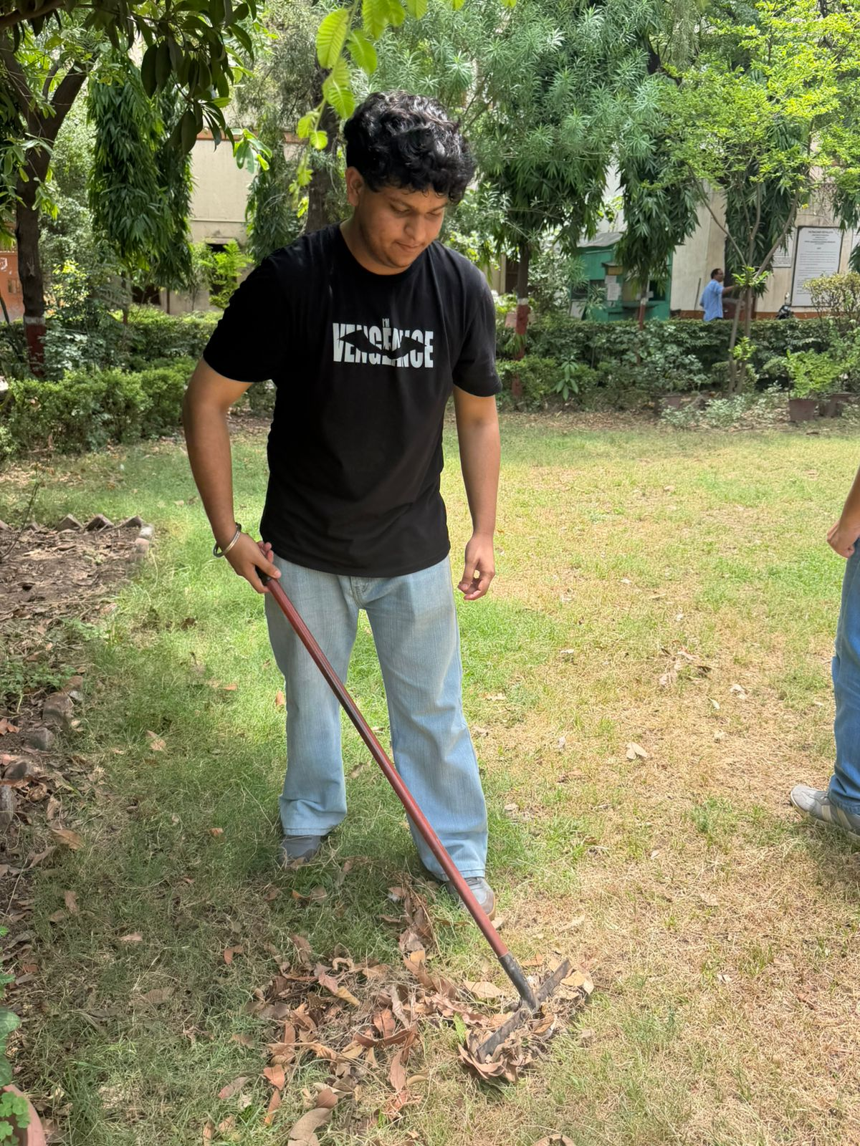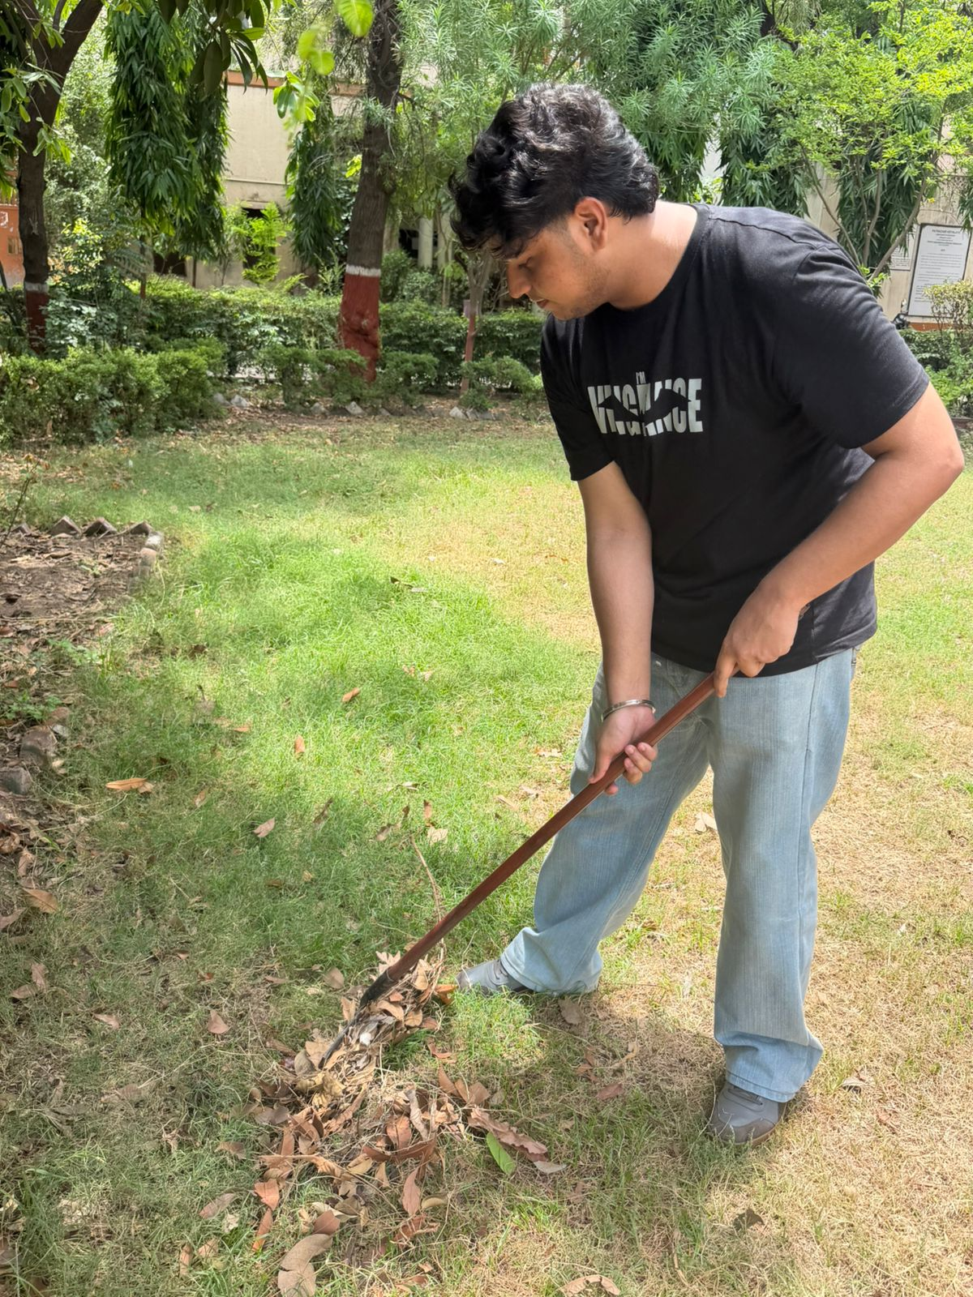
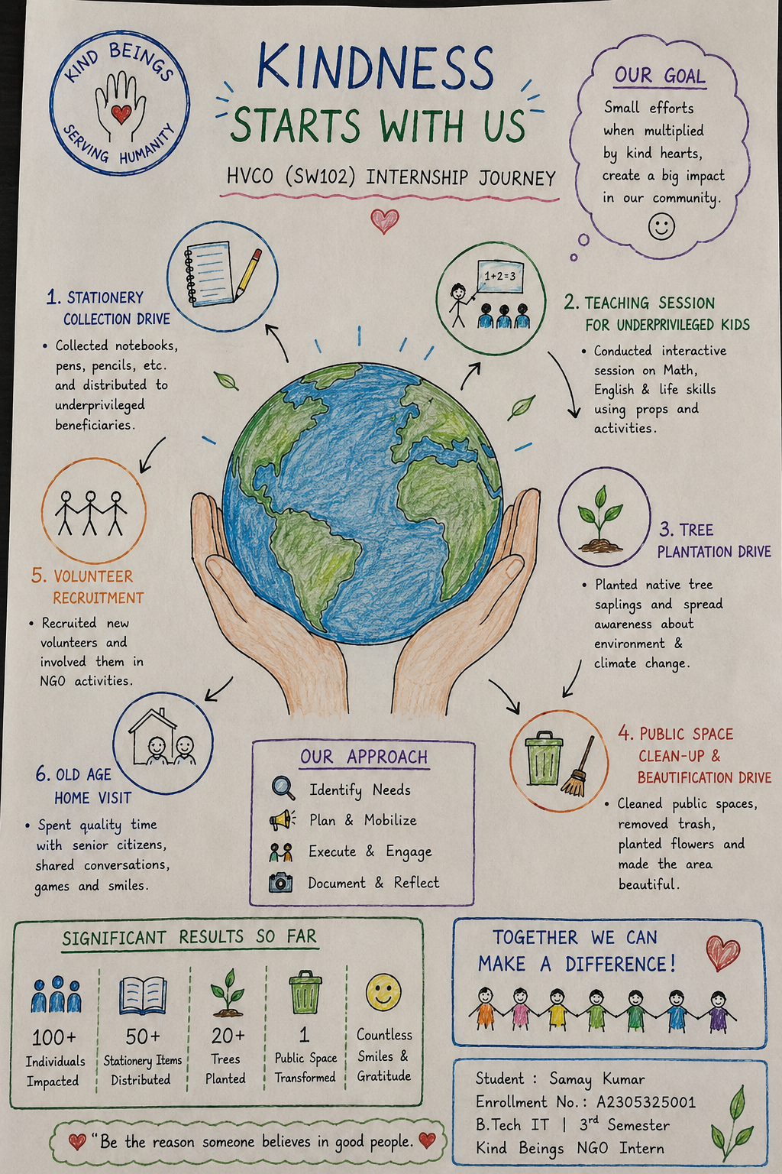


Student Signature  Samay Kumar  Enrollment No.: A2305325001  Date: 15th June 2026 | Faculty Coordinator Signature  Name: Prof. Vivek Jangra  Date: _______________________  Remarks: ____________________

