HUMAN VALUES AND COMMUNITY OUTREACH
(HVCO) REPORT

VOLUNTEER WORK WITH KIND BEINGS NGO
SUBMITTED BY
Samay Kumar – A2305325001
IN PARTIAL FULFILMENT OF REQUIREMENTS FOR THE AWARD OF
THE DEGREE OF
BACHELOR OF TECHNOLOGY
(INFORMATION TECHNOLOGY)

UNDER THE GUIDANCE OF
DR VIVEK JANGRA
(Associate Professor, Staff Code – 307882)

DEPARTMENT OF INFORMATION TECHNOLOGY
AMITY SCHOOL OF ENGINEERING AND TECHNOLOGY (ASET), NOIDA
AMITY UNIVERSITY UTTAR PRADESH (AUUP)
JULY 2026

Acknowledgements

The satisfaction and pleasure that accompany the successful completion of this internship would be incomplete without acknowledging the people whose guidance and cooperation made it possible. I would like to thank my faculty guide, Dr Vivek Jangra, Associate Professor, Department of Information Technology, Amity School of Engineering and Technology (ASET), Amity University Uttar Pradesh, Noida, for his continuous guidance and encouragement throughout this Human Values and Community Outreach (HVCO) internship.
I would also like to sincerely thank Ms Sanya Bajaj, Regional Manager, and the entire team at Kind Beings NGO for welcoming me into their volunteer community, for their patient guidance during every task, and for the opportunity to contribute meaningfully to their mission of "giving meaning to lives." Without their support, coordination, and encouragement, the completion of this internship would not have been possible.
I am also grateful to everyone at Kind Beings, the children, elderly residents, and community members, who welcomed me with warmth during every activity, and to all those who indirectly supported the successful completion of this internship.
Samay Kumar

Table of Contents

1. Introduction 4
2. Objectives 4
3. Rationale of the Study 4
4. Area of Study 4
5. Methodology of Study 4
6. About Kind Beings NGO 4
6.1 Main Goals of Kind Beings 4
6.2 Mission and Vision 5
6.3 Values Followed by the NGO 5
6.4 Activities/Initiatives Undertaken 5
7. Volunteer Work Undertaken at the NGO 7
7.1 Challenges Faced and Solutions Adopted 7
7.2 Observations 8
8. Work Done for the NGO 9
9. Results, Observation and Analysis 12
10. Creativity/Innovation in Area of Study 13
11. Log Sheet 14
12. Appointment Letter from NGO 15
13. Weekly Progress Reports 16
14. Certificate of Completion 26
15. Conclusion 27
16. References and Bibliography 27

1. Introduction

Non-Governmental Organizations (NGOs) play a vital role in modern society. Formed by groups of individuals who come together to address specific social issues, NGOs often operate independently of government and corporate interests, focusing instead on providing direct aid and support to communities in need. Their work spans humanitarian aid, education, healthcare, environmental protection, and advocacy - all aimed at bringing about positive, on-ground change.
As part of the Human Values and Community Outreach (HVCO – SW102) course requirement, this internship was undertaken with Kind Beings NGO, a Delhi-based, government-registered organization founded in November 2018. Kind Beings works across education, women empowerment, hunger relief, animal welfare, and environmental care, with the core belief that consistent, small acts of kindness can create lasting social change.
This report documents the internship undertaken with Kind Beings between June 3, 2026, and June 29, 2026, under the guidance of Agency Representative Mr. Vineet Goel and Regional Manager Ms. Sanya Bajaj, and Faculty Guide Dr Vivek Jangra of ASET, Noida. Over the course of the internship, twelve structured tasks were completed spanning digital outreach, direct community engagement, education, elderly care, environmental action, and animal welfare - providing hands-on exposure to grassroots social work and community outreach practices.

2. Objectives

The internship was designed around the following objectives, as outlined by Kind Beings NGO and the HVCO course structure:
- To actively contribute to Kind Beings' mission of creating sustainable social impact through education, empowerment, compassion, and action.
- To gain first-hand experience in program planning, community engagement, resource mobilization, and stakeholder communication.
- To develop practical skills in organizing and executing offline community drives - planning, promotion, and execution.
- To build awareness and advocacy skills by expanding the NGO's social media presence and volunteer base.
- To cultivate empathy, responsibility, and teamwork through direct interaction with underprivileged children, the elderly, and animals in need.
- To reflect critically on personal growth, challenges faced, and lessons learned over the internship.

3. Rationale of the Study

Volunteering with an NGO offers a structured way to contribute to society while developing life and professional skills. Classroom learning on human values and social responsibility gains depth only when tested against real community needs. This internship bridged that gap, translating theoretical understanding of empathy and social responsibility into tangible, on-ground action. Kind Beings' task-based model was well suited to this, requiring engagement across a diverse spectrum of issues - education, elderly care, environmental sustainability, and animal welfare - rather than one narrow activity, giving a well-rounded understanding of grassroots social work.

4. Area of Study

Carried out primarily within Delhi NCR, aligned with Kind Beings' core initiatives:
- Education & Youth Development (Edushala) - teaching and stationery support at a local orphanage.
- Elderly Care & Companionship - engagement at an old age home.
- Environmental Sustainability (World's Makeover) - tree plantation and clean-up drives.
- Animal Welfare (Be Kind to Animals) - stray animal feeding drive.
- Public Health & Safety Awareness - road safety and waste-reduction campaigns.
- Organizational Growth - social media outreach and volunteer recruitment for Kind Beings.

5. Methodology of Study

An action-based, task-oriented methodology was followed for each of the twelve tasks:
- Planning - understanding guidelines, identifying a venue/partner, and securing mentor approval where required.
- Coordination - collaborating with peers, host institutions, and college administration for logistics/permissions.
- Execution - carrying out the activity directly, mostly in groups.
- Documentation - recording via photographs, videos, and a structured log sheet (date, task, description, location, participants).
- Reporting & Reflection - submitting evidence to the Agency Supervisor (Sanya Bajaj) for validation, concluding with a reflection video.

6. About Kind Beings NGO

Kind Beings is a government-registered non-governmental organization founded in November 2018 and headquartered at D-1/234, 235 New Kondali, Mayur Vihar Phase – 3, New Delhi. It is a collective of young professionals driven by the shared purpose of creating meaningful social impact through consistent acts of kindness. What began as a small volunteer initiative with 10+ volunteers in a single state has, over the years, grown into a fast-rising grassroots organization active across nine states, having supported over 6,000 beneficiaries with the help of more than 2,000 young volunteers.
Kind Beings has partnered with reputed institutions such as HCL, Dell, Young Indians, NDIM, FIENA, Those in Need, and World Animal Protection to deliver measurable, on-ground impact across its key focus areas.

6.1 Main Goals of Kind Beings
- Community-Driven Social Impact: To address real-world community needs through consistent, action-oriented programs rather than one-off gestures.
- Youth Empowerment and Volunteering: To build a strong, youth-led community of volunteers driving measurable social impact across the country.
- Multi-Sector Welfare: To improve lives across education, women's empowerment, hunger relief, animal welfare, and environmental care.
- Skill and Character Development: To provide volunteers with vocational, mentorship, and leadership opportunities alongside their community service.

6.2 Mission and Vision
Mission:
To create sustainable social impact by addressing real community needs through education, empowerment, compassion, and action - enabling individuals and communities to live with dignity through opportunity, self-belief, and a culture of kindness built on consistent grassroots effort.
Vision:
To build an inclusive and compassionate society where every individual has access to basic necessities, equal opportunities, and the freedom to grow without barriers - a future where kindness is a way of life rather than an occasional gesture.

6.3 Values Followed by the NGO
- Empathy with Responsibility - understanding problems and acting on them.
- Action over Intent - driving real change through consistent effort rather than good intentions alone.
- Collaboration - building partnerships that multiply impact.
- Integrity and Transparency - maintaining trust as the foundation of all work undertaken.

6.4 Activities/Initiatives Undertaken
Edushala (Education):
Kind Beings' flagship education initiative, supporting underprivileged children through regular teaching sessions, academic mentorship, and access to basic learning resources in a safe, encouraging environment.
Strong SHE (Women Empowerment):
Focused on building confidence, awareness, and self-belief among girls and women from underserved communities through interactive sessions on education, health, rights, and personal growth.
World's Makeover (Environment & Cleanliness):
An environmental initiative promoting responsible living and hygiene awareness through cleanliness drives and community-owned public space maintenance.
Be Kind to Animals (Animal Welfare):
Dedicated to the protection and care of stray and abandoned animals through feeding drives, awareness sessions, and community engagement around humane treatment.
Annapurna (Hunger Relief):
A food security initiative that organizes regular meal-distribution drives for underserved communities, ensuring no one is deprived of dignity due to hunger.

7. Volunteer Work Undertaken at the NGO

Before any tasks were assigned, an orientation was undertaken with the Kind Beings team, including an introduction to the organization's values, expectations from volunteers, and the registration process, followed by direct communication with the Regional Manager, Ms. Sanya Bajaj, and Representative, Mr. Vineet Goel, who acted as points of contact throughout the internship.
Twelve structured tasks were assigned in total, ranging from digital outreach (growing Kind Beings' social media presence and referring new volunteers) to on-ground community engagement - including an orphanage visit, a stationery collection drive, an old age home visit, a teaching session for underprivileged children, a tree plantation drive, a waste-reduction awareness session, a road safety campaign, a stray animal feeding drive, and a community clean-up and beautification drive. The internship concluded with a personal reflection video summarizing the overall experience.
Each task required independent planning - identifying a suitable venue or partner institution, securing any necessary approvals, coordinating logistics, executing the activity (often in a small peer group), and documenting the outcome through photographs and a structured log sheet submitted to the Agency Supervisor for validation.

7.1 Challenges Faced and Solutions Adopted
Limited Institutional Access:
Securing timely approval to conduct on-campus activities, such as the stationery collection drive, presented significant bureaucratic hurdles. Navigating the administrative layers required managing multiple levels of permissions and addressing concerns regarding campus logistics. This challenge was overcome through persistent follow-ups and proactive planning; by approaching the college administration well ahead of the intended dates with a clearly outlined purpose and detailed logistics plan, I was able to demonstrate the initiative's value and secure the necessary support efficiently.
Engaging a Public Audience:
Unlike visits to institutions like orphanages where an audience was already present, the road safety campaign required engaging strangers in a bustling market setting. There was a notable psychological barrier to engagement, as passers-by were often preoccupied or hesitant to stop. To overcome this, I adopted a friendly, non-intrusive demeanor and utilized visually engaging handouts. This approachable style, combined with clear, accessible messaging, helped lower participants' hesitation and facilitated meaningful interactions with pedestrians and commuters.
Sustaining Children's Attention:
During the teaching and waste-reduction sessions, maintaining the focus of a mixed-age group of children proved difficult using traditional, lecture-based instruction. To address this, I shifted toward experiential learning methods, incorporating storytelling, interactive games, and visual charts. These techniques were far more effective for diverse age groups, as they transformed abstract concepts into tangible experiences, keeping the children actively involved and significantly improving their retention of the session's core messages.
Converting Interest into Registered Volunteers:
Volunteer recruitment required bridging the gap between passive digital interest and active commitment. Converting casual social media followers into registered volunteers necessitated personalized outreach and one-on-one conversations. These direct interactions were essential to address skepticism regarding the registration process and to clearly communicate the personal and social value of the volunteer experience. By providing individualized guidance and sharing the impact of Kind Beings' work, I was able to transform casual interest into tangible participation.
Limited Institutional Access:
Securing timely approval to conduct activities such as the stationery drive required coordinating with college administration in advance.
Resolution: Approached the administration well ahead of the planned date and clearly outlined the drive's purpose and logistics, which helped secure quick approval.
Engaging a Public Audience:
Unlike orphanage or old-age-home visits - where an audience was already gathered - the road safety awareness campaign required actively engaging strangers (pedestrians, commuters, and auto-rickshaw drivers) at a busy market intersection.
Resolution: Used simple, visual handouts and a friendly, direct approach to make passers-by comfortable enough to stop and engage with the campaign.
Sustaining Children's Attention:
During the teaching session and waste-reduction awareness activity, maintaining the attention of a mixed-age group of children proved challenging with a purely lecture-based approach.
Resolution: Shifted to interactive formats - storytelling, visual charts, and posters - which noticeably improved engagement and retention.
Converting Interest into Registered Volunteers:
Volunteer recruitment required more than casual interest - it involved guiding a prospective volunteer through the complete registration and payment process.
Resolution: Maintained direct follow-up over WhatsApp with the referred contact until the registration and payment steps were fully completed.

7.2 Observations
Activities conducted within an established institutional setting - such as the local orphanage - consistently saw the highest and most reliable participation, reflecting the trust Kind Beings has built with such partner institutions over time. Public-facing awareness campaigns required noticeably more proactive effort to engage participants but offered broader reach beyond the volunteer's immediate network. Smaller, one-on-one interactions - such as the old age home visit with just eight residents - proved to be some of the most personally rewarding activities, reinforcing that meaningful impact is not always proportional to the number of people reached.

8. Work Done for the NGO (Task-wise)
Each of the twelve tasks assigned by Kind Beings was approached as a distinct planning-to-documentation cycle. The account below sets out what each task required, how it was carried out, and what it achieved, supported by photographic evidence collected in the field.
Task 1 - Social Media Presence Expansion Objective: Grow Kind Beings' following across Instagram, Facebook, and LinkedIn (targets of 25 Instagram followers, 20 Facebook likes, and 30 LinkedIn followers) by mobilising personal networks. Execution: Rather than a single generic post, outreach was tailored to individual contacts - sharing Edushala-related content with friends interested in education, and animal welfare posts with those more inclined toward that cause. Friends and family were personally encouraged to follow, like, and share the organization's pages. Outcome: Delivered 25+ new Instagram followers, directly contributing to Kind Beings' digital reach and visibility.
Task 2 - Offline Activity: Orphanage Visit Objective: Organize and execute an offline community drive benefitting a chosen cause, from the list of Kind Beings' suggested activities. Execution: A group visit was planned and approved by the Internship Mentor, then carried out at a local orphanage. Educational charts (fruits, vegetables, general knowledge) and storybooks were distributed, and time was spent directly interacting with the children to spread positivity beyond material distribution alone. Outcome: Reached over 15 children, combining resource distribution with genuine social engagement.
Task 3 - Volunteer Recruitment Objective: Bring 1–2 new volunteers into the Kind Beings community through personal outreach. Execution: Ms. Harshika was identified and referred, then personally guided through Kind Beings' full onboarding process - the WhatsApp introduction, submission of personal and academic details, and payment of the ₹200 lifetime registration fee - with consistent follow-up to ensure the process was completed rather than left half-finished. Outcome: One volunteer successfully registered, expanding Kind Beings' active volunteer base.
Task 4 - Stationery Collection Drive Objective: Plan and run a stationery collection drive in coordination with an educational institution, culminating in distribution to beneficiaries. Execution: College administration was approached in advance to secure the necessary approvals, following which collection points were set up to gather notebooks, pens, pencils, and other supplies. The drive was carried through to completion by personally distributing the collected material to orphanage beneficiaries, rather than treating collection as the end goal. Outcome: Supplies distributed to 20+ children, closing the loop between collection and impact.
Task 5 - Old Age Home Visit Objective: Bring companionship, conversation, and light engagement to residents of a local old age home. Execution: A visit was coordinated and scheduled with the old age home's management. Time was spent listening to residents' stories and engaging them in conversation, and a game of carrom was introduced as an active, familiar way for residents to participate rather than remain passive recipients of a visit. Outcome: Meaningful, one-on-one engagement with 8 residents - a smaller but notably deep interaction relative to other tasks.
Task 6 - Teaching Session for Underprivileged Kids Objective: Design and deliver an interactive learning session for underprivileged children at a partner institution. Execution: A session covering basic literacy and life skills was planned around the children's existing curriculum and delivered using storytelling, visual charts, and simple hands-on activities rather than a purely lecture-based format, in order to sustain attention across a mixed-age group. Outcome: Engaged 25+ children in an interactive, enjoyable learning environment.
Task 7 - Tree Plantation Drive Objective: Organize a plantation drive that combines environmental action with awareness-building among participants. Execution: A community park was identified as the plantation site, and native saplings suited to the local soil and climate were sourced and planted with a group of volunteers. Planting was paired with brief, informal explanations of why each species was chosen and its role in the local ecosystem, turning the activity into an environmental science lesson as much as a physical task. Outcome: 10+ participants engaged, with saplings planted and watered at the site.
Task 8 - Waste Reduction & Creative Reuse Awareness Objective: Raise awareness on reducing waste and encouraging creative reuse of materials among a young audience. Execution: Simple, colour-coded Reduce–Reuse–Recycle posters were prepared specifically to be intuitive for children, and used as the centrepiece of an interactive awareness session held at a local orphanage. Outcome: Engaged 10–20 children in discussion around sustainable waste practices.
Task 9 - Road Safety Awareness Campaign Objective: Educate the community on road safety measures and traffic rules through a public awareness campaign. Execution: A booth was set up at a busy local market intersection, and visually-led, minimal-text handouts (accessible to varying literacy levels) were distributed. Outreach was deliberately extended beyond students and pedestrians to include auto-rickshaw drivers and other commuters, broadening the campaign's practical reach. Outcome: Engaged approximately 25 members of the public directly on road safety practices.
Task 10 - Stray Animal Feeding Drive Objective: Feed stray animals in the neighbourhood while monitoring their general condition. Execution: A 7-volunteer group effort was organized to feed stray animals using dry food and water at designated safe spots. Beyond feeding, each animal's visible condition was quietly observed before and after, adding a basic welfare-monitoring dimension to the activity. Outcome: Multiple animals fed and observed; awareness of the drive shared on social media.
Task 11 - Clean-up & Beautification Drive Objective: Improve and beautify a chosen public space through a community-driven clean-up. Execution: A cleanliness drive was conducted at a community park, clearing leaves and debris. Rather than treating children as spectators, they were actively involved in the clean-up process itself, turning the activity into an informal lesson in civic responsibility alongside its physical outcome. Outcome: Park cleared and beautified, with 25+ children engaged in the process.
Task 12 - Reflection Video Submission Objective: Reflect on the full internship journey and share key learnings, challenges, and impact. Execution: A short reflection video was recorded following a structured narrative arc - introduction, challenges faced, personal growth, and advice for future interns - rather than an unstructured recap, making the final submission a more useful reference for those who follow. Outcome: Internship concluded on June 29, 2026, with a complete personal account of the experience submitted to the mentor.

9. Results, Observation and Analysis
Quantitatively, the internship touched over 150 beneficiaries and participants across twelve tasks - children, elderly residents, animals, and the public - plus 25+ new social media followers and one newly registered volunteer.
Key observations:
- Activities at the local orphanage (Tasks 2, 4, 6, 8) drew the highest participation, reflecting strong existing trust between Kind Beings and the institution.
- Interactive formats (storytelling, DIY posters, games) sustained children's engagement far better than lecture-style delivery.
- Public-facing campaigns (road safety, waste reduction) needed more proactive effort to engage strangers than institution-based activities.
- The old age home visit, despite only 8 residents, yielded the deepest one-on-one engagement - impact isn't always proportional to headcount.
- Volunteer recruitment was the most effort-intensive task relative to its single-volunteer outcome, reflecting the trust-building required.
- Feedback from beneficiaries (orphanage children, elderly residents) was consistently positive: they valued that sessions combined learning with fun, and felt genuinely heard.
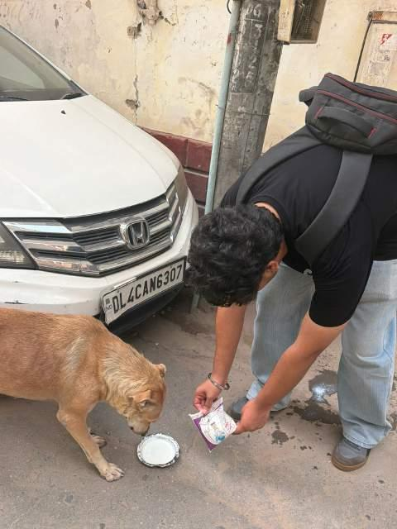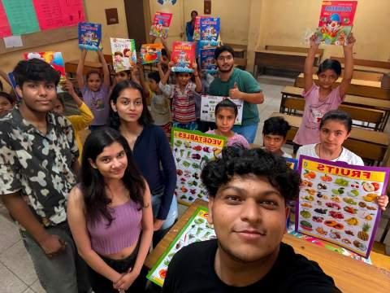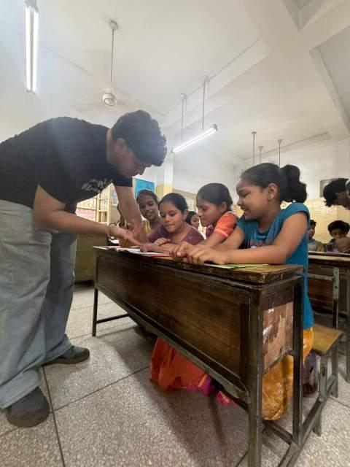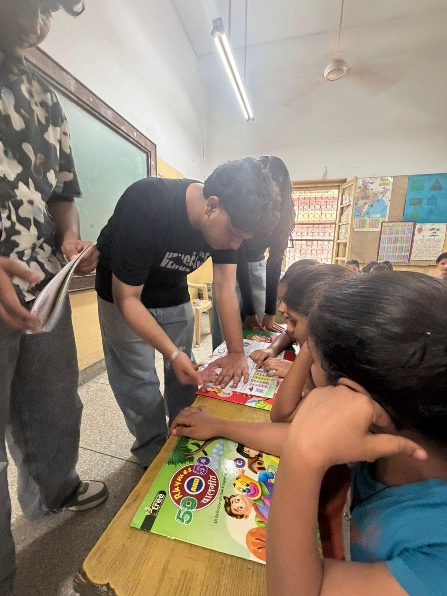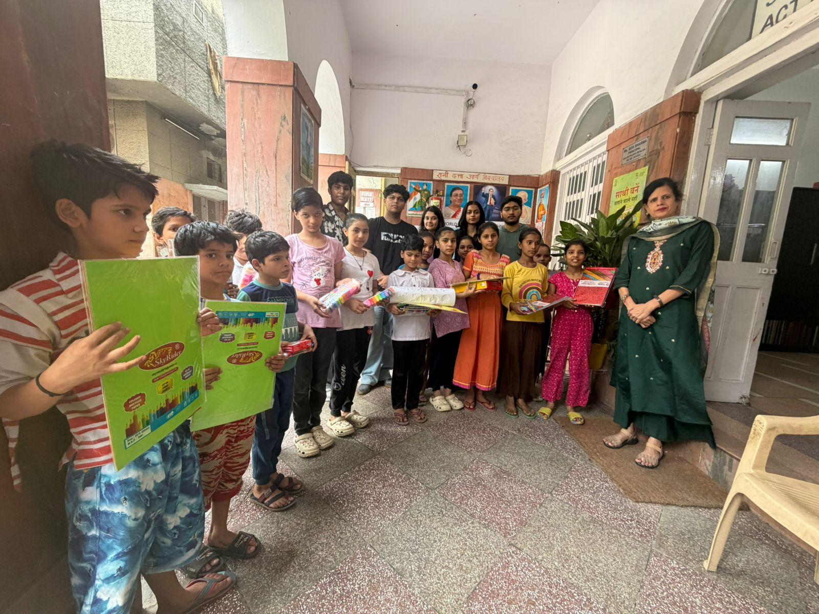
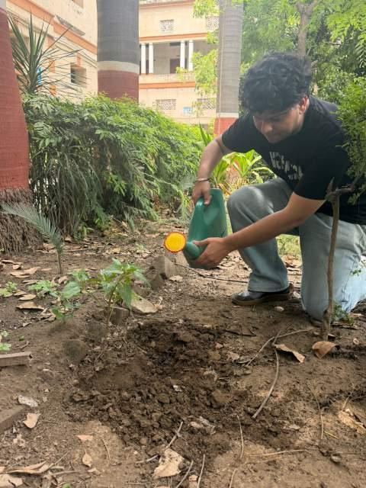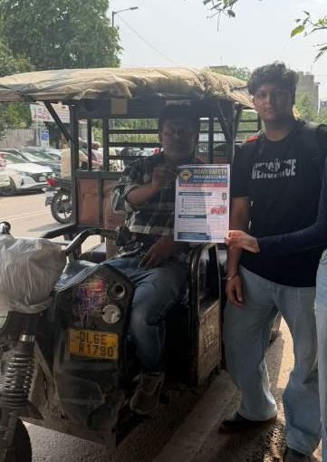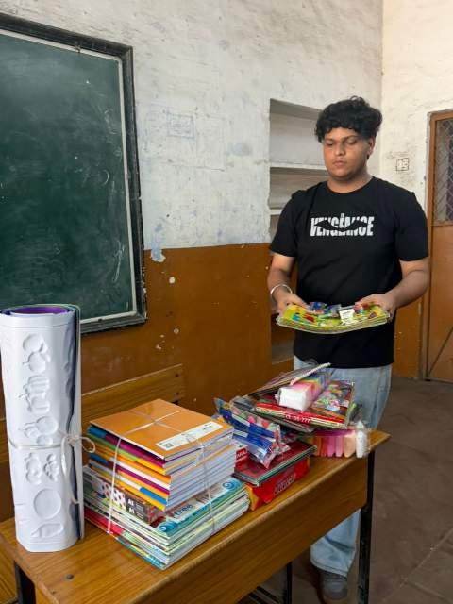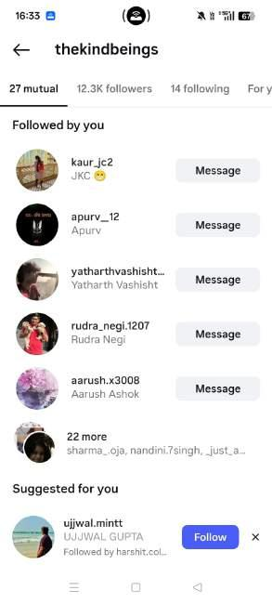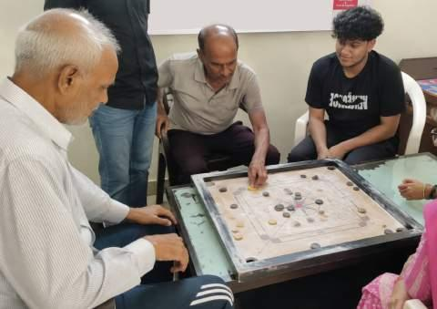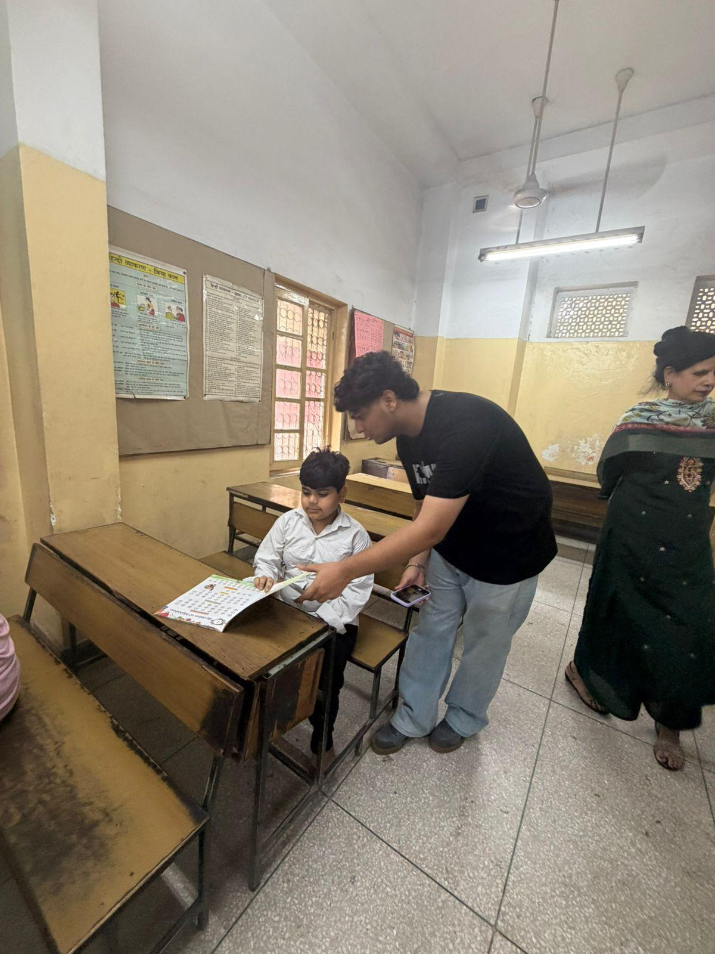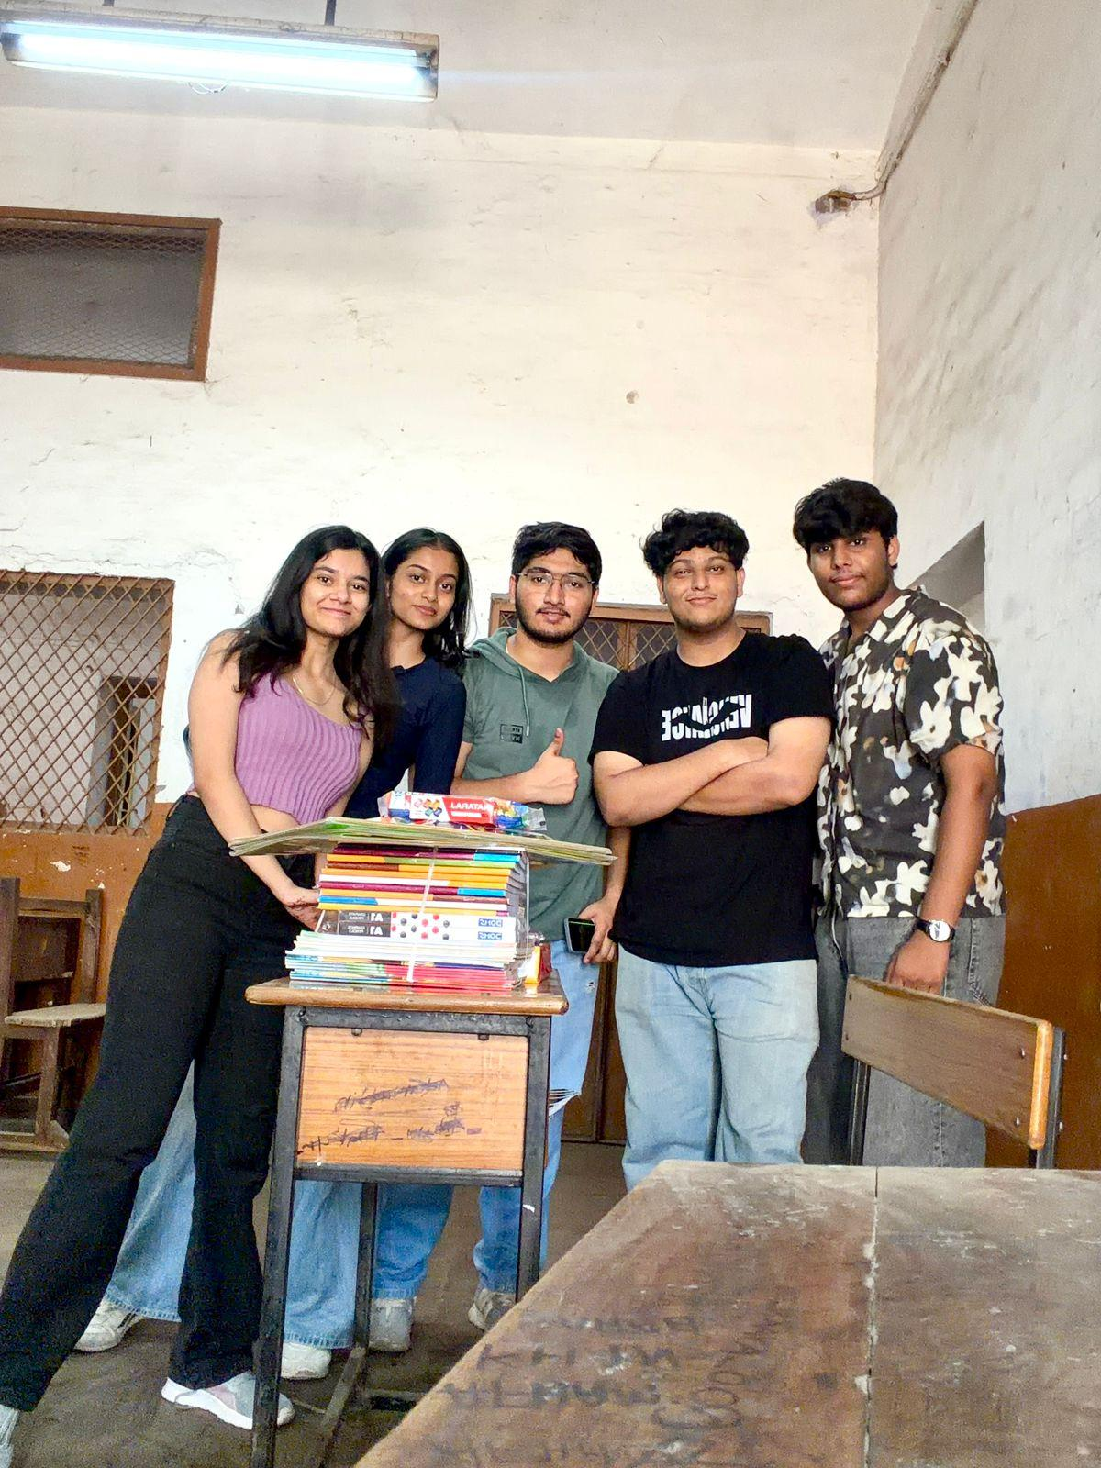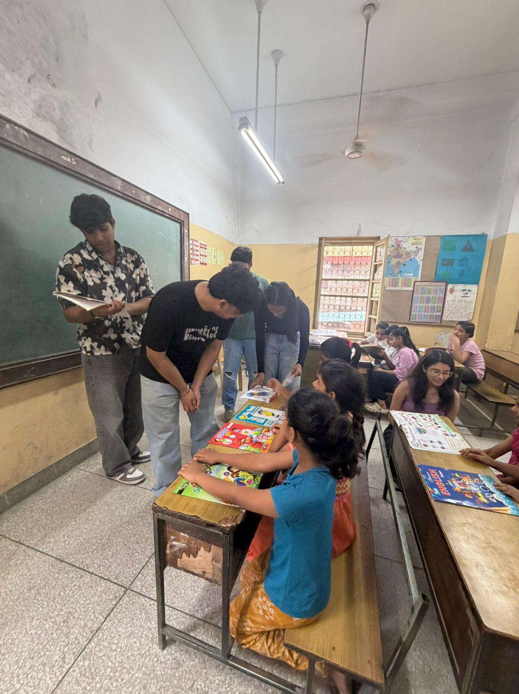

10. Creativity/Innovation in Area of Study
- In Task 6, literacy sessions were transformed into engaging experiences for children by integrating storytelling with colorful visual aids covering fruits, vegetables, and general knowledge.
- Task 8 featured the development of intuitive, color-coded posters for the "Reduce–Reuse–Recycle" initiative, specifically designed to resonate with a younger demographic.
- The scope of the road safety campaign in Task 9 was broadened by engaging auto-rickshaw drivers and market commuters alongside students at high-traffic intersections.
- Operational efficiency was achieved in Task 4 by integrating stationery procurement and final beneficiary distribution into a single, cohesive project cycle.
- A collaborative, group-centric approach was maintained during orphanage visits, plantation drives, and cleanliness campaigns to optimize logistical execution and foster teamwork.
- Social media outreach in Task 1 utilized highly personalized messaging that aligned Kind Beings' specific programs, such as Edushala, with the personal interests of individual contacts.
- To preserve the dignity of old age home residents in Task 5, interactive games like carrom were introduced, replacing passive visits with active companionship and shared activity.
- The Task 7 plantation drive was enhanced by providing participants with scientific insights into native sapling selection and their specific role in the local ecosystem.
- In Task 10, the animal feeding initiative was layered with a basic welfare-monitoring component, where volunteers quietly assessed the visible health of each animal.
- Task 11's cleanliness drive empowered children to become active participants in community service, utilizing the cleanup as a practical lesson in civic mindfulness.
- Visual-first design principles were applied to all public-facing materials in Tasks 1 and 9, ensuring that messaging remained accessible across diverse literacy levels.
- The final reflection in Task 12 was organized around a structured narrative framework—covering hurdles and personal evolution—to provide a meaningful resource for future volunteers.

11. Log Sheet
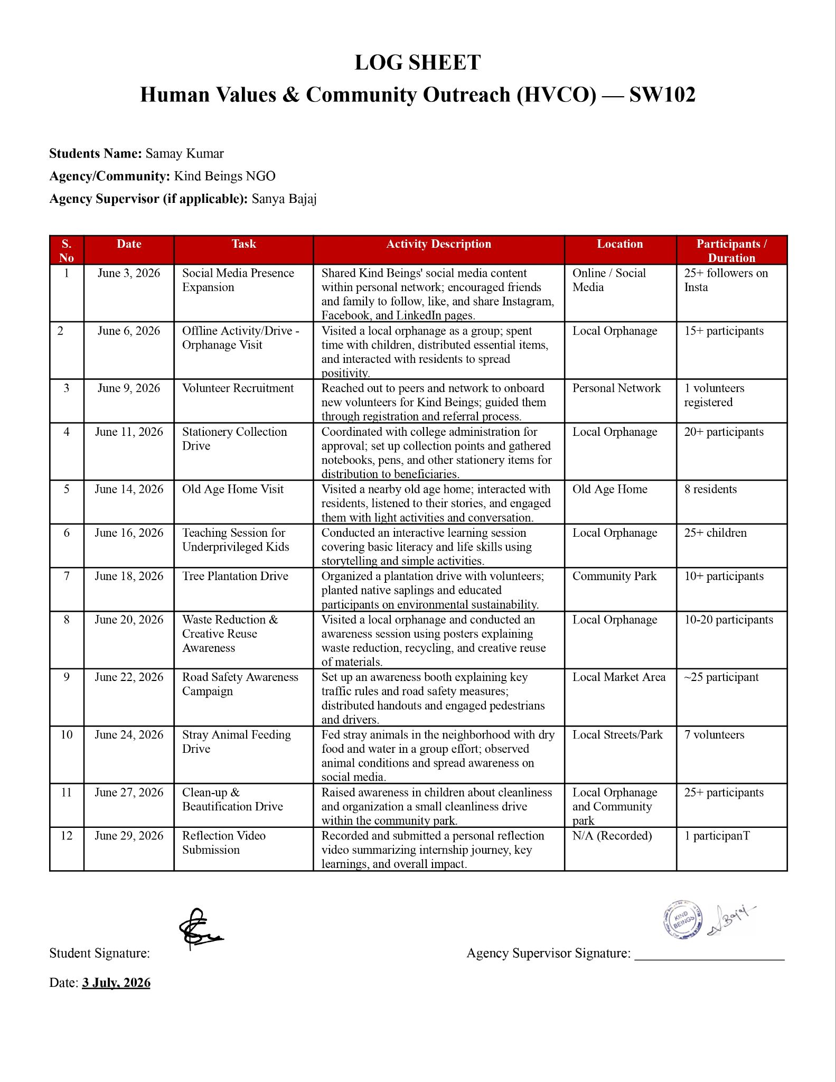

12. APPOINTMENT LETTER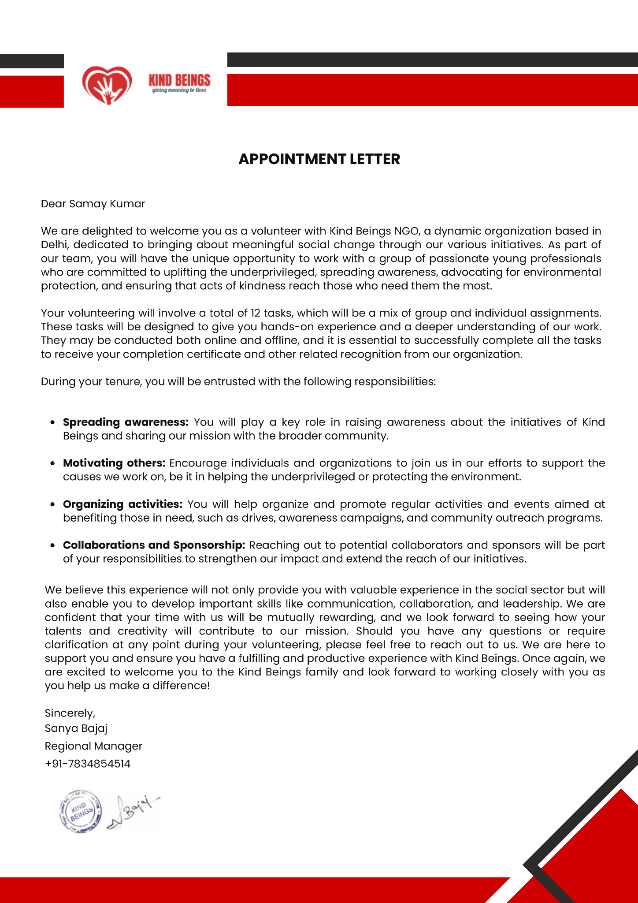

13. WEEKLY PROGRESS REPORTS
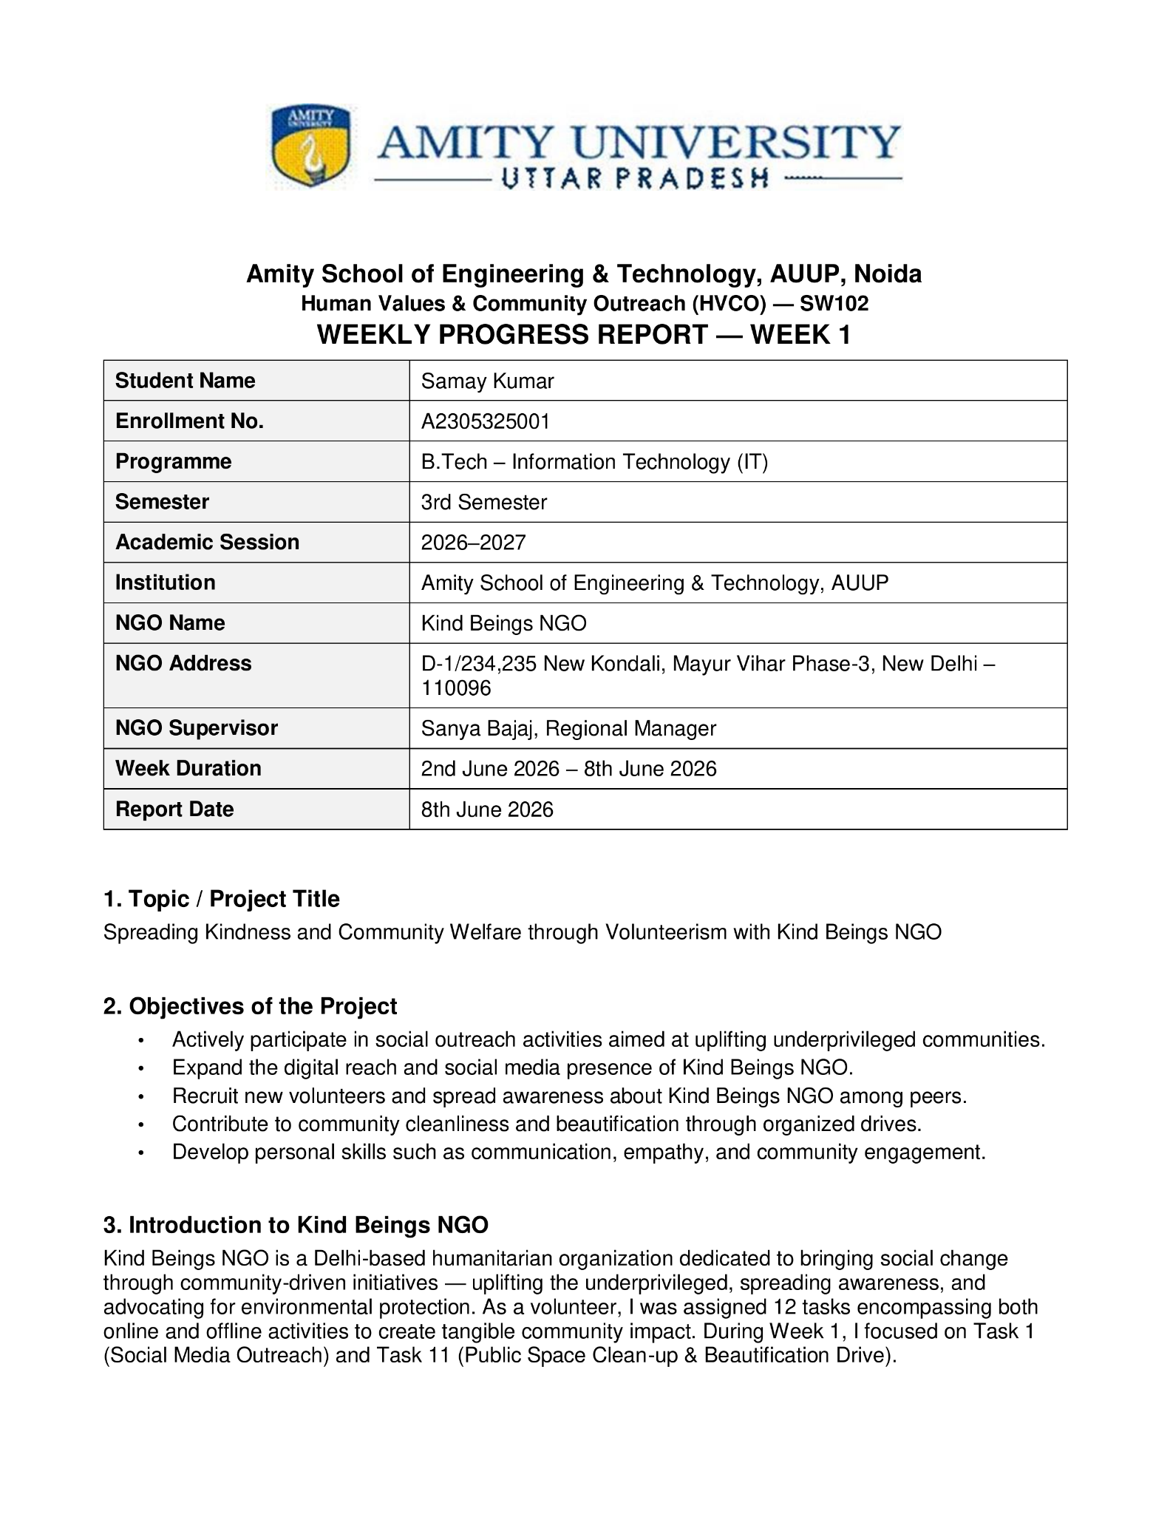
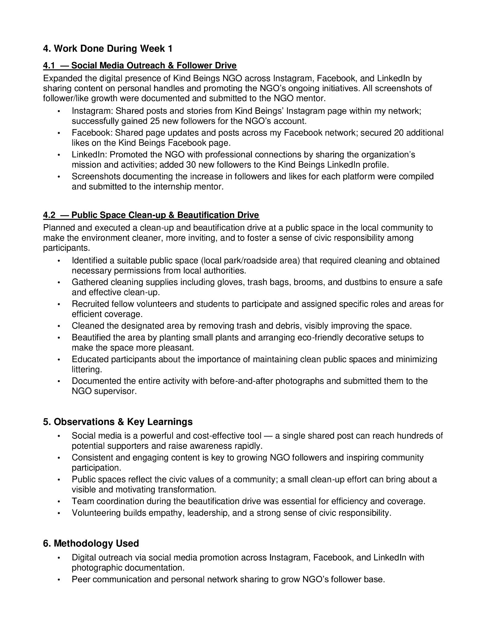
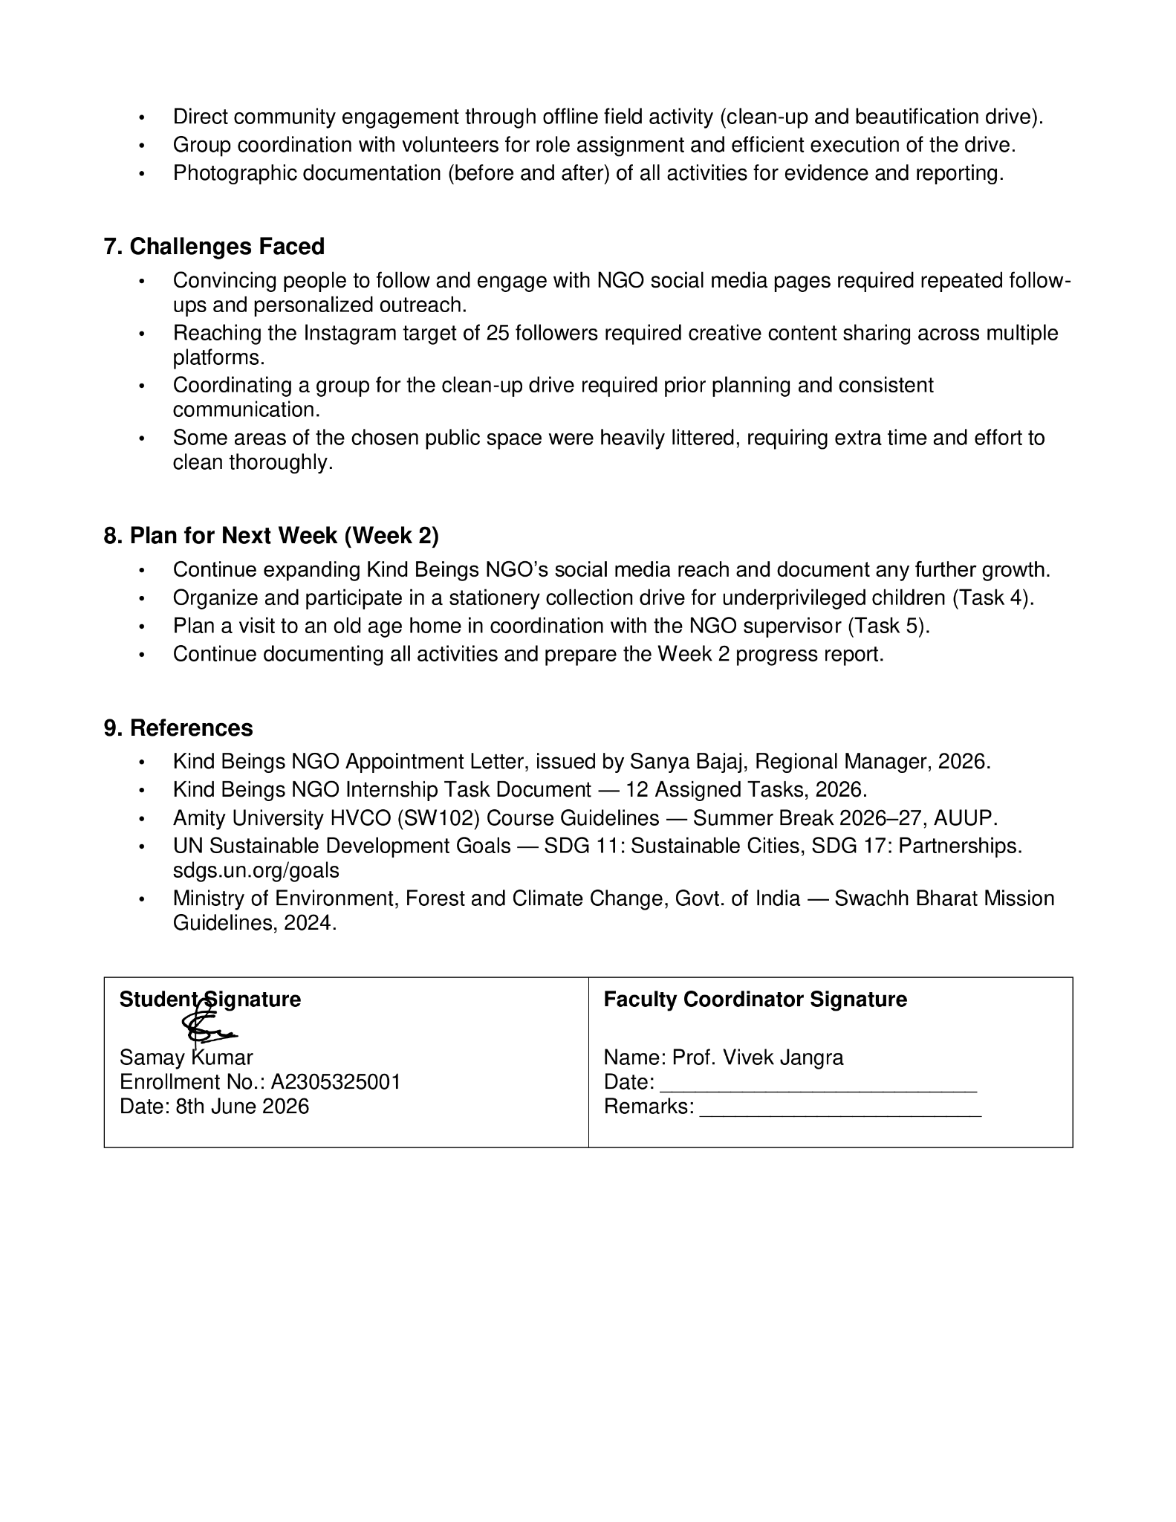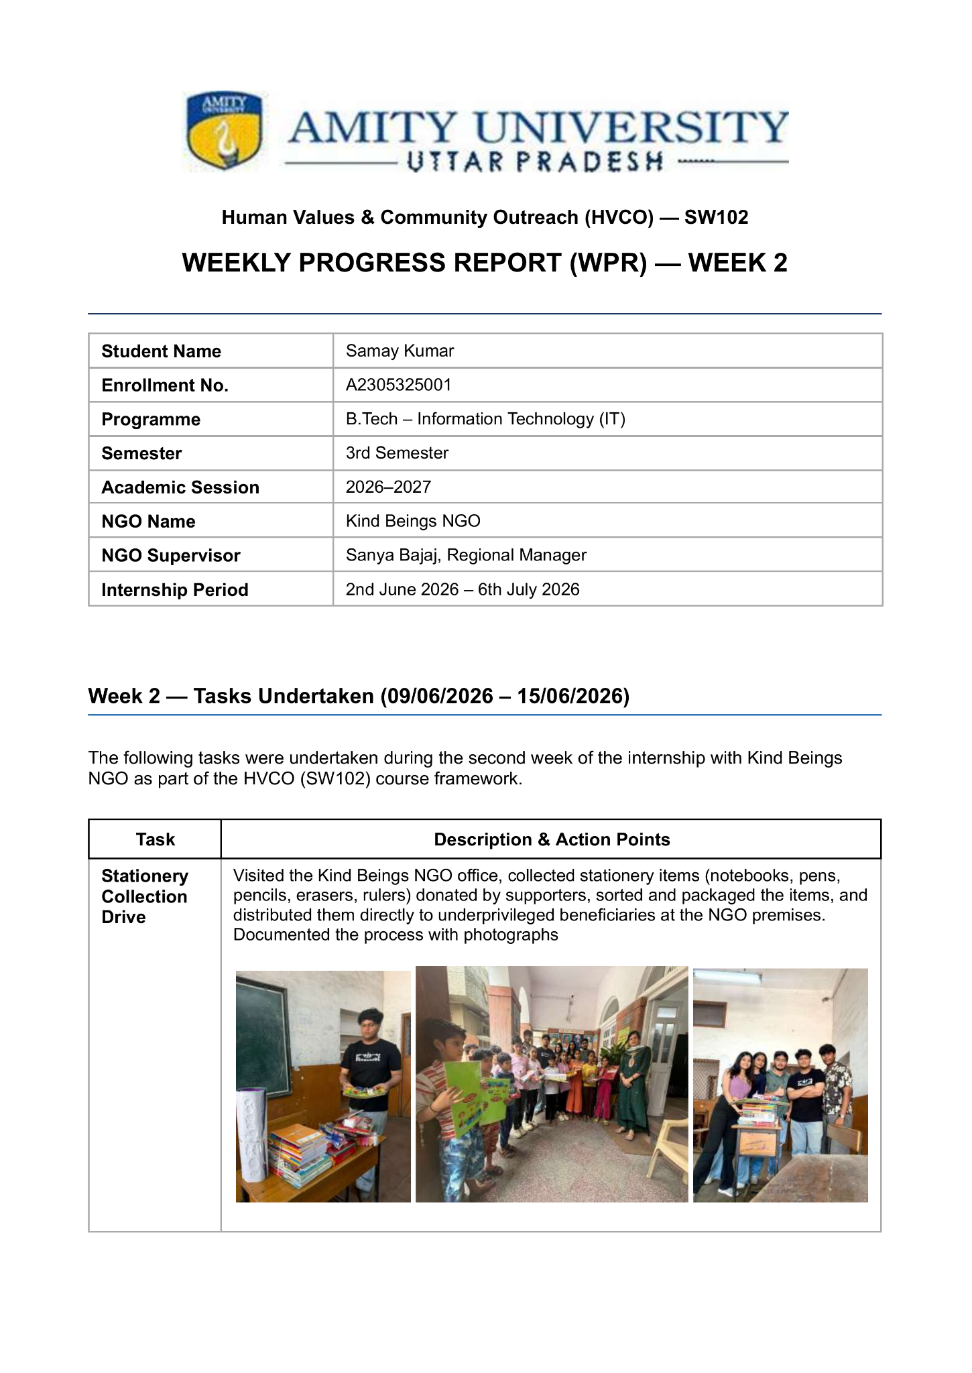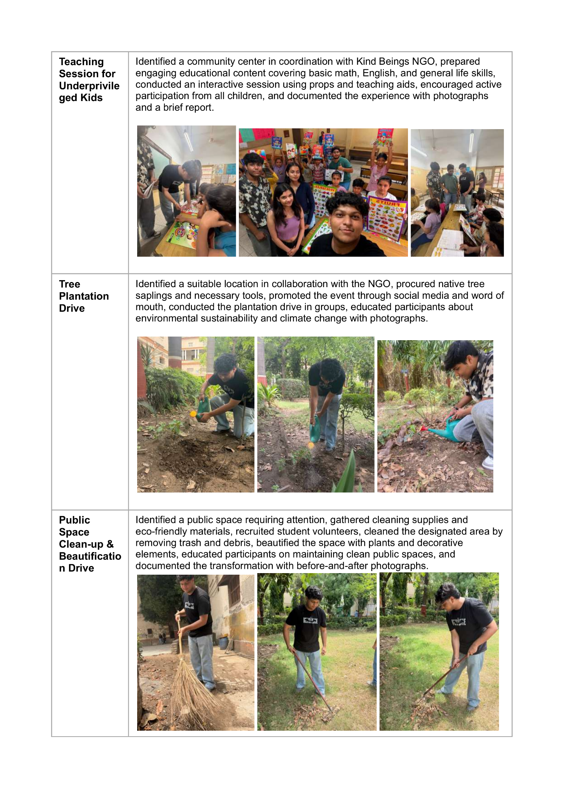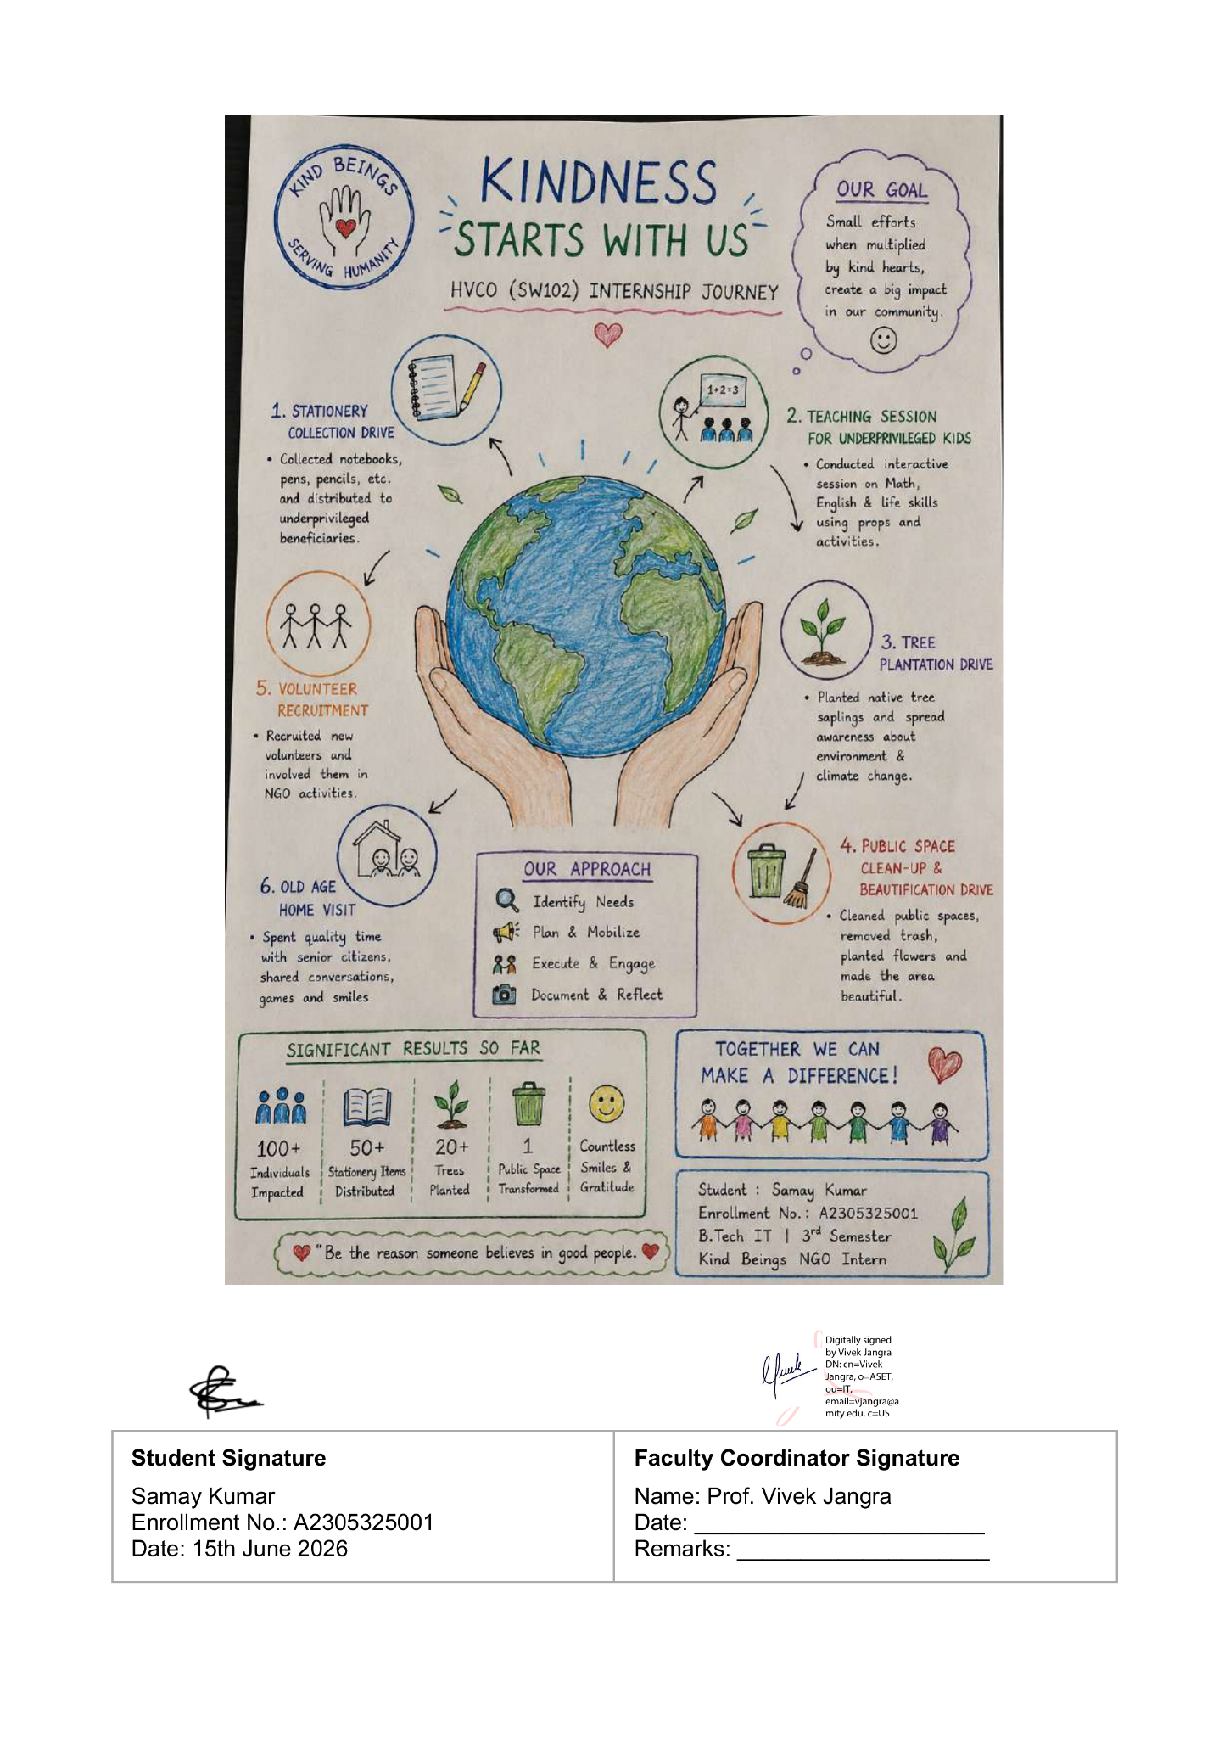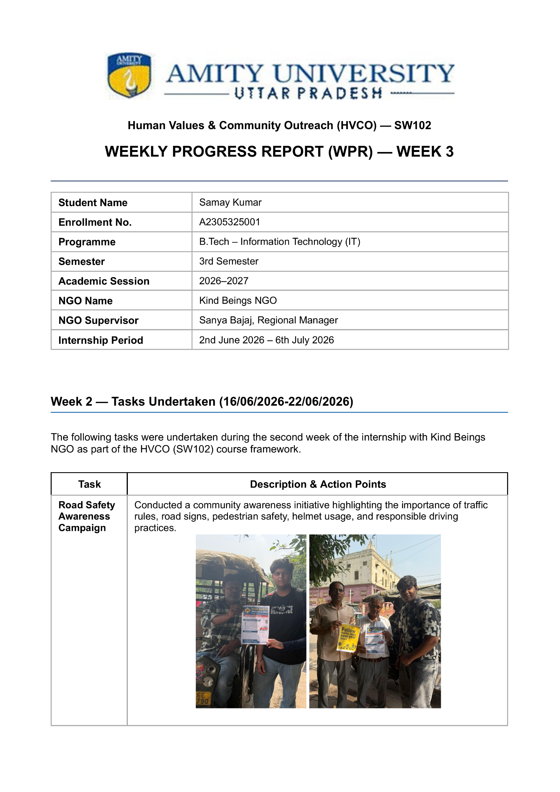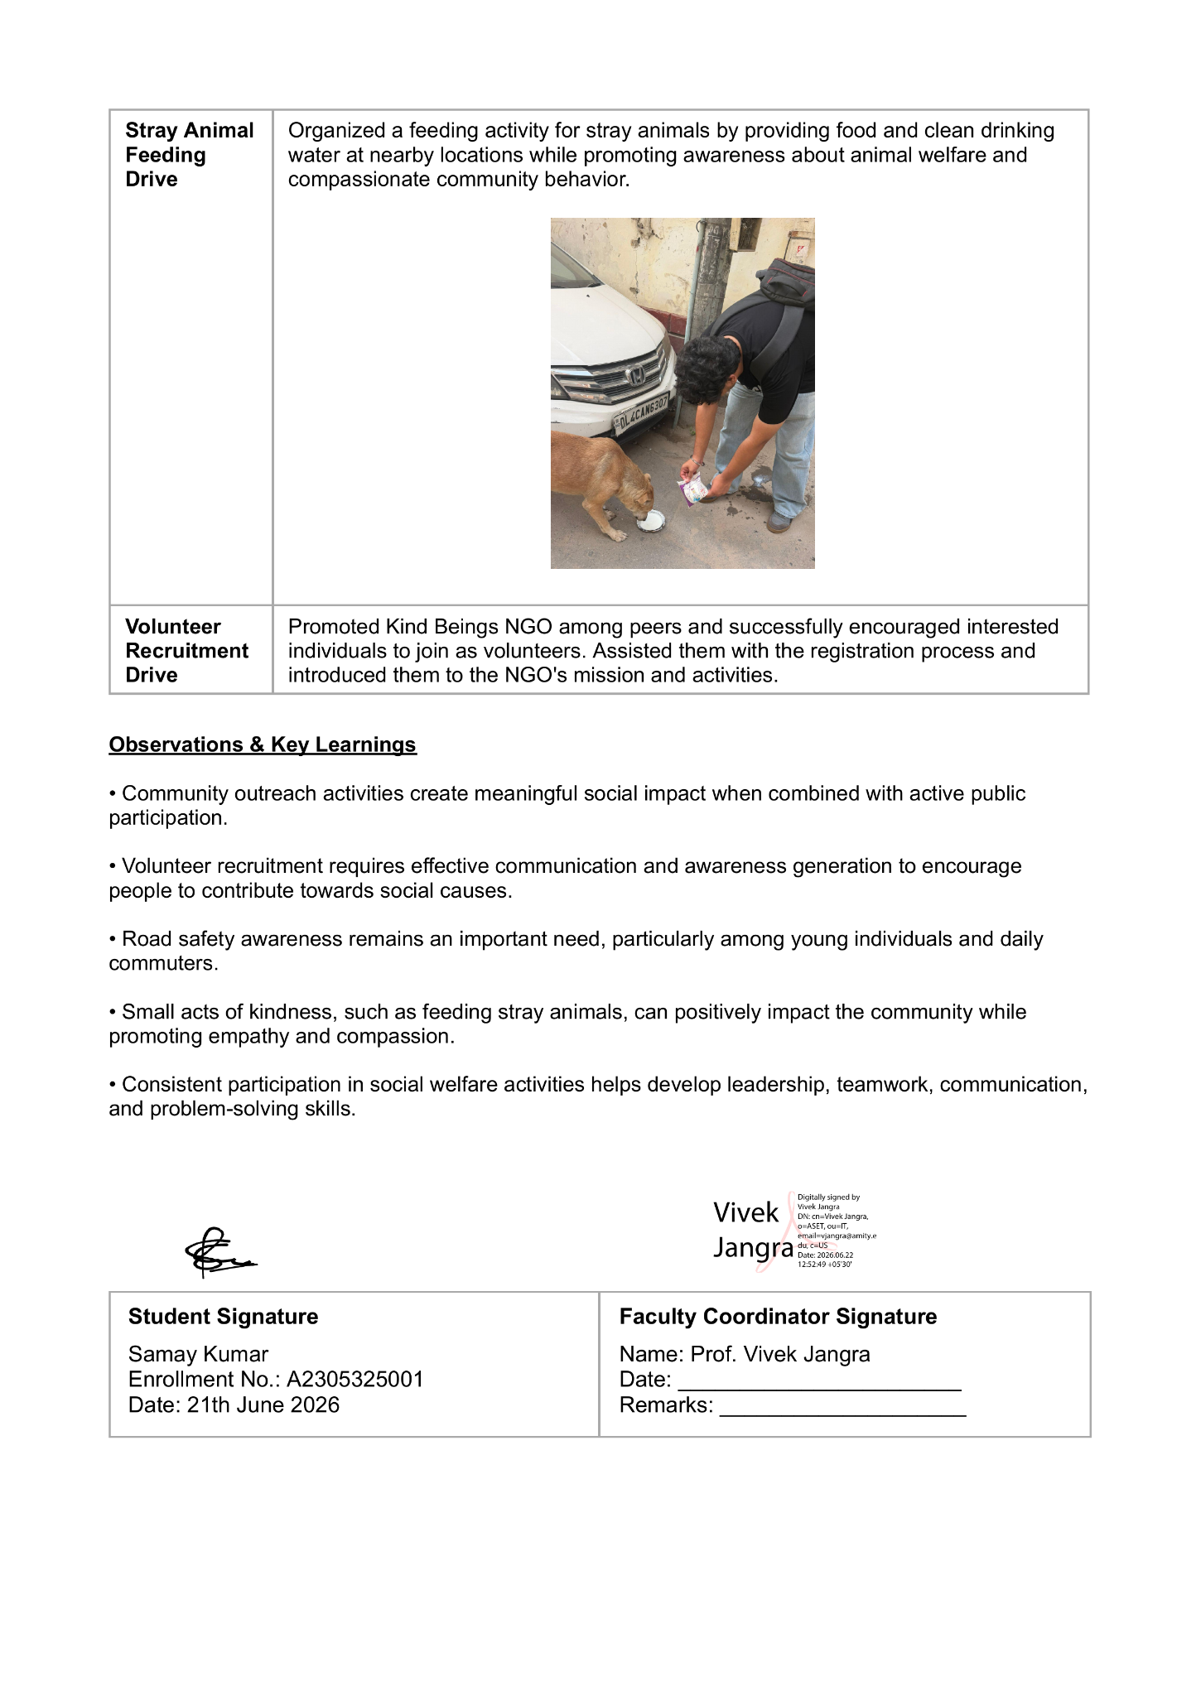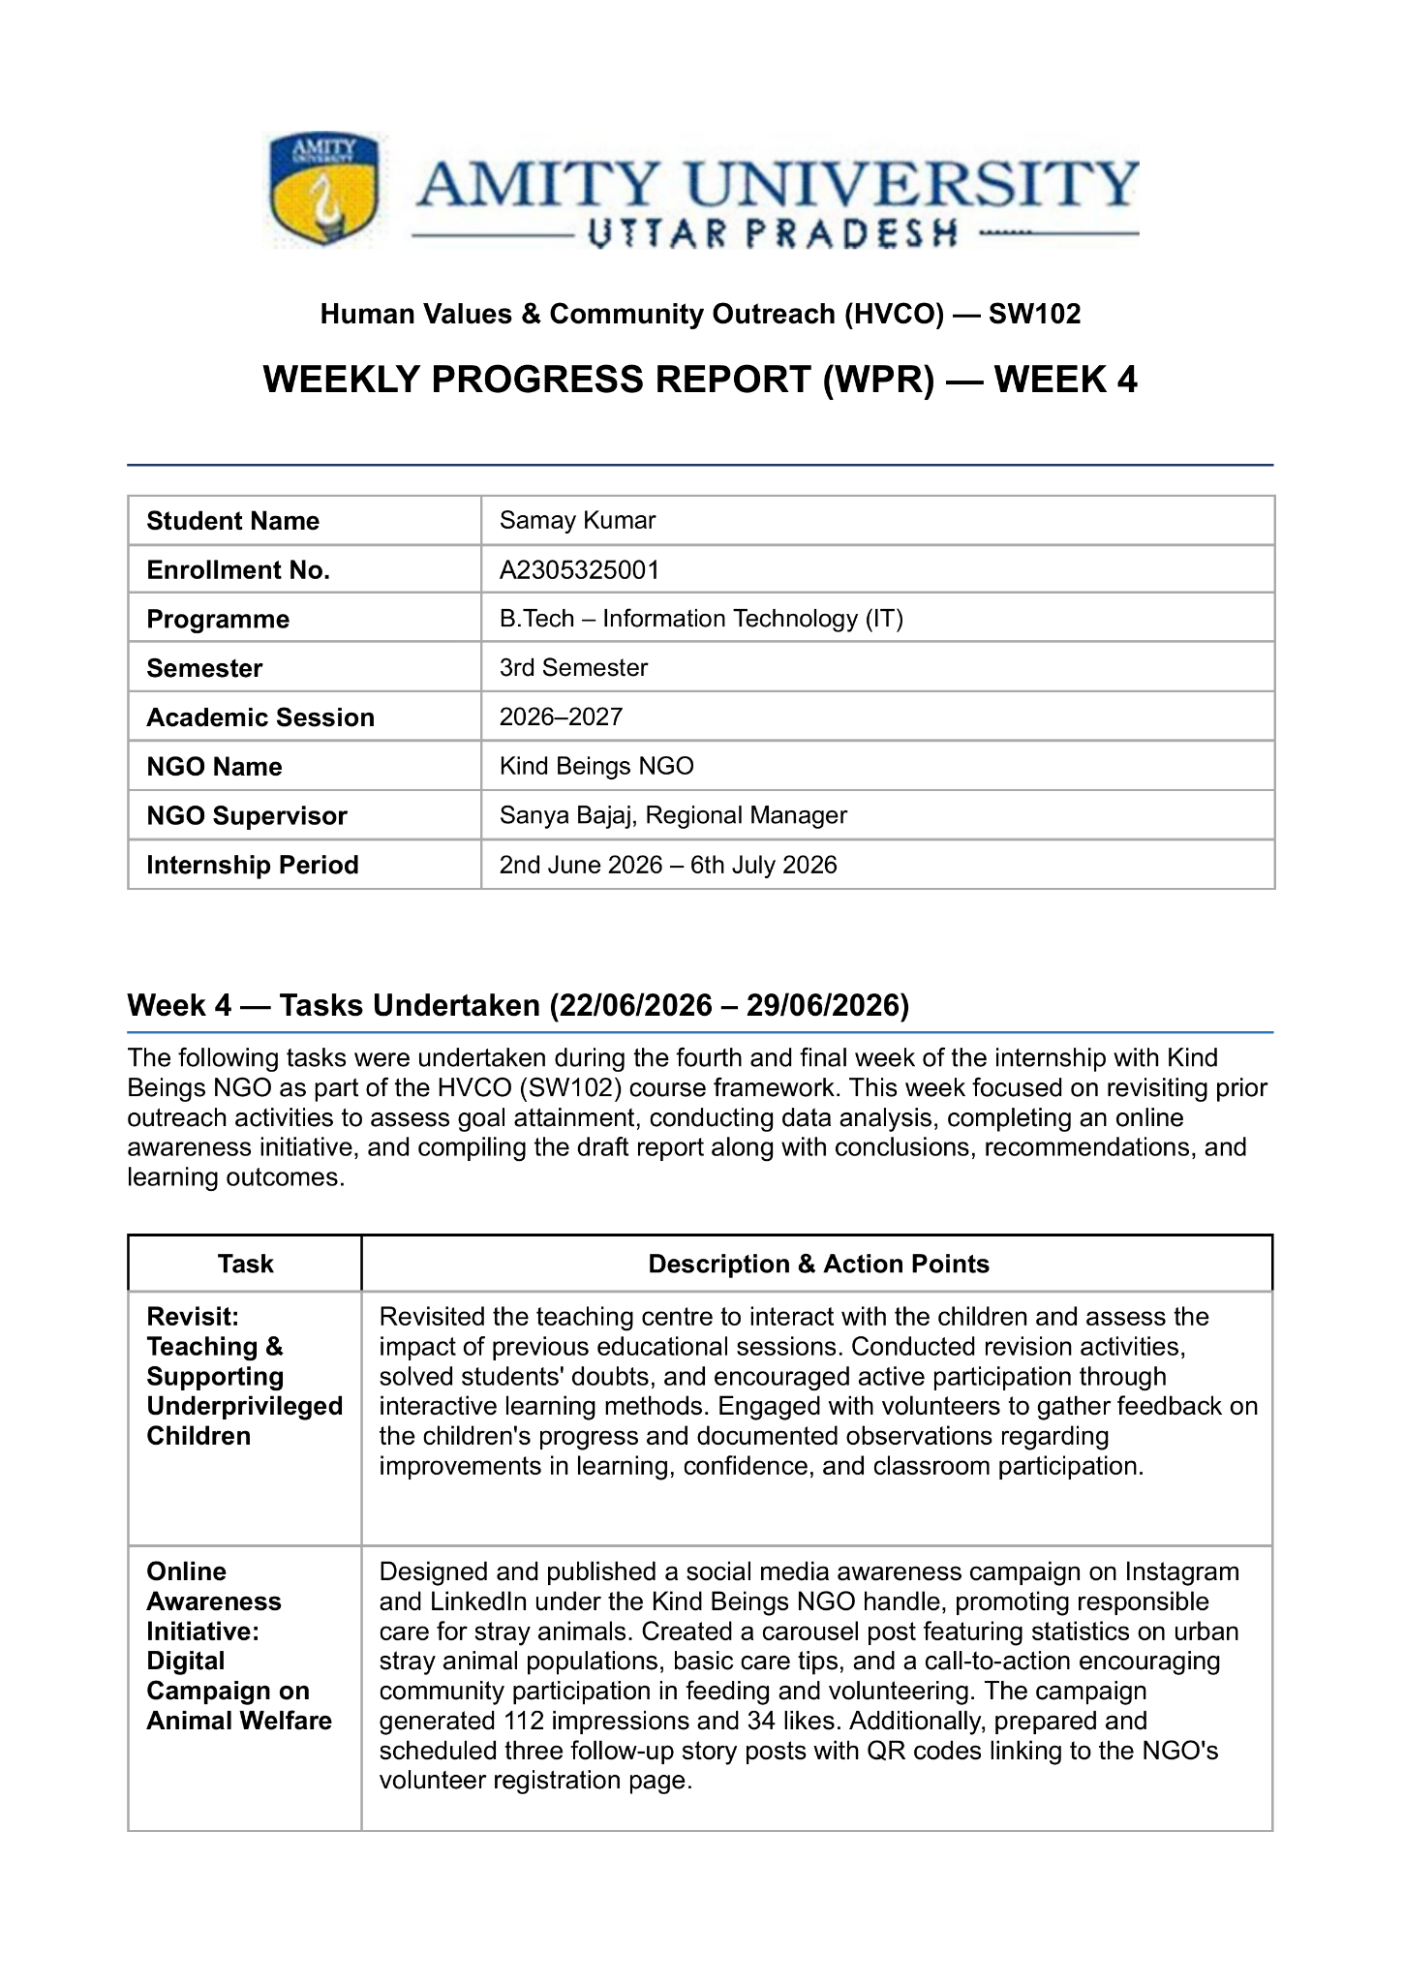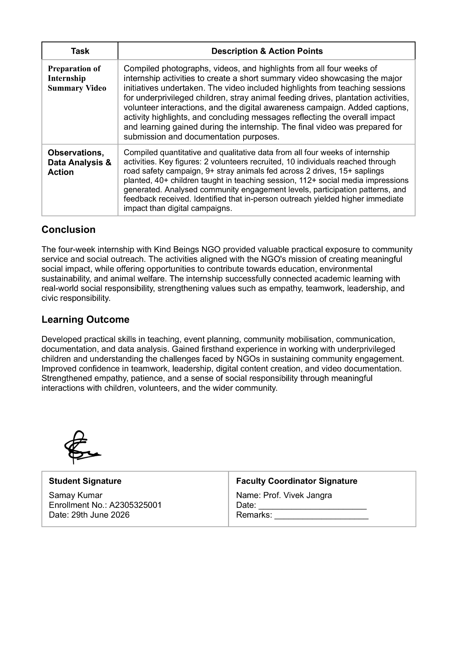

14. CERTIFICATE OF COMPLETION

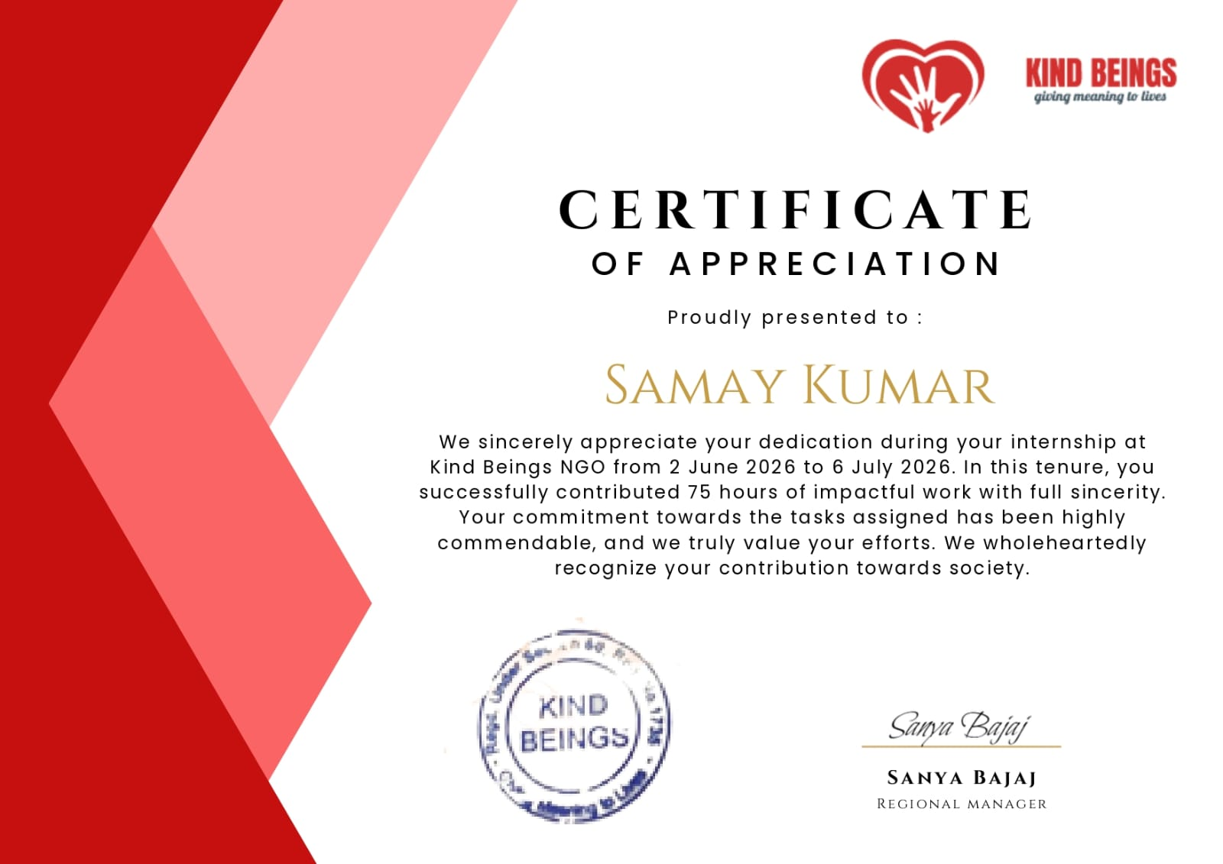

10. Learning Outcomes
- Gained hands-on exposure in managing community service projects, encompassing the full lifecycle from initial conceptualization to formal documentation.
- Refined interpersonal and organizational abilities through continuous liaison with partner institutions, student peers, and agency supervisors.
- Cultivated a deeper sense of empathy and professional patience by engaging directly with vulnerable demographics, including children and the elderly.
- Acquired a comprehensive understanding of grassroots NGO mechanics, including volunteer onboarding, strategic resource mobilization, and stakeholder relations.
- Developed heightened advocacy and awareness regarding environmental sustainability and animal welfare mandates.
- Increased leadership confidence through the successful management of collective activities and public-facing awareness initiatives.

15. Conclusion
The internship with Kind Beings NGO proved to be a genuinely enriching experience, offering practical, hands-on exposure to grassroots community outreach across education, elderly care, environmental sustainability, animal welfare, and public awareness. It reinforced several valuable lessons:
- The importance of coming forward and taking initiative to help those in need, rather than waiting for someone else to act.
- That meaningful impact often comes from consistent, small-scale actions rather than one-time grand gestures.
- The value of empathy and patience, particularly while working with children and elderly individuals.
- That challenges - whether institutional, logistical, or interpersonal - can almost always be resolved through proactive coordination and communication.
- The importance of documentation and structured reflection in converting field experience into lasting learning.
I would like to thank Kind Beings NGO, its Representative Mr. Vineet Goel, Regional Manager Ms. Sanya Bajaj, and my Faculty Guide Dr Vivek Jangra for making this internship a meaningful and well-supported learning experience. This internship has strengthened my resolve to continue contributing to such community-driven causes in the future and to encourage others to do the same.
Beyond fulfilling an academic requirement, this internship helped me understand how technology students can contribute meaningfully to society through communication, organization, and community engagement. The experience strengthened my appreciation for volunteer work and encouraged me to continue participating in social initiatives in the future.

16. References and Bibliography

- Desai, V., and R. Kumar. Fundamentals of Rural Development and NGO Management. Himalaya Publishing House, 2019.
- Chandra, R. NGOs and Social Development in India. Kalpaz Publications, 2018.
- Kumar, S. "Role of NGOs in Community Development: A Case Study Approach." Indian Journal of Social Work, vol. 45, no. 2, 2020, pp. 112–126.
- Ministry of Corporate Affairs. Guidelines on Corporate Social Responsibility and Community Outreach. Government of India Publication, 2021.
- Batra, A. "Volunteerism Among Youth in Urban India: Motivations and Outcomes." Journal of Social Sciences and Humanities, vol. 12, no. 3, 2022, pp. 45–58.
- UNICEF India. Child-Friendly Community Engagement: A Practitioner's Handbook. United Nations Children's Fund, 2020.
- Narayan, D. Voices of the Poor: Can Anyone Hear Us? World Bank Publications, 2000.
- Singh, P. "Grassroots Organizations and Sustainable Development Goals in India." International Journal of Development Studies, vol. 9, no. 1, 2021, pp. 78–95.
- World Health Organization. Community-Based Health and Hygiene Awareness Programs: A Field Guide. WHO Press, 2019.
- Gandhi, M. K. My Experiments with Truth. Navajivan Publishing House, 1927.
- Sen, A. Development as Freedom. Oxford University Press, 1999.
- National Council for Teacher Education. Human Values and Professional Ethics in Higher Education. NCTE Publication, 2020.

