**Lab 1: Measurements and Graphical Analysis**

**Procedure**

1. Gather the required materials for data collection:
   1. Ruler to measure the radii of the disks
   2. Digital balance to measure the mass of disks
   3. 5 aluminum foil disks of varying radii
   4. Computer/paper to record data
2. Measure the thickness of the disks
   1. Fold one of the disks 8 times
   2. Use the ruler to estimate the height of the folded disk
   3. Count the number of layers created when the disk is folded: 16 layers
   4. Divide the height of the folded disk by 16 to find the thickness of a disk
3. Measure the radius of the disks
   1. Fold the disks in half to form creases across the foil (one side to the other)
   2. Measure the crease (diameter) for each disk with the ruler (on the cm side)
   3. Divide the diameter by 2 to find the radius of each disk
   4. Record the data in a table
4. After measuring the radii of the disks, weigh each disk using the digital balance (g)
   1. Record the data in the table

**Mass, Radius, and Radius2** **Values of 5 Disks**

Thickness: 0.00625 cm

| Number | Mass (g) | Radius (cm) |  | Radius2 (cm2) |
| --- | --- | --- | --- | --- |
| 1 | 0.07 | 2.25 |  | 5.06 |
| 2 | 0.14 | 3.15 |  | 9.92 |
| 3 | 0.20 | 3.85 |  | 14.82 |
| 4 | 0.37 | 5.35 |  | 28.6 |
| 5 | 0.71 | 7.05 |  | 49.7 |

What is the precision of the meterstick I used?

The precision of the meterstick I used was to the tenth of a centimeter. I know this because the data I recorded was to the tenths of centimeters as my most accurate measurement. The measurements recorded do not exceed more than tenths of centimeters.

**Mass of Disks (g) vs Radius of Disks (cm)**

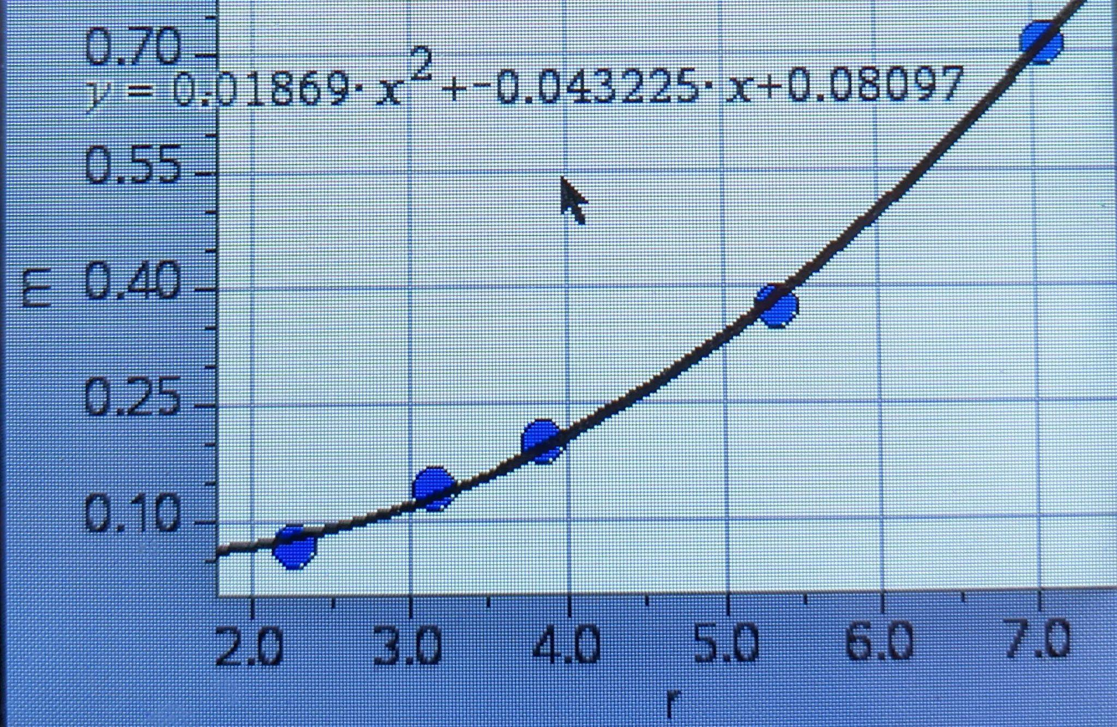

x-Axis - Mass of Disks (g)

y-Axis - Radius of Disks (cm)

Best fit line equation: y=0.01869x2-0.043225x+0.08097

**Mass of Disks (g) vs Radius2 of Disks (cm2)**

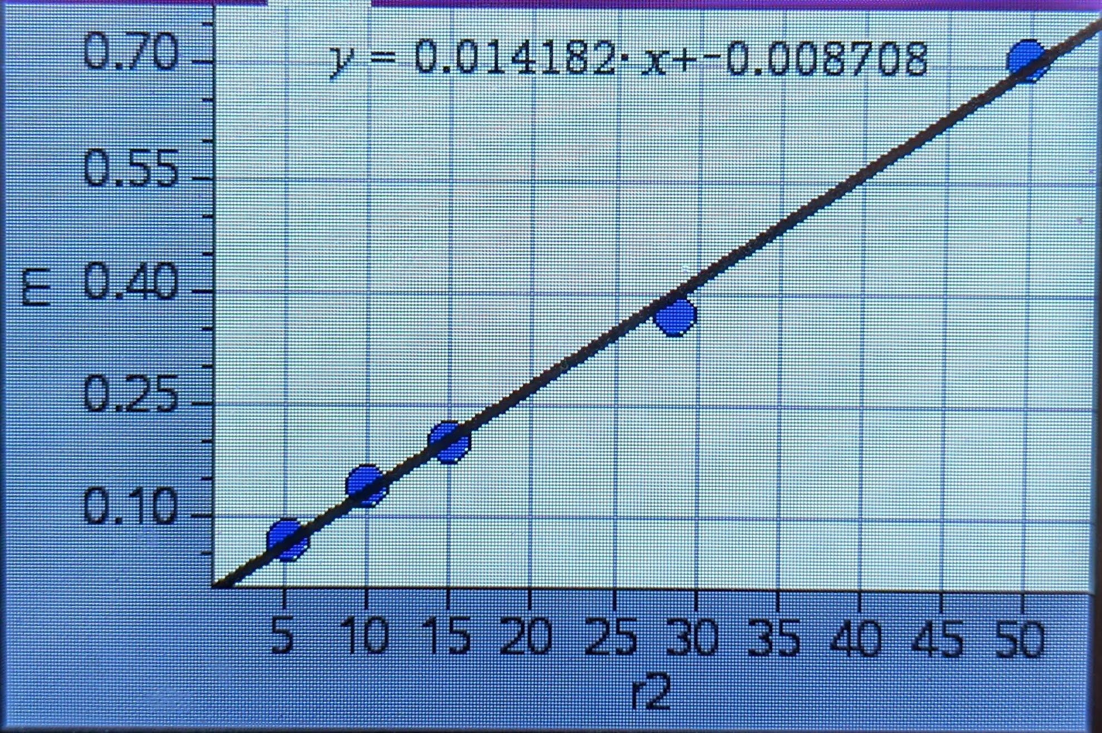

x-Axis - Mass of Disks (g)

y-Axis - Radius2 of Disks (cm2)

Best fit line equation: y=0.014182x2-0.008708

**Analysis Questions**

1. The independent variable is the radius2 of the disks because it changes the mass, which is the dependent variable.
2. ρ = m / v

ρ = m / 𝜋r2h

ρ * 𝜋r2h = m

since r2 is the x value

slope = ρ𝜋h

The slope represents (density g/cm3) * 𝜋 * h

y (g) = m (g/cm2) * x (cm2) + b (g)

g = g/cm2 * cm2 + g

g = g + g

g = g

The equation is dimensionally correct

1. Conceptually, yes the ‘b’ value in the equation should be 0, as it would indicate that while the radius is zero the mass is zero. This would be correct as a radius of zero would mean that the disk does not exist and, therefore, the mass should be 0. However, the ‘b’ value for my equation is close but not zero due to experimental errors.
2. Estimated thickness value: 0.00625 cm

Experimental density: ρ = mass / volume

slope = ρ𝜋h

0.014182 g/cm2 = ρ𝜋h

0.014182 g/cm2 = ρ𝜋 (0.00625 cm)

0.014182 g/cm2 / 𝜋 (0.00625 cm) = ρ

0.72 g/cm3 = ρ

((actual - theoretical) / actual) * 100

((2.7 g/cm3 - 0.72 g/cm3) / 2.7 g/cm3) * 100

= 73.3 % error

1. The experimental density value that was calculated was extremely low compared to the actual density for aluminum foil. One possible reason for this instance is the fact that the weight of the aluminum foil disks would fluctuate when placed on different areas of the digital balance. This may have led to an inaccurate recording of the mass which, in turn, would affect the slope of the graph, as slope is calculated with the x (radius2) and y (mass) points. The wrong slope would mean that the experimental density value would be skewed and therefore have a higher percent error. Another possible error for this experiment would be the incorrect estimation of the thickness of the disks. When measuring the height of the folded disk there were gaps between the layers which were not a part of the disk itself, so the estimated thickness is greater than it should have been. By having an imprecise thickness value, the experimental density is lower than the actual density of aluminum foil. The high percent error may be a result of these possible inaccuracies.

**Synthesis Questions**

1. If disks of a different thickness were used, the slope of the linearized graph would be steeper. This is because a greater thickness would mean that the mass of the disks would have increased. Since the thickness is the only factor that was changed the radius would not be affected as it is just measuring half of the diameter (which is staying the same). So if the radius values stay the same the radius2 values also stay the same. So the increased mass values would cause a steeper slope as the radius values stay the same. The experimental density would probably not stay the same, since a greater thickness would be easier for measuring the height of the disks, therefore making it more accurate. The estimated thickness value for this experiment was too large, so the calculated experimental density value was too small. If thicker disks were given the height of the disks measured would be more precise, making the density greater and more accurate, as well.
2. If disks of the same thickness were given, but the material used was steel, the slope of the m versus r2 graph would be steeper. This is caused by steel's higher density which ranges between 7.85 g/cm3 and 8.03 g/cm3 compared to aluminum’s density of 2.7 g/cm3. A higher density would mean a higher mass so the steel disks would weigh more while the radius and radius2 would stay the same, therefore creating a steeper slope.

x - axis - radius2 (cm2)

y - axis - disk mass (g)

Blue line - Steel

Red line - Aluminum

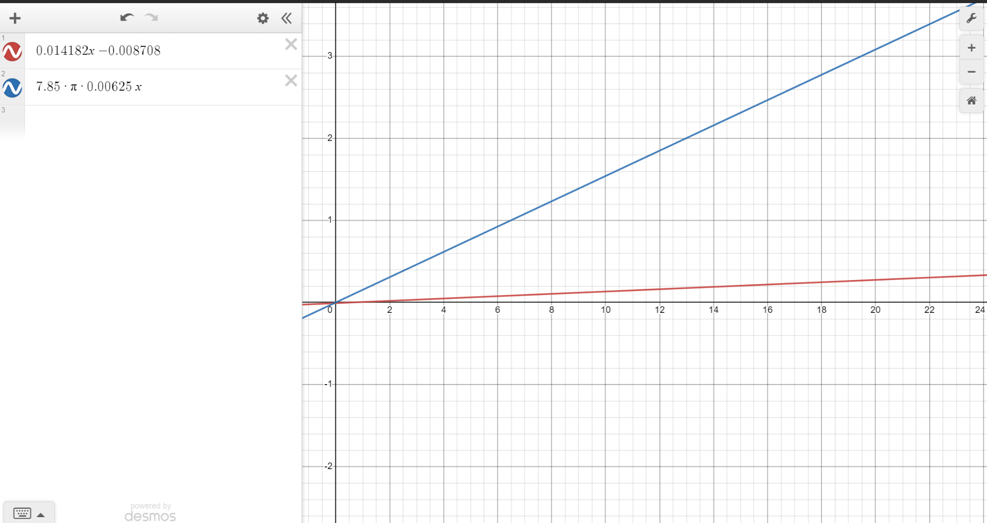

1. ρ = m / v

ρ = m / 𝜋r2h

ρ * 𝜋r2h = m

since r2 is the x value

slope = ρ𝜋h

slope / 𝜋h = ρ

0.5 cm = height

122 kg/m2 = slope

122 kg/m2 * 1000 g * 1m2 = 12.2 g/cm2

1 kg (100cm)2

(12.2 g/cm2) / (0.5 cm * 𝜋) = 7.77 g/cm3

The unknown density value calculated is 7.77 g/cm3 which is closest to the density value of iron which is 7.8 g/cm3. So the unknown material is iron.

**Multiple Choice Questions**

1. ρ = m / v

ρ = m / 𝜋r2h

ρ * 𝜋r2h = m

Circumference of a circle = 2𝜋r

c = 2𝜋r

c / 2𝜋 = r

ρ * 𝜋 * (c / 2𝜋)2 * h = m

ρ * 𝜋 * (c2 / 4𝜋2) * h = m

ρ * ~~𝜋~~ * (c2 / 4~~𝜋~~~~2~~) * h = m

ρ * (c2 / 4𝜋) * h = m

(ρh / 4𝜋) * c2 = m

Slope = ρh / 4𝜋 → **E**

1. Skip
2. ρ = m / v

Volume of a sphere = 4/3 * 𝜋r3

ρ = m / (4/3 * 𝜋r3)

ρ * (4/3 * 𝜋r3) = m

ρ * 4𝜋/3 * r3 = m

ρ * 4𝜋/3 = slope

r3 = x value → **C**

y=mx+b