**N@™**

**Presentations**

We were able to present to several different people including others in CSA, CSP, and parents. It was exciting to show our website to people who have seen how it had been developed along the way compared to the parents who are coming in for the first time to see it. We wanted to grab people's attention at first since our website is a math website, and math is not the most interesting topic. So to do this we had the 2048 game on our page which did attract many people’s interest. Next, we would typically show them the derivative calculator and desmos as they are both interesting and math-related. We also showed our RBP data which listed different questions that past students have used for their projects so that future students can have a reference.

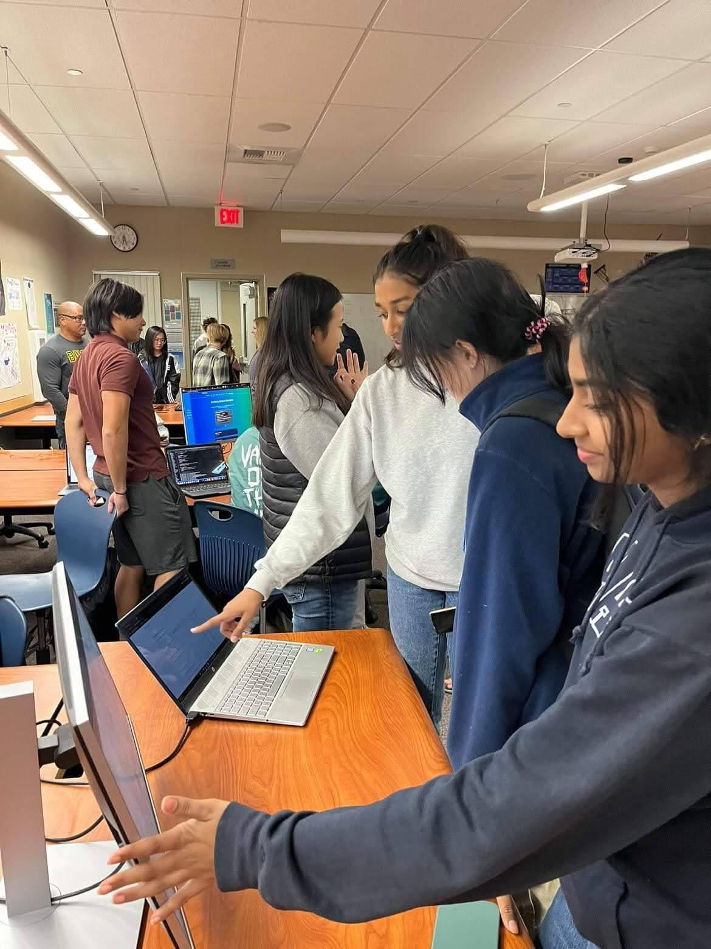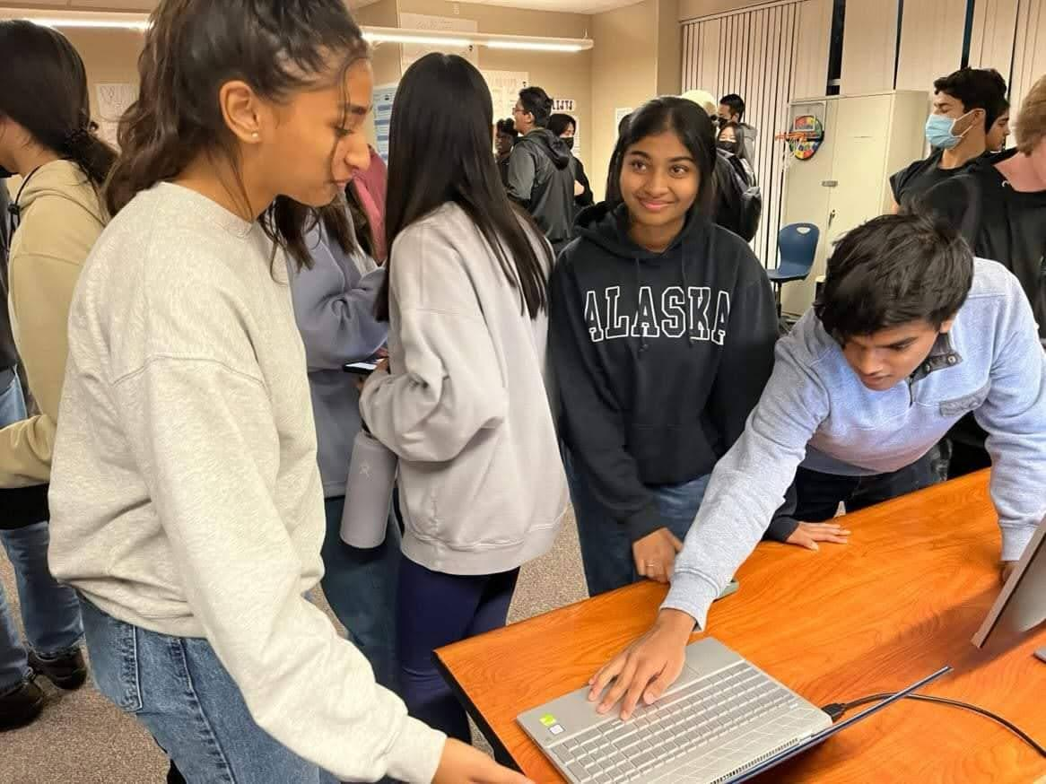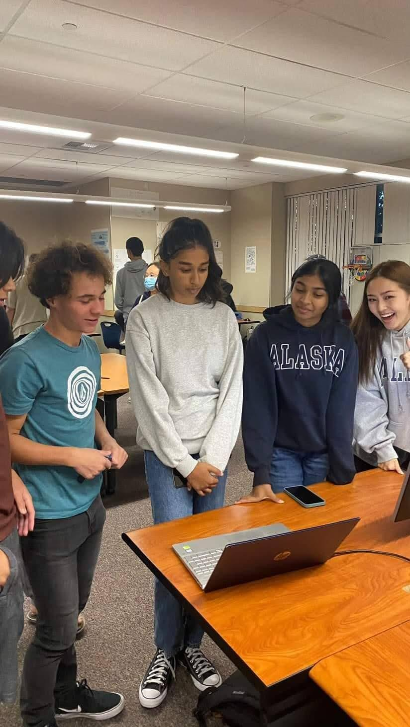

**Other Projects**

We also checked out other art projects like 3d animation, ceramics, drawing, and AP Studio art.

