**Test Corrections**

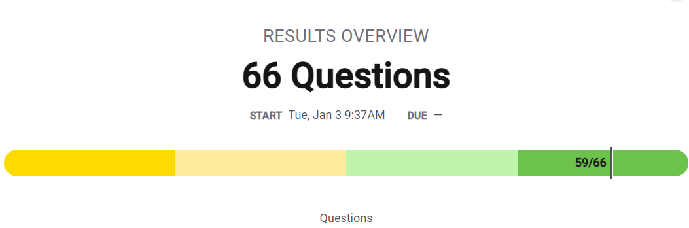

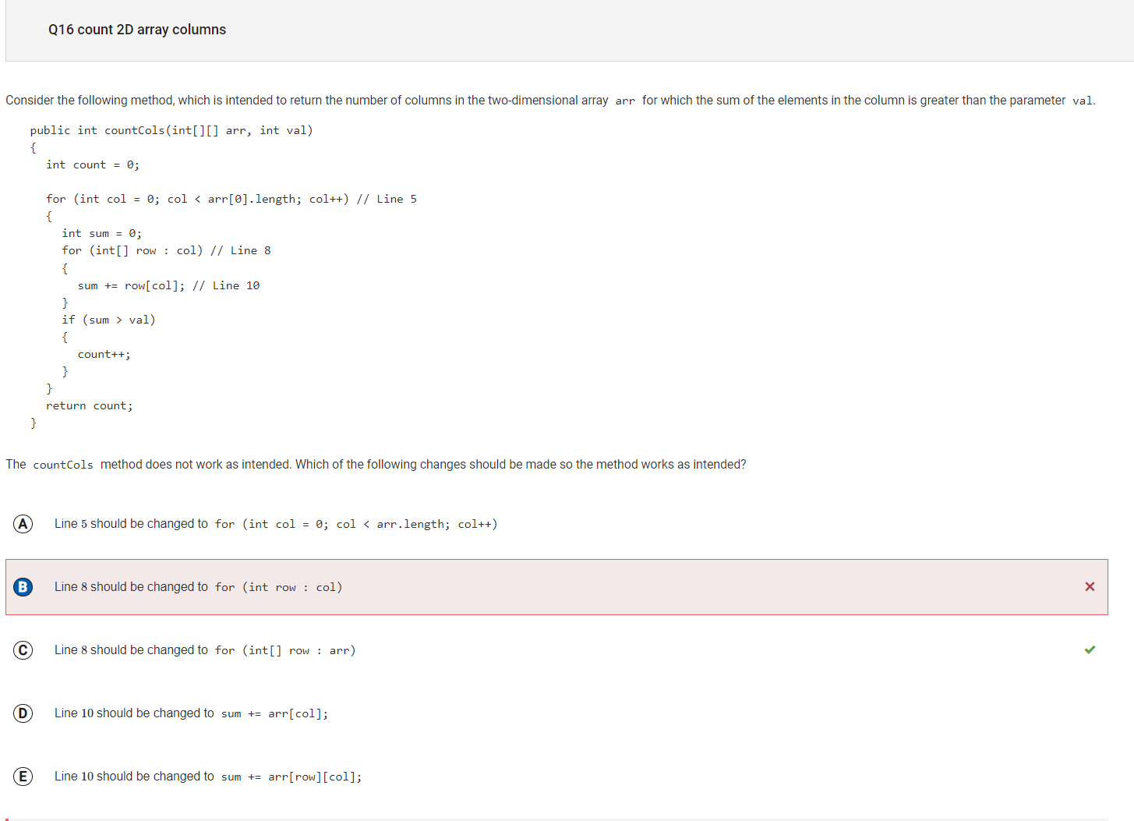

B is the wrong answer because the loop is supposed to go through the rows of the 2D Array and each row of the arr is a 1D Array.

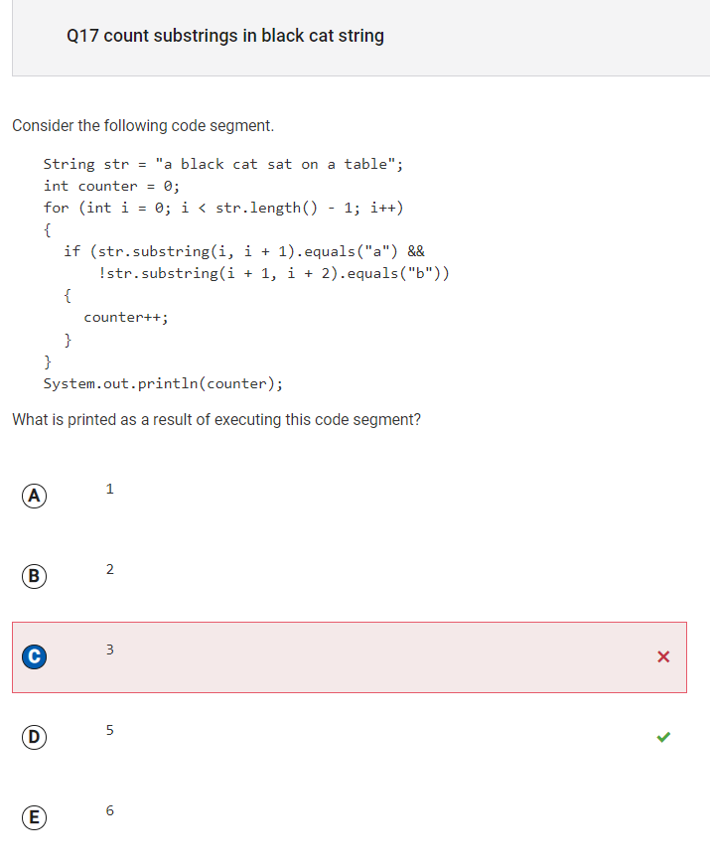

C is the wrong answer because this would be the answer if the counter was countring when a is not followed by b and not followed by a space. The code is asking for a not followed by b.

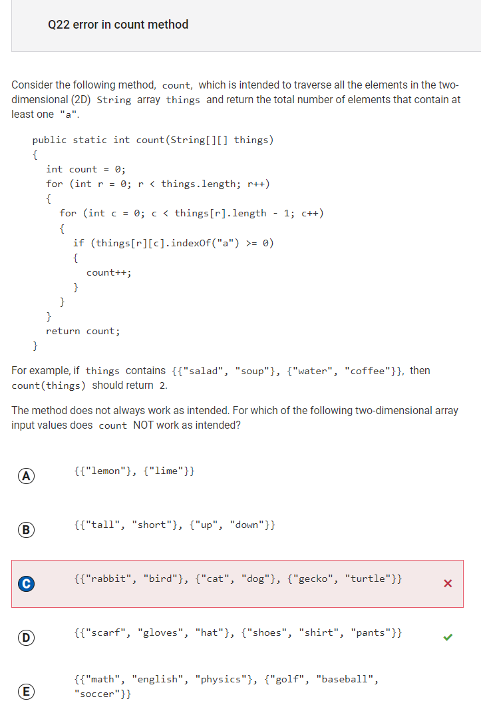

C is incorrect because the code does not work when the last element in all the columns does not have the letter a in it. So the option that would not work would be d.

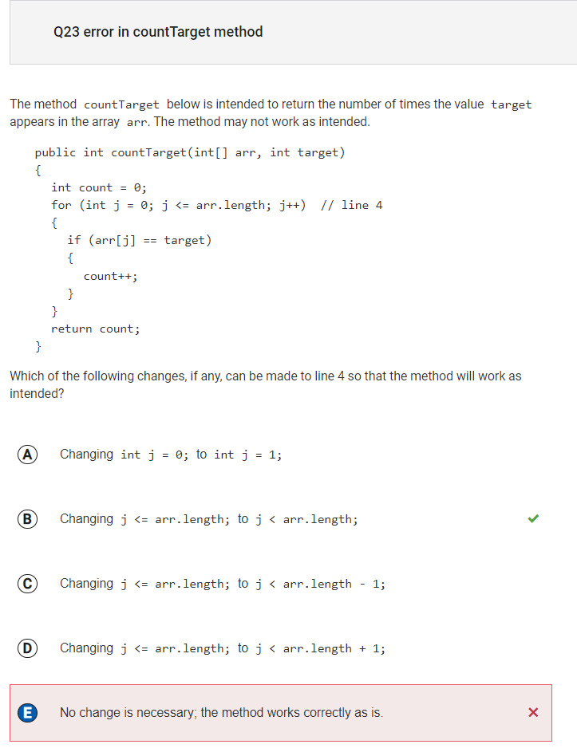

E is incorrect because the method does not always work. B would be the correct option because the loop should only iterate while j < arr.length.

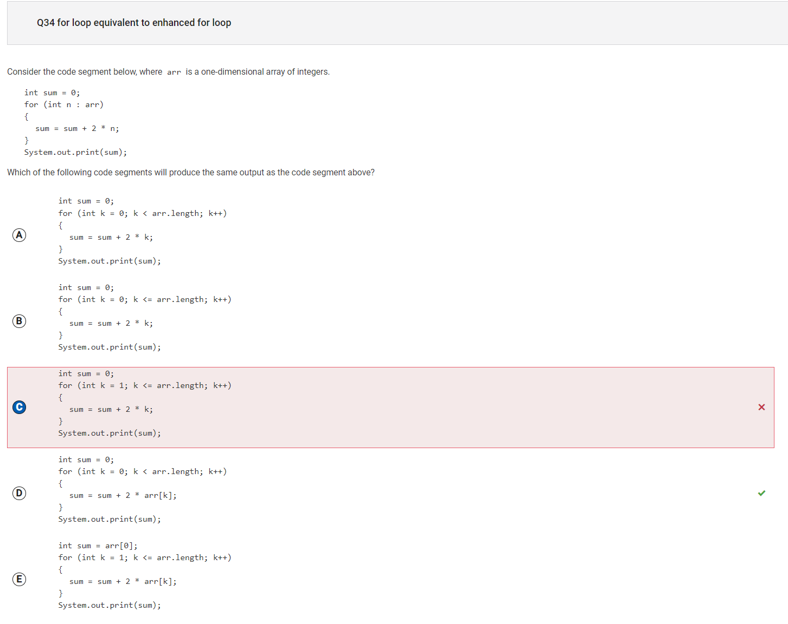

C is the incorrect answer because the original code outputs the sum of twice the elements in the array, but this code prints twice the sum of the integers from 1 to the array length.

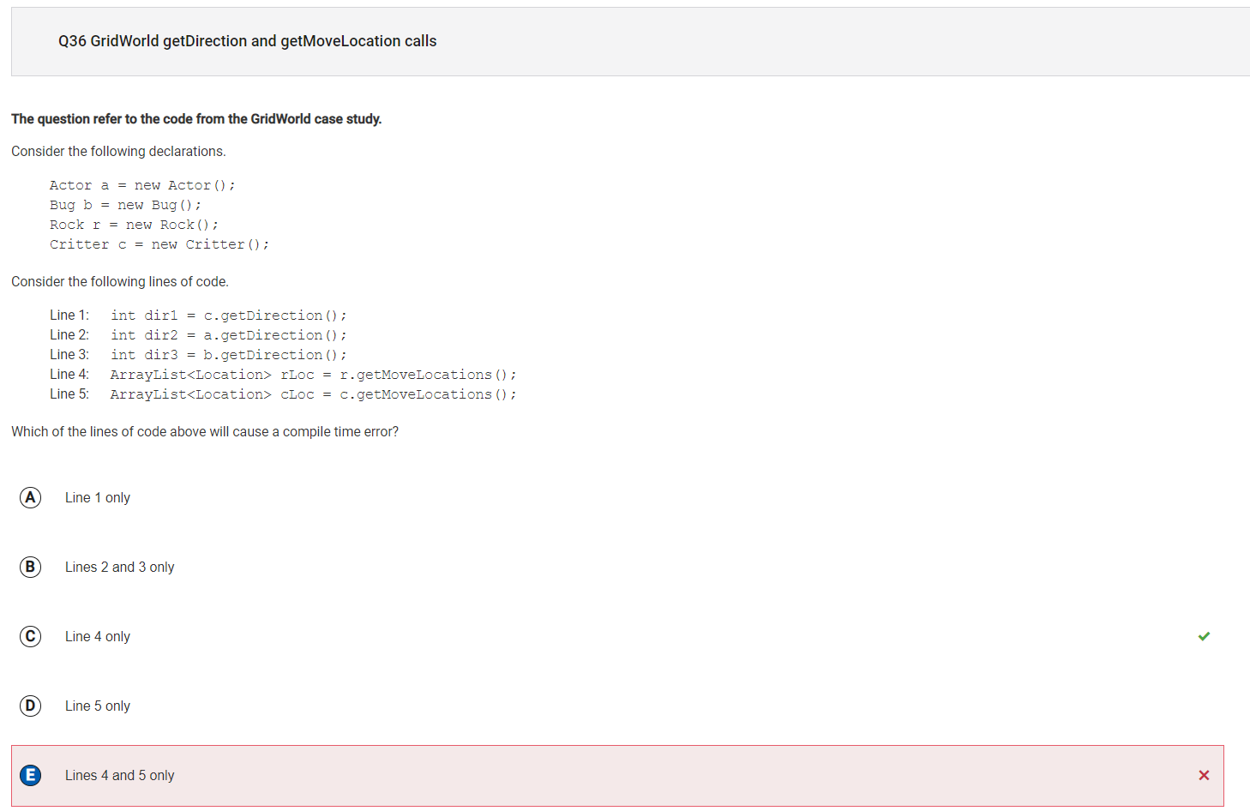

E is incorrect because only line 4 will cause the error not both.

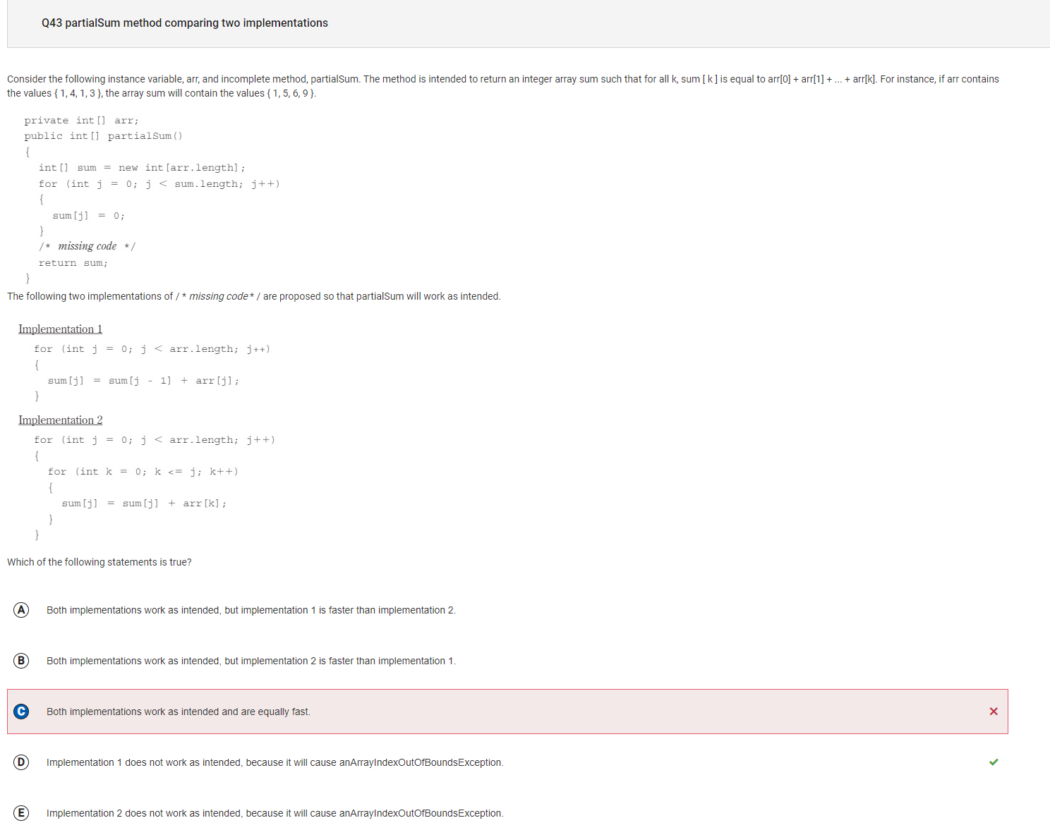

C is incorrect because the first segment will cause an out of bounds error and both codes do not work.