**Test Corrections**

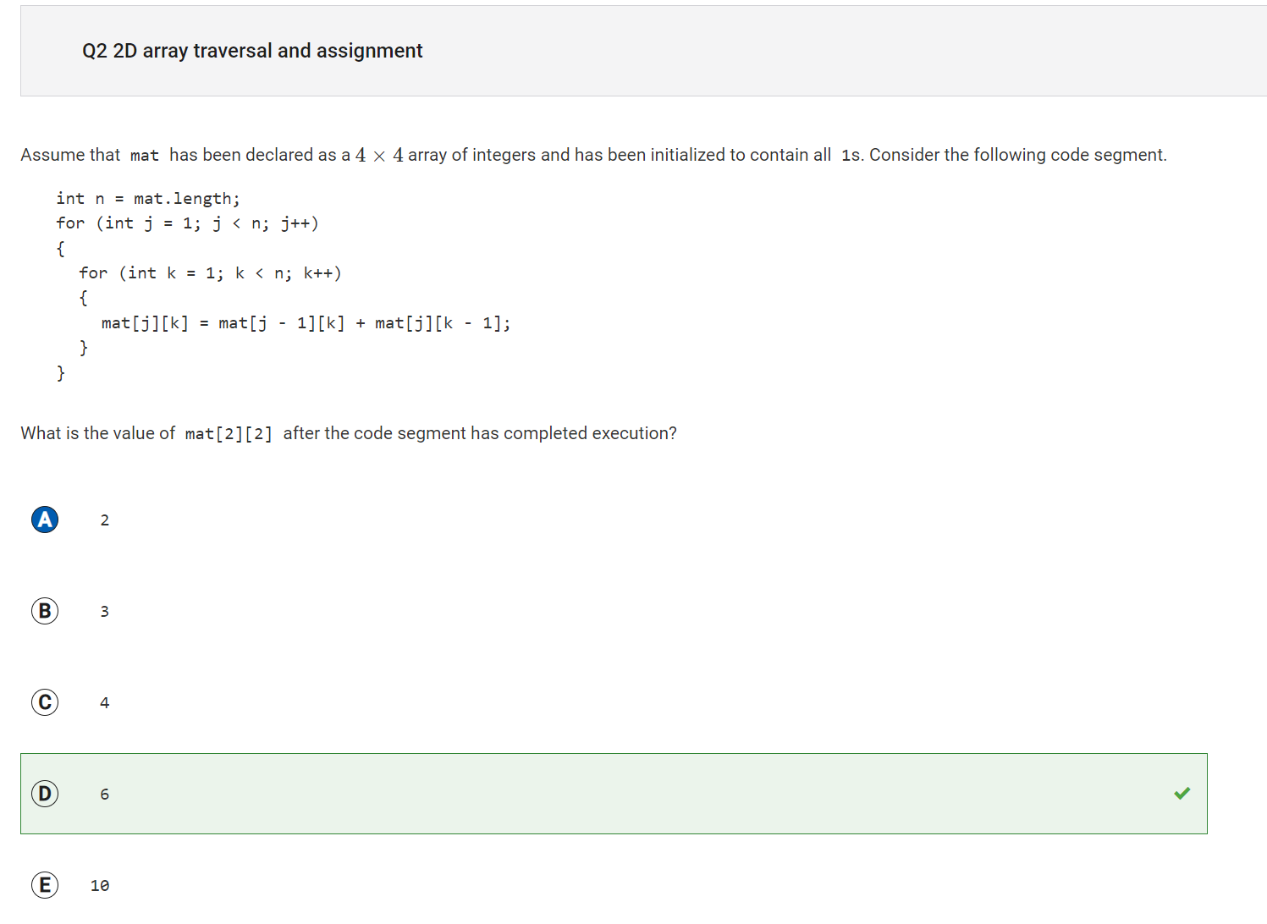

A would be incorrect because this would give the result if the elements around mat[2][2] did not change because of the previous iteration.

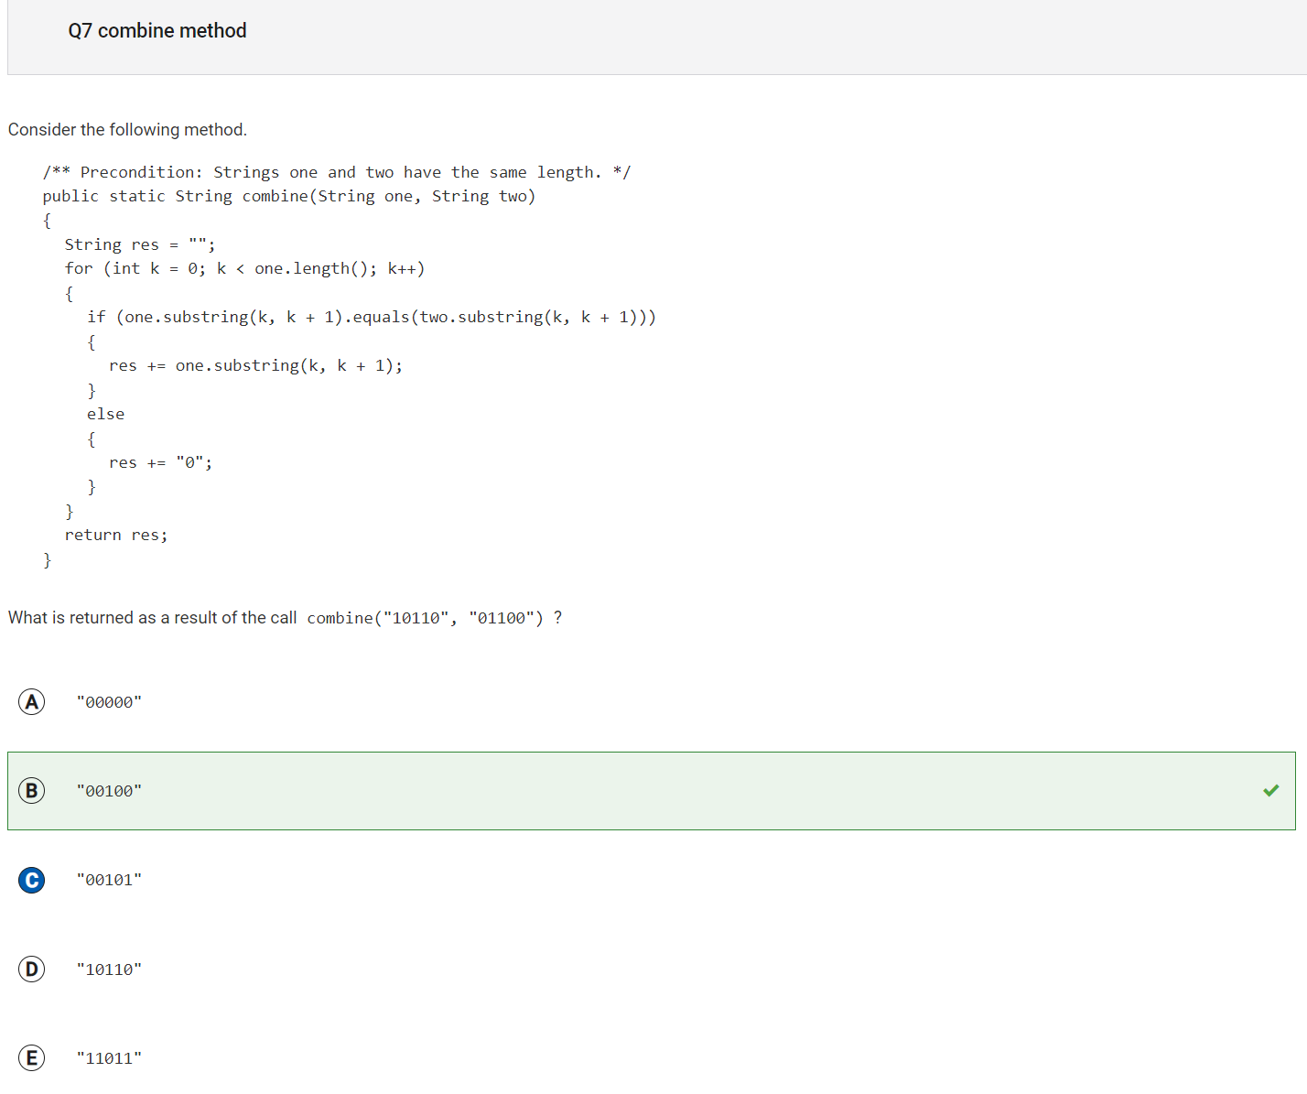

C would be incorrect because it would mean that the fourth number in both of the strings were equal and that is not the case.

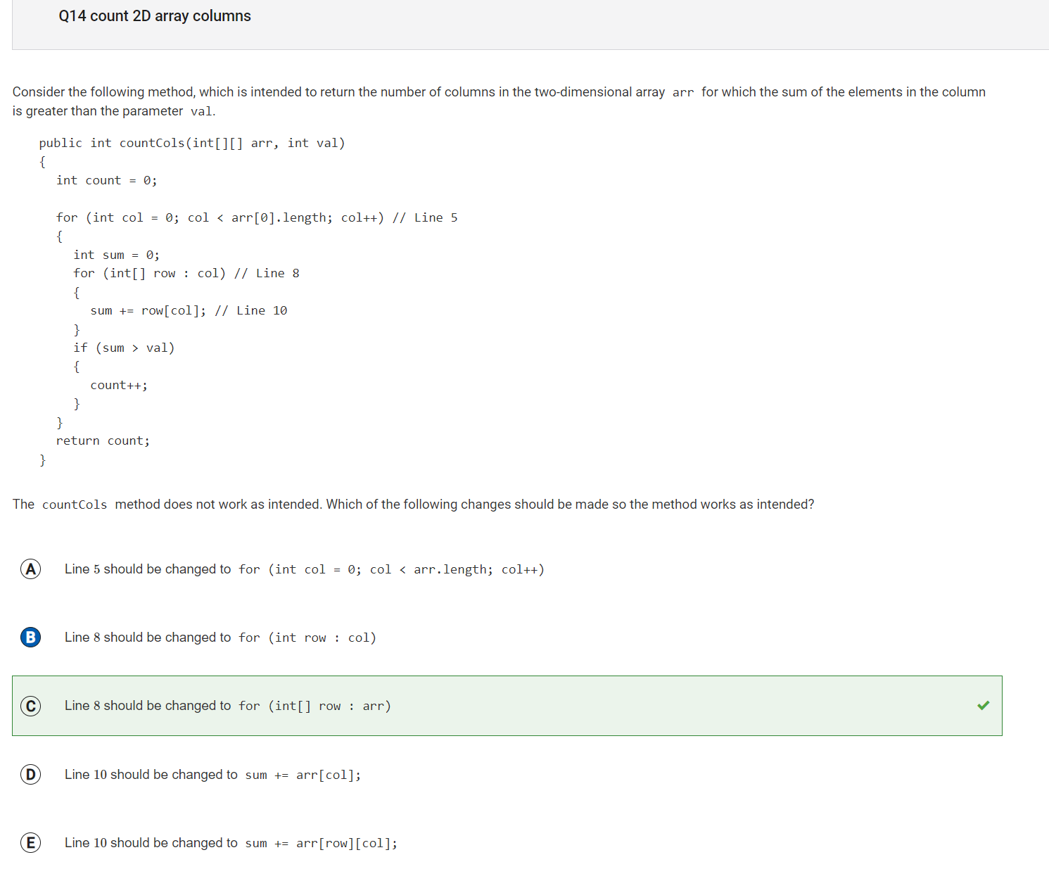

B is incorrect because line 8 is supposed to traverse through the two dimensional array (arr), but with B it is not doing that C does because of the int[]

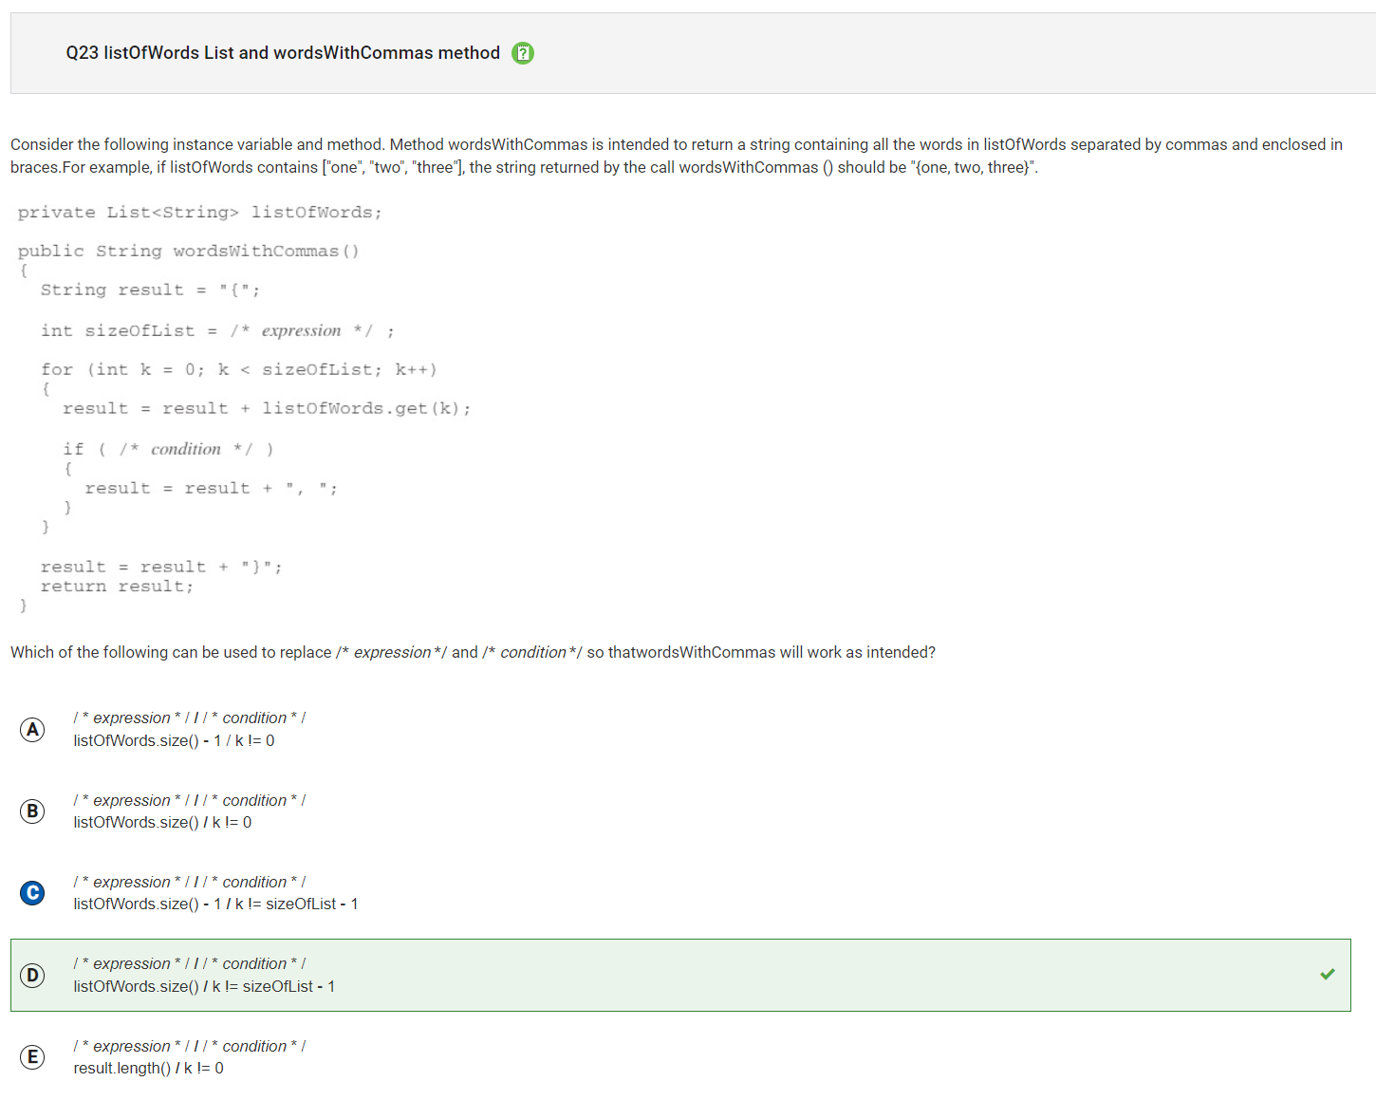

C is incorrect because by subtracting one we are skipping the last element of the list, but without subtracting one we would get the actual size of the list.

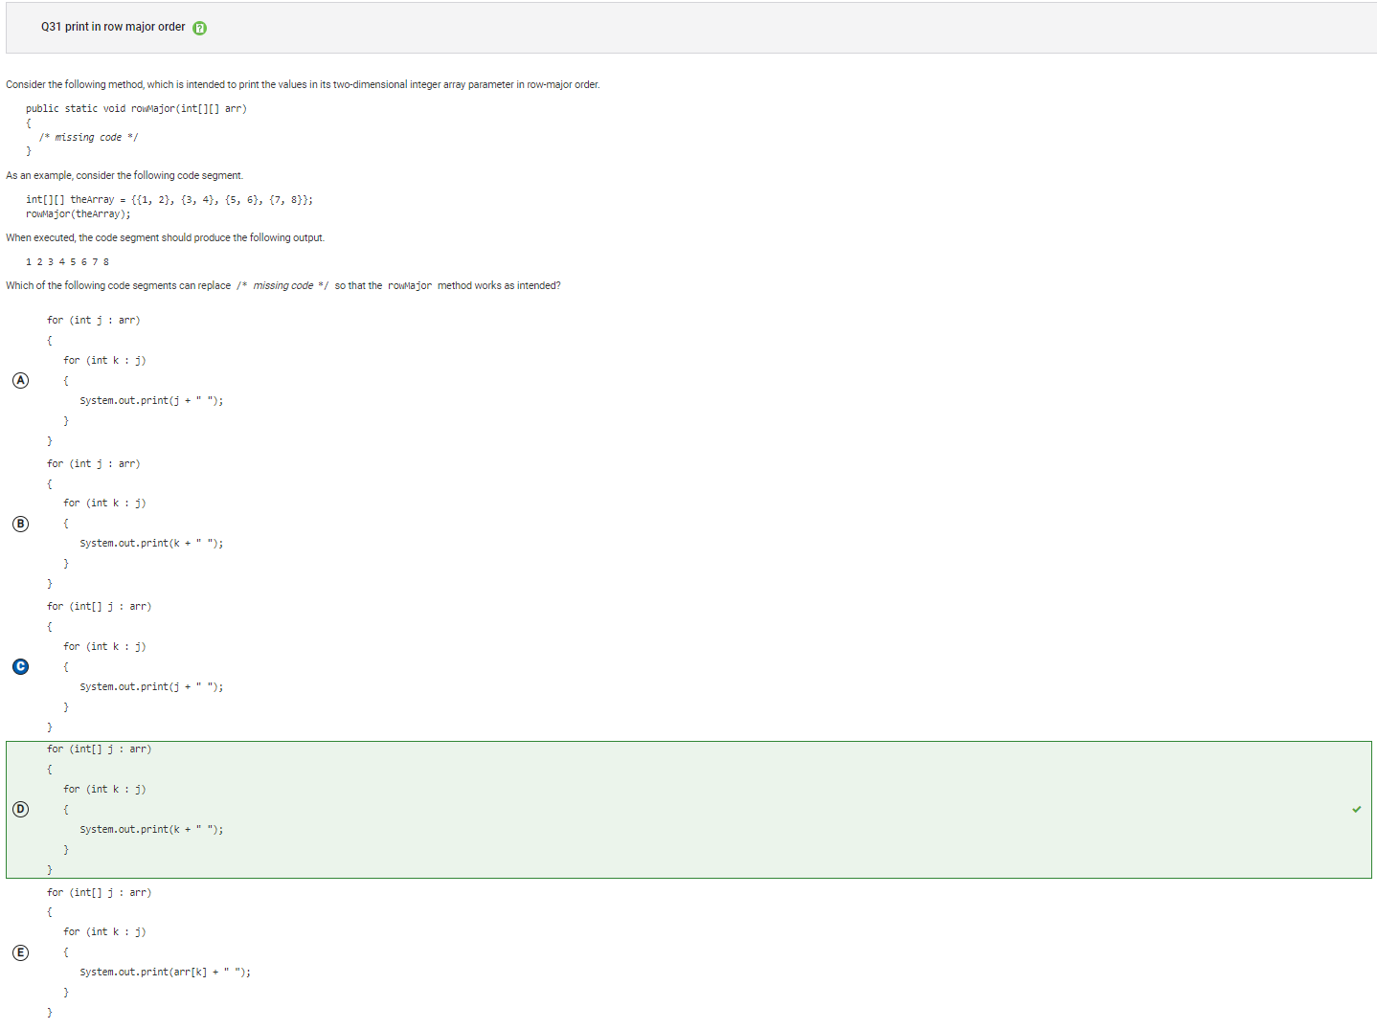

C is incorrect because it trys to print j which is a row of the array instead of an element j.

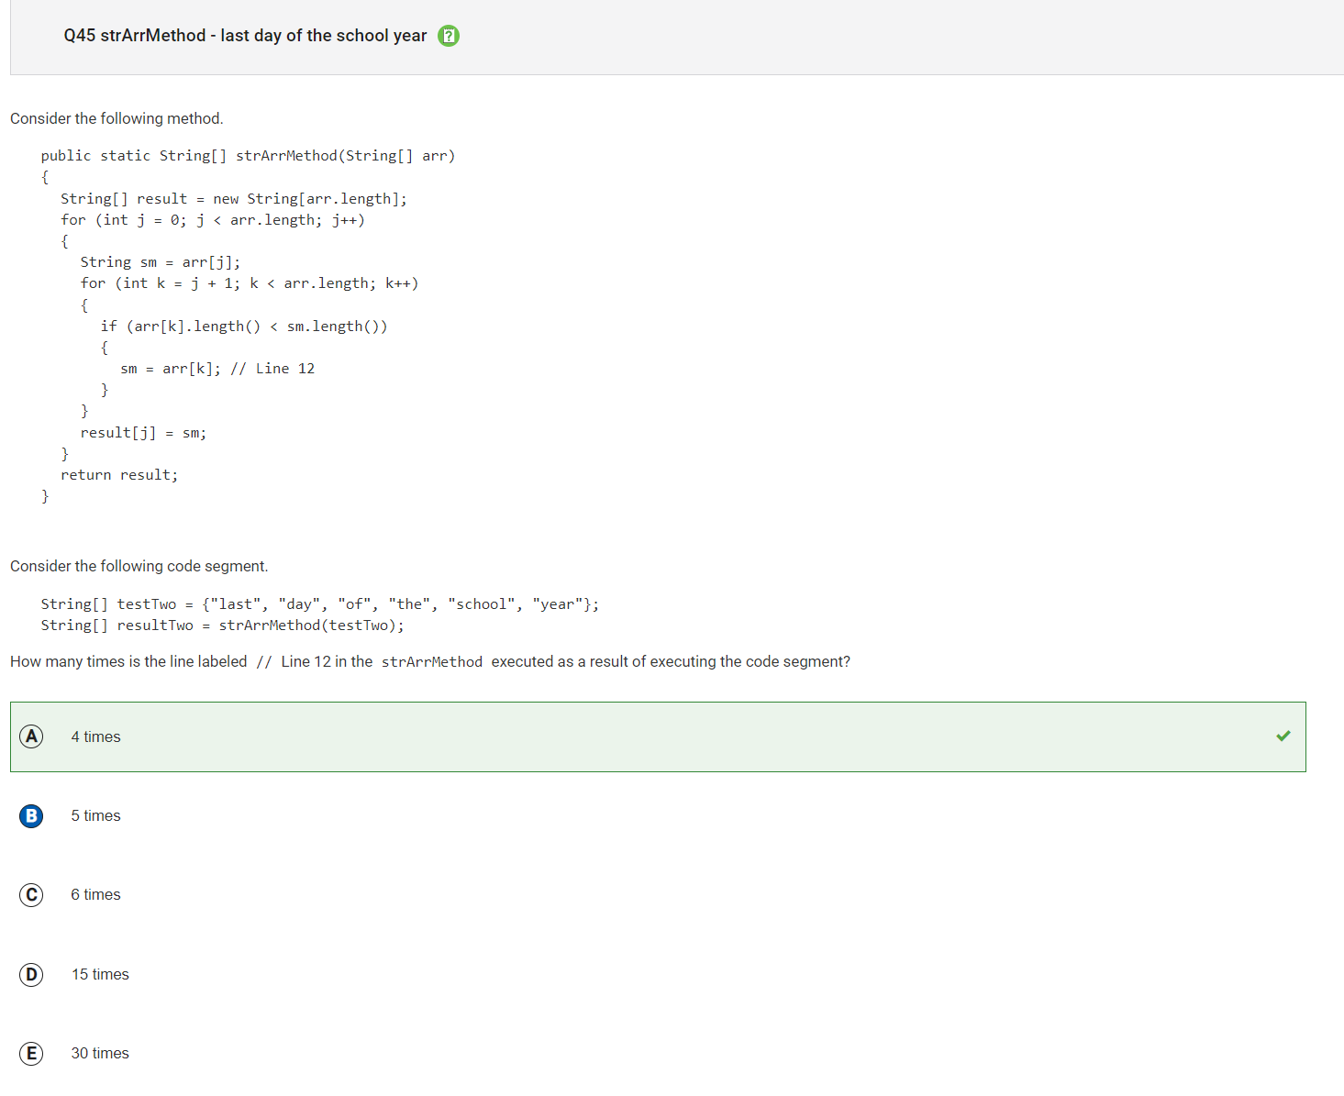

B is incorrect because this would be the answer if sm was updated when a string shorter than arr[j] was found instead of a new smallest value being found.