**DEEN DAYAL UPADHYAYA COLLEGE**

**(UNIVERSITY OF DELHI)**



**PRACTICAL FILE**

**(Artificial Intelligence)**

**NAME :** SAKSHAM NEGI

**COURSE :** B Sc(H) COMPUTER SCIENCE

**ROLL NO. :** 22HCS4146

**SEMESTER :** VI

**SUBMITTED TO:**

MRS. ANUJA SONI

1. **Write a PROLOG program to implement the family tree and demonstrate the family relationship.**

**CODE :**

% gender

male(john).

male(paul).

male(david).

male(mark).

female(lisa).

female(mary).

female(anna).

female(susan).

% parent(child, parent)

parent(paul, john).

parent(paul, lisa).

parent(mary, john).

parent(mary, lisa).

parent(anna, david).

parent(anna, mary).

parent(mark, david).

parent(mark, mary).

% --- Rules ---

father(X, Y) :- parent(X, Y), male(X).

mother(X, Y) :- parent(X, Y), female(X).

parent(X, Y) :- father(X, Y).

parent(X, Y) :- mother(X, Y).

sibling(X, Y) :- parent(Z, X), parent(Z, Y), X \= Y.

brother(X, Y) :- sibling(X, Y), male(X).

sister(X, Y) :- sibling(X, Y), female(X).

grandparent(X, Y) :- parent(X, Z), parent(Z, Y).

uncle(X, Y) :- parent(X, Z), cousin(Z, Y), male(X).

aunt(X, Y) :- parent(X, Z), cousin(Z, Y), female(X).

cousin(X, Y) :- parent(A, X), parent(B, Y), sibling(A, B).

ancestor(X, Y) :- parent(X, Y).

ancestor(X, Y) :- parent(X, Z), ancestor(Z, Y).

**OUTPUT:**

| ?- father(paul, X).

X = john ?

yes

| ?- mother(mary, X).

X = john ?

yes

| ?- brother(john, X).

X = lisa ?

yes

| ?- sister(lisa , X).

X = john ?

yes

| ?- sibling(lisa, X).

X = john ?

yes

| ?- parent(X, paul).

no

| ?- grandparent(anna,X).

X = john ?

yes

| ?- uncle(paul,X).

no

| ?- aunt(mary,X).

no

| ?- cousin(anna,X).

no

| ?- ancestor(anna,X).

X = david ? ;

X = mary ? ;

X = john ?

(16 ms) yes

| ?-

1. **Write a PROLOG program to implement conc(L1, L2, L3) where L2 is the list to be appended with L1 to get the resulted list L3.**

**CODE :**

% conc(L1,L2,L3) where L3 is L2 appended to L1

go :- write('Enter a list : '),read(L1),nl,

write('Enter the list to be appended : '),read(L2),nl,

conc(L1,L2,L3),

write('The new list is : '),write(L3).

conc([],L,L).

conc([H|T1],L2,[H|T3]) :- conc(T1,L2,T3).

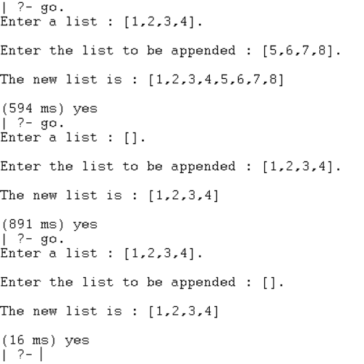**OUTPUT:**

1. **Write a PROLOG program to implement reverse(L, R) where List L is original and List R is reversed list.**

**CODE :**

% Reversing a list reverse(L,R)

go :- write('Enter the List : '),read(L),nl,

myreverse(L,R),

write('The reversed list is '),write(R).

myreverse([],[]).

myreverse([H],[H]).

myreverse([H|T],R) :- myreverse(T,R1),conc(R1,[H],R).

conc([],L1,L1).

conc([H|T],L2,[H|L3]) :- conc(T,L2,L3).

OUTPUT:

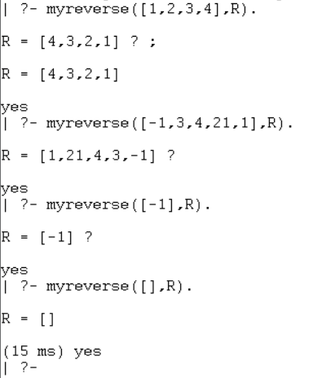

1. **Write a PROLOG program to calculate the sum of two numbers.**

**CODE :**

% Addition of two number

go :- write('Enter the first number'),nl,read(A),

write('Enter the second the number'),nl,read(B),

sum(A,B,C),

write('The Sum is'),nl,

write(C).

sum(X,Y,Z):- Z is X+Y.

**OUTPUT:**

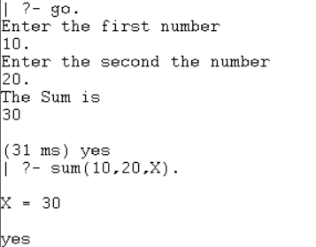

1. **Write a PROLOG program to implement max(X, Y, M) so that M is the maximum of two numbers X and Y.**

**CODE :**

% Maximum of two numbers

go :- write('Enter the first number : '),read(X),nl,

write('Enter the second number : '),read(Y),nl,

max(X,Y,M),

write('Maximum of the two numbers is : '),write(M).

max(X,Y,M) :- X>=Y,

M is X.

max(X,Y,M) :- X<Y,

M is Y.

**OUTPUT:**

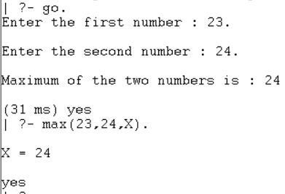

1. **Write a program in PROLOG to implement factorial (N, F) where F represents the factorial of a number N.**

**CODE :**

% Implement factorial (N,F) where

fact(0,1).

fact(N,F) :- N>0,

N1 is N-1,

fact(N1,F1),

F is N*F1.

**OUTPUT:**

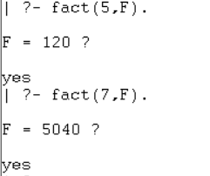

1. **Write a program in PROLOG to implement generate_fib(N,T) where T represents the Nth term of the Fibonacci series.**

**CODE :**

% PROLOG to implement generate_fib(N,T)

fibo(1,0):- !.

fibo(2,1):- !.

fibo(3,1):- !.

fibo(A,X):- M is A-1,

N is A-2,

fibo(M,W),

fibo(N,L),X is W+L.

**OUTPUT:**

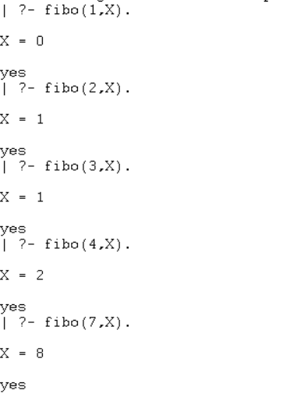

1. **Write a PROLOG program to implement power (Num, Pow, Ans) : where Num is raised to the power Pow to get Ans.**

**CODE :**

% power(Num, Pow, Ans)

power(Num,0,1) :- !.

power(Num,Pow,Ans):-

Pow > 0,

Pow1 is Pow - 1,

power(Num,Pow1,Temp),

Ans is Temp * Num.

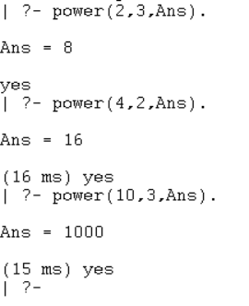**OUTPUT:**

1. **PROLOG program to implement multi (N1, N2, R) : where N1 and N2 denotes the numbers to be multiplied and R represents the result.**

**CODE :**

% multi(N1,N2,R) : where R is N1*N2

multi(N1,N2,R):-

R is N1 * N2.

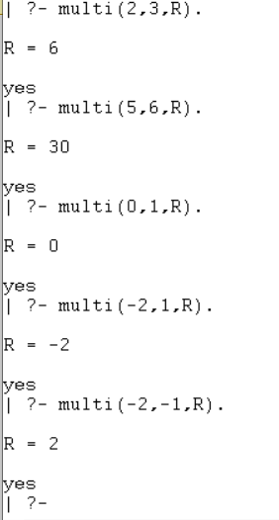**OUTPUT:**

1. **Write a PROLOG program to implement memb(X, L): to check whether X is a member of L or not.**

**CODE :**

% Member function to check if X is a member of L.

go :- write('Enter the element : '),read(X),nl,

write('Enter the list : '),read(L),

mem(X,L).

mem(X,[X|_]).

mem(X,[H|T]):- mem(X,T).

**OUTPUT:**

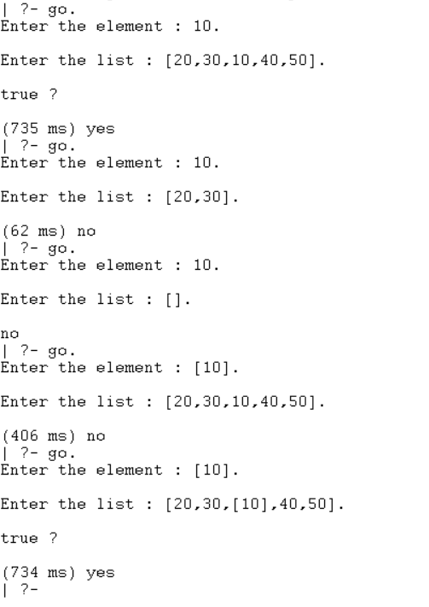

1. **Write a PROLOG program to implement sumlist(L, S) so that S is the sum of a given list L.**

**CODE :**

% Sum of a list sumlist(L,S) S is sum of L

go :- write('Enter the list : '),read(L),nl,

sumlist(L,S),

write('The sum of the list is : '),write(S).

sumlist([],0).

sumlist([H|T],S) :- sumlist(T,R),

S is R+H.

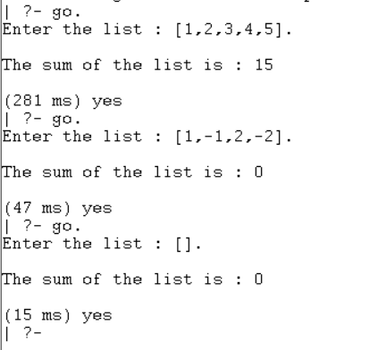**OUTPUT:**

1. **Write a PROLOG program to implement two predicates evenlength(List) and oddlength(List) so that they are true if their argument is a list of even or odd length respectively.**

**CODE :**

% Main program

go :-

write('Enter a list: '), read(L), nl,

( evenlength(L) ->

write('The list is of even length.')

; oddlength(L) ->

write('The list is of odd length.')

;

write('Invalid input.')

).

% evenlength: true if list has even number of elements

evenlength([]).

evenlength([_,_|T]) :- evenlength(T).

% oddlength: true if list has odd number of elements

oddlength([_]).

oddlength([_,_|T]) :- oddlength(T).

**OUTPUT:**

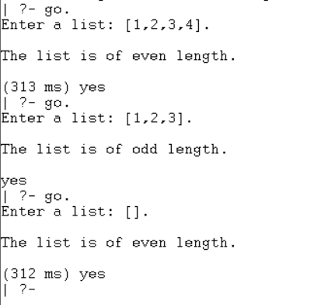

1. **Write a PROLOG program to implement maxlist(L, M) so that M is the maximum number in the list.**

**CODE :**

go :- write('Enter a list : '),read(L),nl,

maxlist(L,M),

write('The maximum element in the list is : '),write(M).

maxlist([X],X) :- !.

maxlist([H1,H2|T],M) :- maxtwo(H1,H2,M1),

maxlist([M1|T],M).

maxtwo(X,Y,M) :- X>=Y,

M is X.

maxtwo(X,Y,M) :- X<Y,

M is Y.

**OUTPUT:**

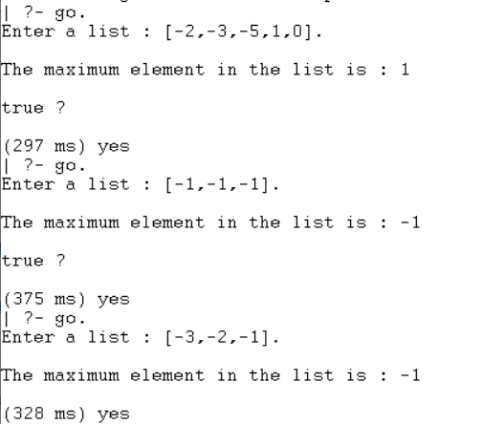

1. **Write a PROLOG program to implement insert(I, N, L, R) that inserts an item I into Nth position of list L to generate a list R.**

**CODE :**

% Insertion at index in list

go :- write('Enter the list : '),read(L),

write('Enter the position : '),read(N),

write('Enter to be inserted : '),read(I),

insert_nth(I,N,L,R),

write('The resultant list is : '),write(R).

insert_nth(I,1,T,[I|T]) :- !.

insert_nth(X,N,[Y|T],[Y|T1]) :- N>1,

N1 is N-1,

insert_nth(X,N1,T,T1).

**OUTPUT:**

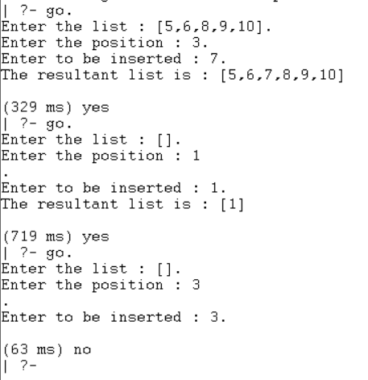

1. **Write a PROLOG program to implement delete(N, L, R) that removes the element on Nth position from a list L to generate a list R.**

**CODE :**

% Deleting the nth element in a list

go :- write('Enter the list : '),read(L),nl,

write('Enter the position : '),read(N),nl,

delete_nth(N,L,R),

write('The new list is : '),write(R).

delete_nth(1,[_|T],T).

delete_nth(N,[H|T1],[H|T2]) :- N>1,

N1 is N-1,

delete_nth(N1,T1,T2).

**OUTPUT:**

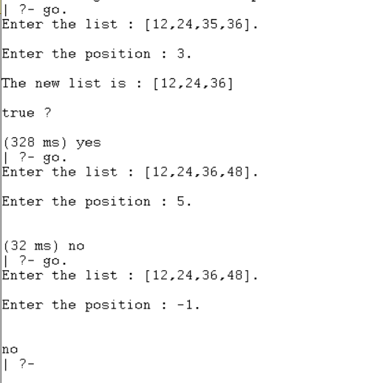

PRACTICE QUESTIONS

**Program1:** Write a Prolog Program for the context Free Grammer that recognizes the following sentence : “ the dog eats the cat”

**Your grammar should support the following structure:**

* A sentence (s) consists of a **noun phrase** (np) followed by a **verb phrase** (vp).
* A noun phrase (np) consists of a determiner (det) followed by a noun (n).
* A verb phrase (vp) consists of a verb (v) followed optionally by another noun phrase (np)

**Define lexical rules for the words:**

* + Determiner: the
  + Nouns: dog, cat
  + Verb: eats

CODE :-

% Grammar rules for CFG

s --> np, vp.

np --> det,n.

vp --> v.

vp --> v,np.

% Lexicons

det --> [the].

n --> [dog].

n --> [cat].

v --> [eats].

OUTPUT :-

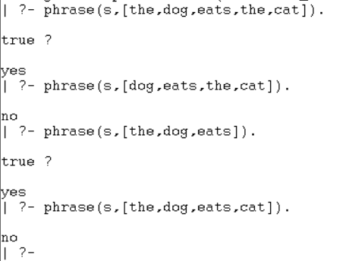

**Program2:** Write a Prolog Program for the context Free Grammer that recognizes the following sentence : “The robot helps the human”

**Your grammar should support the following structure:**

* A sentence (s) consists of a **noun phrase** (np) followed by a **verb phrase** (vp).
* A noun phrase (np) consists of a determiner (det) followed by a noun (n).
* A verb phrase (vp) consists of a verb (v) followed optionally by another noun phrase (np)

**Define lexical rules for the words:**

* + Determiner: the
  + Nouns: robot, human
  + Verb: helps

CODE :-

% Grammar for CFG

s --> np,vp.

np --> det,n.

vp --> v.

vp --> v,np.

% Lexicons

det --> [the].

n --> [robot].

n --> [humans].

v --> [helps].

OUTPUT :-

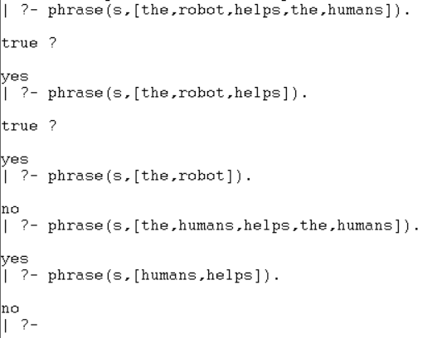

**Program3:** Write a Prolog Program to check if there is a route from one node to another in a directed graph.

The graph is defined by the following edges:

p → q

q → r

q → s

s → t

CODE :-

% Edges

edge(p,q).

edge(q,r).

edge(q,s).

edge(s,t).

%Direct Route

route(X,Y) :- edge(X,Y).

%Indirect Route

route(X,Y) :- edge(X,Z) , route(Z,Y).

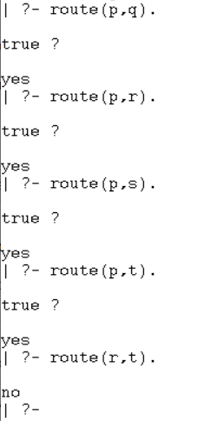**OUTPUT:-**

**Program4:** Write a Prolog Program for the context Free Grammer that recognizes the following sentence : “ The girl reads the book.”

**Your grammar should support the following structure:**

* A sentence (s) consists of a **noun phrase** (np) followed by a **verb phrase** (vp).
* A noun phrase (np) consists of a determiner (det) followed by a noun (n).
* A verb phrase (vp) consists of a verb (v) followed optionally by another noun phrase (np)

**Define lexical rules for the words:**

* + Determiner: the
  + Nouns: girl, book
  + Verb: reads

**CODE :-**

**% Grammar for CFG**

**s --> np,vp.**

**np --> det,n.**

**vp --> v.**

**vp --> v,np.**

**% lexicons**

**det --> [the].**

**n --> [girl].**

**n --> [book].**

**v --> [reads].**

**OUTPUT:-**

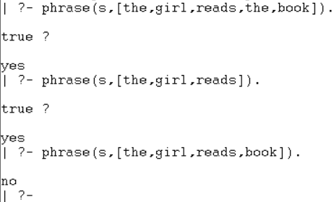

**Program5:** Write a Prolog Program to check if there is a route from one node to another in a directed graph.

The graph is defined by the following edges:

e → f

g → h

i → j

k → l

CODE :-

% Edges

edge(e,f).

edge(g,h).

edge(i,j).

edge(k,l).

% Direct route

route(X,Y) :- edge(X,Y).

% Indirect route

route(X,Y) :- edge(X,Z) , route(Z,Y).

OUTPUT :-

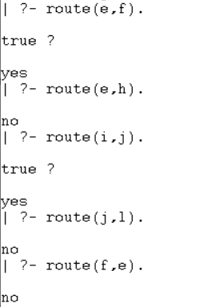

**Program6:** Write a Prolog Program for the context Free Grammer that recognizes the following sentence : “ The boy kicks the ball.”

**Your grammar should support the following structure:**

* A sentence (s) consists of a **noun phrase** (np) followed by a **verb phrase** (vp).
* A noun phrase (np) consists of a determiner (det) followed by a noun (n).
* A verb phrase (vp) consists of a verb (v) followed optionally by another noun phrase (np)

**Define lexical rules for the words:**

* + Determiner: the
  + Nouns: boy, ball
  + Verb: kicks

**CODE :-**

**% Grammar**

**s --> np,vp.**

**np --> det,n.**

**vp --> v.**

**vp --> v,np.**

**% Lexicons**

**det --> [the].**

**n --> [boy].**

**n --> [ball].**

**v --> [kicks].**

**OUTPUT:-**

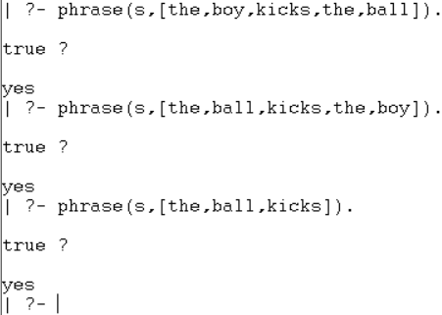

**Program7:** Write a Prolog Program for the context Free Grammer that recognizes the following sentence : “ The bird sees the worm.”

**Your grammar should support the following structure:**

* A sentence (s) consists of a **noun phrase** (np) followed by a **verb phrase** (vp).
* A noun phrase (np) consists of a determiner (det) followed by a noun (n).
* A verb phrase (vp) consists of a verb (v) followed optionally by another noun phrase (np)

**Define lexical rules for the words:**

* + Determiner: the
  + Nouns: bird, worm
  + Verb: sees

**CODE :-**

**% Grammar**

**s --> np,vp.**

**np --> det,n.**

**vp --> v.**

**vp --> v,np.**

**% Lexicons**

**det --> [the].**

**n --> [bird].**

**n --> [worm].**

**v --> [sees].**

**OUTPUT:-**

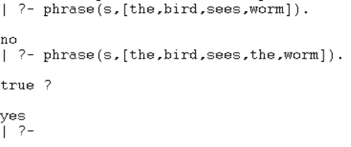

**Program8:** Write a Prolog Program for the context Free Grammer that recognizes the following sentence : “ The chef cooks the meal.”

**Your grammar should support the following structure:**

* A sentence (s) consists of a **noun phrase** (np) followed by a **verb phrase** (vp).
* A noun phrase (np) consists of a determiner (det) followed by a noun (n).
* A verb phrase (vp) consists of a verb (v) followed optionally by another noun phrase (np)

**Define lexical rules for the words:**

* + Determiner: the
  + Nouns: chef, meal
  + Verb: cooks

**CODE :-**

**% Grammar**

**s --> np,vp.**

**np --> det,n.**

**vp --> v.**

**vp --> v,np.**

**% Lexicons**

**det --> [the].**

**n --> [chef].**

**n --> [meal].**

**v --> [cooks].**

**OUTPUT :-**

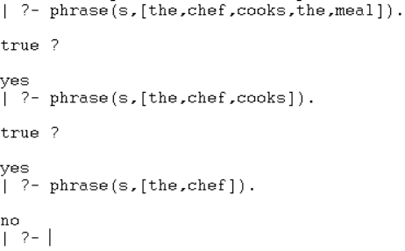

**Program9:** Write a Prolog Program for the context Free Grammer that recognizes the following sentence : “ The lion hunts the deer.”

**Your grammar should support the following structure:**

* A sentence (s) consists of a **noun phrase** (np) followed by a **verb phrase** (vp).
* A noun phrase (np) consists of a determiner (det) followed by a noun (n).
* A verb phrase (vp) consists of a verb (v) followed optionally by another noun phrase (np)

**Define lexical rules for the words:**

* + Determiner: the
  + Nouns: lion, deer
  + Verb: hunts

CODE :-

% Grammar

s --> np,vp.

np --> det,n.

vp --> v.

vp --> v,np.

% Lexicons

det --> [the].

n --> [lion].

n --> [deer].

v --> [hunts].

OUPUT :-

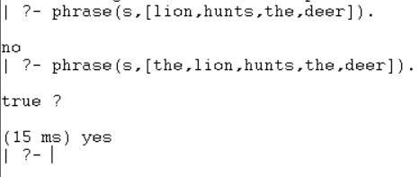

**Program10:** Write a Prolog Program for the context Free Grammer that recognizes the following sentence : “ The teacher scolds the student.”

**Your grammar should support the following structure:**

* A sentence (s) consists of a **noun phrase** (np) followed by a **verb phrase** (vp).
* A noun phrase (np) consists of a determiner (det) followed by a noun (n).
* A verb phrase (vp) consists of a verb (v) followed optionally by another noun phrase (np)

**Define lexical rules for the words:**

* + Determiner: the
  + Nouns: teacher, student
  + Verb: scolds

**CODE :-**

**% Grammar**

**s --> np,vp.**

**np --> det,n.**

**vp --> v.**

**vp --> v,np.**

**% Lexicons**

**det --> [the].**

**n --> [teacher].**

**n --> [student].**

**v --> [scolds].**

**OUTPUT:-**

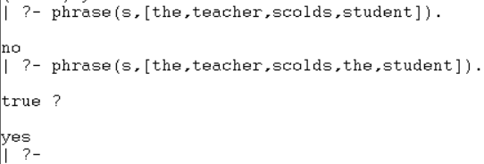

**Program11:** Write a Prolog Program to check if there is a route from one node to another in a directed graph.

The graph is defined by the following edges:

j→ k

l → m

n → o

p → q

CODE :-

% Edges

edge(j,k).

edge(l,m).

edge(n,o).

edge(p,q).

% Direct route

route(X,Y) :- edge(X,Y).

% Indirect route

route(X,Y) :- edge(X,Z), route(Z,Y).

OUPUT:-

