**Parking System Project**

Tables

1. Table 1 (static row number column numb)

1. Table 2 (static row number column number)

1. Table 3 (Dynamic Rows)

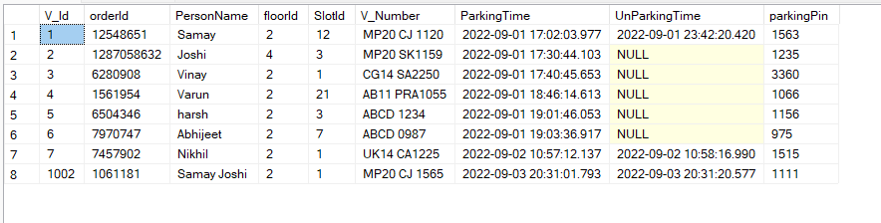

Stored Procedures

1. Procedure to get parking data

1. Procedure to get floor (slots) availability data according to the choice

1. Insert vehicle and owner data records into Vehicle table.

1. Procedure to SET and UNSET the Parking slots according to the floors

1. Procedure to Update Parking time (During Unparking of the vehicle)

1. Procedure to Validate the vehicle owner using password pin.

Project Screenshots

1. Main Menu

1. For Incorrect Option

1. Getting Parking Availability
2. Case 1 (When there are slots available)

1. Case 2 (When there are slots available in some floors)

1. Case 3 (When there are no slots available in the entire parking)

1. Park a vehicle (Option 2)
   1. Getting Floor wise availability

1. Incorrect choice of floor

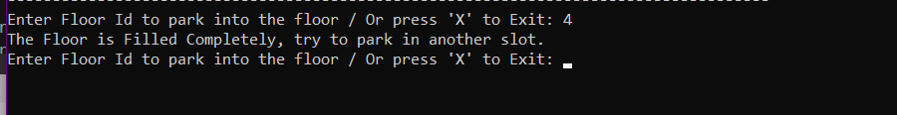

* 1. Correct choice will show the floor wise availability of the slots

1. Incorrect Choice

* 1. Correct Choice will lead to other options

* 1. A message with some credentials will be appeared, which will be needed during unparking.

1. Unparking a Vehicle (Option 3)

This option will ask for some credentials

After correct Input Vehicle will be unparked.

The slots and the parking data will be changed accordingly.

And the vehicle table will store the data of vehicle and owner with timestamp

