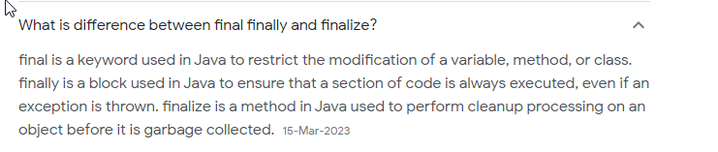

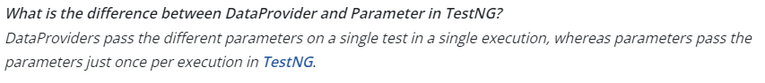

Capgemini

Framework explanation

Annotations

Difference between @dataprovider and @parameter

Reverse string and print vowels

Difference between inner and outer join

What is encapsulation

Constructors, this, super

Difference between delete and drop

