

**Database Management System-IT2040**

**Election and election center information management System**

**Name| R.D.S.H.Jayawardena**

**Student ID| IT20074968**

Page 1

**1.Requirements**

* Election duty officer has a :Election_ID(unique) , name , age , salary and address
* Commissioner of election is a Election duty officer with the following attributes: service_period , email and Telephone.
* Polling clerks are also Election duty officer they have: working hours.
* Election duty Police officers are also Election duty officer they have following attributes: police station.
* Candidates have candidate_ID(unique) , District , NIC and Name .
* Election is an Entity with following attributes: name , starting time , ending time , date and budget
* Election centers have a center_ID(unique), Constituency, Name(e.g.”counting or voting”) and No of clerks.
* One election has a one commissioner and one commissioner can manage on multiple elections
* One candidate can participate a many election and one election has a many candidates , It is must for a candidate has a party.
* Many polling clerks work on a one election center and one polling clerk can work in one election center
* One candidate has a one party and one party has a many candidates.
* Parties have a color , name(unique) , secretary and president.
* Many parties participant an one election .
* If a candidate wins , he will be given a position, position is weak entity it has Salary , Name , service period and No of votes.
* Foreign Election observers monitoring the election , many observer can monitoring the one elections and observer has following attributes :Name , Organization(e.g.”PAFFREL”) , Organization_ID (unique) and Country.
* Polling clerk use a postal vote during the relevant period , postal vote has following attributes:Name , Duty of election, Administrative district and Serial number(unique).
* Voter is an entity it has :Name , NIC(unique) , Age and Address . One Voter can vote a many Elections after reaching the required age.
* Election commission has a departments ,department has a Dep_ID(unique),secretary,name,telephone and No_employee .
* One commissioner can manage many departments
* One election centers has many vehicles ,election duty vehicle has following attributes: Vehicle number(unique),type,payment and driver name.

Page 2

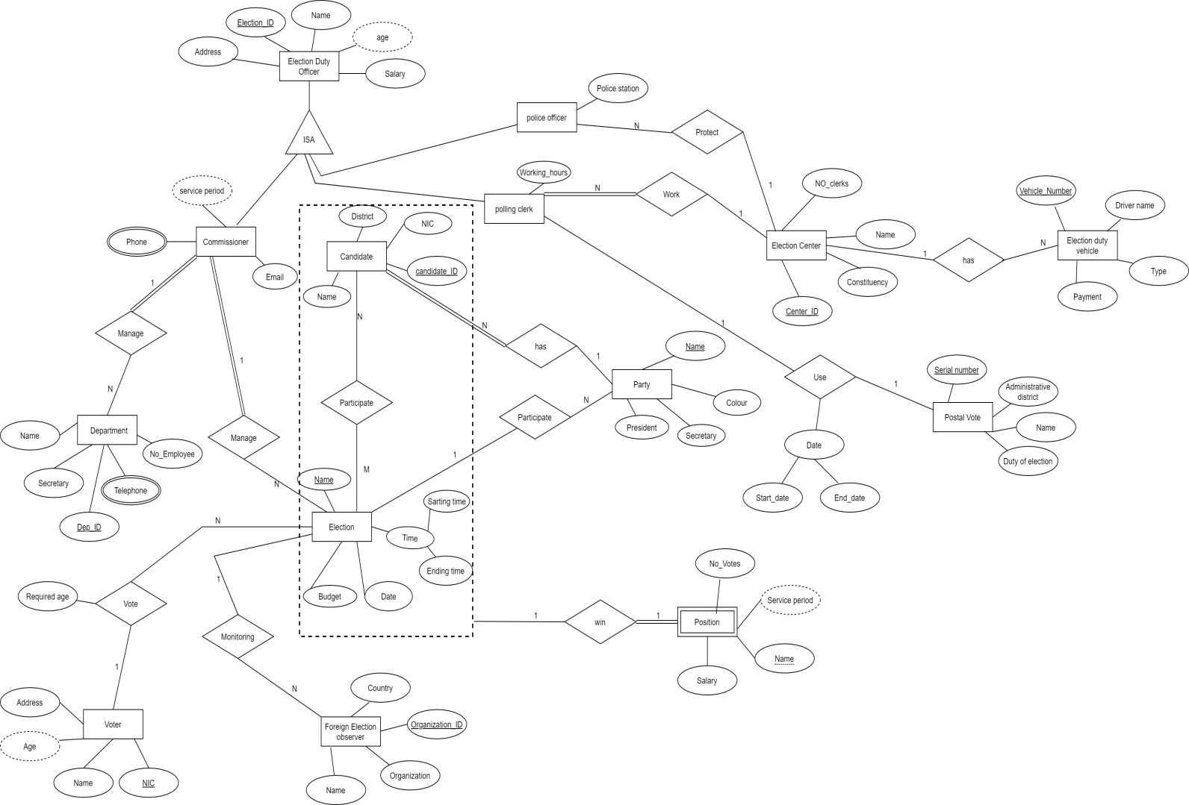**2.EER Diagram**

Page 3

**3.Relational model**

I selected **option 1** to draw the relational table for ISA hierarchy Because of that Election duty officer is a super class and commissioner , polling clerk and police officer are subclasses . These 3 subclasses not totally cover the super class .And these subclasses has many relations . option 3 and 4 are not suitable because these superclass has 3 subclasses and the have many attributes .

* Election_duty_officer(Election_ID, Address, Name, Age, Salary)
* Commissioner(Election_CID, Service period, Email)

foreign key(Election_CID) references Election_duty_officer(Election_ID)

* Commissioner_Phone(Election_CID, Phone)

foreign key(Election_CID,Phone) references Commissioner(Election_CID)

* Polling_clerk(Election_PCID, Work hours, Center_ID)

foreign key(Election_PCID) references Election_duty_officer(Election_ID)

foreign key(Center_ID) references Election_center(Center_ID)

* Police_officer(Election_POID, Center_ID, Police station)

foreign key(Election_POID) references Election_duty_officer(Election_ID)

foreign key(Center_ID) references Election_ceter(Center_ID)

* Election_center(Center_ID, No_clerks, Name, Constituency)
* Postal_vote(Serial number, Administrative district, Name, Duty of election, Start_date, End_date, Election_PCID)

foreign key(Election_PCID) references polling_clerk(Election_PCID)

* Department(Dep_ID, Secretary, No_Employee, Name, Election_CID)

Foreign key(Election_CID) references Commissioner(Election_CID)

* Department_Phone( Dep_ID, Phone)

foreign key(Dep_ID,Phone) references Department(Dep_ID)

Page 4

* Candidate(Candidate_ID, District, NIC, Name, Party name)

foreign key(Party name) references Party(Name)

* Participate(Candidate_ID, Election Name)

foreign key(Candidate_ID,Election Name) references Candidate(Candidate_ID)

foreign key(Candidate_ID,Election Name) references Election(Name)

* Election(Name, Starting time, Ending time, Date, Budget, NIC, Election_CID, Required age)

foreign key(Election_CID) references Commissioner(Election_CID)

foreign key(NIC) references Voter(NIC)

* Party(Name, Colour, Secretary, President, Election Name)

foreign key(Election Name) references Election(Name)

* Voter(NIC, Age, Name, Address)
* Foreign_Election_Observer(Organization_ID, Name, Organization, Country, Election Name)

foreign key(Election Name) references Election(Name)

* Position (Name, Candidate_ID, Election Name, Salary, Service period, No_Votes)

foreign key(Candidate_ID,Election Name) reference Participate(Candidate_ID,Election Name)

* Postal_Vote(Serial Number, Administrative district, Name, Duty of election, Start_date, End_date, Election_PCID)

foreign key(Election_PCID) references Polling_clerk(Election_PCID)

* Election_duty_vehicle(Vehicle number, Type, Driver name, Payment, Center_ID)

Foreign key(Center_ID) references Election_center(Center_ID)

Page 5

**4.Queries**

**Query 1**

What are the addresses where more than two officers from the same address of the C12 Election center are serving?

select count(p.election_POID),e.address

FROM Election_duty_officer e,election_center c,police_officer p

where e.election_id=p.election_POID and p.center_ID = c.center_ID and p.center_ID='C12'

GROUP BY e.address

having count(p.election_POID)>2

**Query 2**

What are the Election_POID of police officer who earn more than RS:25000?

select P.election_POID

from police_officer p

where exists (select*

from Election_duty_officer e

where e.election_id=p.election_POID and e.salary>25000

)

Page 6

**5.Function or Procedure**

Function for returns the salary of police officer in a given election_POID

create function getmysal(@did char(10))returns int

as

begin

declare @sal int

select @sal = e.salary

from Election_duty_officer e,police_officer p

where e.election_id=@did AND e.election_id=p.election_POID

return @sal

end

----Calling the function created previously-------

declare @show int

exec @show =getmysal'E044'

PRINT @show

**6.Trigger**

create trigger center_idinsert

on police_officer

for insert,update

as

begin

declare @center_ID char(10)

declare @election_POID CHAR(10)

declare @police_station varchar(10)

select @center_ID=center_ID ,@election_POID= election_POID, @police_station =police_station from inserted;

if @center_ID is null set @center_ID = @police_station;

if @police_station is null set @police_station = @center_ID;

insert into police_officer(election_POID,center_ID,police_station)

values(@center_ID,@election_POID,@police_station);

end

Page 7