**Project Title:** **Workforce Administration Solution (Admin)**

**By**

**SAMBAREDDY SAIPRIYA**

**Email id: saipriya080604@gmail.com**

**Project Abstract**

The Workforce Administration Solution is an innovative software platform designed to streamline employee management within organizations. By automating processes related to project assignments, asset management, and performance tracking, it provides a centralized system to oversee employee activities. The system allows for tracking the number of projects an employee is working on, as well as managing the assets they are assigned, ensuring greater efficiency and accountability.

With this solution, users can engage in real-time Salesforce projects, implement data modeling, and customize user interfaces. The platform also supports importing bulk data, enhancing scalability, while maintaining high security standards within the Salesforce environment. Additionally, the solution fosters collaboration among groups, promoting teamwork and collective productivity.

Through its integrated reporting and dashboard features, the Workforce Administration Solution provides insights that help organizations monitor performance and make informed decisions. By leveraging these capabilities, businesses can better manage their workforce, ensure effective project execution, and optimize asset utilization. This tool is a comprehensive solution aimed at improving both individual and organizational performance across multiple business functions.

**INDEX PAGE**

|  |  |
| --- | --- |
| **Topics** | **Page No.** |
| TASK 1 | 4-5 |
| TASK 2 | 6-8 |
| TASK 3 | 8-9 |
| TASK 4 | 9-10 |
| TASK 5 | 11-15 |
| TASK 6 | 16 |
| TASK 7 | 17 |
| TASK 8 | 17-18 |
| TASK 9 | 18-20 |
| TASK 10 | 21 |
| TASK 11 | 22-24 |
| TASK 12 | 24-25 |
| TASK 13 | 26 |
| TASK 14 | 27-28 |
| TASK 15 | 28-29 |
| TASK 16 | 29-30 |
| TASK 17 | 31 |

**INTRODUCTION**

The Workforce Administration Solution is a comprehensive Salesforce-based application designed to optimize workforce and asset management. It streamlines the tracking of employee projects, performance, and asset assignments, serving as a centralized hub for organizational efficiency. By automating administrative tasks, the solution reduces manual effort and enhances productivity, enabling better resource utilization and oversight.

This innovative tool equips organizations with powerful features, including data modeling, interface customization, bulk data handling, and security measures. Additionally, it fosters collaboration and provides actionable insights through advanced reporting and dashboard capabilities, ensuring informed decision-making.

**TASK1: Create and activate salesforce account**

**1.1 Creating Developer Account**

Creating a developer org in salesforce.   
1. Go to <https://developer.salesforce.com/signup>  
2. On the sign up form, enter the following details :

1. First name & Last name
2. Email
3. Role : Developer
4. Company : College Name
5. County : India
6. Postal Code : pin code

Username : should be a combination of your name and company  
This need not be an actual email id; you can give anything in the format: username@organization.com   
Click on sign me up after filling these. 

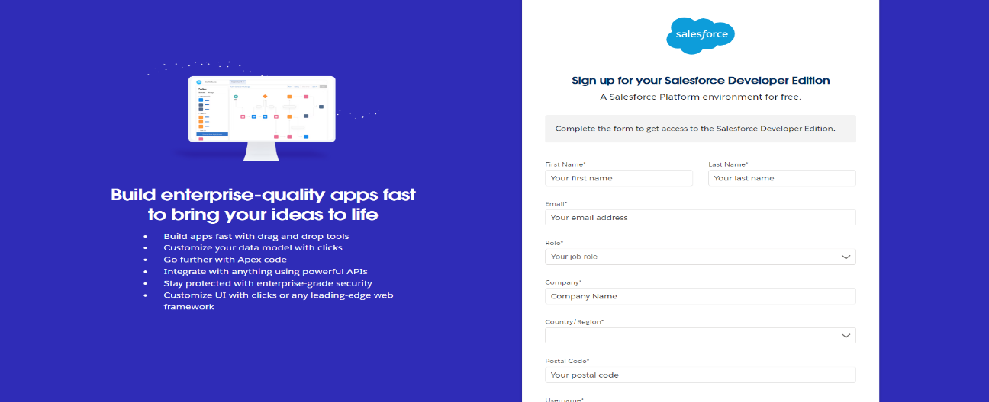

**1.2 Account Activation**

1. Go to the inbox of the email that you used while signing up. Click on the verify account to activate your account. The email may take 5-10mins.

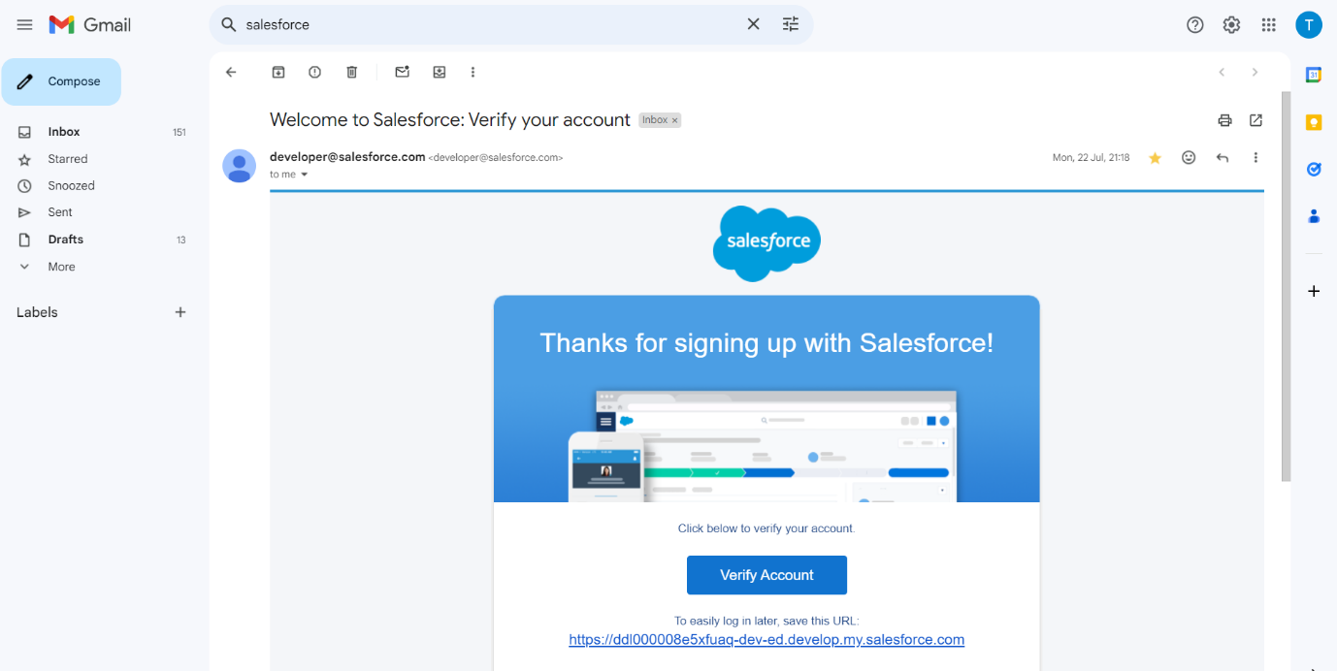2. Click on Verify Account

3. Give a password and answer a security question and click on change password.

4. when you will redirect to your salesforce setup page.

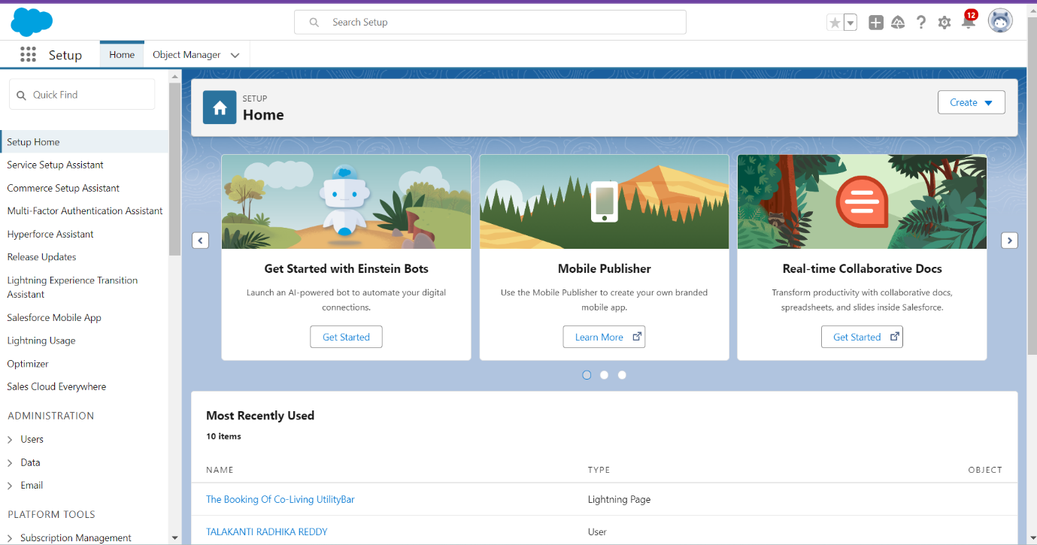

**TASK2: Create Objects**

Salesforce objects are database tables that permit you to store data that is specific to an organization. What are the types of Salesforce objects   
Salesforce objects are of two types:   
  
1. Standard Objects: Standard objects are the kind of objects that are provided by salesforce.com such as users, contracts, reports, dashboards, etc.   
2. Custom Objects: Custom objects are those objects that are created by users. They supply information that is unique and essential to their organization. They are the heart of any application and provide a structure for sharing data.

**2.1 Create a custom object for Employee**

To create a custom object, follow these steps:

1. **From Setup Page**:

* Navigate to **Object Manager**.
* Click **Create** → **Custom Object**.

2. **Enter Details**:

* **Label Name**: Employee.
* **Plural Label**: Employees.

3. **Record Name Configuration**:

* **Record Name**: Employee ID.
* **Data Type**: Auto Number.
* **Display Format**: EMS-{0000}.
* **Starting Number**: 1.

4. **Enable Features**:

* Select **Allow Reports**.
* Select **Allow Search**.

5. **Save**:

* Click **Save** to finalize. 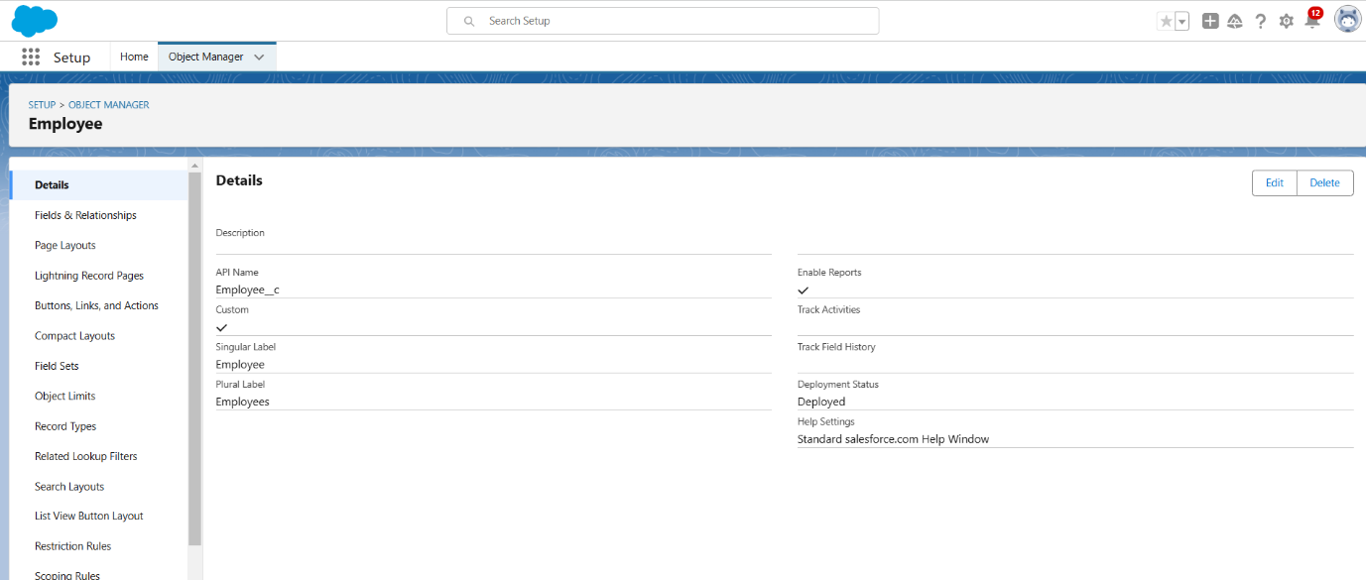

**2.2 Create a custom object for Project**

To create a custom object, follow these steps:

1. **Navigate to Object Manager**:

* From the setup page, click **Object Manager** → **Create** → **Custom Object**.

2. **Enter Object Details**:

* **Label Name**: Project.
* **Plural Label**: Projects.

3. **Record Name Configuration**:

* **Record Name**: Project ID.
* **Data Type**: Auto Number.
* **Display Format**: Proj-{0000}.
* **Starting Number**: 1.

4. **Enable Features**:

* Check **Allow Reports**.
* Check **Allow Search**.

5. **Save**:

* Click **Save** to create the object

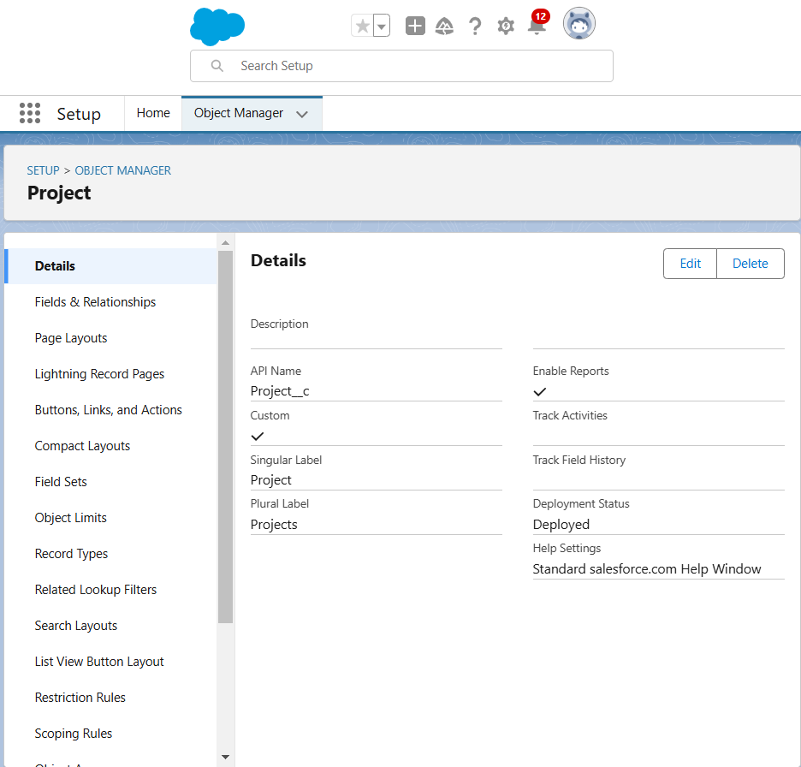

**2.3 Create a custom object for ProjectTask, Asset, Asset Service**

To create a custom object, follow these steps:

1. Same as before steps and data type is text.
2. Follow remaining steps as mentioned previously.

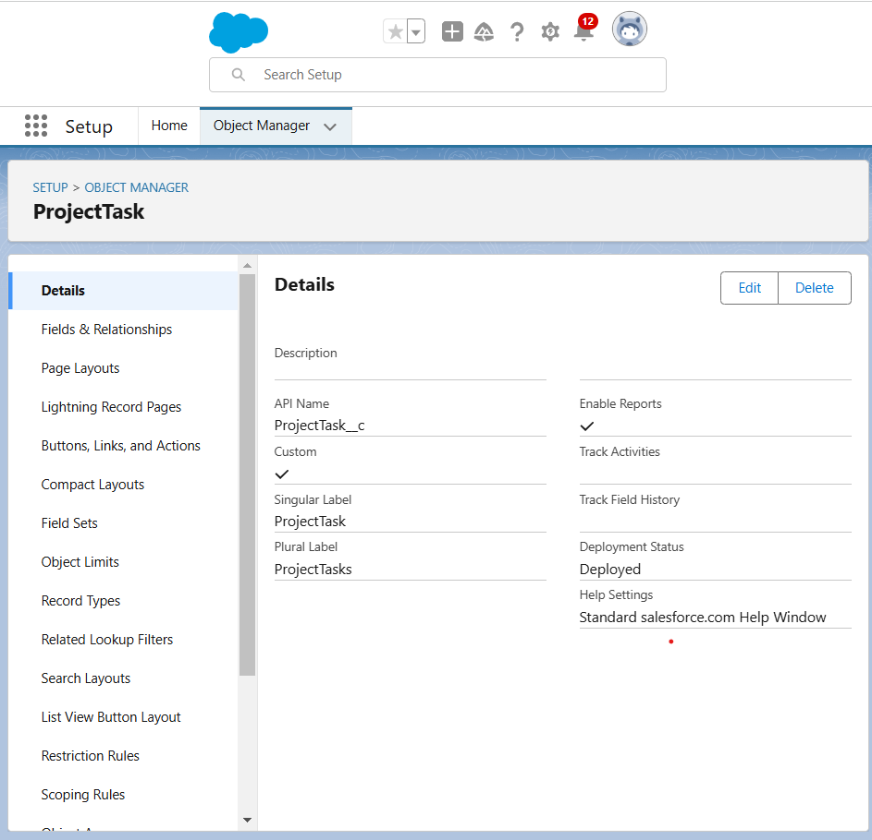

**TASK3: Creating Tabs**

A tab is like a user interface that is used to build records for objects and to view the records in the objects.

Types of Tabs:

1. Custom Tabs
2. Web Tabs
3. Visualforce Tabs
4. Lightning Component Tabs
5. Lightning Page Tabs

**3.1 Creating a Tab for Total Employee**

To create a Tab:(Employee)

1. Go to setup page --> type Tabs in Quick Find bar --> click on tabs --> New (under custom object tab )
2. Select Object(Employee) --> Select any tab style --> Next (Add to profiles page) keep it as default --> Next (Add to Custom App) keep it as default --> Save.
3. Follow the previous steps for remaining objects Project, Project Task, Asset, Asset Service.

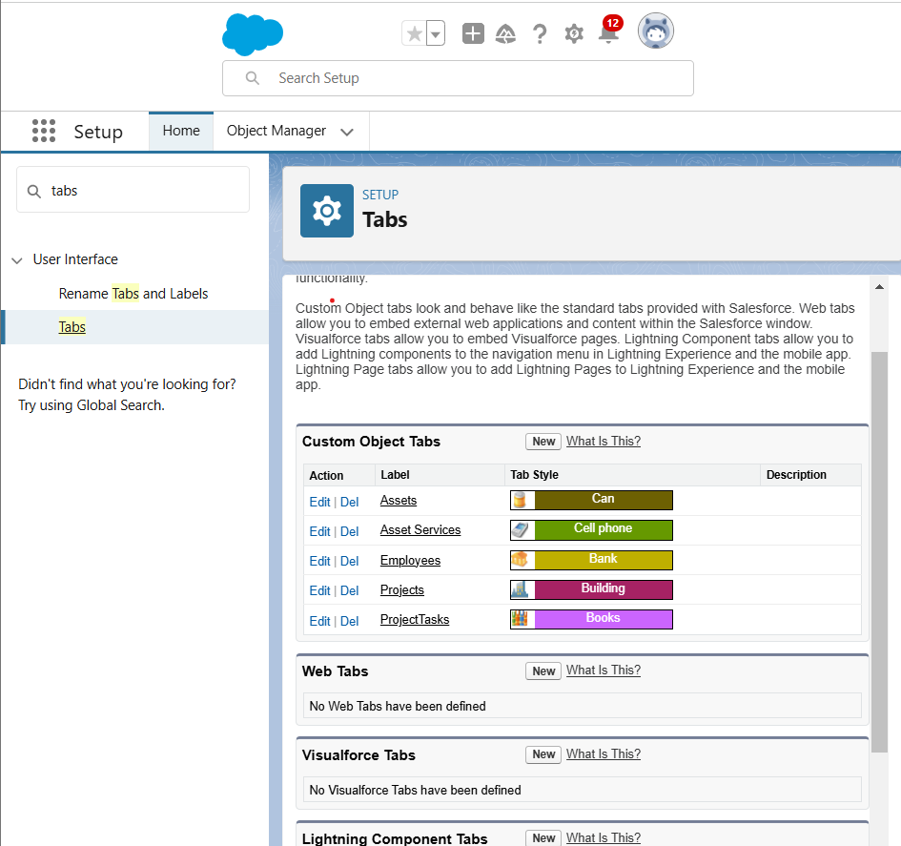

**TASK4: The Lightning App**

An app is a collection of items that work together to serve a particular function. In Lightning Experience, Lightning apps give your users access to sets of objects, tabs, and other items all in one convenient bundle in the navigation bar.

Lightning apps let you brand your apps with a custom color and logo. You can even include a utility bar and Lightning page tabs in your Lightning app. Members of your org can work more efficiently by easily switching between apps.

**4.1 Create a Lightning App**

1. Go to setup page > search “app manager” in quick find > select “app manager” > click on New lightning App.

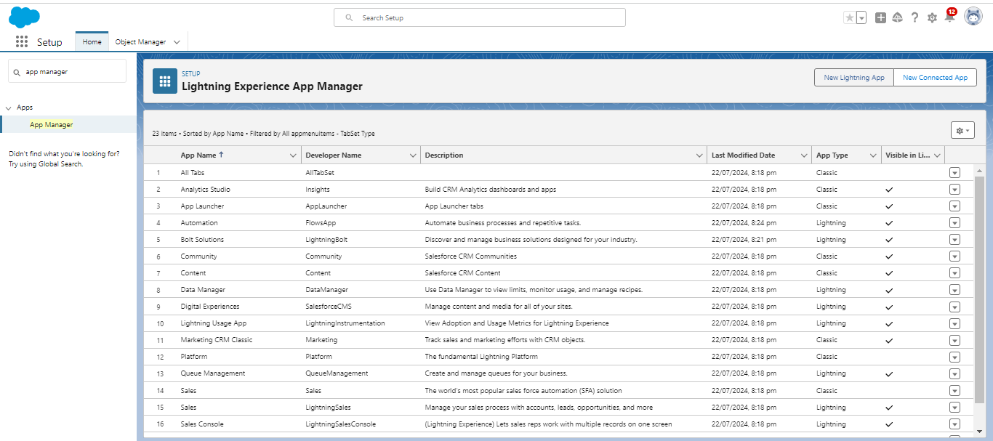  
2. Fill the app name in app details and branding > Next  > (App option page) keep it as default > Next > (Utility Items) keep it as default > Next.

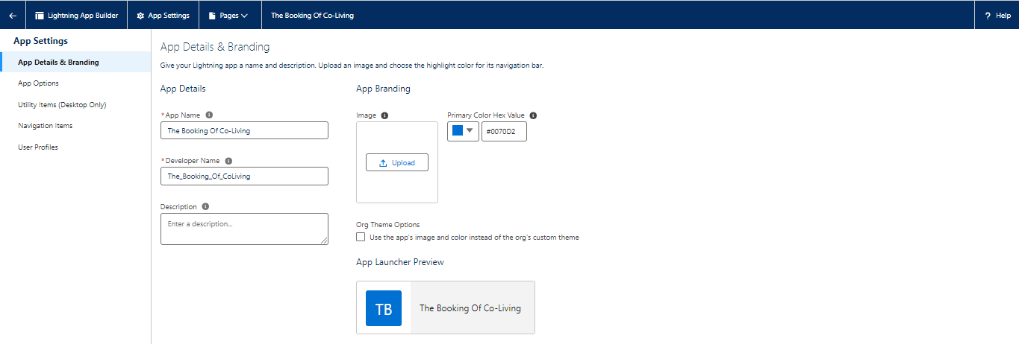

3. To Add Navigation Items: Ctrl and Select the items (Employees, Projects, ProjectTask, Assets, Asset Services, Reports, Dashboard) from the search bar and move it using the arrow button > Next.

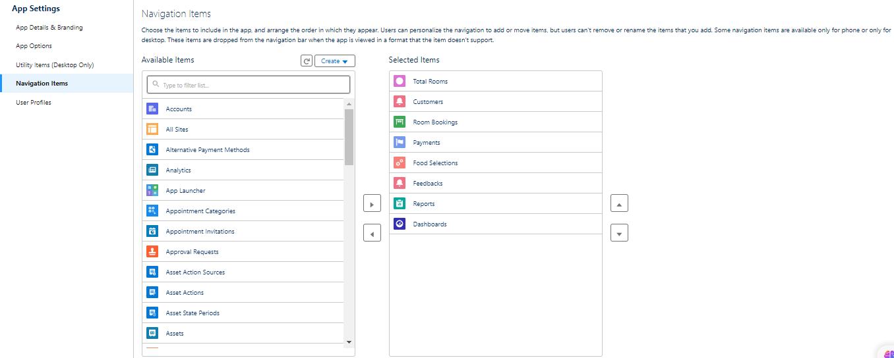  
4. To Add User Profiles:

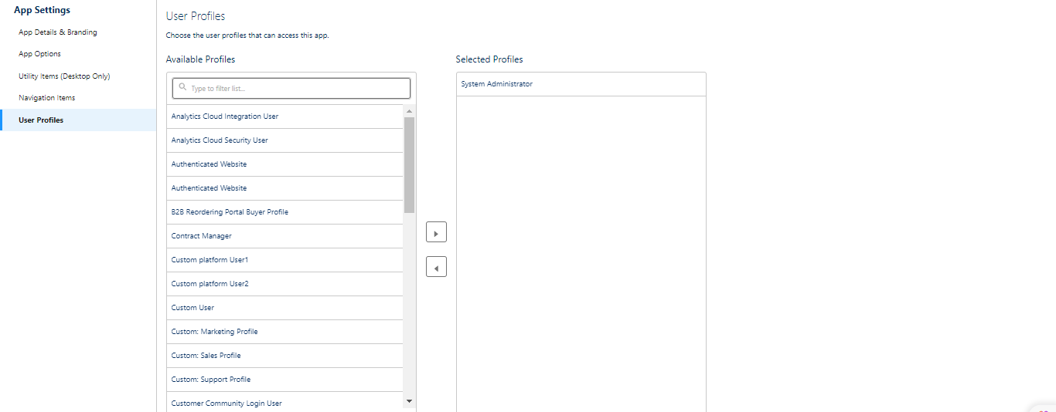

5. Search profiles (System administrator) in the search bar > click on the arrow button > save & finish.

**TASK5: Fields & Relationships**

When we talk about Salesforce, Fields represent the data stored in the columns of a relational database. It can also hold any valuable information that you require for a specific object. Hence, the overall searching, deletion, and editing of the records become simpler and quicker.

Types of Fields

1. Standard Fields
2. Custom Fields

**Standard Fields:**

As the name suggests, the Standard Fields are the predefined fields in Salesforce that perform a standard task. The main point is that you can’t simply delete a Standard Field until it is a non-required standard field. Otherwise, users have the option to delete them at any point from the application freely. Moreover, we have some fields that you will find common in every Salesforce application. They are,

1. Created By

2. Owner

3. Last Modified

4. Field Made During Object Creation

**Custom Fields:**

On the other side of the coin, Custom Fields are highly flexible, and users can change them according to requirements. Moreover, each organizer or company can use them if necessary. It means you need not always include them in the records, unlike Standard fields. Hence, the final decision depends on the user, and he can add/remove Custom Fields of any given form.

### **5.1 Creation of fields for the Employee object**

**5.1.1 To create fields in an object:**1. Go to setup > click on Object Manager > type object name(Employee) in search bar > click on the object.

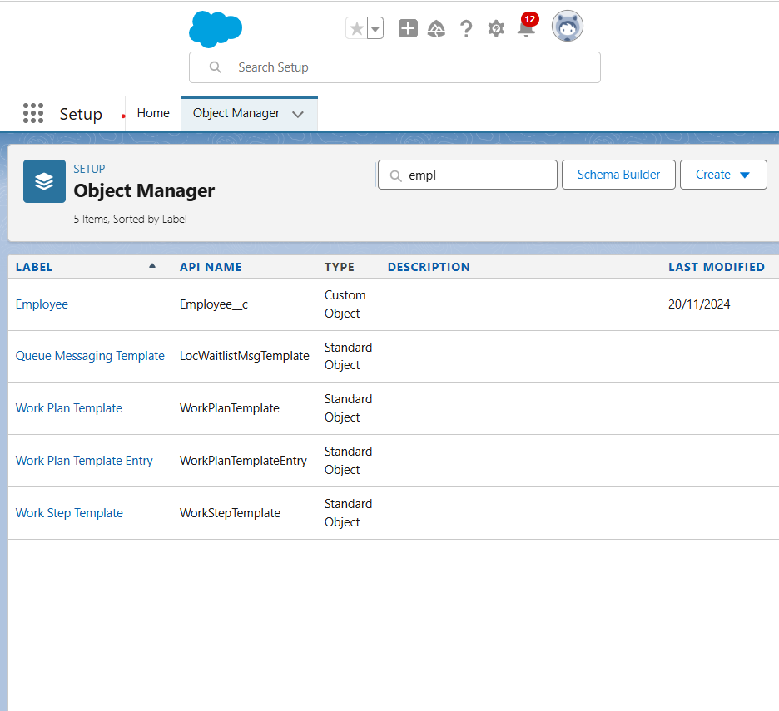

2. Now click on “Fields & Relationships” > New  
3. Select Data Type as a “Text”  
4. Click on next  
5. Fill the Above as following:

1. Field Label: Employee Name
2. Field Name : gets auto generated
3. Click on Next > Next > Save and new.

**5.1.2 To create another fields in an object:**

1. Repeat step 1 and 2 mentioned in activity 1
2. Select Data type as “Date” and click Next.
3. Click on Next.
4. Fill the above as following:

a. Field Label: Date of Birth.

b. Field Name : gets auto generated.

c.  Click on Next --> Next --> Save and new.

**5.1.3 To create another fields in an object:**

1. Go to setup > click on Object Manager > type object name(Employee) in search bar > click on the object.
2. Now click on “Fields & Relationships” ? New
3. Select Data type as a “Formula” and Click on Next
4. Fill the Above as following:

* Field Label: Age
* Field Name : It’s gets auto generated
* Click on Next > Next > Save and new.

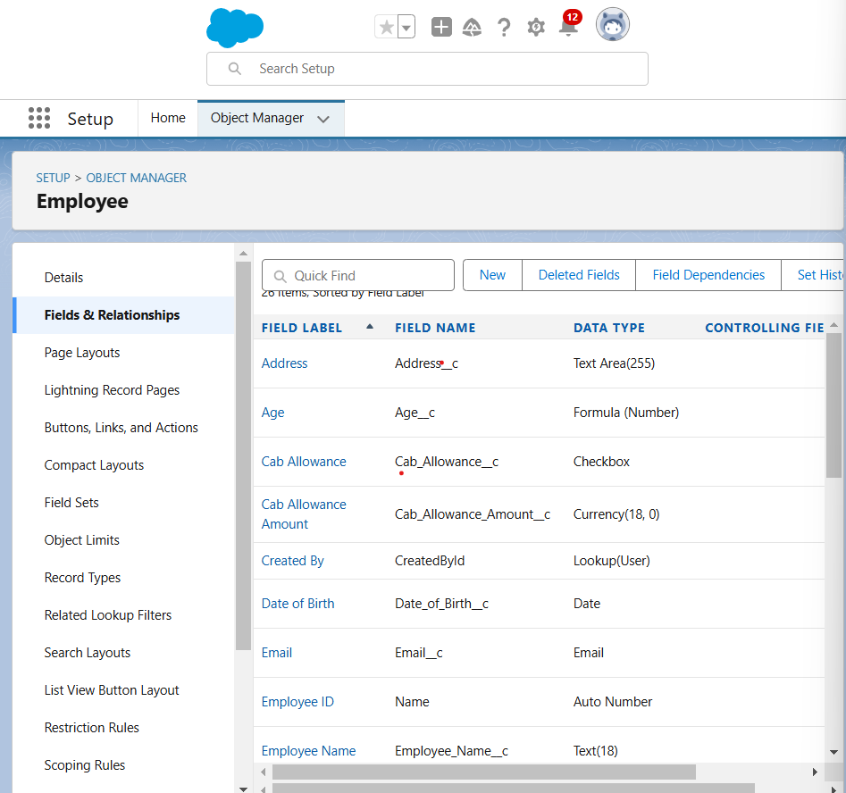

**5.2 Creation of fields between Employee and Asset Object**

**5.2.1 To create fields in an object:** To Create a Master-Detail relationship

1. Go to the setup page --> click on object manager --> type object name(ProjectTask) in the quick find bar --> click on the object.

2. Click on fields & relationship --> click on New.

3. Select “Master-Detail relationship” as data type and click Next.

4. For field label related to: select “Employee” object and click Next.

5. Give Field Label as “Employee Name” and click Next.

6. Next --> Next --> Save & New.

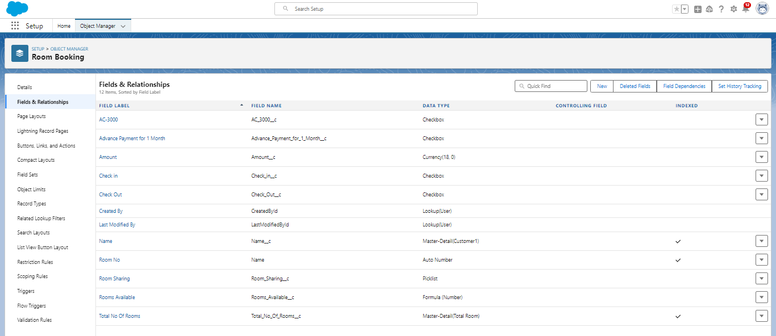

### **5.3 Creation of Fields & Relationship for remaining fields using data types mentioned in the given table**

|  |  |  |
| --- | --- | --- |
| **Sl No** | **Object Name** | **Field** |
| **1** | **Employee** | |  |  | | --- | --- | | **Field Name** | **Data type** | | **1          Qualification** | **Text** | | **2          Address** | **Text Area** | | **3          Experience** | **Text Area** | | **4          Phone no** | **Phone** | | **5          Email** | **Email** | | **6          Joining date** | **Date** | | **7          Mode of Work** | **Picklist: Values**   |  | | --- | | **On Site**  **Remote** | | | **8          Cab Allowance** | **Check box** | | **9          Food Allowances** | **Check box** | | **10          Wifi Allowances** | **Check box** | | **11          Cab Allowance Amount** | **Currency** | | **12          Food Allowance Amount** | **Currency** | | **13          Wifi Allowance Amount** | **Currency** | | **14          Login Time** | **Time** | | **15          Logout Time** | **Time** | | **16          LinkedIn Profile** | **url** | |
| **2** | **Project** | |  |  | | --- | --- | | **Field Name** | **Data type** | | **1      Project Name**  **2          Project Lead**  **3          Start Date**  **4          End Date**  **5          Project Status** | **Text**  **Text**  **Date**  **Date**  **Picklist: Values**   |  | | --- | | **Completed**  **On Going**  **Not Yet Started** | | |
| **3** | **ProjectTask** | |  |  | | --- | --- | | **Field Name** | **Data type** | | **1      Project Task**  **2          Finishes in**      **3          Working Hours**  **4          Employee Name** | **MDR with project object**  **Formula : (Project_Task__r.Start_Date__c  -  Project_Task__r.End_Date__c ) Formula return type: Number**  **Numbers**  **Master Detail relationship with Employee object** |   **Note: here in Finishes in field, Start Date and End Date belong to Employee Object.** |
| **4** | **Asset Service** | |  |  | | --- | --- | | **Field Name** | **Data type** | | **1      Asset Id**    **2          Type**      **3          Technician**  **4          Subject**  **5          Description** | **Lookup relationship with Asset object**  **Picklist: Values**   |  | | --- | | **Technical Issue**  **Non Technical Issue** |   **Text**  **Text Area**  **Text Long** | |
| **5** | **Asset** | |  |  | | --- | --- | | **Field Name** | **Data type** | | **1          Asset Type**              **2      Model Name**  **3          Employee Name**    **4          Date Of Issue** | **Picklist: Values**   |  | | --- | | **Laptop Charger**  **Mouse**  **Monitor**  **CPU** |     **Text**  **Lookup relationship with Employee Object**  **Formula ( Joining date) Formula Return type: date** |   **Note: here in the Date of Issue field, the Joining date field belongs to the Employee Object.** |

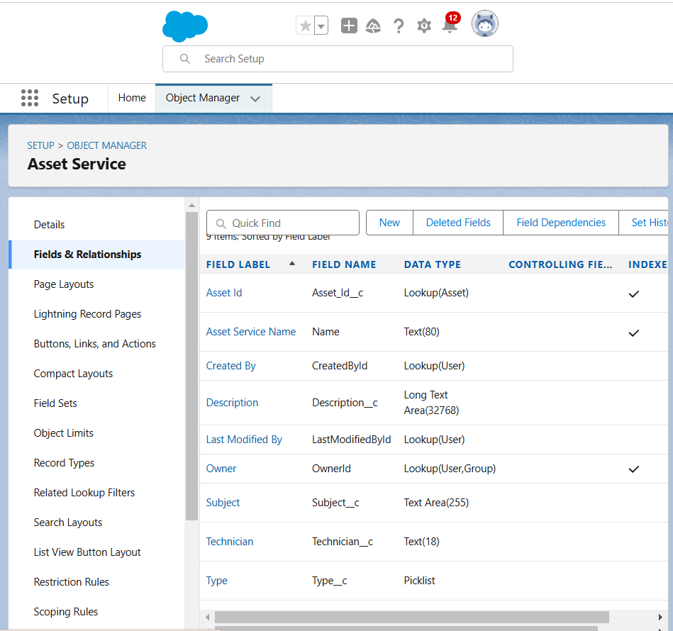

**TASK6: Setting OWD**

Organization-Wide Defaults, or OWDs, are the pattern security rules that you can follow for your Salesforce instance. Organization Wide Defaults are utilized to confine who can access what information in your CRM. You can award access through different methods that we will discuss later (sharing principles, Role Hierarchy, Sales Teams, and Account groups, manual sharing, and so forth).

Primarily, there are four levels of access that can be set in Salesforce OWD and they are-

1. Public Read/Write/Transfer

2. Public Read/Write

3. Public Read/Only

4. Private

**6.1 Create OWD Setting**

1. Go to Set Up --> in the Quick Find box type "Sharing Settings" --> click on it.
2. Click Edit in the Organization-Wide Defaults area.
3. Search for the Employee object.
4. Under default internal access and default external access change the options to “Private” and under grant access using hierarchies select the check box.
5. Click on save.
6. This Setting is for all the Users Which have been Created.

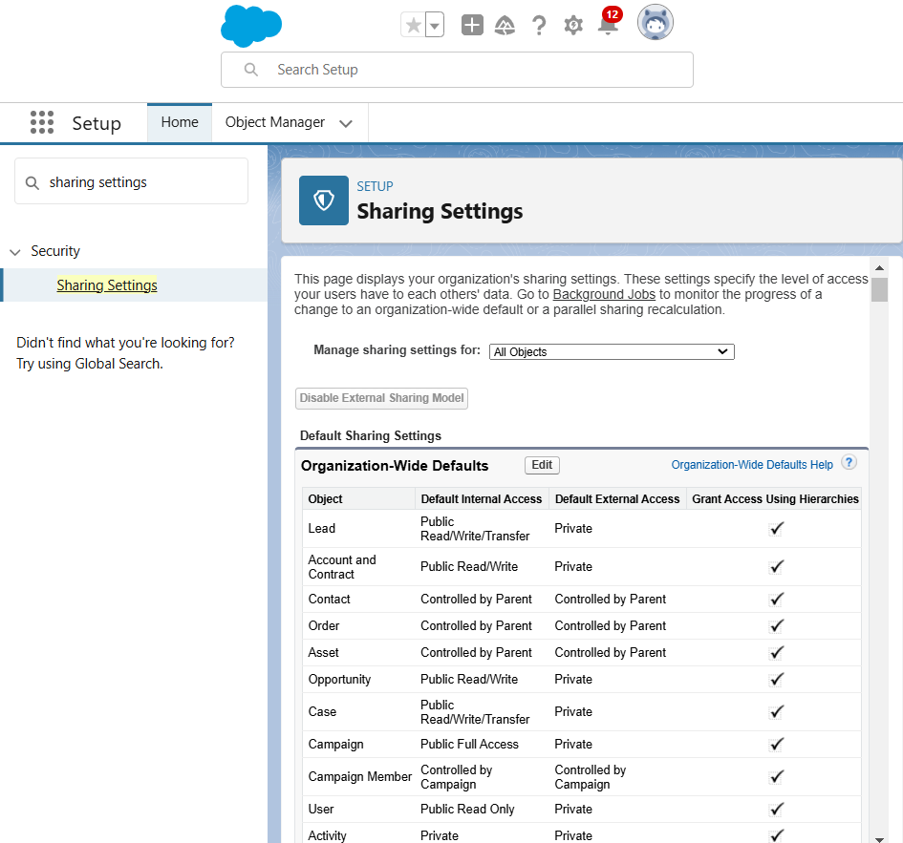

### **6.2 Set OWD as Private for Project and Asset Service objects.**

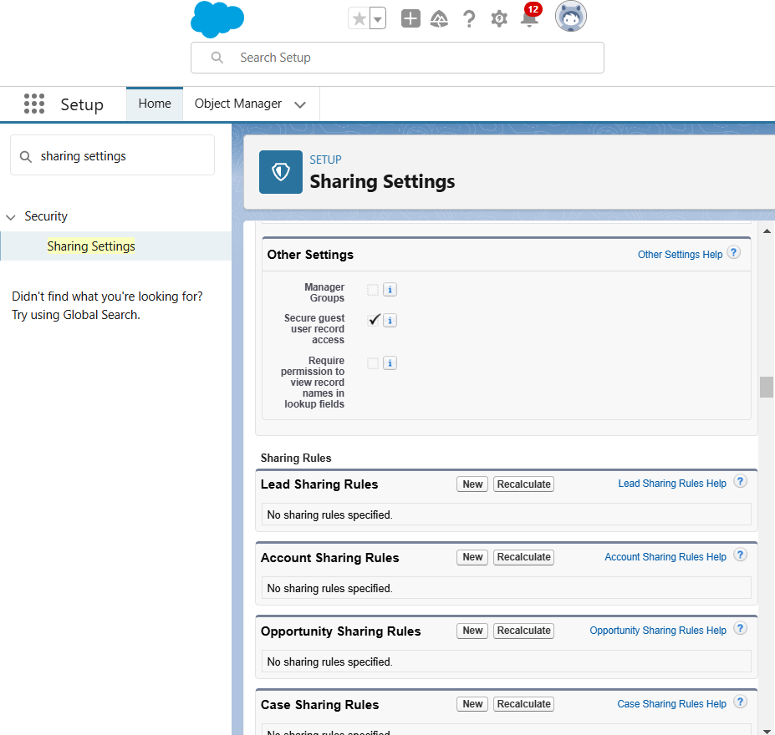

**TASK7: User Adoption**

**7.1 Create a Record(Employee)**

1. Click on App Launcher on the left side of the screen.
2. Search Employee Management System & click on it.
3. Click on the Employee tab.
4. Click  New.
5. Fill the Details and click on Save.

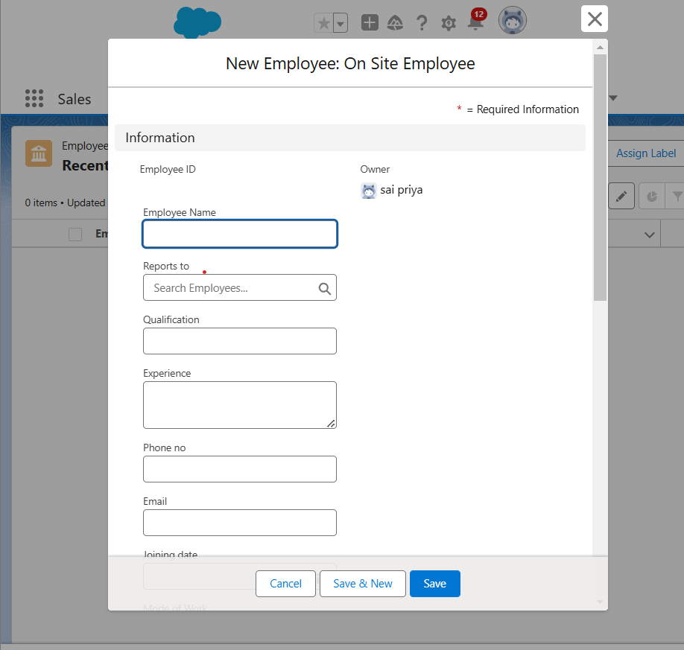

**7.2 View A record (Employee)**

1. Click on App Launcher on the left side of the screen.
2. Search Employee Management System & click on it.
3. Click on the Employee Tab.
4. Click on any record name. you can see the details of the Employee

**7.3 Delete a record(Employee)**

1. Click on App Launcher on the left side of the screen.
2. Search Employee Management System & click on it.
3. Click on the Employee Tab.
4. Click on Arrow at right hand side on that Particular record.
5. Click delete.

**TASK8: Import Data**

Data Import lets you upload data from external sources and combine it with data you collect via Analytics. You can then use Analytics to organize and analyze all of your data in ways that better reflect your business.

1. From Setup, click the Home tab.
2. In the Quick Find box, enter Data Import and select Data Import Wizard.
3. Click Launch Wizard.
4. Click the Custom Objects tab and select the Employee object.
5. Select Add new records.
6. Click CSV and choose file Employee_CSV which we made earlier. Click Next.
7. Since the field names in the CSV file (CSV Header) are the same as the field names in your object (Mapped Salesforce Object), the fields are automatically mapped. Click Next.
8. The next screen gives you a summary of your data import. Click Start Import.
9. Click OK on the popup.
10. Scroll down the page and verify that your data has been imported under batches.
11. Make sure you have 0 records under the records failed column.

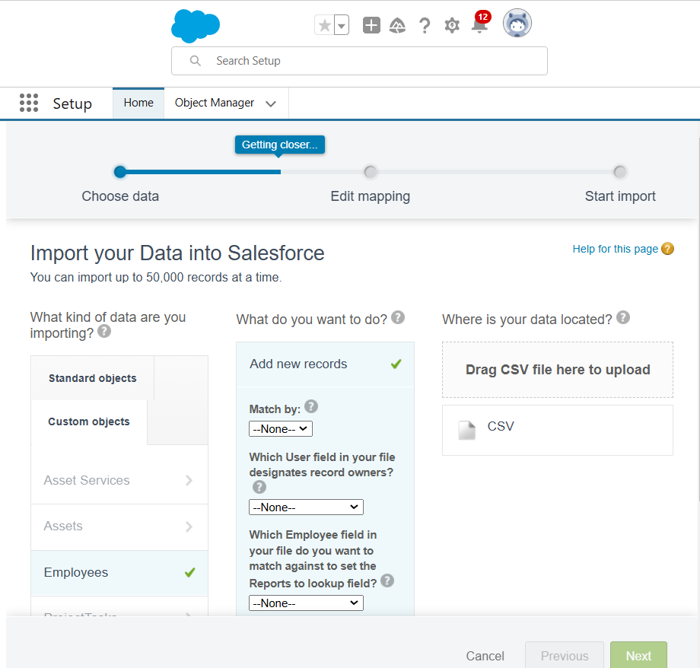

**TASK9: Creating Profiles**

A profile is a group/collection of settings and permissions that define what a user can do in salesforce. Profile controls “Object permissions, Field permissions, User permissions, Tab settings, App settings, Apex class access, Visualforce page access, Page layouts, Record Types, Login hours & Login IP ranges. You can define profiles by the user's job function. For example, System Administrator, Developer, Sales Representative.

Types of profiles in salesforce

1. Standard profiles:

By default, salesforce provides below standard profiles.

* Contract Manager
* Read Only
* Marketing User
* Solutions Manager
* Standard User
* System Administrator.

2. Custom Profiles:

Custom ones defined by us.

They can be deleted if there are no users assigned with that particular one.

**9.1 Custom user Profile**

1. To create a new profile: 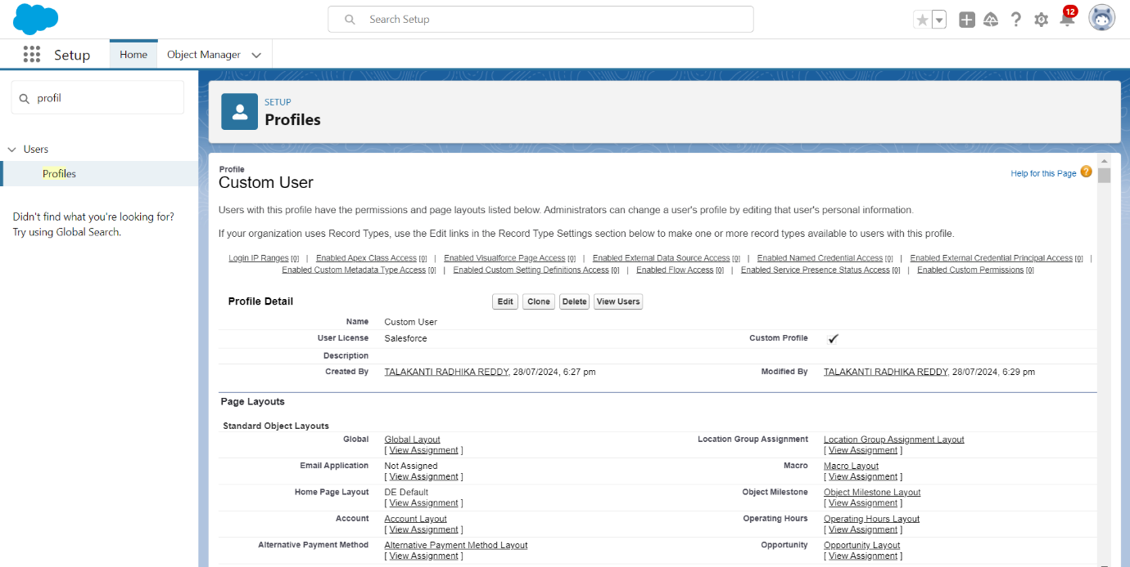Go to setup > type profiles in quick find box > click on profiles > clone the desired profile (Standard User)

2. Enter profile name (Custom User) > Save.

3. While still on the profile page, then click Edit.

4. Scroll down to Custom Object Permissions and Give All access permissions for Customers, Feedbacks, Food selections, Payments, Room Bookings and Total Rooms.

5. Scroll down and Click on Save.

**9.2 Custom platform HR**

To create a new profile:

1. **Access Profiles**:

* Go to **Setup** → Type **Profiles** in the Quick Find box → Click on **Profiles**.

2. **Clone Desired Profile**:

* Select the profile to clone (e.g., **Standard User**) → Click **Clone** → Enter the new profile name (e.g., **HR**) → Click **Save**.

3. **Edit the Profile**:

* On the profile page, click **Edit**.

4. **Set Permissions**:

* Scroll to **Custom Object Permissions** → Assign access for **Assets** and **Asset Services**.

5. **Save Changes**:

* Click **Save** to apply the updates.

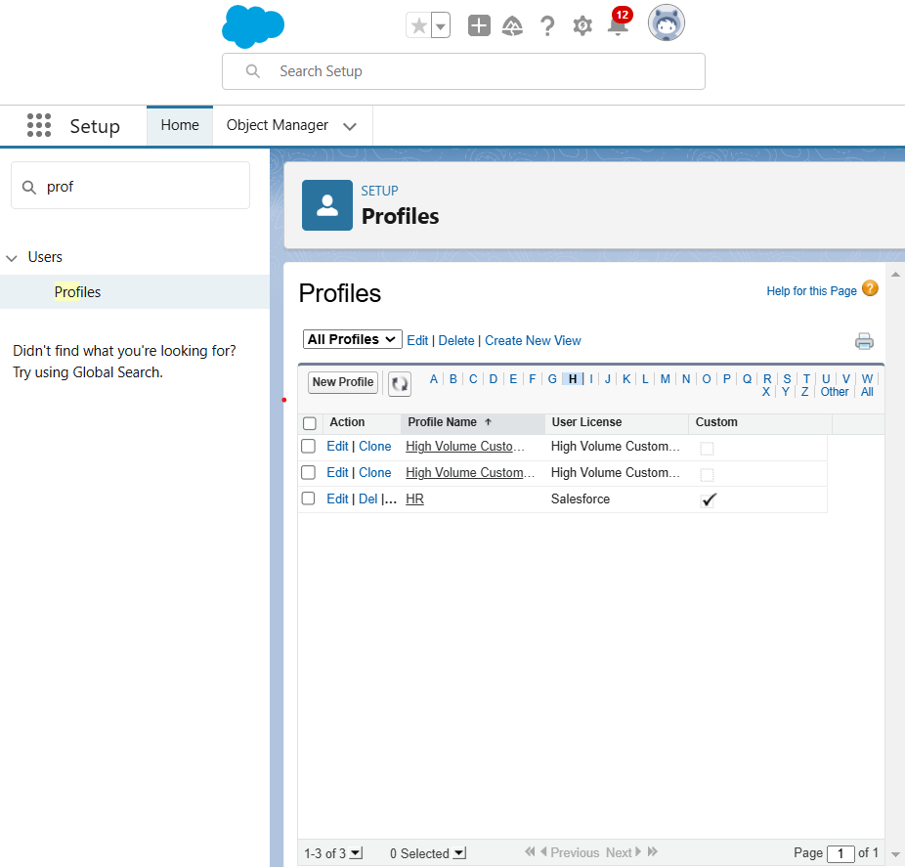

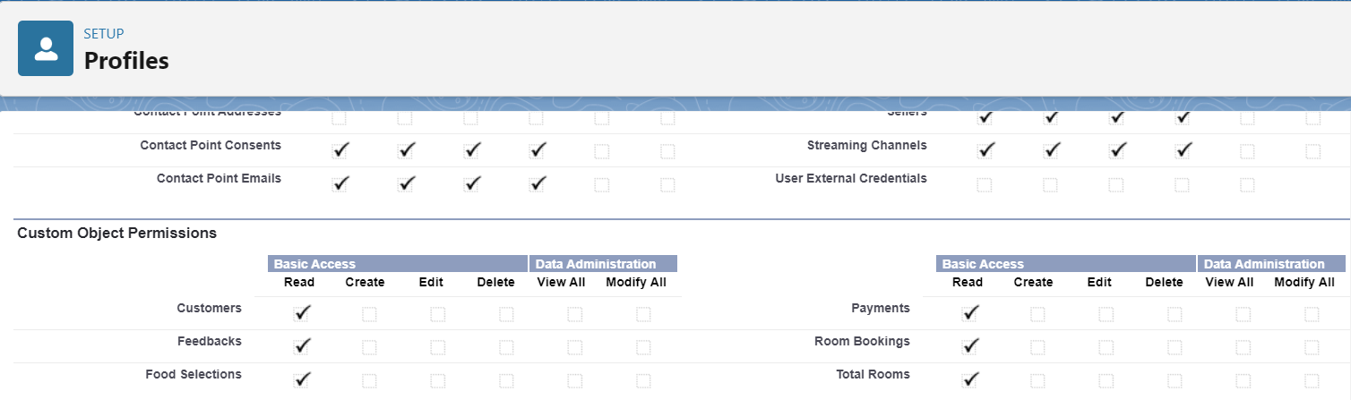

**9.3 Custom platform Manager**

1. Go to setup --> type profiles in quick find box --> click on profiles --> clone the desired profile (Salesforce Platform User) --> enter profile name (Manager) --> Save.

2. While still on the profile page, then click Edit.

3. Scroll down to Custom Object Permissions and Give access permissions for Employee, Project and Project Task objects.

4. Scroll down and Click on Save.

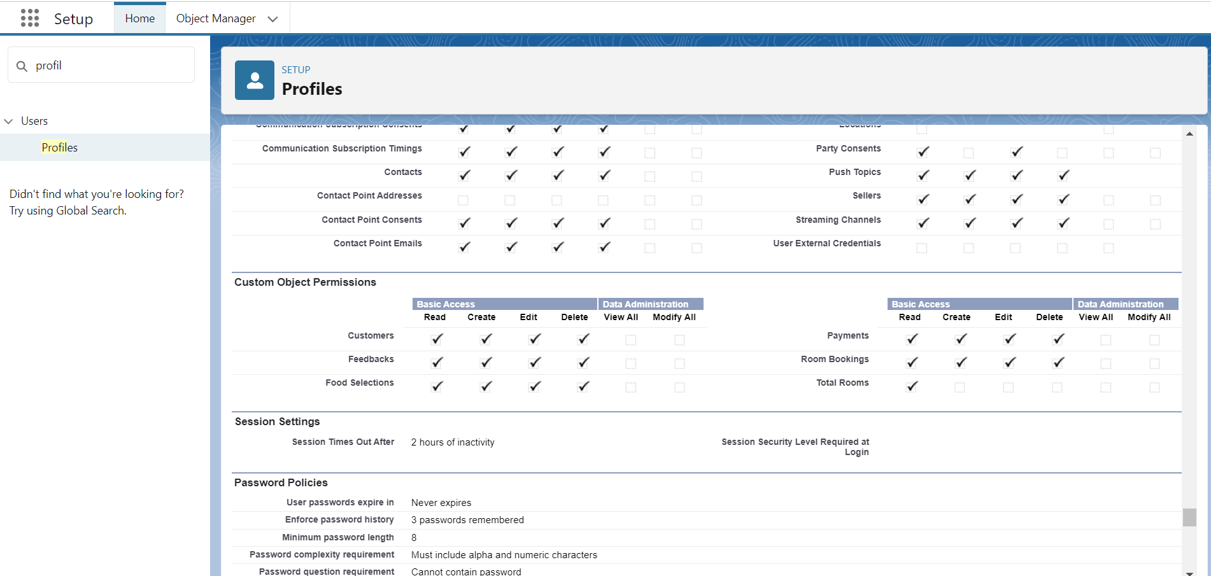

**TASK10: Creating Roles**

A role in Salesforce defines a user's visibility access at the record level. Roles may be used to specify the types of access that people in your Salesforce organization can have to data. Simply put, it describes what a user could see within the Salesforce organization.

**10.1 HR Role**

1. Go to quick find --> Search for Roles --> click on set up roles.

2. Click on Expand All and click on add role under whom this role works.

3. Give Label as “HR” and Role name gets auto populated. Check to whom this role (HR) reports. Then click on Save.

4. Refer the below diagram to understand which role reports to which role.

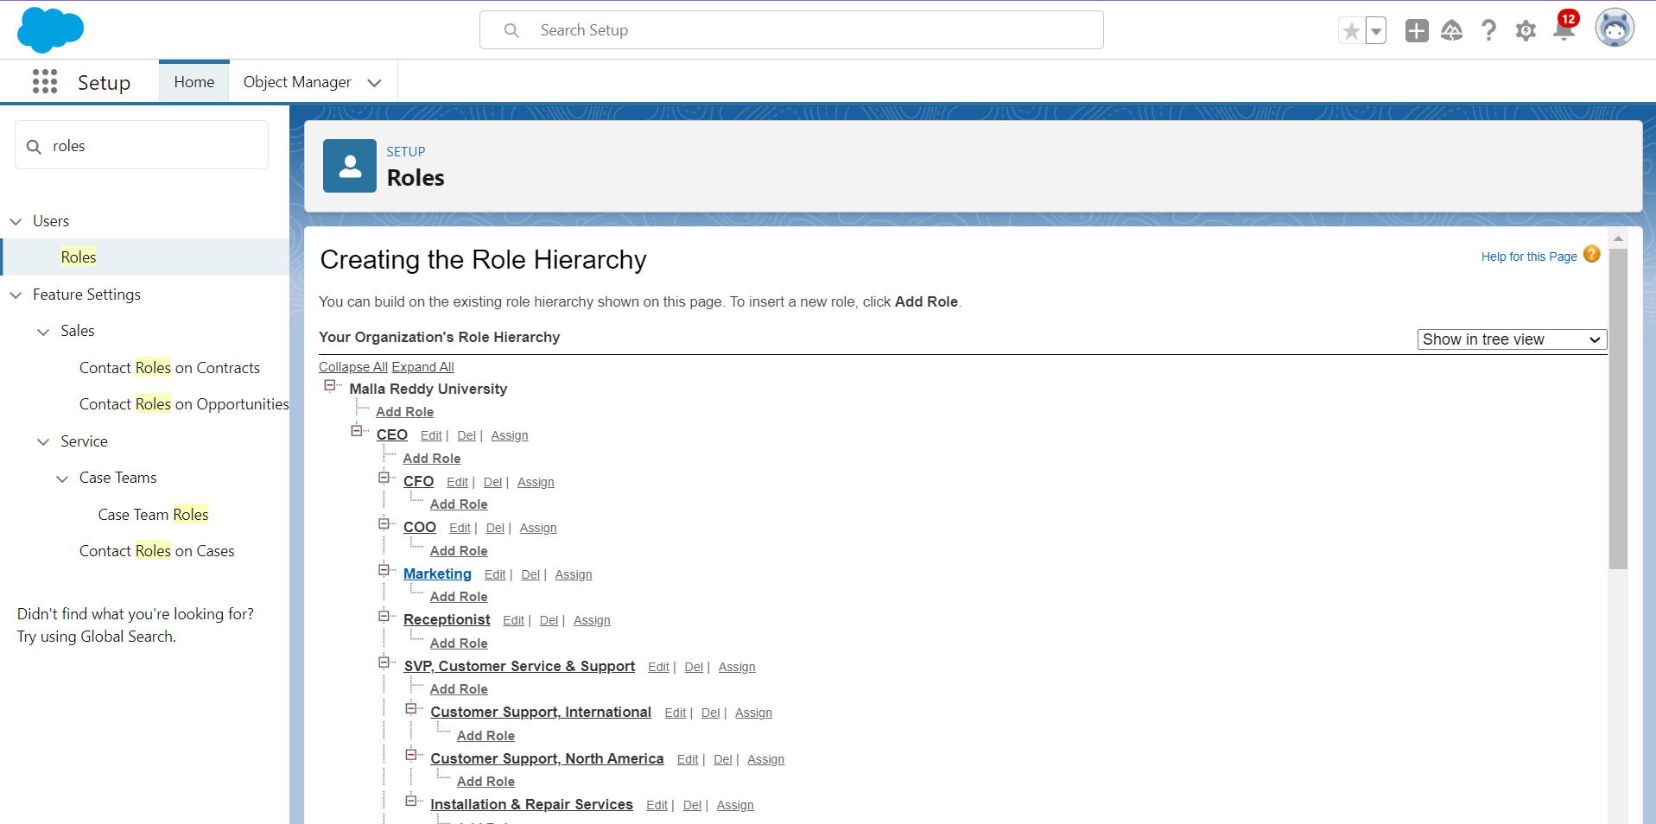

**10.2 Create Three more roles on Manager, On Site Employee, Remote Employee**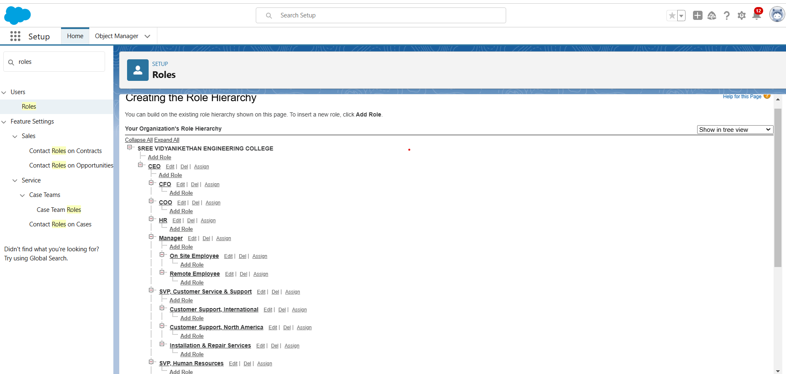

**TASK11: Users**

A user is anyone who logs in to Salesforce. Users are employees at your company, such as sales reps, managers, and IT specialists, who need access to the company's records. Every user in Salesforce has a user account. The user account identifies the user, and the user account settings determine what features and records the user can access.

**11.1 Create User**

1. Go to setup --> type users in quick find box --> select users --> click New user.

2. Fill in the fields

     First Name    : Niklaus

     Last Name    : Mikaelson

     Alias              : nik

     Email id        : saipriya080604@gmail.com

     Username    : Nik@mik.com

     Nick Name   : Nik

     Role              : HR

     User license : Salesforce

     Profiles         : HR  
3.     Save.

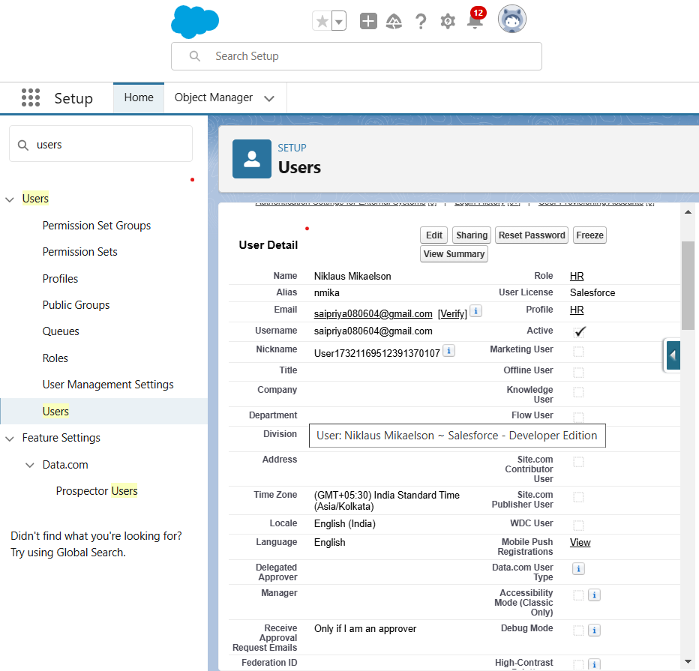

**11.2 Create Another User**

1. Go to setup --> type users in quick find box --> select users --> click New user.

2. Fill in the fields

      First Name    : Kol

       Last Name    : Mikaelson

       Alias              : kol

       Email id        : saipriya080604@gmail.com

       Username      : kol@mik.com

       Nick Name    : kmik

       Role              : Manager

       User license   : Salesforce Platform

       Profiles          : Manager

3. Save.

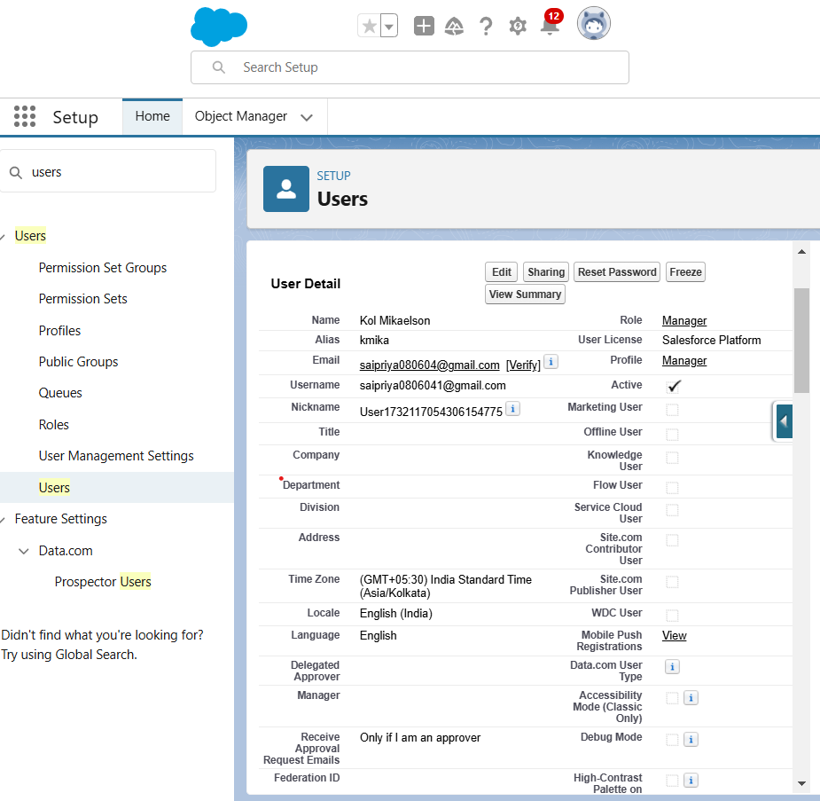

**11.3 Create Another User**

1. Go to setup > type users in quick find box > select users > click New user.
2. Fill in the fields

* First Name : sai
* Last Name : kumar
* Alias : saku
* Email id : saipriya080604@gmail.com
* Username : sai@kumar.com
* Nick Name: skumar
* Role : On Site Employee
* User licence: Salesforce Platform
* Profiles : Manager

1. Save

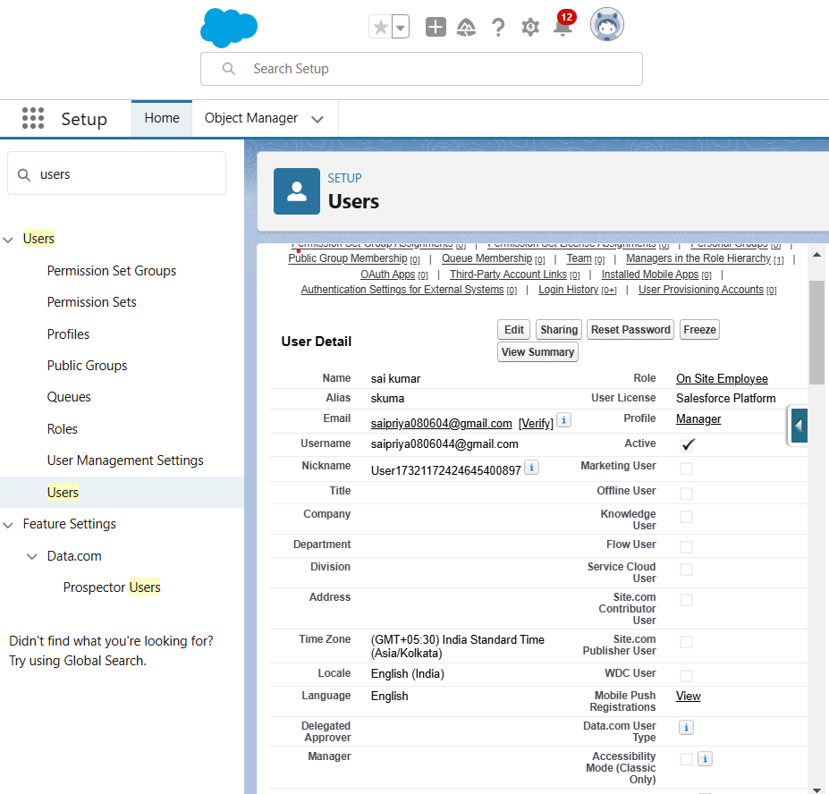

**TASK12: Page Layouts**

Page Layout in Salesforce allows you to customize and organize the detail and edit pages for records. It controls the visibility and arrangement of fields, related lists, and custom links on both standard and custom objects, enhancing the user interface for specific roles or purposes

**12.1 Create a Page layout for Employee Object**

1. Go to Setup > Click on Object Manager > Search for the object (Employee) > From drop down click on Edit.
2. Click on Page layout > Click on New.
3. Give Page layout Name as “On Site Employee Layout” and click on Save.
4. Drag and drop the Section from the highlight panel below the Information and name it as “Personal Information” and click Ok.
5. Drag Date of Birth, Address and Age fields from Employee Information to Personal Information section.
6. Similarly perform the above step to create “Allowances” and add allowances fields in it as shown below.
7. Click Save.
8. Make sure your page layout looks like the picture above.

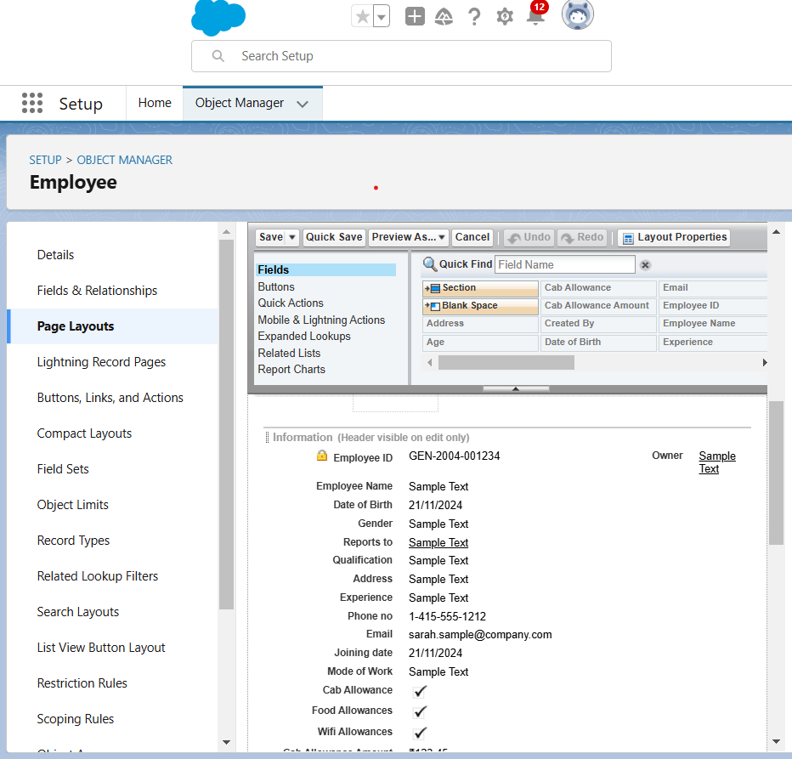

**12.2 Creating another Page Layout**

1. Create another page layout and name it as “Remote Employee Layout”,  and in the allowances section use only Wifi Allowance and Wifi Allowances Amount fields.

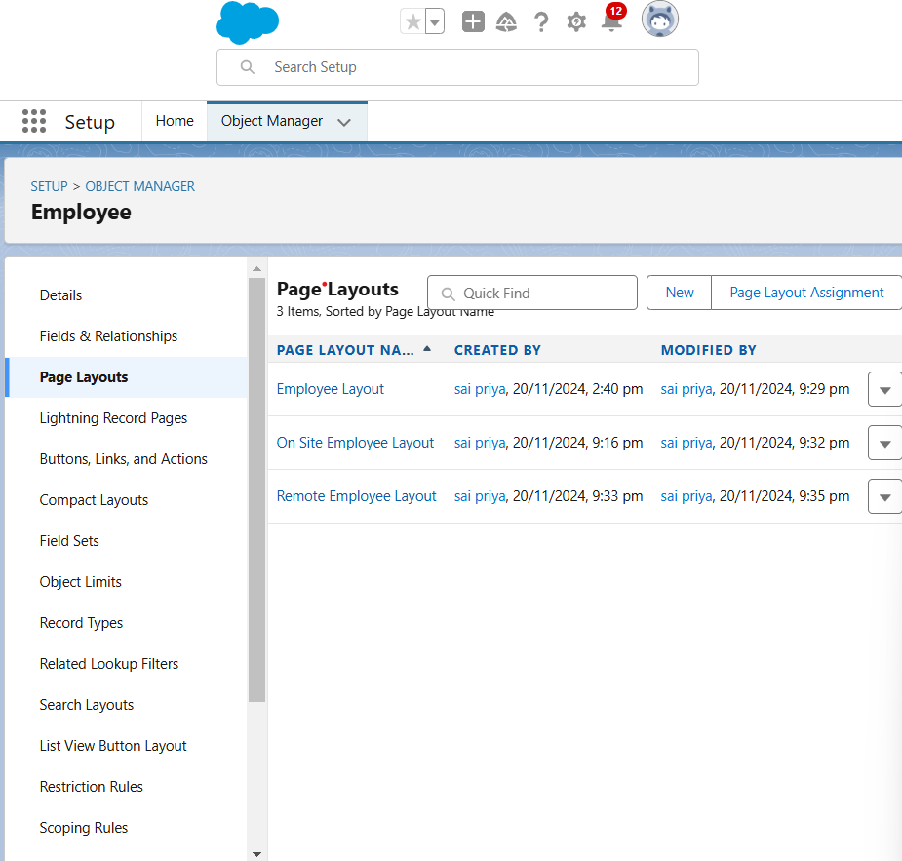

**TASK13: Chatter Group**

Salesforce Chatter Groups are collaborative spaces within the Salesforce platform that enable teams to communicate, share information, and collaborate on projects. They provide a centralized hub for discussions, file sharing, and updates, allowing users to stay connected, streamline workflows, and enhance productivity.

To Create a chatter group:

1. Click the App Launcher.
2. Enter Groups in the Search apps and items... box and select Groups.
3. Click New.
4. Fill in the new group information with these details:

|  |  |
| --- | --- |
| Field | Value |
| 1      Group Name  2      Description  3      Access Type  4      Allow Customers | Internal Discussion  Give a understanding Description on your own  Private  Checked |

1. Click Save & Next. Skip the Upload Picture section and click Next.
2. On the Manage Members screen, click Add next to users you created in the previous activity.
3. Click Done.
4. This is how your group interface looks like.
5. Where it says Share an update, post this message to the group: Welcome to the Internal Discussion Group, here you can post anything which is related to ongoing projects.
6. Click Share.

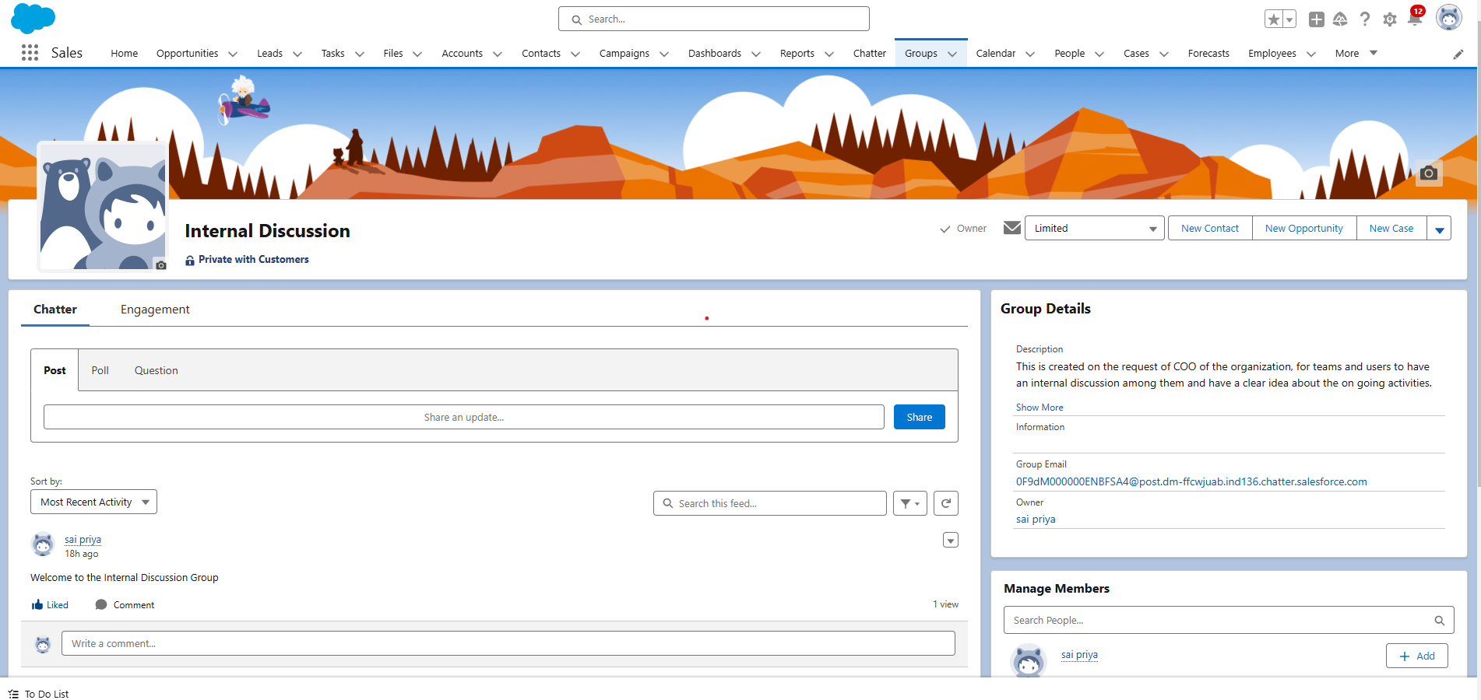

**TASK14: Record Types**

Record Types in Salesforce allow you to categorize records within an object, enabling different page layouts, field settings, required fields, and picklist values for each type. This feature is applicable to both standard and custom objects and helps create customized business processes, offering flexibility by tailoring the interface and data for various use cases.

**14.1 Create On Site Employee Record Type**

To create a Record Type:

1. Go to Setup > click on Object Manager > Search for the object (Employee) > from drop down click Edit.

2. From the left panel click Record Types > New.

3. Give Record Type Label as “On Site Employee” and make it active.  
4. Uncheck for “Make Available”.  
5. Scroll  down and check for the Manager & System Administrator profile and click on Next.  
6. Select “Apply a different layout for each profile”, and change page layout to On Site Employee Layout for manager profile and System Administrator.

7. click Save.

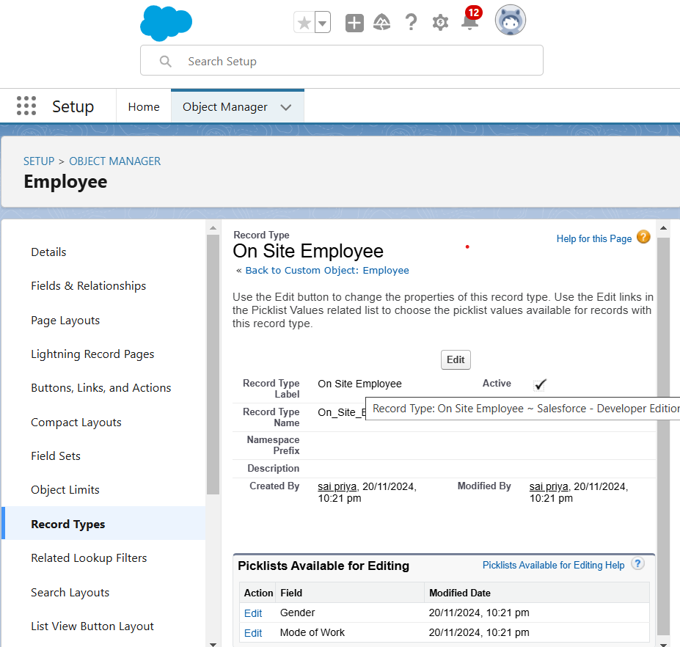

**14.2 Create Remote Employee Record Type**

1. Create another Record Type with name “Remote Employee” following the step from activity 1.

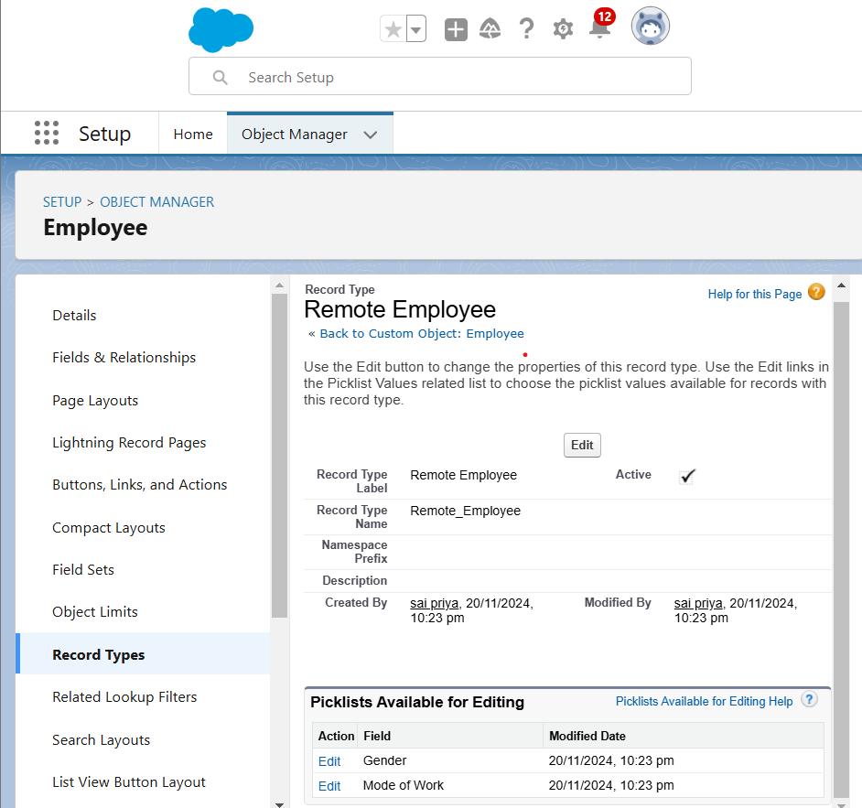

**TASK15: Permission Sets**

A permission set is a collection of settings and permissions that give users access to various tools and functions. Permission sets extend users' functional access without changing their profiles. Users can have only one profile but, depending on the Salesforce edition, they can have multiple permission sets.

To Create a Permission Set:

1. Go to setup --> type “permission sets” in quick search --> select permission sets --> New.

2. Enter the label name as “Per to Emp” --> Save.

3. Under Apps Select object settings.

4. Click on Employee object --> click on Edit --> under object permission check for read and create.

5. Click on Save.

6. After saving the permission click on the Manage assignment  
7. Now click on the Manage Assignment.  
8. Click on Add Assignment.

9. Now select the users(any one user with the profile “On Site Employee”) and click on Next.

10. Click on Assign

11. Click on Done.

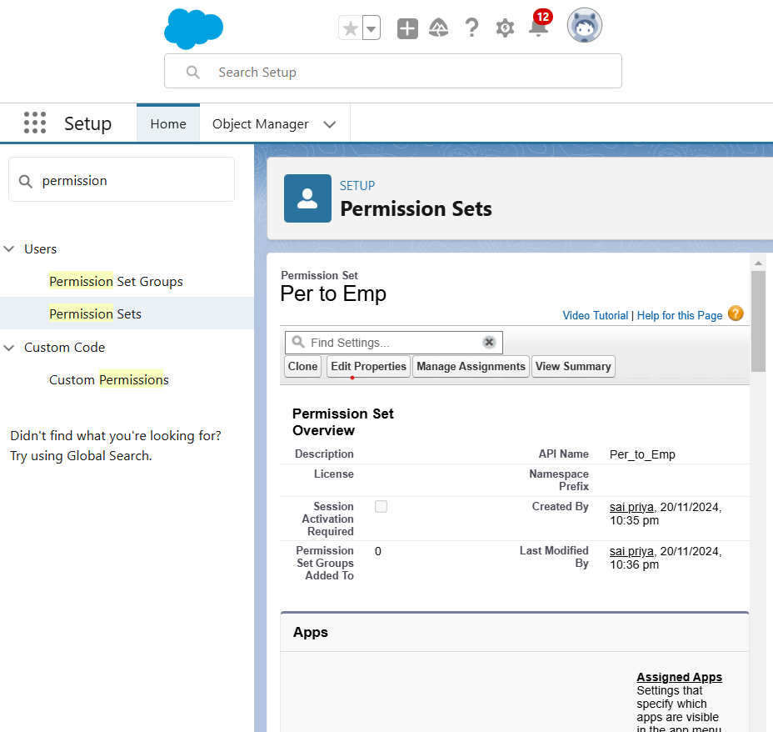

**TASK16: Reports**

Reports give you access to your Salesforce data. You can examine your Salesforce data in almost infinite combinations, display it in easy-to-understand formats, and share the resulting insights with others. Before building, reading, and sharing reports, review these reporting basics.   
Types of Reports in Salesforce

1. Tabular
2. Summary
3. Matrix
4. Joined Reports

**16.1 Create Report**

1. Go to the app --> click on the reports tab

2. Click New Report.

3. Select report type from category or from report type panel or from search panel --> click on start report.

4. Customize your report

5. Save or run it.

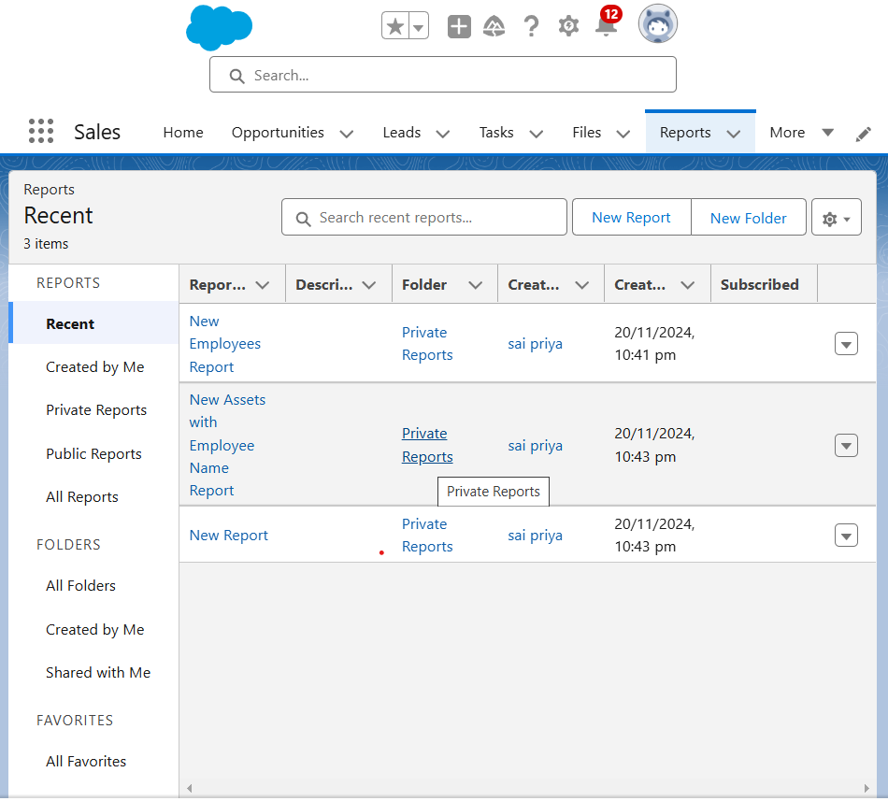

**16.2 Create Another Report**

1. Create a report with report type: “Employees with ProjectTasks and Projects”.

2. Create a report with report type: “Employees with Assets”.

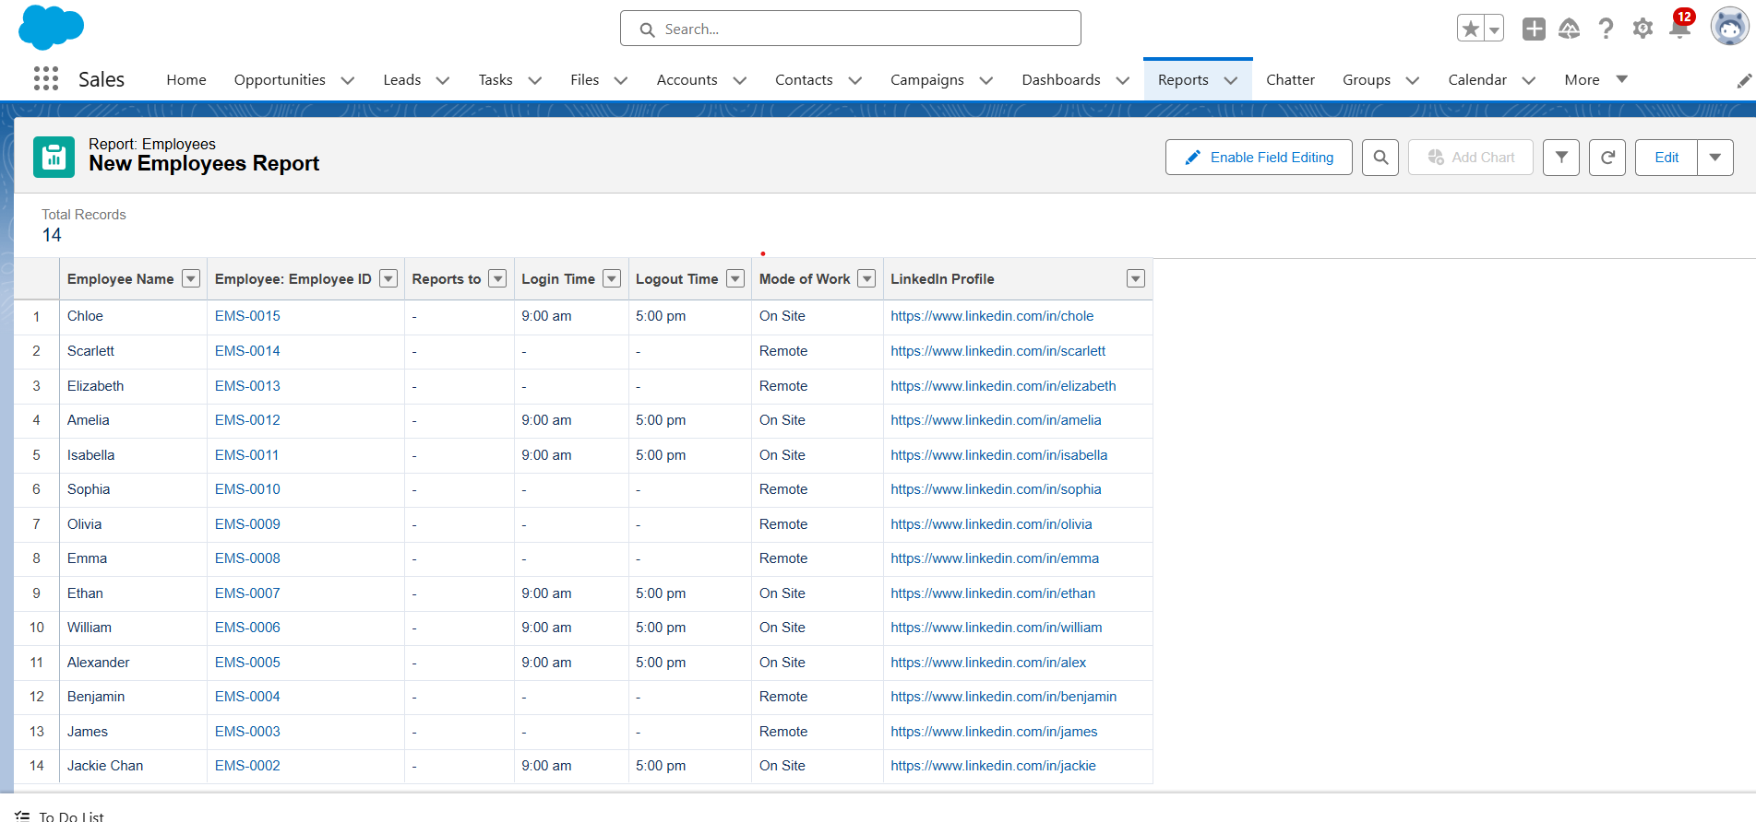

**Taks17: Dashboards**

Dashboards help you visually understand changing business conditions so you can make decisions based on the real-time data you’ve gathered with reports. Use dashboards to help users identify trends, sort out quantities, and measure the impact of their activities. Before building, reading, and sharing dashboards, review these dashboard basics.

### **17.1 Create Dashboard**

1. Go to the app > click on the Dashboards tabs.

2. Give a Name and click on Create.  
3. Select add component.  
4. Select a Report and click on select.  
5. Click Add then click on Save and then click on Done.

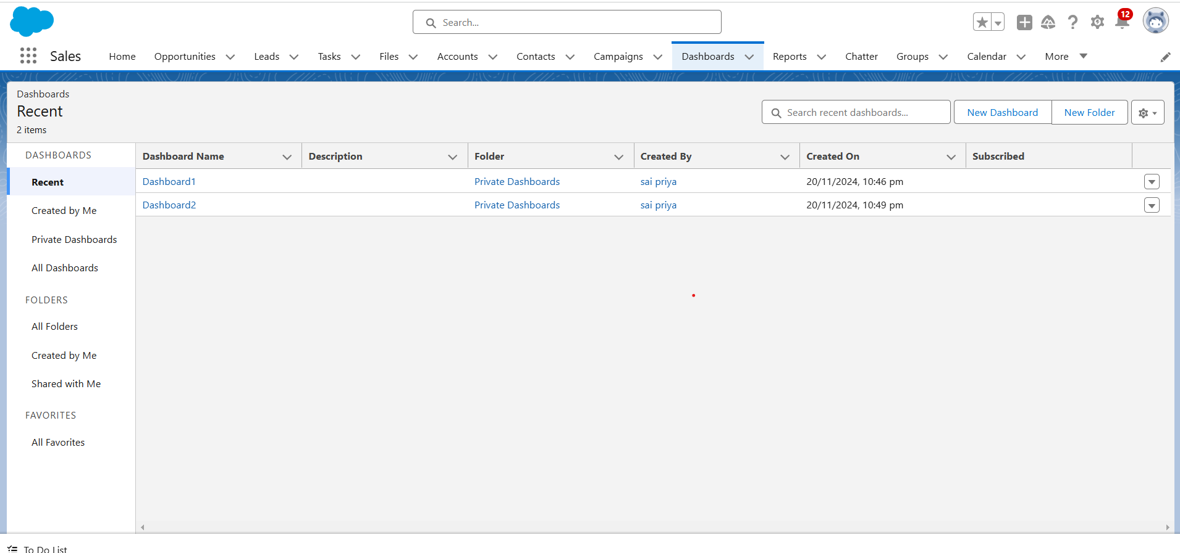

### **17.2 Create Another Dashboard**

1. Go to the app > click on the Dashboard tabs and click on new Dashboard.
2. Give a Name and click on Create.
3. Select add component.
4. Select a Report and click on select.
5. Click Add then click on Save and then click on Done.

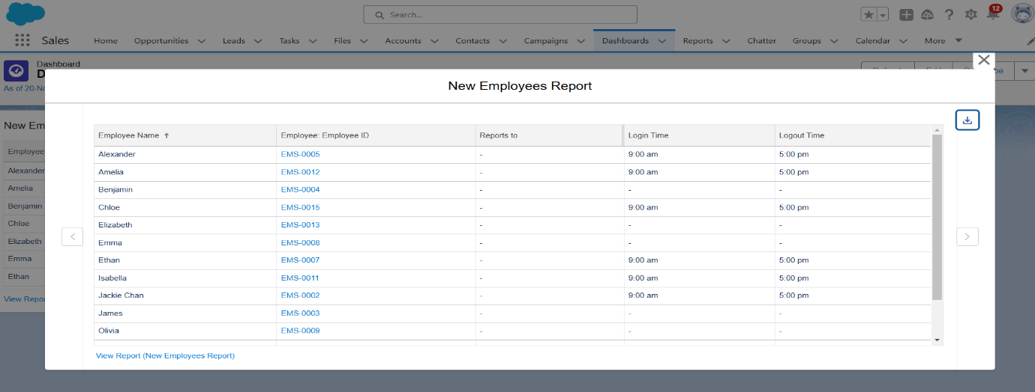

**Conclusion**

The Workforce Administration Solution aims to simplify the management of employee data, project assignments, and asset tracking. By leveraging the power of Salesforce, it enables efficient data handling, performance monitoring, and automation of workflows. The solution also facilitates enhanced collaboration among teams, allowing for better decision-making and process optimization.

By exploring key features such as data modelling, UI customization, security, and group collaboration, users gain valuable insights and hands-on experience that contribute to more effective management of resources. This solution empowers organizations to improve operational efficiency and scalability.