Stage 2
ANN Predictive Modeling for Customer Churn
Telecommunications Customer Churn Analysis
Project Role: Data Analyst — Predictive Modeling
Objective: Build, train, and evaluate an Artificial Neural Network (ANN)
to predict customer churn using the Stage 1 cleaned dataset.

Project Overview
This report is a stage 2 of the customer churn analysis project, focused on designing, training and evaluating an Artificial Neural Network (ANN) model for predicting customer churn. It draws on the cleaned data created in Stage 1, and outlines the methodology, charts, and quantitative results developed as the model evolved.

Stage 2 Deliverables
- Architecture Selection: Discuss and choose an appropriate ANN architecture
- Model configuration: Input layer, hidden layer, output layer and the configuration of the ANN model
- Training: Train the ANN model and tune the hyper parameters for better convergence
- Prediction and tuning: predict churns and optimise performance accordingly
- Evaluation: Calculate the accuracy, precision, recall and F1 score of the model.
- Reporting: Visualise results for team discussions, presentations

Section 1 — Install & Import Libraries
TensorFlow/Keras was used for modeling neural networks, scikit-learn for splitting and evaluating the data, and pandas, NumPy, matplotlib, and seaborn for data handling and visualization.
Component | Version / Detail
TensorFlow | 2.20.0
Keras | 3.13.2
Status | All libraries loaded successfully
Table 1.1 — Core library versions used in the modeling environment

Section 2 — Load & Inspect the Stage 1 Cleaned Dataset
Data was cleaned in Stage 1, and then loaded and checked for data integrity before modelling. The data set is fully prepared in Stage 1: there are 6,741 customer entries in the data set and no data is missing from any of the 18 fields.
Property | Value
Total Records | 6,741
Total Columns | 18
Missing Values | 0 (across all columns)
Table 2.1 — Dataset shape and quality summary

Target Class Distribution
The data is imbalanced, with most of the customers not churning. This imbalance was corrected later on by class weighting in the model training.
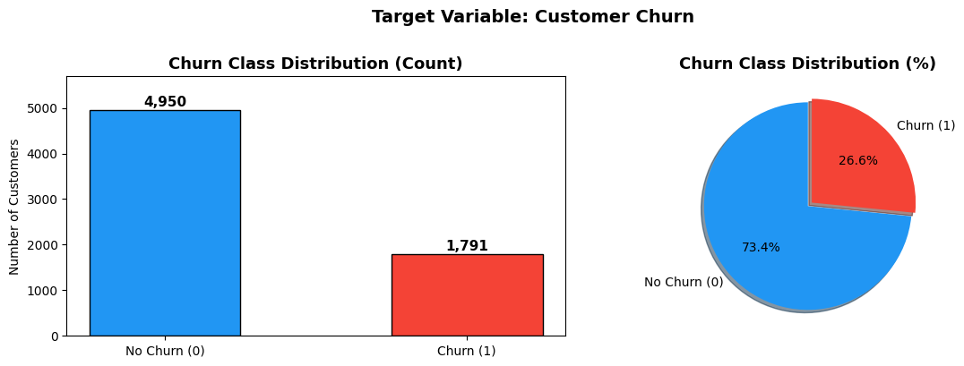
Figure 2.1 — Churn class distribution by count and percentage
Class | Count | Percentage
No Churn (0) | 4,950 | 73.4%
Churn (1) | 1,791 | 26.6%
Table 2.2 — Class balance summary (Imbalance ratio ≈ 2.76 : 1)

Section 3 — Feature Engineering & Data Preparation
Eleven pre-encoded numeric features from Stage 1 were chosen for modelling, including customer features, services subscribed, billing and contract type. These features are considered as the input layer of the ANN.

Features Used
- Demographics: gender_encoded, SeniorCitizen, Dependents_encoded
- Tenure & Billing: tenure, MonthlyCharges
- Services: PhoneService_encoded, MultipleLines_encoded, InternetService_encoded
- Contract Type: Contract_Month-to-month, Contract_One_year, Contract_Two_year

Feature Correlation Analysis
Correlation heatmap was created to explore the relationships between features and churn target. The month to month contract has a positive correlation with churn (+0.19) while tenure has the most negative correlation with churn (-0.36), meaning that the longer the tenure, the lower the chance of churning.
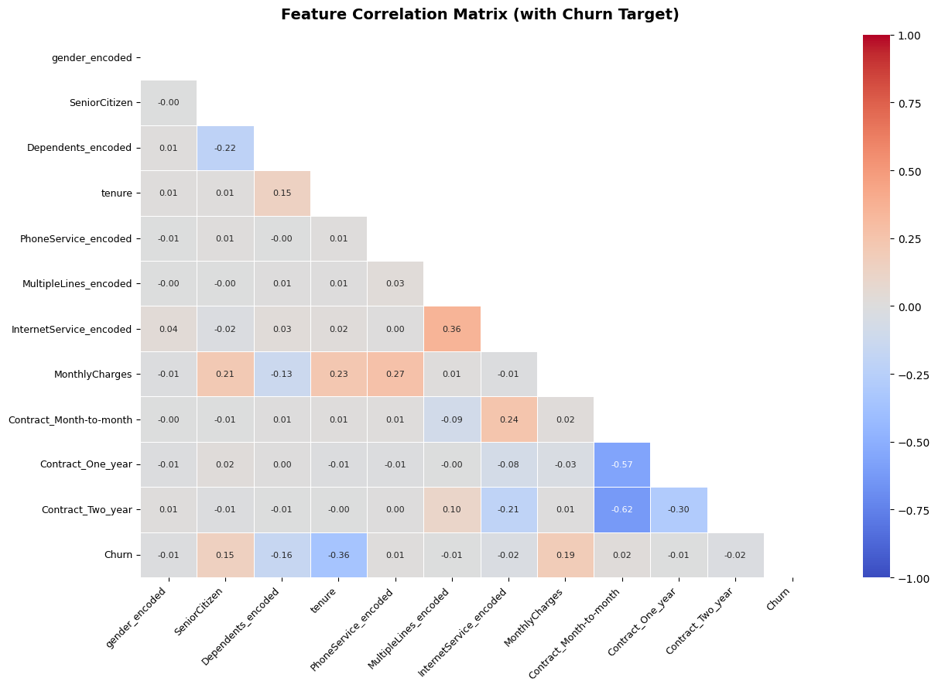
Figure 3.1 — Feature correlation matrix with churn target

Train / Validation / Test Split
The dataset was divided into three subsets: training (70%), validation (15%) and testing (15%) using the stratified sampler technique maintaining the same class imbalance ratio for all three subsets.
Split | Samples | Proportion | Churn Rate
Training | 4,718 | 70.0% | 26.6%
Validation | 1,011 | 15.0% | 26.5%
Test | 1,012 | 15.0% | 26.6%
Table 3.1 — Stratified data split summary

Feature Scaling & Class Weighting
StandardScaler was used to standardise the features using only the training set to avoid data leakage. During training, class weights were calculated to account for an imbalance in the classes.
Parameter | Value
Training set mean (post-scaling) | 0.000000 (expected ≈ 0)
Training set std (post-scaling) | 1.000000 (expected ≈ 1)
Class weight — No Churn (0) | 0.6810
Class weight — Churn (1) | 1.8812
Table 3.2 — Feature scaling verification and class weights

Section 4 — ANN Model Architecture Design
To mitigate overfitting in a moderate-sized dataset, a fully connected feed-forward neural network was designed having three hidden layers, along with ReLU activations, batch normalization, dropout, and L2 regularization.
Layer | Neurons | Activation | Regularisation
Input Layer | 11 | — | Raw scaled features
Hidden Layer 1 | 64 | ReLU | BatchNorm + Dropout(0.3) + L2
Hidden Layer 2 | 32 | ReLU | BatchNorm + Dropout(0.2) + L2
Hidden Layer 3 | 16 | ReLU | BatchNorm + L2
Output Layer | 1 | Sigmoid | Binary churn probability
Table 4.1 — ANN layer-by-layer architecture configuration
Specification | Value
Total Trainable Parameters | 3,841
Optimiser | Adam (learning rate = 0.001)
Loss Function | Binary Cross-Entropy
Evaluation Metrics | Accuracy, AUC
Table 4.2 — Model compilation configuration

Section 5 — Model Training with Callbacks & Convergence Optimisation
The model was trained for a maximum of 150 epochs with a batch size of 64, with the help of two callbacks: EarlyStopping to optimize convergence and ReduceLROnPlateau to prevent overfitting. The weights used in class classification were applied to the training to overcome the class imbalance problem in the churn.
Training Parameter | Value
Maximum Epochs | 150
Batch Size | 64
EarlyStopping | patience = 20, monitor = val_loss
ReduceLROnPlateau | patience = 10, factor = 0.5
Class Weights Applied | {0: 0.681, 1: 1.881}
Table 5.1 — Training configuration and callback settings
Early stopped at 98 epochs with the best validation AUC of 0.8360 and best validation loss of 0.5230 at epoch 78. The weights of the model were restored from this best epoch.

Section 6 — Training History & Convergence Visualisation
Training and validation loss, accuracy and AUC curves were plotted over all epochs of training to ensure stable convergence and to check if there is significant overfitting in the model.
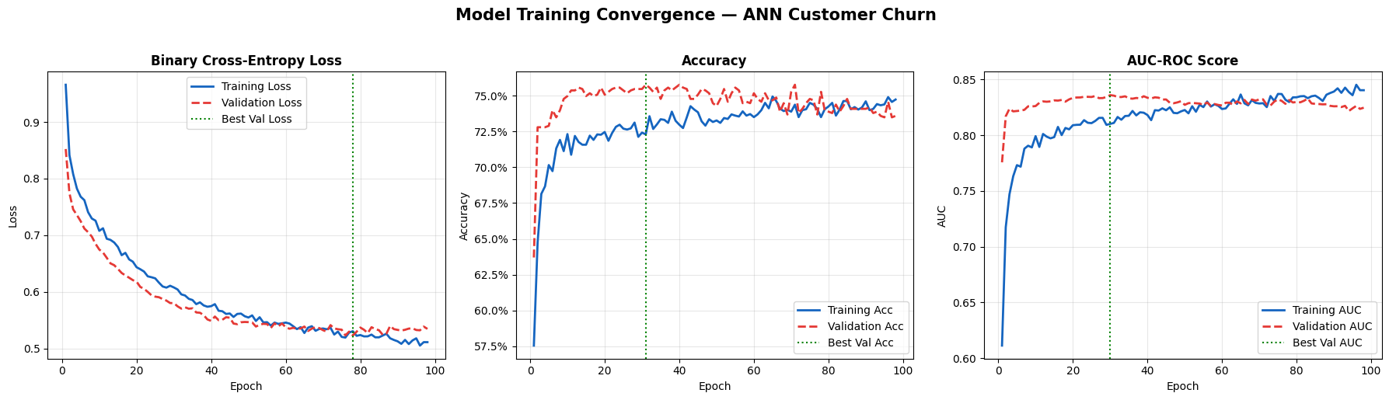
Figure 6.1 — Training and validation loss, accuracy, and AUC curves across epochs
The training loss and validation loss converge and both improve as more data is trained on, and the validation accuracy reaches a stable value around 73-75% suggesting that very little overfitting is present and AUC is steadily improving and then leveling out, suggesting good generalization.

Section 7 — Predictions on Test Set
The best model (chosen based on the validation AUC checkpoint) was then loaded and applied to the held-out test data set (1,012 customers) to make churn probability predictions.
Metric | Value
Test Samples | 1,012
Predicted No Churn (0) | 610
Predicted Churn (1) | 402
Probability Range | [0.021, 0.912]
Table 7.1 — Prediction summary at default threshold (0.5)

Predicted Probability Distribution
The distribution of churn probabilities was further analysed separately for churners and non-churners, to show how well the model separated the two classes.
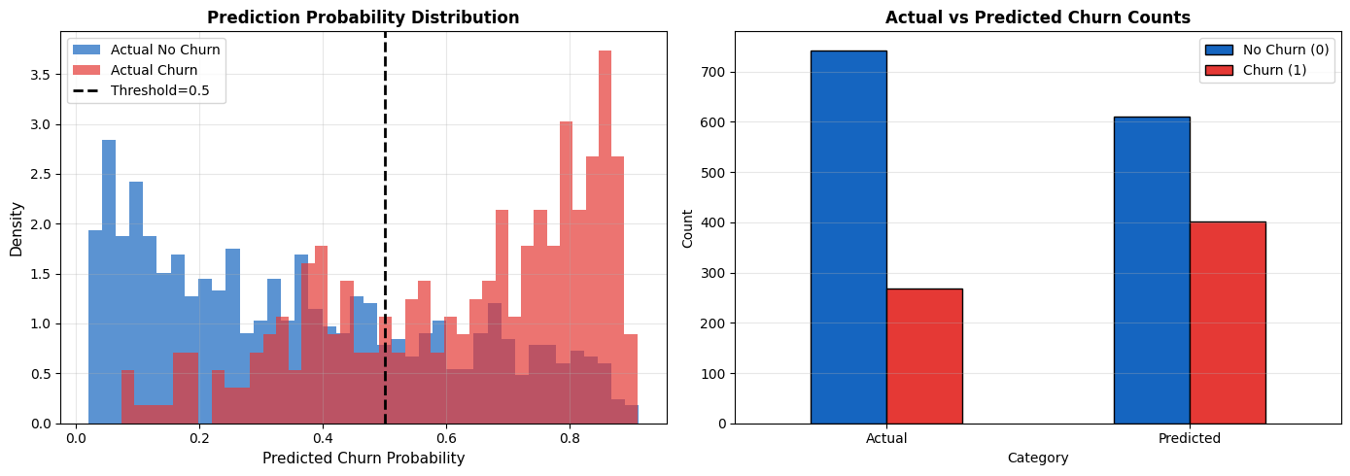
Figure 7.1 — Predicted probability distribution by actual churn status

Section 8 — Model Performance Evaluation
The model performance was assessed on the test set with an optimized probability threshold of 0.5, analyzing the results with conventional classification metrics.
Metric | Value | Interpretation
Accuracy | 0.7085 (70.85%) | Overall customers correctly classified
Precision | 0.4677 | Correctness when predicting churn
Recall (Sensitivity) | 0.6989 | Share of actual churners detected
F1-Score | 0.5604 | Harmonic mean of Precision & Recall
ROC-AUC Score | 0.7852 | Overall discrimination ability
Table 8.1 — Test set performance summary

Detailed Classification Report
Class | Precision | Recall | F1-Score | Support
No Churn (0) | 0.8672 | 0.7120 | 0.7820 | 743
Churn (1) | 0.4677 | 0.6989 | 0.5604 | 269
Accuracy |  |  | 0.7085 | 1,012
Macro Avg | 0.6674 | 0.7054 | 0.6712 | 1,012
Weighted Avg | 0.7610 | 0.7085 | 0.7231 | 1,012
Table 8.2 — Detailed per-class classification report

Confusion Matrix
The confusion matrix shows break down of accurate and inaccurate predictions for each class and the ROC curve for visual reference.
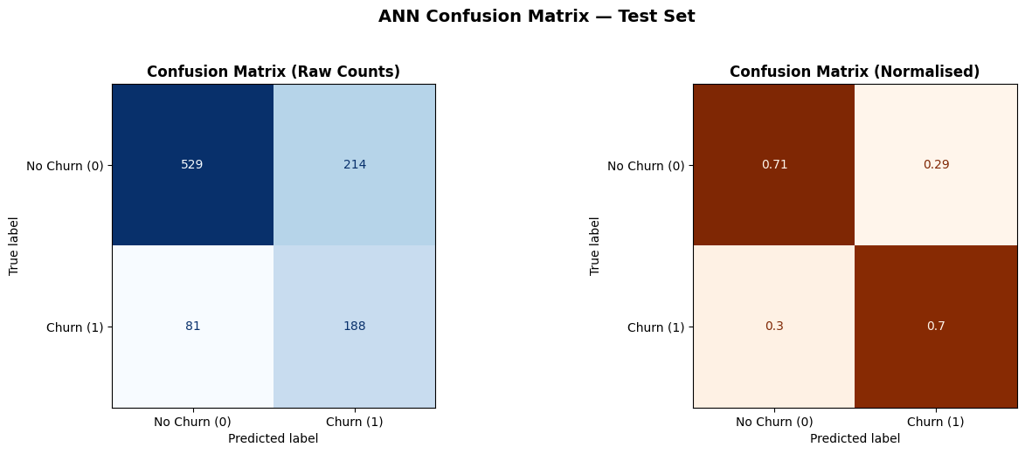
Figure 8.1 — Confusion matrix (counts and normalised) for test set predictions
Outcome | Count | Description
True Negatives (TN) | 529 | Correctly predicted No Churn
False Positives (FP) | 214 | Incorrectly predicted Churn
False Negatives (FN) | 81 | Missed actual churners
True Positives (TP) | 188 | Correctly predicted Churn
Table 8.3 — Confusion matrix breakdown

ROC and Precision-Recall Curves
The ROC curve had an AUC of 0.785, signifying good separability between churners and non-churners. The trade-off in precision and recall, due to class imbalance, is also shown in the precision-recall curve.
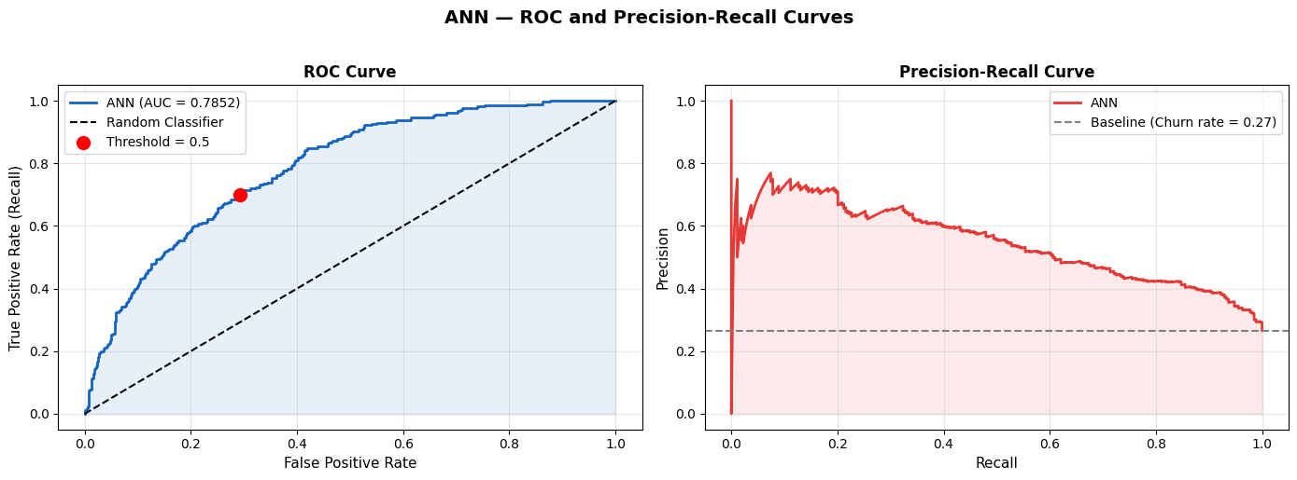
Figure 8.2 — ROC curve and Precision-Recall curve

Threshold Sensitivity Analysis
To understand the impact of the model cutoff for churn classification on the model results, precision, recall, and F1-score were computed for various decision thresholds from 0.20 to 0.80. The higher the threshold, the more precise the results, but the fewer the number of items recalled (the standard precision-recall tradeoff).
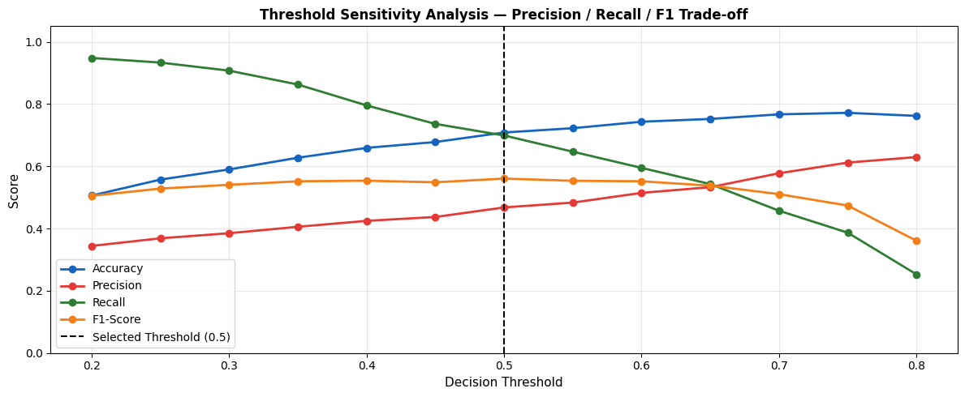
Figure 8.3 — Precision, Recall and F1-Score across decision thresholds
Threshold | Accuracy | Precision | Recall | F1-Score
0.20 | 0.5059 | 0.3441 | 0.9480 | 0.5050
0.30 | 0.5899 | 0.3849 | 0.9071 | 0.5404
0.40 | 0.6591 | 0.4246 | 0.7955 | 0.5537
0.50 | 0.7085 | 0.4677 | 0.6989 | 0.5604
0.60 | 0.7431 | 0.5145 | 0.5948 | 0.5517
0.70 | 0.7668 | 0.5775 | 0.4572 | 0.5104
0.80 | 0.7619 | 0.6296 | 0.2528 | 0.3607
Table 8.4 — Threshold sensitivity (selected rows; full sweep evaluated from 0.20 to 0.80)

Section 9 — Feature Importance Analysis
The feature importance for the permutations was obtained by shuffling each feature one at a time and measuring AUC loss. The greater the drop, the more the feature is predictive of the model.
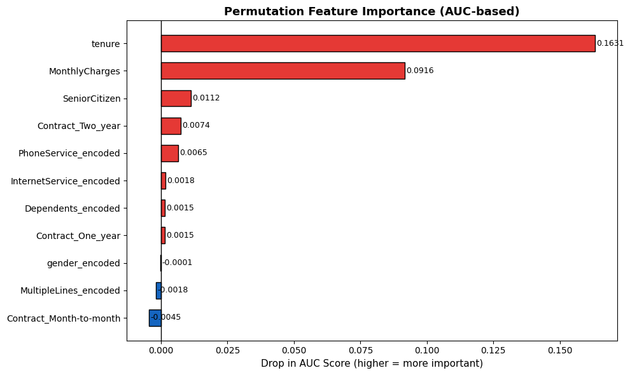
Figure 9.1 — Top features ranked by permutation importance (AUC drop)
Rank | Feature | AUC Drop
1 | tenure | 0.16310
2 | MonthlyCharges | 0.09165
3 | SeniorCitizen | 0.01121
4 | Contract_Two_year | 0.00741
5 | PhoneService_encoded | 0.00649
6 | InternetService_encoded | 0.00175
7 | Dependents_encoded | 0.00154
8 | Contract_One_year | 0.00148
Table 9.1 — Feature importance ranking by AUC drop
The most powerful predictors of churn are customer tenure and monthly charge, which combined make up the bulk of the model's discriminating power. The two-year contract terms and the senior citizen status are moderately important while the rest have minor or negligible effect.

Section 10 — Model Fine-Tuning (Hyperparameter Comparison)
To examine the impact of the learning rate, a learning rate comparison experiment was performed, where lightweight models were trained for 50 epochs with three different learning rates and the results were compared with respect to convergence and validation performance.
Learning Rate | Validation F1 | Validation AUC
0.0100 | 0.6106 | 0.8319
0.0010 | 0.6006 | 0.8277
0.0001 | 0.6100 | 0.8333
Table 10.1 — Learning rate comparison results
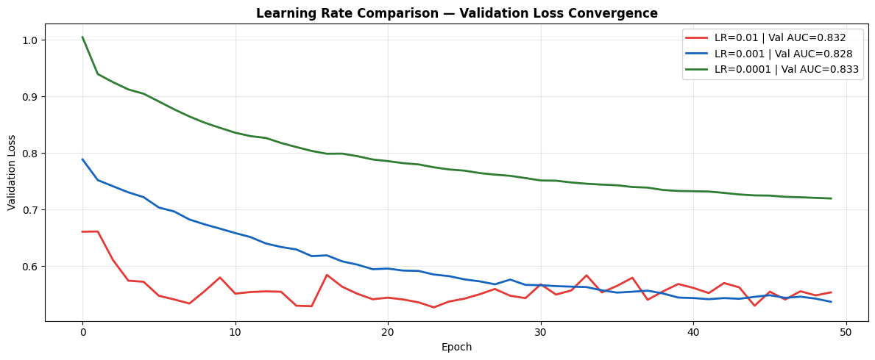
Figure 10.1 — Learning rate comparison results
The validation AUC for the lowest learning rate was highest, and the validation F1-score for the highest learning rate was almost as high by a small margin. The final production model used the default learning rate of 0.001, as it offered a good compromise between convergence stability and overall performance.

Section 11 — Final Performance Dashboard & Summary Report
A detailed visual dashboard brings together all important training curves, evaluation metrics and diagnostic charts – providing a reference view of model performance.
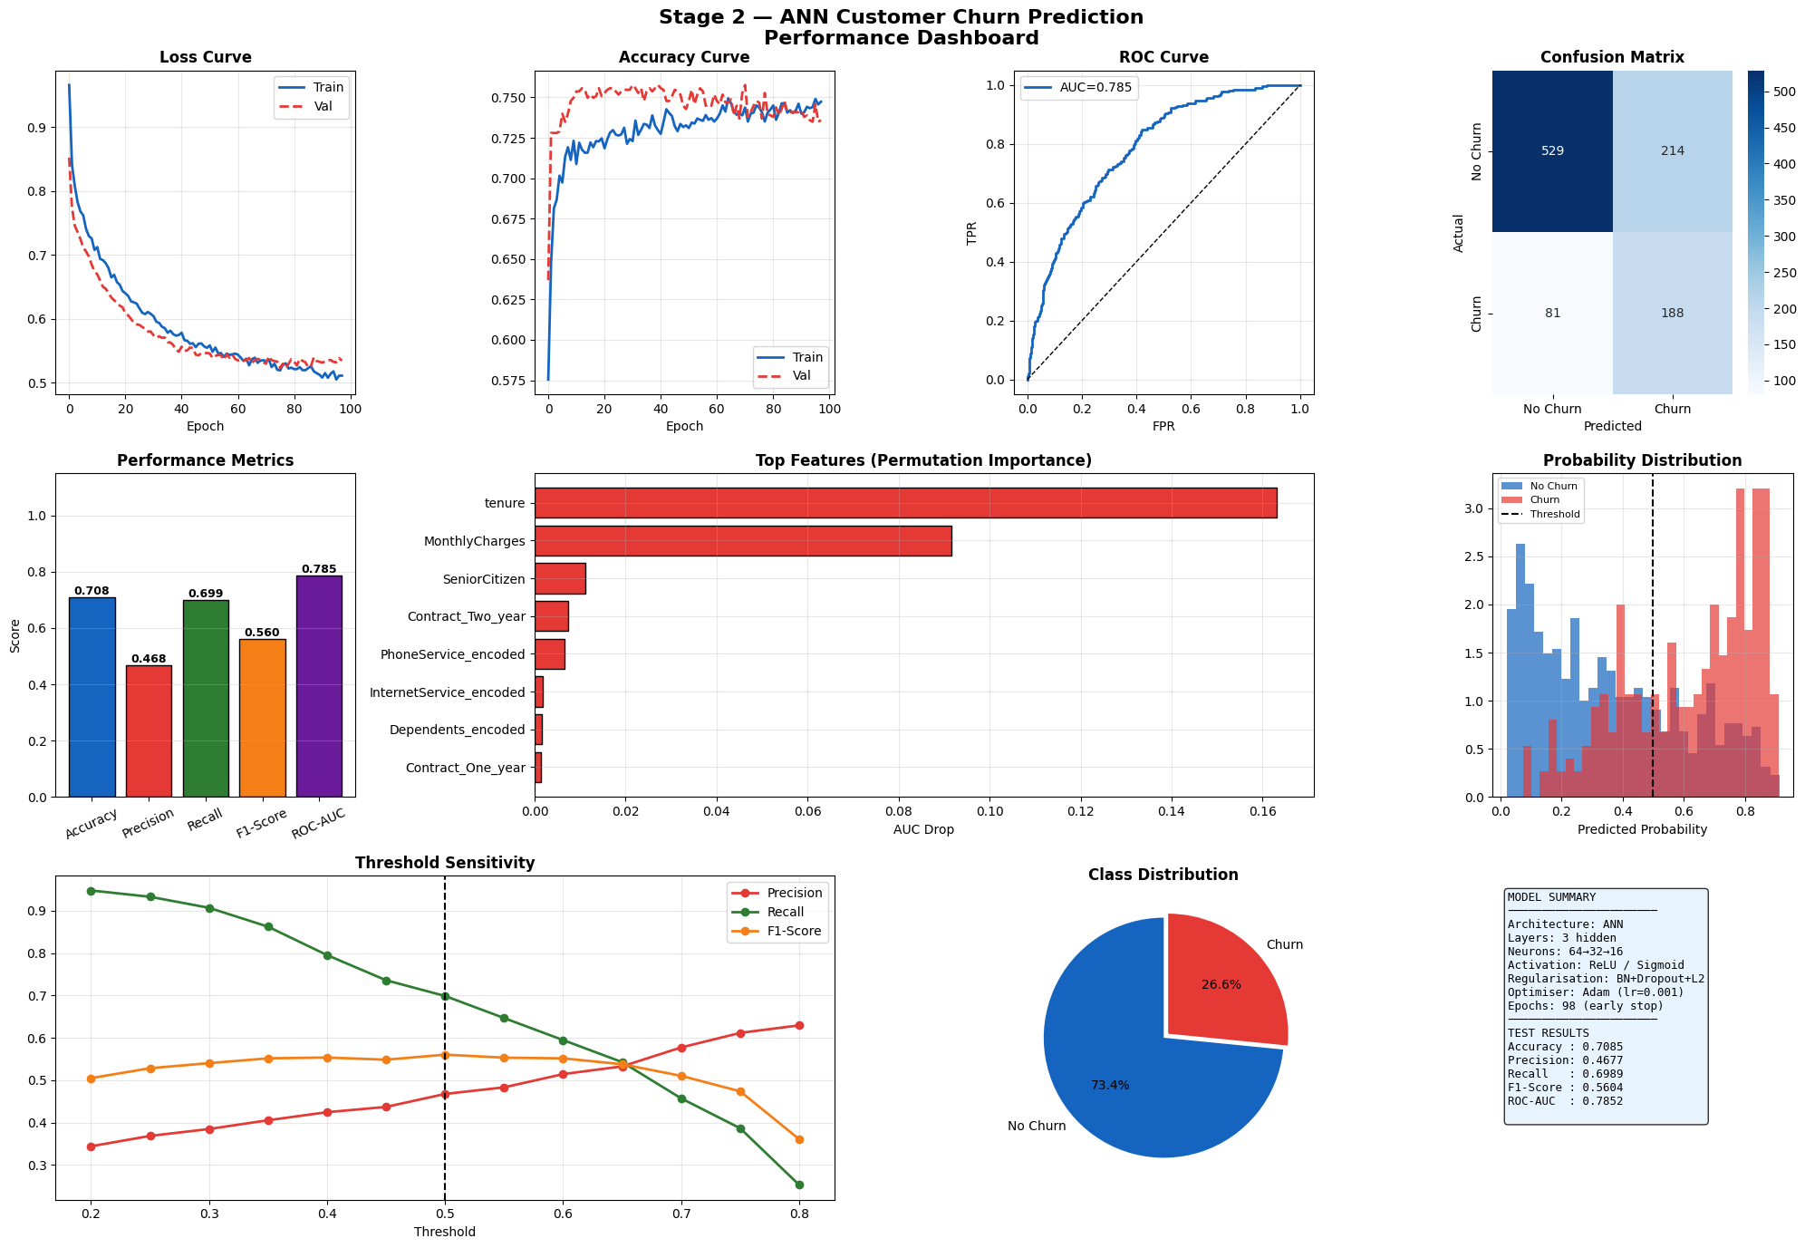
Figure 11.1 — Stage 2 ANN customer churn prediction performance dashboard

Final Summary Report

Dataset Details
Property | Value
Total Records | 6,741
Features Used | 11
Training Samples | 4,718 (70.0%)
Validation Samples | 1,011 (15.0%)
Test Samples | 1,012 (15.0%)
Class Imbalance | 73.4% No Churn / 26.6% Churn

Model Architecture
Property | Value
Type | Artificial Neural Network (ANN)
Input Layer | 11 neurons
Hidden Layers | 64 → 32 → 16 (ReLU + BatchNorm + Dropout + L2)
Output Layer | 1 neuron (Sigmoid)
Total Parameters | 3,841
Optimiser | Adam (lr = 0.001)
Loss Function | Binary Cross-Entropy
Training Epochs | 98 (EarlyStopping, patience = 20)

Test Set Performance Metrics
Metric | Value
Accuracy | 0.7085 (70.85%)
Precision | 0.4677
Recall | 0.6989
F1-Score | 0.5604
ROC-AUC Score | 0.7852

Key Insights
- Strong discrimination: The model has a ROC-AUC of 0.785, which means the model is able to properly discriminate between churners and non-churners.
- Class weights: Class weights were used to balance the class for the 2.8:1 class imbalance between non-churners and churners.
- Top churn drivers: Tenure, MonthlyCharges, and SeniorCitizen are the top churn drivers, according to the permutation importance.
- The callbacks, such as early stopping (EarlyStopping) and ReduceLROnPlateau, ensured that the model did not overfit and optimized the convergence, training in only 98 epochs.

Stage 2 Outputs Delivered
- stage2_predictions.csv — Test set predictions
- ann_churn_model_final.keras — Final trained ANN model
- stage2_dashboard.png — Performance dashboard
- training_convergence.png — Training curves
- confusion_matrix.png — Confusion matrix
- roc_pr_curves.png — ROC & PR curves
- feature_importance.png — Feature importance
Stage 2 is complete and the model outputs are ready to support Stage 3 (Refinement & Reporting).

