⚡ FIRELINE BY OPSNERVE
FireLine
AI-Powered Restaurant Operations Platform
The Operational Nervous System

System Architecture • AI Intelligence • Department Operations • Benefits
120+ API Endpoints • 18 Migrations • 22 Test Packages • 170+ Commits

Table of Contents
━━━━━━━━━━━━━━━━━━━━━━━━━━━━━━━━━━━━━━━━━━━━━━━━━━━━━━━━━━━━━━━━━━━━━━━━━━━━━━━━
1. Executive Summary
2. System Architecture
3. AI Intelligence Layer
3.1 Predictive Maintenance
3.2 Financial Intelligence
3.3 Inventory Intelligence
3.4 Menu Intelligence
3.5 Customer Intelligence
3.6 Labor Intelligence
3.7 Vendor Intelligence
3.8 Operations Intelligence
3.9 Marketing Intelligence
3.10 Multi-Location Intelligence
4. Department Operations
5. Quantified Benefits
6. Technical Innovation
7. Roadmap & Future Vision

1. Executive Summary
━━━━━━━━━━━━━━━━━━━━━━━━━━━━━━━━━━━━━━━━━━━━━━━━━━━━━━━━━━━━━━━━━━━━━━━━━━━━━━━━
FireLine is an AI-powered restaurant operations platform designed for multi-location restaurant chains, ghost kitchens, and franchise groups. Built by OpsNerve, FireLine transforms how restaurants operate by replacing reactive management with predictive, AI-driven intelligence across every department.
Unlike traditional restaurant management systems that merely record data, FireLine's AI Intelligence Layer analyzes patterns across 10 interconnected modules — inventory, financial, menu, labor, customer, vendor, operations, kitchen, marketing, and maintenance — to deliver actionable insights before problems become crises.

Key Differentiators
- AI-First: Cross-Module Intelligence — inventory alerts inform financial insights, customer data shapes menu decisions
- Probabilistic Reasoning: Cause attribution with confidence scores, not just threshold alerts
- Tiered Autonomy: AI handles routine decisions, escalates complex ones to managers
- Multi-Tenant: Zero-trust data isolation via PostgreSQL Row-Level Security

Business Impact
Metric | Impact | How
Food Cost Reduction | 2-5% | Variance detection, auto-reordering, expiry tracking
Labor Optimization | 3-8% | Demand scheduling, overtime prevention
Churn Prevention | 8-12% | Predictive win-back for high-CLV guests
Equipment Uptime | +15-25% | Predictive maintenance from sensor trends
Waste Reduction | 20-30% | Expiry tracking, FIFO, usage variance alerts

2. System Architecture
━━━━━━━━━━━━━━━━━━━━━━━━━━━━━━━━━━━━━━━━━━━━━━━━━━━━━━━━━━━━━━━━━━━━━━━━━━━━━━━━
FireLine is built as a Go modular monolith with a React TypeScript frontend and Expo React Native tablet app. The architecture prioritizes simplicity, performance, and multi-tenant security.

Technology Stack
Component | Technology
Backend | Go 1.26 — 15+ domain packages, 120+ REST endpoints
Frontend | React 19 + TypeScript + Tailwind CSS + Recharts
Tablet App | Expo SDK 55 + React Native (Count, Waste, Receive, KDS)
Database | PostgreSQL 16 with Row-Level Security, 18 migrations
Infrastructure | AWS ECS Fargate (Terraform), Docker, CI/CD
Deployment | Vercel (frontend) + Railway (backend) + Neon (database)

Multi-Tenant Data Isolation
Every table uses PostgreSQL Row-Level Security (RLS) with a FORCE policy tied to the tenant context. The dual-pool architecture separates tenant-scoped operations (appPool with RLS) from pre-tenant operations like signup and login (adminPool with superuser access). This ensures zero data leakage between organizations.

Event-Driven Architecture
An in-process event bus with NATS-compatible subject matching enables real-time cross-module communication. When an order is processed, it triggers simultaneous inventory depletion, financial P&L updates, customer profile enrichment, and alert evaluation — all within milliseconds.

3. AI Intelligence Layer
━━━━━━━━━━━━━━━━━━━━━━━━━━━━━━━━━━━━━━━━━━━━━━━━━━━━━━━━━━━━━━━━━━━━━━━━━━━━━━━━
The AI Intelligence Layer is FireLine's core differentiator — 10 interconnected modules that transform raw restaurant data into predictive, actionable intelligence. Each module operates independently but shares insights through the event bus, creating compound intelligence that no single-purpose tool can match.

3.1 Predictive Maintenance
FireLine analyzes equipment sensor readings from daily kitchen reports to detect degradation patterns before equipment fails. The system matches temperature trends against historical failure curves and generates preventive maintenance tickets with root cause analysis and confidence scores.
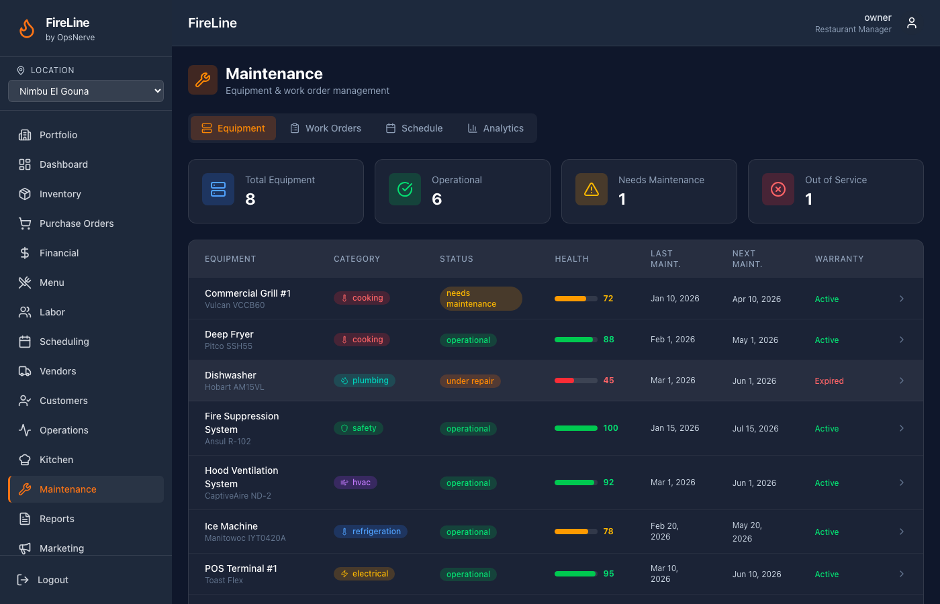
- Example: Walk-in Cooler: Detected +0.35°C/day drift over 14 days → 87% confidence compressor degradation
- Grill Station: Detected +0.6°C/day sensor drift → 82% confidence thermocouple failure
- AC System: Detected dining room temp rising 22°C→27°C → 79% confidence AC degradation
- Auto-generated tickets include: risk assessment, inventory at risk, and numbered action steps

3.2 Financial Intelligence
Real-time P&L calculation with channel-aware margins, budget variance analysis, cost center breakdown, and Z-score-based anomaly detection. The drill-down chain goes from P&L summary → cost center → menu item → ingredient → vendor invoice, enabling root cause analysis of any financial deviation.
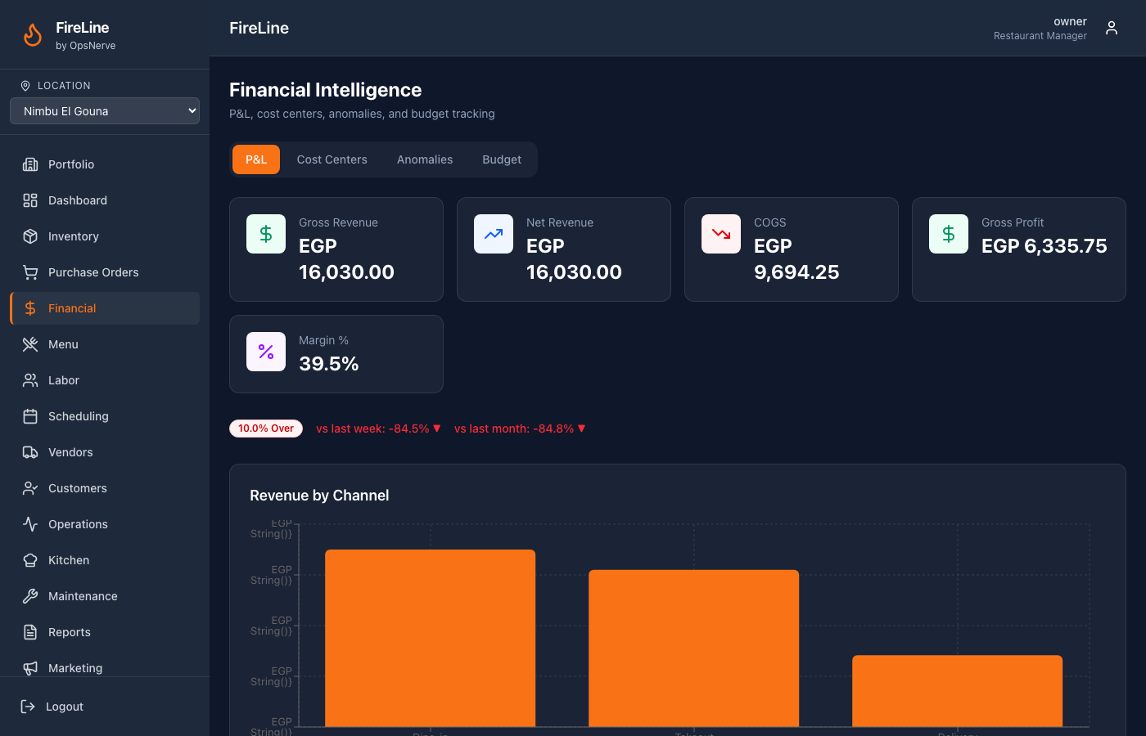
- Budget vs actual variance with on_track/over/under status
- Transaction anomaly detection: excessive voids, comps, off-hours transactions, discount rate spikes
- Period comparison: current vs last week, last month, last year

3.3 Inventory Intelligence
Theoretical vs actual usage calculation, physical counting workflow with anti-anchoring bias, variance categorization with probabilistic cause attribution, PAR breach detection, auto-generated purchase orders, and expiry date tracking with batch numbers.
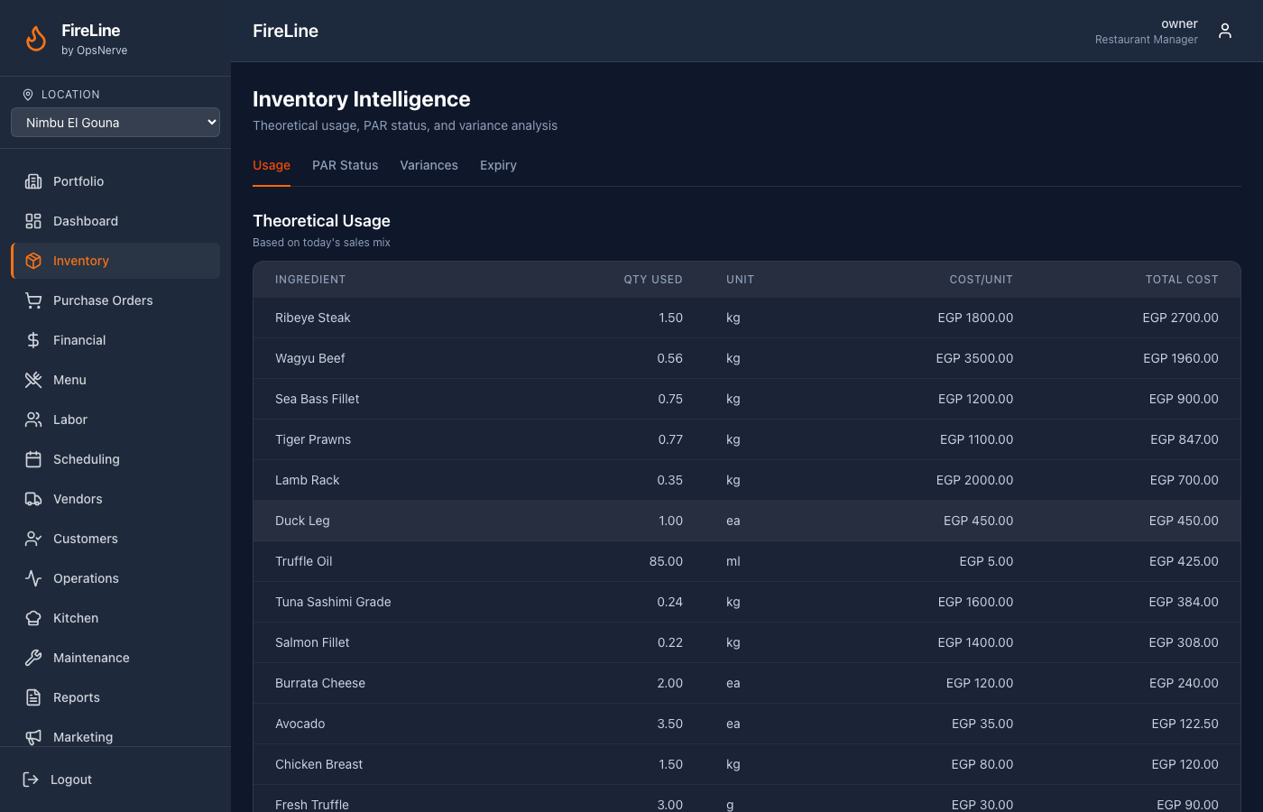
- Probabilistic Attribution: Variance causes: portioning (35%), unrecorded waste (40%), measurement error (10%), recipe error (10%), theft signal (20%)
- Auto-Reordering: PAR breach → auto-PO generation → manager one-tap approval
- Expiry Tracking: Batch-level tracking with shelf-life alerts and FIFO enforcement

3.4 Menu Intelligence
5-dimension scoring (margin, velocity, complexity, satisfaction, strategic value) with 8-class classification. Simulation sandbox for price changes, item removal impact, and ingredient cost propagation.
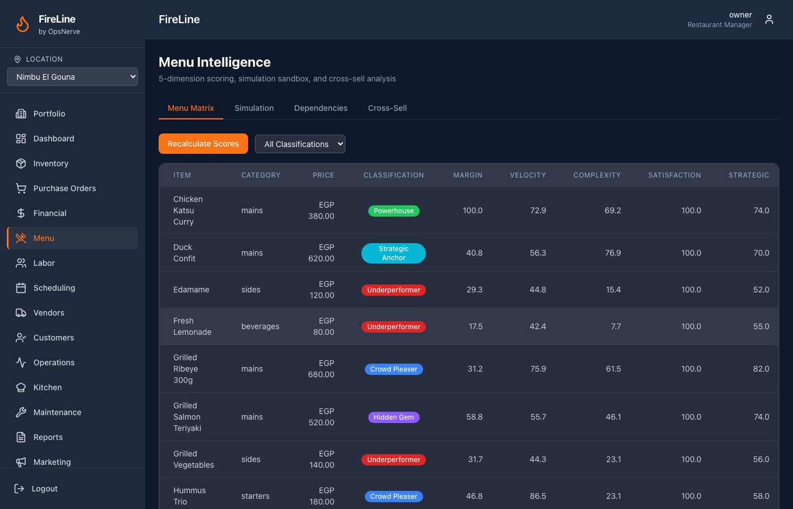
- 8 Classes: Powerhouse, Hidden Gem, Crowd Pleaser, Workhorse, Complex Star, Declining Star, Underperformer, Strategic Anchor
- Cross-sell affinity analysis identifies co-ordered item pairs
- Ingredient dependency graph detects single-point-of-failure ingredients

3.5 Customer Intelligence
Guest profile resolution via SHA-256 payment token hashing, CLV scoring, RFM segmentation, and churn prediction using visit frequency decay models.
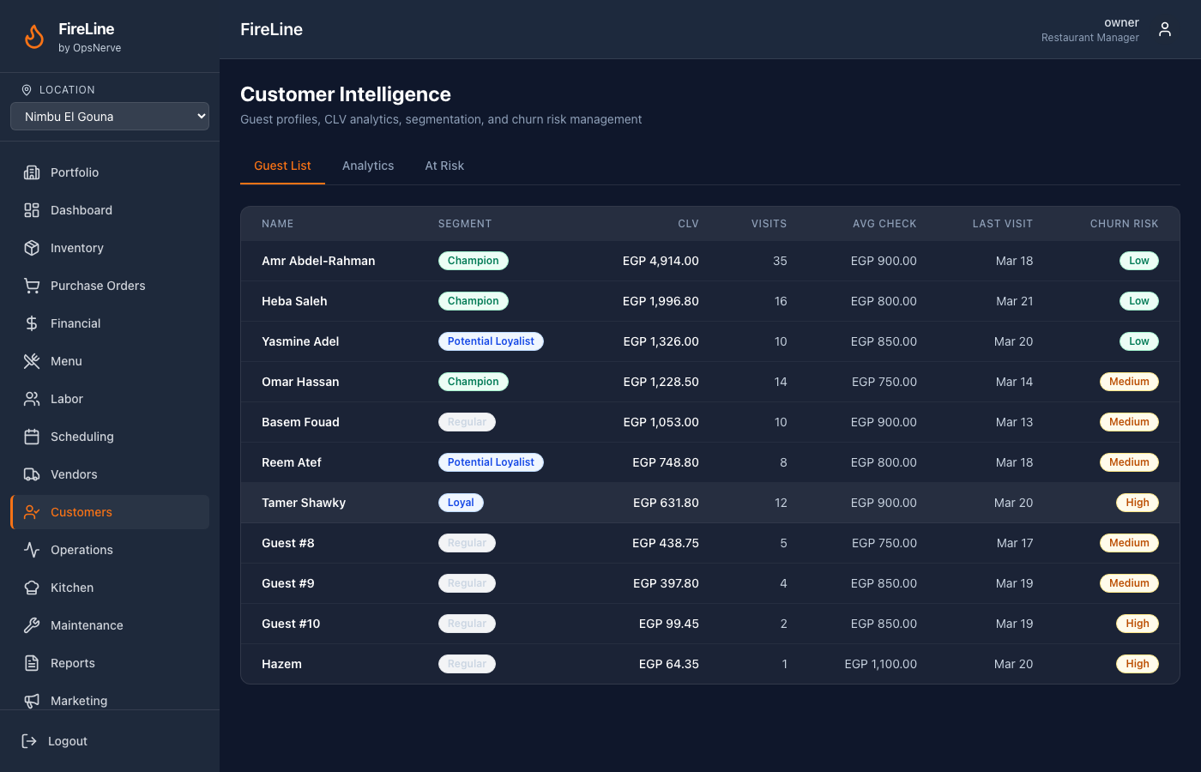
- CLV = avg_check × visit_frequency × predicted_lifespan × margin_factor
- Churn tiers: low (0.05), medium (0.25), high (0.60), critical (0.90)
- Win-back alerts for high-CLV guests entering high/critical churn risk

3.6 Labor Intelligence
ELU (Effective Labor Unit) ratings per employee per station, Staff Point System for gamified performance, demand-based scheduling with constraint satisfaction, overtime detection, and shift swap workflow.
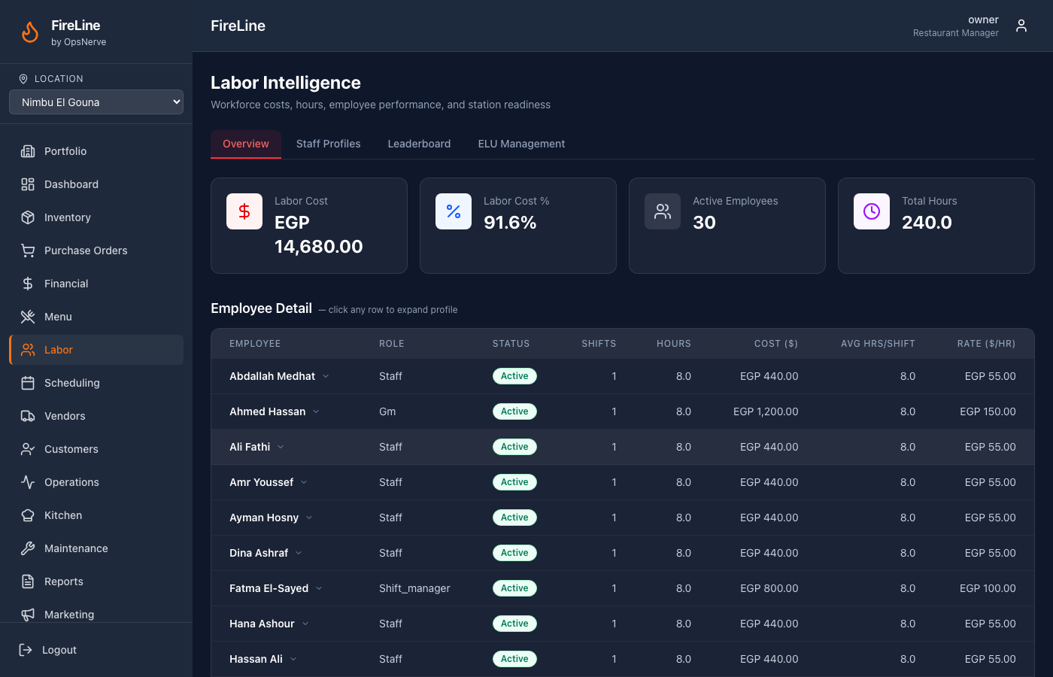

3.7 Vendor Intelligence
Vendor Reliability Score (VRS) — composite of price (30%), delivery (25%), quality (25%), accuracy (20%). OTIF tracking, price trend analysis, anomaly detection, and vendor recommendation engine.
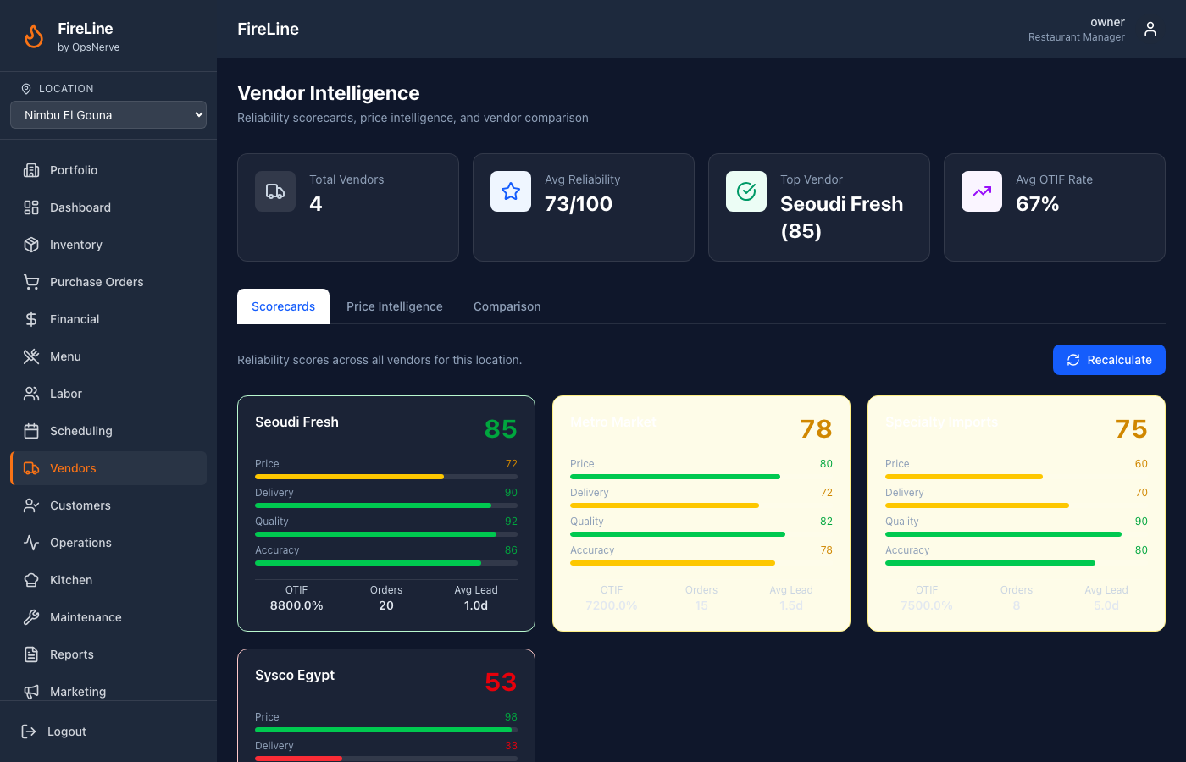

3.8 Operations Intelligence
Kitchen capacity model with station load monitoring, KDS ticket routing, overload detection with tiered autonomy response (auto-throttle at 85%, recommend at 95%), operational health score, and 5 planning horizons.
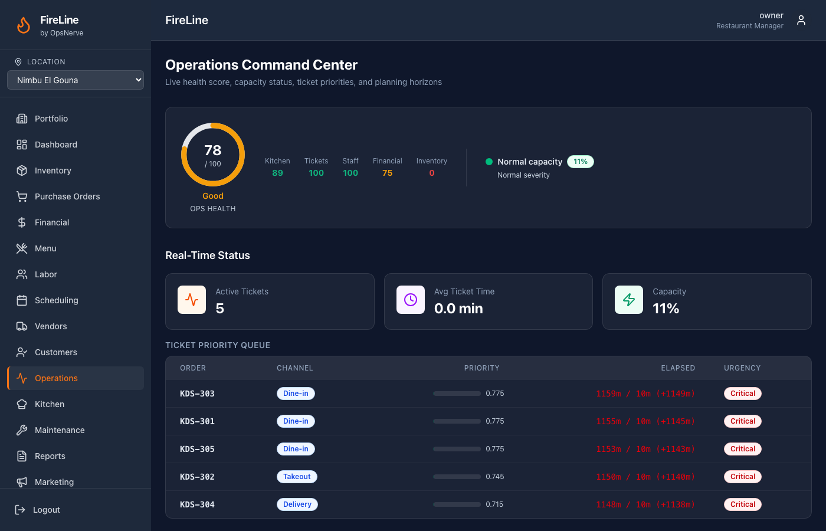

3.9 Marketing & Multi-Location Intelligence
Campaign engine with segment targeting, loyalty program with tier progression, portfolio hierarchy with cross-location benchmarking, best practice detection and propagation.

4. Department Operations
━━━━━━━━━━━━━━━━━━━━━━━━━━━━━━━━━━━━━━━━━━━━━━━━━━━━━━━━━━━━━━━━━━━━━━━━━━━━━━━━

CEO / Owner
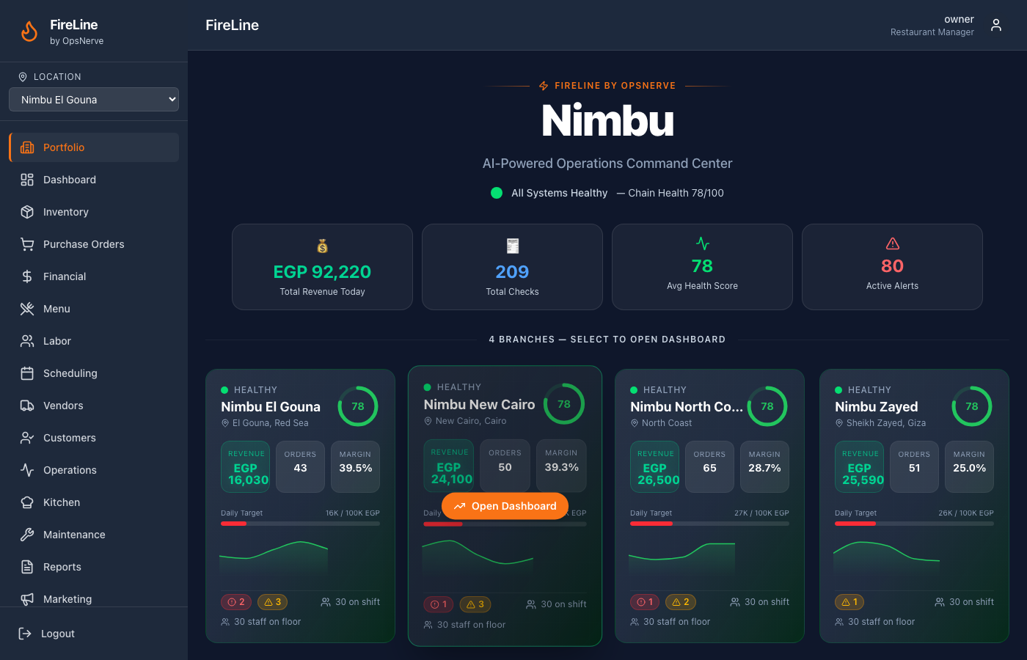
- Portfolio overview: all branches at a glance with health scores, revenue, alerts
- Executive Briefing: AI-prioritized issues, performance highlights, strategic outlook
- AI Recommendations: actionable suggestions with projected impact and confidence scores
- Assign actions to team members (GMs, Finance, Legal, HR), comment, track resolution

General Manager
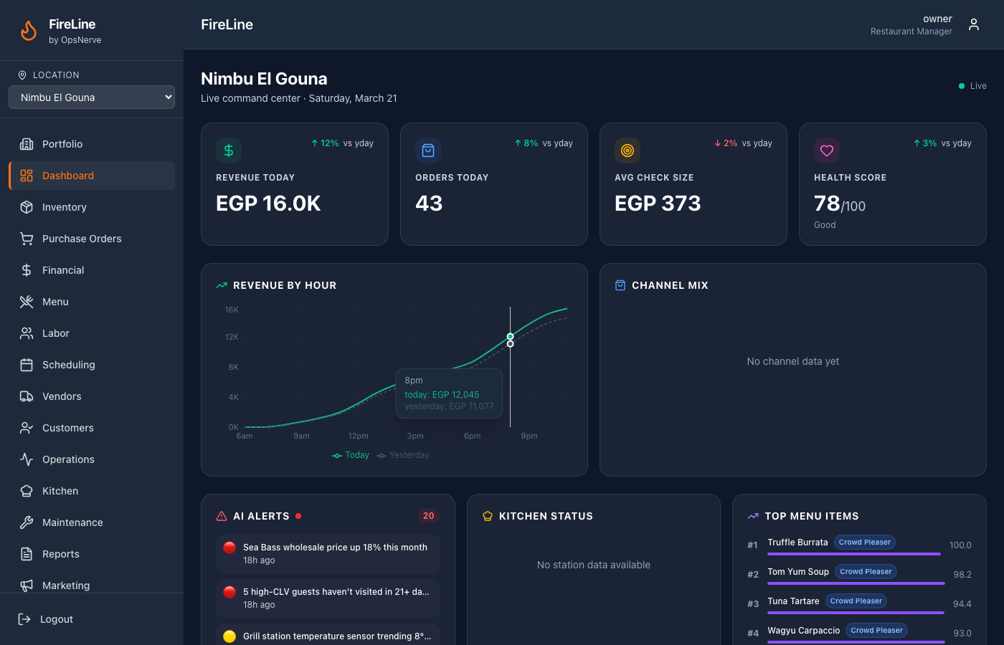
- Real-time dashboard: revenue by hour, channel mix, alert queue, kitchen pulse, top sellers
- Financial drill-down: P&L → category → item → ingredient → vendor
- AI-drafted schedules, shift swap management, overtime monitoring

Kitchen Manager
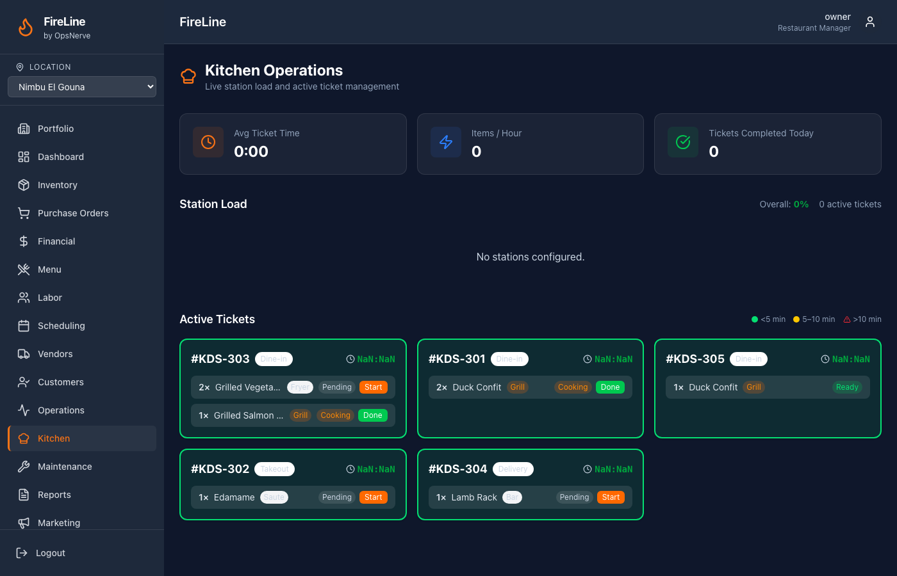
- KDS: station-specific ticket routing with urgency coloring
- Kitchen capacity monitoring with overload alerts
- Equipment health monitoring, AI preventive maintenance tickets

Inventory Manager
- Physical counting on tablet (category-grouped, offline-capable, anti-anchoring bias)
- Waste logging with reason classification
- Variance analysis with AI cause attribution
- Expiry tracking, delivery receiving with line-by-line verification

Finance / Accounting
- Budget management with variance reports
- Cost center analysis by ingredient category
- Transaction anomaly detection (fraud prevention)

5. Quantified Benefits
━━━━━━━━━━━━━━━━━━━━━━━━━━━━━━━━━━━━━━━━━━━━━━━━━━━━━━━━━━━━━━━━━━━━━━━━━━━━━━━━
Area | Impact | Mechanism
Food Cost | 2-5% reduction | Variance detection, portioning alerts, automated reordering, expiry tracking
Labor Cost | 3-8% optimization | Demand-based scheduling, overtime prevention, ELU-optimized assignment
Customer Retention | 8-12% churn prevented | Predictive win-back campaigns for high-CLV guests at risk
Equipment Uptime | 15-25% less downtime | Predictive maintenance from daily sensor trend analysis
Food Waste | 20-30% reduction | Expiry tracking, FIFO enforcement, usage variance alerts

Competitive Advantages
- Cross-Module Intelligence: Inventory alerts feed financial insights; customer data informs menu decisions; equipment trends trigger purchasing
- Probabilistic Reasoning: Every alert includes cause attribution with confidence scores, not just threshold triggers
- Tiered Autonomy: AI handles routine (auto-PO, throttle delivery), recommends medium (86 complex items), escalates complex (call staff, close channel)
- Infinite Scalability: Add locations with zero additional setup — RLS + event bus + templates handle everything

6. Technical Innovation
━━━━━━━━━━━━━━━━━━━━━━━━━━━━━━━━━━━━━━━━━━━━━━━━━━━━━━━━━━━━━━━━━━━━━━━━━━━━━━━━

Event-Driven Cross-Module Communication
NATS-compatible subject matching with wildcard routing enables real-time intelligence propagation. A single order event triggers inventory depletion, financial update, customer enrichment, and alert evaluation simultaneously.

Row-Level Security for Multi-Tenancy
PostgreSQL RLS with FORCE policy + dual connection pool architecture ensures zero data leakage. Every query is automatically scoped to the authenticated tenant — no application-level filtering needed.

Probabilistic Variance Attribution
Instead of simple threshold alerts, the variance engine assigns probability distributions across causes (portioning 35%, unrecorded waste 40%, etc.) based on signal analysis.

Predictive Equipment Maintenance
Pattern matching daily sensor readings against historical failure curves with confidence scoring. Auto-generates maintenance tickets with root cause prediction and risk assessment.

Anti-Anchoring Bias in Counting
Expected quantities are hidden during physical inventory counts to prevent psychological anchoring, only revealed during the review step.

Demand-Forecast-Driven PO Generation
Automated purchase orders triggered by PAR breach detection, with vendor selection optimized by reliability score and price intelligence.

7. Roadmap & Future Vision
━━━━━━━━━━━━━━━━━━━━━━━━━━━━━━━━━━━━━━━━━━━━━━━━━━━━━━━━━━━━━━━━━━━━━━━━━━━━━━━━

Near-Term (Q2 2026)
- Prophet ML demand forecasting for inventory and labor
- Real POS integration: Toast, Square, Clover
- Manager mobile app (React Native)
- SOC 2 readiness assessment

Medium-Term (Q3 2026)
- Computer vision for waste detection and portion verification
- Voice-activated KDS commands for hands-free kitchen operation
- NLP sentiment analysis from Google/Yelp reviews
- Franchise template management and rollout system

Long-Term (Q4 2026+)
- Blockchain-based supply chain verification
- Autonomous operations mode: AI runs day-to-day, humans set strategy
- White-label platform for restaurant technology companies
- International expansion with multi-currency and regulatory compliance

━━━━━━━━━━━━━━━━━━━━━━━━━━━━━━━━━━━━━━━━━━━━━━━━━━━━━━━━
FireLine by OpsNerve
Live Demo: fireline-nimbu.vercel.app
GitHub: github.com/sambawy01/Fire-Line
Contact: sambawy@gmail.com

