**Table S1.** Mean (SE) values of segmented power-law model parameters estimated in rigid nasal pathway casts of infants with a superimposed breathing of 0.75 Hz and individually calculated tidal volumes. Data show parameters calculated for the expiratory limb. V’bp: flow at the breakpoint, k1: steepness of the first segment (when V’≤ V’bp); k2: steepness of the second segment (when V’>V’bp).

|  |  |  |  |  |  |
| --- | --- | --- | --- | --- | --- |
| **ID** | **ln V’bp**  **(SE)** | **intercept**  **(SE)** | **k1**  **(SE)** | **k2**  **(SE)** | **adjusted r2** |
| **cast 001** | 3.25  (0.017) | 2.19  (0.03) | 0.073  (0.013) | 1.169  (0.031) | 0.990 |
| **cast 003** | 3.57  (0.023) | 1.81  (0.03) | 0.022  (0.010) | 0.976  (0.029) | 0.984 |
| **cast 005** | 3.87  (0.024) | 0.41  (0.03) | 0.021  (0.009) | 0.843  (0.025) | 0.986 |
| **cast 006** | 3.78  (0.018) | 2.92  (0.05) | 0.024  (0.015) | 1.506  (0.045) | 0.983 |
| **cast 007** | 3.55  (0.034) | 0.62  (0.03) | 0.039  (0.011) | 0.779  (0.034) | 0.974 |
| **cast 008** | 3.93  (0.023) | 2.16  (0.03) | 0.005  (0.008) | 0.930  (0.025) | 0.985 |
| **cast 009** | 4.21  (0.027) | 1.82  (0.07) | 0.132  (0.020) | 1.160  (0.052) | 0.976 |
| **cast 010** | 4.11  (0.021) | 0.74  (0.03) | 0.036  (0.010) | 1.060  (0.034) | 0.983 |
| **cast 012** | 4.15  (0.031) | 1.75  (0.08) | 0.018  (0.022) | 1.064  (0.050) | 0.969 |
| **cast 014** | 3.50  (0.021) | 1.27  (0.03) | 0.042  (0.010) | 0.911  (0.024) | 0.989 |
| **cast 015** | 4.19  (0.026) | 2.12  (0.07) | -0.032  (0.020) | 1.042  (0.037) | 0.979 |
| **cast 016** | 3.34  (0.022) | 1.10  (0.03) | 0.075  (0.012) | 1.026  (0.029) | 0.988 |
| **cast 017** | 4.30  (0.019) | 2.16  (0.06) | 0.012  (0.015) | 1.215  (0.037) | 0.985 |
| **cast 018** | 3.82  (0.02) | 1.80  (0.05) | 0.031  (0.016) | 0.935  (0.024) | 0.991 |
| **cast 019** | 3.96  (0.019) | 0.83  (0.03) | 0.062  (0.010) | 0.874  (0.026) | 0.989 |
| **cast 021** | 4.02  (0.019) | 1.70  (0.03) | 0.045  (0.011) | 1.140  (0.032) | 0.986 |
| **cast 022** | 4.35  (0.023) | 2.04  (0.09) | 0.059  (0.024) | 1.306  (0.051) | 0.977 |
| **cast 025** | 4.20  (0.020) | 1.30  (0.03) | 0.055  (0.010) | 1.058  (0.033) | 0.985 |
| **cast 026** | 3.88  (0.02) | 2.73  (0.03) | 0.033  (0.010) | 1.223  (0.036) | 0.984 |
| **cast 027** | 3.84  (0.022) | 0.20  (0.04) | 0.044  (0.013) | 0.897  (0.027) | 0.987 |
| **cast 028** | 3.92  (0.025) | 0.84  (0.05) | 0.047  (0.014) | 0.910  (0.029) | 0.986 |
| **cast 030** | 3.92  (0.026) | 2.65  (0.05) | 0.007  (0.016) | 0.944  (0.034) | 0.979 |
| **cast 032** | 3.69  (0.019) | 1.09  (0.02) | 0.033  (0.007) | 0.892  (0.022) | 0.991 |
| **cast_034** | 4.19  (0.03) | 0.75  (0.04) | 0.028  (0.012) | 1.052  (0.044) | 0.974 |
| **cast_035** | 3.39  (0.022) | 0.29  (0.02) | 0.043  (0.009) | 0.888  (0.026) | 0.988 |
| **cast 039** | 3.88  (0.026) | 1.88  (0.06) | 0.017  (0.020) | 1.160  (0.041) | 0.980 |
| **cast 040** | 3.87  (0.026) | 0.41  (0.03) | 0.014  (0.009) | 0.889  (0.032) | 0.979 |
| **cast 041** | 3.90  (0.033) | -0.02  (0.04) | 0.040  (0.015) | 0.856  (0.036) | 0.975 |
| **cast 042** | 4.40  (0.026) | 1.38  (0.06) | 0.086  (0.017) | 1.055  (0.043) | 0.979 |
| **cast 043** | 4.48  (0.019) | 1.10  (0.04) | 0.080  (0.012) | 0.981  (0.028) | 0.989 |
| **cast 051** | 4.30  (0.045) | 0.54  (0.06) | 0.031  (0.018) | 0.788  (0.044) | 0.951 |
| **cast 175** | 4.03  (0.024) | 0.97  (0.06) | 0.053  (0.017) | 0.897  (0.029) | 0.988 |
| **cast 220** | 4.35  (0.021) | 2.20  (0.06) | 0.009  (0.016) | 1.348  (0.043) | 0.981 |
| **cast 300** | 4.30  (0.024) | 1.09  (0.04) | 0.092  (0.012) | 0.968  (0.034) | 0.985 |
| **cast 398** | 4.68  (0.021) | 0.66  (0.03) | 0.016  (0.008) | 0.855  (0.027) | 0.982 |
| **cast 444** | 4.24  (0.022) | 0.19  (0.05) | 0.061  (0.013) | 0.976  (0.033) | 0.985 |
| **cast 457** | 3.25  (0.017) | 2.13  (0.03) | 0.066  (0.011) | 0.993  (0.028) | 0.990 |
| **cast 609** | 4.22  (0.019) | 2.34  (0.03) | 0.035  (0.008) | 1.056  (0.034) | 0.985 |
| **cast 619** | 4.11  (0.019) | 2.49  (0.06) | 0.021  (0.017) | 1.261  (0.040) | 0.985 |
| **cast 651** | 4.42  (0.023) | 1.32  (0.07) | 0.139  (0.019) | 1.005  (0.039) | 0.985 |
| **cast 832** | 4.04  (0.029) | 0.73  (0.04) | 0.057  (0.013) | 0.875  (0.038) | 0.977 |
| **cast 955** | 4.37  (0.021) | 1.69  (0.05) | 0.021  (0.014) | 1.015  (0.033) | 0.984 |
| **cast 968** | 4.38  (0.020) | 1.86  (0.04) | 0.050  (0.011) | 1.354  (0.047) | 0.981 |
| **cast 7418** | 4.23  (0.028) | 1.89  (0.10) | 0.053  (0.028) | 1.171  (0.052) | 0.977 |
| **cast 9025** | 4.50  (0.020) | 1.57  (0.07) | 0.117  (0.019) | 1.244  (0.042) | 0.986 |

**Table S2.** The characteristics of newborns involved in oscillatory mechanics measurements. PVN: per vias naturalis, SC: Caesarean section, M: male, F: female.

|  |  |  |  |  |  |  |
| --- | --- | --- | --- | --- | --- | --- |
| **ID** | **Measurement after delivery (hours)** | **Length (cm)** | **Weight (g)** | **Gestational age (week)** | **Delivery** | **Sex** |
| **#1** | 3 | 45 | 2820 | 38 | PVN | M |
| **#2** | 8 | 47 | 2870 | 39 | PVN | F |
| **#3** | 56 | 46 | 2400 | 39 | PVN | F |
| **#4** | 62 | 53 | 3900 | 39 | PVN | F |
| **#5** | 39 | 48 | 2760 | 37 | SC | F |
| **#6** | 42 | 50 | 3120 | 41 | SC | M |
| **#7** | 30 | 50 | 3380 | 38-5 | SC | F |
| **#8** | 34 | 50 | 2650 | 39-2 | PVN | M |
| **#9** | 31 | 47 | 2800 | 39-2 | SC | F |
| **#10** | 26 | 52 | 3130 | 39-5 | SC | M |
| **#11** | 91 | 47 | 2340 | 36-2 | SC | F |
| **#12** | 58 | 48 | 3190 | 38 | PVN | F |
| **#13** | 40 | 47 | 2680 | 40-6 | PVN | F |
| **#14** | 75 | 52 | 3460 | 40 | SC | M |
| **#15** | 25 | 49 | 3070 | 39 | SC | F |

**Table S3.** Model parameters estimated in newborns (SE: standard error). V’bp: flow at the breakpoint, k1: steepness of the first segment (when V’≤ V’bp); k2: steepness of the second segment (when V’>V’bp).

|  |  |  |  |  |  |
| --- | --- | --- | --- | --- | --- |
| **ID** | **ln V’bp**  **(SE)** | **intercept (SE)** | **k1**  **(SE)** | **k2**  **(SE)** | **adjusted r2** |
|  |  |  |  |  |  |
| **#1** | 3.71  (0.052) | 3.52  (0.07) | 0.104  (0.023) | 0.788  (0.053) | 0.93 |
| **#2** | 3.87  (0.082) | 3.43  (0.05) | 0.022  (0.016) | 0.450  (0.043) | 0.86 |
| **#3** | 3.18  (0.129) | 4.04  (0.07) | -0.007  (0.028) | 0.443  (0.047) | 0.69 |
| **#4** | 4.11  (0.14) | 3.72  (0.20) | -0.016  (0.063) | 0.775  (0.127) | 0.72 |
| **#5** | 3.63  (0.056) | 3.52  (0.03) | 0.013  (0.011) | 0.446  (0.034) | 0.84 |
| **#6** | 4.07  (0.126) | 3.67  (0.07) | 0.000  (0.024) | 0.506  (0.075) | 0.75 |
| **#7** | 3.60  (0.071) | 3.96  (0.05) | 0.027  (0.019) | 0.617  (0.047) | 0.87 |
| **#8** | 3.91  (0.074) | 2.70  (0.08) | 0.076  (0.024) | 0.393  (0.058) | 0.91 |
| **#9** | 3.37  (0.070) | 3.72  (0.07) | 0.018  (0.028) | 0.681  (0.054) | 0.87 |
| **#10** | 3.98  (0.052) | 3.88  (0.06) | 0.054  (0.018) | 0.728  (0.056) | 0.92 |
| **#11** | 3.37  (0.13) | 4.88  (0.29) | -0.174  (0.104) | 0.746  (0.123) | 0.63 |
| **#12** | 3.94  (0.155) | 4.47  (0.10) | 0.019  (0.031) | 0.561  (0.121) | 0.62 |
| **#13** | 3.66  (0.148) | 3.53  (0.11) | 0.073  (0.034) | 0.385  (0.074) | 0.80 |
| **#14** | 3.79  (0.063) | 3.06  (0.08) | 0.026  (0.024) | 0.644  (0.056) | 0.88 |
| **#15** | 4.22  (0.095) | 3.85  (0.09) | 0.038  (0.027) | 0.793  (0.167) | 0.66 |

**Figure S1.** Nasal resistance (Rn) versus volume acceleration (V”) in randomly selected upper airway casts. Different colour indicate different respiratory rate and/or tidal volume (VT) of simulated breathing pattern. Solid line is the linear regression fitted to end-expiratory point of resistance (ReE) and V” (V”eE), while dotted line is fitted to end-inspiratory points (ReI and V”eI). The intercept of the linear regressions is a close estimate of the lowest oscillatory R (R0) measured at baseline conditions.

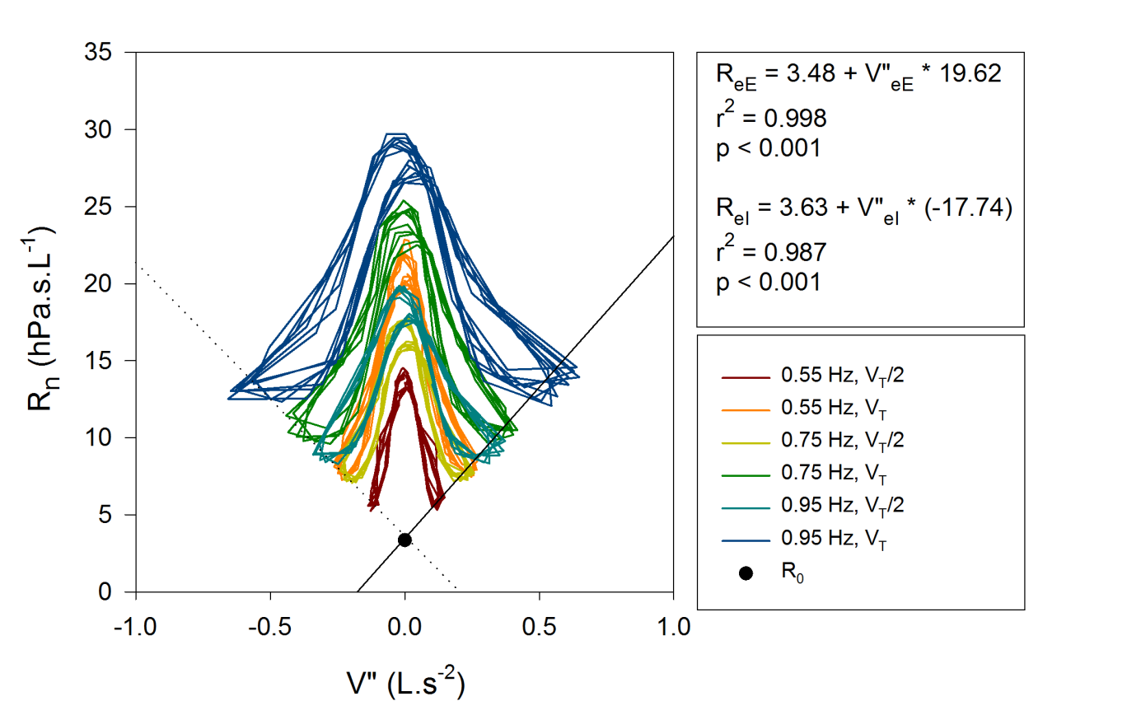

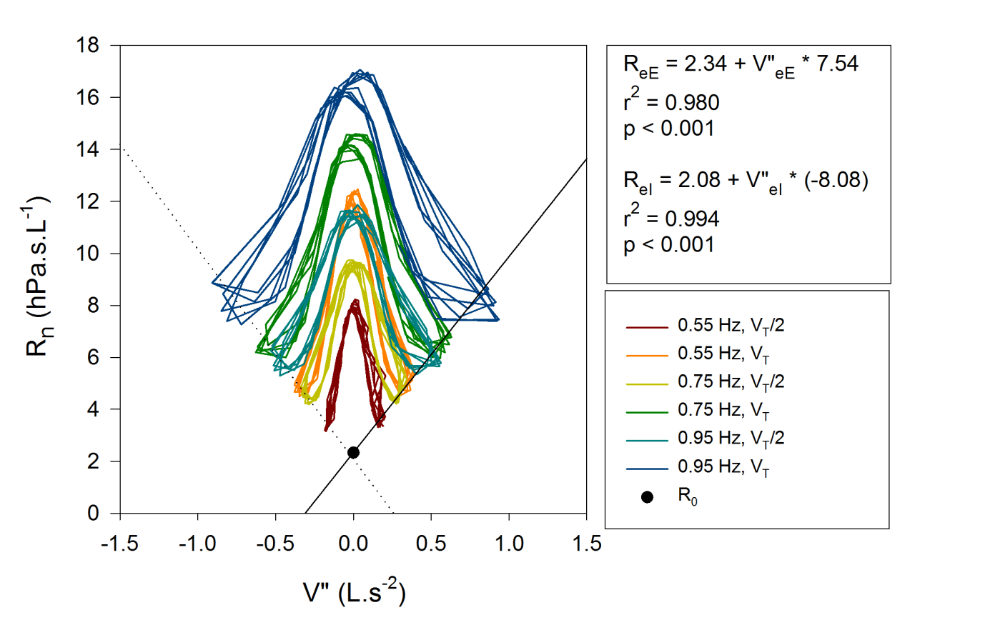

Figure S1 continued

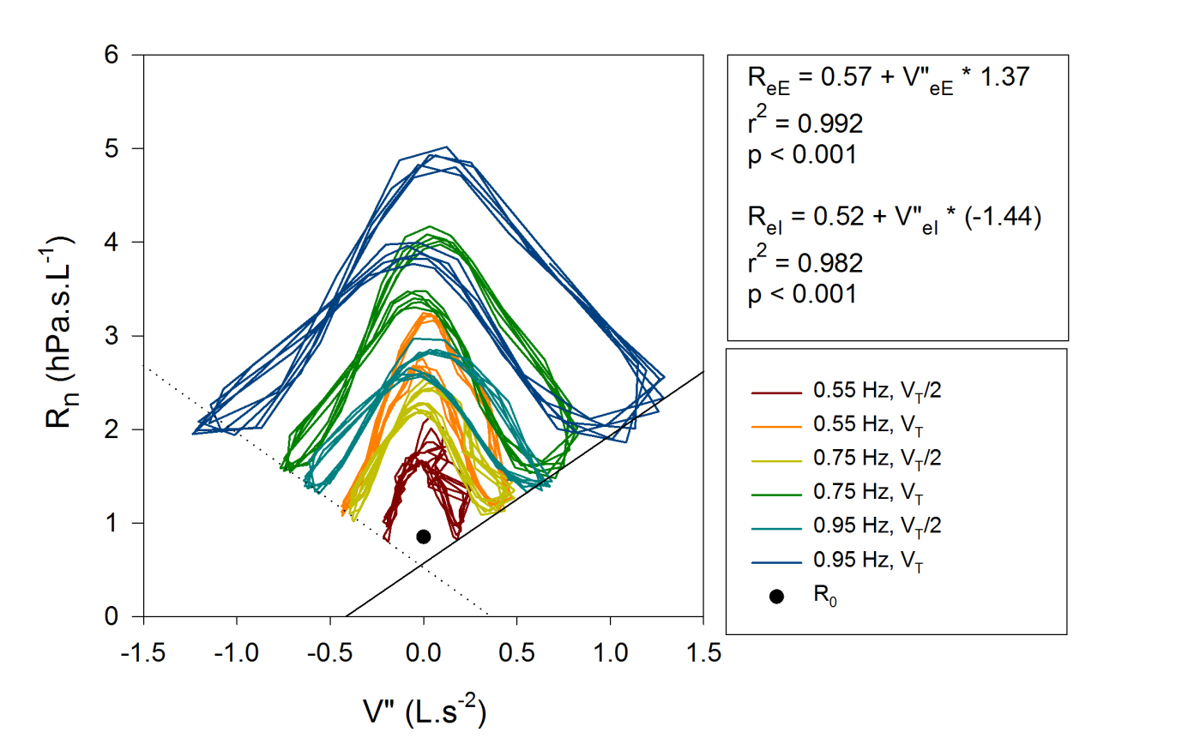

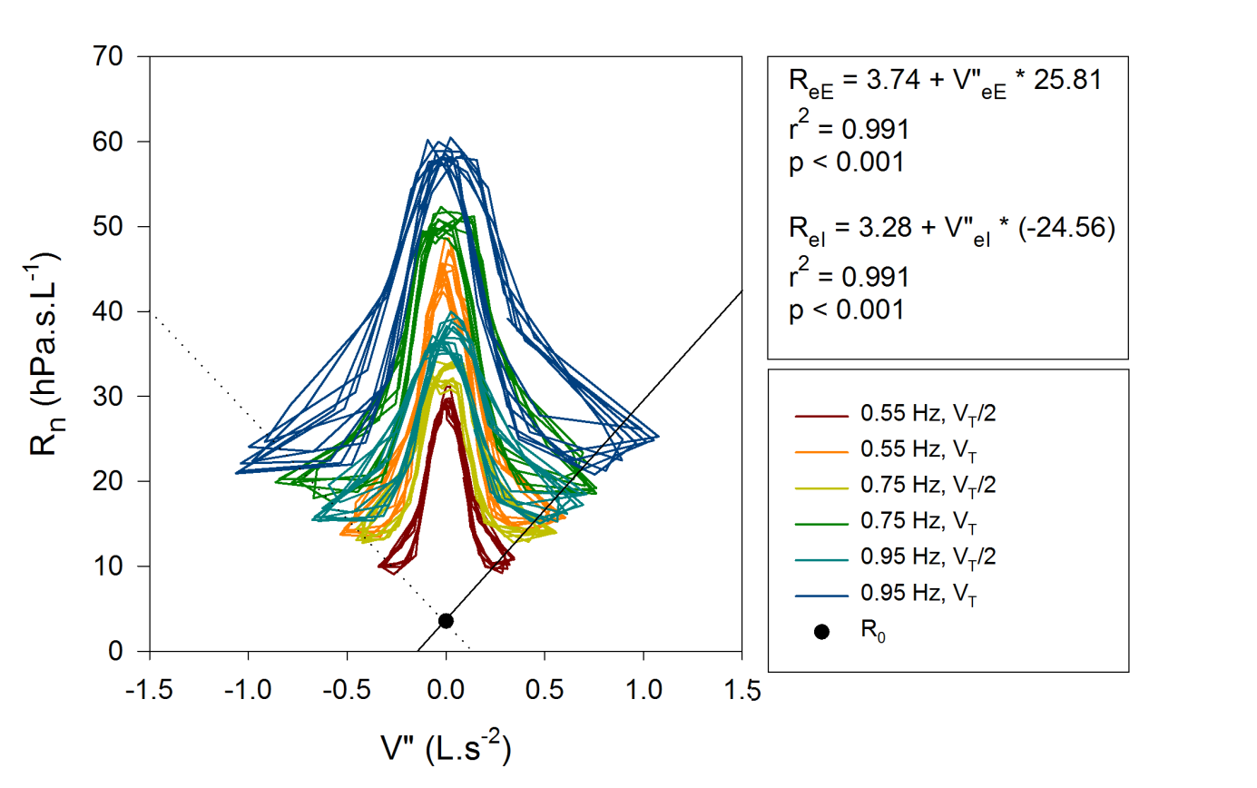

Figure S1 continued

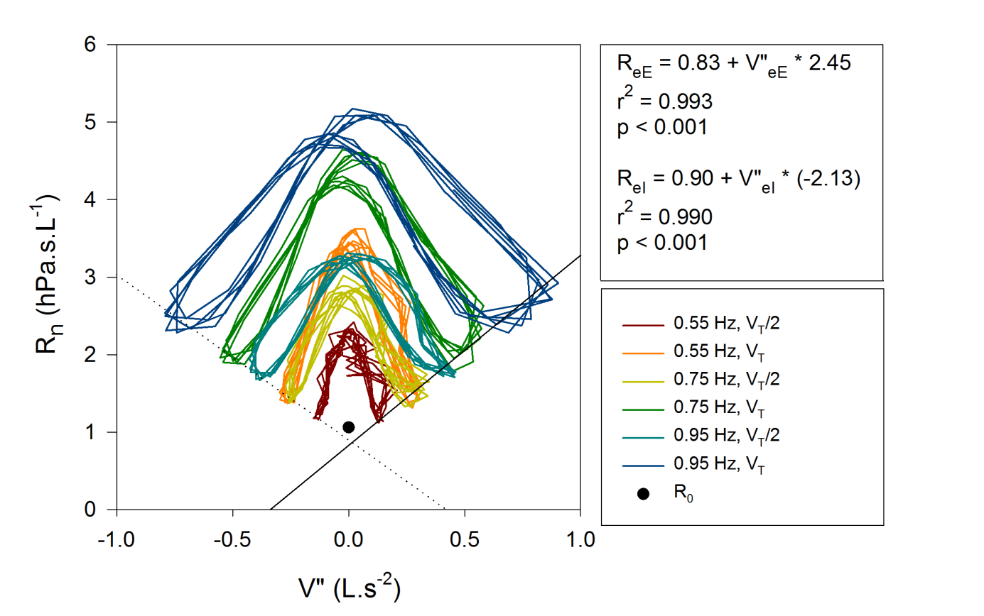

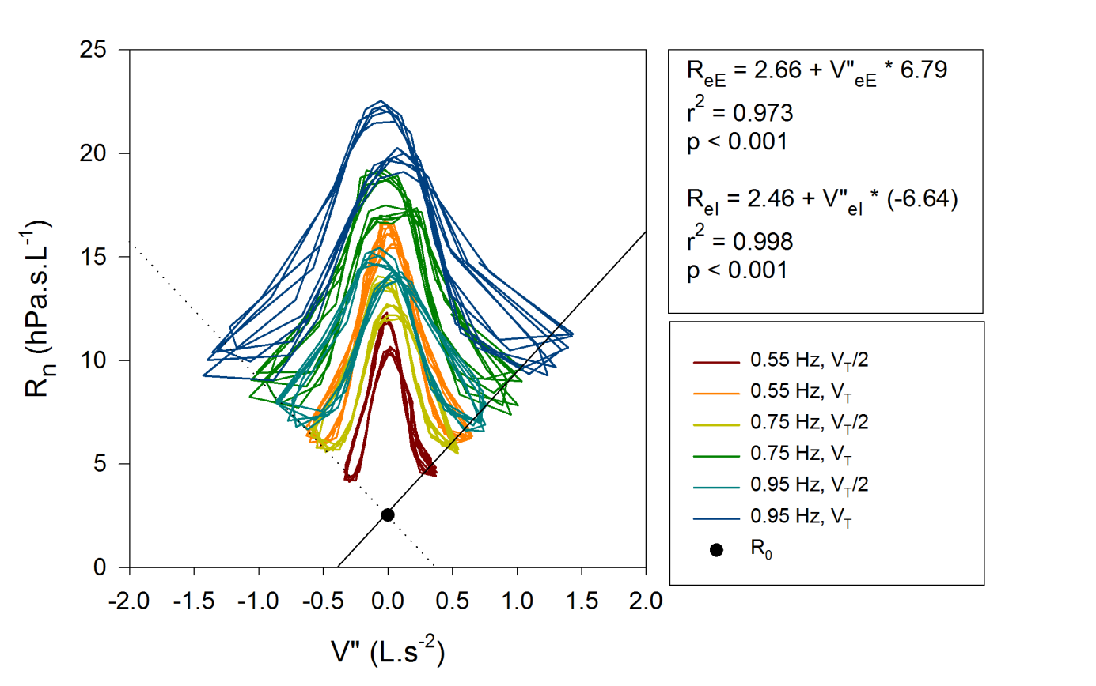

Figure S1 continued

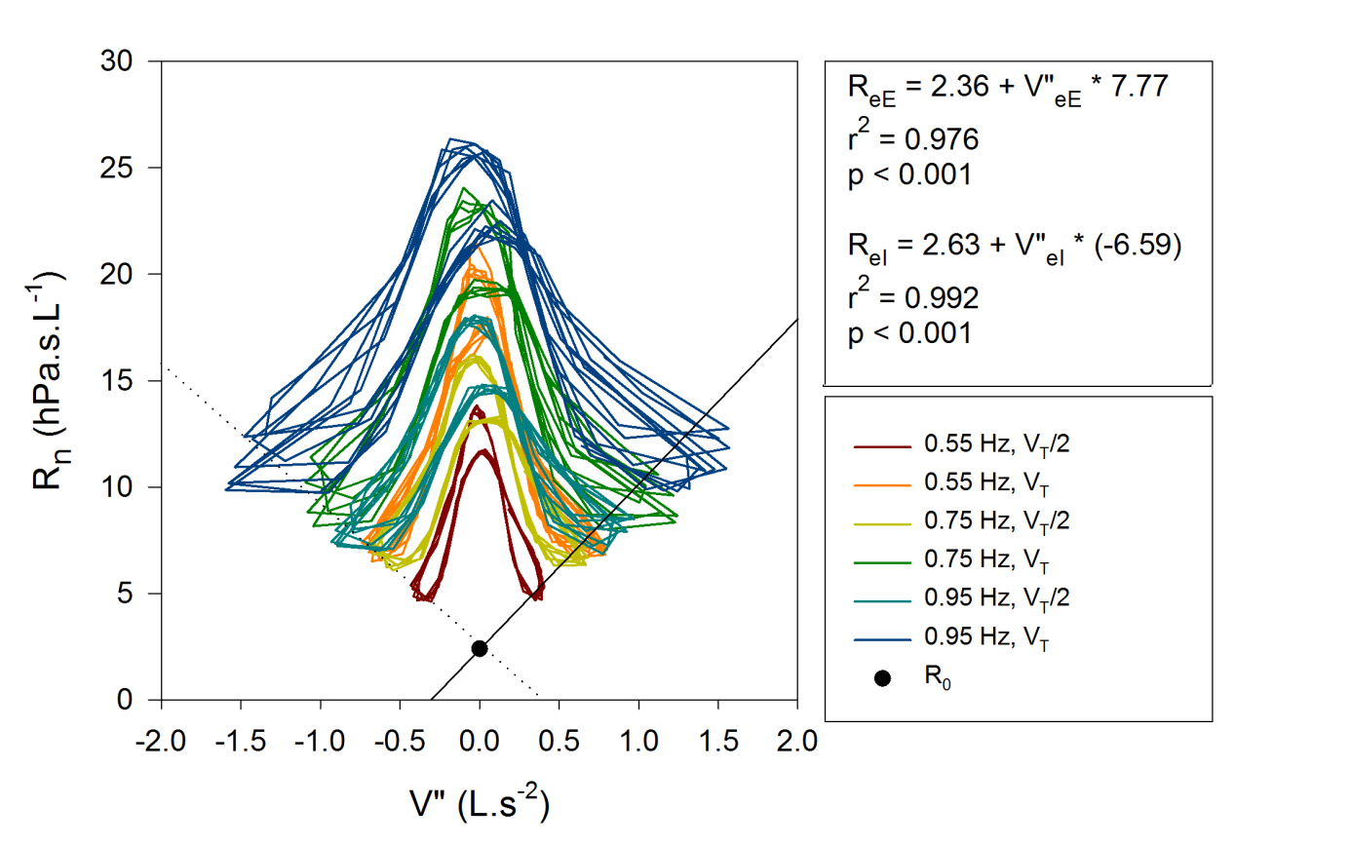

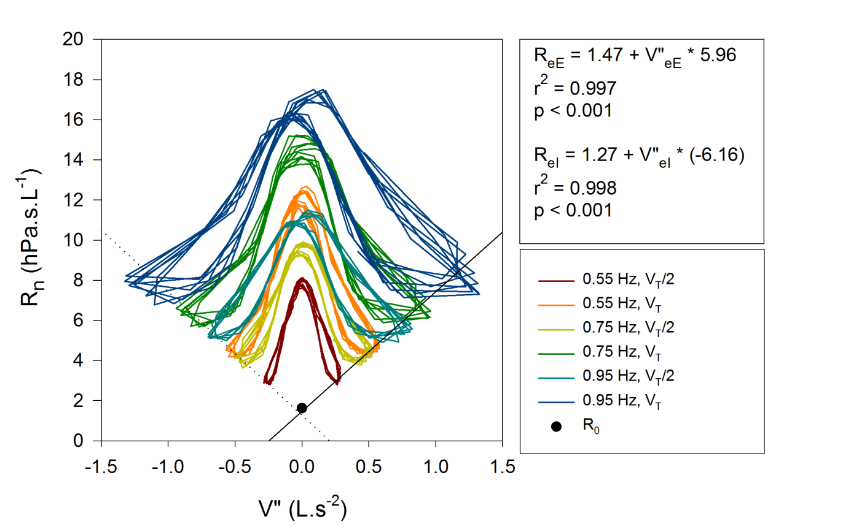

**Figure S2.** Respiratory system resistance (Rrs) vs flow (V’) graphs of newborns - in vivo measurement with segmented model. Only expiratory limb is visualised. Note the logarithmic scale.

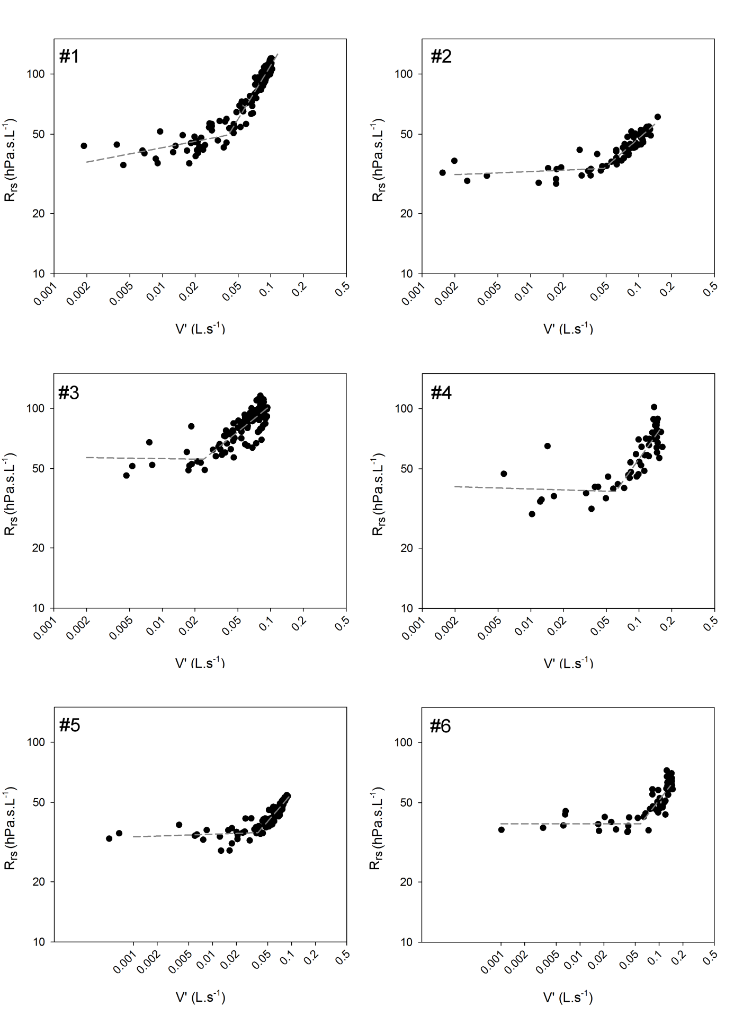

Figure S2 Continued

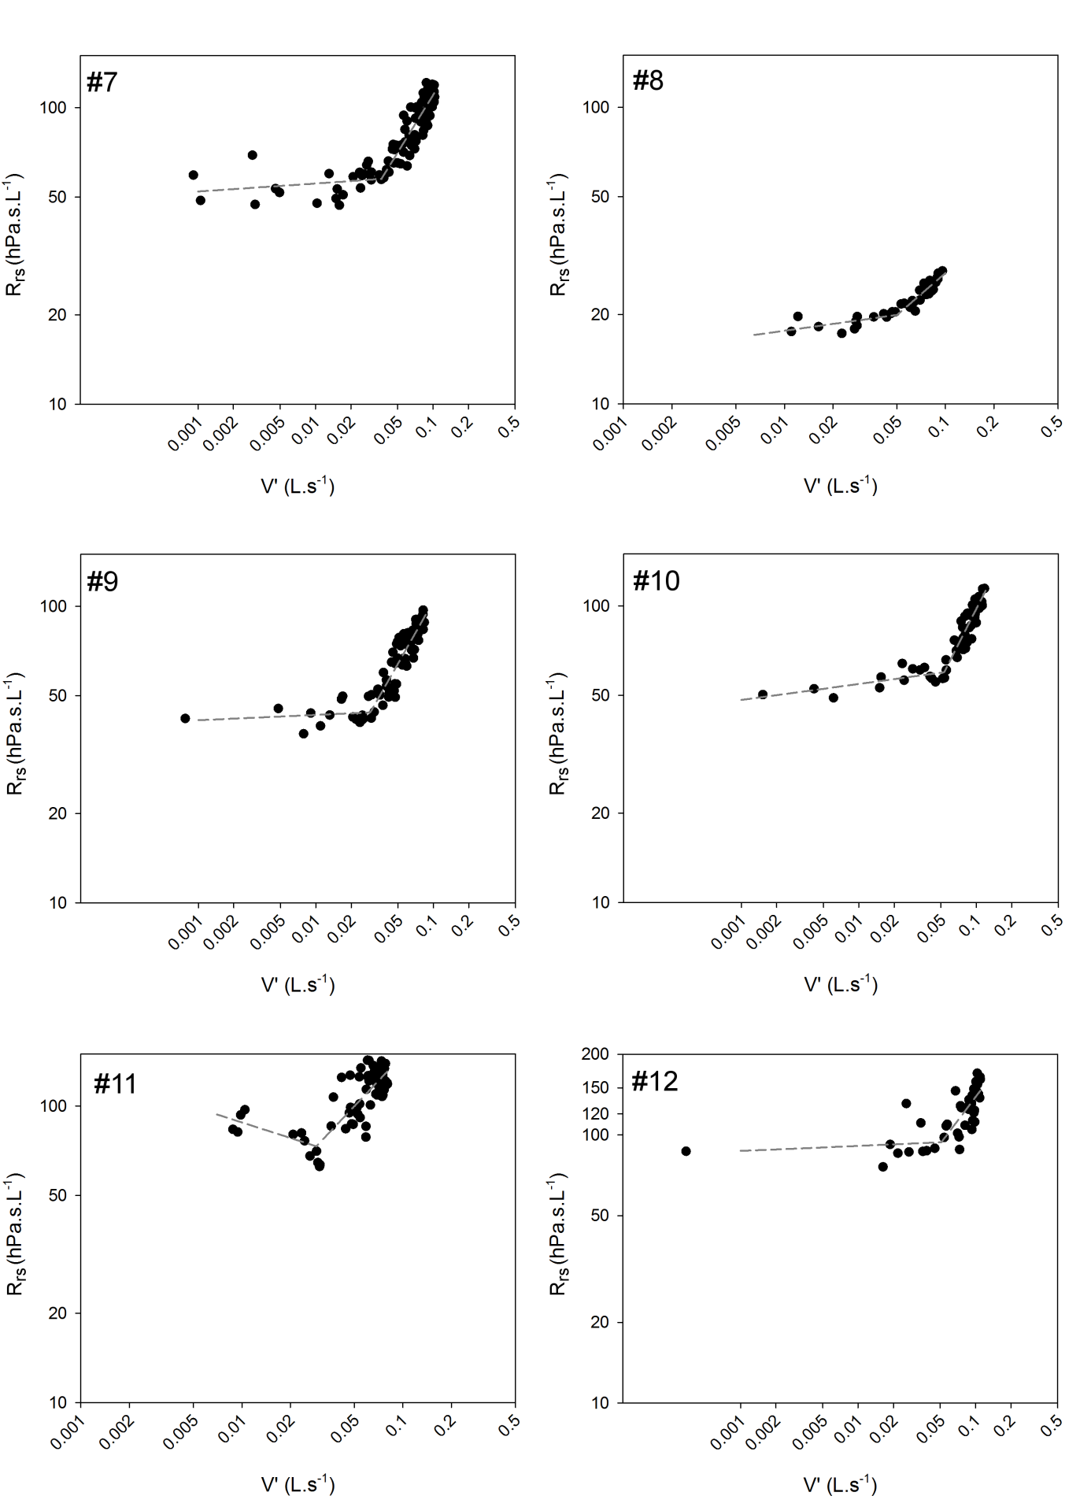

Figure S2 Continued

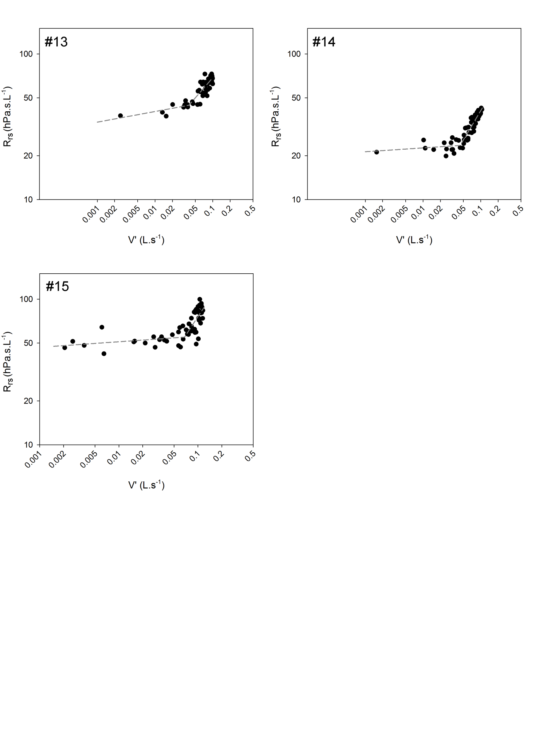

**Figure S3.** The effect of the geometrical correction on end-expiratory and end-inspiratory resistance (ReE and ReI, respectively), and the difference between ReE and ReI (ΔR) in healthy newborns (n=15). ΔR values are more realistic after correction, indicating less masking effect of the dynamic nonlinearities arising in the upper airways.

